6. Tilshead Village Hall Plot
Plot of land as shown in conveyance. Owned by the Parish Council.
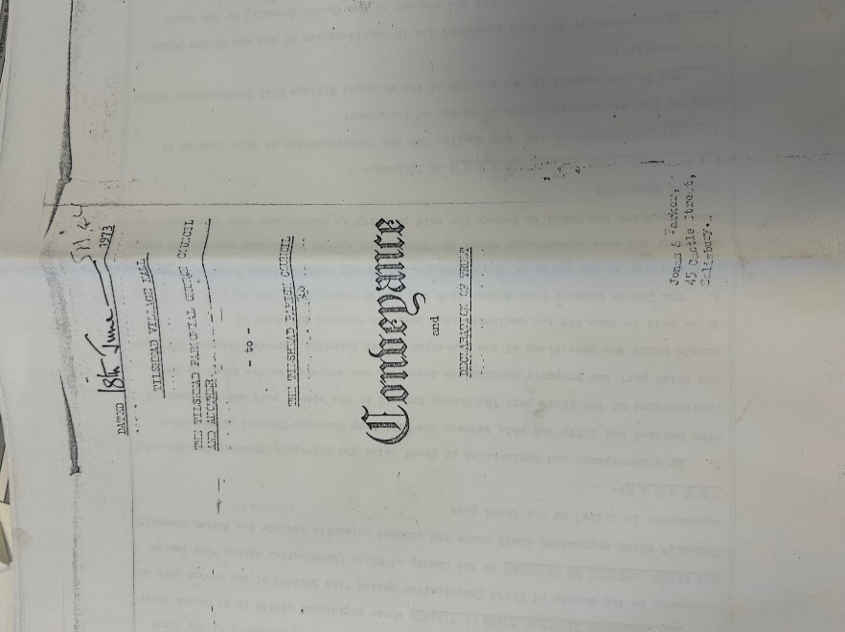
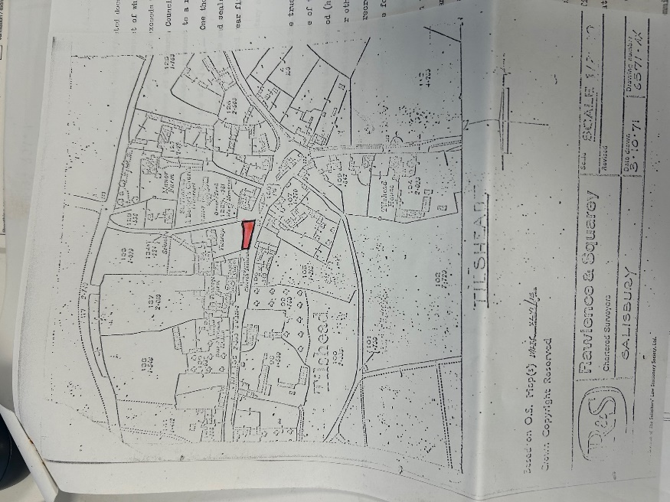
Parish Council are the Custodian Trustee, and the Village Hall are the Management Trustees.

