APPLICATION FOR HOUSEHOLDER PLANNING PERMISSION
DELEGATED REPORT

APPLICATION REFERENCE: | PL/2026/00332
APPLICATION TYPE: | Householder planning permission
SITE ADDRESS: | 24 Meadowfield, Bradford on Avon, BA15 1PL
DEVELOPMENT DESCRIPTION: | Proposed first-floor balcony above existing rear extension
RECOMMENDATION: | That Planning Permission be REFUSED

PROPOSAL

The proposal seeks planning permission for a first-floor balcony area over an existing single storey rear extension. The works would involve inserting patio doors to access the external space. Following officer’s concerns in regard to potential adverse overlooking impacts, revised plans were received (29.04.2026) and consulted on for the requisite 21-day period. The revised plans raised the height of the balcony elevations from 1.1m to 1.25m and introduced obscure glazed panels.

SITE DESCRIPTION/CONTEXT
This application relates to a detached dwelling, 24 Meadowfield, located within an established residential cul-de-sac area in Bradford on Avon. The host dwelling benefits from an off-road parking area to the front elevation and a detached garage.

The surrounding properties are all similar in style comprising of large, detached dwellings sitting on a steeply sloping hill overlooking the valley below. The application site sits within the Bath and Bradford on Avon Special Area of Conservation for bats.

PLANNING HISTORY
N/A

RELEVANT POLICIES AND GUIDANCE

Wiltshire Core Strategy:

Core Policy 2 Delivery Strategy
Core Policy 7 – Spatial Strategy for the Bradford on Avon Community Area
Core Policy 50 – Biodiversity and Geodiversity
Core Policy 57 - Ensuring High Quality Design and Place Shaping
Emerging Policy – Wiltshire Local Plan Review
At Full Council on 19 May, the elected members of Wiltshire Council agreed to withdraw the emerging WLP. The said Plan has no material weight for the purposes of the application.
Bradford on Avon Neighbourhood Plan 2013 – 2026 Made October 2017

Wiltshire Design Guide: Appendix D – Design Guidance for Householder extensions

The National Planning Policy Framework (NPPF)

The Planning Practice Guidance

National Design Guide

CONSULTATION RESPONSES
Bradford on Avon Town Council: No objection

REPRESENTATIONS
One letter of support was received from a neighbouring occupier.
Bradford on Avon Preservation Trust: No objection

ASSESSMENT
Section 38(6) of the Planning and Compulsory Purchase Act 2004 states:

"If regard is to be had to the development plan for the purposes of any determination to be made under the planning Acts, the determination must be made in accordance with the plan unless material considerations indicate otherwise."

In accordance with this statutory requirement, this application has been assessed against the relevant policies of the Development Plan, including the adopted Wiltshire Core Strategy (2015) and, where applicable, any made Neighbourhood Plans.

Design and Impact upon the character and context of the area
Core Policy 57 - Ensuring High Quality Design and Place Shaping of the Wiltshire Core Strategy seeks to ensure that all new development is of high design quality, reflecting local context, character, and distinctiveness.

The proposal seeks to insert a balcony area over an existing single storey extension that sits on the south rear elevation. The balcony would consist of glazed panels, sitting at a height of 1.25m with the side panels obscure glazed. The existing flat roof of the extension would have composite decking installed and the applicant seeks to remove the existing window that serves the first floor living room and replace it with patio doors to access the balcony area. The balcony area would extend over the existing ground floor extension by a depth of 2.1m and width of 4m.

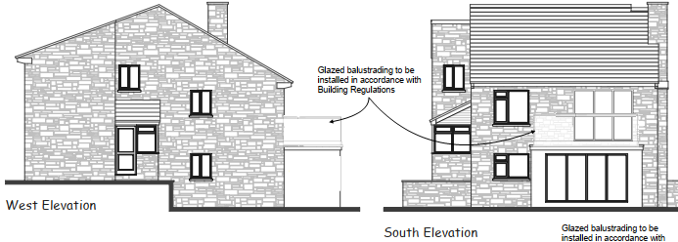
Proposed balcony area on the rear elevation of the host dwelling

The proposal would present as a light touch development with the addition of simple glazed panels, and whilst there would be some change to the roofscape of the existing rear extension the change would be modest, and would integrate effectively into the existing built form of the host dwelling and surrounding setting. The development would appear to be in keeping with the character and appearance of the immediate area with a similar development present on the rear elevation of an adjacent dwelling at No.20 Meadowfield.

It is considered that the proposal would by virtue of its height, scale and design constitute a complementary addition to the host dwelling that would appear commensurate to the size of the property and plot.

Having regard to the above, the proposal complies with the design principles set out in Core Policy 57 of the Wiltshire Core Strategy and Appendix D of the Wiltshire Design Guide.

Amenity
Point vii of Core Policy 57 - Ensuring High Quality Design and Place Shaping of the Wiltshire Core Strategy seeks to ensure that developments do not adversely affect neighbouring properties. It requires that development should ensure the impact on the amenities of existing occupants/neighbours is acceptable and that appropriate levels of amenity are achievable within the development itself, including the consideration of privacy, overshadowing, vibration, and pollution (e.g. light intrusion, noise, smoke, fumes, effluent, waste or litter).

Residential amenity is affected by significant changes to the environment including privacy, outlook, daylight and sunlight, and living areas within private gardens, and any proposed development therefore needs to be carefully considered accordingly.

Appendix D of the Wiltshire Design Guide expects a well-designed householder development to respect neighbouring properties, advising that they should not be unduly overbearing or unduly obtrusive, and that windows should not directly overlook neighbouring properties

The National Planning Policy Framework (NPPF), particularly Paragraph 135(f), stresses that planning decisions should ensure developments provide a high standard of amenity for existing and future users.

The proposed development has been assessed in terms of its potential impact on the residential amenity of neighbouring properties, with particular regard to loss of light, overshadowing, loss of privacy, and overbearing effects. No overbearing or overshadowing impacts or loss of light would occur to neighbouring properties given the nature of the proposal.

The proposal has been subject to revised plans as officers raised concerns that the proposal would introduce some adverse overlooking to the rear gardens of neighbouring properties. Revised plans were received which raised the height of the side elevations of the balcony area from 1.1m to 1.25m, and the applicant proposes that the side panels would be obscure glazed to help mitigate any overlooking to the adjacent properties (at No.22 Meadowfield and 78 Winsley Road) when the occupiers are seated on the balcony area.

The proposal would introduce an accessible platform at first floor level, that would sit at a height of 2.7m, designed for external use the area would be large enough to accommodate an outdoor seating area with the potential for an outdoor dining area also, extending over an area of 8.4m2. Officers acknowledge that whilst seated on the balcony area, overlooking to the adjacent properties to the east and west would be mitigated to some extent because of the obscure glazed panels.

However, the adjacent dwellings would still be subject to adverse overlooking when the applicant is stood on the balcony area. Officers visited the site and were able to access the outside space and view the surroundings. From the elevated position it was possible to gain direct sight down and into the immediately adjacent rear garden of No.78 Winsley Road to the east. In addition, officers were able to look freely towards rear gardens of properties slightly further afield surrounding the application site.

The site photos below illustrate views across from the proposed raised platform area to the private residential rear curtilages of the adjacent dwellings. The photos were taken in April when the mature trees and shrubs were in full leaf.

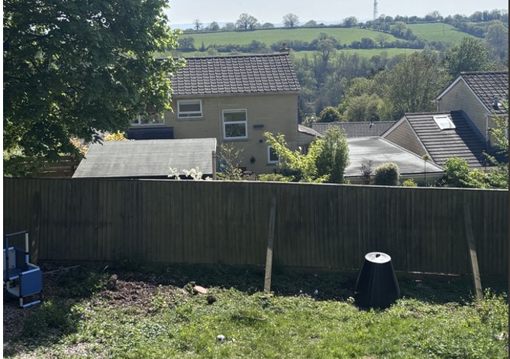
View from the proposed balcony area to the south (rear)
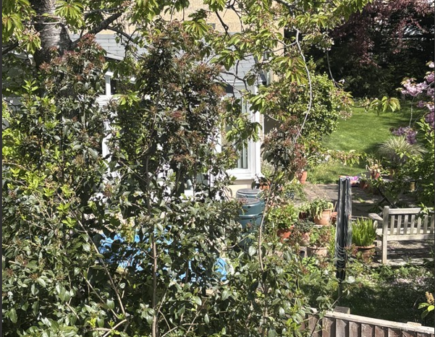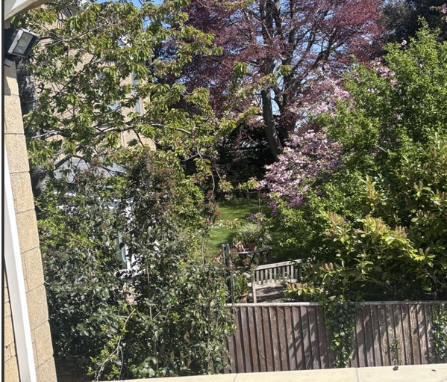
View from the balcony area to the neighbouring garden to the east No.78 Winsley Road

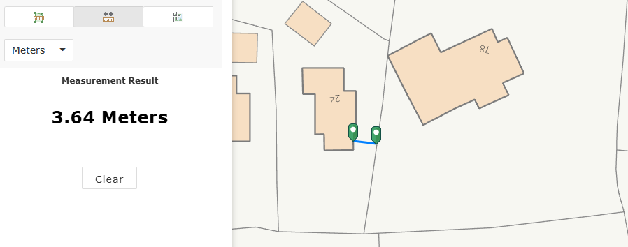
In the map insert above the separation distance from the proposed first floor balcony area to the common shared boundary with the neighbour to the east at No.78 Winsley Road is identified as 3.6m

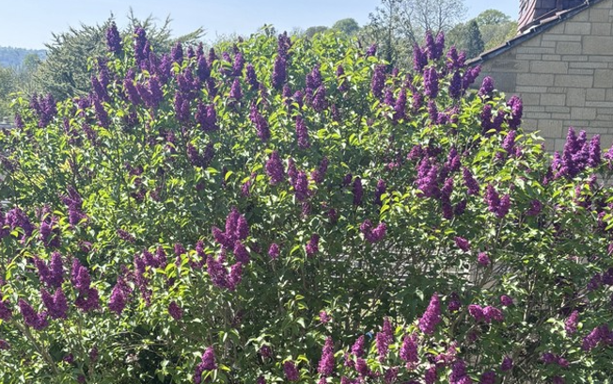
View from the proposed balcony area to the neighbouring garden to the west No.22 Meadowfield
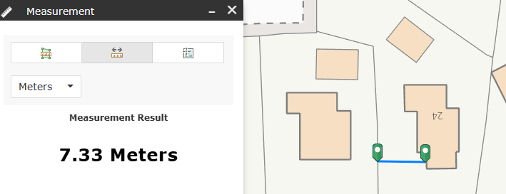
In the map insert above the separation distance from the proposed first floor balcony area to the common shared boundary with the neighbour to the west at No 22 Meadowfield is identified as 7.3m.

The Council’s preferred ‘general rule of thumb’ would be of 21 metres between habitable windows of adjacent properties and 10.5 metres between first floor habitable windows and neighbour’s gardens (which approach has been accepted as good practice by the Planning Inspectorate)

Officers consider that the sense of being overlooked from this vantage point to some neighbouring occupiers would be both real and materially different from anything that may have been experienced from the original outlook from the existing first floor window. Therefore, officers are of the opinion that this would likely be intrusive and detrimental to neighbours’ living conditions.

It is acknowledged that there are intervening boundary features in the form of mature trees and shrubs on both sides of the common shared boundary between the host dwelling and the properties to the east and west. However, the presence of existing mature soft landscaping treatments cannot be relied upon to ensure that no overlooking would occur given the potential for these trees to be removed at any point in the future. The application site does not lie within a conservation area, and the trees are not subject to Preservation Orders, so permission would not be required for these trees to be removed.

The properties within the cul-de-sac already experience a degree of mutual overlooking and officers are cognisant that some balcony arrangements are present within the immediate area, however the outdoor space at No 24 would provide an opportunity for prolonged use, especially during fine weather and at times when others would be likely using their rear garden spaces where a degree of privacy would reasonably be expected.

The harm identified means that the proposed works would conflict with WCS Policy CP57 where it seeks to ensure development is compatible with adjoining buildings and uses, including having regard to levels of privacy. For the same reason there is conflict with the National Planning Policy Framework’s objectives for achieving well-designed places with a high standard of amenity for existing and future users.

It is considered that the proposal would materially increase the level of actual and perceived overlooking, and it is considered that the harm would be unacceptable in this instance. Consequently, the proposal is not considered to satisfy adopted local design guidance and safeguard appropriate levels of amenity for neighbouring occupiers as required by CP57 (vii).

The proposal therefore conflicts with Paragraph 135(f) of the National Planning Policy Framework (NPPF), for failing to provide a high standard of amenity for existing and future users, Core Policy 57 point vii in respect of safeguarding residential amenity and also Appendix D of the Wiltshire Design Guide.

Ecology Impact
Core Policy 50 of the Wiltshire Core Strategy seeks to protect and enhance biodiversity and geodiversity, including through ensuring that development avoids harm to protected species and habitats.

The National Planning Policy Framework (NPPF), in Paragraphs 193, requires that development minimises impacts on and provides net gains for biodiversity, including ensuring mitigation is secured where harm cannot be avoided.

The application site sits within the Bath and Bradford on Avon Special Area of Conservation for bats and as this application involves disturbance within the application site due consideration has to be given to the potential disturbance of any bats because of the proposed development.

Given the established high density urban residential nature of the location, it is considered highly unlikely that any bats would be affected and significant effects relating to the disturbance to bats can be ruled out.

As a precautionary measure an informative would be added to any decision that in event any evidence of bat activity is detected that the applicant should follow the advice of a professional ecologist or contact Natural England.

As such, the development complies with Core Policy 50 of the Wiltshire Core Strategy and the relevant provisions of the NPPF.

Biodiversity Net Gain
Householder planning applications are exempt from the requirement to deliver Biodiversity Net Gain under Schedule 7A, Section 4(2)(a) of the Town and Country Planning Act 1990, as inserted by the Environment Act 2021.

CONCLUSION
The proposed development is considered to be unacceptable in terms of its relationship with the surrounding area, as it would result in any unacceptable harm to the amenities of neighbouring occupiers.

The proposal is therefore considered to conflict with the relevant policies of the Wiltshire Core Strategy, the Wiltshire Local Plan, and the National Planning Policy Framework. As such, the application is recommended for refusal.

RECOMMENDATION: That Planning Permission be REFUSED

Refusal Reason
The proposal would materially increase the level of actual and perceived overlooking, and it is considered that the harm would be unacceptable in this instance. Consequently, the proposal is not considered to satisfy adopted local design guidance and safeguard appropriate levels of amenity for neighbouring occupiers as required by CP57 (vii).

The proposal therefore conflicts with Paragraph 135(f) of the National Planning Policy Framework (NPPF), for failing to provide a high standard of amenity for existing and future users, Core Policy 57 point vii in respect of safeguarding residential amenity and also Appendix D of the Wiltshire Design Guide.

