14. Materials used in Proposal
Materials to be used in the proposal:
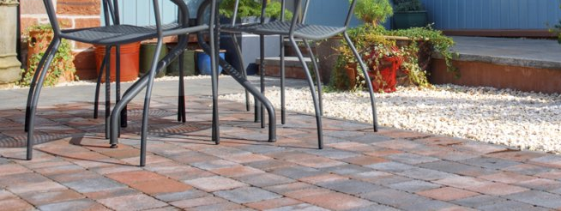
1. Block Paviours

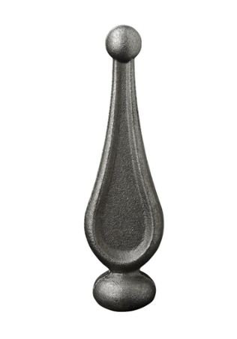
2. Railings, Tear Drop Finial.

3. Staddle Stone Planter.
