APPLICATION FOR PRIOR NOTIFICATION - AGRICULTURAL
CASE OFFICER REPORT

APPLICATION REFERENCE: | PL/2026/03065
APPLICATION TYPE: | Prior approval Part 14 Class OA: Installation etc of a solar canopy on non-domestic, off-street parking
SITE ADDRESS: | County Hall, Bythesea Road, Trowbridge, BA14 8JN
DEVELOPMENT DESCRIPTION: | Solar Car Ports on the Former East Wing Car Park Site. This Is Now Being Developed as a New Leisure Centre
RECOMMENDATION: | That prior approval is required and GRANTED

SITE DESCRIPTION/CONTEXT

The application site as illustrated below is within the centre of Trowbridge and sits opposite County Hall to the northeast.

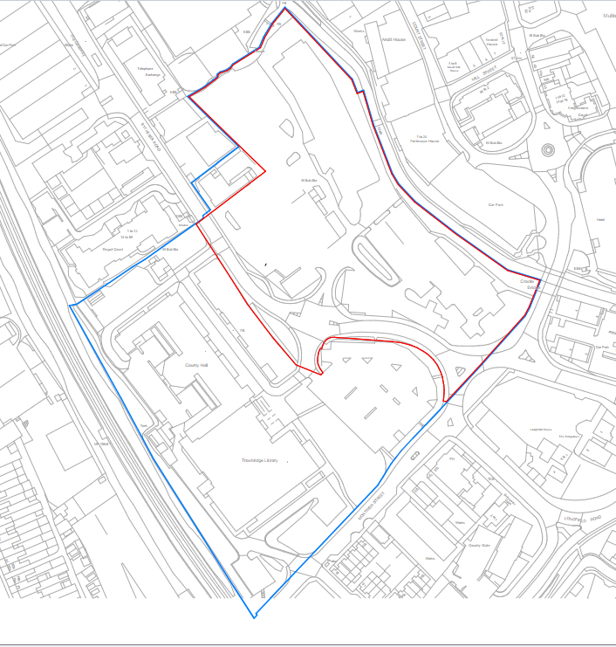

To the north of the site is the rear of the ASDA building. The northeast boundary is formed by the River Biss with tall buildings beyond, including historic former mills. The riverbank is lined with mature trees and vegetation below the tree canopy. The south and west of the site is bounded by Castle Street and Bythesea Road.

The site is outside of, but immediately adjacent to, the Trowbridge Town Centre Conservation Area. The Conservation Area sits to the northeast and includes the River Biss.

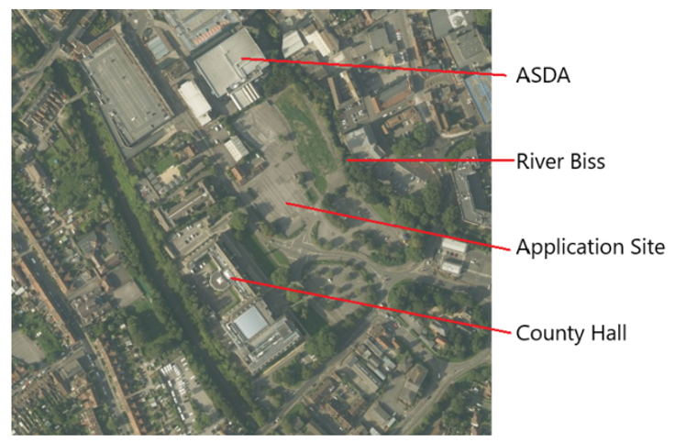

PROPOSAL

The proposal seeks to install solar carports within the leisure centre car park to the north of the site. Shown in the below plan extract.

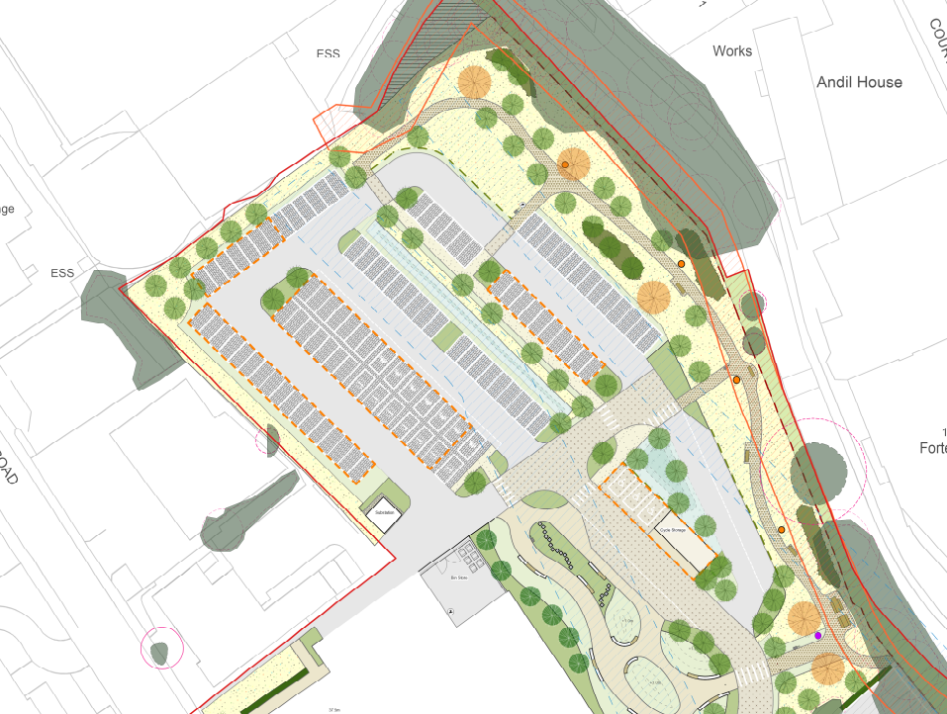

RELEVANT PLANNING HISTORY

Proposal / Summary
PL/2024/08255 - Wiltshire Council R3 Decision - Approve with Conditions Date: 11/12/2024 – Construction of a Leisure Centre and Ancillary Works
PL/2025/05418 - Wiltshire Council R3 Decision - Approve with Conditions Date: 19/9/2025 – Installation of car park canopy in visitors car park.

RELEVANT LEGISLATION, POLICY AND GUIDANCE
This application is assessed under Article 3 of the Town and Country Planning (General Permitted Development) (England) Order 2015 (as amended), which grants planning permission for certain types of development described in Schedule 2 of the Order. The grant of permission is subject to the limitations, conditions, and provisions set out within the relevant Classes of permitted development.

Under Schedule 2, Part 14, Class OA of the Town and Country Planning (General Permitted Development) (England) Order 2015 (as amended), certain types of development may be permitted, namely: The installation, alteration or replacement of a solar canopy within an area lawfully used as off-street parking other than for a dwellinghouse or a block of flats.

Where such development is proposed, the developer is required to apply to the local planning authority for a determination as to whether prior approval is needed. For this site, not on article 2(3) land, prior approval may be required as to whether the solar canopy’s siting, design and external appearance, in particular the impact of glare on the occupiers of neighbouring premises is acceptable.

ASSESSMENT

Does the Proposal Qualify as Permitted Development?

Yes.

Having completed the detailed assessment checklist at Appendix 1 of this report, it is concluded that the proposed development qualifies as permitted development under Schedule 2, Part 14, Class OA of the Town and Country Planning (General Permitted Development) (England) Order 2015 (as amended), and the assessment may now proceed to consider the siting, design, and external appearance of the development as required by the GPDO.

Is Prior Approval Required?

The solar canopy’s siting, design and external appearance, in particular the impact of glare on the occupiers of neighbouring premises:

Siting

The siting, located in the rear car park behind the new leisure centre, would not impact on neighbouring land uses or neighbouring amenity. The car park is surrounded by the rear of commercial buildings or the trees that line the river. There would be no impact beyond the site itself.

Design and external appearance

Here are some example elevations of the proposed solar carports:

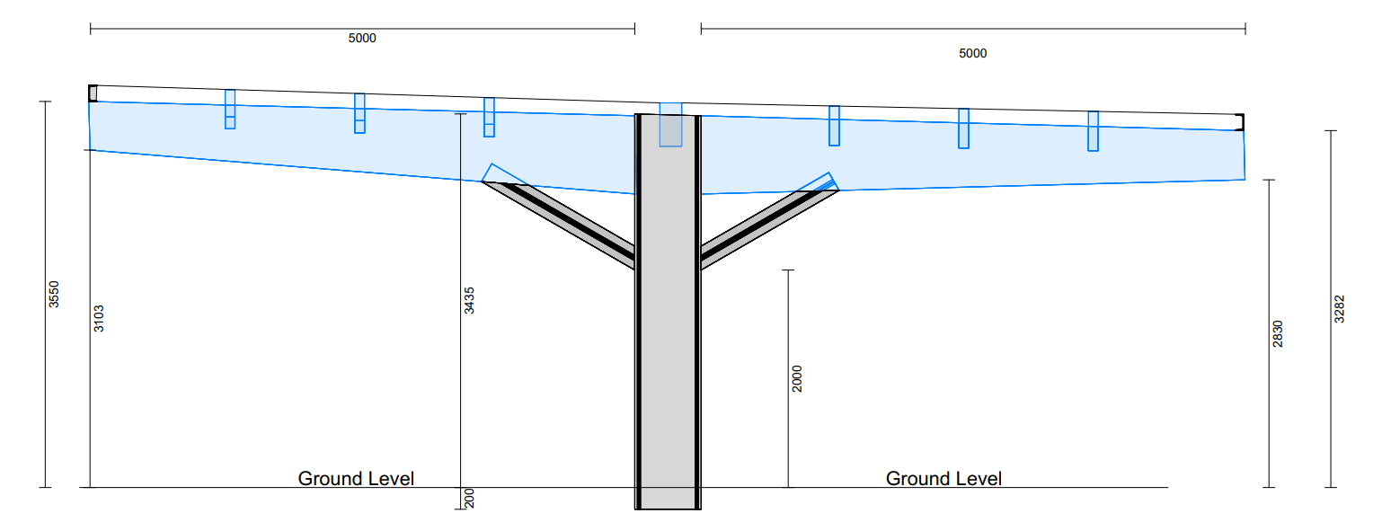

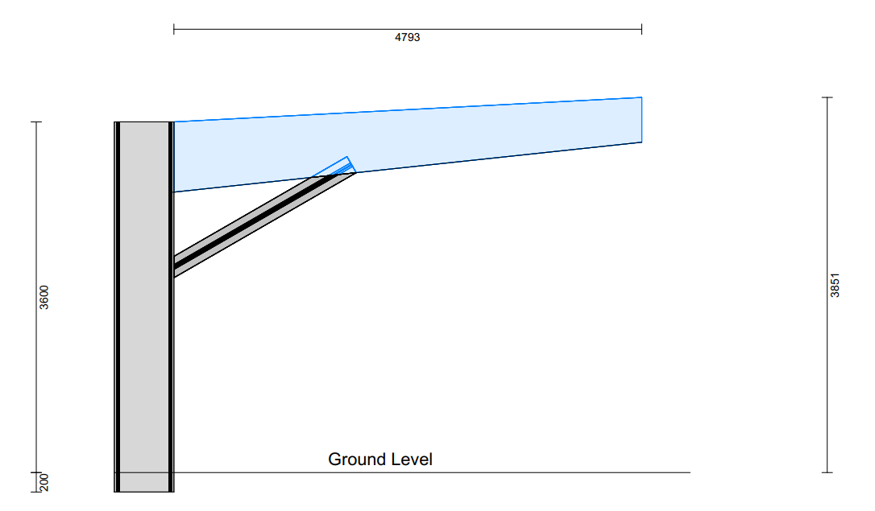

The carports would be of a functional design, with structural members being only large enough to hold the weight of the roofs/solar panels. This would present as a modern and functional design that would fit in with the prevailing urban character of the site, especially in consideration of the appearance of the leisure centre.

Impact of glare on the occupiers of neighbouring premises

As noted above, the site is not bounded by residential dwellings and therefore no residential amenity harm would be caused. The commercial neighbours would not be harmed either, given the small-scale nature of the carports. Solar panels are designed to absorb rather than reflect light.

CONCLUSION

The proposed development has been assessed against the provisions, limitations, and conditions set out in Schedule 2, Part 14, Class OA of the Town and Country Planning (General Permitted Development) (England) Order 2015 (as amended). Based on the submitted plans, supporting documentation, and the findings of this report, it is concluded that the proposal complies with the criteria for permitted development and therefore falls within the scope of Class OA. Following assessment, it is determined that prior approval is required in relation to the siting / design / external appearance of the development.

Having considered the relevant matters, it is further concluded that:

Prior approval is granted, subject to the development being carried out in accordance with the submitted details.

RECOMMENDATION:
That prior approval is required and GRANTED.

A
APPENDIX 1 – PERMITTED DEVELOPMENT CHECKLIST
 | Permitted Development | Yes / No
OA | Does the proposal involve the installation, alteration or replacement of a solar canopy within an area lawfully used as off-street parking other than for a dwellinghouse or a block of flats? | Yes
Criteria (OA.1) – Development not permitted by Class A:
(a) | if any part of the development—  (i) exceeds 4 metres in height above ground level  (ii) is within 10 metres of the curtilage of a dwellinghouse or a block of flats | (i) No  (ii) No
(b) | Would the development be within the curtilage of a dwellinghouse or a block of flats? | No
(c) | Would the development be on a site designated as a scheduled monument or on land within the curtilage of a scheduled monument? | No
(d) | Would the development be within the curtilage of a listed building? | No
(e) | Would the development be for the display of an advertisement? | No
(f) | If the off-street parking area is in use by virtue of Class B (temporary use of land) of Part 4 (temporary buildings and uses). | No

