PL/2026/02088
Site: Rixon Farm, Rixon Gate, Ashton Keynes, Swindon, SN6 6QW
Proposal: Reposition full height glazing from inside face of circular stone columns to outside face of circular stone columns
_______________________________________________________________________

Recommendations:

X | Comment
 | Support in principle subject to amendments to the scheme (as set out below)
 | Support subject to conditions (as set out below)
X | Object (for reasons set out below)
 | No objections

Scope of comments: the following comments relate to the built historic environment.

Site Description:
Rixon Farmhouse and associated farm buildings are located on Rixon Gate a lane that runs east out of the village of Ashton Keynes and about 1km east of the centre of the village. There are lakes 50 to the north and 150 to the south of the farm part of the Cotswold Water Park.

The farmhouse is a two storey with attic built in the late 18th century in limestone rubble with ashlar quoins. The roof is hipped to left with gable stack and stone slates. It has 3 bays with left rear wing of 2 bays. A central door with tripartite sash windows either side and 12 pane sashes to first floor and two hipped dormers to attic.

To the north of the Farmhouse are separately listed linear range of barns are located parallel and abutting Rixon Gate Lane. They are 17th and 18th century and built in limestone rubble.

The main barn is central with ashlar quoins and stone slate roofs. It is 4 bays with midstrey to south and half hipped roof. It has three tiers of ventilation ports on the north side and doors in the second bay.

Attached to the west directly north of the application garage is a two storey 2 bay stables built in limestone rubble with concrete roof tile.

Attached to the stables at the west end is simple open sided structure, a 6 bay stone cowhouse subject of the application with stone tile roof supported on circular rubble columns to the open front to the south on to the farmyard.

This building had at least partly collapsed and has been substantially rebuilt.

To the east of the main barn is a 6-bay structure with limestone lower half raised in in 19th century brick work to provide an attic.

Heritage Assets:
Rixon Farm Barn and Associated Farm Buildings Rixon Gate Ashton Keynes grade II
Rixon Farmhouse Rixon Gate Ashton Keynes grade II

Relevant planning History: 2026/02018 Vary Condition 2 (Plans) of 14/03493/FUL - Full Planning Permission for the Demolition of Existing Agricultural Buildings and Erect 2 Dwellings with Parking and associated Landscaping. Conversion of Barn to Form Single Dwelling. Change of Use of Ground Floor Barn and Extension to Form Single Dwelling including Existing First Floor Residential Use (Pursuant to 05/02731/FUL) Erection of Garage for Farmhouse

The Proposal: Permission is being sought to amend the Cow shed conversion as approved in the previous permission ref PL/2024/01252 granted on 16th August 2024.

The approved design approach introduced a mix of glazed and timber clad cavity walls behind columns as the original permission, with an end bay kept open to reflect the original from of the building. This was a s73 application to the original planning permission re 14/03493/FUL.

Policy: From the point of view of the historic environment the main statutory tests are set out within the Planning (Listed Building and Conservation Areas) Act 1990. Sections 16 (LBC) and 66 (PP) require that special regard be given to the desirability of preserving listed buildings, their settings or any features of special architectural or historic interest which they possess.

The NPPF outlines government policy, including its policy in respect of the historic environment. Section 16 of the NPPF 'Conserving and enhancing the historic environment' sets out the Government's high-level policies concerning heritage and sustainable development.

Paragraphs 213-15 of the NPPF require a balanced approach with any harm which would be caused being weighed against the potential public benefits which might be achieved.

Paragraph 210 requires local planning authorities should take account of the desirability of sustaining and enhancing the significance of heritage assets and of new development making a positive contribution to local character and distinctiveness.

National Planning Practice Guidance provides guidance on interpreting the NPPF.

The Council’s Core Strategy Policy CP58 ‘Ensuring the conservation of the historic environment’ requires that “designated heritage assets and their settings will be conserved, and where appropriate enhanced, in a manner appropriate to their significance.”

Wiltshire Council’s Core Strategy Policy CP57 ‘Ensuring high quality design and place shaping’: A high standard of design is required in all new developments, including extensions, alterations, and changes of use of existing buildings. Development is expected to create a strong sense of place through drawing on the local context and being complementary to the locality.
Historic England Advice Note 2 – Making changes to Heritage Assets illustrates the application of policies set out in the NPPF in determining applications for PP and LBC.

Assessment: The NPPF confirms that when considering the impact of a proposed development on the significance of a designated heritage asset, great weight should be given to the asset’s conservation (and the more important the asset, the greater the weight should be). It makes clear that any harm to a designated heritage asset requires clear and convincing justification.

Previous Comments 2026/02018
The approved design approach introduced a mix of glazed and timber clad cavity walls set behind the principal feature to significance of the Cowshed barn, the rounded stone columns which create the six open bays as the original permission, with an end bay kept open to reflect the original form of the building.

The applicant now considers that the ‘openness’ of the original structure is compromised by this solution.

The applicant’s principal issue with the approved approach is that the new eaves details is compromised as it creates an ‘unbalanced roof structure’ with the proposed eaves details and some minor cleaning and installation of internal blinds issues.

The applicant has therefore proposed to continue the glass along the full length of the south elevation. This the application suggests can be achieved without compromising the buildings original form and appearance and preserves the simplicity of the original building.

The applicant also provides a detail for the new eaves details with external full height glazing and a very specific example with the glazing outside the line of the columns or posts that has been approved elsewhere and this relates to a conversion C16th grade II listed barn conversion where the original timber posts and ceiling beams and braces were integrated (not the roof trusses).

In this case the majority of the structure, stone columns and timber trusses are all new and therefore the need to preserve the original historic fabric appearance has not the same weight in consideration.

Each case needs to be considered on its own merits.

The starting point is normally the Historic England guidance on Adapting Historic Farm Buildings where it discusses approaches to ‘Openings’ and ‘Glazing’.

Openings
The historic pattern of openings is related to the function of the building over time and often makes a fundamental contribution to its mass and character. …..Where new openings are added or new windows inserted within existing door openings, great care needs to be given to their placing and design….

The large cart doors that lead into the threshing bays of barns pose a particular design challenge in adaptation schemes…..New entrance screens which are slightly recessed with a simple vertical emphasis can be effective.

Full glazing can alter the scale of the building and can give too much prominence to the opening. However, if the cart doors still survive or replacements are designed this can successfully reduce the impact of glazing.

Alternatively, this bay can be left open and unconverted or used for storage or garaging. This allows the large doors and the space behind, which may still retain its original floor finish, to be left unaltered.

Glazing
The glazing of openings is a particularly subtle aspect of design in farm building adaption work. In masonry structures setting glazing deep in the reveal of existing openings (where were really glazed) creates shadow lines and minimises reflections and impact.

The guidance has a number of examples of how to design appropriate glazing responses to barn conversions based on the above principles keeping it simple and setting back the glazing in deep reveals.

The applicants’ modernist clean lines architectural approach is at odds with the organic and rugged circular stone columns which are considered the significant structural element of the Cowshed that form the 6 open bays. It is therefore a strong consideration in any design response to preserve the stone columns as visible and not impinged
To achieve this involves setting the new external elevation as deep as possible, set back behind the columns and that the new elevation treatments should be more solid than glazed as full glazing can alter the scale of the building and can give too much prominence to the large open elevation.

There is a specific need therefore in conversion for open sided farm buildings to equally reflect solid through reinterpretation of cart doors to work together with glazing elements designed to reduce the adverse impacts of full glazing.

The glazing of openings is a particularly subtle aspect of design in farm building adaption works and the benefit from setting glazing deep behind the eaves of existing openings to create deep shadow and minimise reflections and adverse visual impact needs to be carefully considered and understood.

The minor compromise that has resulted in this case is the impact on the new trusses and connection with the stone columns. However, this is considered much less harmful than the now proposed full glazing to the eaves detail.
In addition, a non-heritage issue but one that is of concern and growing issue is the impact on Birds striking glazing a cause of avian mortality. The birds cannot perceive the glass instead seeing reflections of the sky and foliage as clear flyways.

Bird strikes and mortality can be reduced by significantly reducing and breaking up the glazing and reflections to signal a barrier to the birds.

Response to applicants counter response

The applicants have responded specifically these comments and I will respond to their comments:

The officer’s assessment treats deep recessing as though it is automatically the least harmful solution.

I acknowledge that in architecture there is no right response to and complex design issue. However, in this instance deep recessing of large areas of glazing to large barn openings in conversion has become the most reasonable and established architectural approach including being adopted within Historic England guidance for Adapting Traditional farm buildings as it does achieve positive and identifiable benefits.

I attach a case I experienced recently which I consider shows the benefits of the approach it is a former commercial shed at the Waterway Museum in Ellesmere Port Cheshire rather than and agricultural buidlng but shows the same principals apply to industrial buildings as former farm buildings. Here the cast iron columns are given the appropriate prominence through the recessing of the glazing to form a café and shop for the Museum.

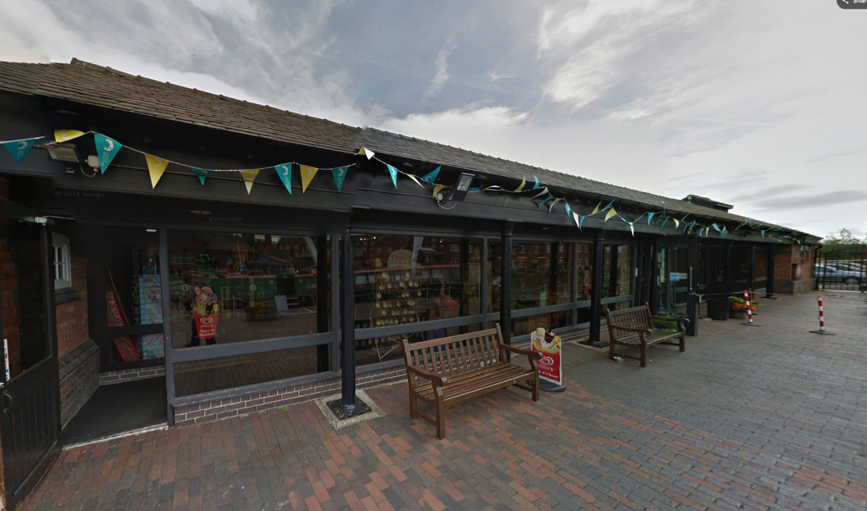
Pic. Waterway Museum Reception shop and Café in Ellesmere Port Cheshire

The applicant considers this approach ‘does not work for an open-sided cowshed. Its significance lies in the rhythm of the piers, the openness of the bays and the simplicity of the roof structure’ A glazed line can preserve that openness better than a more solid recessed infill wall.’

I consider that it works most effectively for open sided barns such as Linhay and Cowsheds or former open sided industrial buildings because it preserves the understating of the openness and reinforces the rhythm of the significant structural piers/columns.

My response is based on good evidence of the multiple schemes of conversion that have successfully adopted the recessing of glazing approach.

I therefore respectfully support my view that the applicants approach is at best less successful and in my view harmful to have full-height glazed treatment external to the columns directly under the eaves to the south elevation.

This objection does place weight on the significance of the stone piers to the architectural and historic interest of the Cowshed even though these columns have collapsed and or been deconstructed and rebuilt as they fully recognise the history, condition and reconstruction of this part of the building.

The recessed glazing approach in my view better preserves the open-fronted character and allow appreciation of the architectural and historic interest of the columns as structural and visual elements. It better reveals the essential historic character and understanding that this building was constructed as an open-fronted agricultural structure with a simple roof carried on a rhythm of stone piers.

The use of solid infill elements recessed has specific benefits of allowing deeper visual recessiveness, and reflects historic boarded doors sometime added to these structures during their working life, while full glazing has significant issues not least in reflectivity and it reinforces illumination of interiors especially at night that are in my view a harmful to understanding of the original form of these structures with dark recessed interiors.

The proposed full height glazing located in front of the columns tight under the eaves expresses the glazing and, in my view, would be overly visually dominant to the elevation. This issue cannot be adequality addressed by specification and detailing as suggested by the applicant.

Bird-strike concern is recognised as a non-heritage concern however it is design and architectural issue that can be at least partly resolved by recessing the glazing and introducing more solid elements into the infill materials and form. I note the applicant does not dismiss that issue but I do not agree that it can be sufficiently mitigated by innovation in glass technology.

Similarly, I do not consider that a reem of added conditions is appropriate and rather than as an approach to mitigation conversely suggests that the architectural approach is not the best for this building if it requires so many mitigating conditions to achieve it.

The applicant’s response has not provided any overwhelming case for their approach and I maintain when comparing the options that the recessing of the glazing /solid walling inside the stone columns and leaving some bays open is a substantially better option for preserving both architecturally and historically interest but also as a Wildlife protection.

I therefore maintain my objection of the applicants architectural approach with full height glazing located tight under the eaves and outside of the structural columns.

Summary: The glazing of openings is a particularly subtle aspect of design in farm building adaption works and the benefit from setting glazing deep behind the eaves of existing openings to create deep shadow and minimise reflections and adverse visual impact needs to be carefully considered and understood.

The applicant’s response has not provided any overwhelming case for their approach, and I maintain when comparing the options that the recessing of the glazing /solid walling inside the stone columns and leaving some bays open is a substantially better option for preserving both architecturally and historically interest but also as a Wildlife protection.

I therefore maintain my objection of the applicant’s architectural approach with full height glazing located tight under the eaves and outside of the structural columns.

I do not consider that a reem of added conditions is appropriate and rather than as an approach to mitigation conversely suggests that the architectural approach is not the best for this building if it requires so many mitigating conditions to achieve it.

