APPLICATION FOR HOUSEHOLDER PLANNING PERMISSION
DELEGATED REPORT

APPLICATION REFERENCE: | PL/2026/03345
APPLICATION TYPE: | Householder Planning Permission
SITE ADDRESS: | Honeysuckle Cottage, 3 Lower Road, Edington, Westbury, BA13 4QN
DEVELOPMENT DESCRIPTION: | Creation of 2no. off road parking bays
RECOMMENDATION: | That Planning Permission be REFUSED

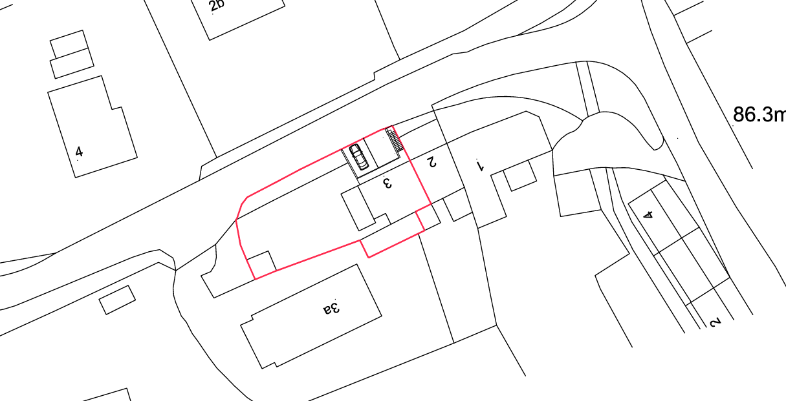
PROPOSAL

The application seeks planning permission for the excavation of the existing front bank to form two off-street parking spaces serving the dwelling. The works would include the construction of retaining walls to the rear and sides of the excavated area, with details indicating that these would be finished in brickwork subject to Local Authority approval. New access steps would be formed around the parking area, comprising brick risers with either brick treads or concrete paving slabs, and fitted with external balustrading in either timber or metal. The parking bays themselves would be surfaced in a fully permeable, SuDS-compliant resin-bound material.

SITE DESCRIPTION / CONTEXT

The application site comprises an end of terrace two-storey dwelling forming part of a row of three properties, positioned at an elevated level above Lower Road due to the natural topography which slopes upwards to the south. The dwelling is characterised by a mix of painted brick and white uPVC elements under a tiled roof. The surrounding area displays a varied character with a mix of boundary treatments including brick walls, railings, fencing, and established vegetation such as hedgerows and trees. To the north are larger detached properties set within more spacious plots, whilst the wider setting is typical of an edge-of-village location, with open fields and countryside views to the east. The site is located within the Edington Conservation Area, with additional constraints including proximity to a public right of way, designation within a Special Landscape Area, and adjacency to a priority habitat to the south.

PLANNING HISTORY

No relevant planning history has been identified for the site subject of this application.

RELEVANT LEGISLATION, POLICIES AND GUIDANCE

Wiltshire Core Strategy:

Wiltshire Core Strategy:

Core Policy 1 Settlement Strategy;
Core Policy 2 Delivery Strategy;
Core Policy 32 Spatial Strategy: Westbury Community Area;
Core Policy 50 Biodiversity and Geodiversity;
Core Policy 51 Landscape;
Core Policy 57 Ensuring High-Quality Design and Place Shaping;
Core Policy 58 Ensuring Conservation of the Historic Environment;
Core Policy 60 Sustainable Transport;
Core Policy 61 Transport and Development;
Core Policy 64 Demand Management;
Core Policy 67 Flood Risk;

The National Planning Policy Framework (NPPF) and The Planning Practice Guidance (PPG)

Wiltshire Design Guide - Appendix D – Design Guidance for Householder extensions

The Wiltshire Local Transport Plan 2011 – 2026: Car Parking Strategy (March 2015).

The Wiltshire Local Transport Plan 4 (LTP4) (March 2025)

Emerging Policy – Wiltshire Local Plan Review

At Full Council on 19 May, the elected members of Wiltshire Council agreed to withdraw the emerging WLP. The said Plan has no material weight for the purposes of the application.

CONSULTATION RESPONSES

Edington Parish Council – Supports
The Parish Council supports the proposal, noting that it would remove a vehicle from on-street parking on a narrow section of Lower Road near the Monastery Road junction. It considers the off-road parking space beneficial given that Lower Road is used as a through route.

Local Highway Authority (Wiltshire Council) – Objects
The proposal fails to provide adequate visibility splays in both directions, falling significantly below the required standard for a 20mph road, and cannot accommodate vehicle turning within the site, resulting in reversing onto the highway. Additional concerns are raised regarding the encroachment of part of the development onto the public highway and the reliance on mirrors to mitigate poor visibility, which are not supported.

REPRESENTATIONS

No comments received.

ASSESSMENT

Section 38(6) of the Planning and Compulsory Purchase Act 2004 states:

"If regard is to be had to the development plan for the purposes of any determination to be made under the planning Acts, the determination must be made in accordance with the plan unless material considerations indicate otherwise."

In accordance with this statutory requirement, this application has been assessed against the relevant policies of the Development Plan, including the adopted Wiltshire Core Strategy (2015) and, where applicable, any made Neighbourhood Plans.

The proposed development does not constitute a householder extension, but rather involves engineering operations to form a new vehicular access and off-street parking area within the domestic curtilage. Whilst development within residential curtilages is not unacceptable in principle, such proposals must be assessed on their individual merits, having particular regard to their impact on the character of the area, heritage assets, and highway safety, having regard to Core Policies 57, 58, 60 and 61 of the Wiltshire Core Strategy.

Design and Impact the upon the character and context of the area

Core Policy 57 Ensuring High Quality Design and Place Shaping of the Wiltshire Core Strategy requires all new development to achieve a high standard of design that responds positively to its local context. Proposals must reinforce and enhance local character and distinctiveness, relate appropriately to the surrounding landscape, and demonstrate a thoughtful response to existing townscape features. This includes careful consideration of elements such as building height, scale, massing, building line, materials, and overall appearance, ensuring new development integrates harmoniously with its setting.

The proposed works relate to the excavation of a relatively small section of the existing front garden, which appears to be of limited functional value due to its steep gradient and constrained size making it difficult to maintain or utilise for meaningful planting. As such, the principle of introducing a parking area in this location would not result in the loss of a high-quality amenity area. However, the application lacks detailed specification of materials, with a number of elements, including the retaining walls, steps, balustrading, and surfacing, reserved for later approval. Whilst it is considered that an acceptable design solution could potentially be achieved—through the use of materials reflective of the host dwelling, such as red brick for the retaining structures and a muted, recessive tone for the resin-bound surface—the absence of firm details limits a full assessment at this stage. The choice of balustrading, in particular, would require careful consideration, with a simple timber design likely to be more appropriate within the wider street scene, although a suitably detailed metal alternative could also be acceptable. Subject to the imposition of suitably robust conditions securing all external materials and finishes, the proposal is considered capable of integrating satisfactorily with the character of the host dwelling and would therefore broadly accord with the requirements of Core Policies 51 and 57 of the Wiltshire Core Strategy.

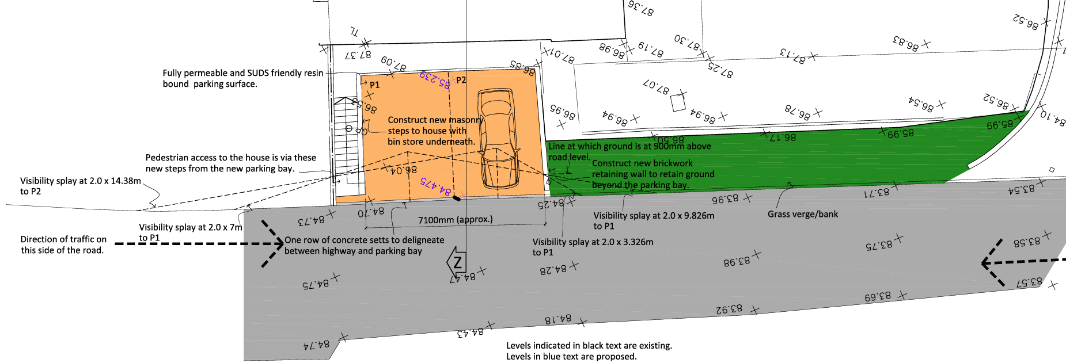
Proposed Site Plan

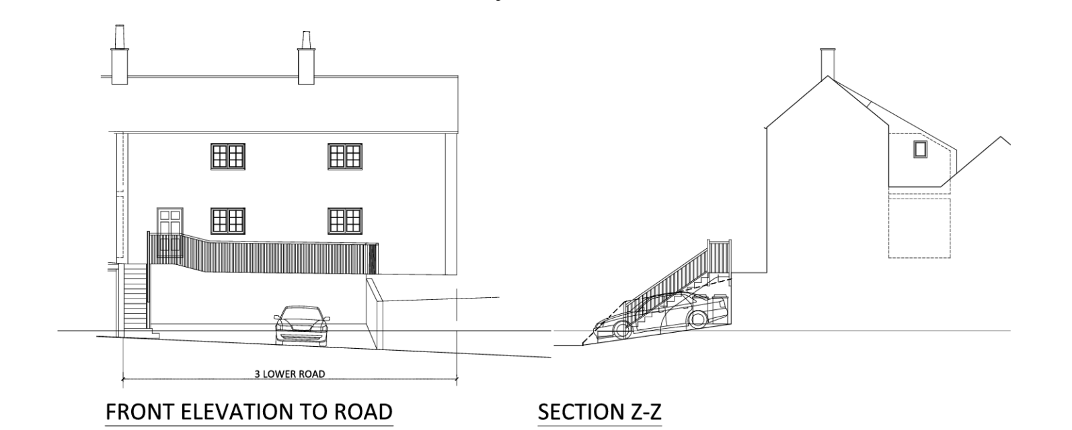
Proposed Elevations

Conservation and Heritage

Core Policy 58 outlines development consideration with regard to the historic environment. The policy states that heritage assets and their settings must be conserved and, where appropriate, enhanced through any proposed development. In assessing the proposal, special attention has been paid to the desirability of preserving or enhancing the character or appearance of the Edington Conservation Area, in accordance with Section 72(1) of the Planning (Listed Buildings and Conservation Areas) Act 1990.

The site lies within the Edington Conservation Area, where development is required to preserve or enhance its character and appearance. In this instance, the proposed works for the creation of a double parking bay and associated engineering works would result in the loss of a modest, cottage-style front garden previously enclosed by a picket fence and introduce a more engineered form of frontage that is considered to be at odds with the prevailing character of this part of the terrace and streetscene. Whilst some variation exists within the wider streetscene, including more modernised frontages, the works would nonetheless introduce a more urbanised form of development that would erode the traditional domestic frontage within a sensitive heritage setting. The existing frontage, although unexceptional in terms of historic value, contributes positively to the informal and verdant character of the Conservation Area, and its removal would result in a discernible and material change which would fail to preserve its character and appearance

Taking these factors into account, the proposal would give rise to less than substantial harm, at the lower end of the spectrum, to the character, appearance and significance of the Edington Conservation Area. In accordance with the NPPF, any harm to heritage assets must be weighed against the public benefits of the proposal. In this instance, the benefits are limited and primarily relate to the provision of private off-street parking, which in this case would not represent wider public benefit in light of the adverse impact on the highway, set out in a subsequent section of the report. It is therefore considered that in the absence of public benefit associated with the proposed creation of off-street parking, the identified harm, whilst limited, would not be outweighed.

As such, it is concluded that the proposal fails to preserve the character and appearance of the Conservation Area and conflicts with Core Policy 58 of the Wiltshire Core Strategy and the relevant provisions of the NPPF and that this would support a reason for refusal having regard to the duties set out in Section 72 of the Act.

Amenity

Point vii of Core Policy 57 Ensuring High Quality Design and Place Shaping of the Wiltshire Core Strategy seeks to ensure that developments do not adversely affect neighbouring properties. The National Planning Policy Framework (NPPF), particularly Paragraph 135, stresses that planning decisions should ensure developments provide a high standard of amenity for existing and future users.

The proposed development relates solely to the formation of two off-street parking spaces within the front curtilage of the property and does not introduce built form at a scale or position that would impact upon neighbouring amenity. The works would not give rise to issues of overlooking, loss of privacy, overbearing impact, or loss of light to adjoining occupiers. Activity associated with the use of the parking spaces would be typical of a residential setting and would not generate noise or disturbance beyond that ordinarily expected. As such, the proposal would not result in any unacceptable impact on the living conditions of neighbouring residents and accords with the provisions of Core Policy 57 and the NPPF.

The proposal therefore accords with Core Policy 57 point vii in respect of safeguarding residential amenity and Appendix D of the Wiltshire Design Guide.

Transport and Highways

Core Policy 60 of the WCS states that Council will support and encourage safe and efficient movement of people and, where necessary, mitigate the impact of development on transport users and local communities. Core Policy 61 specifies that development should demonstrate that consideration has been given to a hierarchy of transport users and that proposals must, where relevant, serve as a safe access to the highway network. Paragraph 116 of the NPPF states that “Development should only be prevented or refused on highways grounds if there would be an unacceptable impact on highway safety, or the residual cumulative impacts on the road network, following mitigation, would be severe, taking into account all reasonable future scenarios”.

The proposed development seeks to introduce a new vehicular access and the provision of two off-street parking spaces to serve the existing dwelling. Lower Road is a constrained carriageway with limited frontage widths and no continuous footway provision in the vicinity of the site. The application site occupies an elevated position above the highway, with a steeply sloping bank forming the existing front boundary treatment. Visibility along the highway is restricted by the alignment of the road, changes in levels, and the presence of established boundary features. These characteristics are material to the consideration of the suitability of forming a new vehicular access at this location. It is acknowledged that the proposal would not increase trip generation and may provide some limited benefit through the removal of on-street parking along this section of Lower Road. Nevertheless, the acceptability of the development must be determined with regard to whether a safe and suitable access can be achieved, having regard to the requirements of Core Policies 60 and 61 of the Wiltshire Core Strategy and the guidance set out within the NPPF.

The Highway Authority has raised a clear and substantive objection to the proposal on the basis that the required visibility splays cannot be achieved. For a road subject to a 20mph speed limit, visibility of approximately 2.4m x 25m in both directions is required; however, the submitted details demonstrate that visibility falls significantly below these standards. The maximum achievable splays vary between the two proposed spaces, with the eastern space providing visibility of approximately 7m to the east and 9.8m to the west, and the western space providing approximately 14.4m to the east and only 3.3m to the west. Even when taking the most favourable measurements, visibility remains substantially deficient in both directions. These limitations arise from the constrained frontage, the rising land levels and retained bank, and adjacent boundary features. As a result, vehicles emerging from the site would have very limited opportunity to observe oncoming traffic, including pedestrians and cyclists, creating a materially increased risk of conflict.

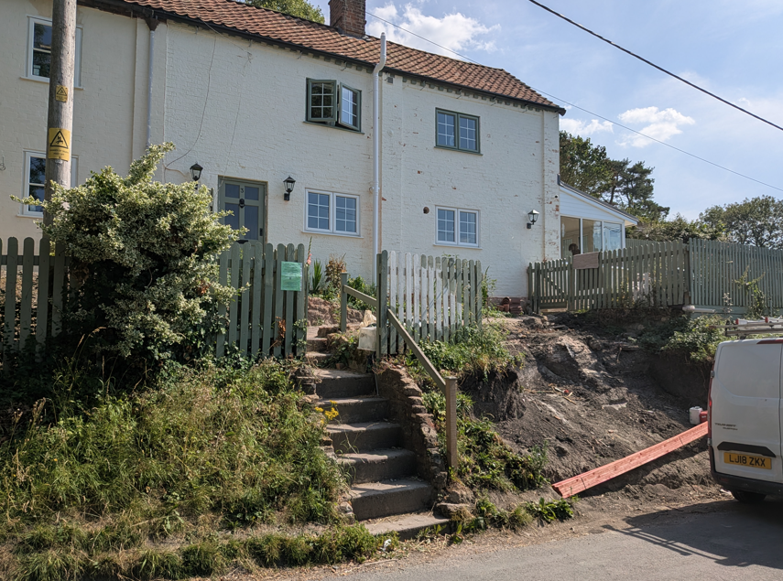
Front Elevation

In addition, the site is incapable of accommodating adequate turning provision, resulting in vehicles needing to reverse into or out of the highway, which is contrary to accepted highway safety principles, particularly on a classified route. The Highway Authority also notes that part of the western parking space would encroach onto recorded public highway, further compounding concerns. The suggestion that mirrors could be used to overcome visibility deficiencies is not supported and is afforded no weight due to their inherent unreliability and inability to provide a safe or enforceable solution. Whilst the existing parking arrangements in the Lower Road area are recognised to be constrained, the proposal would introduce a formalised access arrangement that fails to meet required safety standards. Having regard to paragraph 116 of the National Planning Policy Framework, the cumulative effect of these deficiencies is considered to result in a severe impact on the safe and efficient operation of the highway network. As such, the development is considered to result in an unacceptable impact on highway safety and conflicts with Core Policies 60 and 61 of the Wiltshire Core Strategy and Paragraph 116 of the National Planning Policy Framework.

Ecology

The WCS, through Core Policy 50, states that development proposals are expected to avoid and reduce disturbance of sensitive wildlife species and habitats. Biodiversity Net Gain (BNG) was established as a mandatory aspect of planning evaluation through Schedule 7A of the Town and Country Planning Act 1990 (as amended by the Environment Act 2021 Schedule 14).

Householder planning applications are exempt from the requirement to deliver Biodiversity Net Gain under Schedule 7A, Section 4(2)(a) of the Town and Country Planning Act 1990, as inserted by the Environment Act 2021.

The proposal is confined to a small area of domestic curtilage adjacent to the highway, which appears to be of limited ecological value, comprising maintained or unmanaged garden land rather than any substantive habitat. Given the scale and nature of the works, and the absence of any identified ecological features of importance within the affected area, the development is unlikely to result in harm to protected species or habitats. Whilst a priority habitat is identified to the south of the site, the proposed works are confined to the established domestic curtilage adjacent to the highway and are physically separated from this habitat. No direct or indirect impacts are therefore anticipated. The proposal is therefore considered to comply with Core Policy 50 and relevant national guidance.

Flooding and Drainage

Core Policy 67 Flood Risk of the Wiltshire Core Strategy requires all development to be located, designed, and constructed to minimise vulnerability to flooding and to avoid increasing flood risk elsewhere. Proposals must demonstrate that surface water can be managed safely and sustainably, incorporating appropriate drainage solutions—such as sustainable drainage systems (SuDS)—that ensure runoff rates and volumes do not exceed pre‑development levels. Development should provide measurable betterment where necessary, ensuring that drainage strategies are robust, technically compliant, and aligned with national policy. The NPPF sets out the application of a sequential, risk-based approach to the location of new development in paragraph 172.

The scale of the proposed development is minor, comprising approximately 23 square metres of new parking provision within an existing residential curtilage. The use of a permeable, SuDS-compliant resin-bound surface would assist in maintaining appropriate surface water drainage and ensure that runoff rates are not materially increased. In the event of approval a condition requiring means of preventing water runoff onto the highway would be recommended. Given the limited extent of the works and their domestic context, the development is not considered to give rise to flood risk concerns, either within the site or elsewhere. Accordingly, the proposal is acceptable in drainage and flood risk terms and accords with Core Policy 67 of the Wiltshire Core Strategy and the provisions of the NPPF.

CONCLUSION

Whilst the proposed development is considered acceptable in terms of its impact on design, residential amenity, ecology, and drainage, significant concerns arise in respect of highway safety. The proposal fails to demonstrate that a safe and suitable access to the highway network can be achieved, due to severely restricted visibility splays in both directions, the absence of on-site turning provision resulting in reversing manoeuvres onto the public highway, and the partial encroachment of the development onto highway land. These deficiencies represent a clear conflict with adopted highway standards and give rise to an unacceptable risk of conflict between vehicles. In accordance with Paragraph 116 of the NPPF, this harm is sufficient to warrant refusal, as it constitutes an unacceptable impact on highway safety that is not outweighed by other considerations.

Additionally, whilst a suitable design, with materials to be agreed by condition, can be achieved, the significant alteration to the site frontage would fail to preserve the character and appearance of the Conservation Area and there is less than substantial harm to heritage assets as a result, contrary to Core Policy 58 of the Wiltshire Core Strategy and the provisions of the NPPF.

The application is therefore recommended for refusal.

RECOMMENDATION: That Planning Permission be REFUSED for the following reason(s):

1.
The proposed development, by reason of inadequate visibility splays in both directions, the lack of sufficient space to enable vehicles to enter and leave the site in a forward gear, and the partial encroachment of the development onto the public highway, would result in the creation of a substandard and unsafe means of access. The proposal would require vehicles to reverse onto and from the public highway, whilst restricted visibility would fail to provide drivers with sufficient opportunity to observe approaching vehicles and other highway users, thereby increasing the risk of collisions. The development would therefore result in an unacceptable impact on highway safety and is consequently contrary to Core Policies 60 and 61 of the Wiltshire Core Strategy and Paragraph 116 of the National Planning Policy Framework.

2.
The proposed development, by reason of the loss of the existing informal cottage-style frontage and the introduction of a prominent engineered parking area, retaining structures and associated domestic paraphernalia, would result in an urbanising and visually intrusive form of development that would fail to preserve the character and appearance of the Edington Conservation Area. This would give rise to less than substantial harm to the significance of the designated heritage asset. The identified harm is not outweighed by any public benefits arising from the proposal. The development therefore conflicts with Core Policy 58 of the Wiltshire Core Strategy, the statutory duty under Section 72(1) of the Planning (Listed Buildings and Conservation Areas) Act 1990, and the heritage objectives of the National Planning Policy Framework.

