APPLICATION FOR HOUSEHOLDER PLANNING PERMISSION
DELEGATED REPORT

APPLICATION REFERENCE: | PL/2026/02413
APPLICATION TYPE: | Householder Planning Permission
SITE ADDRESS: | 2 Lower Road, Edington, Westbury, BA13 4QN
DEVELOPMENT DESCRIPTION: | Single storey rear extension and works to create an off road parking bay at the front of the house.
RECOMMENDATION: | That Planning Permission be REFUSED
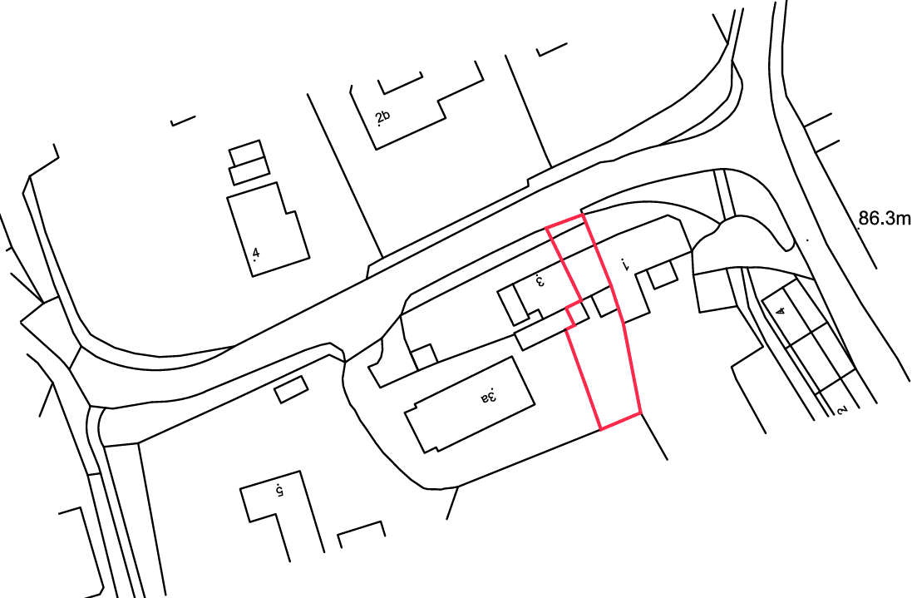
PROPOSAL

The application seeks planning permission for the erection of a single storey rear extension and the formation of an off-road parking bay to the front of the property, including associated excavation works and retaining structures. The proposed parking area would be constructed with a permeable resin-bound surface and enclosed by retaining walls, with steps and balustrading providing access to the dwelling. The rear extension would be modest in scale with a flat roof finished in EPDM synthetic membrane and incorporating a polycarbonate rooflight, with walls finished in render and timber doors and windows.

SITE DESCRIPTION / CONTEXT

The application site comprises a mid-terrace two-storey dwelling forming part of a row of three properties, positioned at an elevated level above Lower Road due to the natural topography which slopes upwards to the south. The dwelling is characterised by a mix of painted brick and white uPVC elements under a tiled roof. The surrounding area displays a varied character with a mix of boundary treatments including brick walls, railings, fencing, and established vegetation such as hedgerows and trees. To the north are larger detached properties set within more spacious plots, whilst the wider setting is typical of an edge-of-village location, with open fields and countryside views to the east. The site is located within the Edington Conservation Area, with additional constraints including proximity to a public right of way, designation within a Special Landscape Area, and adjacency to a priority habitat to the south.

PLANNING HISTORY

No relevant planning history has been identified for the site subject of this application.

RELEVANT LEGISLATION, POLICIES AND GUIDANCE

Wiltshire Core Strategy:

Core Policy 1 Settlement Strategy;
Core Policy 2 Delivery Strategy;
Core Policy 32 Spatial Strategy: Westbury Community Area;
Core Policy 50 Biodiversity and Geodiversity;
Core Policy 51 Landscape;
Core Policy 57 Ensuring High-Quality Design and Place Shaping;
Core Policy 58 Ensuring Conservation of the Historic Environment;
Core Policy 60 Sustainable Transport;
Core Policy 61 Transport and Development;
Core Policy 64 Demand Management;
Core Policy 67 Flood Risk;

The National Planning Policy Framework (NPPF) and The Planning Practice Guidance (PPG)

Wiltshire Design Guide - Appendix D – Design Guidance for Householder extensions

The Wiltshire Local Transport Plan 2011 – 2026: Car Parking Strategy (March 2015).

The Wiltshire Local Transport Plan 4 (LTP4) (March 2025)

Emerging Policy – Wiltshire Local Plan Review

At Full Council on 19 May, the elected members of Wiltshire Council agreed to withdraw the emerging WLP. The said Plan has no material weight for the purposes of the application.

CONSULTATION RESPONSES

Edington Parish Council – Supports
The Parish Council supports the proposal, noting that it would remove a vehicle from on-street parking on a narrow section of Lower Road near the Monastery Road junction. It considers the off-road parking space beneficial given that Lower Road is used as a through route.

Local Highway Authority (Wiltshire Council) – Objects
No objection raised to the proposed rear extension but objects to the creation of the front parking bay and vehicle access. The proposed access fails to provide the required visibility splays and on-site turning area, meaning vehicles could not safely enter and leave the site in a forward gear, resulting in highway safety concerns.

REPRESENTATIONS

No comments received.

ASSESSMENT

Section 38(6) of the Planning and Compulsory Purchase Act 2004 states:

"If regard is to be had to the development plan for the purposes of any determination to be made under the planning Acts, the determination must be made in accordance with the plan unless material considerations indicate otherwise."

In accordance with this statutory requirement, this application has been assessed against the relevant policies of the Development Plan, including the adopted Wiltshire Core Strategy (2015) and, where applicable, any made Neighbourhood Plans.

Householder extensions are generally acceptable in principle, as they typically fall within the established residential curtilage of a property and do not result in new residential development in the open countryside. The proposal also involves engineering operations to form a new vehicular access and off-street parking area within the domestic curtilage. Whilst such development within residential curtilages is not unacceptable in principle, such proposals must be assessed on their individual merits, having particular regard to their impact on the character of the area, heritage assets, and highway safety, having regard to Core Policies 57, 58, 60 and 61 of the Wiltshire Core Strategy.

Design and Impact the upon the character and context of the area

Core Policy 57 Ensuring High Quality Design and Place Shaping of the Wiltshire Core Strategy requires all new development to achieve a high standard of design that responds positively to its local context. Proposals must reinforce and enhance local character and distinctiveness, relate appropriately to the surrounding landscape, and demonstrate a thoughtful response to existing townscape features. This includes careful consideration of elements such as building height, scale, massing, building line, materials, and overall appearance, ensuring new development integrates harmoniously with its setting.

Core Policy 51 of the WCS states that development should conserve and protect existing landscape character. It additionally states that local features such as hedgerows and watercourses must be considered as part of any analysis, as well as other matters which relate to the overall distinctive quality of the specific locality in question.

The proposed rear extension, by virtue of its modest footprint, single-storey scale, and siting to the rear, would appear as a proportionate and subordinate addition to the host dwelling. The use of materials, including render and timber joinery, would be consistent with and complementary to the existing property, ensuring a coherent appearance. Given its limited visibility from the public realm, the extension would not result in harm to the character or appearance of the streetscene or the wider Conservation Area.

In respect of the proposed front parking bay, the excavation of the front garden and introduction of engineered retaining walls would alter the immediate frontage. The introduction of a hardstanding in place of a vegetated frontage would have a minor urbanising effect within a verdant setting in this context. However the use of appropriate materials secured by condition would assist in assimilating the development into its context and on balance, this harm is considered limited. Overall, subject to appropriate material control, the visual impact of the proposal is not considered to be unduly harmful in the context of the character and appearance of host dwelling

The site is located within a Special Landscape Area and benefits from a verdant setting characterised by boundary vegetation and views towards open countryside. The proposed development would result in the partial loss of vegetated frontage to accommodate the parking bay, introducing a more engineered form of development. However, the scale of this change is relatively limited and the effect would not significantly undermine the wider landscape character and setting, particularly given the retention of surrounding vegetation and the domestic context of the site. The rear extension would not be visually prominent within the wider landscape. As such, the proposal is considered to conserve the overall landscape character and accords with relevant landscape policies.

Having regard to the above, the proposal complies with the design principles set out in Core Policy 51 and 57 of the Wiltshire Core Strategy and Appendix D of the Wiltshire Design Guide and the NPPF.

Conservation and Heritage

Core Policy 58 outlines development consideration with regard to the historic environment. The policy states that heritage assets and their settings must be conserved and, where appropriate, enhanced through any proposed development. In assessing the proposal, special attention has been paid to the desirability of preserving or enhancing the character or appearance of the Edington Conservation Area, in accordance with Section 72(1) of the Planning (Listed Buildings and Conservation Areas) Act 1990.

The site lies within the Edington Conservation Area, where there is a statutory duty to preserve or enhance its character and appearance. The proposed rear extension, by virtue of its modest scale, subordinate form and limited visibility from public viewpoints, would not result in harm to the significance of the Conservation Area.

However, the alterations to the front of the property, including the creation of the parking bay and associated engineering works, would result in the loss of the existing informal, cottage-style frontage and introduce a more engineered appearance that is considered to be at odds with the prevailing character of this part of the terrace and streetscene. Whilst there is some variation within the wider streetscene, the works would nonetheless introduce a more urbanised form of development that would erode the traditional domestic frontage within a sensitive heritage setting. The works to the frontage would not have a neutral impact on the character and appearance of the Conservation Area and would therefore fail to preserve its character and appearance.

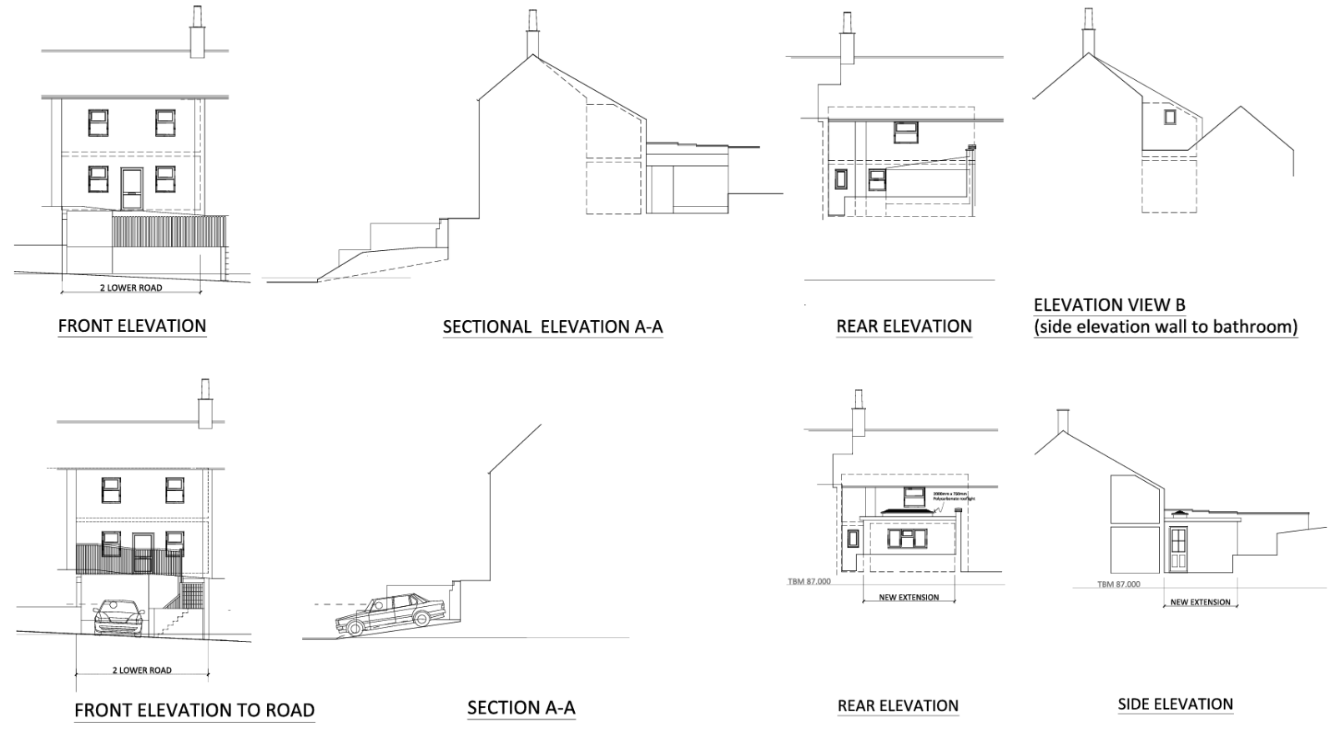
Existing and Proposed Elevations

Taking these factors into account, it is concluded that the proposal would give rise to less than substantial harm, at the lower end of the spectrum, to the character, appearance and significance of the Edington Conservation Area. In accordance with the NPPF, any harm to heritage assets must be weighed against the public benefits of the proposal. In this instance, the identified benefits are limited and primarily relate to the provision of private off-street parking, which in this case would not represent wider public benefit in light of the adverse impact on the highway, set out in a subsequent section of the report. It is therefore considered that in the absence of public benefit associated with the proposed creation of off-street parking, the identified harm, whilst limited, would not be outweighed.

As such, it is concluded that the proposal fails to preserve the character and appearance of the Conservation Area and conflicts with Core Policy 58 of the Wiltshire Core Strategy and the provisions of the NPPF and that this would support a reason for refusal having regard to the duties set out in Section 72 of the Act.

Amenity

Point vii of Core Policy 57 Ensuring High Quality Design and Place Shaping of the Wiltshire Core Strategy seeks to ensure that developments do not adversely affect neighbouring properties. The National Planning Policy Framework (NPPF), particularly Paragraph 135, stresses that planning decisions should ensure developments provide a high standard of amenity for existing and future users.

The proposed rear extension is limited in scale and height and would not project to an extent that would result in an overbearing or oppressive impact on neighbouring occupiers. It would not introduce any side-facing habitable room windows that would give rise to overlooking or loss of privacy. Openings are directed southwards into the applicant’s own garden area, thereby maintaining acceptable levels of amenity for adjacent properties. Given its scale and relationship to neighbouring boundaries, the proposal would not result in a material loss of light or outlook. Furthermore, the use of the parking area to the front is not considered to introduce unacceptable levels of noise or disturbance beyond that typically associated with a residential use. Accordingly, the proposal would not result in harm to neighbouring amenity and is considered to comply with relevant amenity policies and guidance.

The proposal is appropriately sited, designed, and oriented to ensure that it would not result in unacceptable impact upon/to the amenities or living conditions of neighbouring residential occupiers, particularly in terms of outlook, privacy, or access to natural light. The proposal therefore accords with Core Policy 57 point vii in respect of safeguarding residential amenity and Appendix D of the Wiltshire Design Guide.

Transport and Highways

Core Policy 60 of the WCS states that Council will support and encourage safe and efficient movement of people and, where necessary, mitigate the impact of development on transport users and local communities. Core Policy 61 specifies that development should demonstrate that consideration has been given to a hierarchy of transport users and that proposals must, where relevant, serve as a safe access to the highway network. Paragraph 116 of the NPPF states that “Development should only be prevented or refused on highways grounds if there would be an unacceptable impact on highway safety, or the residual cumulative impacts on the road network, following mitigation, would be severe, taking into account all reasonable future scenarios”. The WCS, through Core Policy 64, outlines the need for development to comply with a minimum level of parking standards.

The proposed development seeks to introduce a new vehicular access and off-street parking provision to serve an existing mid-terrace dwelling fronting Lower Road. It is acknowledged that the proposal would not result in an uplift in trip generation and may offer some benefit through the removal of an element of existing on-street parking, which currently constrains the carriageway. However, the acceptability of the proposal must be considered primarily in terms of whether it would provide a safe and suitable means of access in accordance with adopted highway standards.

In this regard, the Highway Authority has raised clear and substantive objections. The site is located on a section of road subject to a 20mph speed limit, where visibility splays of approximately 2.4m x 25m are required in both directions. The submitted plans demonstrate that these standards cannot be achieved, with visibility to the east being particularly constrained due to both the neighbouring properties front boundary treatment, the raising topography of the site, and the proximity of the junction with Monastery Road (approximately 29m from the site). The applicant’s own evidence indicates that only very limited visibility of approximately 3.5m can be achieved in this direction. This represents a significant shortfall against required standards and would create a scenario whereby vehicles emerging from the proposed parking bay would have insufficient opportunity to observe and respond safely to oncoming traffic, including pedestrians/cyclists using the highway. This risk is materially exacerbated by the site’s relationship with the nearby junction, particularly for vehicles turning westbound from Monastery Road, which would have very limited awareness of vehicles manoeuvring out of the site.

Furthermore, the proposal is incapable of providing sufficient space within the site for vehicles to turn, resulting in a reliance on vehicles reversing either into or out of the highway. This arrangement is generally considered unacceptable in highway safety terms, particularly on a through route where traffic movements are influenced by a nearby junction. The suggestion that visibility limitations could be mitigated through the use of mirrors is not supported by the Highway Authority and accordingly is given no weight, given the inherent reliability issues associated with such measures. The location of any such mirror would be outside of the application site and therefore could not be reasonably conditioned.

Whilst it is recognised that the existing parking situation along Lower Road is constrained and suboptimal, the proposal would result in a substandard access arrangement that fails to meet current safety requirements and introduces an increased potential for conflict between highway users. Having regard to paragraph 116 of the National Planning Policy Framework, the cumulative effect of these deficiencies is considered to result in a severe impact on the safe and efficient operation of the highway network. As such, the development is considered to result in an unacceptable impact on highway safety and conflicts with Core Policies 60 and 61 of the Wiltshire Core Strategy and Paragraph 116 of the National Planning Policy Framework.

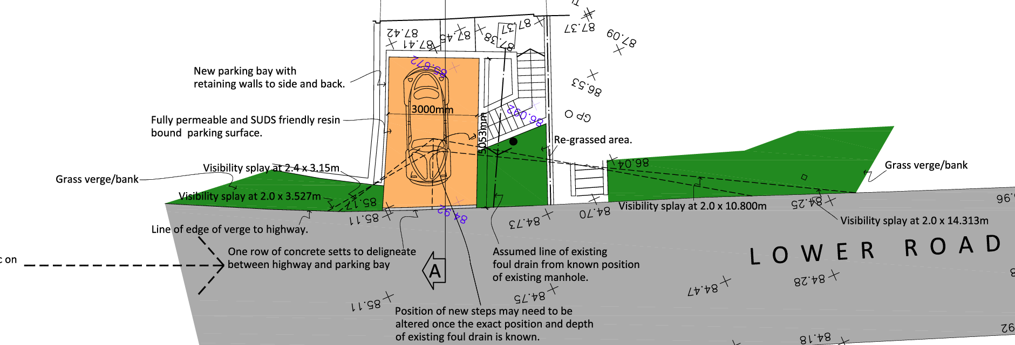
Proposed Parking Space

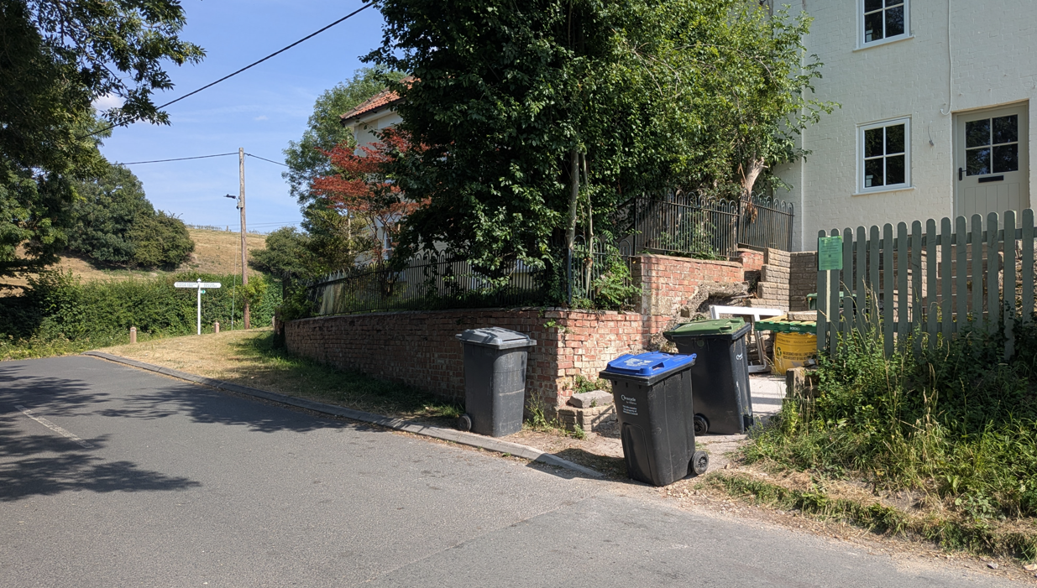
Front Elevation

Ecology

The WCS, through Core Policy 50, states that development proposals are expected to avoid and reduce disturbance of sensitive wildlife species and habitats. Biodiversity Net Gain (BNG) was established as a mandatory aspect of planning evaluation through Schedule 7A of the Town and Country Planning Act 1990 (as amended by the Environment Act 2021 Schedule 14).

Householder planning applications are exempt from the requirement to deliver Biodiversity Net Gain under Schedule 7A, Section 4(2)(a) of the Town and Country Planning Act 1990, as inserted by the Environment Act 2021.

The proposal relates primarily to development within an existing residential curtilage, with the rear extension occupying an area of hardstanding or managed garden space, thereby limiting its impact on ecological features. Whilst a priority habitat is noted adjoining the site to the south, the development is separated from this area and is not considered likely to result in direct harm or disturbance. Given the limited scale and nature of the works, the proposal is unlikely to give rise to impacts on protected species. The proposal is therefore considered to accord with relevant ecological policies and national guidance.

Flooding and Drainage

Core Policy 67 Flood Risk of the Wiltshire Core Strategy requires all development to be located, designed, and constructed to minimise vulnerability to flooding and to avoid increasing flood risk elsewhere. Proposals must demonstrate that surface water can be managed safely and sustainably, incorporating appropriate drainage solutions—such as sustainable drainage systems (SuDS)—that ensure runoff rates and volumes do not exceed pre‑development levels. Development should provide measurable betterment where necessary, ensuring that drainage strategies are robust, technically compliant, and aligned with national policy. The NPPF sets out the application of a sequential, risk-based approach to the location of new development in paragraph 172.

The site lies within Flood Zone 1, indicating a low probability of fluvial flooding. The Council’s Strategic Flood Risk Assessment identifies a potential risk of groundwater flooding, with levels relatively close to the surface; however, the scale of the development is modest and primarily confined to an existing residential plot. The use of a permeable surface for the proposed parking area represents a sustainable drainage approach which would assist in managing surface water run-off. There is no identified risk of surface water flooding affecting the site. In the event of approval a condition requiring means of preventing water runoff onto the highway would be recommended. In the absence of any significant intensification of development or increase in impermeable area, the proposal is not considered to exacerbate flood risk on or off the site. As such, the development is acceptable in flood risk and drainage terms and complies with relevant policy.

CONCLUSION

The proposed rear extension is considered to be acceptable in principle and would not give rise to harm in respect of design, residential amenity, ecology, or flood risk, complying with the relevant policies of the Wiltshire Core Strategy and the NPPF in those respects. However, significant concerns arise in relation to the formation of the proposed vehicular access and off-street parking provision. The development fails to demonstrate that a safe and suitable access to the highway network can be achieved, due to severely restricted visibility to the east, the proximity of the junction with Monastery Road, and the inability to accommodate turning within the site, resulting in vehicles needing to reverse onto the highway. Notwithstanding the existing constrained parking arrangements along Lower Road, the proposal would result in a substandard and unsafe access arrangement which would give rise to an unacceptable risk to highway safety.

Paragraph 116 of the NPPF makes clear that development should be refused where there would be an unacceptable impact on highway safety. In this instance, the identified harm is clear and is afforded significant weight. There are no material considerations that would outweigh this harm. Accordingly, the application is recommended for refusal on highway safety grounds, with conflict identified against Core Policies 60 and 61 of the Wiltshire Core Strategy and the provisions of the NPPF.

Additionally, whilst a suitable design, with materials to be agreed by condition, can be achieved, the significant alteration to the site frontage would fail to preserve the character and appearance of the Conservation Area and there is less than substantial harm to heritage assets as a result, contrary to Core Policy 58 of the Wiltshire Core Strategy and the provisions of the NPPF.

The application is therefore recommended for refusal.

RECOMMENDATION: That Planning Permission be REFUSED for the following reason(s):

1.
The proposed development, by reason of inadequate visibility splays at the site access in both directions, particularly to the east as a consequence of site constraints and the proximity of the junction with Monastery Road, together with the failure to provide adequate on-site turning facilities, would result in an unsatisfactory means of access. The proposal would necessitate vehicles reversing onto and from the public highway, whilst the restricted visibility available to drivers would increase the likelihood of conflict with passing vehicles, pedestrians and other highway users. The development would therefore give rise to an unacceptable risk to highway safety. As such, the proposal is contrary to Core Policies 60 and 61 of the Wiltshire Core Strategy and Paragraph 116 of the National Planning Policy Framework.

2.
The proposed development, by reason of the loss of the existing informal cottage-style frontage and the introduction of a prominent engineered parking area, retaining structures and associated domestic paraphernalia, would result in an urbanising and visually intrusive form of development that would fail to preserve the character and appearance of the Edington Conservation Area. This would give rise to less than substantial harm to the significance of the designated heritage asset. The identified harm is not outweighed by any public benefits arising from the proposal. The development therefore conflicts with Core Policy 58 of the Wiltshire Core Strategy, the statutory duty under Section 72(1) of the Planning (Listed Buildings and Conservation Areas) Act 1990, and the heritage objectives of the National Planning Policy Framework.

