APPLICATION FOR ADVERTISEMENT CONSENT
CASE OFFICER REPORT

APPLICATION REFERENCE: | PL/2026/02794
APPLICATION TYPE: | Consent to display an advertisement
SITE ADDRESS: | Blackberries Camping Park, Farleigh Rise, Monkton Farleigh, BA15 2QP
DEVELOPMENT DESCRIPTION: | New roadside sign on the western side of the site entrance to replace the existing sign.
RECOMMENDATION: | that advertisement consent be GRANTED

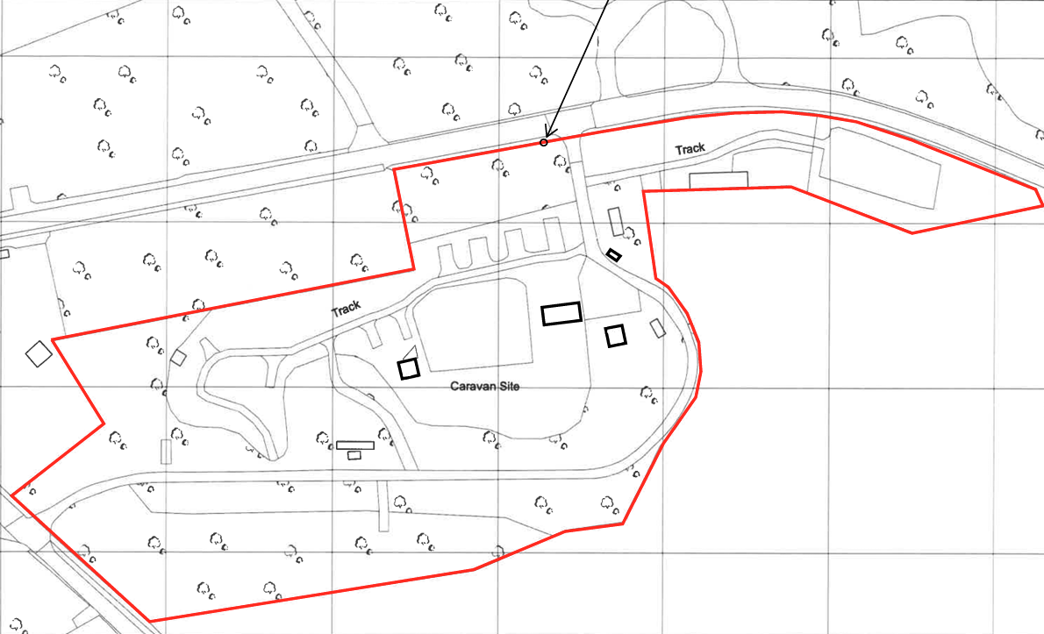

SITE DESCRIPTION/CONTEXT

The application site comprises an established rural campsite accessed from Farleigh Rise, an unclassified country lane within open countryside to the north of Monkton Farleigh. The site is characterised by its highly rural setting, being surrounded by agricultural land, mature trees and hedgerows which provide substantial enclosure and screening. The site lies within the Cotswolds National Landscape and outside any defined settlement boundary. There are no nearby designated heritage assets that are materially affected by the proposal, and the entrance where the advertisement would be displayed is located along a relatively quiet stretch of country lane where signage associated with the lawful operation of the campsite is already present.

PROPOSAL

Advertisement consent is sought for the replacement of an existing hanging entrance sign with a freestanding timber-framed sign of slightly larger dimensions positioned at the site entrance. The proposal also includes a new fascia graphic displaying the campsite branding and wayfinding information together with a fixed LED downlight mounted above the sign to provide external illumination of the advertisement during hours of darkness.

RELEVANT LEGISLATION, POLICIES AND GUIDANCE

The Town and Country Planning (Control of Advertisements) (England) Regulations 2007

National Planning Policy Framework (NPPF)
- Paragraph 141

Planning Practice Guidance (PPG)
- Advertisements

Wiltshire Core Strategy 2015 (WCS):
- Core Policy 51 Landscape
- Core Policy 57 Ensuring High Quality Design & Space Shaping
- Core Policy 62 Development Impacts on the Transport Network

Supplementary Planning Documents:

Institute of Lighting Professionals: The Brightness of Illuminated Advertisements (2014) PLG 05.

RELEVANT PLANNING HISTORY:

Reference No. | Proposal / Summary | Decision
W/13/00050/FUL | Change of use to small camping facility, conversion of existing building to toilet/shower facilities and erection of stable block and associated works | Approved with Conditions
16/01161/FUL | Additional 5 pitches at Blackberries Camping Park ; new reception building ; small disabled toilet/shower attached to existing facilities | Approved with Conditions
18/09137/FUL | Retention of additional touring and camping pitches, retention of existing site facility buildings and storage container and new pot washing facilities | Approved with Conditions
19/05883/DOC | Discharge condition 3, 5 and 6 of 18/09137/FUL | Approved

ISSUES

The issues that are relevant to the consideration of an application for consent to display advertisements are the effects of the proposal on ‘amenity’ and ‘public safety’.

CONSULTEE RESPONSES

The following consultees were invited to comment on this application:

Monkton Farleigh Parish Council: No Objection

Wiltshire Council’s Highways Engineer: No Objection (subject to conditions)
No highway objection, subject to conditions requiring the sign to be located wholly on private land and outside the public highway. Any illumination must be static, not visible from the highway, and comply with relevant lighting guidance.

RESPRESENTATIONS
Below is a summary of the representations received during the consultation period. Only material planning considerations have been taken into account in the assessment of this application. Non-material issues, such as property values or private legal disputes, cannot be considered in the determination process.

ASSESSMENT
Regulation 3 of The Town and Country Planning (Control of Advertisements) (England) Regulations 2007 requires that local planning authorities exercise their powers in relation to the display of advertisements in the interests of amenity and public safety, taking into account the provisions of the development plan, in so far as they are material, and any other relevant factors.

The NPPF (141) is clear that the quality and character of places can suffer when advertisements are poorly sited and designed and should be subject to control only in the interests of amenity and public safety, also considering the cumulative impacts.

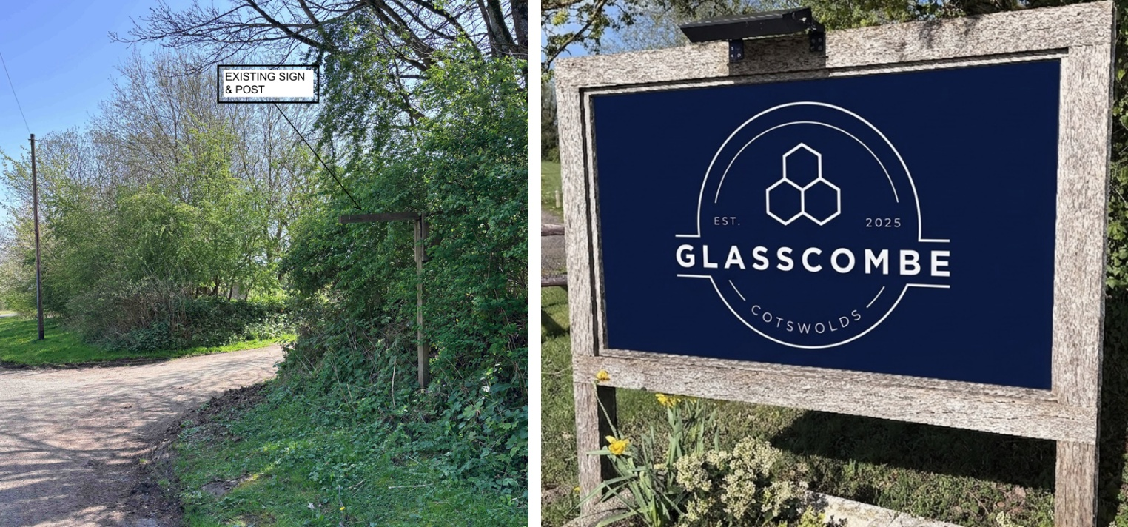
Existing hanging signpost, and proposed sign

Impact on Amenity:
Policy Context
“Amenity” is not exhaustively defined in the Town and Country Planning (Control of Advertisements) (England) Regulations 2007, but is generally understood to include both visual and aural amenity. Factors relevant to amenity include the general characteristics of the locality, such as the presence of features of historic, architectural, cultural, or similar interest.

In broader planning terms, as reflected in the National Planning Policy Framework (NPPF), amenity refers to the quality or character of an area and the elements that contribute to the overall enjoyment and liveability of a place.

CP57 requires a high standard of design in all proposals, including (x) the sensitive design of advertisements and signage.

Assessment

The principle of a directional and identification sign at the entrance to the campsite is well established, as the proposal replaces an existing sign serving the same purpose. Whilst the proposed sign would be modestly larger than the existing hanging sign, it remains proportionate to its function and is of a scale appropriate to the entrance it serves.

In design terms, the proposal is considered sympathetic to its rural surroundings. The sign incorporates a timber frame and a restrained colour palette comprising dark navy colouring with contrasting white lettering. These muted tones avoid an overly prominent or visually intrusive appearance whilst providing clear identification for visitors. Given the site's location within open countryside and the presence of substantial surrounding vegetation, including mature hedgerows and trees along the site boundary, the advertisement would sit comfortably within its setting and would not appear incongruous or urbanising.

The site lies within the Cotswolds National Landscape; however, the proposal is limited in scale, relates directly to an existing recreational use and replaces an established sign in broadly the same location. The advertisement would not introduce significant visual clutter nor result in any material harm to the wider landscape character of the area.

With regard to illumination, the proposed fitting is a small externally mounted LED downlight (5.4W, approximately 400 lumens). In practical terms, 400 lumens is a relatively modest light output, broadly comparable to a low-powered domestic lamp, and is not considered excessive for the illumination of a sign of this scale. The downward-facing arrangement is also preferable as it focuses light onto the sign face and helps minimise upward light spill into the surrounding countryside. This approach also reduces the potential for impacts upon ecological receptors, including commuting and foraging bats associated with nearby habitats. Notwithstanding this, it is reasonable and necessary to impose conditions controlling the visibility and intensity of illumination to ensure compliance with highway safety requirements and relevant lighting guidance.

Overall, the proposal is considered to preserve the visual amenity of the area and accords with the interests of amenity set out within the Town and Country Planning (Control of Advertisements) (England) Regulations 2007 and Core Policy 57 of the Wiltshire Core Strategy.

It is therefore considered that the proposed advertisement would not cause harm to the visual amenity of the area and would comply with the relevant provisions of the Town and Country Planning (Control of Advertisements) (England) Regulations 2007.

Impact on Public Safety:
Policy Context
“Public safety” is not exhaustively defined in the Town and Country Planning (Control of Advertisements) (England) Regulations 2007, but it generally refers to the potential impact of a development or advertisement on the safe use and operation of public spaces, including roads, footpaths, and other areas accessible to the public.

In assessing public safety, the Local Planning Authority (LPA) may consider:
- Whether the proposal would obstruct visibility for road users or pedestrians;
- Whether it could distract, confuse, or mislead drivers, particularly near junctions or crossings;
- Whether it interferes with traffic signs, signals, or street lighting;
- Whether it poses a physical hazard, such as through poor structural integrity or inappropriate siting.

The National Planning Policy Framework (NPPF) also supports the principle that planning decisions should ensure developments create places that are safe, inclusive, and accessible, and that they do not undermine public safety or security.

CP62 advises that proposals should provide appropriate mitigating measures to offset any adverse impacts on the transport network at both the implementation and operational stages.

Assessment

The proposed advertisement would be positioned at the established entrance to an existing campsite and would replace an existing sign which currently performs a similar directional and identification function. The principle of signage at this location is therefore already accepted and necessary to assist visitors in locating the lawful use of the site.

The site is accessed from Farleigh Rise, a lightly trafficked rural lane. The proposed sign would be located along a straight section of road and is not situated in close proximity to a junction, pedestrian crossing, traffic signals or other highway features that could increase the likelihood of driver distraction. The advertisement would be static in nature and would not incorporate moving images, digital displays, flashing illumination or changing content.

Wiltshire Council's Highway Officer has raised no objection to the proposal subject to conditions requiring the sign to be located wholly outside the public highway, that any illumination remains static and that the light source is not directly visible from the highway. A further condition is recommended to ensure illumination levels accord with the Institute of Lighting Professionals Professional Lighting Guide 05 (PLG05). These requirements are considered appropriate and would ensure that the advertisement does not create an unacceptable distraction or hazard to road users.

Whilst the sign would be illuminated, the lighting arrangement is limited to a single externally mounted downlight designed to illuminate the sign face rather than draw attention through brightness or visual effects. Subject to compliance with the recommended lighting conditions, the illumination is not considered likely to prejudice highway safety.

Accordingly, having regard to the nature, scale and siting of the proposal, together with the absence of any objection from the Highway Authority, it is considered that the advertisement would not adversely affect public safety.

It is therefore considered that the proposal would not result in an unacceptable impact on public safety and would satisfy the relevant provisions of the Town and Country Planning (Control of Advertisements) (England) Regulations 2007.

CONCLUSION:

The proposed advertisement has been assessed in accordance with the relevant provisions of the Town and Country Planning (Control of Advertisements) (England) Regulations 2007.

It is considered that the advertisement, by reason of its design, scale, siting, and method of illumination, would not result in harm to the visual amenity of the area, including the setting of any nearby heritage assets. Furthermore, the proposal is not considered to pose a risk to public safety, either individually or cumulatively with other signage in the vicinity.

Subject to the recommended conditions, the proposal is therefore considered acceptable and it is recommended that advertisement consent be granted.

RECOMMENDATION:
It is recommended that advertisement consent be GRANTED subject to condition(s).

1.
This consent shall expire five years from the date of this decision.

REASON: In accordance with Regulation 14 of the Town and Country Planning (Control of Advertisements) (England) Regulations 2007.

2.
The advertisement hereby permitted shall be displayed only in accordance with the approved plans and supporting documents:

Proposed Elevations (30 April 2026)
Location Plan (30 April 2026)
Proposed Render (30 April 2026)
LED Downlight Product Specification (13 May 2026)

REASON: For the avoidance of doubt and in the interests of proper planning.

3.
No part of the advertisement hereby approved shall be located within the limits of the public highway.

REASON: In the interests of public safety.

4.
Any illumination of the advertisement shall be static only. No flashing, intermittent, moving or variable illumination shall be displayed at any time.

REASON: In the interests of public safety.

5.
The illumination of the advertisement shall be implemented and maintained in such a manner that no source of light is directly visible from the public highway.

REASON: In the interests of public safety.

6.
The intensity of the illumination of the advertisement shall be no greater than that recommended by the Institute of Lighting Professionals Professional Lighting Guide PLG05: Brightness of Illuminated Advertisements (or any document revoking and re-enacting that guidance).

REASON: In the interests of amenity and public safety.

INFORMATIVE

The applicant is advised that this advertisement consent is subject to the standard conditions prescribed by Regulation 2(1) of Schedule 2, the Town and Country Planning (Control of Advertisements) (England) Regulations 2007. These conditions apply automatically to all advertisement consents and relate to matters including landowner consent, highway safety, maintenance of advertisements and structures, and restoration of the site following removal of an advertisement.

1) No advertisement is to be displayed without the permission of the owner of the site or any other person with an interest in the site entitled to grant permission.

2) No advertisement shall be sited or displayed so as to

- endanger persons using any highway, railway, waterway, dock, harbour or aerodrome (civil or military);

- obscure, or hinder the ready interpretation of, any traffic sign, railway signal or aid to navigation by water or air; or

- hinder the operation of any device used for the purpose of security or surveillance or for measuring the speed of any vehicle.

3) Any advertisement displayed, and any site used for the display of advertisements, shall be maintained in a condition that does not impair the visual amenity of the site.

4) Any structure or hoarding erected or used principally for the purpose of displaying advertisements shall be maintained in a condition that does not endanger the public.

5) Where an advertisement is required under the Regulations to be removed, the site shall be left in a condition that does not endanger the public or impair visual amenity.

