APPLICATION FOR HOUSEHOLDER PLANNING PERMISSION DELEGATED REPORT

APPLICATION REFERENCE: | PL/2026/03456
APPLICATION TYPE: | Householder planning permission
SITE ADDRESS: | Glenesk, Rollestone Road, Shrewton, Salisbury, SP3 4HG
DEVELOPMENT DESCRIPTION: | Retention of decking and associated roof structure and timber fencing (Retrospective)
RECOMMENDATION: | That Planning Permission be GRANTED

PROPOSAL

The proposal seeks planning permission for the retention of an area of decking including a roof and timber fencing which have been erected on the south west side of the annexe.

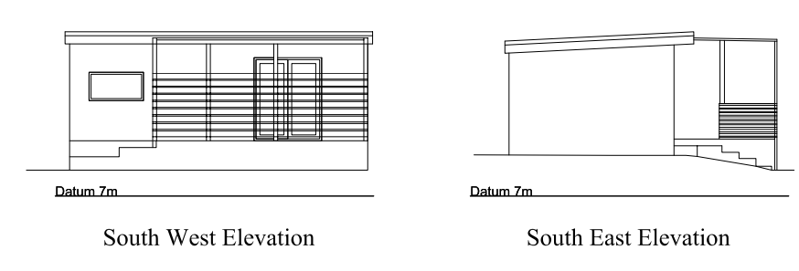

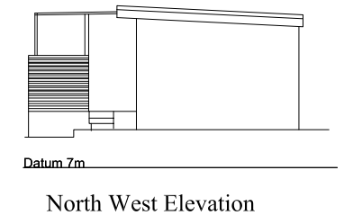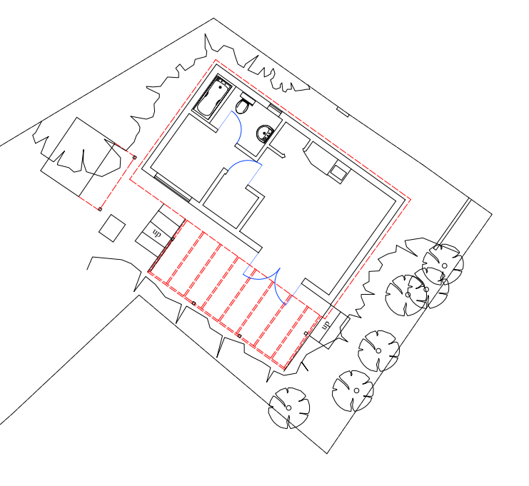

Photo below provided within the supporting statement of the annexe.

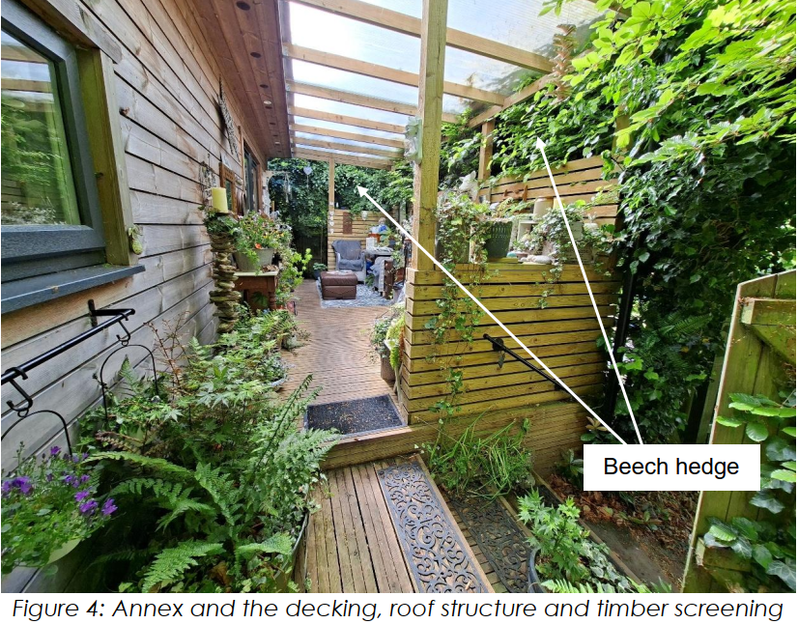

SITE DESCRIPTION/CONTEXT

The application site relates to an existing two storey, semi-detached thatched residential dwelling, built circa 1930, accessed via a private unmade road known as Rollestone Road that connects to both the A360 Amesbury Road and the B3083 and serves a residential area within the settlement boundary of the large village of Shrewton, as defined by Wiltshire Core Strategy (WCS) core policies 1 (Settlement Boundary), 2 (Delivery Strategy) and 4 (Spatial Strategy for the Amesbury Community Area). The site is surrounded by other residential properties and their amenity/parking provision, some of which have been subject to alterations and or extensions over time. There are no designated heritage assets/listed buildings in the immediate vicinity. The application site has a slightly unusual residential curtilage which is not of a uniform shape, with a short dogleg at the northern (rear) end of the garden.

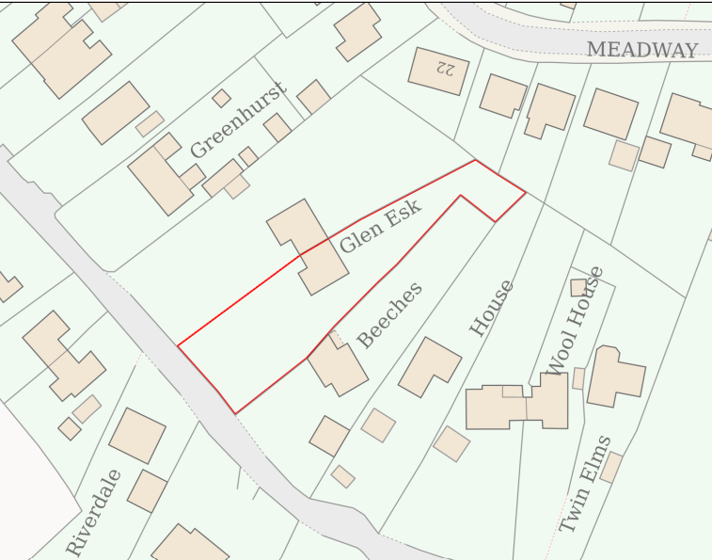

The application site includes a single storey detached one bed annexe located within the above mentioned dogleg at the northern end of the rear garden; erected following the grant of planning permission in 2020 – reference 20/01543/FUL.

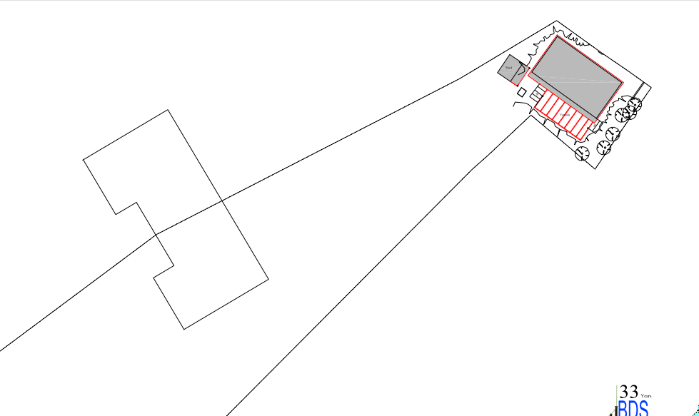

The site is situated within a Special Landscape Area, as defined by saved Salisbury District Local Plan (SDLP) policy C6. Whilst it is not in the immediate vicinity of any river and is in Flood Zone 1, it is situated within the River Avon Catchment. It is also within 2.7 kilometres of the Stonehenge World Heritage Site and is within the Salisbury Plain Special Protection Area (SPA) 6.4km buffer.

The annexe remains subject to Condition 4 of planning permission 20/01543/FUL restricting its occupation to purposes ancillary to the main dwelling known as Glen Esk.

PLANNING HISTORY

Proposal / Summary
20/01543/FUL - Full planning permission Decision - Approve with Conditions Date: 26/6/2020 – To build a granny annex at the rear of the site address.

RELEVANT POLICIES AND GUIDANCE

The National Planning Policy Framework (NPPF)
The Planning Practice Guidance
National Design Guide

Wiltshire Core Strategy:

- Core Policy 1: Settlement Strategy
- Core Policy 2: Delivery Strategy
- Core Policy 4: Spatial Strategy for the Amesbury Community Area
- Core Policy 50: Biodiversity and Geodiversity
- Core Policy 51: Landscape
- Core Policy 57 Ensuring High Quality Design and Place Shaping
- Core Policy 61: Transport and New Development
- Core Policy 64: Demand Management
- Core Policy 69: River Avon SAC

Special Landscape Area - saved Salisbury District Local Plan (SDLP) policy C6

Wiltshire Design Guide: Appendix D – Design Guidance for Householder extensions
Creating Places Design Guide

Shrewton was designated as a Neighbourhood Area in 2015. As of 2025, a Neighbourhood Plan has not yet been adopted, although a draft plan for the period 2024–2038 is under discussion. The plan is still in early stages and has not progressed to formal submission or referendum.

CONSULTATION RESPONSES

Parish Council: Object for the following reasons

- Fire risk due to the timber construction
- Lack of drainage and run off rainwater from the roof into neighbouring properties
- Breach in Building Regulations regarding materials
- Breach in planning regulation for the height of the decking
- Property if advertised for sale with annexe described as suitable for use as outside office/gym/leisure and accommodation for an elderly relative. 2020 application had multiple objections regarding loss of privacy to neighbouring properties, but consent granted for an annexe for elderly family member, this should be taken into account.

REPRESENTATIONS

Four comments were received and summarised below

Comment 1. Concerns relating to –

Fire risk and access for emergency services

Comment 2. Objections relating to -

Fire Risk,
Building Control and Drainage
Loss of Amenity,
Environmental and Failure to Consider Alternatives
Scale of Development
Inaccuracy of Application Details

Comment 3. Concerns relating to -

Fire risk
Concerns what future owners will use the space for
Comment 4. Objections relating to -

Loss of privacy to surrounding properties (in particular the property known as 'Beeches', which is directly overlooked by the 'annex').

Beech hedge is deciduous and does loses leaves in the autumn providing views from annexe through hedge into neighbours’ gardens

Permission was given for an annexe for single occupancy; decking provides facilities for multiple persons to congregate as a gathering.

Fire risk
ASSESSMENT

Section 38(6) of the Planning and Compulsory Purchase Act 2004 states:

"If regard is to be had to the development plan for the purposes of any determination to be made under the planning Acts, the determination must be made in accordance with the plan unless material considerations indicate otherwise."

In accordance with this statutory requirement, this application has been assessed against the relevant policies of the Development Plan, including the adopted Wiltshire Core Strategy (2015) and, where applicable, any made Neighbourhood Plans.

Design and Impact upon the upon the character and context of the area

Core Policy 57 - Ensuring High Quality Design and Place Shaping of the Wiltshire Core Strategy seeks to ensure that all new development is of high design quality, reflecting local context, character, and distinctiveness.

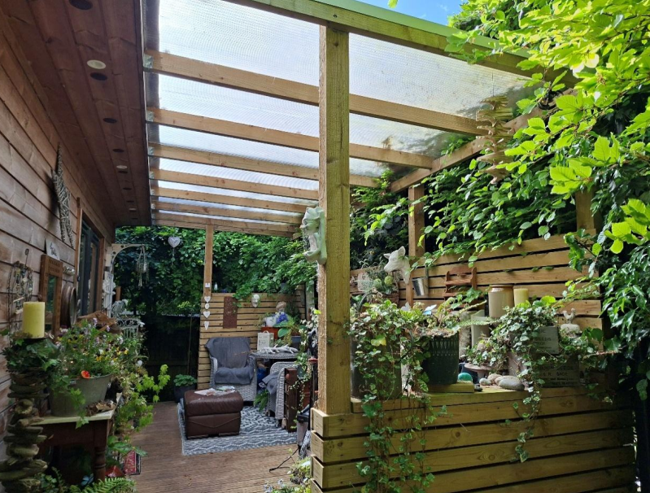

The decking area, associated roof structure and timber screening ( as per photo above) are considered to be modest domestic additions situated within the residential curtilage of the site. The development is positioned to the rear of the property and is well screened by existing boundary treatments and mature vegetation, resulting in a high degree of containment. Whilst the annexe and associated structures may be visible from limited viewpoints within neighbouring properties, they are not prominent features within the wider area.

The decking area itself is not visible from outside the application site and therefore has no material impact on the street scene or the character and appearance of the surrounding locality. Having regard to its scale, design, siting and limited visibility, the development is considered to integrate satisfactorily with its surroundings and does not result in harm to the visual amenities, character or appearance of the area. Accordingly, the proposal is considered to accord with the design principles set out in Core Policy 57 of the Wiltshire Core Strategy and Appendix D of the Wiltshire Design Guide.

Given the limited scale of the development, its location within a private residential garden and the absence of public visibility, the proposal would not adversely affect the qualities or characteristics of the Special Landscape Area and complies with Core Policy 51 and saved Policy C6 of the Salisbury District Local Plan.

Amenity

Point vii of Core Policy 57 - Ensuring High Quality Design and Place Shaping of the Wiltshire Core Strategy seeks to ensure that developments do not adversely affect neighbouring properties.

The National Planning Policy Framework (NPPF), particularly Paragraph 135(f), stresses that planning decisions should ensure developments provide a high standard of amenity for existing and future users.

The proposed development has been assessed in terms of its potential impact on the residential amenity of neighbouring properties, with particular regard to loss of light, overshadowing, loss of privacy, and overbearing effects.

Four representations have been received objecting to the proposal. The issues raised include alleged loss of privacy and overlooking, fire safety concerns, drainage matters, compliance with Building Regulations, the scale of the development and concerns regarding the future use of the annexe.

In assessing the proposal, the principal planning consideration is its effect on the living conditions of neighbouring occupiers, having particular regard to privacy, overlooking, overshadowing, dominance and general disturbance.

The decking with covered area and associated fencing are located adjacent to the approved annexe at the rear of the application site. The development is separated from neighbouring dwellings by substantial distances and is positioned at the far end of surrounding residential gardens. Existing boundary treatments, including fencing and established vegetation, provide screening between the application site and neighbouring land.

The decking area will be used in association with the existing residential use of Glen Esk and ancillary to the existing annexe, the garden area in this location can be used for a number of people to gather in a residential garden, the decking is in reality no different to this apart from being undercover.

Particular consideration has been given to the relationship with The Beeches, from where objections have been received regarding overlooking and loss of privacy. Whilst some views of the annexe and associated structures may be available from neighbouring properties and gardens, the case officer's site inspection confirmed that the decking area is enclosed by timber screening and benefits from additional screening provided by existing boundary vegetation. Furthermore, the decked area is raised approx. 0.70m above ground level and does not create a new first-floor viewing position or otherwise give rise to direct overlooking of neighbouring dwellings. Whilst the boundary hedge is deciduous, the timber screening erected around the decking area provides an additional and permanent form of screening independent of seasonal vegetation coverage.

Some degree of intervisibility between neighbouring properties is typical within residential environments such as this. Any additional views that may be available during autumn and winter months are not considered to result in a level of harm that would justify refusal of the application in this instance.

Furthermore, whilst objections have been received from residents of properties within Meadway, the decking area is positioned on the south-western side of the annexe and is screened by the annexe structure itself when viewed from the north. Consequently, the decking area is not readily visible from properties along Meadway, and it is not considered that the proposal would result in any material loss of privacy, overlooking or disturbance to those occupiers.

Northbrook is located to the east of the site and shares a boundary with the application site adjacent to the annexe. The common boundary in this location is defined by an approximately 1.8 metre high close boarded fence. Observations made during the site visit confirmed that the boundary treatment effectively restricts intervisibility between the decking area and Northbrook, with no direct views into the neighbouring garden identified. Accordingly, the development is not considered to give rise to any material loss of privacy or overlooking in respect of this neighbouring property.

Taking account of the siting of the development, the existing screening and the relationship to neighbouring properties, it is not considered that the proposal results in a material increase in overlooking or loss of privacy when compared with the established use of the annexe and garden area.

Concerns relating to fire safety, Building Regulations and drainage arrangements have been noted. However, such matters are either addressed through separate legislative controls or fall outside the scope of planning consideration and therefore carry limited weight in the determination of this application. Concerns regarding the potential future use of the annexe are similarly noted; however, the annexe remains subject to the occupancy restrictions imposed under planning permission 20/01543/FUL and no changes to those restrictions are proposed as part of the current application.

Having regard to the above, it is considered that the development does not give rise to unacceptable harm to the amenities of neighbouring occupiers. The proposal therefore accords with Core Policy 57 point vii in respect of safeguarding residential amenity and Appendix D of the Wiltshire Design Guide.

Ecology Impact

Core Policy 50 of the Wiltshire Core Strategy seeks to protect and enhance biodiversity and geodiversity, including through ensuring that development avoids harm to protected species and habitats.

The National Planning Policy Framework (NPPF), in Paragraph 193, requires that development minimises impacts on and provides net gains for biodiversity, including ensuring mitigation is secured where harm cannot be avoided.

As is identified above, the site is also situated within the 6.4 kilometres buffer of the Salisbury Plain SPA and is also within the River Avon Special SAC Catchment. As the development relates to the retention of decking associated with an existing ancillary annexe and does not relate to development which would create an additional unit of overnight accommodation or bring more visitors to the locality which could cause harm to the Special Protection Area, the development is not considered to harm either of these two protected areas.

Biodiversity Net Gain - Householder planning applications are exempt from the requirement to deliver Biodiversity Net Gain under Schedule 7A, Section 4(2)(a) of the Town and Country Planning Act 1990, as inserted by the Environment Act 2021.

As such, the development complies with Core Policy 50 and 69 of the Wiltshire Core Strategy and the relevant provisions of the NPPF.

CONCLUSION

The retrospective development has been assessed against all material planning considerations, including the representations received from neighbouring occupiers and the Parish Council. For the reasons set out above, the proposal is not considered to result in unacceptable harm to the character or appearance of the area, the amenities of neighbouring occupiers or any other material planning consideration. The proposal is therefore considered to accord with the relevant provisions of the Wiltshire Core Strategy and the National Planning Policy Framework.

RECOMMENDATION: That Planning Permission be GRANTED subject to conditions.

1. The development hereby permitted shall be carried out in accordance with the following approved plans.

Application form received 01/06/2026
Location plan received 01/06/2026
Proposed block plan Dwg no BDS-05-26-01 received 01/06/2026
Proposed elevations Dwg no BDS-05-26-06 received 01/06/2026
Proposed floor plan Dwg no BDS-05-26-04 received 01/06/2026

REASON: For the avoidance of doubt and in the interests of proper planning

