Supplementary Statement - Planning Application PL/2023/02830,
Replacement shed in the churchyard of
St John the Baptist Church, Bishopstone, Salisbury

Response to queries raised regarding the application for a replacement shed.

- Can you confirm if there is currently a concrete or other base, if there is not, is one proposed? What ground treatment is proposed, will there be any digging of the ground? Due to the location of the shed, impacts on trees and archaeology (graves) are a concern in this regard.

The replacement shed is as near in design as we can find to the old shed, but it is slightly smaller, so the footprint will be smaller. The new shed will be raised up on breeze blocks to enable air flow under the floor. Until we remove the old shed, we will not be able to confirm whether or not it is sitting on a base layer of any kind. But we will not need to do any ground works, so there will be no impact at all on nearby graves, or tree roots.

- Please can you provide details about the toilet, how does this drain, is there existing drainage which will be reused or will the new shed require new drainage?

The toilet is completely self-contained. Waste drains into the lower tank (see attached photograph of existing arrangement). The tank can then be removed, and is emptied into a septic tank belonging to a parishioner. The shed will not require any form of drainage.

- It would be preferred if the shed were finished in a dark stain to help the shed blend into the trees and limit the visual impacts in the locality. Please could you confirm this is ok and also provide details of a proposed stain/colour.

It is proposed to paint the shed a dark green called Ducks Back by Cuprinol. This will help it to blend in with the dark green foliage of the two overhanging yew trees.
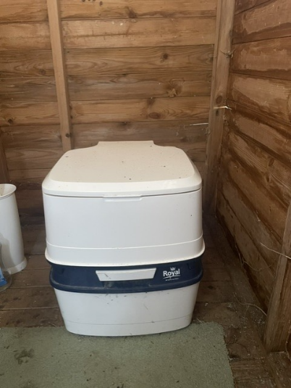 The section below and including the blue band, is the lower detachable tank.

