APPLICATION FOR HOUSEHOLDER PLANNING PERMISSION
DELEGATED REPORT

APPLICATION REFERENCE: | PL/2026/03279
APPLICATION TYPE: | Householder planning permission
SITE ADDRESS: | 10 Southwick Road, North Bradley, Trowbridge, BA14 0SD
DEVELOPMENT DESCRIPTION: | Single storey rear extension to provide larger kitchen, dining area and bedroom and wc/shower room
RECOMMENDATION: | That Planning Permission be GRANTED

SITE DESCRIPTION/CONTEXT
The subject property is an end-terrace, two-storey dwelling, in a modern expansion of North Bradley in an area characterised by shared design and materiality.

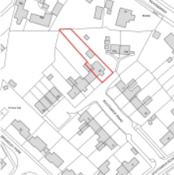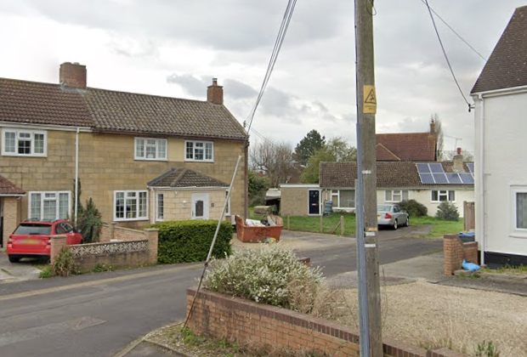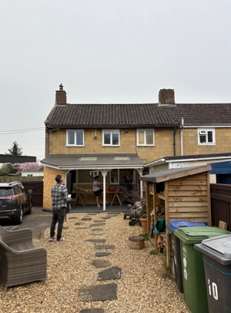

Location Plan and Google Earth and submitted Site Photos

The property includes an unusual, covered area to the rear, as per photo above, for which there is no planning history.

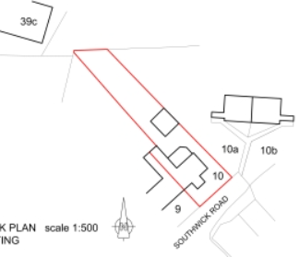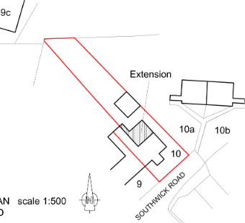

Existing and Proposed Block Plans

PROPOSAL

The proposal seeks planning permission for:
- knock through existing kitchen into proposed extension with lantern within a flat roof and an overhang/aluminium parapet, enabling an open plan kitchen/dining/living space.
- enlarge existing bedroom, increased side projection of 1m, with corner window,
- reconfiguration of existing GF utility/bathroom,
- widen/knock through from living space into proposed extension.

Proposed materials include light grey aluminium parapet capping, flat roof and render, against existing recon stone and concrete tiles.

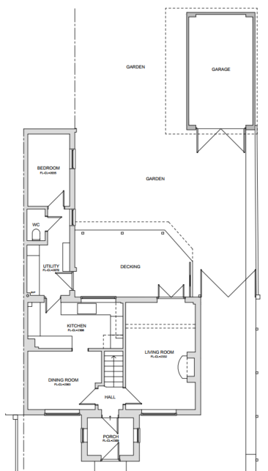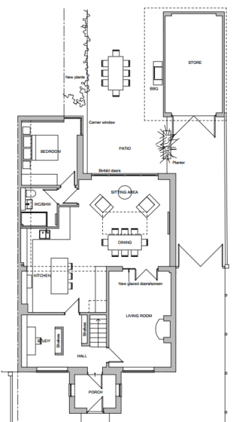

Existing and Proposed Ground Floor Plan

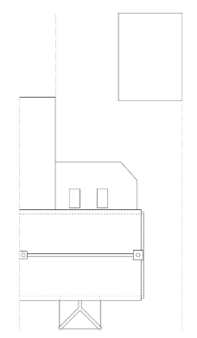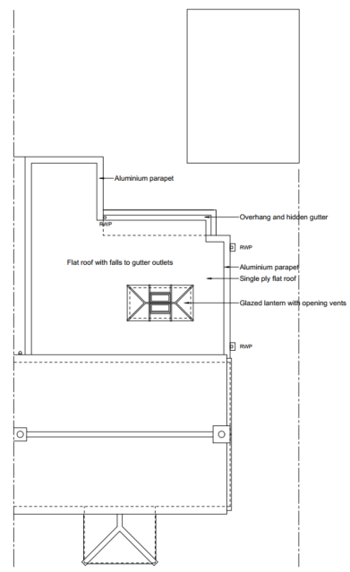

Existing and Proposed Roof Plan

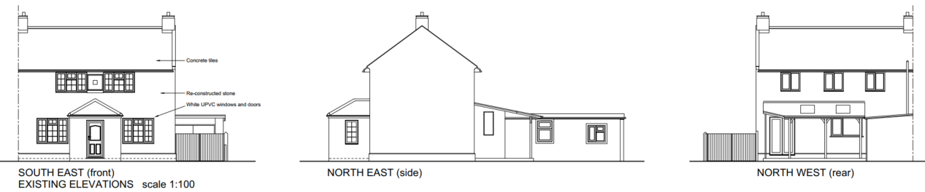

Existing Elevations

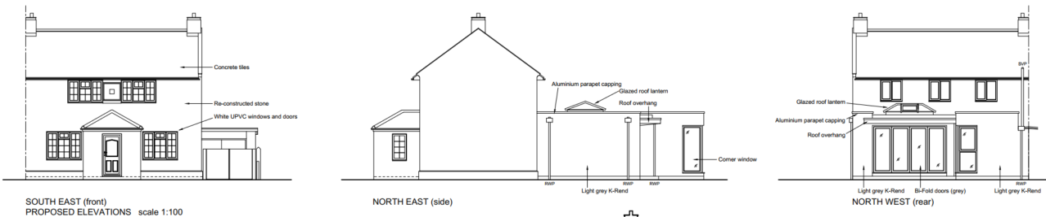

Proposed Elevations

PLANNING HISTORY
W/88/01238/FUL – extension – approve with conditions – no.8.
20/02494/FUL – enlargement of existing rear single storey outbuilding extension to form new habitable rooms – approve with conditions – no.7.

RELEVANT POLICIES AND GUIDANCE
The National Planning Policy Framework (NPPF)
The Planning Practice Guidance
National Design Guide
Wiltshire Design Guide: Appendix D – Design Guidance for Householder extensions

Wiltshire Core Strategy:
- Core Policy 57 Ensuring High Quality Design and Place Shaping

North Bradley Neighbourhood Plan, made 2021

CONSULTATION RESPONSES
North Bradley Parish Council: No comment at the time of writing, consultation deadline passed.

REPRESENTATIONS
One comment received, stating that once proposed works are completed, no impact is expected.

ASSESSMENT
Section 38(6) of the Planning and Compulsory Purchase Act 2004 states:

"If regard is to be had to the development plan for the purposes of any determination to be made under the planning Acts, the determination must be made in accordance with the plan unless material considerations indicate otherwise."

In accordance with this statutory requirement, this application has been assessed against the relevant policies of the Development Plan, including the adopted Wiltshire Core Strategy (2015) and, where applicable, any made Neighbourhood Plans.

Design and Impact upon the upon the character and context of the area
Core Policy 57 - Ensuring High Quality Design and Place Shaping of the Wiltshire Core Strategy seeks to ensure that all new development is of high design quality, reflecting local context, character, and distinctiveness.

During the lifecycle of the application, amendments were requested such that plans showed the rear single storey extension to make clear what this structure was.

The proposed extension is considered commensurate with the existing host dwelling and rear extensions, and in line with similar precedent development. The increased side projection of the existing rear bedroom addition is a minimal 1m so retaining scale and form.

Discounting the existing lean-to garden structure, the proposed extension would be 25m², if considering the existing built structure, the proposed extension would be 17m².

Historic aerial mapping shows the lean-to garden structure was extant by 2017.

The design is effectively for a moderately scaled extension, sited within the internal corner of existing structures, and maintaining the existing side building line 2.6m from the boundary. The proposal would clarify roof forms and fenestration, helping the extension integrate successfully.

Modern materials are considered appropriate and will balance effectively against the existing recon stone and clay tiles, appearing neutral; not challenging whilst legible as a modern addition.

Having regard to the above, the proposal complies with the design principles set out in Core Policy 57 of the Wiltshire Core Strategy and Appendix D of the Wiltshire Design Guide.

Amenity
Point vii of Core Policy 57 - Ensuring High Quality Design and Place Shaping of the Wiltshire Core Strategy seeks to ensure that developments do not adversely affect neighbouring properties.

The National Planning Policy Framework (NPPF), particularly Paragraph 135(f), stresses that planning decisions should ensure developments provide a high standard of amenity for existing and future users.

The proposed development has been assessed in terms of its potential impact on the residential amenity of neighbouring properties, with particular regard to loss of light, overshadowing, loss of privacy, and overbearing effects.

As single storey extensions to the rear, at a height of 3.2m, less than that of the existing rear extension, there are no concerns with overbearing or overshadowing.

Any impact to privacy caused by the proposed corner window, and reduction of windows to the existing rear extension, can be managed by standard boundary treatments. The proposed lantern would be at height to not cause any negative impact to privacy.

The proposal therefore accords with Core Policy 57 point vii in respect of safeguarding residential amenity and Appendix D of the Wiltshire Design Guide.

Biodiversity Net Gain
Householder planning applications are exempt from the requirement to deliver Biodiversity Net Gain under Schedule 7A, Section 4(2)(a) of the Town and Country Planning Act 1990, as inserted by the Environment Act 2021.

CONCLUSION
The proposed development is considered to be acceptable in terms of its design, scale, and relationship with the surrounding area. It would not result in any unacceptable harm to the character of the locality, or the amenities of neighbouring occupiers.

The proposal is therefore considered to comply with the relevant policies of the Wiltshire Core Strategy, the Wiltshire Local Plan, and the National Planning Policy Framework. As such, the application is recommended for approval, subject to the conditions set out below.

RECOMMENDATION: That Planning Permission be GRANTED subject to conditions.

