APPLICATION FOR HOUSEHOLDER PLANNING PERMISSION
DELEGATED REPORT

APPLICATION REFERENCE: | PL/2026/02889
APPLICATION TYPE: | Householder planning permission
SITE ADDRESS: | 3 Coburg Square, Melksham, SN12 7EP
DEVELOPMENT DESCRIPTION: | Reconstruction of existing single-storey rear outbuildings to form habitable accommodation, part two-storey front/side extension, erection of a front porch, and internal alterations.
RECOMMENDATION: | That Planning Permission be GRANTED

PROPOSAL

The proposal seeks planning permission for the Reconstruction of existing single-storey rear outbuildings to form habitable accommodation, part two-storey front/side extension, erection of a front porch, and internal alterations at 3 Coburg Square, Melksham, SN12 7EP.

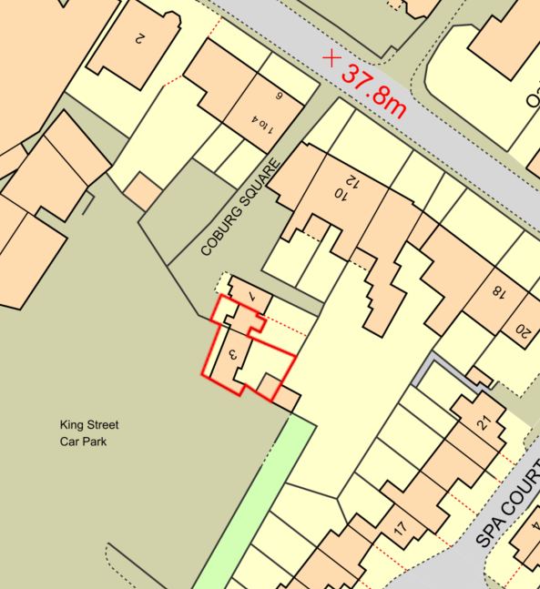

Site Location Plan

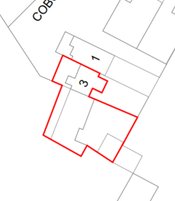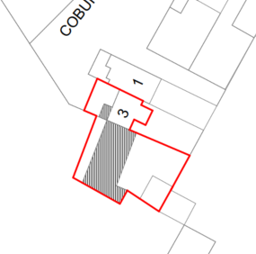

Existing and Proposed Block Plans

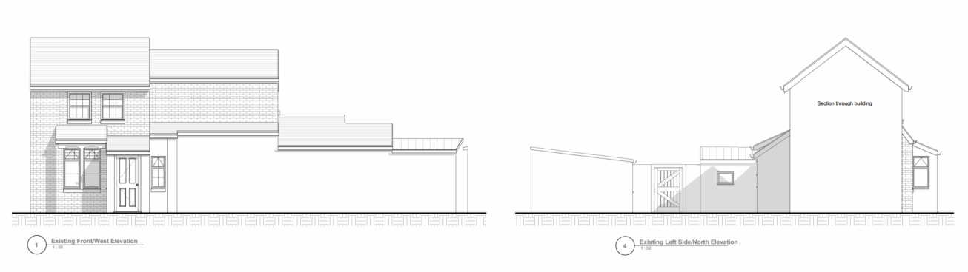

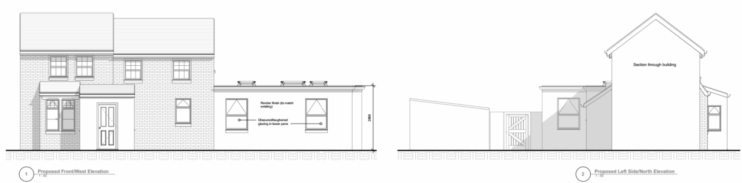

Existing (top) and Proposed (bottom) Front and Side (north) elevations

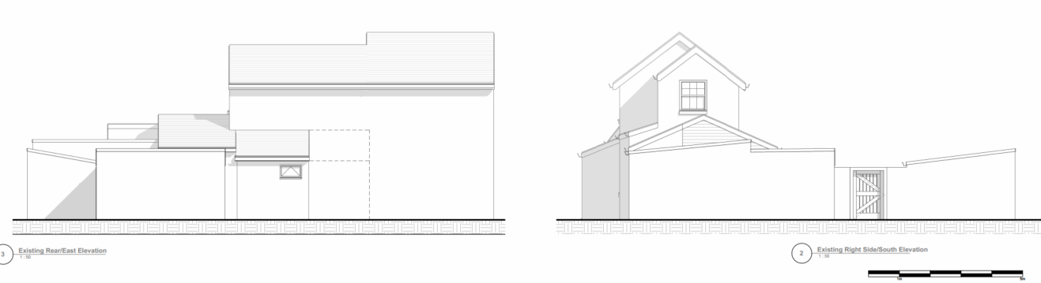

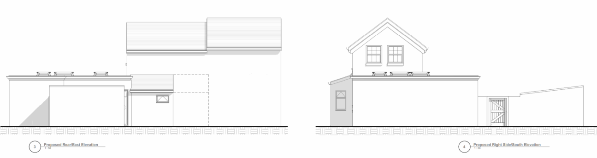

Existing (top) and Proposed (bottom) Rear and Side (south) elevations

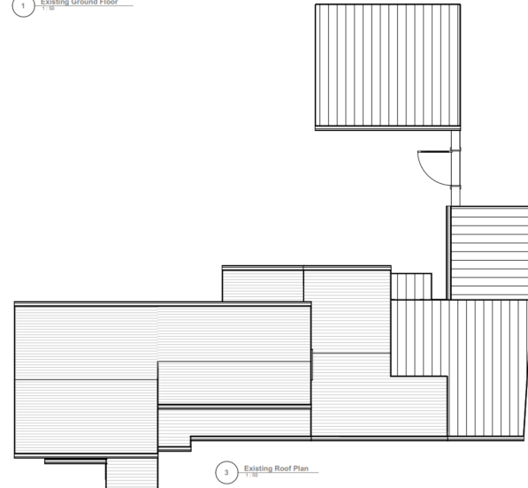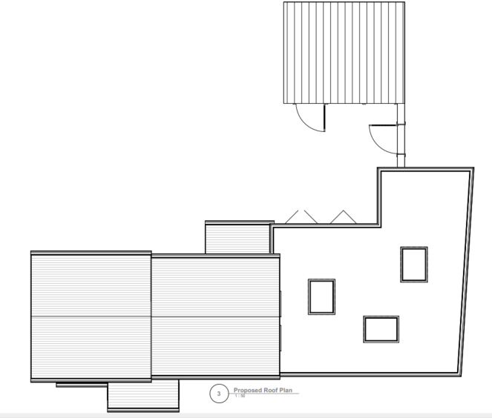

Existing and Proposed Roof Plan

The two-storey extension would be built using matching bricks and roof tiles, with the single storey extension being finished with render (also to match existing render).

SITE DESCRIPTION/CONTEXT

No. 3 is a two-storey semi-detached dwelling adjoining No. 1. As shown in the photograph below, the pair reads visually almost as a single dwelling, with No. 1 forming the principal and more prominent element, while No. 3 appears subordinate, albeit with a relatively wide frontage.

No. 3 has also been subject to a series of asymmetrical single- and two-storey extensions on its southern elevation. These additions have resulted in a somewhat convoluted form and have contributed to an incongruous appearance, both in relation to the host dwelling itself and the semi-detached pair as a whole.

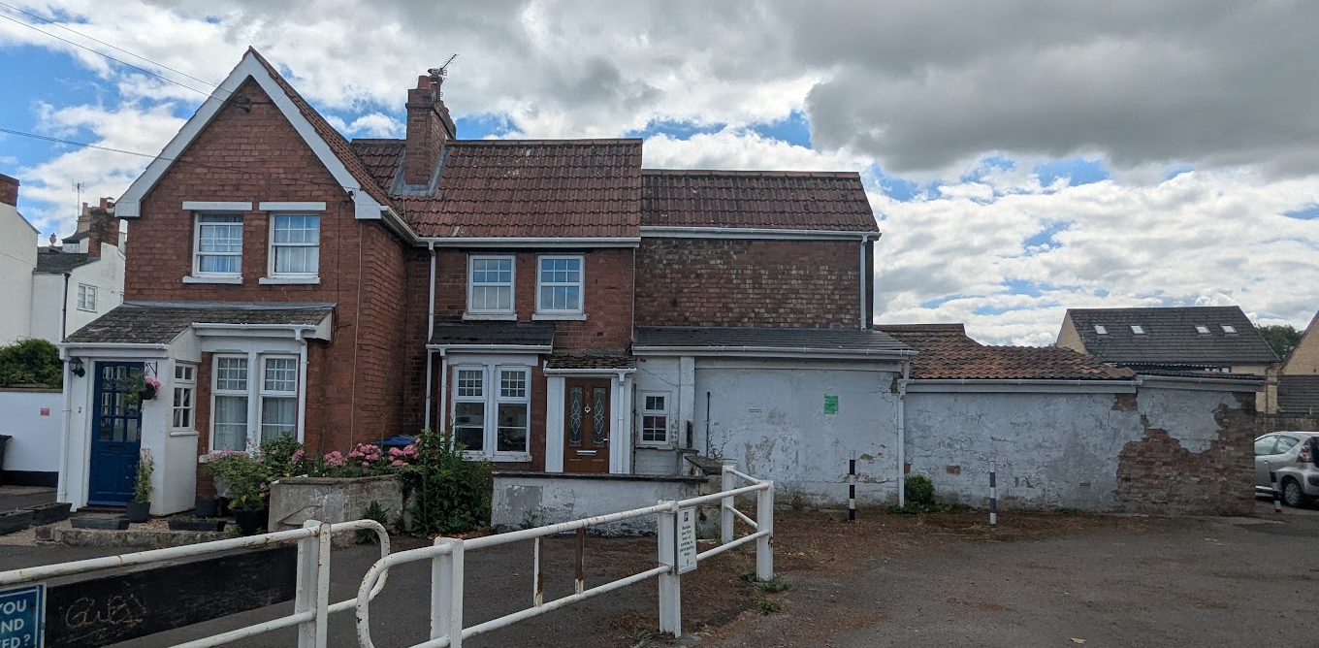

No 1 (left) and No 3 centre and right

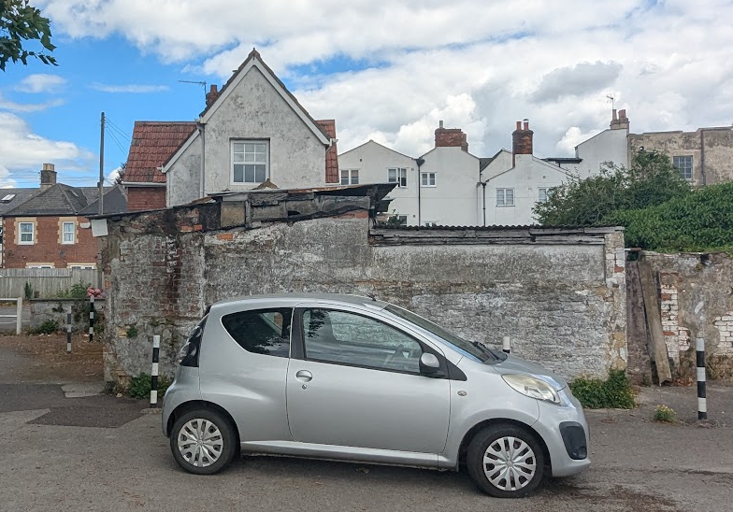

View from the south and the King Street Car Park

The application site faces out onto Coburg Square and the King Street Public car park. No 3 shares a residential boundary with No 1, but also No 14 Spa Road.

The application site is subject to the following planning policy constraints:

- Melksham Conservation Area
- No’s 10,12,14,16, 18&20 are grade II listed buildings

There are no other policy constraints.

PLANNING HISTORY

There is no relevant planning history on the site.

RELEVANT POLICIES AND GUIDANCE

National Context:

The National Planning Policy Framework (NPPF)

The NPPF outlines government policy for planning. Chapter 16 of the NPPF 'Conserving and enhancing the historic environment' sets out the Government's high-level policies concerning heritage and sustainable development.

The Planning Practice Guidance

From the point of view of the historic environment the main statutory tests are set out within the Planning (Listed Building and Conservation Areas) Act 1990.

Section 66 requires that special regard be given to the desirability of preserving listed buildings, their settings or any features of special architectural or historic interest which they possess.

Section 72(1) of the Act requires the Council to pay special attention to the desirability of preserving or enhancing the character or appearance of designated Conservation Areas.

Local Context:

Wiltshire Core Strategy:

- Core Policy 57 Ensuring High Quality Design and Place Shaping
- Core Policy 58: Ensuring the Conservation of the Historic Environment

The Council’s Core Strategy Policy CP58 ‘Ensuring the conservation of the historic environment’ requires that designated and non-designated heritage assets and their settings will be conserved, and where appropriate enhanced, in a manner appropriate to their significance and encourages proposals which improve the condition of heritage assets at risk.

The Council’s Core Strategy CP 57: Ensuring high quality design requires a high quality of design in all new developments. The policy requires applicants to “demonstrate how the proposal will make a positive contribution to the character of Wiltshire through (amongst other things) responding to the value of the natural and historic environment and being sympathetic to and conserving historic buildings and landscapes. Development is required to respond positively to the existing in terms of building layouts, built form, height, mass, scale, building line, plot size, elevational design, materials, streetscape and rooflines to effectively integrate the building into its setting.

Melksham Neighbourhood Plan 2025

Melsham Urban Design Study 2006

Wiltshire Design Guide: Appendix D – Design Guidance for Householder extensions

CONSULTATION RESPONSES

Melksham Town Council: No objection

But have concerns over the lack of allocated parking. Please be mindful of pressures of parking in the area and ask for a solution.

REPRESENTATIONS

The application was advertised by 6 neighbour notification letters and by site notice allowing for 21 days consultation.

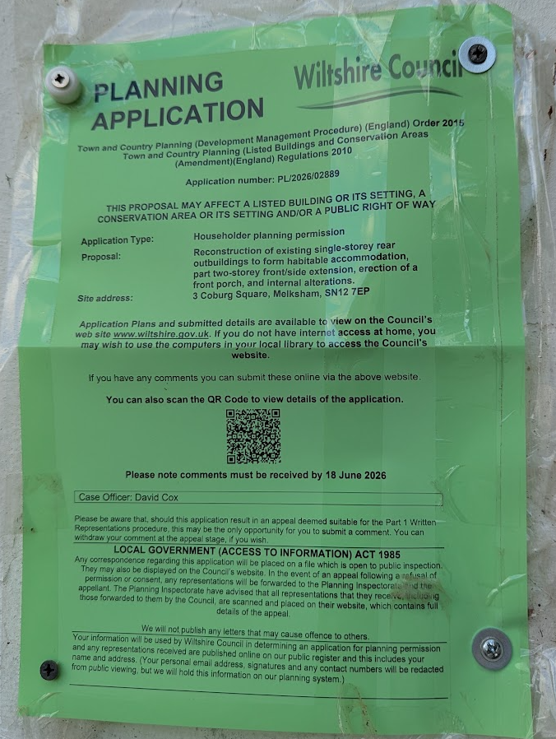

No comments were received.

ASSESSMENT

Section 38(6) of the Planning and Compulsory Purchase Act 2004 states:

"If regard is to be had to the development plan for the purposes of any determination to be made under the planning Acts, the determination must be made in accordance with the plan unless material considerations indicate otherwise."

In accordance with this statutory requirement, this application has been assessed against the relevant policies of the Development Plan, including the adopted Wiltshire Core Strategy (2015) and, where applicable, any made Neighbourhood Plans.

Design and Impact upon the upon the character and context of the area

Core Policy 57 - Ensuring High Quality Design and Place Shaping of the Wiltshire Core Strategy seeks to ensure that all new development is of high design quality, reflecting local context, character, and distinctiveness.

The existing building has a somewhat unbalanced and convoluted appearance, arising from its combination of single- and two-storey elements. While the proposed development would retain a mix of two-storey projections, a porch, bay window and a substantial single-storey side extension, it would rationalise the form of the southern part of the dwelling by creating a more coherent and consistent single-storey block at ground-floor level.

At first-floor level, the existing two-storey extension terminates abruptly, contributing to the incongruous appearance of the dwelling. Extending this element along the front (western) elevation would create a more balanced relationship between the two-storey components, resulting in a more symmetrical and harmonious appearance.

Overall, the proposed extensions would represent a significant enhancement to the visual appearance of the host dwelling, whilst also delivering substantial improvements to the living accommodation and amenity enjoyed by the occupants.

Having regard to the above, the proposal complies with the design principles set out in Core Policy 57 of the Wiltshire Core Strategy and Appendix D of the Wiltshire Design Guide.

Amenity

Point vii of Core Policy 57 - Ensuring High Quality Design and Place Shaping of the Wiltshire Core Strategy seeks to ensure that developments do not adversely affect neighbouring properties.

The National Planning Policy Framework (NPPF), particularly Paragraph 135(f), stresses that planning decisions should ensure developments provide a high standard of amenity for existing and future users.

The proposed development has been assessed in terms of its potential impact on the residential amenity of neighbouring properties, with particular regard to loss of light, overshadowing, loss of privacy, and overbearing effects.

By reason of the siting, scale and orientation of the proposed extensions, and their relationship to neighbouring boundaries, it is not considered that the development would give rise to any unacceptable loss of light, increased overshadowing, or overbearing impact to adjoining occupiers.

The proposal would not introduce any new or materially harmful overlooking, having regard to the existing relationship between properties and intervening distances.

The proposal therefore accords with Core Policy 57 point vii in respect of safeguarding residential amenity and Appendix D of the Wiltshire Design Guide.

Highways Impact

Core Policy 57 (xiv) of the Wiltshire Core Strategy seeks to ensure that development must meet the requirements of Core Policy 61. This policy requires proposals to be capable of being served by safe access to the highway network. Core Policy 64 seeks to ensure compliance with parking standards set out in the Local Transport Plan.

The National Planning Policy Framework (NPPF) advises that development should only be prevented or refused on highways grounds where there would be an unacceptable impact on highway safety, or where the residual cumulative impacts on the road network would be severe. It also requires safe and suitable access to be achieved for all users.
The Town Council has raised concerns regarding parking provision. However, it is noted that the existing dwelling does not benefit from any off-street parking, and no parking spaces are proposed as part of the development. Whilst the proposal would increase the accommodation from a two-bedroom to a three-bedroom dwelling, this would not alter the parking requirement that would ordinarily apply to new residential development, as both two and three-bedroom dwellings require the same level of parking provision under Wiltshire's adopted standards. Furthermore, the proposal relates to the extension and alteration of an existing dwelling rather than the creation of a new residential unit.

Although it may be physically possible to create off-street parking within the site, this would result in a significant reduction in the available garden space and would be detrimental to the residential amenity of the property. In addition, the site occupies a sustainable town centre location with access to a number of public car parks, including the adjacent public car park, where long-term parking permits are (normally) available. In these circumstances, there is no policy basis to require the provision of off-street parking or to substantiate a refusal of planning permission on parking grounds.

The proposal would not alter the existing access arrangements and is not considered likely to generate a level of traffic that would result in any adverse impact on highway safety or the efficient operation of the local highway network.

Accordingly, the proposal is considered to comply with Core Policies 57, 61 and 64 of the Wiltshire Core Strategy, the provisions of the National Planning Policy Framework, and the parking standards contained within the Wiltshire Local Transport Plan.

Heritage Impact

As set out in the Design section of this report, the proposed development would result in a significant enhancement to the appearance and condition of the host building. Consequently, it is considered that the character of the conservation area would be preserved and its appearance enhanced.

The nearby listed buildings, located approximately 20–40 metres to the north, are substantial three-storey structures that are visible from the public car park. The significance of these heritage assets is derived principally from their prominently detailed and architecturally rich principal elevations. It is a characteristic of buildings of this period that design emphasis was often placed on front elevations, with rear elevations serving a more functional purpose. Whilst the settings of the listed buildings do extend across the car park and application site, the contribution made by this area to their significance is limited. This is due to the size of the car park, the presence of a mature Plane tree within its centre, and the existing appearance of No. 3 and its boundary treatments, which currently present a somewhat untidy aspect when viewed from the car park.

The proposal would improve the appearance of No. 3 and, as such, would preserve the settings of the nearby listed buildings. The development would not result in harm to the significance of these designated heritage assets or to the significance of the conservation area.

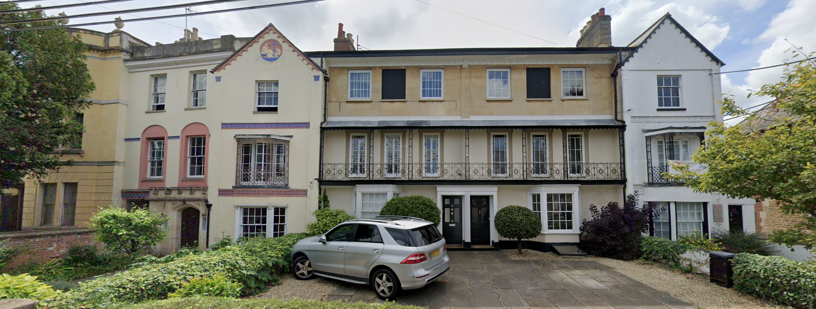

July 2024 Google Street View Image of the front elevations of the listed buildings

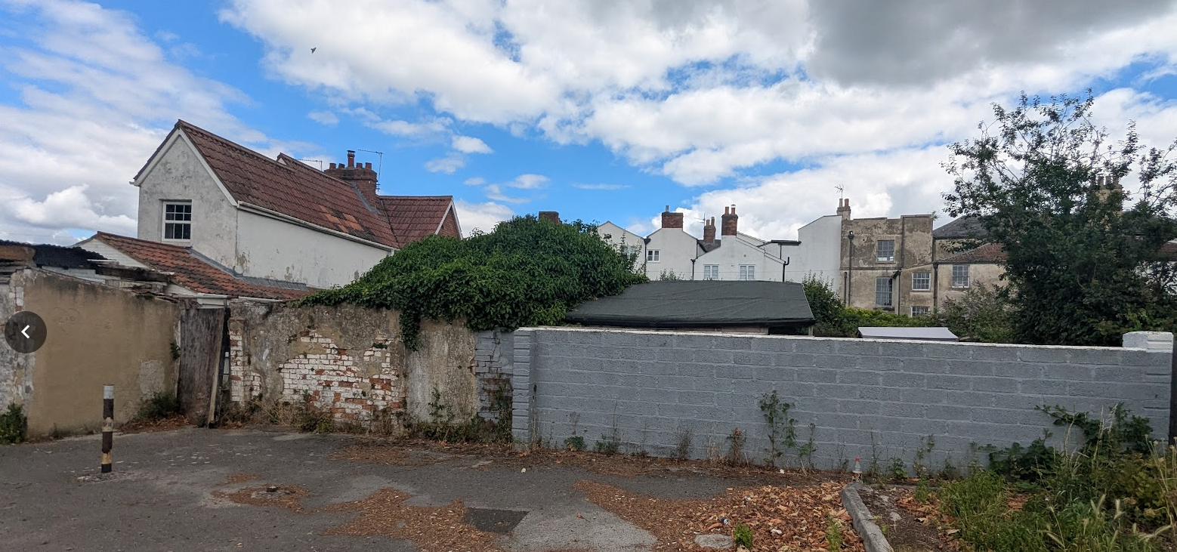

Application site (left) and listed buildings centre and right in the foreground

Accordingly, by virtue of its scale, design and materials, the proposal is considered to preserve the character and appearance of the conservation area and preserve the settings of the nearby listed buildings. The development would not result in harm to the significance of any heritage asset.

In applying the relevant policies of the National Planning Policy Framework, particular regard has been given to paragraphs 205-15, which require decision-makers to identify and assess the significance of heritage assets and the impact of development upon that significance.

In this case, the proposal would not result in harm to the significance of the conservation area or the setting of nearby listed buildings. As such, there is no requirement to undertake the further balancing exercise set out in respect of ‘less than substantial harm’.

In reaching this conclusion, the Council has had special regard to the desirability of preserving the setting of listed buildings, and has paid special attention to the desirability of preserving or enhancing the character or appearance of the conservation area, in accordance with Sections 66 and 72 of the Planning (Listed Buildings and Conservation Areas) Act 1990.

The development is therefore considered to comply with Core Policy 58 of the Wiltshire Core Strategy and Sections 66 and 72 of the Planning (Listed Buildings and Conservation Areas) Act 1990, as well as the relevant provisions of the NPPF.

Biodiversity Net Gain

Householder planning applications are exempt from the requirement to deliver Biodiversity Net Gain under Schedule 7A, Section 4(2)(a) of the Town and Country Planning Act 1990, as inserted by the Environment Act 2021.

CONCLUSION

The proposed development is considered to be acceptable in terms of its design, scale, and relationship with the surrounding area. It would not result in any unacceptable harm to the character of the locality, the amenities of neighbouring occupiers, or the interests of highway safety, heritage, or ecology.

The proposal is therefore considered to comply with the relevant policies of the Wiltshire Core Strategy, the Wiltshire Local Plan, and the National Planning Policy Framework. As such, the application is recommended for approval, subject to the conditions set out below.

RECOMMENDATION: That Planning Permission be GRANTED subject to conditions.

