APPLICATION FOR HOUSEHOLDER PLANNING PERMISSION
DELEGATED REPORT

APPLICATION REFERENCE: | PL/2026/03029
APPLICATION TYPE: | Householder planning permission
SITE ADDRESS: | 13 Storridge Road, Westbury, BA13 4HX
DEVELOPMENT DESCRIPTION: | Demolish existing outbuilding then adapt and extend existing house
RECOMMENDATION: | That Planning Permission be GRANTED

PROPOSAL

The scheme seeks to remodel and extend an existing single storey rear extension and remove a detached outbuilding to the rear of the host dwelling.

SITE DESCRIPTION/CONTEXT

This application relates to a semi-detached two storey dwelling, 13 Storridge Road, located within an established residential area in Westbury. The host dwelling benefits from an off-road parking area to the front elevation. The surrounding properties are all similar in style comprising of semi-detached pairs.

This proposal falls within the recreational impact zone of the Salisbury Plain Special Protection Area for birds, and sits within the Bath and Bradford on Avon Special Area of Conservation for bats as well as the grey, hatched zone of the Trowbridge and Westbury Bat Mitigation Strategy (TWBMS)

PLANNING HISTORY

N/a

RELEVANT POLICIES AND GUIDANCE

The Wiltshire Core Strategy (WCS) 2015
Core Policy 2 – Delivery Strategy
Core Policy 32 – Spatial Strategy for the Westbury Community Area
Core Policy 57 – Ensuring High Quality Design and Place Shaping
Emerging Policy – Wiltshire Local Plan Review
At Full Council on 19 May, the elected members of Wiltshire Council agreed to withdraw the emerging WLP. The said Plan has no material weight for the purposes of the application.
Westbury Neighbourhood Plan 2023-2036

Wiltshire Design Guide: Appendix D – Design Guidance for Householder extensions

The National Planning Policy Framework (NPPF)

The Planning Practice Guidance

National Design Guide

CONSULTATION RESPONSES

Heywood Parish Council: No comment received

REPRESENTATIONS
One letter in support of the proposal was received.

ASSESSMENT
Section 38(6) of the Planning and Compulsory Purchase Act 2004 states:

"If regard is to be had to the development plan for the purposes of any determination to be made under the planning Acts, the determination must be made in accordance with the plan unless material considerations indicate otherwise."

In accordance with this statutory requirement, this application has been assessed against the relevant policies of the Development Plan, including the adopted Wiltshire Core Strategy (2015) and, where applicable, any made Neighbourhood Plans.

Design and Impact upon the upon the character and context of the area
Core Policy 57 - Ensuring High Quality Design and Place Shaping of the Wiltshire Core Strategy seeks to ensure that all new development is of high design quality, reflecting local context, character, and distinctiveness.

The scheme seeks to remodel and extend an existing single storey rear extension and remove a detached outbuilding to the rear of the host dwelling.

The extension would extend over the existing footprint with an additional length of 2.2m and have a flat roof form. The extension would sit at a height of 2.8m with a staggered floor plan. Windows would be inserted on the southeast side elevation and windows and patio doors on the rear elevation.
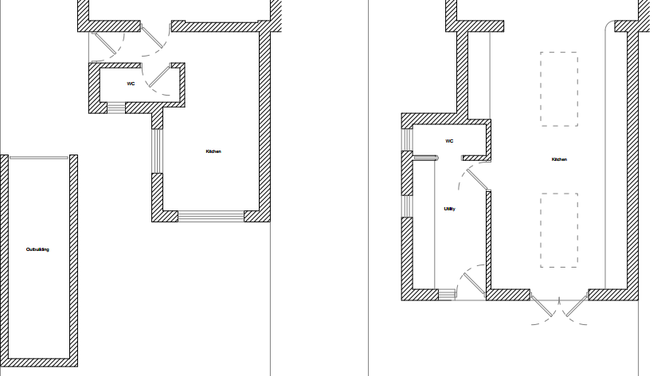

Existing (left) and proposed (right) ground floor plan

The use of matching materials (brick elevations with matching UPVC fenestration) would ensure the proposal would integrate into the existing built form of the host dwelling and surrounding setting.

It is considered that the extension would by virtue of its height, scale and design constitute a complementary addition to the host dwelling that would appear commensurate to the size of the property and plot. Having regard to the above, the proposal complies with the design principles set out in Core Policy 57 of the Wiltshire Core Strategy and Appendix D of the Wiltshire Design Guide.

Amenity
Point vii of Core Policy 57 - Ensuring High Quality Design and Place Shaping of the Wiltshire Core Strategy seeks to ensure that developments do not adversely affect neighbouring properties.

The National Planning Policy Framework (NPPF), particularly Paragraph 135(f), stresses that planning decisions should ensure developments provide a high standard of amenity for existing and future users.

The proposed development has been assessed in terms of its potential impact on the residential amenity of neighbouring properties, with particular regard to loss of light, overshadowing, loss of privacy, and overbearing effects.

The two windows proposed on the southeast side elevation of the extension, serving a bathroom and utility room, would be obscure glazed and the patio doors and window on the rear elevation would overlook the private residential rear curtilage of the host dwelling, therefore no overlooking concerns are raised.

The scheme relates to a single storey extension extending over the footprint of existing built form, removing an existing outbuilding that sits close to the common shared boundary with the property at No.11. Storridge Road. Therefore, officers raise no concerns in regard to any potential adverse overbearing or overshadowing impacts, or loss of light to neighbouring properties.

The proposal therefore accords with Core Policy 57 point vii in respect of safeguarding residential amenity and Appendix D of the Wiltshire Design Guide.

Ecology Impact
Core Policy 50 of the Wiltshire Core Strategy seeks to protect and enhance biodiversity and geodiversity, including through ensuring that development avoids harm to protected species and habitats.

The National Planning Policy Framework (NPPF), in Paragraphs 193, requires that development minimises impacts on and provides net gains for biodiversity, including ensuring mitigation is secured where harm cannot be avoided.

This proposal falls within the recreational impact zone of the Salisbury Plain Special Protection Area for birds. Therefore, potential disturbance to nesting birds through the creation of additional visitor numbers to the Salisbury Plain has to be assessed. However, given that this proposal relates to an extension to existing accommodation only, without the creation of separate independent living accommodation, it is considered that there would not be any adverse impacts on the Special Protection Area.

The application site sits within the Bath and Bradford on Avon Special Area of Conservation for bats as well as the grey, hatched zone of the Trowbridge and Westbury Bat Mitigation Strategy (TWBMS) therefore due consideration has to be given to the potential disturbance of any bats because of the proposed development.

The proposed development comprises an extension of existing residential development consisting of limited built form close to the existing dwelling which does not involve works to the roof. Given the established high density urban residential nature of the location, it is considered highly unlikely that any bats would be affected and significant effects relating to the disturbance to bats can be ruled out.

As a precautionary measure an informative would be added to any decision that in event any evidence of bat activity is detected that the applicant should follow the advice of a professional ecologist or contact Natural England.

As such, the development complies with Core Policy 50 of the Wiltshire Core Strategy and the relevant provisions of the NPPF.

Biodiversity Net Gain
Householder planning applications are exempt from the requirement to deliver Biodiversity Net Gain under Schedule 7A, Section 4(2)(a) of the Town and Country Planning Act 1990, as inserted by the Environment Act 2021.

CONCLUSION
The proposed development is considered to be acceptable in terms of its design, scale, and relationship with the surrounding area. It would not result in any unacceptable harm to the character of the locality, the amenities of neighbouring occupiers, or the interests of ecology.

The proposal is therefore considered to comply with the relevant policies of the Wiltshire Core Strategy, the Wiltshire Local Plan, and the National Planning Policy Framework. As such, the application is recommended for approval, subject to the conditions set out below.

RECOMMENDATION: That Planning Permission be GRANTED subject to conditions.

Conditions

1. The development hereby permitted shall be begun before the expiration of three years from the date of this permission.
REASON: To comply with the provisions of Section 91 of the Town and Country Planning Act 1990 as amended by the Planning and Compulsory Purchase Act 2004.

2. The development hereby permitted shall be carried out in accordance with the following approved plans and documents:
Location Plan DWG No PP 001 - Received 08.05.2026
Existing Block Plan DWG No PP 005 - Received 08.05.2026
Proposed Block Plan DWG No PP 006 - Received 01.06.2026
Existing & Proposed Floor Plan DWG No PP 010 - Received 01.06.2026
Existing & Proposed Rear Elevation DWG No PP 020 - Received 08.05.2026
Existing & Proposed Side Elevation 1 DWG No PP 021 - Received 01.06.2026
Existing & Proposed Side Elevation 2 DWG No PP 022 - Received 01.06.2026
Existing & Proposed Front Elevation DWG No PP 023 - Received 08.05.2026

REASON: For the avoidance of doubt and in the interests of proper planning.

3. Before the development hereby permitted is first occupied the windows in the southeast elevation shall be glazed with obscure glass only [to an obscurity level of no less than level 3] and the windows shall be permanently maintained with obscure glazing in perpetuity.

REASON: In the interests of residential amenity and privacy.

Informative

Ecology
If bats or evidence of bats are found during the works, the applicant is advised to stop work and follow advice from an independent ecologist or to contact Natural England’s Bat Line through the internet.

