APPLICATION FOR HOUSEHOLDER PLANNING PERMISSION
DELEGATED REPORT

APPLICATION REFERENCE: | PL/2026/03270
APPLICATION TYPE: | Householder planning permission
SITE ADDRESS: | Bahama, 6, Great Bedwyn, Marlborough, SN8 3LP
DEVELOPMENT DESCRIPTION: | Proposed landscaping of the front garden, including the relocation of the oil tank, bin store, and parking spaces
RECOMMENDATION: | That Planning Permission be GRANTED

PROPOSAL

The proposal seeks planning permission for Proposed landscaping of the front garden, including the relocation of the oil tank, bin store, and parking spaces at Bahama, 6, Great Bedwyn, Marlborough, SN8 3LP.

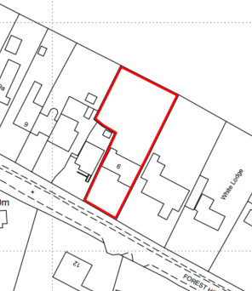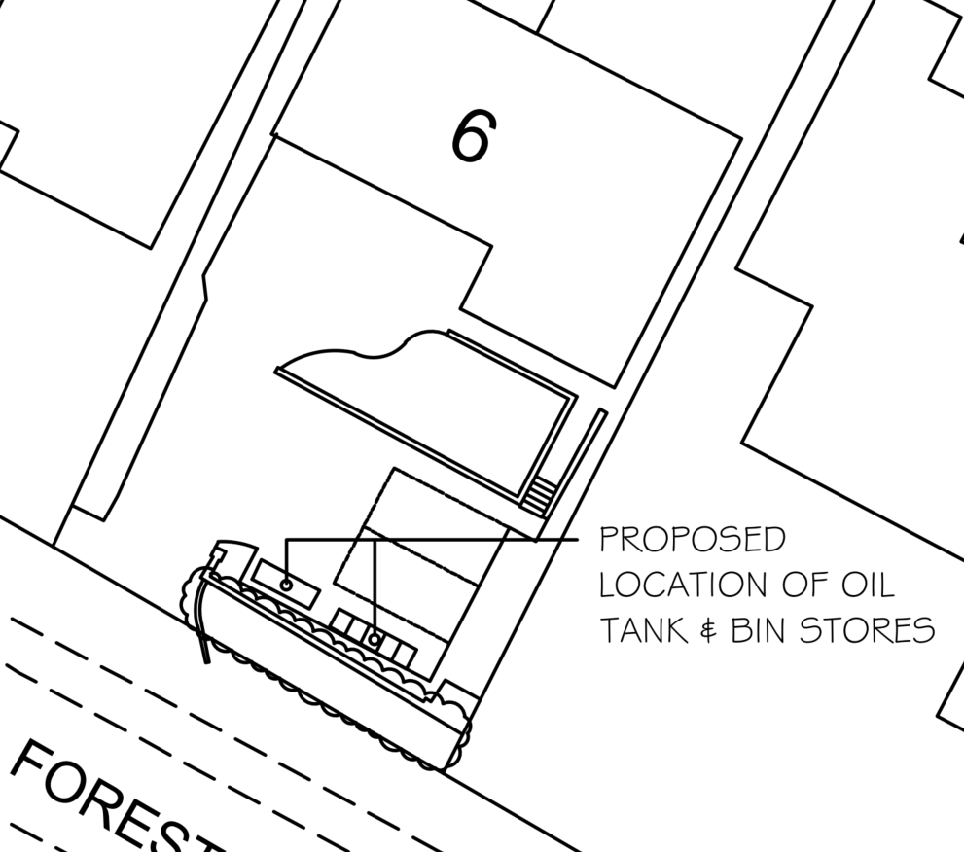

Site Location Plan and Extract from Proposed Block Plan

The site currently benefits from parking provision immediately in front of the dwelling, with a grassed lawn situated adjacent to the road. The proposed development would convert part of this lawn into two parking spaces, necessitating the removal of two trees, and would also provide space for an external oil tank and bin storage. In addition, the existing driveway would be regraded to create a more consistent and gentler slope, replacing the current arrangement of a steep driveway leading to a level parking area. As part of the scheme, approximately half of the existing hardstanding used for parking would be reinstated as landscaped garden space, while the remaining section of driveway serving the dwelling would be retained. The existing garden wall would also be re-built allowing for a wider vehicular access.

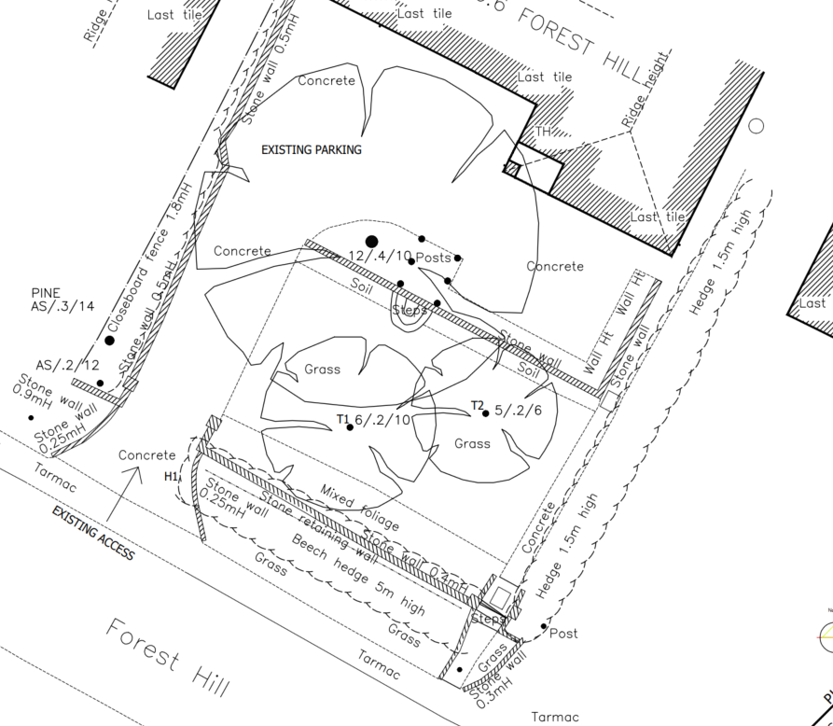

Existing Site Plan

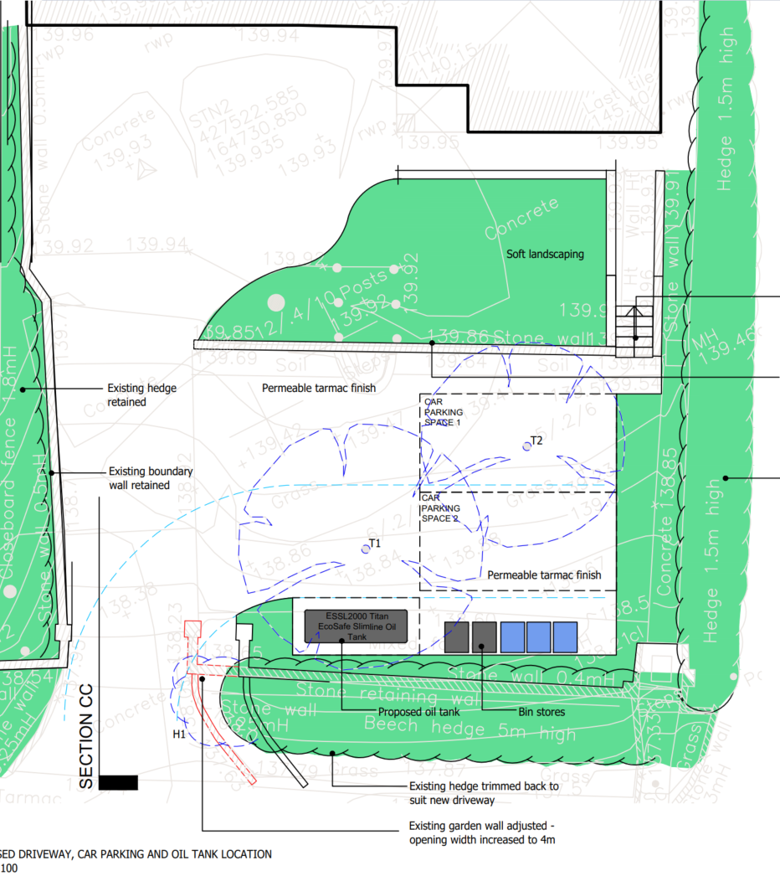

Proposed Site Plan

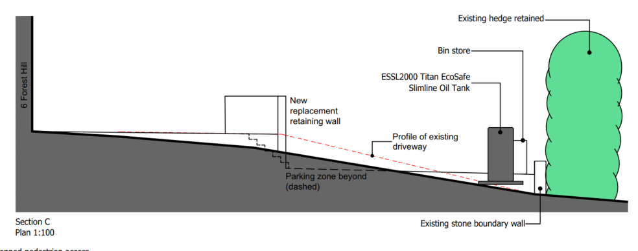

Proposed Cross Section Plan

SITE DESCRIPTION/CONTEXT

The application site lies within the defined Limits of Development for Great Bedwyn, which is identified as a Large Village within the Wiltshire Core Strategy. The site is situated on the western edge of the settlement and occupies the northern side of Forest Road, where the pattern of development is characterised by dwellings set at a higher level than the road.

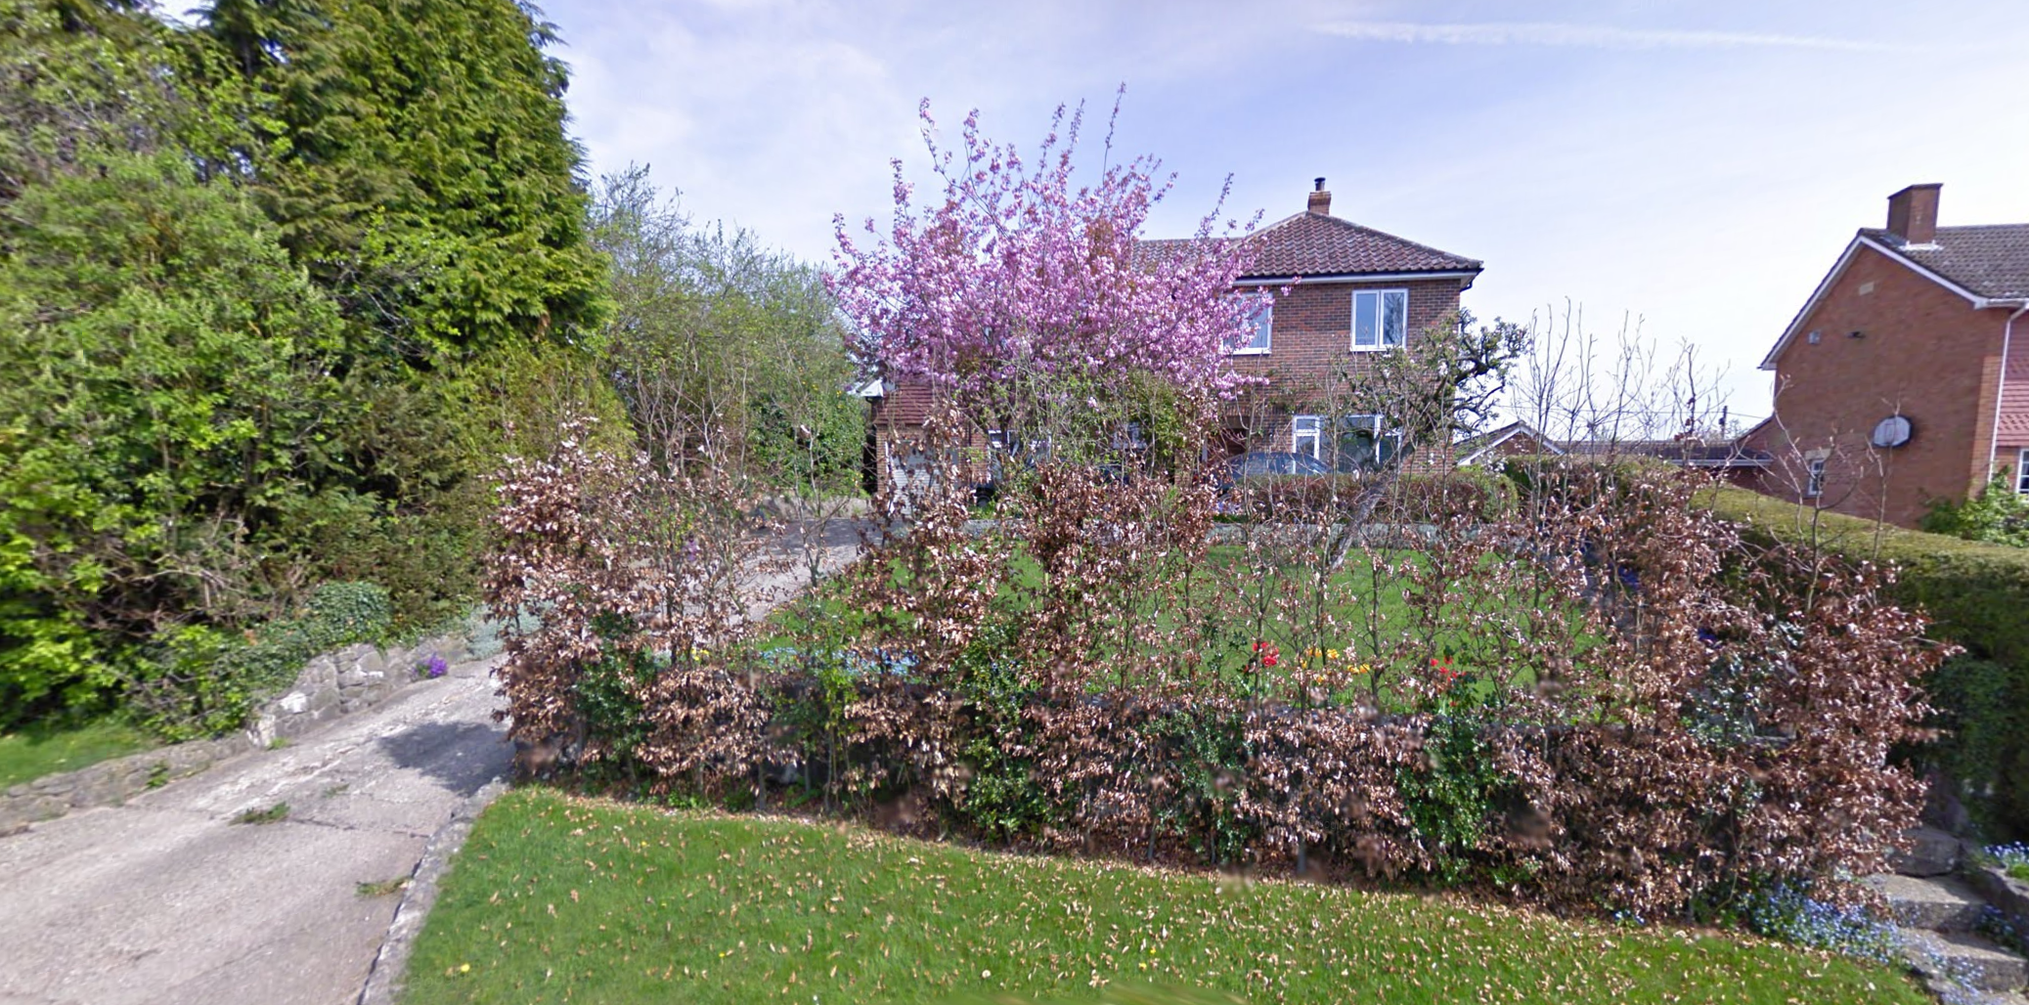

April 2009 Google Street View Image of the site

Bahama has a large mature hedge which largely screens the dwelling from the road. The hedge is proposed to be retained in the application.

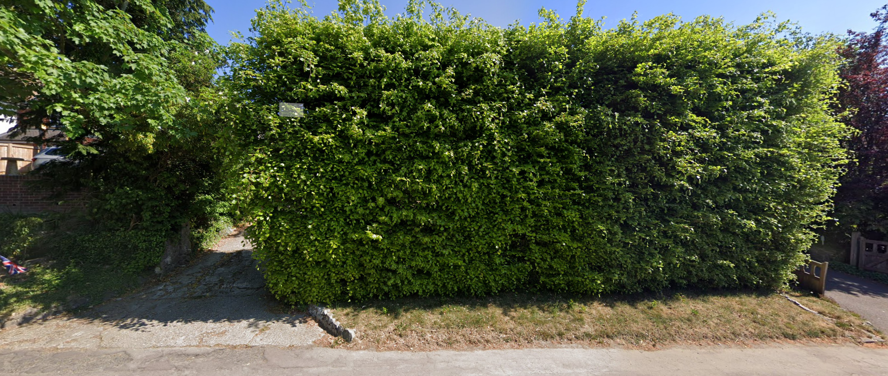

May 2025 Google Street View Image of the site

The application site is subject to the following planning policy constraints:

- Great Bedwyn Conservation Area
- North Wessex Downs National Landscape
- Ground water being between 0.025 and 0.5m of the surface

PLANNING HISTORY

Whilst there is planning history on the site, none of it is relevant to this application.

PLANNING POLICY

National Context:

The National Planning Policy Framework (NPPF)

The NPPF outlines government policy for planning. Chapter 16 of the NPPF 'Conserving and enhancing the historic environment' sets out the Government's high-level policies concerning heritage and sustainable development.

The Planning Practice Guidance

From the point of view of the historic environment the main statutory tests are set out within the Planning (Listed Building and Conservation Areas) Act 1990.

Section 66 requires that special regard be given to the desirability of preserving listed buildings, their settings or any features of special architectural or historic interest which they possess.

Section 72(1) of the Act requires the Council to pay special attention to the desirability of preserving or enhancing the character or appearance of designated Conservation Areas.
Local Context:

Wiltshire Core Strategy:

- Core Policy 57 Ensuring High Quality Design and Place Shaping
- Core Policy 51: Landscape
- Core Policy 58: Ensuring the Conservation of the Historic Environment
- Core Policy 61: Transport and New Development
- Core Policy 64: Demand Management
- Core Policy 67: Flood Risk

The Council’s Core Strategy Policy CP58 ‘Ensuring the conservation of the historic environment’ requires that designated and non-designated heritage assets and their settings will be conserved, and where appropriate enhanced, in a manner appropriate to their significance and encourages proposals which improve the condition of heritage assets at risk.

The Council’s Core Strategy CP 57: Ensuring high quality design requires a high quality of design in all new developments. The policy requires applicants to “demonstrate how the proposal will make a positive contribution to the character of Wiltshire through (amongst other things) responding to the value of the natural and historic environment and being sympathetic to and conserving historic buildings and landscapes. Development is required to respond positively to the existing in terms of building layouts, built form, height, mass, scale, building line, plot size, elevational design, materials, streetscape and rooflines to effectively integrate the building into its setting.

Wiltshire Council Strategic Flood Risk Assessments 2019 and 2024

Wiltshire Design Guide: Appendix D – Design Guidance for Householder extensions

Great Bedwyn was designated for a Neighbourhood Plan in 2016 but have not progressed to referendum for adoption.

Great Bedwyn Conservation Area Statement March 2007

CONSULTATION RESPONSES

Great Bedwyn Parish Council: No objection

We would ask that the pavement is made good at the same time if possible as the builders have caused some considerable damage to it.

Wiltshire Council Highways Officer: No objection

Wiltshire Council Tree Officer: No objection

The Apple and Laburnum trees located within the front garden and identified as T1 & T2 on the Proposed Driveway and Oil Tank Location plan, Ref: 22080 PL122A, are small trees of limited amenity value which are largely hidden from public view by the front Beech hedge.

REPRESENTATIONS

Neighbours were consulted by 5 neighbour notification letters and by site notice for 21 days.

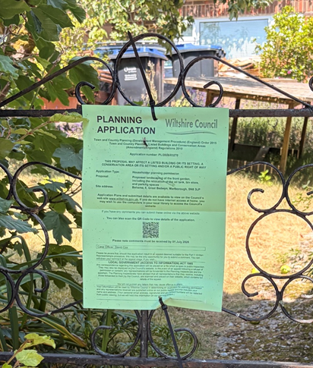

No comments were received.

ASSESSMENT

Section 38(6) of the Planning and Compulsory Purchase Act 2004 states:

"If regard is to be had to the development plan for the purposes of any determination to be made under the planning Acts, the determination must be made in accordance with the plan unless material considerations indicate otherwise."

In accordance with this statutory requirement, this application has been assessed against the relevant policies of the Development Plan, including the adopted Wiltshire Core Strategy (2015) and, where applicable, any made Neighbourhood Plans.

Design and Impact upon the upon the character and context of the area

Core Policy 57 - Ensuring High Quality Design and Place Shaping of the Wiltshire Core Strategy seeks to ensure that all new development is of high design quality, reflecting local context, character, and distinctiveness.

The dwellings along Forest Road are generally set back from the highway and occupy an elevated position above road level. They are typically enclosed by mature and well-established hedgerows, which contribute significantly to the verdant character of the street scene. Although the area is clearly residential in nature, it displays a distinctive blend of urban and rural characteristics.

Recent development at the neighbouring site, resulting in the construction of No. 7A under planning permission 19/10971/FUL (Proposed New Dwelling and Highways Entrance), represents something of an exception to this established character. As the associated hedgerow planting has not yet fully matured, the elevated brick retaining wall and driveway remain prominent features within the street scene.

In the present case, some concern could arise from the introduction of parking spaces closer to the highway and the provision of a relatively large external oil tank. However, unlike the neighbouring development, the proposal does not involve the construction of a retaining wall or elevated parking area and would retain the substantial existing roadside hedge (despite the loss of approximately 1m of its width to accommodate the wider vehicular access). Consequently, any visual impact arising from the proposed works would be considerably less pronounced and would be effectively mitigated by the existing vegetation, thereby limiting any adverse effect on the character and appearance of the area.

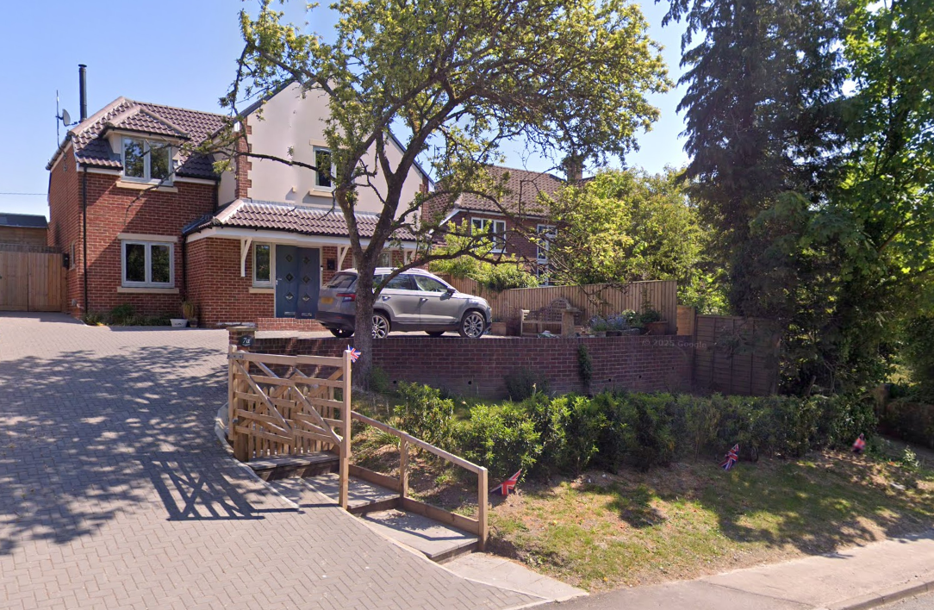

No 7a following its introduction to the street scene

Having regard to the above, the proposal complies with the design principles set out in Core Policy 57 of the Wiltshire Core Strategy and Appendix D of the Wiltshire Design Guide.

Amenity

Point vii of Core Policy 57 - Ensuring High Quality Design and Place Shaping of the Wiltshire Core Strategy seeks to ensure that developments do not adversely affect neighbouring properties.

The National Planning Policy Framework (NPPF), particularly Paragraph 135(f), stresses that planning decisions should ensure developments provide a high standard of amenity for existing and future users.

The proposed development has been assessed in terms of its potential impact on the residential amenity of neighbouring properties, with particular regard to loss of light, overshadowing, loss of privacy, and overbearing effects.

No harm would be caused to neighbouring amenity as the car parking spaces would be closer to the road and therefore further away from neighbouring properties gardens and windows (on the same side).

The proposal therefore accords with Core Policy 57 point vii in respect of safeguarding residential amenity and Appendix D of the Wiltshire Design Guide.

Highways Impact

Core Policy 57 (xiv) of the Wiltshire Core Strategy seeks to ensure that development must meet the requirements of Core Policy 61. This policy requires proposals to be capable of being served by safe access to the highway network. Core Policy 64 seeks to ensure compliance with parking standards set out in the Local Transport Plan.

The National Planning Policy Framework (NPPF), particularly Paragraph 115 and 116, requires that development proposals do not have an unacceptable impact on highway safety and that safe and suitable access to the site can be achieved for all users.

The proposed development would not give rise to any adverse impacts on highway safety. Officers consider that the regrading of the existing driveway would represent an improvement over the current arrangement, which is characterised by a steep gradient. The scheme provides sufficient parking and turning space in accordance with Wiltshire Council’s adopted parking standards, ensuring that vehicles can enter and leave the site in a safe and convenient manner. The proposed access arrangements are considered acceptable, and no objection has been raised by the Council’s Highway Officer.

The proposal is therefore considered to comply with Core Policies 57 (xiv), 61 and 64 of the Wiltshire Core Strategy, the NPPF, and the Wiltshire Local Transport Plan.

Heritage Impact

The Great Bedwyn Conservation Area Statement sets out that the centre of the village is of the most significant archaeological interest, but it does state:

“Forest Hill extends west out of Great Bedwyn rising gradually from the main village towards
Savernake Forest. The road is in a shallow cutting with hedges and trees framing vistas from
the upper part of the historic village towards its historic core. The residential buildings here
largely date from the twentieth century are detached and well spaced and have considerable foliage and trees between them.

The stretch of road is characterised by its high green banks and an avenue of trees which help
create an Arcadian character on the periphery of the village and provide another special dimension to the character of the conservation area. The majority of the tree cover has been
planted in the later part of the C20 in the large gardens of the dwellings also built in this period.
The trees and hedges are thus a mixture of native and introduced species bearing little resemblance to the traditional native trees and hedges seen in the wider countryside or the more historic parts of the settlement.”

As set out in the design section, the proposal would retain the majority of its key hedgerow landscaping, and the regrading works would actually be more in keeping with the character of the conservation area by having ‘shallow cutting’ rather than the existing steep embankment and then level parking area. The proposal would look more natural than the existing situation. The hedge would also screen the oil tank and the bin store from view.

While existing hedgerows cannot be relied upon indefinitely, nor used to justify development that would otherwise result in unacceptable harm, there is no evidence to suggest that the established roadside hedge would not be retained, particularly given that similar mature boundary treatments are a prevailing feature along Forest Road. Nevertheless, even in the absence of the hedge, the proposed parking spaces would not be significantly elevated above the level of the highway and would therefore have a limited visual presence within the street scene. Similarly, the proposed oil tank would serve a necessary functional requirement of the dwelling and would be positioned in a logical and practical location to facilitate maintenance and fuel deliveries.

Accordingly, neither the parking arrangement nor the siting of the oil tank is considered to result in unacceptable harm to the character and appearance of the area. These elements do not, either individually or cumulatively, give rise to impacts that would justify refusal of the application.

The proposal, by virtue of its scale, design, and use of materials, is considered to preserve the character and appearance of the conservation area and would not result in any harm to its historic significance.

The development is therefore considered to comply with Core Policy 58 of the Wiltshire Core Strategy and Sections 66 and 72 of the Planning (Listed Buildings and Conservation Areas) Act 1990, as well as the relevant provisions of the NPPF.

National Landscape

Core Policy 51 of the Wiltshire Core Strategy requires all development to protect, conserve, and where possible enhance the character and quality of Wiltshire’s landscapes, giving particular weight to designated areas such as National Landscapes.

The National Planning Policy Framework (NPPF), in Paragraph 189, states that “great weight” should be given to conserving and enhancing landscape and scenic beauty in National Landscapes (formerly Areas of Outstanding Natural Beauty). Development within or affecting the setting of a National Landscape must demonstrate that it will not result in unacceptable harm to the special qualities of that area.

The proposal, by virtue of its scale, siting, and design, would not harm the special qualities or scenic character of the North Wessex Downs National Landscape. The retention of the main hedge and partial replacement of the on site landscaping ensures that any localised impacts are minimised.

The development therefore complies with Core Policy 51 of the Wiltshire Core Strategy and Paragraph 187 of the NPPF in conserving and enhancing the National Landscape.

Drainage and Flood Risk

The application site is within flood zone 1 but is within the second highest risk category of ground water flooding and in accordance with the Council’s 2019 and 2024 Strategic flood risk assessments (SFRA) the site cannot be considered to be at a low risk of flooding.

However, paragraph 176 of the NPPF states;

“Applications for some minor development and changes of use⁶² should also not be subject to the sequential test, nor the exception test set out below, but should still meet the requirements for site-specific flood risk assessments set out in footnote⁶³.

⁶² This includes householder development

⁶³ A site-specific flood risk assessment should be provided for all development in Flood Zones 2 and 3. In Flood Zone 1, an assessment should accompany all proposals involving: sites of 1 hectare or more; land which has been identified by the Environment Agency as having critical drainage problems; land identified in a strategic flood risk assessment as being at increased flood risk in future; or land that may be subject to other sources of flooding, where its development would introduce a more vulnerable use.”

This is a householder application and therefore footnote ⁶² applies (excluding the need for the sequential test) and the site is not within flood zone 2 and 3. However, as the site is within flood zone 1 and the SFRA shows this site to be in a high risk of ground water flooding, a site specific flood risk assessment should normally be required.

The Council has developed a flood risk assessment form for applicants to submit with householder applications, but these focus on protecting the dwelling itself from potential ground water damage by ensuring that ground levels of development are not lower than the existing levels and use flood resilient materials etc.

As this application does not involve extensions, it is not considered or deemed necessary to require the form or any other site-specific flood risk assessment.

Officers consider that the submitted Flood Risk Assessment is sufficient and therefore the risk of ground water can be effectively managed.

Whilst Highway Officers have not requested any specific conditions, it is considered necessary to impose a surface water drainage condition due to the site's sloping topography. This is to ensure that surface water runoff does not discharge onto the adjacent public highway.

Officers acknowledge that the proposed driveway will be constructed using permeable tarmacadam; however, the driveway would extend for approximately 18 metres on a downward gradient. In such circumstances, it cannot be assumed that all surface water will be adequately absorbed by the permeable surface. Accordingly, a condition is recommended requiring the installation of an ACO drain, or similar linear drainage system, at the lower end of the driveway to intercept and manage surface water runoff before it reaches the highway.

The Council is therefore satisfied that Core Policy 67 is satisfied and the site can be adequately drained.

Other issues

The Parish Council requests that the pavement is made good as ‘builders’ have made damage to it. This falls outside the remit of the application and the planning departments control. If the highway is damaged, notification should be made to the Councils Highways department.

Biodiversity Net Gain

Householder planning applications are exempt from the requirement to deliver Biodiversity Net Gain under Schedule 7A, Section 4(2)(a) of the Town and Country Planning Act 1990, as inserted by the Environment Act 2021.

CONCLUSION

The proposed development is considered to be acceptable in terms of its design, scale, and relationship with the surrounding area. It would not result in any unacceptable harm to the character of the locality, the amenities of neighbouring occupiers, or the interests of highway safety, heritage, or ecology.

The proposal is therefore considered to comply with the relevant policies of the Wiltshire Core Strategy, the Wiltshire Local Plan, and the National Planning Policy Framework. As such, the application is recommended for approval, subject to the conditions.

RECOMMENDATION: That Planning Permission be GRANTED subject to conditions.

