APPLICATION FOR HOUSEHOLDER PLANNING PERMISSION
DELEGATED REPORT

APPLICATION REFERENCE: | PL/2026/03142
APPLICATION TYPE: | Householder Planning Permission
SITE ADDRESS: | The Roscote, 6 Martins Lane, Keevil, Trowbridge, BA14 6NB
DEVELOPMENT DESCRIPTION: | Proposed internal and external alterations including the replacement of a flat roof with pitched roof.
RECOMMENDATION: | That Planning Permission be GRANTED

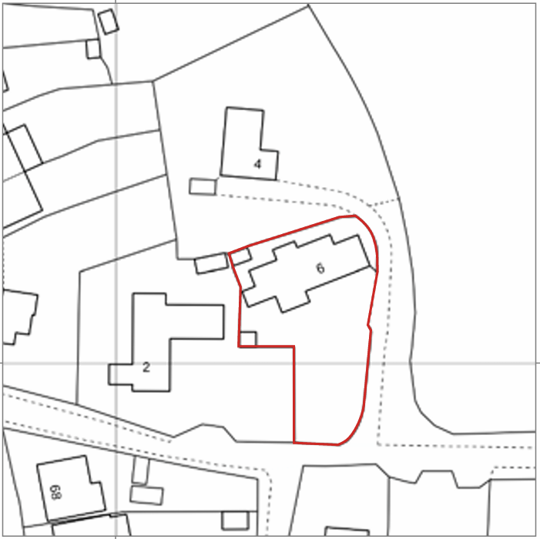

PROPOSAL

The application seeks permission for internal and external alterations to the dwelling. The primary element of the proposal is the replacement of the existing flat roof over the eastern garage and ancillary accommodation with a pitched roof, alongside internal reconfiguration to form an open plan kitchen and dining space. The former kitchen would be repurposed as a utility area. Other works include the replacement of the existing front porch with a modestly altered structure of similar footprint and scale. Following concerns raised during the application process, the originally proposed timber cladding has been removed and replaced with a materials schedule that broadly retains and extends the existing palette of the dwelling, including rendered and stone finishes.

SITE DESCRIPTION / CONTEXT

The application site comprises a detached bungalow located within the settlement of Keevil, forming part of the built-up area of this small village within the Melksham Community Area. The site lies within the Keevil Conservation Area (CA/W/119) and marks the edge of this designation, with development to the south characterised by a cohesive group of later 20th century dwellings of similar scale and appearance. The host dwelling is a modest bungalow constructed in a mix of modern materials including render and rubble stone-style elevations in a buff tone, with concrete tile roofing, white uPVC fenestration, and areas of weatherboarding. The property has been extended over time, with flat roof additions to both eastern and western sides, the eastern element forming a double garage. The surrounding character is typified by low-density development set within generous plots, with strong boundary treatments of hedgerows and trees and views across open countryside to the east. A Public Right of Way (KEEV29, Martins Lane) runs along the southern boundary. Immediately to the west, approximately 4.5 metres from the application site, lies Forge Cottage, a Grade II listed building dating from circa 1600. The listed building is a timber-framed cottage with brick infill and a Roman tile roof, of clear historic and architectural significance. The site lies within Flood Zone 1, with the Council’s Strategic Flood Risk Assessment identifying no surface water flood risk but noting a high potential for groundwater flooding due to shallow water table levels.

PLANNING HISTORY

Reference No. | Proposal / Summary | Decision
W/84/01155/FUL | Additional bedroom and garage | Approved with Conditions
W/02/01165/FUL | Single storey extension | Approved with Conditions

RELEVANT LEGISLATION, POLICIES AND GUIDANCE

Wiltshire Core Strategy:

Core Policy 1 Settlement Strategy;
Core Policy 2 Delivery Strategy;
Core Policy 15 Spatial Strategy: Melksham Community Area;
Core Policy 50 Biodiversity and Geodiversity;
Core Policy 51 Landscape;
Core Policy 57 Ensuring High-Quality Design and Place Shaping;
Core Policy 58 Ensuring Conservation of the Historic Environment;
Core Policy 60 Sustainable Transport;
Core Policy 61 Transport and Development;
Core Policy 64 Demand Management;
Core Policy 67 Flood Risk;

The National Planning Policy Framework (NPPF)

The Planning Practice Guidance (PPG)

Wiltshire Design Guide - Appendix D – Design Guidance for Householder extensions

The Wiltshire Local Transport Plan 2011 – 2026: Car Parking Strategy (March 2015).

The Wiltshire Local Transport Plan 4 (LTP4) (March 2025)

Emerging Policy – Wiltshire Local Plan Review

At Full Council on 19 May, the elected members of Wiltshire Council agreed to withdraw the emerging WLP. The said Plan has now been withdrawn and no material weight for the purposes of the application.

CONSULTATION RESPONSES

Keevil Parish Council – Objection
Insufficient information had been provided, particularly the absence of a Heritage Statement and clarity on materials, which limited their ability to fully assess the impact of the proposal within the conservation area.

Whilst the Parish Council requested reconsultation following submission of further heritage information, the amended plans and supporting Design and Access Statement have addressed the concerns raised, particularly through the removal of the proposed timber cladding. The changes do not introduce new or materially different impacts and therefore reconsultation is not considered necessary in this instance.

Conservation Officer (Wiltshire Council) – Objection
No objection to the pitched roof element, considering it an improvement, but objected to the use of timber cladding as uncharacteristic of the area and likely to result in less than substantial harm to the conservation area, a concern which has since been addressed through amended plans removing the cladding.

REPRESENTATIONS

No comments received.

ASSESSMENT

Section 38(6) of the Planning and Compulsory Purchase Act 2004 states:

"If regard is to be had to the development plan for the purposes of any determination to be made under the planning Acts, the determination must be made in accordance with the plan unless material considerations indicate otherwise."

In accordance with this statutory requirement, this application has been assessed against the relevant policies of the Development Plan, including the adopted Wiltshire Core Strategy (2015) and, where applicable, any made Neighbourhood Plans.

Householder extensions are generally acceptable in principle, as they typically fall within the established residential curtilage of a property and do not result in new residential development in the open countryside.

Design and Impact the upon the character and context of the area

Core Policy 57 Ensuring High Quality Design and Place Shaping of the Wiltshire Core Strategy requires all new development to achieve a high standard of design that responds positively to its local context. Proposals must reinforce and enhance local character and distinctiveness, relate appropriately to the surrounding landscape, and demonstrate a thoughtful response to existing townscape features. This includes careful consideration of elements such as building height, scale, massing, building line, materials, and overall appearance, ensuring new development integrates harmoniously with its setting.

The key design changes involve the introduction of a pitched roof to replace an existing flat roof and minor alterations to the front porch. The pitched roof is considered to represent a visual improvement, reducing the utilitarian appearance of the flat-roofed extension and better assimilating the building into its surroundings. Importantly, the initial concerns regarding timber cladding, which was not representative of the established material palette of either the conservation area or the adjacent listed building, have been addressed through amended plans. The revised materials strategy retains and extends the existing buff stone and render finishes, with limited and appropriate use of white cladding at high level. As such, the development now reflects local distinctiveness and preserves the character and appearance of the conservation area in accordance with Core Policy 57.

Having regard to the above, the proposal complies with the design principles set out in Core Policy 57 of the Wiltshire Core Strategy and Appendix D of the Wiltshire Design Guide.

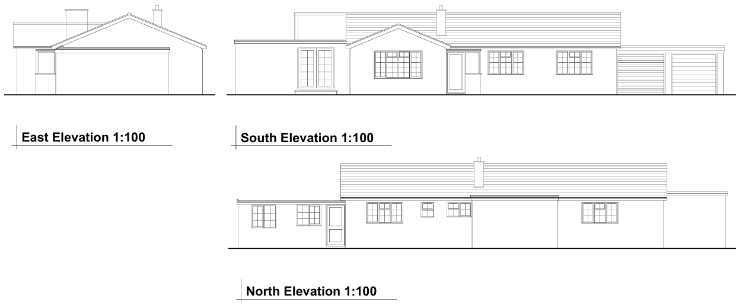
Existing Elevations

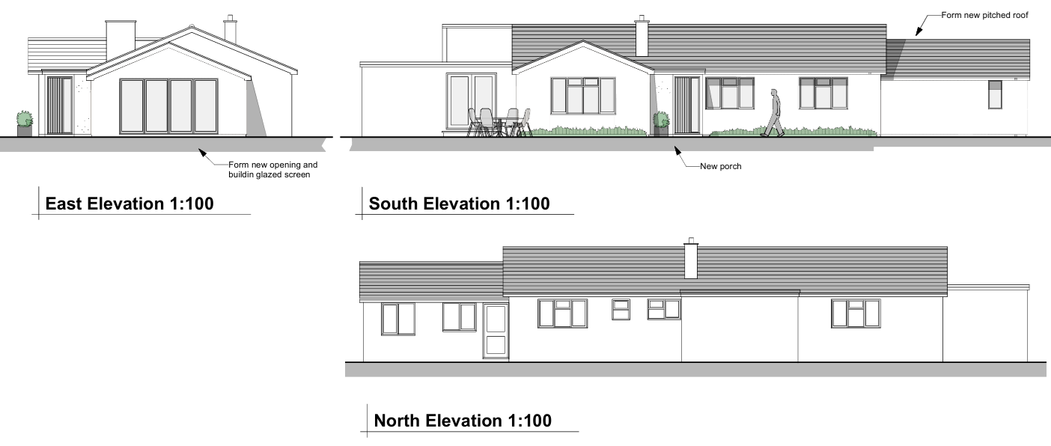
Proposed Elevations

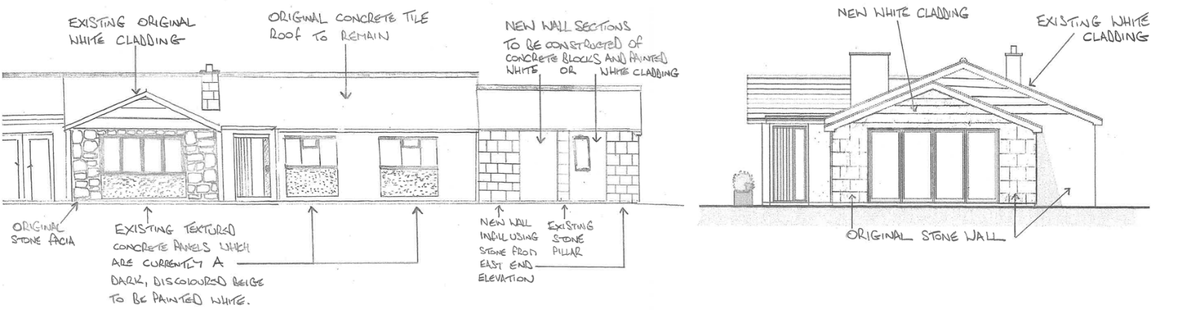
Materials Schedule East and North Elevations

Conservation and Heritage

Core Policy 58 outlines development consideration with regard to the historic environment. The policy states that heritage assets and their settings must be conserved and, where appropriate, enhanced through any proposed development.

The application site lies within the Keevil Conservation Area and approximately 4.5 metres to the east of Forge Cottage, a Grade II listed building. The proposal therefore engages the statutory duties under Sections 66 and 72 of the Planning (Listed Buildings and Conservation Areas) Act 1990.

The submitted Design and Access Statement explains that the works are intended to renovate and modernise a dwelling that has been vacant and in a deteriorated condition for several years. It confirms that the principal external alterations are located at the furthest point from the listed building and are considered to have an imperceptible effect on its setting, and that the material approach has been informed by the character of Martins Lane, where rendered finishes are a common feature.

In heritage terms, the proposal is modest. The introduction of a pitched roof in place of the existing flat roof is considered to be an aesthetic improvement that better reflects a conventional domestic form. Following amendments, the removal of timber cladding and retention of a palette of render and stone ensures that the development aligns with the host dwelling and surrounding properties, avoiding previously identified concerns.

Given the limited scale of the works, their siting away from Forge Cottage, and the use of appropriate materials, the proposal would preserve the setting of the listed building and the character and appearance of the conservation area. The proposal therefore results in no harm to designated heritage assets and accords with Core Policy 58 and the relevant provisions of the NPPF.

Amenity

Point vii of Core Policy 57 Ensuring High Quality Design and Place Shaping of the Wiltshire Core Strategy seeks to ensure that developments do not adversely affect neighbouring properties. The National Planning Policy Framework (NPPF), particularly Paragraph 135, stresses that planning decisions should ensure developments provide a high standard of amenity for existing and future users.

The proposal introduces no significant additional built form beyond the modest increase in roof height associated with the pitched roof and a minor porch alteration. The works are located such that they do not result in overlooking, loss of privacy, overshadowing or overbearing impacts upon neighbouring properties. Open aspects to the south and east further reduce any potential for harm. The proposal accords with Core Policy 57 in respect of residential amenity.

The proposal is appropriately sited, designed, and oriented to ensure that it would not result in unacceptable impact upon/to the amenities or living conditions of neighbouring residential occupiers, particularly in terms of outlook, privacy, or access to natural light.

The proposal therefore accords with Core Policy 57 point vii in respect of safeguarding residential amenity and Appendix D of the Wiltshire Design Guide.

Transport and Highways

Core Policy 60 of the WCS states that Council will support and encourage safe and efficient movement of people and, where necessary, mitigate the impact of development on transport users and local communities. Core Policy 61 specifies that development should demonstrate that consideration has been given to a hierarchy of transport users and that proposals must, where relevant, serve as a safe access to the highway network. Paragraph 116 of the NPPF states that “Development should only be prevented or refused on highways grounds if there would be an unacceptable impact on highway safety, or the residual cumulative impacts on the road network, following mitigation, would be severe, taking into account all reasonable future scenarios”. The WCS, through Core Policy 64, outlines the need for development to comply with a minimum level of parking standards.

The development does not result in additional bedrooms and therefore does not increase parking demand. Although the garage space is lost, sufficient off-street parking remains within the curtilage to meet policy requirements. The presence of the adjacent Public Right of Way is unaffected by the proposal.

Ecology

The WCS, through Core Policy 50, states that development proposals are expected to avoid and reduce disturbance of sensitive wildlife species and habitats. Biodiversity Net Gain (BNG) was established as a mandatory aspect of planning evaluation through Schedule 7A of the Town and Country Planning Act 1990 (as amended by the Environment Act 2021 Schedule 14).

Householder planning applications are exempt from the requirement to deliver Biodiversity Net Gain under Schedule 7A, Section 4(2)(a) of the Town and Country Planning Act 1990, as inserted by the Environment Act 2021. There are no identified ecological constraints, and the proposal does not involve an expansion of the building footprint. As such, no ecological impacts are anticipated, and it is overall considered acceptable.

Flooding and Drainage

Core Policy 67 Flood Risk of the Wiltshire Core Strategy requires all development to be located, designed, and constructed to minimise vulnerability to flooding and to avoid increasing flood risk elsewhere. Proposals must demonstrate that surface water can be managed safely and sustainably, incorporating appropriate drainage solutions—such as sustainable drainage systems (SuDS)—that ensure runoff rates and volumes do not exceed pre‑development levels. Development should provide measurable betterment where necessary, ensuring that drainage strategies are robust, technically compliant, and aligned with national policy. The NPPF sets out the application of a sequential, risk-based approach to the location of new development in paragraph 172.

The site lies within Flood Zone 1 and the proposal does not increase the impermeable area. Despite the noted groundwater risk, the development is minor in scale and does not give rise to additional flood risk concerns.

CONCLUSION

The proposed development, as amended, represents a modest and proportionate alteration to an existing dwelling that respects the character and appearance of the Keevil Conservation Area and preserves the setting of the adjacent Grade II listed building. The proposal raises no adverse impacts in respect of amenity, highways, ecology or flood risk. It is therefore in accordance with the relevant policies of the development plan and the NPPF.

RECOMMENDATION: That Planning Permission be GRANTED subject to the following conditions:

1.
The development hereby permitted shall be begun before the expiration of three years from the date of this permission.
REASON: To comply with the provisions of Section 91 of the Town and Country Planning Act 1990 as amended by the Planning and Compulsory Purchase Act 2004.

2.
The development hereby permitted shall be carried out in accordance with the following approved plans and documents:

Proposed Floor Plan, Elevations and Block Plan 1265/2 Rev 1
Location Plan (15 May 2026)

REASON: For the avoidance of doubt and in the interests of proper planning.

3.
The development hereby permitted shall be carried out in accordance with the approved plans and the details contained within the documents titled “South Elevation Materials Schedule” and “East Elevation Materials Schedule”, both received by the Local Planning Authority on 3rd July 2026. Notwithstanding the approved drawings, the external materials and finishes of the development shall be constructed strictly in accordance with these material schedule documents. No variation to the approved materials shall be made without the prior written consent of the Local Planning Authority.

REASON: The approved elevation drawings do not specify the external finishes of the development. This condition is required in the interests of visual amenity and to ensure the development preserves the character and appearance of the Keevil Conservation Area, in accordance with Core Policies 57 and 58 of the Wiltshire Core Strategy.

