COMPARELLI
John Comparelli Architect BA, AA Dip, MSc, ARB
Overhouse, The Avenue, Tisbury, Salisbury, Wiltshire, SP3 6JG
MOB: 07932 025 040 comparelli@btinternet.com www.comparelli.com

Design And Access Statement

For; Holly House
Ansty Coombe
Ansty, Wiltshire
SP3 5PZ

Date: 10.07.2026

Introduction
Holly House is a post war 1 ½ storey building in the Ansty Coombe conservation area. It is masonry built, rendered elevations with a clay tiled roof. It is situated in a garden of 1190m2.

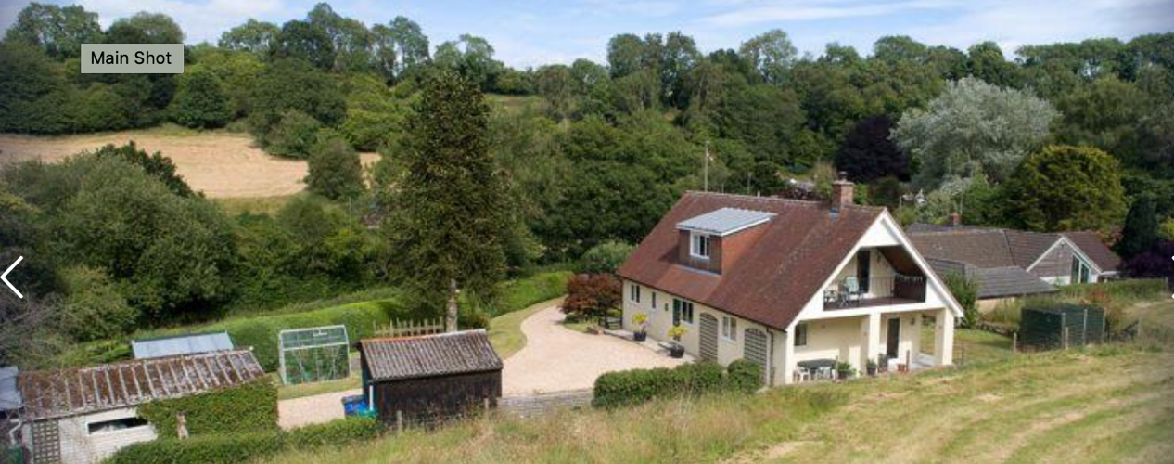

Figure 1 Rear elevation of Holly Hs
Showing out buildings to the left of image and balcony / terrace to the adjacent field

Proposal
This application proposes;
- Adding a 2 storey extension to the NE gable elevation
- Rotating and raising the roof at the SW end of the house
- Replacing the existing sheds and garage with a 1 ½ storey garage with ancillary accommodation over.

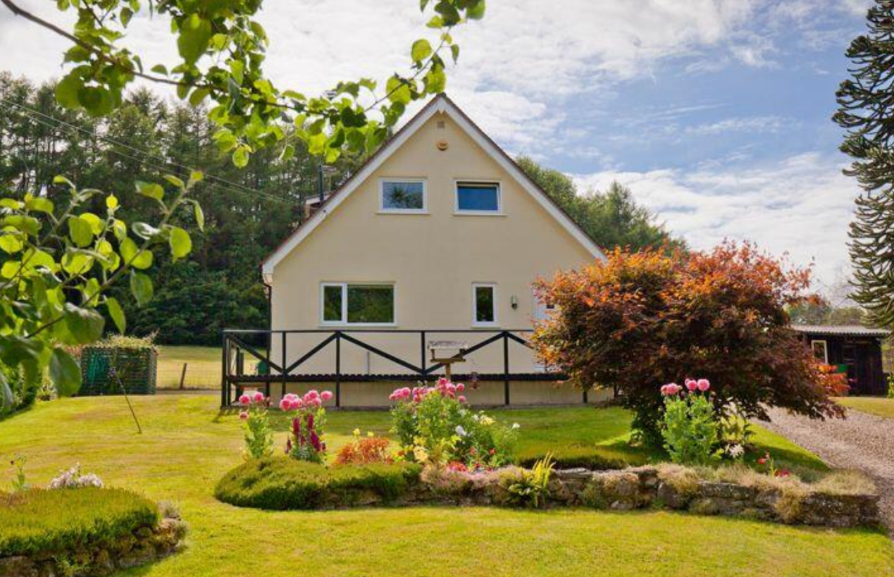

Figure 2
NE Gable elevation facing Ansty Coombe Lane and Site of proposed 2 Storey extension

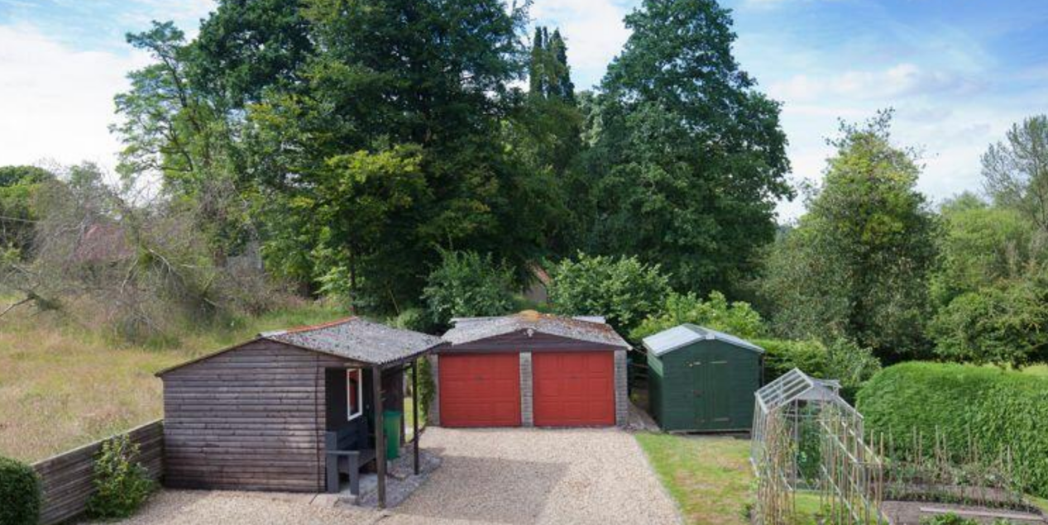

Figure 3
Existing Shed and site of proposed 3 bay garage with ancillary accommodation over

Amount
Gross Internal Area (GIA)

Existing House
GR FL 103.5m2 (exclusive of outbuildings)
1st FL 77.4m2 (exclusive of eaves storage)
Total 180.9m2

Proposed Extension
GR FL 32.1m2
1st FL 32.1m2
Total 64.2m2

Total Proposed Gross internal of House (exclusive of proposed 1 ½ storey garage)
180.9m2
+64.2m2
245.1m2
245.1m2/180.9m2 = house GIA increase = 35.5%

Proposed GIA 1 ½ storey garage with Ancillary accommodation over
18.0m2 GR FL (enclosed storage and stair lobby)
30.6m2 1st FL (exclusive of eaves storage)
48.6m2

Total Proposed GIA of dwelling inclusive of garage and house

245.1m2 house
48.6m2 garage / annex
293.7m2 total proposed GIA

Increase of dwelling GIA
293.7m2 proposed / 180.0m2 existing = dwelling 62.4% increase in GIA

Existing Foot print house
118.0m2

Existing Garage and Sheds foot print
41.3m2 garage
17.2m2 shed 1
7.5m2 shed 2
66.0m2 total out buildings

Existing Foot Print total
118.0m2 house
+66.0m2 out buildings
184.0m2

Proposed Footprint
118.0m2 existing house
37.8m2 proposed two storey extension
55.1m2 garage with accommodation over
210.9m2 total proposed footprint

210.9m2 / 184.0 m2 = 14.6% increase in foot print

Foot Print to Site 1190m2
Existing 184.0m2 = 15.5% Proposed 210.9m2 = 17.6% footprint increase of 2.1%

Layout House
The layout of the house remains traditional with more public space on the ground floor, the stairs central and the bedrooms located on the first floor.

Ground Floor; The kitchen will be moved further E into the new extension and will benefit from a proposed larder or pantry adjacent. The central entrance hall will be extended to provide more generous access to the kitchen to the NE, the dining and snug to the SE and the Sitting room to the SW.

First Floor; While the extra bedroom (bathroom and en suites) in the centre of the house will be constrained by the existing roof the bedrooms to either end of the house benefit from partially vaulted ceilings.

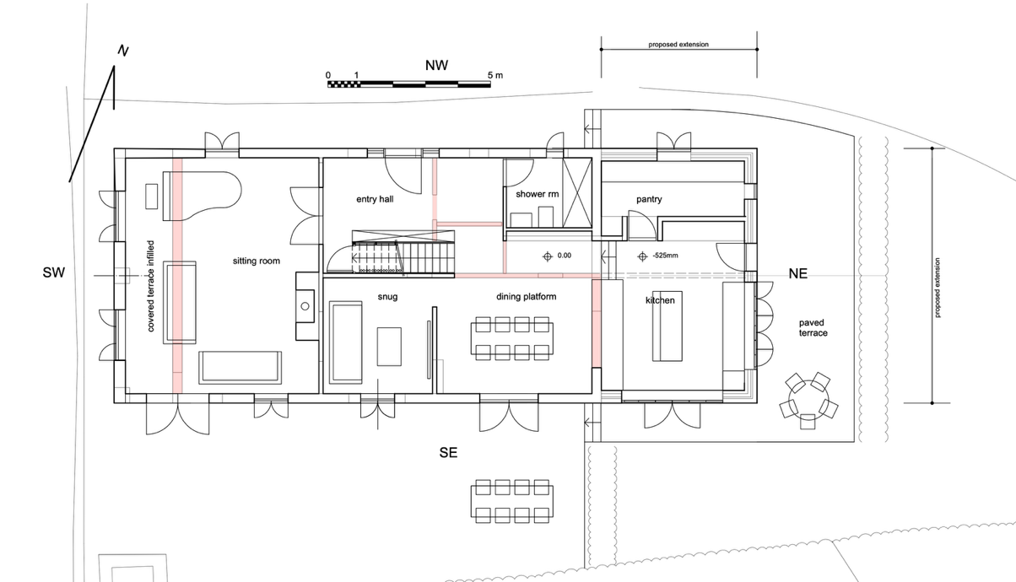
Figure 4. Proposed Gr FL Plan.

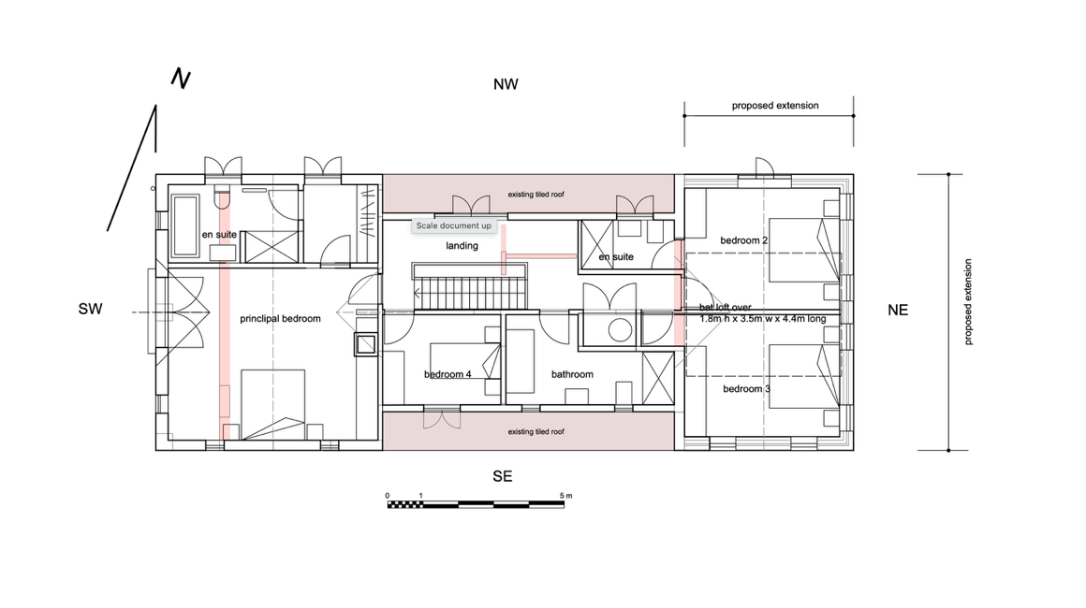
Figure 5. Proposed 1st FL Plan.

Layout Proposed Garage
The proposed 1 ½ storey garage with loft over will replace the existing garage and two garden sheds. It will be located in the same NW corner of the site and, with the removal of the southern most shed, will leave extra room in the drive for vehicles to safely turn within the property.

The 3 bay, timber frame garage will have two parking bays and one storage / access bay. This access bay houses a stair and WC to the open plan loft over.

Use
Holly House will remain a single family dwelling.

Scale
The proposed two storey extension together with the garage with accommodation over will increase the density on site by 2.1%.

By adding the 2 storey extension to the house and rotating and lifting the roof over the existing SW end of the house the roof ridges will increase 1.0m and 1.8mm respectively . This increase in ridge height will provide the first floor with useable space to the perimeter of the existing footprint. The central section of the roof and its ridge height will remain as existing.

The proposed extension (and roof line) takes advantage of the 2.25m slope across the footprint of the house with a 525mm drop in the FFL for the new extension. To mitigate the increase in scale of the extension from the lane the ridge of the extension is kept to 1.0m above the existing ridge.

To mitigate the possible overlooking into the adjoining property from the SE master bedroom gable windows sill levels have been raised to1500mm (5’) above the FFL.

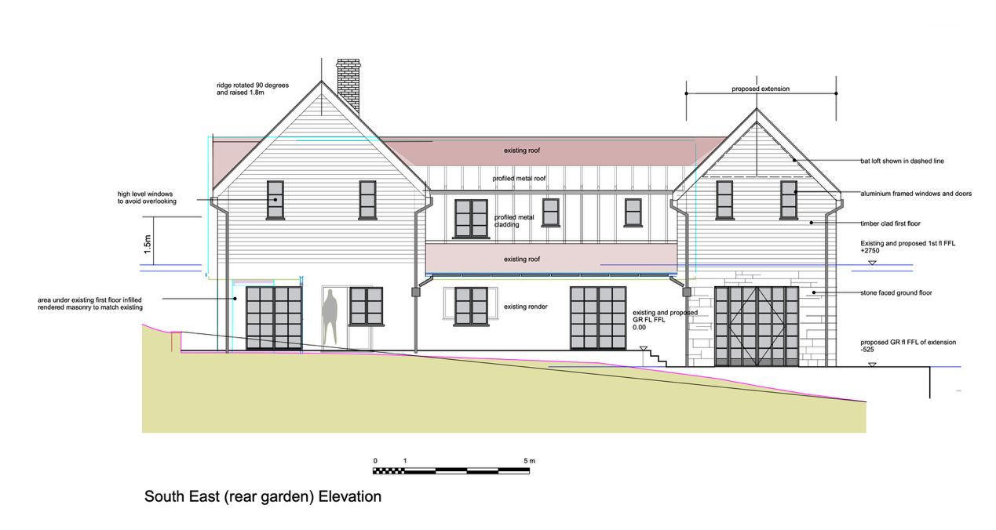
Figure 6 Proposed SE elevation

To mitigate the scale of the garage the eave has been kept to minimum height.

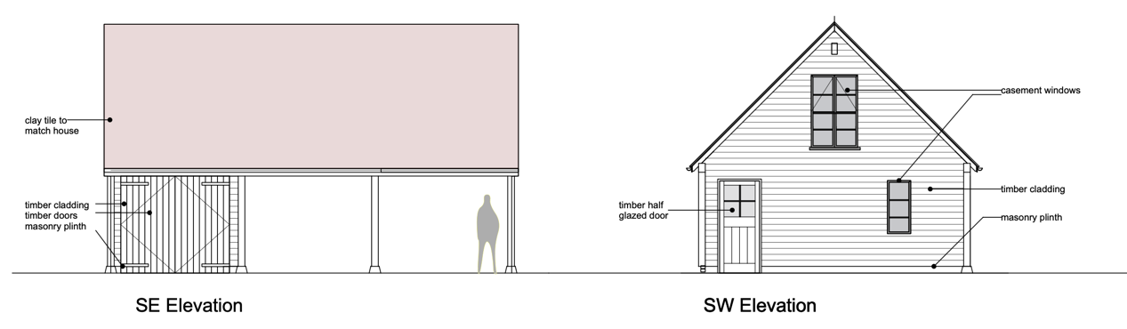
Figure 7. Proposed SE and SW Elevations of garage with loft over.

Landscaping
The garden will remain largely lawned. A terrace will be added adjacent the proposed 1 ½ storey extension to provide a level surface off the kitchen and ‘take out’ some of the site’s slope.

Appearance
The proposed extension will be faced in local stone on the ground floor and timber on the first floor. This choice of local materials will ground the building and enhance the view from the lane below. The roof will be covered in plain clay tiles to match the existing.

The rotated and raised roof at the SW end of the house will reuse the existing plain clay tiles while the new elevation under the eaves and gable will also be clad in timber. These two rotated sections of roof either end of the house will then ‘frame’ the remaining central section of roof and provide a picturesque and balanced outlook.

Access
Beyond a better parking arrangement with turning space at the top of the drive access to the property and house will remain unchanged.

End of Design and Access Statement

