APPLICATION FOR HOUSEHOLDER PLANNING PERMISSION
DELEGATED REPORT

APPLICATION REFERENCE: | PL/2026/03304
APPLICATION TYPE: | Householder planning permission
SITE ADDRESS: | Bibury, Lower Road, Erlestoke, Devizes, SN10 5UE
DEVELOPMENT DESCRIPTION: | Replace an existing blockwork garage with a wooden garage on the same footprint.
RECOMMENDATION: | That Planning Permission be GRANTED

PROPOSAL

The proposal seeks planning permission for the Replacement of an existing blockwork garage with a wooden garage on the same footprint at Bibury, Lower Road, Erlestoke, Devizes.

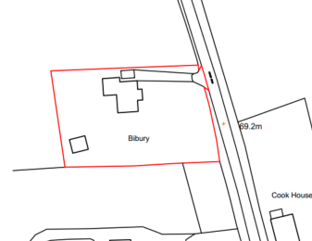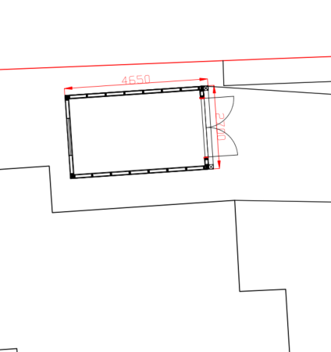

Site Location Plan and extract of proposed Block Plan

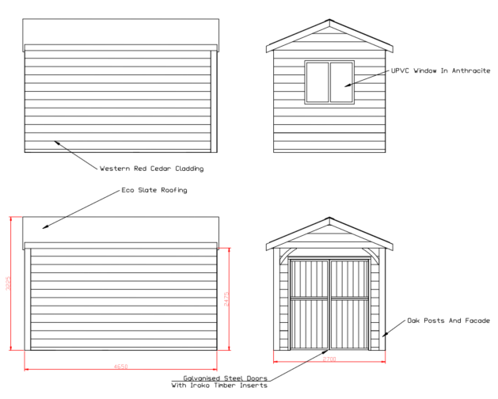

Proposed Elevations

The garage would be circa 4.6m long, 2.7m wide and 3.2m tall to ridge and finished with western red cedar cladding under a ‘eco slate’ roof.

SITE DESCRIPTION/CONTEXT

The existing building has virtually the same footprint (but is circa 14cm shorter) and is finished with rendered block work until a tiled roof. The structure is also substantially higher than the proposed replacement (at 4.2m high).

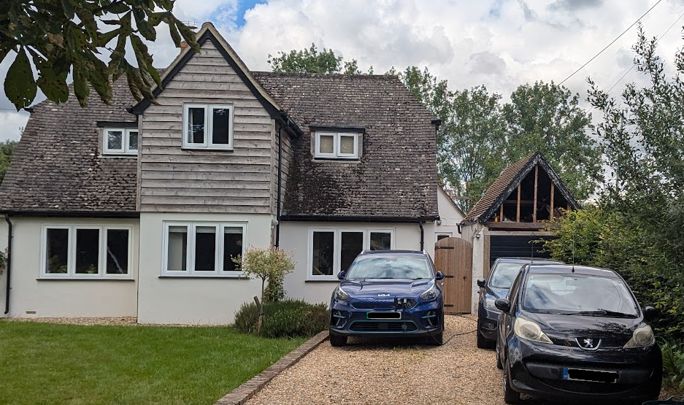

View from front gate onto the main road

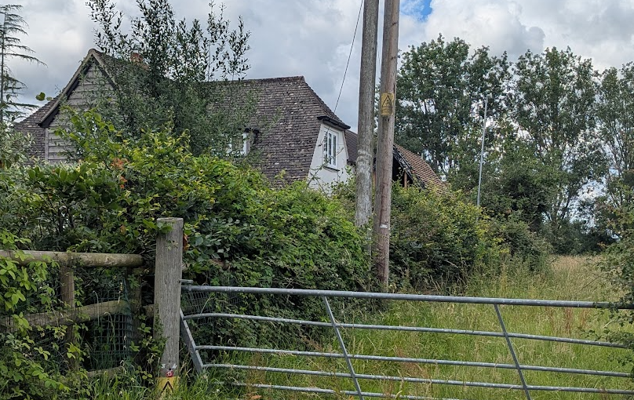

Front view with adjacent field/paddock in the open countryside

Erlestoke is defined as a small village in the Wiltshire Core Strategy (and does not have a limits of development boundary). Whilst the determination as to whether the site is within the built form of the village is not pertinent to the application, it is not considered that the application site is within the built area of the village but is circa 350m away.

The garage is on the northern boundary of the application site which looks out onto open countryside.

The application site is subject to the following planning policy constraints:

- Sailsbury SPA 6.4km buffer zone

The site is not subject to any ground or surface water flood risk, no landscape designations, no heritage constraints and no public rights of way pass near the site.

PLANNING HISTORY

Proposal / Summary
19/02379/FUL - Full planning permission Decision - Approve with Conditions Date: 28/5/2019 – Single storey rear extension and replacement of an existing flat roof with a pitched roof, balcony and solar PV panels.

RELEVANT POLICIES AND GUIDANCE

National Context:

The National Planning Policy Framework (NPPF)

The Planning Practice Guidance

Local Context:

Wiltshire Core Strategy:

- Core Policy 50: Biodiversity and Geodiversity
- Core Policy 57 Ensuring High Quality Design and Place Shaping

Erlestoke does not have a Neighbourhood Plan or area designation.

Wiltshire Design Guide: Appendix D – Design Guidance for Householder extensions

CONSULTATION RESPONSES

Erlestoke Parish Council: No comments received

REPRESENTATIONS
The application was advertised by 2 neighbour notification letters and a site notice erected on site allowing for 21 days of public consultation.

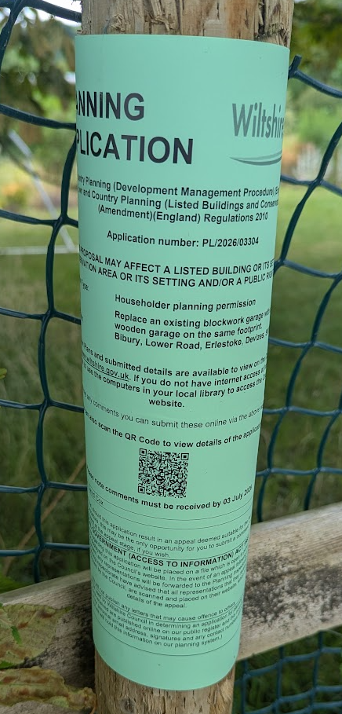

No comments were received.

ASSESSMENT

Section 38(6) of the Planning and Compulsory Purchase Act 2004 states:

"If regard is to be had to the development plan for the purposes of any determination to be made under the planning Acts, the determination must be made in accordance with the plan unless material considerations indicate otherwise."

In accordance with this statutory requirement, this application has been assessed against the relevant policies of the Development Plan, including the adopted Wiltshire Core Strategy (2015) and, where applicable, any made Neighbourhood Plans.

Design and Impact upon the upon the character and context of the area

Core Policy 57 - Ensuring High Quality Design and Place Shaping of the Wiltshire Core Strategy seeks to ensure that all new development is of high design quality, reflecting local context, character, and distinctiveness.

The proposal would represent a betterment than the existing structure by virtue of having less bulk and mass via the lower pitched roof. The timber cladding would mirror that on the projecting gable end on the main dwelling.

Having regard to the above, the proposal complies with the design principles set out in Core Policy 57 of the Wiltshire Core Strategy and Appendix D of the Wiltshire Design Guide.

Amenity

Point vii of Core Policy 57 - Ensuring High Quality Design and Place Shaping of the Wiltshire Core Strategy seeks to ensure that developments do not adversely affect neighbouring properties.

The National Planning Policy Framework (NPPF), particularly Paragraph 135(f), stresses that planning decisions should ensure developments provide a high standard of amenity for existing and future users.

The proposed development has been assessed in terms of its potential impact on the residential amenity of neighbouring properties, with particular regard to loss of light, overshadowing, loss of privacy, and overbearing effects.

No harm would arise to neighbouring amenity, as there are no neighbouring properties adjoining the northern boundary. Furthermore, the proposed development, by virtue of its lower ridge height, would result in an improvement over the approved scheme in this regard.

The proposal therefore accords with Core Policy 57 point vii in respect of safeguarding residential amenity and Appendix D of the Wiltshire Design Guide.

Highways Impact
Core Policy 57 (xiv) of the Wiltshire Core Strategy seeks to ensure that development must meet the requirements of Core Policy 61. This policy requires proposals to be capable of being served by safe access to the highway network. Core Policy 64 seeks to ensure compliance with parking standards set out in the Local Transport Plan.

The National Planning Policy Framework (NPPF), particularly Paragraph 115 and 116, requires that development proposals do not have an unacceptable impact on highway safety and that safe and suitable access to the site can be achieved for all users.

The proposed development would not result in any adverse impact on highway safety as no changes are proposed to the access or the length of the driveway which remains large enough for more than 3 cars to be parked. Therefore adequate parking and turning provision is provided in accordance with Wiltshire’s adopted parking standards, and access arrangements are acceptable.

The proposal is therefore considered to comply with Core Policies 57 (xiv), 61 and 64 of the Wiltshire Core Strategy, the NPPF, and the Wiltshire Local Transport Plan.

Ecology Impact

Core Policy 50 of the Wiltshire Core Strategy seeks to protect and enhance biodiversity and geodiversity, including through ensuring that development avoids harm to protected species and habitats.

The National Planning Policy Framework (NPPF), in Paragraphs 193, requires that development minimises impacts on and provides net gains for biodiversity, including ensuring mitigation is secured where harm cannot be avoided.

The Council’s Ecology Officer has not been consulted on this application, but the application site is within the 6.4km zone of influence of the Salisbury Plain SPA and in light of the HRA for the Wiltshire Core Strategy and the HRA for the Wiltshire Housing Site Allocations Plan it is screened into Appropriate Assessment due to the potential impact of recreational pressure on stone curlew in combination with other plans and projects.

A strategic Appropriate Assessment (AA) has been prepared pertaining to development within the 6.4 km zone of influence that could result in a likely significant effect on the SPA as a result of an increase in recreational / visitor pressure. The AA reached a conclusion of no adverse effects on the integrity of the SPA or its qualifying features provided that the council’s mitigation strategy continues to be implemented. Annual stone curlew monitoring and protection measures continue to be secured by the Council.

In January 2026 Natural England (NE) confirmed that the 2025 strategic AA for Salisbury Plain SPA continues to be supported by NE.

As such, the development complies with Core Policy 50 of the Wiltshire Core Strategy and the relevant provisions of the NPPF.

Biodiversity Net Gain

Householder planning applications are exempt from the requirement to deliver Biodiversity Net Gain under Schedule 7A, Section 4(2)(a) of the Town and Country Planning Act 1990, as inserted by the Environment Act 2021.

CONCLUSION

The proposed development is considered to be acceptable in terms of its design, scale, and relationship with the surrounding area. It would not result in any unacceptable harm to the character of the locality, the amenities of neighbouring occupiers, or the interests of highway safety, heritage, or ecology.

The proposal is therefore considered to comply with the relevant policies of the Wiltshire Core Strategy, the Wiltshire Local Plan, and the National Planning Policy Framework. As such, the application is recommended for approval, subject to the conditions set out below.

RECOMMENDATION: That Planning Permission be GRANTED subject to conditions.

