APPLICATION FOR HOUSEHOLDER PLANNING PERMISSION
DELEGATED REPORT

APPLICATION REFERENCE: | PL/2026/03604
APPLICATION TYPE: | Householder Planning Permission
SITE ADDRESS: | Charlton Manor, Charlton St Peter, Pewsey, SN9 6EU
DEVELOPMENT DESCRIPTION: | Revamp Your Tank Scheme - replacement of septic tank with a treatment plant
RECOMMENDATION: | That Planning Permission be GRANTED

PROPOSAL

The application is seeking approval for the replacement of an existing non-mains sewerage system with a new sewage treatment plant. This development would include the installation of associated equipment such as pipes and cables.

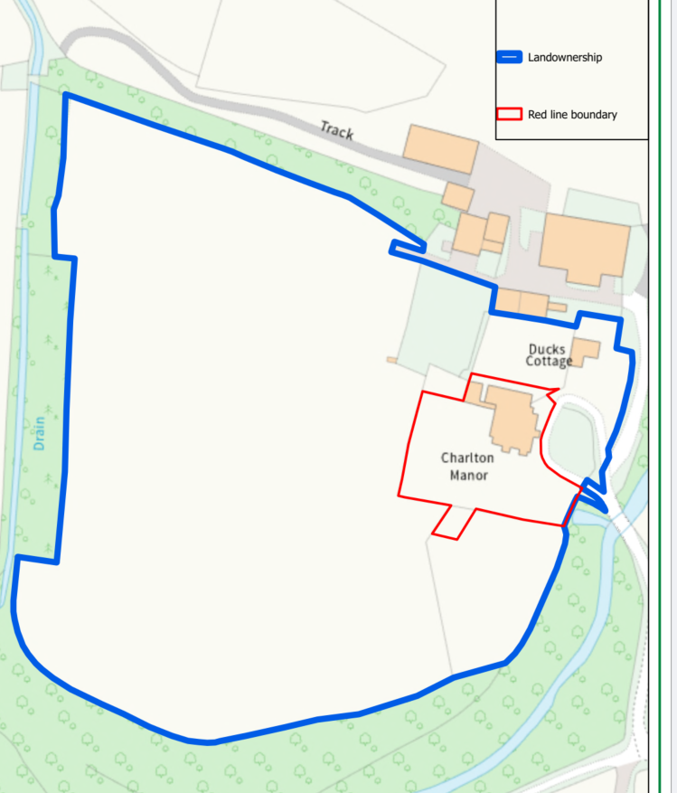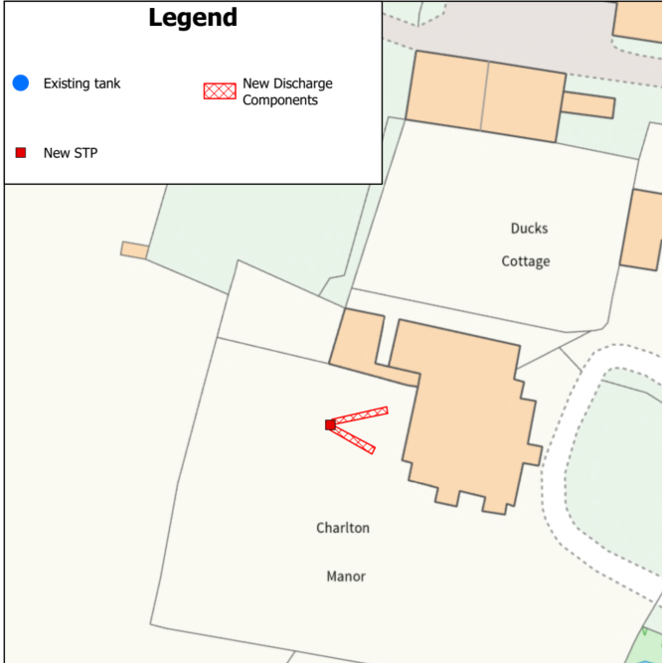

Site Location and Proposed Site Plan

SITE DESCRIPTION / CONTEXT

The application site is comprised of a detached two storey Manor House and associated residential curtilage in the small village of Charlton St Peter. The Manor has a good-sized residential curtilage (the red outline) which is enclosed from the surrounding countryside (within the blue outline) by trees and hedgerow.

The application site is subject to the following planning policy constraints:

- Charlton St Peter (small village) no settlement boundary
- Charlton Manor is a Grade II listed building
- The site is within the Charlton conservation area
- The site is within the Salisbury Plain Special Protection Area 6.4km buffer
- The site is within the Hampshire River Avon Catchment zone
- The site is also within a Great Crested Newt Amber risk zone
- The site is within the North Wessex Downs National Landscape
- Whilst part of the site is within flood zone 2 (the eastern side near the river) the proposed drainage area is within flood zone 1
- Ground water levels are between 0.5m and 5m below the surface (therefore low risk)
- There is no surface water or Climate change impact on surface water flood risk
- The site is not within a ground water source protection zone

PLANNING HISTORY

No relevant planning history has been identified for the site subject of this application.

RELEVANT LEGISLATION, POLICIES AND GUIDANCE

National Context:

The National Planning Policy Framework (NPPF)

The NPPF outlines government policy for planning. Chapter 16 of the NPPF 'Conserving and enhancing the historic environment' sets out the Government's high-level policies concerning heritage and sustainable development.

The Planning Practice Guidance

From the point of view of the historic environment the main statutory tests are set out within the Planning (Listed Building and Conservation Areas) Act 1990.

Section 66 requires that special regard be given to the desirability of preserving listed buildings, their settings or any features of special architectural or historic interest which they possess.

Section 72(1) of the Act requires the Council to pay special attention to the desirability of preserving or enhancing the character or appearance of designated Conservation Areas.

Local Context:

The adopted Wiltshire Core Strategy (WCS), with particular regard to:

- Core Policy 1 Settlement Strategy;
- Core Policy 2 Delivery Strategy;
- Core Policy 18 Spatial Strategy for Pewsey Community Area
- Core Policy 50 Biodiversity and Geodiversity;
- Core Policy 51 Landscape
- Core Policy 57 Ensuring High Quality Design and Place Shaping;
- Core Policy 58 Ensuring the Conservation of the Historic Environment;
- Core Policy 67 Flood Risk;
- Core Policy 69: Protection of the River Avon SAC

The Council’s Core Strategy Policy CP58 ‘Ensuring the conservation of the historic environment’ requires that designated and non-designated heritage assets and their settings will be conserved, and where appropriate enhanced, in a manner appropriate to their significance and encourages proposals which improve the condition of heritage assets at risk.

The Council’s Core Strategy CP 57: Ensuring high quality design requires a high quality of design in all new developments. The policy requires applicants to “demonstrate how the proposal will make a positive contribution to the character of Wiltshire through (amongst other things) responding to the value of the natural and historic environment and being sympathetic to and conserving historic buildings and landscapes. Development is required to respond positively to the existing in terms of building layouts, built form, height, mass, scale, building line, plot size, elevational design, materials, streetscape and rooflines to effectively integrate the building into its setting.

Wiltshire Council Strategic Flood Risk Assessments 2019 and 2024

Charlton and Wilsford do not have a Neighbourhood Plan or area designation

CONSULTATION RESPONSES

Charlton and Wilsford Parish Council: No comments received

WC Drainage Officer: - No comments received

Environment Agency: No comment to make – inappropriate consultation

REPRESENTATIONS

No comments were received.

ASSESSMENT

Section 38(6) of the Planning and Compulsory Purchase Act 2004 states:

"If regard is to be had to the development plan for the purposes of any determination to be made under the planning Acts, the determination must be made in accordance with the plan unless material considerations indicate otherwise."

In accordance with this statutory requirement, this application has been assessed against the relevant policies of the Development Plan, including the adopted Wiltshire Core Strategy (2015) and, where applicable, any made Neighbourhood Plans.

The application proposes the replacement of an existing non-mains drainage system within a residential property. The nature and scale of the works are considered acceptable in principle, and the proposal will be assessed in further detail throughout the remainder of this report.

Flooding and Drainage

Core Policy 67 of the Wiltshire Core Strategy sets out the approach to managing flood risk, supported by paragraph 172 of the NPPF, which requires a sequential, risk-based strategy for locating development. Part of the red outline of the application site lies within Flood Zone 2, indicating a medium to high probability of fluvial flooding. In such areas, development must demonstrate that flood risk has been appropriately assessed and mitigated. However, the proposed treatment plant would be in an area that is within flood zone 1 and the applicants have not submitted a Flood Risk Assessment (FRA).

Paragraph 176 of the NPPF confirms that householder development under 250m² is exempt from the sequential and exception tests. As such, the proposal is considered acceptable in this regard. The works involve minor upgrades to existing infrastructure, with no increase in impermeable surface area.

With regards to drainage and potential pollution impacts, and with ground water levels being potentially 5m below ground the proposal represents the replacement of an existing non-mains drainage system rather than the introduction of a new drainage system. The underlying drainage principle remains unchanged, and the existing system appears to operate satisfactorily. There is no evidence to suggest that the replacement plant would perform less effectively or give rise to unacceptable impacts. Accordingly, it is reasonable to conclude that the proposal would have no material adverse effects in terms of drainage, flood risk or contamination.

Therefore, the development is considered to comply with Core Policy 67 and the relevant provisions of the NPPF.

Design and Impact upon the upon the character and context of the area

Core Policy 57 - Ensuring High Quality Design and Place Shaping of the Wiltshire Core Strategy seeks to ensure that all new development is of high design quality, reflecting local context, character, and distinctiveness.

The development is to replace an underground sewerage system. Although the development works would involve excavation, the completed works would essentially be hidden and would therefore result in no identified harm to the appearance of the site or its locality.

Having regard to the above, the proposal complies with the design principles set out in Core Policy 57 of the Wiltshire Core Strategy and Appendix D of the Wiltshire Design Guide.

Heritage Impact

Given its modest scale, predominantly underground location, and purely functional appearance, the proposed replacement treatment plant would preserve both the character and appearance of the conservation area and the setting of the listed building. The development would not result in harm to the significance of either designated or non-designated heritage assets.

Although there would be short-term disturbance associated with excavation and installation works, these effects would be temporary in nature. Once the works are completed and the ground has been reinstated, the majority of the development would remain concealed below ground level. The only visible element would be the access cover, which would be limited in scale and readily assimilated within the garden setting. As such, the proposal would have a negligible visual presence and would not adversely affect the appreciation or significance of the surrounding heritage assets.

Accordingly, the proposal is considered to preserve the character and appearance of the conservation area and the setting of the listed building. The development therefore accords with Core Policy 58 of the Wiltshire Core Strategy, Sections 66 and 72 of the Planning (Listed Buildings and Conservation Areas) Act 1990, and the relevant heritage policies of the National Planning Policy Framework.

Impact on the National Landscape

Core Policy 51 of the Wiltshire Core Strategy requires all development to protect, conserve, and where possible enhance the character and quality of Wiltshire’s landscapes, giving particular weight to designated areas such as National Landscapes.

The National Planning Policy Framework (NPPF), in Paragraph 176, states that “great weight” should be given to conserving and enhancing landscape and scenic beauty in National Landscapes (formerly Areas of Outstanding Natural Beauty). Development within or affecting the setting of a National Landscape must demonstrate that it will not result in unacceptable harm to the special qualities of that area.

Given the minimal scale, underground siting, and functional nature of the proposed replacement sewage treatment plant, the development would not harm the special qualities or scenic character of the North Wessex Downs National Landscape.

The development therefore complies with Core Policy 51 of the Wiltshire Core Strategy and Paragraph 176 of the NPPF in conserving and enhancing the National Landscape.

Amenity

Point vii of Core Policy 57 - Ensuring High Quality Design and Place Shaping of the Wiltshire Core Strategy seeks to ensure that developments do not adversely affect neighbouring properties.

The National Planning Policy Framework (NPPF), particularly Paragraph 135, stresses that planning decisions should ensure developments provide a high standard of amenity for existing and future users.

No amenity concerns are identified, as the proposed upgrade would be contained within the property curtilage and would not result in any visual or overbearing impact. The system is appropriately sited, designed, and oriented to avoid any unacceptable effects on neighbouring residential amenity, including outlook, privacy, and access to natural light.

The proposal therefore accords with Core Policy 57 point vii in respect of safeguarding residential amenity and Appendix D of the Wiltshire Design Guide.

Ecology

Protected species

Core Policy 50 of the Wiltshire Core Strategy seeks to ensure that development protects, conserves and where possible enhances biodiversity, whilst avoiding and minimising impacts on protected habitats and species.

The proposal comprises the replacement of an existing non-mains drainage system with a sewage treatment plant within the established residential curtilage of Charlton Manor. The works would take place within an area that is already subject to domestic activity and would not result in the loss of habitat or features likely to support protected species. Given the scale and nature of the proposal, it is unlikely that the development would result in harm to protected species or significant ecological interests.

Accordingly, the proposal is considered to accord with Core Policy 50 of the Wiltshire Core Strategy.

River Avon SAC

The application site lies within the Hampshire River Avon catchment and Core Policy 69 of the Wiltshire Core Strategy is therefore relevant. Core Policy 69 seeks to ensure that development does not adversely affect the integrity of the River Avon Special Area of Conservation (SAC) through increased nutrient loading, pollution or other harmful effects.

The proposal does not involve the creation of additional residential accommodation or any intensification of the existing lawful use of the site. Consequently, there would be no increase in foul water generation arising from the development. The proposal instead seeks to replace an existing non-mains drainage system with a modern sewage treatment plant serving the same dwelling.

The replacement system would continue to serve the existing dwelling only and would not increase nutrient loading when compared with the existing situation. Furthermore, modern sewage treatment plants are designed to provide an improved standard of treatment over traditional septic tank systems, resulting in improved effluent quality prior to discharge. In the absence of evidence to the contrary, it is reasonable to conclude that the proposal would not give rise to adverse effects on the integrity of the River Avon SAC.

Any future modification to the proposed system must maintain or enhance phosphorus removal efficiency, and conditions should be imposed to secure this requirement as part of any approval.

Sailsbury Plain SPA

The site lies within the 6.4km zone of influence of the Salisbury Plain SPA. However, the proposal relates solely to the replacement of existing foul drainage infrastructure serving the existing dwelling and does not involve the creation of new residential accommodation or any increase in occupancy. The development would therefore not be expected to increase recreational pressure on the SPA and no adverse effects on its integrity are identified.

BNG

Biodiversity Net Gain (BNG) became a statutory requirement under Schedule 7A of the Town and Country Planning Act 1990, as amended by Schedule 14 of the Environment Act 2021. However, householder applications are exempt from this requirement under Section 4(2)(a) of Schedule 7A.

CONCLUSION

The proposal represents a small-scale upgrade to existing non-mains drainage infrastructure serving an existing dwelling. Subject to the recommended conditions, the development would not result in unacceptable impacts upon heritage assets, landscape character, flood risk, residential amenity or ecological interests and would accord with the relevant policies of the Wiltshire Core Strategy and the National Planning Policy Framework.

RECOMMENDATION: That Planning Permission be GRANTED subject to conditions.

