APPLICATION FOR HOUSEHOLDER PLANNING PERMISSION
DELEGATED REPORT

APPLICATION REFERENCE: | PL/2026/03508
APPLICATION TYPE: | Householder Planning Permission
SITE ADDRESS: | 1 & 2 Field Cottages, Manningford Bruce, Pewsey, SN9 6HU
DEVELOPMENT DESCRIPTION: | Revamp Your Tank Scheme - replacement of septic tank with a treatment plant
RECOMMENDATION: | That Planning Permission be GRANTED

PROPOSAL

The application is seeking approval for the replacement of an existing non-mains sewerage system with a new sewage treatment plant. This development would include the installation of associated equipment such as pipes and cables.

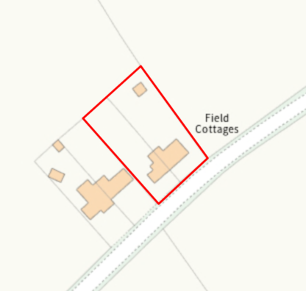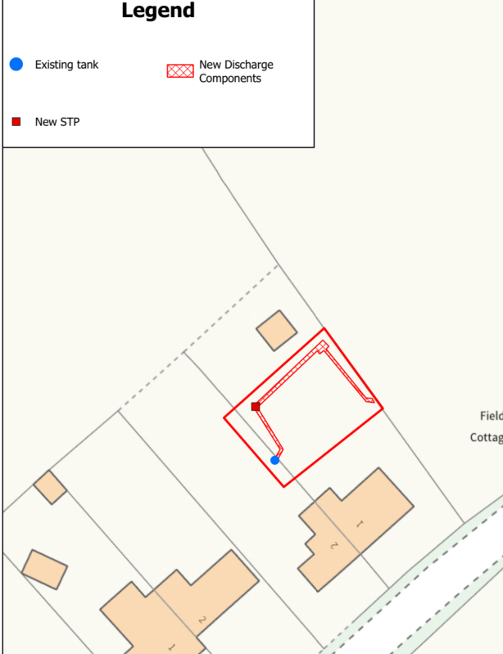

Site Location Plan and Extract from Proposed Site Plan

SITE DESCRIPTION / CONTEXT

No 1 and 2 Field Cottages are a two storey semi-detached pair of dwellings located in a rural area immediately off the A345. There is only one other semi-detached pair immediately adjacent with further development scattered along the A345. No’s 1 & 2 benefit from reasonably deep rear gardens.

The application site is subject to the following planning policy constraints:

- The site is within the Salisbury Plain Special Protection Area 6.4km buffer
- The site is within the Hampshire River Avon Catchment zone
- The site is within the North Wessex Downs National Landscape
- The site is within flood zone 1
- Ground water levels are between 0.025 and 0.5m below the surface (therefore high risk)
- There is no surface water or Climate change impact on surface water flood risk
- The site is not within a ground water source protection zone

PLANNING HISTORY

No relevant planning history has been identified for the site subject of this application.

RELEVANT LEGILSATION, POLICIES AND GUIDANCE

National Context:

The National Planning Policy Framework (NPPF)

The Planning Practice Guidance

Local Context:

The adopted Wiltshire Core Strategy (WCS), with particular regard to:

- Core Policy 1 Settlement Strategy;
- Core Policy 2 Delivery Strategy;
- Core Policy 18 Spatial Strategy Pewsey Community Area
- Core Policy 50 Biodiversity and Geodiversity;
- Core Policy 51 Landscape
- Core Policy 57 Ensuring High Quality Design and Place Shaping;
- Core Policy 58 Ensuring the Conservation of the Historic Environment;
- Core Policy 67 Flood Risk;
- Core Policy 69 Protection of the River Avon SAC

Manningford does not have a Neighbourhood Plan or Area Designation

Wiltshire Design Guide: Appendix D – Design Guidance for Householder extensions

CONSULTATION RESPONSES

Manningford Parish Council: No objection

WC Drainage Officer: No comments received

Environment Agency: No comment to make - inappropriate consultation

REPRESENTATIONS

No comments were received.

ASSESSMENT

Section 38(6) of the Planning and Compulsory Purchase Act 2004 states:

"If regard is to be had to the development plan for the purposes of any determination to be made under the planning Acts, the determination must be made in accordance with the plan unless material considerations indicate otherwise."

In accordance with this statutory requirement, this application has been assessed against the relevant policies of the Development Plan, including the adopted Wiltshire Core Strategy (2015) and, where applicable, any made Neighbourhood Plans.

The application proposes the replacement of existing sewerage equipment within a residential property. The nature and scale of the works are considered acceptable in principle, and the proposal will be assessed in further detail throughout the remainder of this report.

Flooding and Drainage

Core Policy 67 of the Wiltshire Core Strategy sets out the approach to managing flood risk, whilst paragraph 172 of the National Planning Policy Framework (NPPF) requires a sequential, risk-based approach to the location of development. The site is located within Flood Zone 1, which represents the lowest probability of fluvial flooding, thereby meaning the sequential test does not need to be applied.

Officers acknowledge that the site is identified as having potential groundwater emergence at depths of between 0.025m and 0.5m below ground level. However, there is no recorded history of surface water flooding at the site, and it is understood that the proposal will continue to utilise the existing drainage infrastructure, which appears to be operating effectively and without issue. Whilst the site may therefore be susceptible to groundwater flood risk, there is no evidence to suggest that the proposed development would perform any differently from the existing arrangement.

The proposal comprises the replacement of existing sewerage equipment on a like-for-like basis and is not expected to alter the site's drainage characteristics or increase flood risk. Accordingly, no objections are raised on flood risk grounds.

Core Policy 50: Biodiversity and Geodiversity requires development to safeguard ecological and geological interests, ensuring long-term protection and functionality. Additionally, Core Policy 69: Protection of the River Avon SAC emphasises the need to avoid pollution and mitigate disturbance to the SAC through appropriate design and operational measures. Any future modification to the proposed system must maintain or enhance phosphorus removal efficiency, and conditions should be imposed to secure this requirement as part of any approval.

Design and Impact upon the upon the character and context of the area

Core Policy 57 - Ensuring High Quality Design and Place Shaping of the Wiltshire Core Strategy seeks to ensure that all new development is of high design quality, reflecting local context, character, and distinctiveness.

The development is to replace an underground sewerage system. Although the development works would involve excavation, the completed works would essentially be hidden and would therefore result in no identified harm to the appearance of the site or its locality.

Having regard to the above, the proposal complies with the design principles set out in Core Policy 57 of the Wiltshire Core Strategy and Appendix D of the Wiltshire Design Guide.

Impact on the National Landscape

Core Policy 51 of the Wiltshire Core Strategy requires all development to protect, conserve, and where possible enhance the character and quality of Wiltshire’s landscapes, giving particular weight to designated areas such as National Landscapes.

The National Planning Policy Framework (NPPF), in Paragraph 176, states that “great weight” should be given to conserving and enhancing landscape and scenic beauty in National Landscapes (formerly Areas of Outstanding Natural Beauty). Development within or affecting the setting of a National Landscape must demonstrate that it will not result in unacceptable harm to the special qualities of that area.

Given the minimal scale, underground siting, and functional nature of the proposed septic tank, the development would not harm the special qualities or scenic character of the North Wessex Downs National Landscape.

The development therefore complies with Core Policy 51 of the Wiltshire Core Strategy and Paragraph 176 of the NPPF in conserving and enhancing the National Landscape.

Amenity

Point vii of Core Policy 57 - Ensuring High Quality Design and Place Shaping of the Wiltshire Core Strategy seeks to ensure that developments do not adversely affect neighbouring properties.

The National Planning Policy Framework (NPPF), particularly Paragraph 135, stresses that planning decisions should ensure developments provide a high standard of amenity for existing and future users.

No amenity concerns are identified, as the proposed upgrade would be contained within the property curtilage and would not result in any visual or overbearing impact. The system is appropriately sited, designed, and oriented to avoid any unacceptable effects on neighbouring residential amenity, including outlook, privacy, and access to natural light.

The proposal therefore accords with Core Policy 57 point vii in respect of safeguarding residential amenity and Appendix D of the Wiltshire Design Guide.

Ecology

Core Policy 50 of the WCS requires development to avoid and minimise disturbance to sensitive habitats and species.

The proposed development involves a like-for-like replacement of residential equipment within existing curtilage, an area already subject to development. It is therefore unlikely to impact sensitive habitats or species. Furthermore, the updated drainage system retains the existing discharge method while improving nutrient filtration, resulting in a neutral to positive environmental outcome. The proposal is considered to comply with Core Policy 50 and is acceptable in this regard.

The application site is within the 6.4km zone of influence of the Salisbury Plain SPA and in light of the HRA for the Wiltshire Core Strategy and the HRA for the Wiltshire Housing Site Allocations Plan it is screened into Appropriate Assessment due to the potential impact of recreational pressure on stone curlew in combination with other plans and projects.

A strategic Appropriate Assessment (AA) has been prepared pertaining to development within the 6.4 km zone of influence that could result in a likely significant effect on the SPA as a result of an increase in recreational / visitor pressure. The AA reached a conclusion of no adverse effects on the integrity of the SPA or its qualifying features provided that the council’s mitigation strategy continues to be implemented. Annual stone curlew monitoring and protection measures continue to be secured by the Council.

In January 2026 Natural England (NE) confirmed that the 2025 strategic AA for Salisbury Plain SPA continues to be supported by NE.

Biodiversity Net Gain (BNG) became a statutory requirement under Schedule 7A of the Town and Country Planning Act 1990, as amended by Schedule 14 of the Environment Act 2021. However, householder applications are exempt from this requirement under Section 4(2)(a) of Schedule 7A.

CONCLUSION

The proposal is considered to comply with the relevant policies of the Wiltshire Core Strategy and the National Planning Policy Framework. As such, the application is recommended for approval, subject to the conditions set out below.

RECOMMENDATION: That Planning Permission be GRANTED subject to conditions:

