APPLICATION FOR HOUSEHOLDER PLANNING PERMISSION
DELEGATED REPORT

APPLICATION REFERENCE: | PL/2026/02191
APPLICATION TYPE: | Householder Planning Permission
SITE ADDRESS: | 22 Woods Hill, Limpley Stoke, Bath, BA2 7GA
DEVELOPMENT DESCRIPTION: | Proposed extension and associated internal alterations to family dwelling. Proposed demolition of existing garage and extension of roof of existing outbuilding to form open sided car port.
RECOMMENDATION: | That Planning Permission be GRANTED

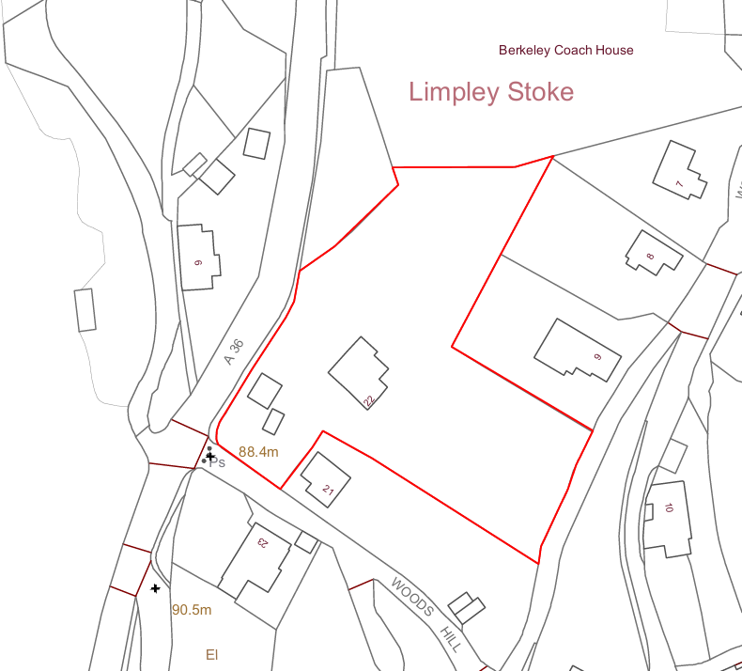
PROPOSAL

The application seeks full planning permission for the demolition of an existing two-storey infill extension and its replacement with a new, slightly larger two-storey side extension to the host dwelling. The proposal would provide a covered porch at lower ground floor level and reconfigure the ground floor to form an enlarged open-plan kitchen and dining area, including the raising of an existing split-level floor. The extension would be constructed with a green oak frame with extensive sliding glazing set on a stone plinth, and finished with a low-pitched standing seam zinc roof and metal rainwater goods. Associated works include the modest enlargement and raising of a decked platform linking the internal spaces with the garden, and the reopening of a previously blocked window at landing level. In addition, the application proposes alterations to existing outbuildings within the parking courtyard, including the demolition of one small garage and the extension of the remaining building to form an open-sided oak-framed car port with a pitched roof to match the existing structure.

SITE DESCRIPTION / CONTEXT

The application site relates to a detached early 20th century dwelling positioned on the steeply sloping hillside of Woods Hill within the rural settlement of Limpley Stoke. The property occupies an elevated position, set back from the road and accessed via a private drive and stepped approach, with associated outbuildings located closer to the highway. Owing to the pronounced topography, the dwelling presents as two storeys from the uphill (northwest) elevation and three storeys from the downhill (southeast) aspect, and benefits from expansive views across the adjacent valley. The surrounding area is characterised by a dispersed pattern of residential development set within a heavily treed landscape, contributing to its rural and scenic qualities. The site lies within the Green Belt and the Cotswolds National Landscape, and is subject to several ecological buffer designations, whilst also being in Flood Zone 1 with no identified flood risk. The nearby A36 runs above the site and forms a notable feature within the wider context.

PLANNING HISTORY

Reference No. | Proposal / Summary | Decision
W/88/00579/FUL | Alterations and extension | Approved
W/88/00270/FUL | Erection of detached double garage | Approved
W/04/00250/FUL | Replacement of unsound, unsafe patio with an engineered timber deck. | Approved

RELEVANT LEGISLATION, POLICIES AND GUIDANCE

Wiltshire Core Strategy:

Core Policy 1 Settlement Strategy;
Core Policy 2 Delivery Strategy;
Core Policy 7 Spatial Strategy: Bradford on Avon Community Area;
Core Policy 50 Biodiversity and Geodiversity;
Core Policy 51 Landscape;
Core Policy 57 Ensuring High-Quality Design and Place Shaping;
Core Policy 58 Ensuring Conservation of the Historic Environment;
Core Policy 60 Sustainable Transport;
Core Policy 61 Transport and Development;
Core Policy 64 Demand Management;
Core Policy 67 Flood Risk;

Freshford and Limpley Stoke Neighbourhood Plan 2014-2039

The National Planning Policy Framework (NPPF)

The Planning Practice Guidance (PPG)

Wiltshire Design Guide - Appendix D – Design Guidance for Householder extensions

The Wiltshire Local Transport Plan 2011 – 2026: Car Parking Strategy (March 2015).

The Wiltshire Local Transport Plan 4 (LTP4) (March 2025)

Emerging Policy – Wiltshire Local Plan Review

At Full Council on 19 May, the elected members of Wiltshire Council agreed to withdraw the emerging WLP. It will now be subject to a legal process to finalise its withdrawal - which is likely to happen in July or August (2026). The said Plan has no material weight for the purposes of the application.

CONSULTATION RESPONSES

Limpley Stoke Parish Council – Supports

Local Highway Authority (Wiltshire Council) – No Objection

Ecology (Wiltshire Council) – No Objection (subject to condition)

REPRESENTATIONS

No comments received.

ASSESSMENT

Section 38(6) of the Planning and Compulsory Purchase Act 2004 states:

"If regard is to be had to the development plan for the purposes of any determination to be made under the planning Acts, the determination must be made in accordance with the plan unless material considerations indicate otherwise."

In accordance with this statutory requirement, this application has been assessed against the relevant policies of the Development Plan, including the adopted Wiltshire Core Strategy (2015) and, where applicable, any made Neighbourhood Plans.

Householder extensions are generally acceptable in principle, as they typically fall within the established residential curtilage of a property and do not result in new residential development in the open countryside.

Greenbelt

Paragraph 153 of the NPPF states that substantial weight should be given to any harm to the Green Belt, including harm to its openness, and that inappropriate development is, by definition, harmful and should not be approved except in very special circumstances. Paragraph 154(c) goes on to confirm that the extension or alteration of a building is not inappropriate development provided that it does not result in disproportionate additions over and above the size of the original building. In this instance, Wiltshire Council does not define a fixed threshold for disproportionate development and therefore the assessment is undertaken on a holistic, case-by-case basis. The planning history indicates that the original dwelling (approximately 871.2m³) has previously been extended by around 373.6m³ (circa 42.8%). The current proposal would result in a cumulative increase to approximately 482.3m³ (circa 55.4%), taking into account the demolition of a small garage, the extension of the remaining garage, and a modest increase in volume to the main dwelling extension of approximately 37.8m³.

Whilst this level of increase marginally exceeds the commonly referenced 50% guideline used by some authorities, the assessment of openness must consider both spatial and visual effects. In this regard, significant weight is given to the nature of the built form proposed. The extension to the main dwelling is largely contained within the existing built footprint, effectively acting as an infill between established elements of the house, and involves a lowered roof profile in part. Furthermore, the extension of the garage, whilst relatively large in cubic terms, would form an open-fronted car port which retains a high degree of visual permeability and does not materially enclose additional land or intensify the use beyond its existing function. The removal of the smaller garage would also reduce built clutter within the site, resulting in a more open and consolidated arrangement.

It is also material that the proposal does not increase the number of bedrooms or alter the overall scale of residential occupation. As such, there would be no associated increase in trip generation, activity levels, or domestic paraphernalia that might otherwise contribute to a perceived urbanising effect on the site. The development therefore does not give rise to any additional harm to openness in functional terms, as the intensity of use would remain comparable to the existing situation. Taking all factors into account, it is considered that although there is a numerical increase in volume, the overall impact on the openness of the Green Belt, both spatially and visually, would be limited and would not conflict with the purposes of including land within it.

Design and Impact the upon the character and context of the area

Core Policy 57 Ensuring High Quality Design and Place Shaping of the Wiltshire Core Strategy requires all new development to achieve a high standard of design that responds positively to its local context. Proposals must reinforce and enhance local character and distinctiveness, relate appropriately to the surrounding landscape, and demonstrate a thoughtful response to existing townscape features. This includes careful consideration of elements such as building height, scale, massing, building line, materials, and overall appearance, ensuring new development integrates harmoniously with its setting. In landscape terms, Core Policy 51 of the Wiltshire Core Strategy and Saved Policy C3 (Special Landscape Area) require development to conserve and, where possible, enhance landscape character. The site lies within both the Green Belt and the Cotswolds National Landscape, where great weight is given to conserving scenic beauty.

With regard to the proposed alterations to the outbuildings and parking area, the demolition of the smaller garage is considered acceptable and beneficial in design terms, as it reduces built form clutter and results in a more coherent and legible arrangement of development at the site entrance. The extension to the remaining garage is also considered appropriate, as it would follow the established height, width, and roof form of the existing structure, resulting in a cohesive and subservient addition. The open-fronted nature of the proposed car port, supported by timber framing, ensures that the structure would appear lightweight and visually permeable, thereby avoiding the creation of an overly dominant built form. The use of matching materials, including concrete roof tiles and timber framing, would further reinforce the visual continuity of the outbuilding group.
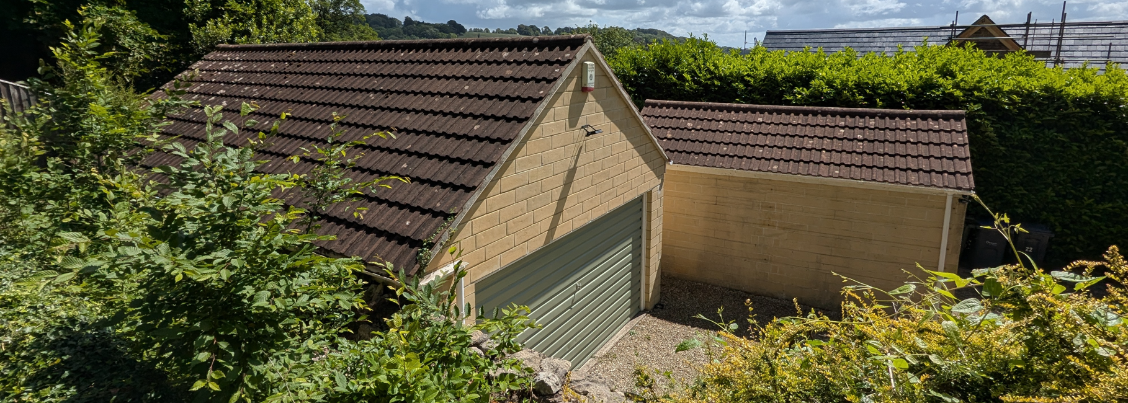
Site Visit (Garages)

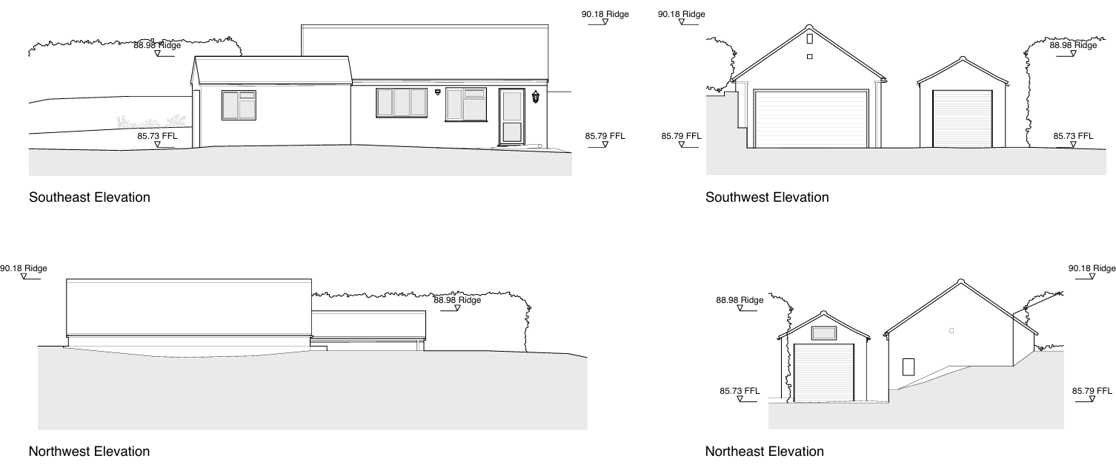
Outbuilding Existing Elevations

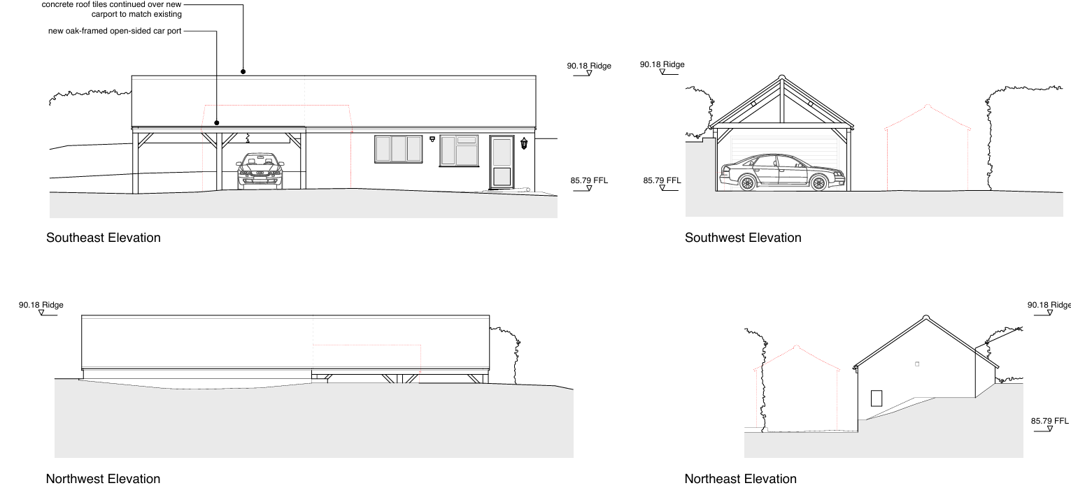
Proposed Outbuilding Elevations

In respect of the proposed extension to the main dwelling, it is noted that the site benefits from very limited public visibility owing to the steep topography and the presence of dense tree cover and boundary vegetation. Views of the dwelling are largely restricted to longer-distance or private vantage points, with the nearest relationship being with No. 9 Woods Hill, located approximately 33 metres away. Within this context, the proposed use of a glazed and timber-framed structure is considered acceptable and represents a high-quality, contemporary design approach that would complement the host building. The standing seam metal roof, whilst more modern in appearance, reflects a material approach that has some local precedent and is visually recessive in its finish.

It is also of note that the extension is positioned in a manner that reads as a form of infill between existing elements of the dwelling, rather than projecting prominently into the landscape. This, combined with the use of extensive glazing, reduces its perceived massing and ensures that it would not appear incongruous within the wider setting. The proposed extension and slight alteration to the raised decking area are similarly considered acceptable, as the dwelling already exhibits a significant amount of raised external platforming. As such, the works would be read as a continuation of the established design language rather than an anomalous addition.

Overall, it is considered that the proposal demonstrates an appropriate response to the character and appearance of the site and its surroundings, and would comply with the design objectives of Core Policies 57 and 51, as well as Saved Policy C3.

Having regard to the above, the proposal complies with the design principles set out in Core Policy 57 of the Wiltshire Core Strategy and Appendix D of the Wiltshire Design Guide.

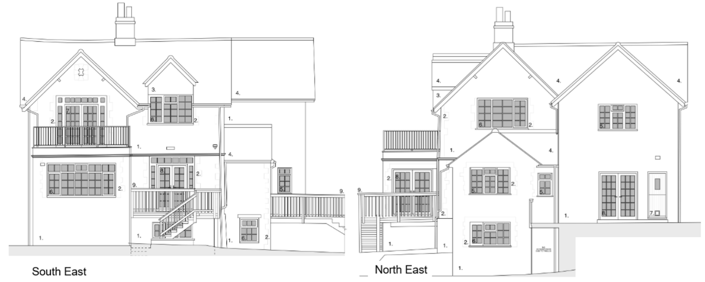
Existing Elevations (Dwelling)
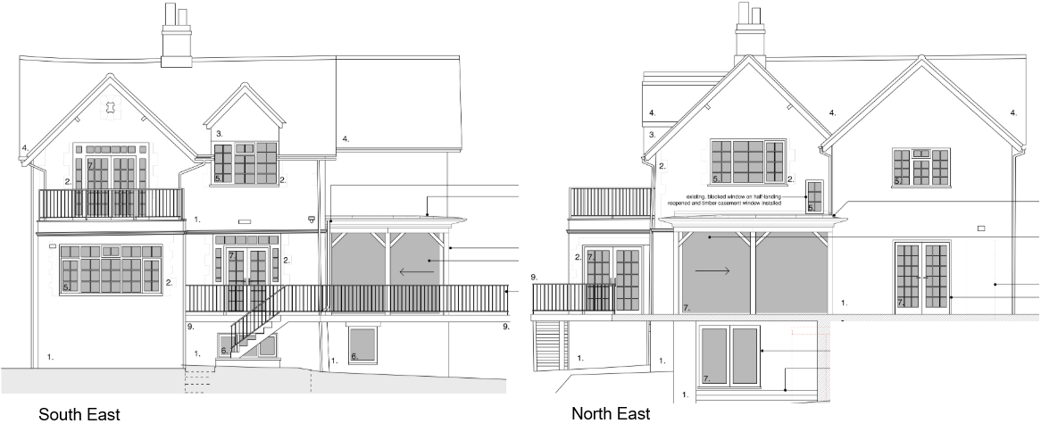
Proposed Elevations (Dwelling)

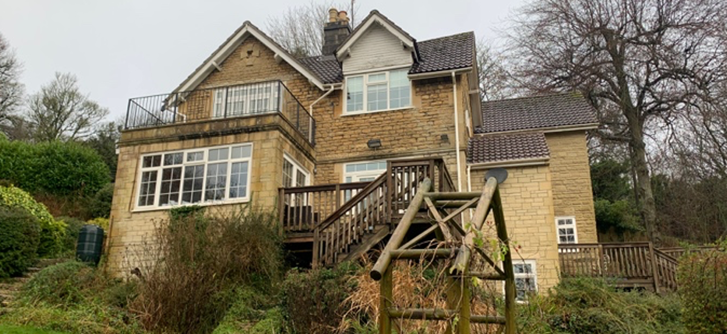
Site Image

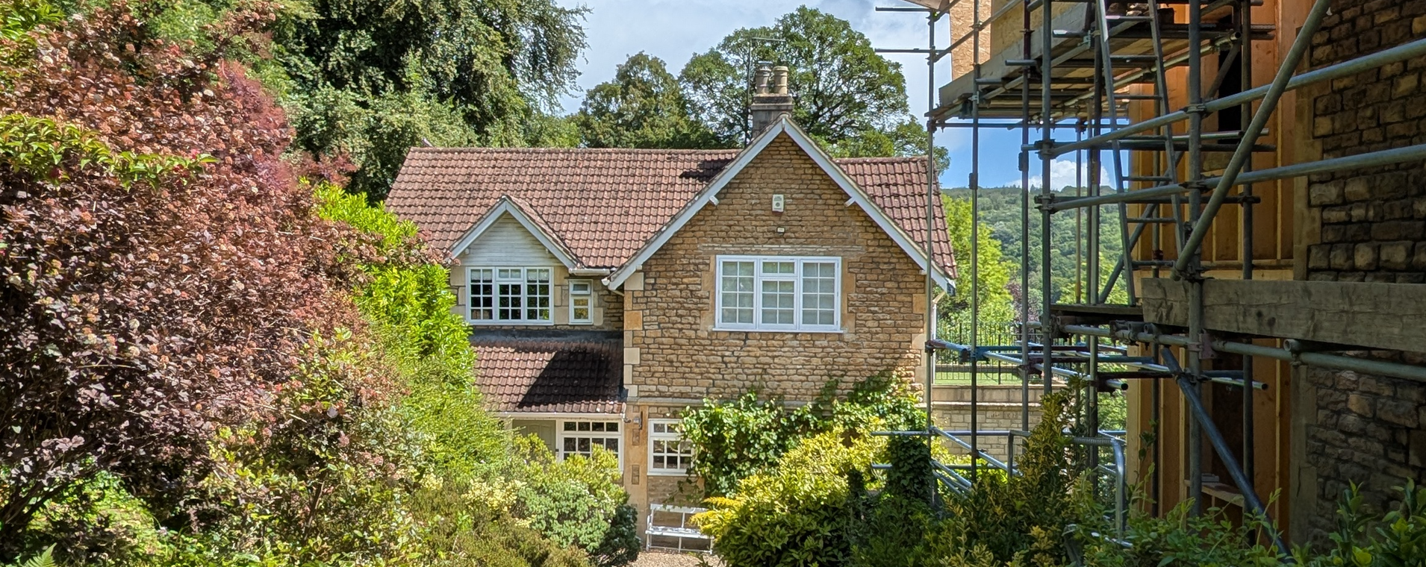
Site Image

Amenity

Point vii of Core Policy 57 (Ensuring High Quality Design and Place Shaping) of the Wiltshire Core Strategy seeks to ensure that development does not result in unacceptable impacts on the amenities of neighbouring occupiers. The National Planning Policy Framework (NPPF), particularly paragraph 135, similarly requires that planning decisions secure a high standard of amenity for existing and future users.

In this case, the proposal is appropriately sited, designed and oriented such that it would not give rise to unacceptable impacts on neighbouring residential amenity. The alterations to the garage are not considered to result in any adverse impacts, given that the structure would remain at a comparable height to the existing building, would not introduce habitable accommodation, and is positioned at the western edge of the site adjacent to the highway rather than neighbouring residential boundaries. As such, there is no realistic potential for overlooking, overshadowing, overbearing impact, or noise and disturbance beyond the existing situation.

With regard to the proposed dwelling extension, this would replace an existing extension and, whilst incorporating a more open and glazed elevation, would remain broadly consistent in terms of scale and sit comfortably within the established built form of the dwelling. The proposal is therefore not considered to give rise to any additional overbearing impact or loss of light. The increased glazing and the extension of the raised decking area would result in a degree of increased outward visibility; however, the nearest neighbouring property (No. 9 Woods Hill) is located approximately 33 metres from the application dwelling. This separation distance, combined with the substantial level of mature vegetation and boundary treatment surrounding the site, would provide effective screening and prevent undue intervisibility. Furthermore, the property already benefits from an existing raised decking area, and the proposal is not considered to materially intensify any perceived overlooking beyond the current baseline condition.

Overall, the proposal is considered to result in a neutral impact on neighbouring amenity and would accord with Core Policy 57 (criterion vii) and the guidance set out within Appendix D of the Wiltshire Design Guide.

Transport and Highways

Core Policies 60 and 61 of the Wiltshire Core Strategy seek to ensure safe and efficient movement and appropriate access arrangements, whilst paragraph 116 of the NPPF advises that development should only be refused where highway impacts would be unacceptable or severe. Core Policy 64 and the Council’s parking standards require adequate on-site provision to serve the development. In this case, the proposal does not increase the number of bedrooms and therefore would not increase parking demand. Although one garage is to be demolished, this space would be retained within the parking and turning area, and the extension to the remaining garage to form an open-fronted car port would maintain and improve the usability of on-site parking. As no changes are proposed to the existing access and there would be no intensification of use, the development is not considered to result in any adverse impact on highway safety or the operation of the network. No objection has been raised by the Highway Authority, and the proposal is therefore considered to comply with Core Policies 60, 61 and 64 of the Wiltshire Core Strategy and the NPPF.

Ecology

Core Policy 50 of the Wiltshire Core Strategy requires development to avoid and minimise impacts on biodiversity and to provide appropriate mitigation and enhancement where necessary. Biodiversity Net Gain (BNG) became mandatory under Schedule 7A of the Town and Country Planning Act 1990 (as amended by the Environment Act 2021); however, as this proposal relates to a householder application, it is exempt from the statutory requirement to deliver BNG.

The site lies within a number of ecological buffer zones associated with the Bath and Bradford-on-Avon Bats SAC (including Bechstein’s, Lesser Horseshoe and Greater Horseshoe bat buffers). A Habitats Regulations Assessment screening has been undertaken by the Council as competent authority, which concluded that, due to the scale and nature of the proposals and the absence of impacts to roosts or foraging habitat, there would be no likely significant effect on the SAC and the proposal can be screened out of Appropriate Assessment.

Bat survey work submitted in support of the application confirms the presence of a small roost within the loft space and, whilst the works would not directly affect this area, there remains potential for disturbance. The Council's Ecologist has therefore raised no objection subject to conditions. Whilst ecological enhancement measures were initially proposed to be secured through a pre-commencement condition, the applicant has subsequently submitted a separate ecological enhancement plan/statement identifying the type, specification and location of enhancement features to be incorporated within the development. The Council's Ecologist has confirmed that this information is acceptable and can be secured through a compliance condition requiring implementation in accordance with the submitted details. In addition, informatives are recommended to advise the applicant of their legal obligations under the Conservation of Habitats and Species Regulations 2017, including the need to obtain a bat mitigation licence prior to works, and to ensure that any external lighting is designed sensitively to avoid harm to foraging and commuting bats.

Evidence of nesting birds was also recorded on site, and works must take place in accordance with precautionary measures set out within the submitted ecological reports to ensure compliance with the Wildlife and Countryside Act 1981 (as amended). Subject to the recommended conditions and informatives, the proposal is considered to accord with Core Policy 50 of the Wiltshire Core Strategy and relevant national policy.

Flooding and Drainage

Core Policy 67 of the Wiltshire Core Strategy requires development to minimise flood risk and ensure that surface water is managed appropriately, whilst the NPPF promotes a risk-based approach to development. The application site lies within Flood Zone 1 and the Council’s Strategic Flood Risk Assessment identifies negligible groundwater flood risk and no surface water flood risk. As a householder development of a minor scale (well below 250m²), the proposal is exempt from the sequential and exception tests under paragraph 176 of the NPPF. Whilst national policy requires a site-specific flood risk assessment where there is evidence of other sources of flooding, the limited scale of the development and low level of identified risk mean that such an assessment is not considered necessary in this instance. Given the modest increase in footprint, it is considered that surface water can be managed within the existing site through appropriate drainage measures, and the proposal would not increase flood risk on or off site. Accordingly, the development is considered to comply with Core Policy 67 and the NPPF.

CONCLUSION

The proposal is considered to be acceptable and in accordance with the relevant policies and guidance outlined above.

RECOMMENDATION: That Planning Permission be GRANTED subject to the following conditions:

1.
The development hereby permitted shall be begun before the expiration of three years from the date of this permission.
REASON: To comply with the provisions of Section 91 of the Town and Country Planning Act 1990 as amended by the Planning and Compulsory Purchase Act 2004.

2.
The development hereby permitted shall be carried out in accordance with the following approved plans and documents:

Location Plan 23_21 – 01
Proposed Lower Ground Floor Plan 23_21 – 21
Proposed Ground Floor Plan 23_21 – 22
Proposed First Floor Plans 23_21 – 23
Proposed Northeast Elevation 23_21 – 25
Proposed Southeast Elevation 23_21 – 26
Proposed Site Block Plan 23_21 – 20
Proposed Roof Plan 23_21 – 24
Proposed Floor Plan – Outbuilding 23_21 – 27
Outbuilding - Proposed Ground Floor Plan 23_21 – 29
Outbuildings - Elevation as Proposed 23_21 – 31
Outbuilding - Proposed Roof Plan 23_21 – 30

REASON: For the avoidance of doubt and in the interests of proper planning.

3.
The development will be carried out in strict accordance with the following documents:

- Bat Survey Report, Abricon, October 2025
- Ecology Mitigation Strategy (23_21 GB 20260318)

REASON: For the avoidance of doubt and for the protection, mitigation and enhancement of biodiversity.

4.
Prior to the commencement of any works, including vegetation removal and demolition, details of the number, design and locations of ecological enhancements – including the type and locations of bat roosting opportunities, bird boxes and invertebrate blocks or similar – shall be submitted to the local authority for approval. The approved details shall be implemented before occupation of the final works.

REASON: To provide mitigation/enhancement for biodiversity.

Informative – Bats

The house at 22 Woods Hill is used as a bat roost. Under the Conservation of Habitats and Species Regulations 2017 (as amended), it is an offence to harm or disturb bats or damage or destroy their roosts. Planning permission for development does not provide a defence against prosecution under this legislation. The applicant is advised that a mitigation licence will be required before any work is undertaken to implement this planning permission. Future conversion of the roof space or replacing the roof could also breach this legislation and advice should be obtained from a professional bat ecologist before proceeding with work of this nature.

Informative – Artificial Lighting

The habitat within the proposed development site and the surrounding area is suitable for roosting, foraging and commuting bats. An increase in artificial lux levels can deter bats which could result in roost abandonment and/or the severance of key foraging areas. This will likely result in a significant negative impact upon the health of bat populations across the region. Artificial light at night can have a substantial adverse effect on biodiversity. Any new lighting should be for the purposes for safe access and security and be in accordance with the appropriate Environmental Zone standards set out by the Institute of Lighting Engineers in their publication GN01:2021, ‘Guidance for the Reduction of Obtrusive Light’ (ILP, 2021), and Guidance note GN08-18 “Bats and artificial lighting in the UK”, issued by the Bat Conservation Trust and Institution of Lighting Professionals.

