Proposed works overview | Description | Materials/  Finishes | Parts of property affected | Photos
1. 2x Attic dormer window, like for like replacement, due to mouldy wood and water ingress | 2x Attic dormer window, like for like replacement, inclusive of dimensions, materials, colour and ironmongery. This is due to severe deterioration of the existing windows which consists of mouldy, flaky wood allowing water ingress into the property, unfortunately they are beyond repair. | Factory fitted: 14mm Clear Toughened SLIMLINE Double Glazed, Low E, Soft Coat, Krypton gas,  WHITE Warm edge spacer Bar.  Full spray shop finish - Hawkers Premium 3 Coat Water Based Microporous System. (all in one colour)  Butt Hinges, Fastener and Stay on one side per window (like for like)  – see attached proposal of works for more details. | 2 x street facing dormer windows on the second story of the property | Figure 1 front profile of the building:  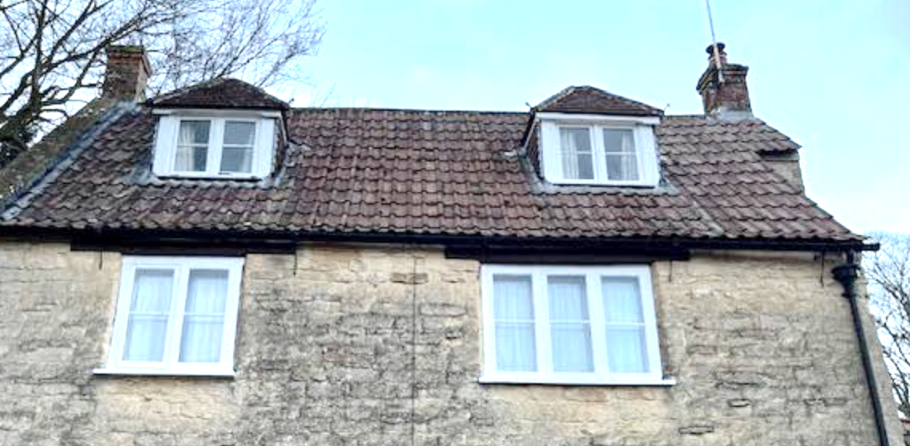  Figure 2: close up of dormer windows with degraded, mouldy wood shown on sill (red)  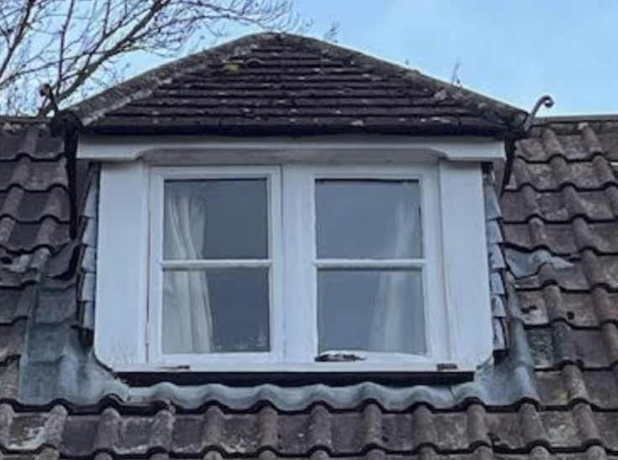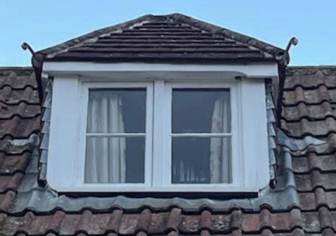  Figure 3: showing blown window, mould and deteriorating wood  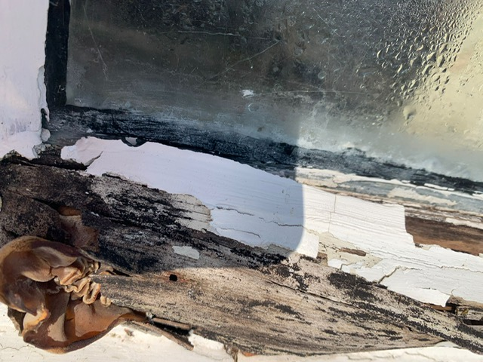  Figure 4: Further deterioration of the wooden framework  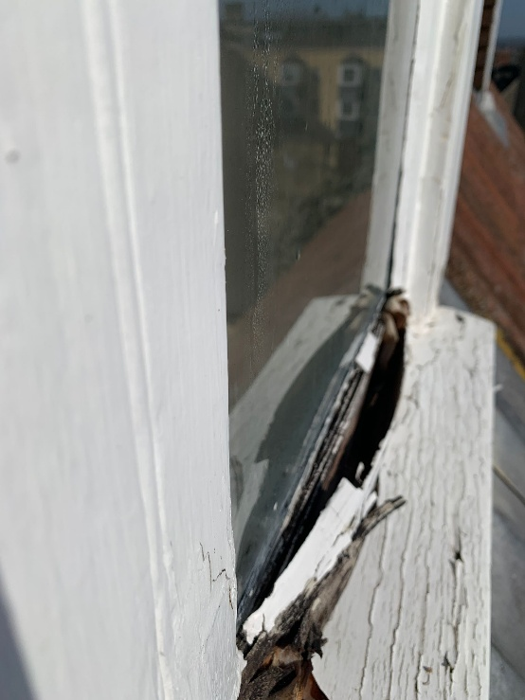  Figure 5: Close up of glazing and broken frame and sill  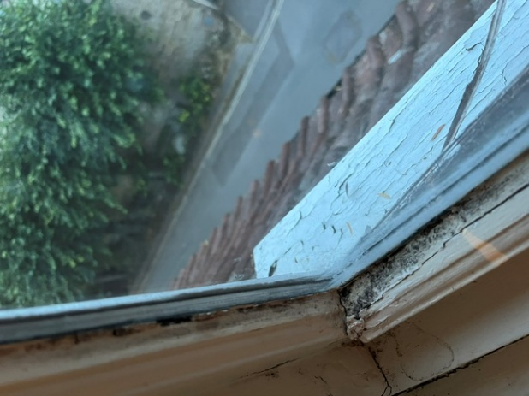  Figure 6: Water ingress through rotten frame  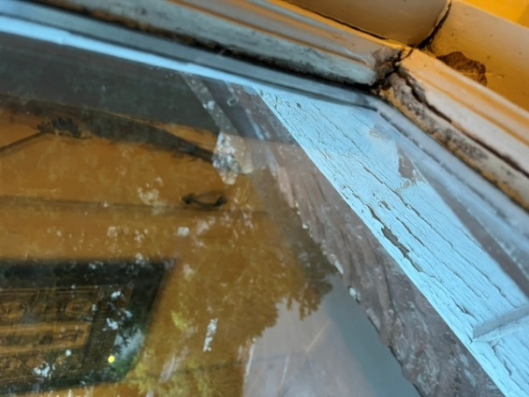  Figure 7: Blown slimline glazing  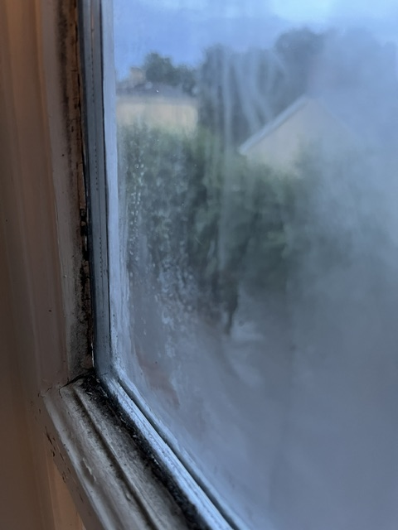  Figure 8: Internal view of windows to show pane orientation and opening  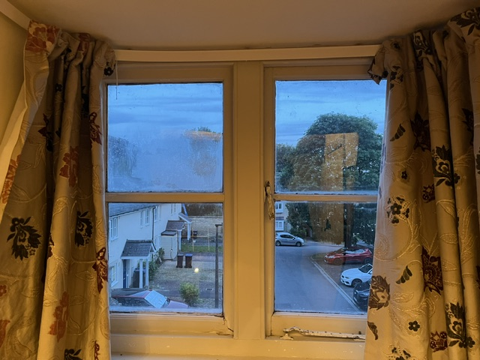  Figure 9: Front profile of the property for reference.  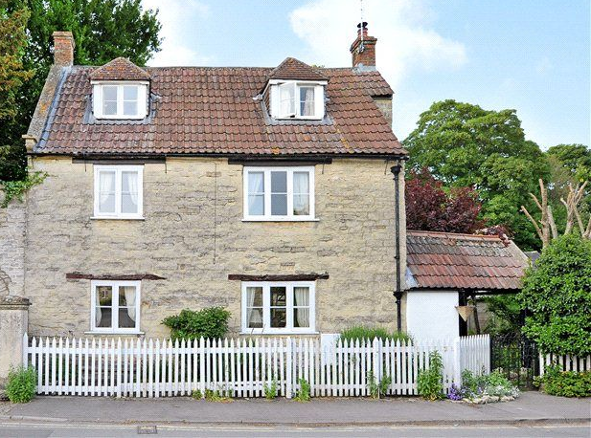
2. Capping 2nd chimney on the west wall of the property | Capping the second (unused) chimney (1) to aid ventilation of the property, helping to reduce moisture build up in the wall.  It will be matched to the chimney cap on the existing chimney (2) | Brewer Cowls Birdguard Round Chimney Cowl with Strap Fix for Solid Fuel – Terracotta, or similar to match existing chimney stack on other chimney  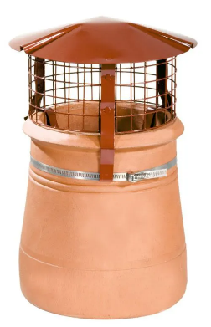 | Chimney as circled in photo | Figure 10: Chimney highlighting chimney to be Capped (1.) to match existing capped chimney (2.)  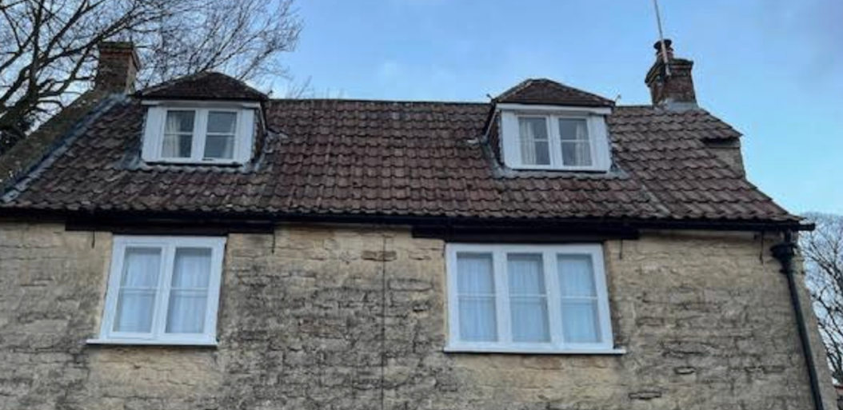  1.  2.  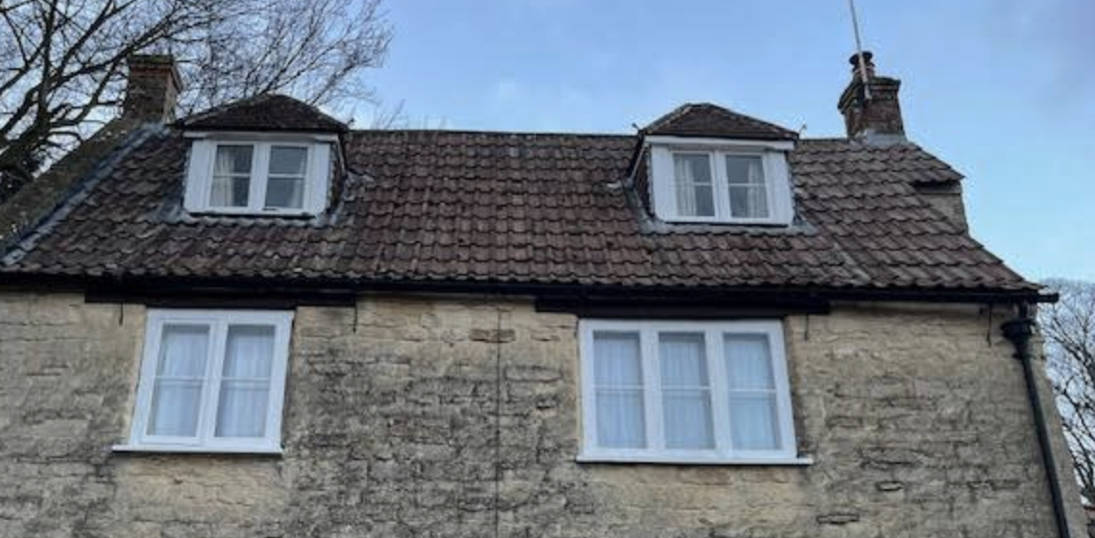  Figure 11: Example image of capped chimney  1.  2.  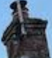
3. White picket fence replacement | Replacing the existing picket fence at the front, road facing, boundary of the property and extending it up the driveway to fully secure the garden. This would involve replacing the existing pointed top fencing with round-top fencing which we feel would better suit the character of the property. | Wooden, white, rounded top, picket fencing to be sourced. Made from tanalised softwood. 1 metre height.  – see attached proposal of works for more details. | Exterior perimeter of the front of the property. See photos below. | Figure 12: Ariel shot showing white picket fence  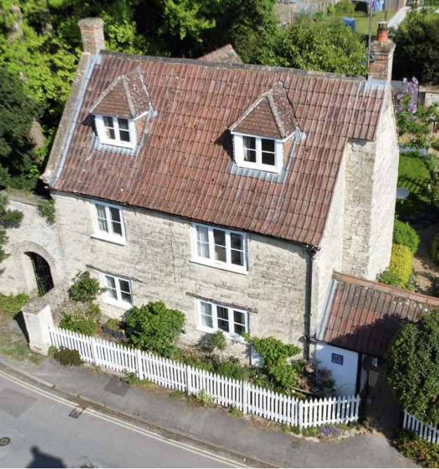  Figure 13 showing close up of main extent of the wooden fencing.  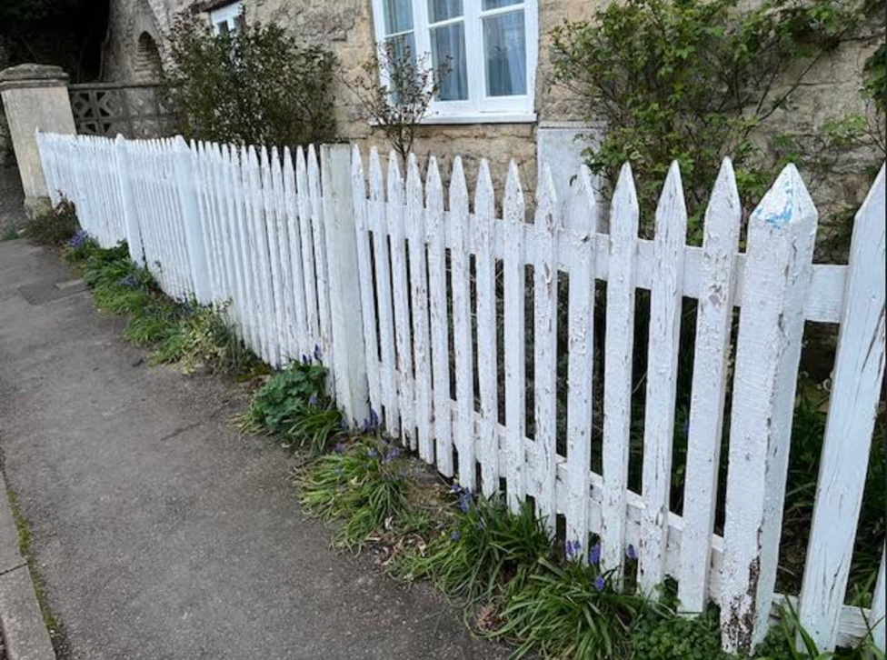  Figure 14: showing rotten wood panels and past repairs  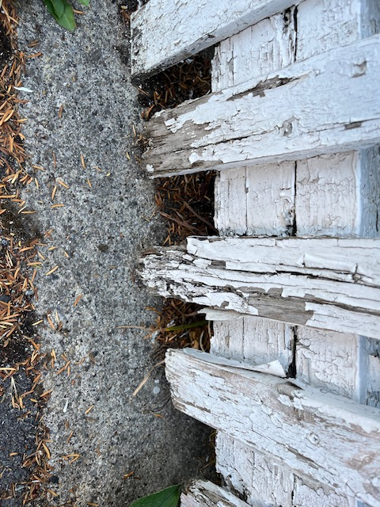  Figure 15: Photo showing rotten posts  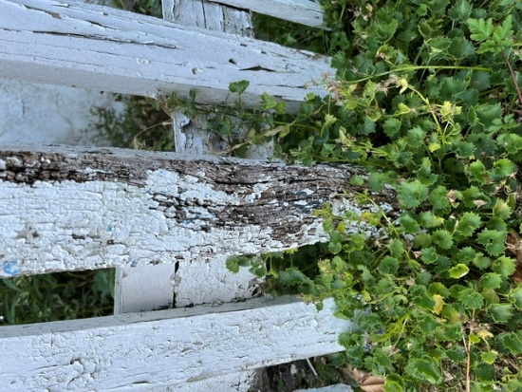  Figure 16: Photo showing secondary extent of picket fencing 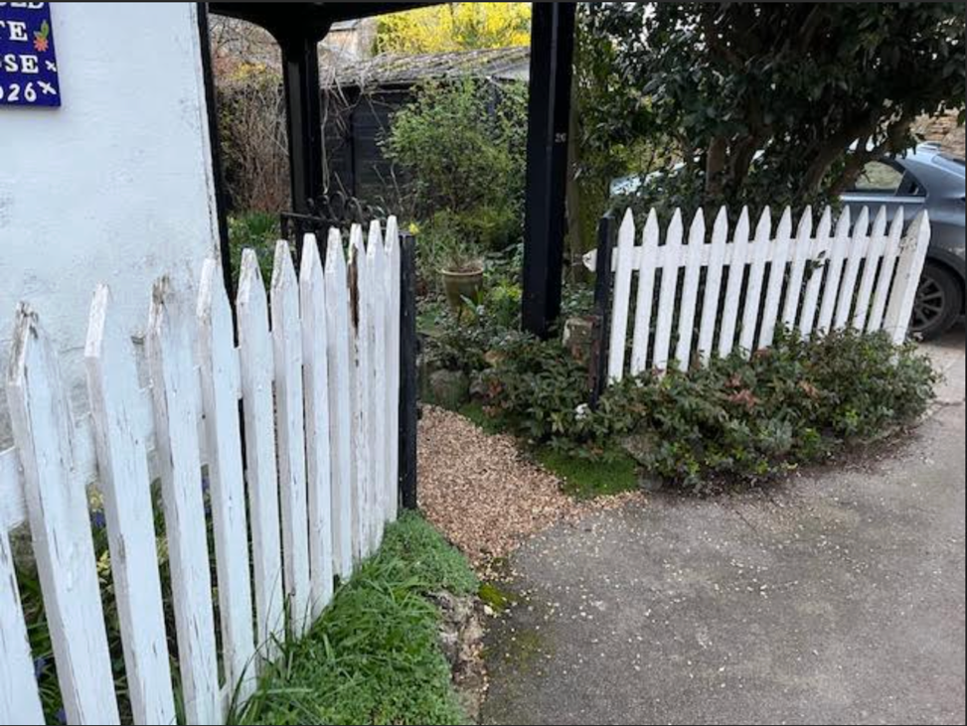  Figure 17: Photo showing the boundary of the proposed new fencing (white hatched lines) to secure the garden  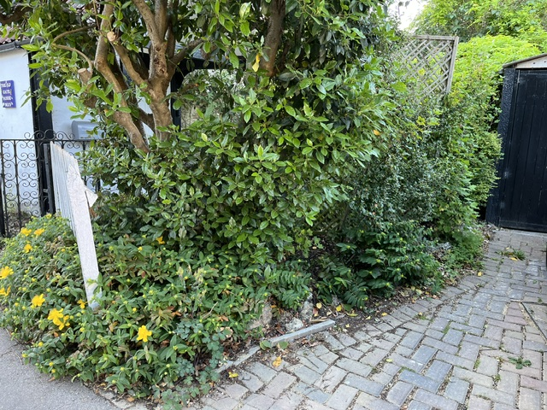  Figure 1 showing the street view of the proposed new fencing  