APPLICATION FOR VARIATION/REMOVAL OF CONDITION
CASE OFFICER REPORT

APPLICATION REFERENCE: | PL/2026/02297
APPLICATION TYPE: | Removal/variation of conditions
SITE ADDRESS: | Land at Church Road, Idmiston, Salisbury, Wiltshire, SP4 0AS
DEVELOPMENT DESCRIPTION: | Vary Conditions 2,3,4 and 5 on PL/2023/04010 - Erection of 2 detached dwellings with integral garaging, access and associated works.
RECOMMENDATION: | Approve with Conditions

SITE DESCRIPTION/CONTEXT

The application site is a parcel of land of 0.34ha located to the north of Church Road in the small settlement of Idmiston. Access to Manor Farm lies immediately to the south east of the site, with residential properties to the west and east and the southern side of Church Road and open fields to the north. The site is undeveloped other than for utility poles and comprises an open area of grassed land which is unenclosed from the remainder of the field which lies to the north and wraps around the rear of the gardens to existing properties. The land slopes upwards from Church Road. The site has no street frontage due to the 'wedge' shape created by the existing built form.

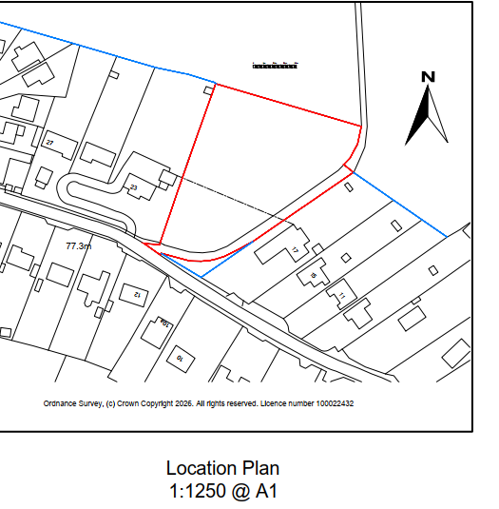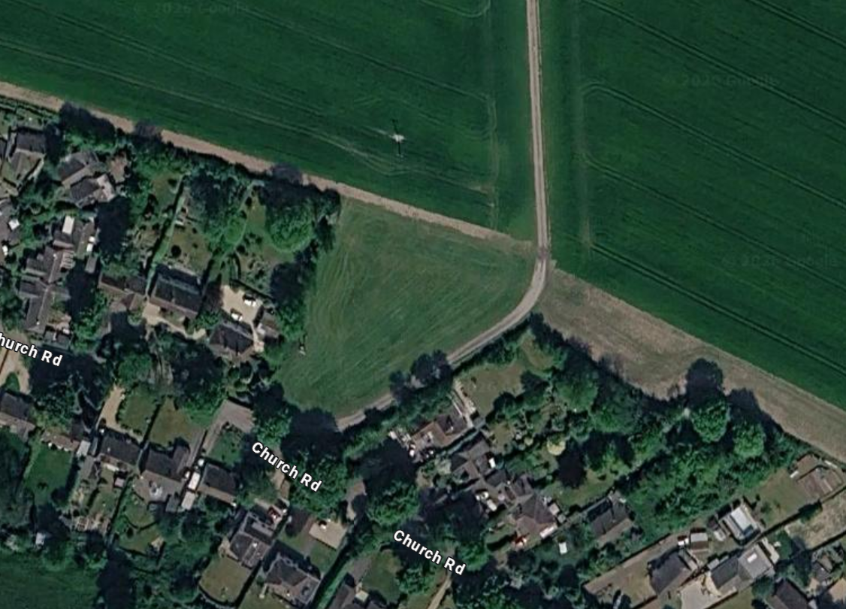

In the Wiltshire Core Strategy core polices 1, 2 and 4, Idmiston is a settlement not identified in the settlement hierarchy that formerly had a boundary and therefore for the purposes of the development plan is considered to be located within designated countryside.

The site is also situated within the catchment of the River Avon Special Area for Conservation (SAC), and within the 6.4km buffer zone of the Salisbury Plain Special Protection Area (SPA). The site is also located within a Special Landscape Area (C6 - a saved policy of the Salisbury District Local Plan).

The site is within Flood Zone 1 and is not identified to be at high risk of flooding from other sources (surface or groundwater) in the Strategic Flood Risk Assessment (SFRA).

The site is not located within a conservation area or National Landscape and there are no immediately listed buildings in the vicinity.

PROPOSAL

This report considers a Section 73 application for the variation/removal of condition(s) imposed on planning permission PL/2023/04010. The application relates to the site at Land at Church Road, Idmiston, Salisbury, Wiltshire, SP4 0AS and seeks to vary/remove condition(s) 2 (plans list), 3 (archaeology), 4 (CEMP) and 5 (materials).

Condition 2

The development hereby permitted shall be carried out in accordance with the following approved plans and documents:

Location and Block Plans

Site Plan 1282-03 Revision C dated 26/09/2023

Existing and Proposed Sections 1282-4 Revision A dated 26/01/2023

Proposed Elevations and Plans Plot 1 1282-05 Revision B dated 20/06/2023

Proposed Elevations and Plans Plot 2 1282-06 Revision B dated 20/06/2023

Appendix E of the Ecological Assessment, No. 0561, Issue: 01, Date: 1st February 2023 by Peach Ecology

Nutrient budget, updated 12th February by Holbury Consultancy Service

Mitigation Technical Note v5

REASON: For the avoidance of doubt and in the interests of proper planning.

Condition 3

No development shall commence within the area indicated by the red line boundary on AD Draughting Architectural Service’s Drawing No. 1282-01, Rev A, dated 26/01/2023 until:

a) A written programme of archaeological investigation, which should include on-site work and off-site work such as the analysis, publishing and archiving of the results, has been submitted to and approved in writing by the Local Planning Authority; and

b) The approved programme of archaeological work has been carried out in accordance with the approved details.

REASON: In order to record and advance understanding of the significance of any heritage assets to be lost in a manner proportionate to their importance and to make this evidence and any archive generated publicly accessible

Condition 4

Prior to the commencement of works, including demolition, ground works/excavation, site clearance, vegetation clearance and boundary treatment works, a brief Construction Environmental Management Plan (CEMP) that is proportional to the scale of the works shall be submitted to the local planning authority for approval in writing. The Plan shall provide details of the avoidance, mitigation and protective measures to be implemented before and during the construction phase, including but not necessarily limited to, the following:

a) Identification of ecological protection areas/buffer zones and tree root protection areas and details of physical means of protection, e.g. exclusion fencing.

b) Working method statements for protected/priority species, such as nesting birds, bats and reptiles.

c) Working method statements for the removal of invasive non-native species.

d) Work schedules for activities with specific timing requirements in order to avoid/reduce potential harm to ecological receptors; including details of when a licensed ecologist and/or ecological clerk of works (ECoW) shall be present on site.

e) Key personnel, responsibilities and contact details (including Site Manager and ecologist/ECoW).

Development shall be carried out in strict accordance with the approved CEMP.

REASON: To ensure adequate protection and mitigation for ecological receptors prior to and during construction, and that works are undertaken in line with current best practice and industry standards and are supervised by a suitably licensed and competent professional ecological consultant where applicable.

Condition 5

No development above slab level shall be undertaken until details of the materials to be used for the external walls and roofs have been submitted to and approved in writing by the Local Planning Authority. Development shall be carried out in accordance with the approved details.

REASON: In the interests of visual amenity and the character and appearance of the area.

RELEVANT PLANNING HISTORY

PL/2024/07311 Discharge of conditions 3 (Archaeological investigation) and 4 (CEMP) relating to application PL/2023/04010. Condition 3 part discharge and condition 4 discharged.

PL/2023/04010 Erection of 2 detached dwellings with integral garaging, access and associated works. Approved with conditions

PL/2022/06193 - Permission in principle for the erection of 2no dwellings – Withdrawn

RELEVANT LEGISLATION, POLICIES AND GUIDANCE

Town and Country Planning Act. 1990 (as amended)

Section 73 of the Town and Country Planning Act. 1990 (as amended) relates to the determination of applications to develop land without compliance with conditions previously attached. It states that:

(2) On such an application the local planning authority shall consider only the question of the conditions subject to which planning permission should be granted, and—

- if they decide that planning permission should be granted subject to conditions differing from those subject to which the previous permission was granted, or that it should be granted unconditionally, they shall grant planning permission accordingly, and

- if they decide that planning permission should be granted subject to the same conditions as those subject to which the previous permission was granted, they shall refuse the application.

The National Planning Practice Guidance (PPG) states the following:

- Nature of the Application: A Section 73 application is treated as a new planning permission, although it does not alter the original permission itself. The original permission remains intact and can still be implemented unless it has expired or been superseded.
- Limitations:
  - Section 73 cannot be used to change the description of development or the operative part of the permission (e.g. the nature or extent of the approved use).
  - It cannot be used to extend the time limit for implementing the original permission.
  - If the proposed changes go beyond what can reasonably be considered under Section 73, a new planning application under Section 70 would be required.
- Decision-making: The local planning authority must consider the application only in relation to the conditions subject to which the original permission was granted. However, it may impose new or revised conditions if granting a new permission.
- Legal Agreements: Because a Section 73 application results in a new permission, any existing Section 106 agreement may need to be varied or replaced via a deed of variation to ensure obligations continue to apply to the new permission.

National Planning Policy:

National Planning Policy Framework (NPPF)
Planning Practice Guidance (PPG)
National Design Guide

Development Plan:
The development plan for Wiltshire comprises the Wiltshire Core Strategy (WCS) (adopted January 2015) and any made neighbourhood plans, which remains the principal statutory planning document guiding development across the county. In line with Section 38(6) of the Planning and Compulsory Purchase Act 2004, planning decisions must be made in accordance with the development plan unless material considerations indicate otherwise.

Though the development plan is considered as a whole, those parts deemed to be particularly relevant to this application are listed below:

The adopted Wiltshire Core Strategy (WCS), with particular regard to:

CP1 Settlement strategy
CP2 Delivery strategy
CP3 Infrastructure requirements
CP4 Amesbury Community Area Strategy
CP43 Affordable Housing
CP45 Meeting Wiltshire’s Housing Needs
CP50 Biodiversity
CP51 Landscape
CP57 Ensuring high quality design and place shaping
CP58 Ensuring the conservation of the historic environment
CP60 Sustainable transport
CP61 Transport and new development
CP69 River Avon SAC

Salisbury District Local Plan Saved Policies (Appendix D WCS): C6 – special landscape area

Supplementary Planning Documents/Guidance:

Idmiston Parish Council Neighbourhood Plan 2015-2026
Wiltshire Local Transport Plan 2011-2026:
Car Parking Strategy (Policy PS6 - Residential parking standards)
Cycling Strategy
Wiltshire Design Guide SPG
The Idmiston, Porton and Gomeldon Village Design Statement
Habitat Regulations Assessment and Mitigation Strategy for Salisbury Plain Special Protection Area 2018
Waste storage and collection: Guidance for developers
Community Infrastructure Levy - Wiltshire Council - Wiltshire Community Infrastructure Levy Revised Wiltshire Planning Obligations SPD October 2016
Conservation of Habitats and Species Regulations 2017 (the ‘Habitats Regulations’)
Conservation of Habitats and Species (Amendment) (EU Exit) Regulations 2019
Wildlife and Countryside Act 1981 as amended
Creating Places Design Guide

ISSUES

The key considerations in the assessment of this application are as follows:

- Determining whether the proposed amendments fall within the scope of Section 73 of the Town and Country Planning Act 1990 which allows for the variation or removal of conditions attached to an existing planning permission.
- Assessing whether the development, as amended, remains in accordance with the relevant policies and provisions of the development plan, and whether the changes materially alter the nature or impacts of the approved scheme.

CONSULTATION RESPONSES

Ecology – no objections subject to condition

Highways – no objections

Parish Council – no objection subject to highways comments relating to parking

Archaeology – no objections

Public protection – no comments to make

REPRESENTATIONS

Below is a summary of the representations received during the consultation period. Only material planning considerations have been taken into account in the assessment of this application. Non-material issues, such as property values or private legal disputes, cannot be considered in the determination process.

No third party representations have been received.

ASSESSMENT

Section 38(6) of the Planning and Compulsory Purchase Act 2004 states:

"If regard is to be had to the development plan for the purposes of any determination to be made under the planning Acts, the determination must be made in accordance with the plan unless material considerations indicate otherwise."

In accordance with this statutory requirement, this application has been assessed against the relevant policies of the Development Plan, including the Wiltshire Core Strategy (2015) and, where applicable, any made Neighbourhood Plans. Consideration has also been given to the policies of the National Planning Policy Framework (NPPF) as a material consideration in the assessment.

Principle of the Development – Do the proposed amendments fall within the scope of s73?

The proposed amendments have been reviewed and are considered to fall within the scope of Section 73 of the Town and Country Planning Act 1990. The changes do not result in a fundamentally different development from that originally approved, nor do they seek to alter the description of development or extend the time limit for implementation. As such, the application is valid under Section 73 and can be determined as a variation of condition(s) attached to the original planning permission.

Compliance with the Development Plan

There have been no significant planning policy changes that would alter the suitability of the principle of development on this site other than the NPPF has been updated in December 2024. The changes to the NPPF do not materially alter national policy consideration of the proposed development. This officer report solely assesses the changes between the proposed scheme and that previously approved and the details considered under conditions 2, 3, 4 and 5.

Character, design and visual impacts (conditions 2 and 5)

Core Policy 51 of the WCS requires that development should protect, conserve and where possible enhance landscape character and must not have a harmful impact upon landscape character, while any negative impacts must be mitigated as far as possible through sensitive design and landscape measures having regard to the visual amenity of the open landscape character.

The site is not within the National Landscape (formerly Area of Outstanding Natural Beauty) and therefore lies outside of any nationally recognised designation. However, it does lie with the local designation of 'Special Landscape Area' defined by saved policy C6 of the Salisbury Local Plan.

Policy C6 states that 'Within the Special Landscape Area, proposals for development in the countryside will be considered having particular regard to the high quality of the landscape. Where proposals which would not have an adverse effect on the quality on the landscape are acceptable, they will be subject to the following criteria;

(i) the siting and scale of development to be sympathetic with the landscape; and
(ii) high standards of landscaping and design, using materials which are appropriate to the locality and reflect the character of the area.'

Core Policy 57 requires that applications should demonstrate how the proposal will make a positive contribution to the character of Wiltshire through –

(i) enhancing local distinctiveness by responding to the value of the natural and historic environment, relating positively to its landscape setting and the existing pattern of development and responding to local topography by ensuring that important views into, within and out of the site are to be retained and enhanced;
(iii) responding positively to the existing townscape and landscape features in terms of building layouts, built form, height, mass, scale, building line, plot size, elevational design, materials, streetscape and rooflines to effectively integrate the building into its setting and
(iv) being sympathetic to and conserving historic buildings and historic landscapes.

The application is seeking consent for changes to the design and siting of the proposed dwellings. The changes proposed as detailed within the submitted planning statement are as follows –

• Plots 1 & 2 moved away from the overhead power cables to achieve a 5m clearance and required by Scottish & Southern Electric
• Rear patio area amended.
• Rear parking area omitted.
• Position of external access stairs to upper ground level changed.
• Entrance driveway design to both plots amended.
• Separate (independent) retaining wall to three sides added to both plots.
• Steel flues changed from external to internal. Brick slip chimneys added to hide the flues above the roofline.
• Dormer windows widened. Actual window width remains the same.
• Front door design changed.

Approved site layout Revised proposed site layout

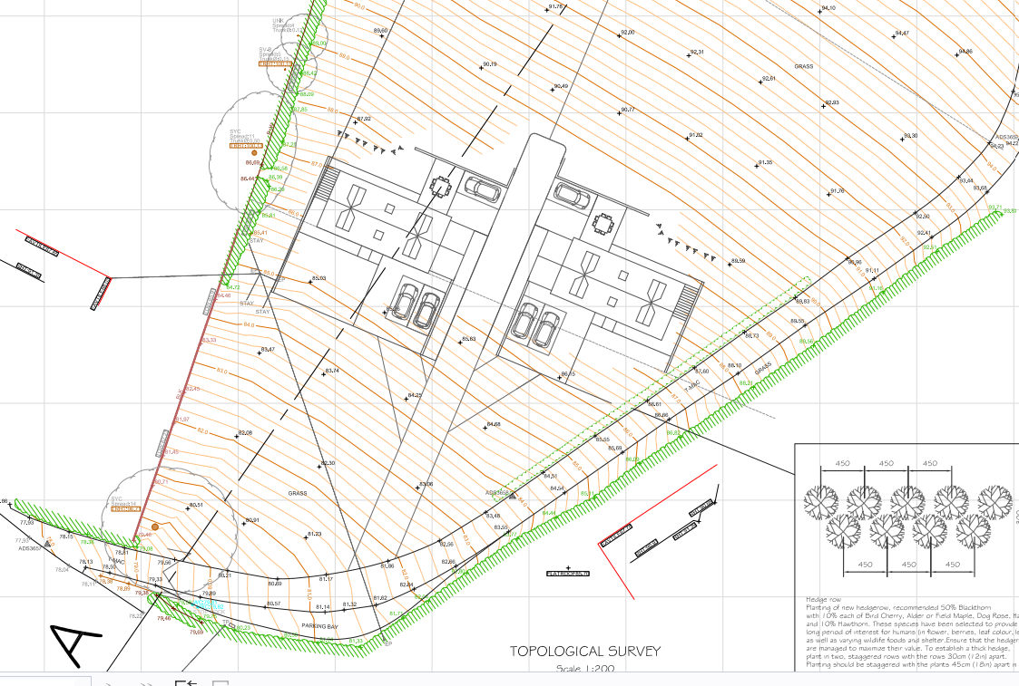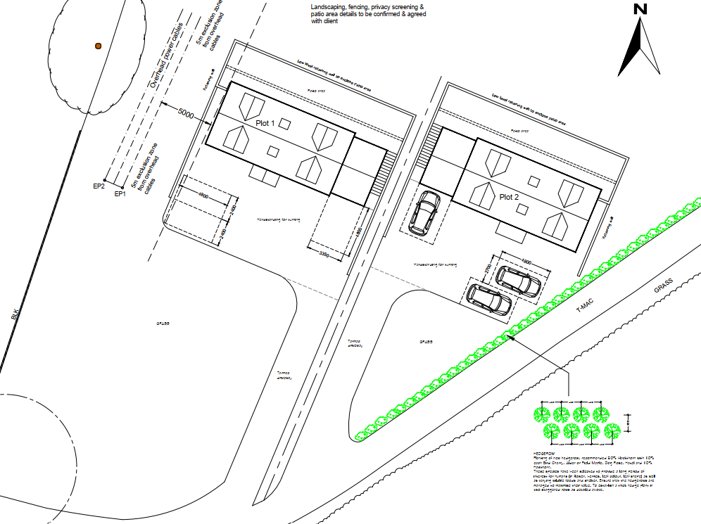

Approved floor plans and elevations plot 1

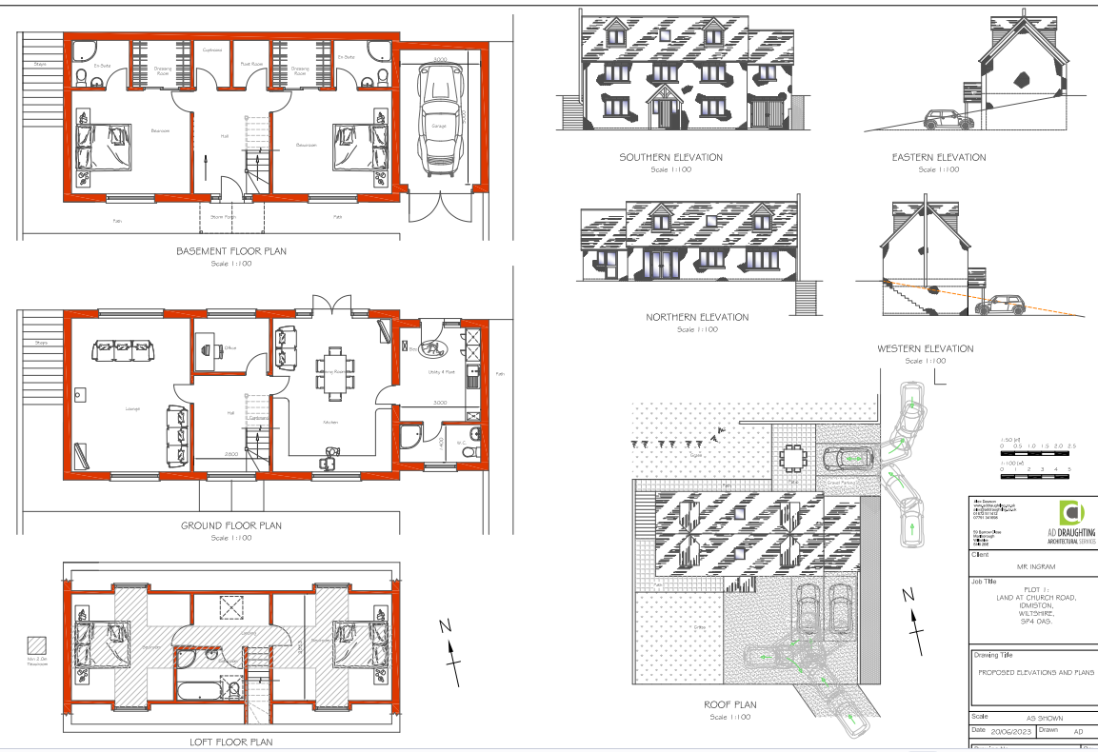

Approved floor plans and elevations plot 2

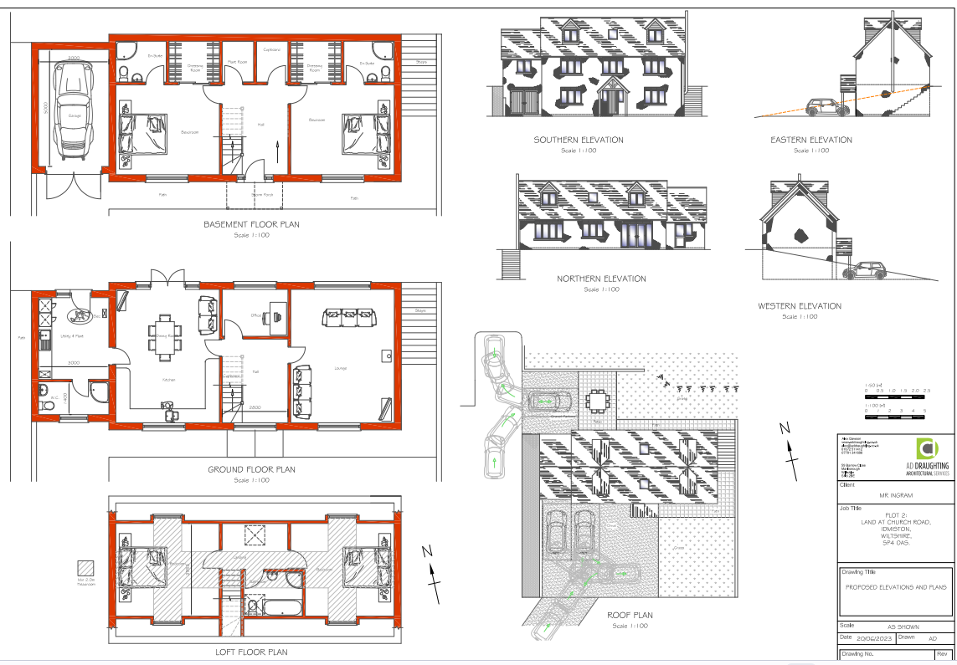

Revised proposed floor plans

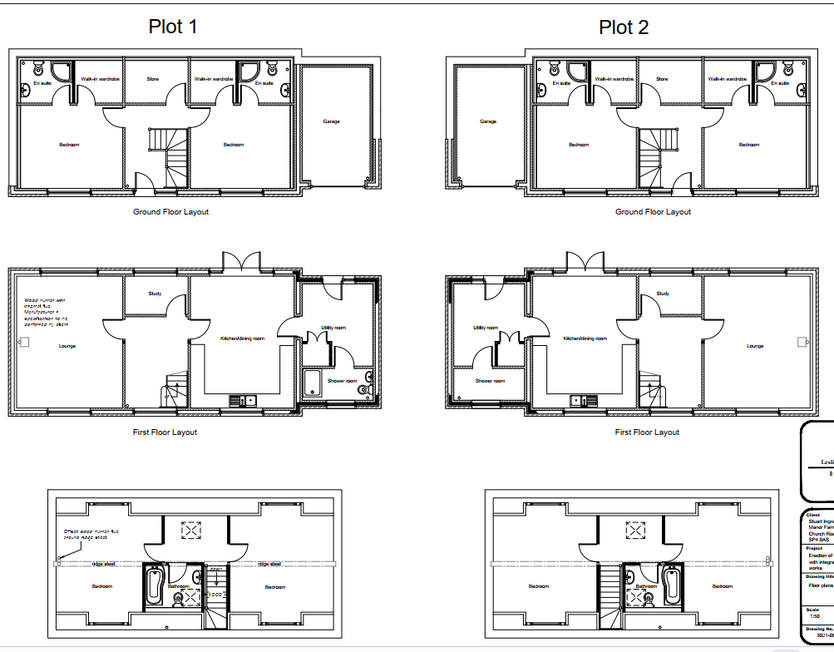

Revised proposed elevations of both plots 1 and 2

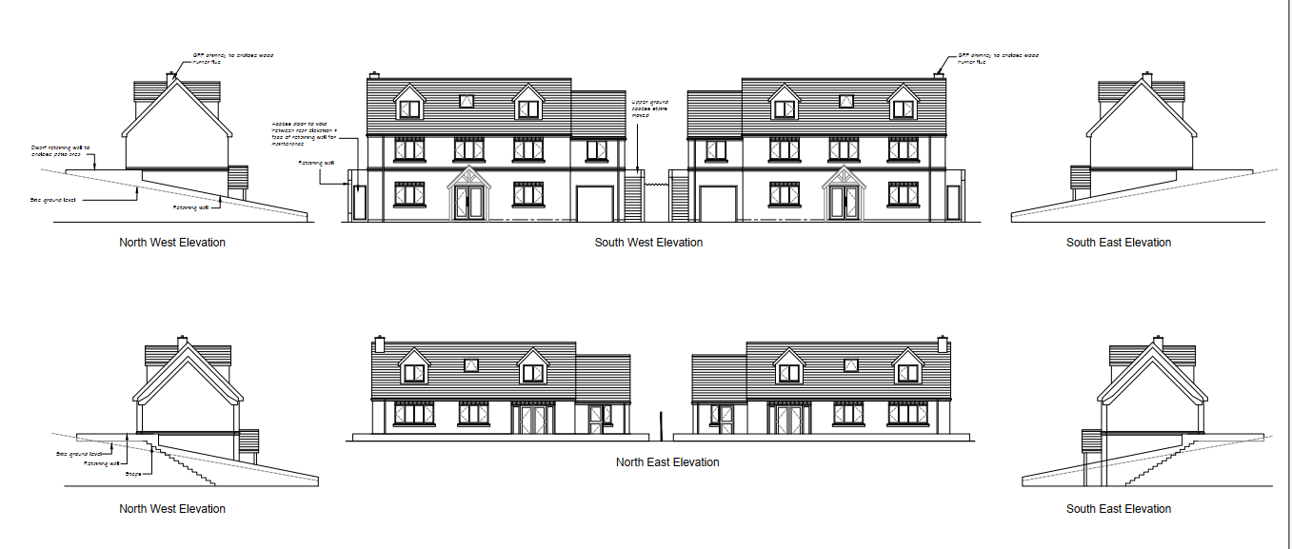

The revised plans ref: 3021-23 also now include details relating to the proposed materials marked on to the drawings, the proposed materials are

Slate roof tiles
• Dormers clad in shiplap boarding
• Michelmersh red multi ATR bricks minimum orange
• Windows – uPVC casement flush fitting Agate grey

The proposed design changes are mainly modest amendments which overall do not have a harmful visual impact or detrimental impact on the character and appearance of the development or local area. Such modest amendments relate to the amendment to the rear patio area, removal of the rear parking area, changes to the external access stairs, changes to the driveway design and design changes to the front door.

The changes to the proposed retaining wall whilst addition walling will not in the context of the overall visual impacts of the proposed scheme create adverse visually impacts.

It is considered that the addition of brick slip chimneys to hide the original steel flues above the ridgeline is an enhancement to the overall appearance and is welcomed.

The widening of the proposed dormers will through their enlargement be more prominent however, the increase in size is not significant and will therefore not create an unwelcome addition to the roof slopes of the proposed dwellings.

The main design change that will have the most impact relates to the moving of the proposed residential dwellings away from the overhead power cables to achieve the 5m clearance as required by Scottish & Southern Electric. The re-siting of the proposed dwellings is further upslope and therefore will be more prominent and less screened by surrounding built form and landscaping. The proposed new position for the proposed dwellings is not far from the approved position and is still very much relatable. The need to mover the dwellings slightly is understood, it is considered that on balance the re-siting of the proposed dwellings will not have a significant impact on the character of the area.

Overall, it is considered that had the proposed amendments currently seeking permission been submitted as part of the original consent, these would have been supported and would not have resulted in a refusal, therefore it is considered that the proposed design changes are acceptable in this instance.

In terms of the proposed materials, it is considered that the materials detailed within the planning statement and on Drg no 3021-23 are acceptable for this location; the choice of brick and natural slate roof with timber cladding to the dormers are considered to be appropriate. A condition will be added to any permission to ensure the development is carried out in accordance with the approved materials.

Impacts on residential amenity

Point vii of Core Policy 57 - Ensuring High Quality Design and Place Shaping of the Wiltshire Core Strategy seeks to ensure that developments do not adversely affect neighbouring properties.

The National Planning Policy Framework (NPPF), particularly Paragraph 135(f), stresses that planning decisions should ensure developments provide a high standard of amenity for existing and future users.

As part of the assessment of the original approval the case officer stated -

The site shares a boundary with No. 23 Church Road, to the west. No. 17 Church Road lies to the east, separated by the existing farm track. Nos. 10, 10A and 12 Church Road are located to the south side of Church Road, opposite the site.

The dwelling to Plot 1 is set back from the dwelling at No. 23, the boundary with this property is formed by established vegetation which currently provides effectively screening. In the event that the vegetation is removed or dies back, any opportunities for overlooking from the first floor windows of the proposed dwelling towards the rear and side of this property would be at an oblique angle and the separation distance is considered adequate to provide a satisfactory relationship. No third party representations from the occupiers of this property have been received to indicate otherwise, although other parties have suggested an adverse impact.

The dwelling to Plot 2 is also set back from the dwelling at No. 17, which is positioned at an angle relative the road and at a lower level. The occupier of this property has commented that it has been agreed with the developer to provide enhanced planting. This is shown on the proposed site plan, and a soft landscaping condition is recommended for the timing of the new planting as well as to ensure that the existing planting along the boundary with No. 23 is protected and replaced if necessary.

Whilst the proposed dwellings would occupy an elevated position, the separation distance to properties to the south side of the highway is significant and separated by a public highway which lies in closer proximity. A reason for refusal on grounds of privacy/overlooking is not considered to be sustainable given the existing highway and distances. The relationship is comparable with the established pattern of development, whilst there may be more established vegetation along the boundaries this is not secured by any planning condition and could be subject to change if it is removed or dies back.

It is also noted that the numbering to the north side of Church Road omits Nos 19 and 21, suggesting that the application site comprising plots which were intended for development historically.
A reason for refusal on residential amenity grounds is not considered to be justified.

The proposed design changes to the proposed dwellings are not considered to significantly alter the impacts in neighbouring dwellings given the nature, scale and siting of the changes.
The only element which raises some additional concerns is the moving of the plots approx. 5 metres away from the power cables as the plots are moved up the slope more and therefore have the potential for increased overlooking towards No 17 and No 23. It is noted that no letters of representation have been received from either of these two dwellings hat are in closest proximity to the development proposal.

The proposed development will however still require the trees and landscaping along the western boundary of the site to be protected as well as additional landscaping along the eastern side of the side. On balance, it is not considered that the moving of the plots will have a significant impact on neighbour amenity, and it is therefore concluded that it remains unjustified to recommend refusal for the proposed amendments on residential amenity grounds.

Highways

The proposed amendments to the previously approved scheme include changes to the driveways and parking layout. The highways authority has confirmed the changes are acceptable and continue to provide adequate parking and turning provision on site. There are therefore no concerns raised in regard to highway safety impacts resulting from the proposed amendments to the original approved scheme.

Archaeology

The site is located within an area of archaeological significance, condition 3 of PL/2023/04010 was a two part condition, part a) required the submission of a written programme of archaeological investigation to be submitted for agreement and part b) requires the work to be carried out in accordance with the agree written programme of archaeological investigation.

A written programme of archaeological investigation was submitted as part of an application to discharge condition 3 under planning reference PL/2024/07311, the written programme of archaeological investigation was agreed and part a) of condition 3 was discharged. Submitted with the current application is a completed report detailing the findings of the works carried out in accordance with the agreed written programme of archaeological investigation.

The Council’s archaeologist has confirmed that the report submitted is acceptable and that condition 3 can be fully discharged, this essentially means that this condition can now be removed from any permission as it is no longer required as it no longer serves a purpose.

Ecology

Condition 4 of the approved application required the submission of a Construction Environmental Management Plan (CEMP). A Construction Environmental Management Plan was submitted as part of an application to discharge condition 4 under planning reference PL/2024/07311, this was approved at the time with no objections raised from the Council’s ecology team.

Therefore, this condition can be reworded as a compliance condition to ensure the works are carried out in accordance with the agree CEMP.

PLANNING BALANCE AND CONCLUSION
In determining this application under Section 73 of the Town and Country Planning Act 1990, the Local Planning Authority has considered whether the proposed amendments fall within the scope of Section 73. The proposed amendments have been assessed against the relevant policies of the Wiltshire Core Strategy, any applicable Neighbourhood Plan, and the National Planning Policy Framework. The assessment has also considered whether the development, as amended, materially alters the nature or impacts of the approved scheme.

The proposed design changes to the approved scheme for the new dwellings are considered to be acceptable by reason of their scale, siting ,design and materials, with no significant impact to neighbouring amenities, highway safety, ecology or archaeology. It is therefore considered to be in accordance with the above listed Core Policies of the adopted Wiltshire Core Strategy and the aims of the NPPF.

The proposed variation of condition(s) is considered acceptable. The proposal remains in accordance with the development plan and relevant national guidance, and there are no material considerations that indicate otherwise.

RECOMMENDATION: That Planning Permission be GRANTED subject to the following conditions

1. The development hereby permitted shall be begun before the expiration of three years from the date of the original permission (26/02/2024 expires 26/02/2027)
REASON: To comply with the provisions of Section 91 of the Town and Country Planning Act 1990 as amended by the Planning and Compulsory Purchase Act 2004

2 The development hereby permitted shall be carried out in accordance with the following approved plans and documents:

Location and Block Plans Drg no 3021-20 (March 2026) received 23/04/2026
Site layout Drg no 3021-22 Rev E received 06/07/2026
Proposed Floor Plans 3021-08 (April 2025) received 23/04/2026
Existing and Proposed Sections Drg no 3021-21 (March 2026) received 23/04/2026
Elevations showing proposed retaining wall Drg no 3021-23 (March 2026) received 23/04/2026
Appendix E of the Ecological Assessment, No. 0561, Issue: 01, Date: 1st February 2023 by Peach Ecology
Nutrient budget, updated 12th February by Holbury Consultancy Service Mitigation Technical Note v5
Proposed elevations Drg no 3021B-07 Rev B received 06/07/2026

REASON: For the avoidance of doubt and in the interests of proper planning.

3. The development will be carried out in strict accordance with the following documents:

• Construction Environment Management Plan (CEMP). 02 August 2024 as approved under discharge of conditions application reference PL/2024/07311.

REASON: For the avoidance of doubt and for the protection, mitigation and enhancement of biodiversity

4. Development shall be carried out in accordance with the materials on plan reference 3021-23 dated March 2026 received 23/04/2026 and the type of slate to be used in the construction of the development hereby permitted shall be natural slate.

REASON: In the interests of visual amenity and the character and appearance of the area.

5. The biodiversity mitigation and enhancement measures will be incorporated into the
development in accordance with:

- Appendix E of the Ecological Assessment, No. 0561, Issue: 01, Date: 1st February 2023 by
Peach Ecology
The installation of these features will be supervised by a professional ecologist and the
measures will continue to be available for wildlife for the lifetime of the development.

REASON: To mitigate for impacts to biodiversity arising from the development.

6. Prior to the first occupation of the two new dwellings hereby approved, the existing septic tank that serves the existing dwelling at 31 Church Road located within the blue line of the Location Plan (Appendix 1 of the report: Nutrient budget, updated 12th February by Holbury Consultancy Service) shall be removed and replaced with the proposed package treatment plant (Graf One2Clean). Any subsequent replacements shall have an equivalent or improved performance specification. The replacement package treatment plant for the existing dwelling (31 Church Road) shall be maintained and operated thereafter for the lifetime of the development.

REASON: To provide ongoing and adequate nutrient mitigation for the nutrient neutrality water
catchment for the life of the development and to ensure that any future PTP is of an equivalent
or improved standard.

7. All existing trees and hedges on the boundary to the west of the site shall be protected from
damage during construction works. The new planting on the boundary to the east of the site shall be carried out in the first planting season following the commencement of the development.

All other soft landscaping comprised in the approved details of landscaping shown on the approved site plan (Drg no 3021-22 Rev E) shall be carried out in the first planting and seeding season following the first occupation of the building(s) or the completion of the development whichever is the sooner.

Trees, hedges and shrubs shall be maintained free from weeds and shall be protected from
damage by vermin and stock. Any existing or new trees, hedges or plants which, within a period of five years, die, are removed, or become seriously damaged or diseased shall be replaced in the next planting season with others of a similar size and species. All hard landscaping shall also be carried out in accordance with the approved details prior to the occupation of any part of the development.

REASON: To ensure a satisfactory landscaped setting for the development and the protection of existing important landscape features.

8. The overnight development hereby approved shall be designed to ensure it does not exceed 110 litres per person per day water consumption levels (which includes external water usage).

REASON: To ensure compliance with the prevailing mitigation strategy for nutrient neutrality in the water catchment within which this development is located.

9. All external lighting provided on site shall be in accordance with the appropriate Environmental Zone standards set out by the Institute of Lighting Professionals (ILP) Guidance Notes on the Avoidance of Obtrusive Light (GN 01/2021) and Guidance note GN08/23 “Bats and artificial lighting at night”, issued by the Bat Conservation Trust and Institution of Lighting Professionals.

REASON: In the interests of the amenities of the area and to minimize impacts on biodiversity caused by light spillage to areas above and outside the development site avoiding illumination of habitat used by bats.

10. No part of the development shall be first occupied, until the visibility splays shown on the approved plans have been provided with no obstruction to visibility at or above a height of 900mm above the nearside carriageway level. The visibility splays shall always be maintained free of obstruction thereafter.

REASON: In the interests of highway safety.

11 No part of the development hereby permitted shall be first occupied until the access, including passing bay, turning area and parking spaces have been completed in accordance with the details shown on the approved plans. The areas shall always be maintained for those purposes thereafter.

REASON: In the interests of highway safety.

12 Notwithstanding the provisions of the Town and Country Planning (General Permitted Development) (England) Order 2015 (as amended by the Town and Country Planning (General Permitted Development) (Amendment) (No.3) (England) Order 2020 (or any Order revoking or re-enacting or amending those Orders with or without modification), no development within Part1, Classes A-C, including any alterations to form new window openings in the walls and roof, shall take place on the dwellinghouse(s) hereby permitted or within their curtilage.

REASON: In the interests of the amenity of the area and to enable the Local Planning Authority to consider individually whether planning permission should be granted for additions, extensions or enlargements.

Informatives:

1. A non-mains sewerage system is proposed. The area in which the development is located is within the River Avon catchment and may experience flooding and ground water conditions of concern. Primary responsibility for ensuring sewage systems for new developments are adequate lies with the Building Control Department. We would recommend you satisfy yourself that a non-mains sewerage system is appropriate and practicable in the circumstances taking into account ground water conditions throughout the year. For further guidance see the National Planning Practice Guidance “Water supply, wastewater and water quality”. Any installation of a Package Treatment Plant needs to meet approval of Environment Agency’s requirements under their permitting role.

2. The applicant is advised to contact the relevant utilities provider for the overhead cables on the site prior to any works being undertaken to ensure that any necessary permission is sought and in the interests of health and safety of workers on site

