APPLICATION FOR HOUSEHOLDER PLANNING PERMISSION
DELEGATED REPORT

APPLICATION REFERENCE: | PL/2026/02646
APPLICATION TYPE: | Householder Planning Permission
SITE ADDRESS: | 26 Winsley Road, Bradford On Avon, BA15 1QS
DEVELOPMENT DESCRIPTION: | First floor extension, replacement of conservatory with garden room and internal alterations.
RECOMMENDATION: | That Planning Permission be GRANTED

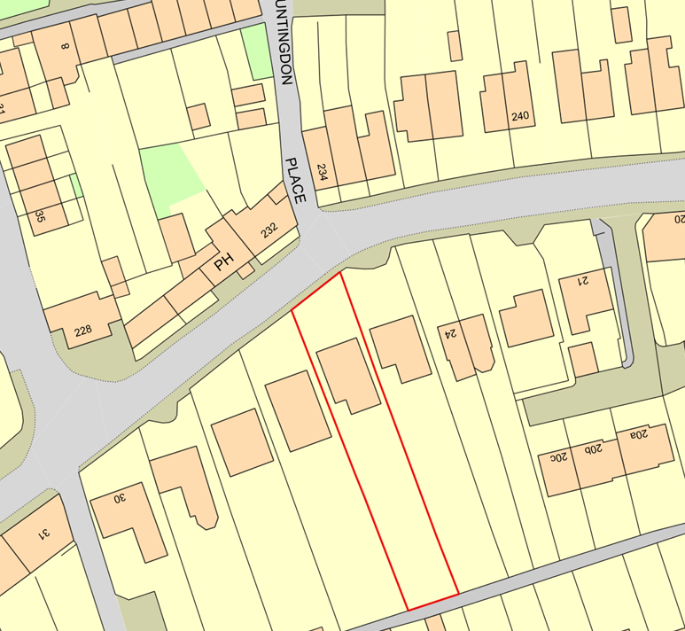

PROPOSAL

The proposal seeks permission for the removal of an existing conservatory and the erection of a single-storey rear garden room in its place, alongside the replacement of an existing patio with a slightly raised terrace flush with the new doors. At first floor level, the development comprises an extension above the existing rear projection, including an enlarged dormer structure to facilitate the creation of two additional bedrooms, increasing the number of first-floor bedrooms from two to three. External alterations include rendering and painting of the rear elevation, replacement fascia and guttering to match the existing dwelling. Internal alterations are also proposed to reconfigure the ground floor layout, including the conversion of existing bedrooms to ancillary residential uses such as a larger kitchen/dining area and a study.

SITE DESCRIPTION / CONTEXT

The application site comprises a residential dwelling located within an established built-up area characterised by a mix of property styles and materials typical of a semi-rural settlement. The site lies outside, but in close proximity to, the Bradford on Avon Conservation Area, which begins on the opposite side of the road (CA/W/31). The wider area is defined by traditional features including stone boundary walls with cock-and-hen coping, hedgerows, and mature planting, contributing to a verdant street scene. The surrounding properties are predominantly residential in nature, with varied architectural detailing and driveway treatments such as gravel, brick, and tarmac. The site also falls within ecological consultation zones, including the 4km Core Roost Buffer and SAC Parcel Buffer for Greater Horseshoe Bats, as well as the 2km Core Roost Buffer for Lesser Horseshoe Bats. The Council’s Strategic Flood Risk Assessment identifies the site as lying within Flood Zone 1, with no recorded risk of flooding from ground or surface water sources.

PLANNING HISTORY

Reference No. | Proposal / Summary | Decision
20/09992/FUL | Provide dropped kerb to form vehicle access | Approved
W/85/00863/FUL | Rear extension | Approved
PL/2022/00949 | Erection of garden room and childrens playhouse (retrospective application). | Approved

RELEVANT LEGISLATION, POLICIES AND GUIDANCE

Wiltshire Core Strategy:

Core Policy 1 Settlement Strategy;
Core Policy 2 Delivery Strategy;
Core Policy 7 Spatial Strategy: Bradford on Avon Community Area;
Core Policy 50 Biodiversity and Geodiversity;
Core Policy 51 Landscape;
Core Policy 57 Ensuring High-Quality Design and Place Shaping;
Core Policy 58 Ensuring Conservation of the Historic Environment;
Core Policy 60 Sustainable Transport;
Core Policy 61 Transport and Development;
Core Policy 64 Demand Management;
Core Policy 67 Flood Risk;

Bradford on Avon Neighbourhood Plan 2013-2026

The National Planning Policy Framework (NPPF)

The Planning Practice Guidance (PPG)

Wiltshire Design Guide - Appendix D – Design Guidance for Householder extensions

The Wiltshire Local Transport Plan 2011 – 2026: Car Parking Strategy (March 2015).

The Wiltshire Local Transport Plan 4 (LTP4) (March 2025)

Emerging Policy – Wiltshire Local Plan Review

At Full Council on 19 May, the elected members of Wiltshire Council agreed to withdraw the emerging WLP. It will now be subject to a legal process to finalise its withdrawal - which is likely to happen in July or August (2026). The said Plan has no material weight for the purposes of the application.

CONSULTATION RESPONSES

Bradford on Avon Town Council – No Objection

REPRESENTATIONS

The application was publicised in accordance with statutory requirements and has generated a total of four representations, comprising two objections (including one from a local amenity group) and two comments of support, one of which raises a concern subject to clarification. The objections raise concerns in relation to the design and scale of the proposed development, particularly the size and appearance of the dormer which is considered by one party to be excessive and lacking sensitivity, as well as the potential for harm to neighbouring residential amenity through overlooking and loss of light. In particular, one neighbouring occupier raises concerns regarding the impact on an east-facing ground floor bedroom window, which currently receives morning sunlight, citing the potential for reduced daylight and an overbearing relationship due to the height and proximity of the first-floor extension. Concerns are also raised regarding increased overlooking, particularly associated with the proposed balconies, with suggestions that Juliet-style balconies would be preferable to mitigate this impact. Additional points reference the design approach taken in similar extensions within the row and the need to ensure compliance with relevant guidance and any existing planning conditions. In contrast, the two supporting representations confirm no objection to the principle of the development, with one adjacent neighbour expressing full support and the other raising only a limited concern relating to potential overlooking from the proposed balconies and indicating that this would be acceptable if restricted to a Juliet balcony form. It is noted that amended plans were subsequently submitted which removed the proposed balconies that formed part of a number of the concerns raised.

ASSESSMENT

Section 38(6) of the Planning and Compulsory Purchase Act 2004 states:

"If regard is to be had to the development plan for the purposes of any determination to be made under the planning Acts, the determination must be made in accordance with the plan unless material considerations indicate otherwise."

In accordance with this statutory requirement, this application has been assessed against the relevant policies of the Development Plan, including the adopted Wiltshire Core Strategy (2015) and, where applicable, any made Neighbourhood Plans.

Householder extensions are generally acceptable in principle, as they typically fall within the established residential curtilage of a property and do not result in new residential development in the open countryside. In this case, the proposal also lies within the defined limits of development set out in the Core Strategy, further reinforcing its acceptability in principle.

Design and Impact the upon the character and context of the area

Core Policy 57 Ensuring High Quality Design and Place Shaping of the Wiltshire Core Strategy requires all new development to achieve a high standard of design that responds positively to its local context. Proposals must reinforce and enhance local character and distinctiveness, relate appropriately to the surrounding landscape, and demonstrate a thoughtful response to existing townscape features. This includes careful consideration of elements such as building height, scale, massing, building line, materials, and overall appearance, ensuring new development integrates harmoniously with its setting. Core Policy 58 outlines development consideration with regard to the historic environment. The policy states that heritage assets and their settings must be conserved and, where appropriate, enhanced through any proposed development.

The proposal would introduce a number of alterations to the host dwelling which, when taken cumulatively, would partially rationalise the existing built form. The dwelling currently presents as a property that has been extended incrementally over time, resulting in a degree of visual fragmentation arising from the combination of a dormer addition, flat roof rear extension, and conservatory. The proposed replacement of the conservatory with a more permanent garden room structure of similar footprint represents a positive intervention, removing a lightweight and dated addition and replacing it with a form that is more closely aligned in design terms with the host dwelling. Similarly, the proposed external finish to the rear dormer, replacing the existing shingle-style cladding with render, would provide a more cohesive and unified appearance. Whilst render does not directly replicate the bath stone characteristic of the host dwelling and surrounding properties, it is considered to represent an improvement in visual coherence when compared to the existing material palette.

Notwithstanding these positive aspects, there remain elements of the proposal which are less successful in design terms. The extension and alteration of the existing rear dormer would result in an increase in its scale and prominence, further emphasising a form of development that is not typically regarded as a high-quality design feature. Whilst it is acknowledged that flat roof dormers are a common and often necessary solution in residential extensions, and that there is a degree of local precedent for such forms within the locality, the enlargement of the structure does not significantly enhance the architectural composition of the host dwelling.

During the course of the application, amended plans were submitted which removed the previously proposed raised roof feature and instead continued the dormer extension with a flat roof form that remains below the ridgeline of the original dwelling. This amendment represents a significant improvement in design terms. The revised roof form is more respectful of the host dwelling, maintains the primacy of the original roof structure, and better accords with the established principle that extensions should remain subordinate to the building they serve.

The amended plans also reduce the depth of the dormer extension and remove the previously proposed balconies from the rear elevation. Whilst these changes are principally relevant to the assessment of residential amenity, they also reduce the overall visual prominence of the development. As amended, the proposal presents a more coherent and less visually intrusive form of development which integrates more successfully with the existing dwelling.

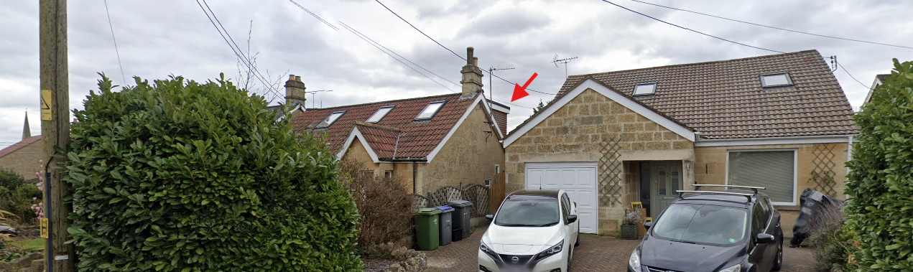
Street-scene View

In assessing these impacts, it is important to recognise that the works are confined to the rear elevation, where visibility from the public realm is limited. The site benefits from substantial boundary treatments and vegetation, and there is no immediate public vantage point to the south of the property. Whilst glimpsed views of the existing dormer are currently available from the street, particularly at oblique angles when passing the site, it is acknowledged that the increased scale of the dormer would incrementally increase its visibility. However, this impact remains limited in the context of the wider street scene.

On balance, whilst the enlarged dormer would inevitably increase the scale and prominence of built form at the rear of the property, the submitted amendments have significantly improved the overall design quality of the proposal. The revised roof form is subordinate to the host dwelling, the material palette would improve the visual coherence of the existing building, and the removal of the balconies reduces visual clutter on the rear elevation. Given the limited visibility of the development from the public realm and its contained position to the rear of the site, the proposal would not result in significant harm to the character or appearance of either the host dwelling or the wider area. As such, the development is considered to accord with the design objectives of Core Policy 57 and would preserve the setting of the nearby Bradford on Avon Conservation Area in accordance with Core Policy 58.

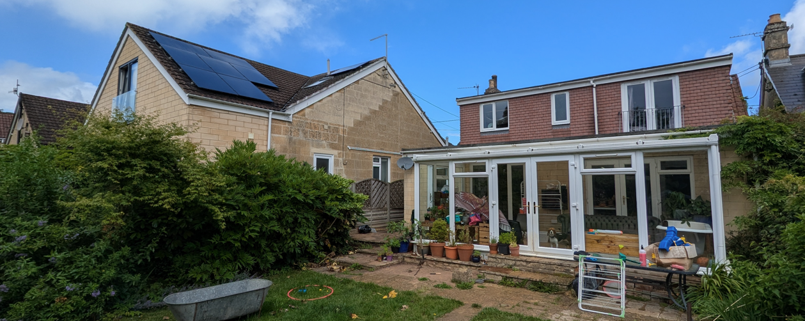
Site Visit (Rear elevation)

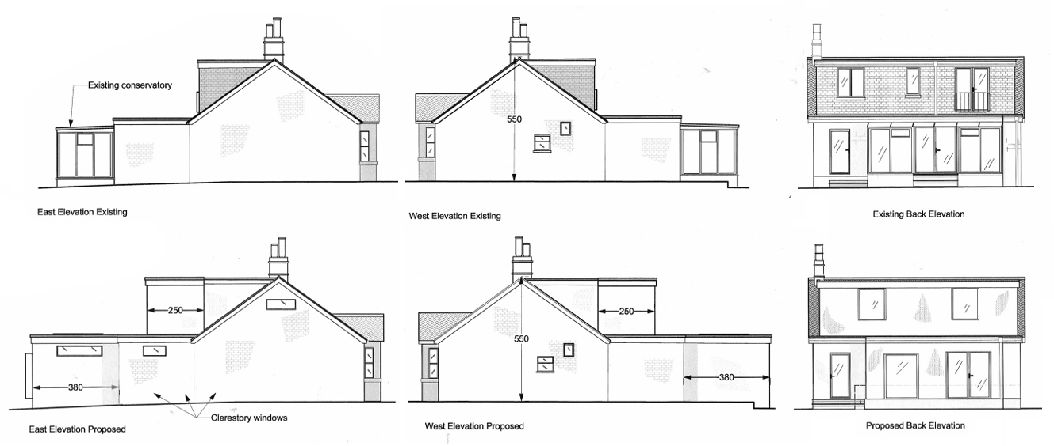
Existing and Proposed Elevations

Having regard to the above, the proposal complies with the design principles set out in Core Policy 57 of the Wiltshire Core Strategy and Appendix D of the Wiltshire Design Guide.

Amenity

Point vii of Core Policy 57 of the Wiltshire Core Strategy seeks to ensure that development proposals do not result in unacceptable impacts on the amenity of neighbouring occupiers. Paragraph 135 of the National Planning Policy Framework similarly requires that development provides a high standard of amenity for existing and future users. In this context, consideration has been given to the potential impacts of the proposal on neighbouring residential amenity, with particular regard to outlook, light, and privacy.

In terms of daylight and sunlight, the primary concern relates to the impact of the first-floor extension on the neighbouring dwelling to the west, specifically an east-facing ground floor bedroom window which serves as the sole source of natural light to that room. Light modelling demonstrates that the proposal would result in an increase in early morning overshadowing, most notably in summer months. This is illustrated within the submitted images for 21 June at approximately 08:00 and 09:30, which represent a reasonable worst-case scenario. These show that, whilst the window would remain in shadow for a longer period during the early morning, direct sunlight would still be received later in the morning and throughout the remainder of the day.

The amended plans reduce the depth of the first-floor extension by approximately 1 metre when compared to the original submission. As a result, the extent and duration of additional overshadowing is marginally reduced from that previously assessed. Whilst there remains a measurable impact upon direct morning sunlight, the modelling demonstrates that the affected window continues to receive direct sunlight during core daylight hours and that any additional shadowing is largely confined to the earlier part of the day. On this basis, it is not considered that the proposal would result in a harmful loss of daylight or sunlight to the neighbouring bedroom.

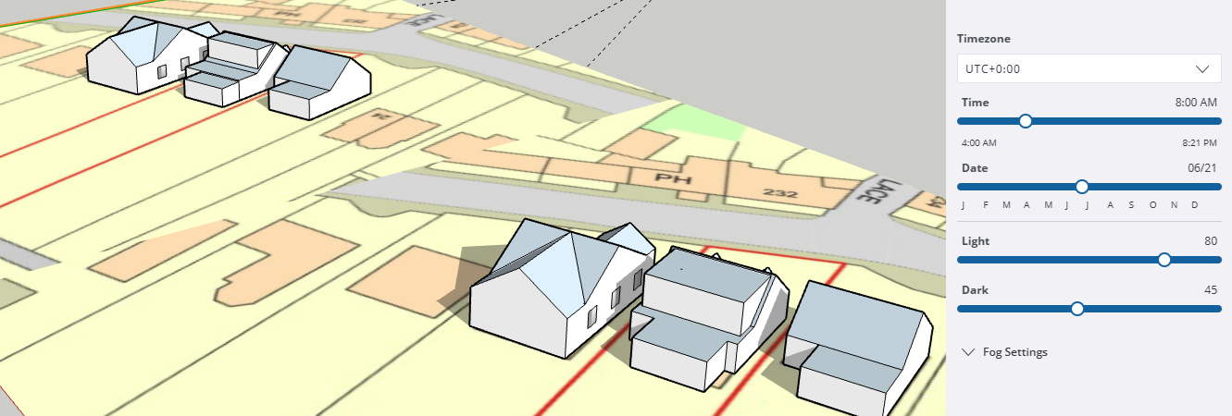
Existing and Proposed Light Impact (June 21 at 8am)

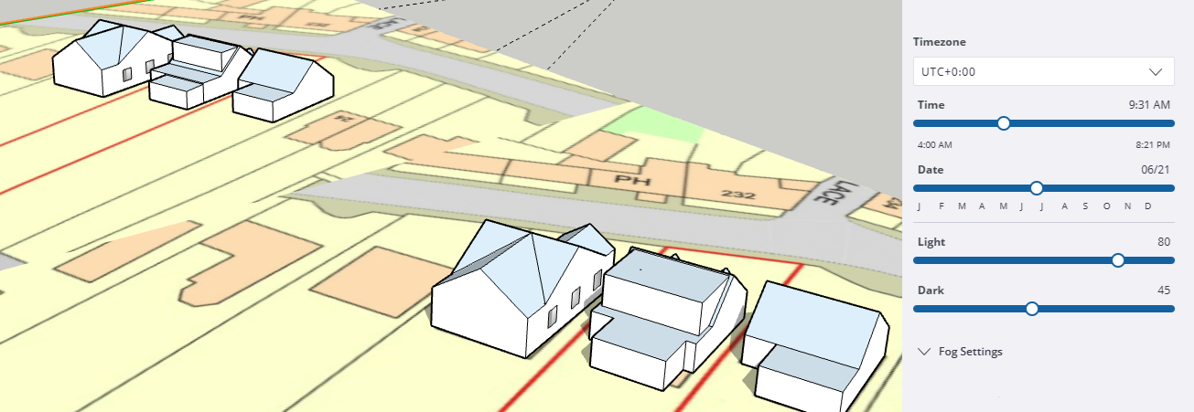
Existing and Proposed Light Impact (June 21 at 9:30am)

Consideration has also been given to the impact of the proposal upon outlook and the sense of enclosure experienced from the neighbouring bedroom. It is acknowledged that this side-facing window occupies an unusual position within the built form and already experiences a degree of enclosure owing to its proximity to the neighbouring dwelling and existing single-storey extension. Whilst occupants are currently afforded views above the existing roofline, much of the outlook from the room is already characterised by neighbouring built form and as such the baseline relationship is already somewhat enclosed.

The proposed first-floor extension would inevitably increase the perception of enclosure experienced from this window by introducing built form above the existing roof projection. However, the revised plans materially reduce this impact. By setting the rear elevation of the extension back by 1 metre and removing the previously proposed raised roof feature, the amended scheme retains a greater degree of openness to the south and south-east than the original proposal. When viewed from within the room, particularly towards the rear of the property, outlook beyond the neighbouring single-storey extension would continue to be available and views towards the rear gardens would remain possible.
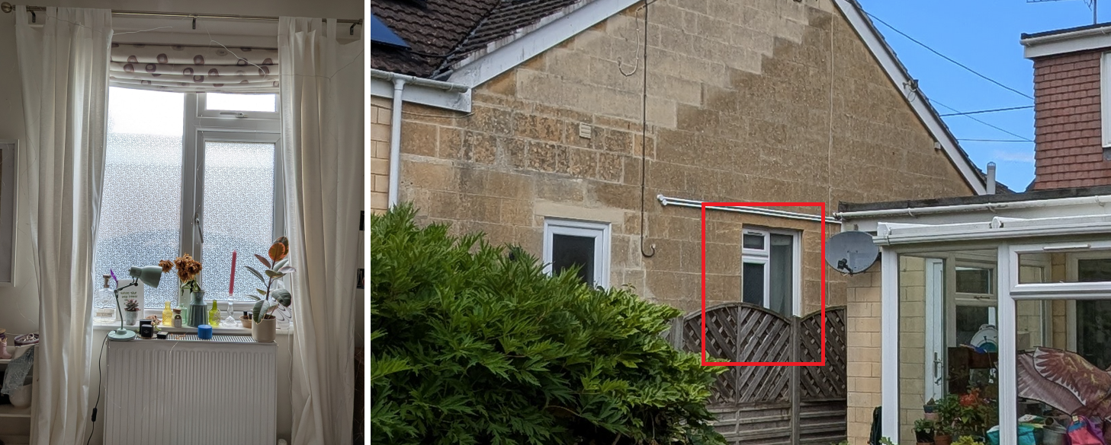
27 Winsley Road (East facing window)

Whilst the development would therefore alter the existing relationship and increase the level of enclosure experienced from the room, it is not considered that the resulting impact would be so severe as to render the bedroom unacceptably oppressive or to materially diminish its reasonable enjoyment. On balance, the amended scheme is judged to retain an acceptable level of outlook given the suburban context of the site and the existing relationship between the two properties.

In respect of privacy, the amended plans remove the previously proposed balconies and replace these with conventional first-floor windows. The relationship between the proposed windows and neighbouring properties remains broadly consistent with the established pattern of rear-facing windows present throughout the surrounding residential area. Whilst the enlarged dormer would permit some additional views when compared to the existing arrangement, these would remain oblique in relation to neighbouring properties and would not give rise to any material loss of privacy beyond that typically expected within a residential environment.

Overall, whilst the proposal would result in some additional enclosure when experienced from the neighbouring side-facing bedroom window, the amended plans have significantly reduced the extent of this impact. When considered alongside the limited effect on daylight and sunlight and the removal of the proposed balconies, the proposal is not considered to result in unacceptable harm to neighbouring residential amenity. The development therefore accords with Core Policy 57 (vii) of the Wiltshire Core Strategy and the amenity objectives of the National Planning Policy Framework.

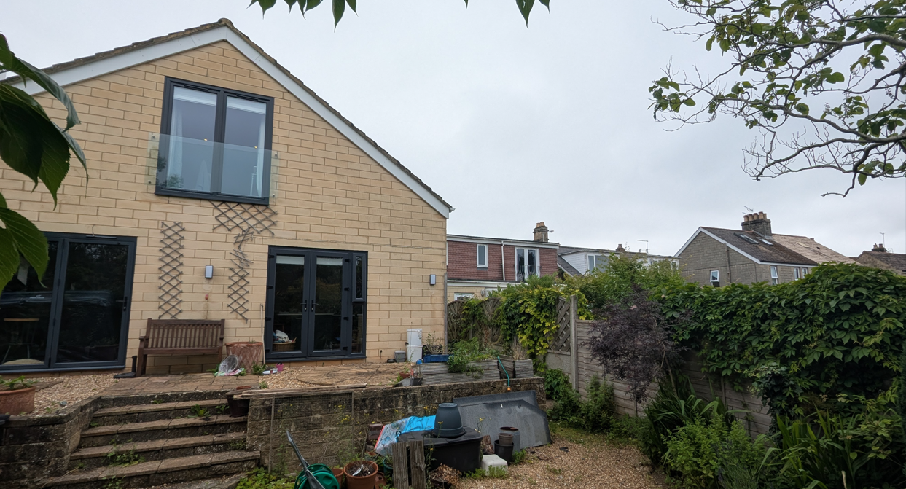
View from garden of 27 Winsley Road

Transport and Highways

Core Policies 60 and 61 of the Wiltshire Core Strategy seek to ensure that development provides safe and efficient movement and appropriate access arrangements, whilst Core Policy 64 and associated guidance require adequate parking provision. Paragraph 116 of the National Planning Policy Framework advises that development should only be refused on highways grounds where impacts would be severe. In this instance, the proposal does not intensify the use of the dwelling in highway terms, as there is no net increase in the number of bedrooms when compared to the existing lawful arrangement. Furthermore, no changes are proposed to the existing access or parking arrangements serving the site. As such, it is considered that the development would not give rise to any adverse impacts on highway safety or parking provision, and the proposal is therefore compliant with the above policies.

Ecology

Core Policy 50 of the Wiltshire Core Strategy seeks to ensure that development avoids harm to protected species and habitats. Whilst Biodiversity Net Gain (BNG) is now a mandatory requirement introduced under Schedule 7A of the Town and Country Planning Act 1990 (as amended), householder applications are exempt from this requirement under Section 4(2)(a) of the same Act. In this instance, the proposal relates to a modest domestic extension within the curtilage of an existing residential property, with only a very limited increase in footprint associated with the replacement of the conservatory. The works are confined to an established residential garden and areas of hardstanding, where the potential for ecological value is low. Although works are proposed to the roof, these are limited to the existing flat roof section of the dormer, where the likelihood of protected species presence is also considered to be low. Notwithstanding this, the site lies within identified ecological buffer zones, and therefore an informative is recommended to remind the applicant of their ongoing legal obligations under the Wildlife and Countryside Act 1981, particularly in the event that protected species are encountered during construction. Subject to this, the proposal is considered to accord with Core Policy 50.

Flooding and Drainage

Core Policy 67 of the Wiltshire Core Strategy requires development to minimise flood risk and ensure appropriate surface water management. The application site is located within Flood Zone 1 and the Council’s Strategic Flood Risk Assessment identifies no risk from ground or surface water flooding. The proposal represents a very modest alteration in drainage terms, with only a negligible increase in built footprint associated with the replacement garden room, largely over an existing developed area. As such, there would be no material increase in impermeable surface area or surface water runoff. Given the scale and nature of the development, a site-specific flood risk assessment is not considered necessary, and it is concluded that the proposal would not increase flood risk on or off site, in accordance with Core Policy 67.

Planning Balance

In overall planning terms, the proposal represents a form of domestic extension that is acceptable in principle and would provide improved family accommodation through the reconfiguration and enlargement of the existing dwelling. The revised scheme would also deliver design improvements through the replacement of the existing conservatory with a more cohesive garden room structure, the rationalisation of external materials, and amendments to the dormer design which improve its relationship with the host dwelling and reduce its visual prominence.

The development has been carefully considered in respect of its impacts on design, neighbouring amenity, highways, ecology, flood risk, and the historic environment. The amended plans have addressed a number of the concerns identified during the course of the application, including the removal of the proposed balconies, the revision of the dormer roof form, and a reduction in the depth of the first-floor extension. Whilst it is acknowledged that the proposal would result in some increased enclosure when experienced from the neighbouring side-facing bedroom window, the amended scheme is considered to retain an acceptable level of outlook and would not result in unacceptable harm to residential amenity. Similarly, the impacts on daylight and sunlight are considered to be limited, and no material privacy concerns are identified.

The proposal is therefore considered to accord with the relevant provisions of the Wiltshire Core Strategy, the Wiltshire Design Guide, and the National Planning Policy Framework. Taking all matters into account, it is concluded that any limited adverse impacts identified are not considered sufficient to outweigh the benefits of the development, and the proposal represents sustainable development for which planning permission should be granted.

CONCLUSION

The proposed development, comprising a first-floor extension and replacement rear garden room, is acceptable in principle and would provide improved internal accommodation for the occupants of the dwelling. The amended scheme is considered to achieve an acceptable standard of design, with the revised dormer form reducing its visual prominence and improving its relationship with the host dwelling. The proposal raises no concerns in respect of highways, ecology, flood risk, or heritage impacts. Careful consideration has also been given to the potential effects on neighbouring residential amenity, particularly in respect of daylight, sunlight, outlook, enclosure, and privacy. Whilst concerns were identified during the assessment of the original submission, the submitted amendments, including the reduction in depth of the first-floor extension, removal of the balconies, and revision of the roof design, have satisfactorily addressed these issues. The proposal is therefore not considered to result in unacceptable harm to neighbouring occupiers and is judged to accord with Core Policy 57 of the Wiltshire Core Strategy and the amenity objectives of the National Planning Policy Framework. Accordingly, the proposal complies with the development plan when read as a whole and is recommended for approval subject to appropriate conditions.

RECOMMENDATION: That Planning Permission be GRANTED subject to the following conditions:

1.
The development hereby permitted shall be begun before the expiration of three years from the date of this permission.
REASON: To comply with the provisions of Section 91 of the Town and Country Planning Act 1990 as amended by the Planning and Compulsory Purchase Act 2004.

2.
The development hereby permitted shall be carried out in accordance with the following approved plans and documents:

Location Plan
Side Elevations Existing and Proposed (Rev 2 05/07)
Rear Elevation Existing and Proposed (Rev 2 04/07)
Ground Floor Plans Existing and Proposed (Rev 1 01/07)
Roof and Boundary Plans Existing and Proposed (Rev 2 06/07)
First Floor Plans Existing and Proposed (Rev 2 02/07)

REASON: For the avoidance of doubt and in the interests of proper planning.

