APPLICATION FOR LISTED BUILDING CONSENT OFFICER DELGATED REPORT

APPLICATION REFERENCE: | PL/2025/08672
APPLICATION TYPE: | Listed building consent (Alt/Ext)
SITE ADDRESS: | Conholt Park, Conholt Lane, Conholt, Andover, SP11 9HA
DESCRIPTION OF WORKS: | Retention of works comprising of New Internal Doorway to Crockery Store relating to Ancillary Building B3.
RECOMMENDATION: | Approve with Conditions

SITE DESCRIPTION/CONTEXT

The application site relates to a large, detached dwelling with associated outbuildings, courtyard stables, walled garden and wider gardens, all situated within approx. 2500 acres of rural estate parkland. The property has two main vehicular accesses one from the south west and one from the north west. The dwelling is grade 2* listed and the Conholt Stable and Carriage House are Grade II listed buildings as identified by the dark black hatching on the GIS map below:

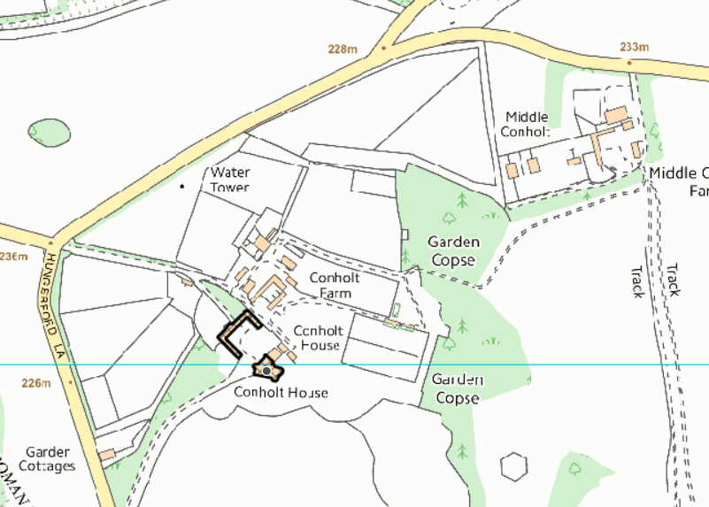

The site is located within the North Wessex Downs National Landscape (formerly known as Area of Outstanding Natural Beauty (AONB)).

Listing

CHUTE - SU 35 NW 6/66 Conholt Park 4.6.52 II*

House in parkland. Late C17, C18 and early C19. Red brick, extended in buff-grey brick with stone dressings to openings, green slate roof. Two storeys, attics and cellars. Original building of late C17, probably 4 bays but partly demolished at north east end. Large south wing forming new front, 1810-11 of 7 bays, further extended later C19 by projecting and canted bay on right, and with billiard room with canted bay to rear. Original block and front build at angle to each other, with entrance at junction, a semicircular Tuscan portico of 4 columns and entablature. Glazed doors. South front has 15-pane sashes to ground floor, 12-paned to upper floor, all with moulded architraves, pulvinated frieze and cornice. Facade has cornice with paired modillion eaves and parapet. Interior has two elegant early C19 drawing and sitting rooms in south west. Through wide corridor from entrance leads to oval central stair hall at rear, with good flying stair and metal balustrade. Earlier wing has mid C18 close-balustered dog-leg stair. Externally, in north re-entrant angle, a disused horse gin by Tasker & Sons of Andover.

Listing NGR: SU3244355004

CHUTE - SU 35 NW 6/67 Stable and carriage house at Conholt Park II

Stable and carriage house on 3 sides of yard. Early-mid C18, extended in late C18. Brick with tiled roofs. Central block facing main house, 4 bays, of vitrified header bond. Two central bays slightly broken forward and pedimented, with brick strings representing cornices. Clock in pediment. Bell tower on 6 columns with domed lead roof and wind vane. Two large carriage arches with timber doors. Outer bays similar large arches and parapet. Block is extended either side as groom's and stable boy's dwellings, each of 2 bays with 6-panelled doors and leaded 3-light windows. Courtyard formed by stable wings, that to left of flint with brick dressings and tiled roof. Varied openings, including 4 doors and timber windows with leaded glazing. Right wing has 5-bay blank shallow arcade. Two carriage house doors now covered with later C19 steel glazed roof on columns. Stable doors and leaded windows. Passage at junction with main block leads to farm to rear.

Listing NGR: SU3240655018

PROPOSAL

The application is seeing retrospective consent for works undertaken, the applicant has laid out the works undertaken within the covering letter and included below -

Ancillary Building (B3) The changes to the ancillary areas addressed critical operational needs while respecting the building's historic fabric:

• New Internal Doorway to Crockery Store (G01) –

This pragmatic modification resolved a significant functional challenge in the preparation areas. Following the approved layout, staff would have had to use an external route to access essential equipment - a situation thoroughly documented in the Estate Director's statement as being incompatible with modern food hygiene standards.

The new doorway:

Was carefully formed within an existing external wall, which had been altered previously o Brought logical connectivity to adjacent food preparation areas
Preserved the original wall surfaces either side of the new opening
Preserved the external appearance of the building by retaining the existing door/window openings

New doorway highlighted in yellow on the submitted ground floor plan
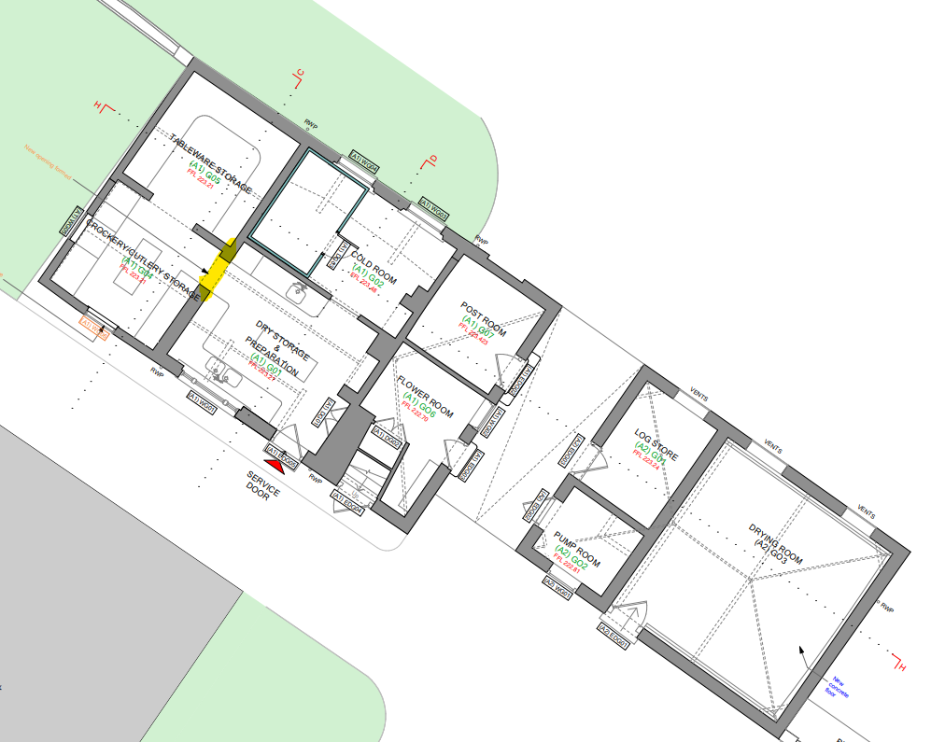

The justification for undertaking the works to the doorway have been detailed by the Estate Director in a letter which has been submitted to support the application. This is included below.

The Preparation Room (G03) & Cold/Freezer Room (G04) will form the operational hub where initial food preparation, plating set-up, and post-service cleaning (including dishwashing) will be conducted. Adjacent to these spaces will be storage facilities for Tableware (G01) & Crockery (G02), used in both preparation and final service.

To ensure seamless functionality, an internal doorway connecting these two sets of spaces is necessary for the following reasons:

1. Hygiene and Compliance: Food handling operations within the estate will follow commercial kitchen standards, which minimize cross-contamination and unnecessary handling. Direct access between the preparation and storage areas will prevent transit through intermediate zones, supporting hygiene protocols by reducing exposure risk.

2. Workflow Deficiency: Staff will be required to access service equipment promptly during set-up and/or cleaning phases. Without direct access, personnel would be required to exit and re-enter adjacent service areas, affecting efficiency and increasing footfall through shared zones, which is counter to best practices.

3. Safe and Controlled Movement: The handling of hot or sharp equipment during peak preparation and cleaning times necessitates clear, unobstructed, and direct routes. This internal doorway provides a safe connection allowing equipment to be transported securely, thereby reducing the likelihood of accidents.

4. Staff Segregation and Functional Zoning: Food service environments benefit from zoning that segregates clean and dirty processes. A direct link between preparation and storage supports this by avoiding operational conflicts that could arise from external or shared circulation spaces. In conclusion, the provision of an internal doorway is justified and critical to maintaining a hygienic, safe, and efficient operation for professional food handling and service delivery

Some of these alterations are linked to the development approved under listed building application PL/2024/03197 and associated full planning application PL/2024/02791. Application PL/2024/02791 is subject to a current S73 application (PL/2025/06421) to vary the approved plans list to align with the plans submitted with this listed building application however the changes made and seeking retrospective consent relate to an internal door only for which only listed building consent is required and technically does not require full planning or an associated S73 application. As the original full and listed building permission were submitted as a joint application with the same plans, any changes made on either permission will require the associated permission to update their plans list to ensure the development remains in accordance with the agreed plans.

The proposals were initially submitted through a S19 application to vary the plans list condition of the original listed building consent. However, this is not a process that is possible for listed building consent to vary the plans and therefore this application was withdrawn and this current listed building application submitted.

RELEVANT PLANNING HISTORY

The application site has an extension site history, of particular relevance to this application are the following which relate to phase 5 of the whole project at Conholt Park:

PL/2024/02791 Alterations and refurbishment of the Courtyard stable (B4) comprising external works for purposes ancillary to the use of Conholt House. Approved

PL/2024/03197 Alterations and refurbishment of the Courtyard stable (B4) comprising internal and external works, and alterations to two ancillary buildings (B2 & B3) comprising internal and external works. Approved

PL/2025/06421 Variation of condition 2 (Approved Docs/ Plans) relating to application PL/2024/02791 Please see Covering Letter. UNDER CONSIDERATION RECOMMENDED APPROVAL

RELEVANT LEGISLATION, POLICIES AND GUIDANCE

Section 66 of the Planning (Listed Buildings and Conservation Areas) Act 1990 requires ‘special regard’ to be given to the desirability of preserving a listed building or its setting. In addition, Section 16 of the Act states that in considering whether to grant listed building consent for any works the local planning authority shall have special regard to the desirability of preserving the building or its setting or any features of special architectural or historic interest which it possesses.

Core Policy 57 states that new development is expected to create a strong sense of place through drawing on the local context and being complementary to the locality. Core Policy 58 aims to ensure that Wiltshire’s heritage assets such as the conservation area are protected and enhanced in order that they continue to make an important contribution to Wiltshire’s environment and quality of life.

The site is within the North Wessex Downs National Landscape. Core Policy 51 seeks to protect, conserve and enhance Wiltshire’s distinctive landscape character and development ‘must not have a harmful impact upon landscape character, while any negative impacts must be mitigated as far as possible through sensitive design and landscape measures.’

The NPPF states that the planning system should contribute to and enhance the natural and local environment by protecting and enhancing landscape and scenic beauty in valued landscapes, which include National Landscapes and that the scale and extent of development should be limited and sensitively designed and located to avoid or minimise adverse impacts.

ISSUES

Impact upon the preservation of the listed building or its setting or any features of special architectural and/or historic interest.

CONSULTATION RESPONSES

Conservation – No objections.

Historic England - Historic England has provided previous advice on aspects of this scheme, and have no further advice to offer on this current application. This should not be interpreted as comment on the merits of the application.

REPRESENTATIONS

None received

ASSESSMENT

In accordance with Section 16(2) of the Planning (Listed Buildings and Conservation Areas) Act 1990, special regard has been given to the significance of the listed building, including its architectural and historic interest, and the desirability of preserving both the building and its setting. Relevant policies within the National Planning Policy Framework (NPPF), particularly Section 16: Conserving and Enhancing the Historic Environment, have also been taken into account. These policies require that any harm to the significance of a designated heritage asset must be clearly justified and weighed against the public benefits of the proposal.

Impact of proposals on the significance and setting of the building/structure:

Understanding the impact of proposed works on a listed building requires a careful and proportionate assessment of how those changes affect the asset’s heritage significance and its setting. This includes both the physical alterations to the building itself and any changes to its spatial or visual relationship with surrounding structures or spaces.

The significance of a heritage asset is not static; it is shaped by its architectural, historic, and communal values, and by how these are experienced in context. Therefore, any intervention must be considered in light of the asset’s identified significance, with attention given to both potential harm and benefits. Benefits may include repairs that support the long-term conservation of the building, improved energy performance, or enhanced public access and understanding.

This assessment is grounded in the statutory duty under Section 16 of the Planning (Listed Buildings and Conservation Areas) Act 1990, which requires special regard to be given to the desirability of preserving the building and its features of special interest. It is also informed by national policy, particularly paragraphs 199–208 of the National Planning Policy Framework (NPPF), and relevant local heritage policies and guidance.

In this instance the main impact as above relates to the listed building, the Council’s conservation officer has been consulted and raised no objections, Historic England have also raised no objections. The full comments made by the conservation officer are included below -

The works relate to one of a pair of outbuildings dating from 1827 immediately to the east of the house. For the heritage assessment relating to this building see application PL/2024/03197. The revision is the provision of an internal doorway between rooms in kitchen-related use.

The adaptation of these historic buildings for the proposed use ensures their maintenance and is highly welcomed. It is clearly expressed why the internal connection is required, while the physical fabric lost is not of particularly special interest and would not affect any significance of the building's layout. I have no concerns.

The works undertaken at odds with the approved application PL/2024/03197 and now seeking retrospective consent are considered to be acceptable and raise no concerns in relation to the impact on the listed building and its setting.

CONCLUSION

The NPPF confirms that when considering the impact of a proposed development on the significance of a designated heritage asset, great weight should be given to the asset’s conservation (and the more important the asset, the greater the weight should be). It makes clear that any harm to a designated heritage asset requires clear and convincing justification.

In this case, the impact of the proposals on heritage assets will be largely positive or at worst neutral and the requirements of current conservation legislation, policy or guidance are considered to be met.

RECOMMENDATION: That Listed Building Consent be GRANTED, subject to the following conditions:

1. The development hereby permitted shall be carried out in accordance with the following approved documents and plans:

Application form received 30/10/2025
Cover Letter - Design and Access Statement received 30/10/2025
Proposed - Ancillary Elevations (2 of 2) 6369-AN-225 (A) received 30/10/2025
Proposed - Ancillary Ground Floor Plan 6369-AN-222 (A) received 30/10/2025
Proposed - Ancillary Roof Plan 6369-AN-223 (A) received 30/10/2025
Location Plan 6369-P5-SP-584 received 30/10/2025
Proposed - Ancillary Sections (1 of 1) 6369-AN-226 (A) received 30/10/2025
Proposed - Ancillary Basement Floor Plan 6369-AN-221 (A) received 30/10/2025
Proposed - Ancillary Elevations (1 of 2) 6369-AN-224 (A) received 30/10/2025
Covering letter dated 10/11/2025 received 30/10/2025

REASON: For the avoidance of doubt and in the interests of proper planning.

