3D Visualisations and Design Context
These visualisations support the Design and Access Statement for the proposed solar photovoltaic installation, replacement workshop and biodiversity tower at 5 The Tynings, Box Hill. The images demonstrate how the proposals integrate with the existing Victorian cottage, surrounding landscape and established built form.

Figure 1 – Site Context Overview
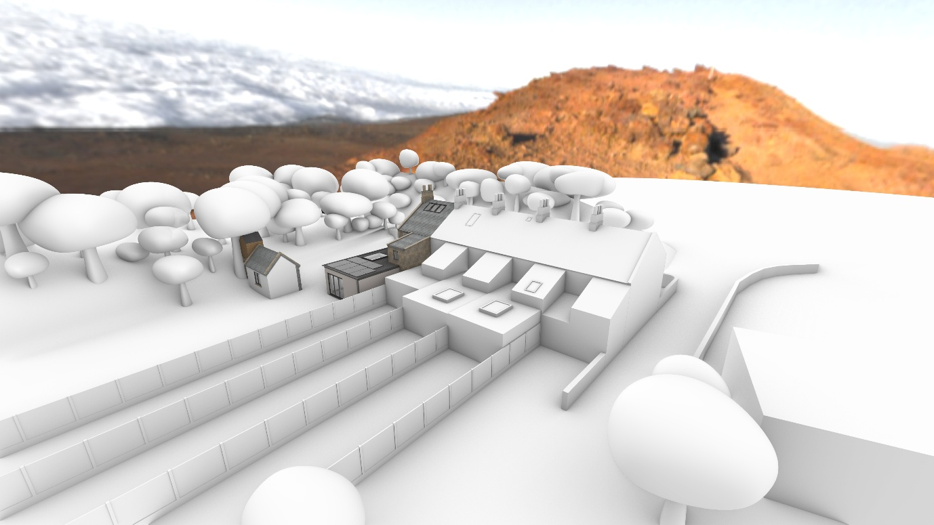This elevated view illustrates the relationship between the existing dwelling, the proposed replacement workshop and the surrounding landscape. The visualisation demonstrates that the workshop remains within an established developed area of the residential curtilage and does not result in encroachment into undeveloped countryside. The proposal preserves the openness of the Green Belt whilst improving the functionality and appearance of the site.

Figure 2 – Rear Context and Workshop Setting
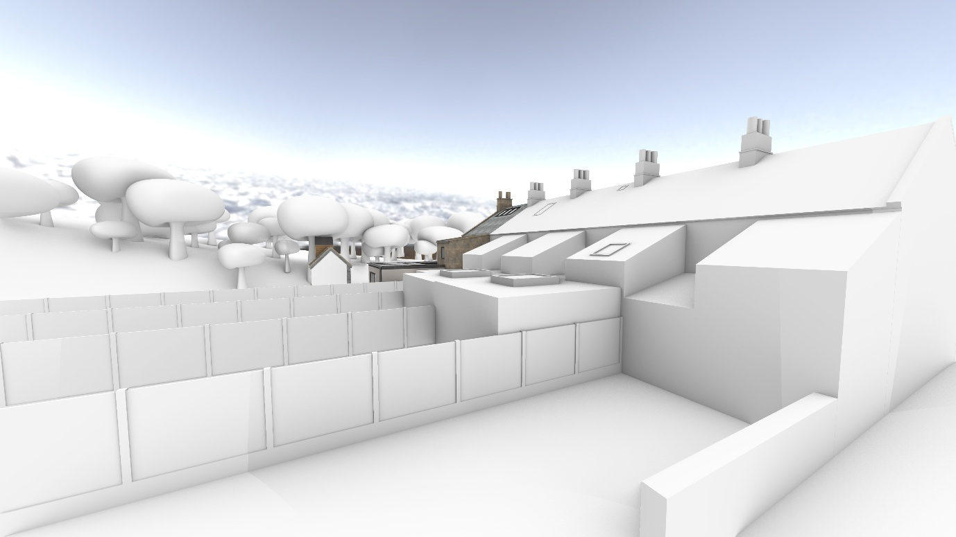This view demonstrates the modest scale of the proposed workshop and its relationship to the existing dwelling. The workshop has been designed as a subordinate ancillary structure inspired by traditional Victorian workshops commonly found throughout Box Hill and the surrounding quarry settlements.

Figure 3 – Front Elevation of Existing Dwelling
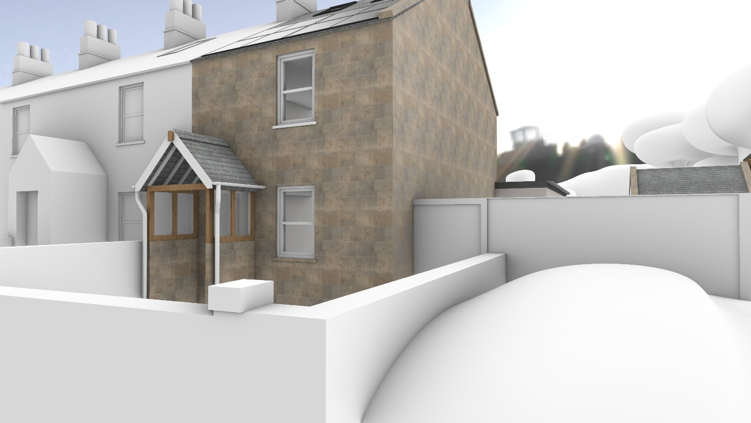
The visualisation illustrates the host dwelling and demonstrates that the proposed solar photovoltaic panels are confined to existing roof slopes. The all-black flush-mounted panels minimise visual impact whilst contributing significantly to the reduction of the property's operational carbon footprint.

Figure 4 – Streetscape and Local Character
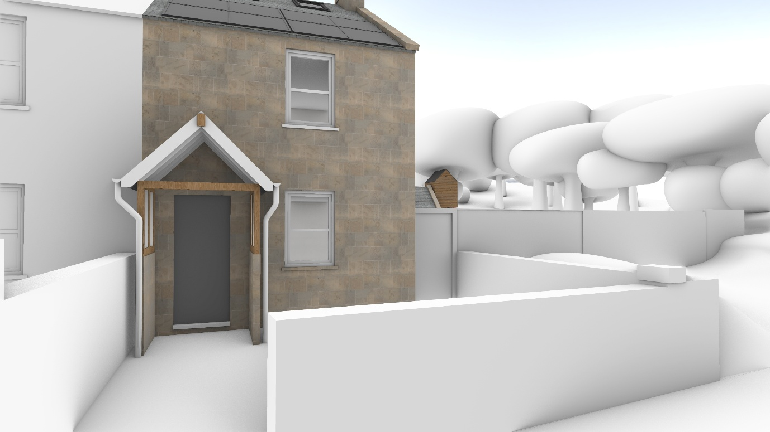This view demonstrates how the proposals respect the established character of The Tynings. The use of traditional materials, reclaimed stone and recycled slate ensures that the development remains sympathetic to the historic appearance of the terrace.

Figure 5 – Wider Landscape View
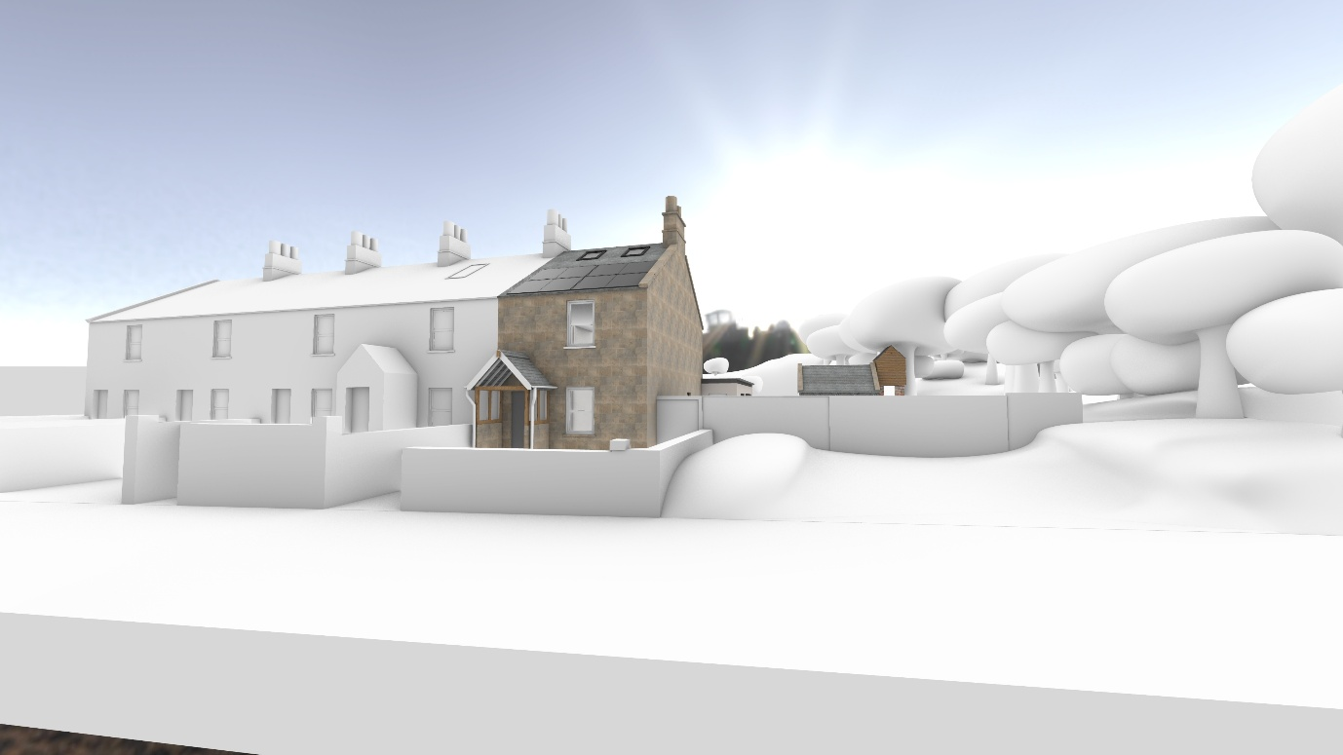The wider perspective demonstrates that the development remains visually contained within the existing residential curtilage. The proposal delivers sustainability, biodiversity enhancement and secure ancillary accommodation whilst maintaining the character of the Cotswold National Landscape.

Design Summary
The visualisations demonstrate the key objectives of the proposal: carbon reduction through renewable energy generation, replacement of a deteriorated historic workshop, biodiversity enhancement through the integrated wildlife tower, and preservation of the historic character of the property. The development has been carefully designed to remain proportionate, visually sympathetic and consistent with the principles set out in the Design and Access Statement.

