Solar Survey and Energy Assessment
5 The Tynings, Box Hill, Wiltshire

Executive Summary
The proposed solar installation comprises ten 400W* bifacial photovoltaic panels (4kWp total capacity), an 5kWh LiFePO4 battery storage system and AI-enabled energy management technology. The system has been specifically designed to maximise renewable energy generation from a constrained historic site through the use of dual roof orientations.

Household Energy Demand
Annual electricity consumption is approximately 2,800 – 3.300 kWh per annum, equivalent to an average daily demand of 7.7 kWh. Peak electricity demand occurs between 07:00–08:30 and 18:00–21:00.

Advanced Renewable Energy Technologies

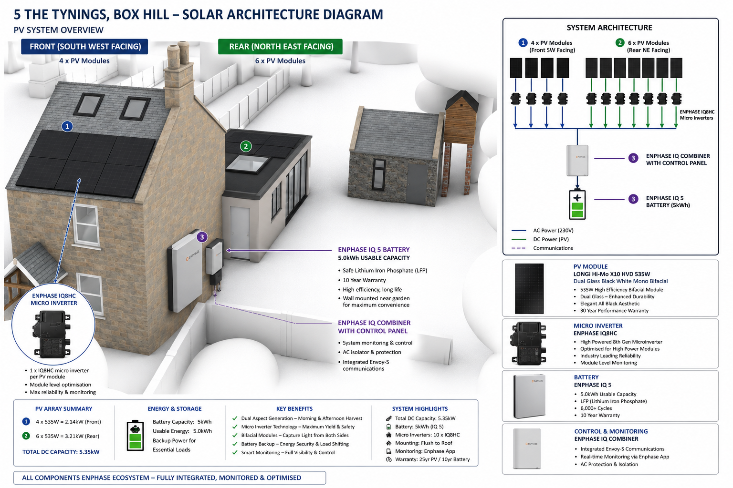

High-Efficiency Bifacial Solar Panels
The proposed system utilises advanced bifacial photovoltaic panels capable of generating electricity from both the front and rear surfaces. This enables the capture of direct, diffuse and reflected light, increasing annual energy yield compared with conventional panels.

LiFePO4 Battery Storage
An 5kWh Lithium Iron Phosphate battery system has been selected due to its enhanced safety, long lifespan, high efficiency and thermal stability. The battery can store approximately one full day of average household consumption and allows solar energy generated during the day to be used during evening peak demand periods.

AI-Enabled Energy Management
Artificial Intelligence enabled software continuously analyses generation, battery charge levels, household demand, weather forecasts and historical performance data. The system automatically optimises energy distribution to maximise self-consumption and minimise imported electricity.

Solar Array Configuration
Six 400W* panels (2.0kWp) are located on the north-east facing rear extension roof and provide generation from sunrise until approximately 14:00. Four 400W* panels (1.6kWp) are located on the south-west facing main roof and become increasingly productive from approximately 14:00 until the evening.
Solar modelling demonstrates that the rear roof experiences increasing shading after approximately 16:00, while the south-west roof remains illuminated. This complementary arrangement extends the generation window and improves battery charging opportunities.

Expected Annual Generation
Based on local solar irradiation data and the proposed technology stack, annual generation is expected to be between 3,200 and 3,500 kWh, with potential performance approaching 3,700 kWh under optimal conditions. Shading and losses for suboptimal facing panels should be equalized through better technology and energy usage. AI controlled storage and mains usage will also contribute to more efficient use of clean energy. Additional storage will be added if overproduction is identified.
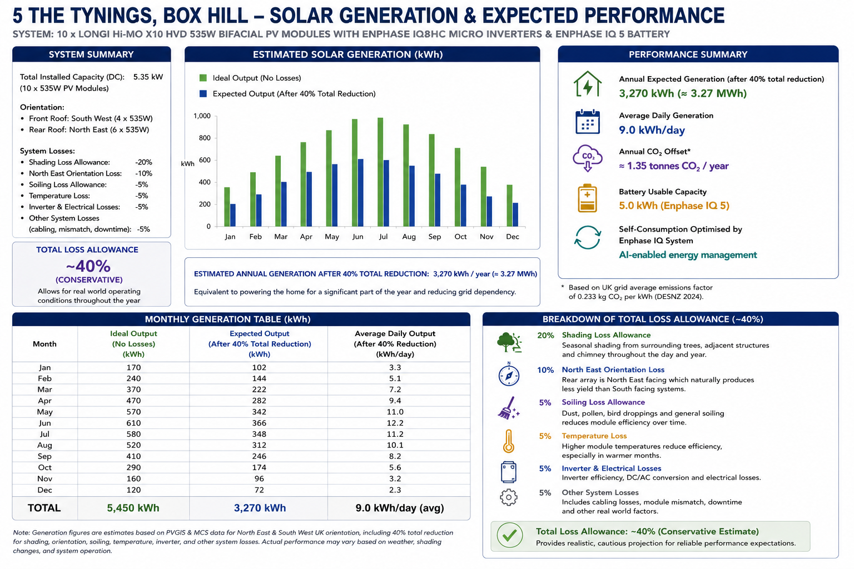

Energy Balance Assessment
The proposed solar installation is expected to generate an amount of electricity broadly equivalent to, or exceeding, the dwelling’s annual electricity demand of 2,800 -3,300 kWh. Self-sufficiency levels of between 80% and 95% are anticipated, significantly reducing dependence upon imported grid electricity.

Daily Energy Profile
Morning: Rear roof array generates electricity and charges the battery.
Afternoon: South-west array continues generation after the rear roof becomes shaded.
Evening: Stored energy is discharged to meet peak household demand between 18:00 and 21:00.

Planning Benefits
The proposal combines bifacial photovoltaic technology, LiFePO4 battery storage, AI-enabled energy optimisation and dual roof orientations to deliver a highly efficient renewable energy system. The approach maximises carbon reduction whilst minimising visual impact on the historic property and surrounding landscape.

* 535w Panels likely to deliver nearer 400w due to suboptimal orientation

