APPLICATION FOR HOUSEHOLDER PLANNING PERMISSION
DELEGATED REPORT

APPLICATION REFERENCE: | PL/2026/02710
APPLICATION TYPE: | Householder planning permission
SITE ADDRESS: | 66 Frome Road, Trowbridge, BA14 0DG
DEVELOPMENT DESCRIPTION: | Retrospective application to regularise external render and slate roof, along with proposed dropped kerb to facilitate two off-street parking bays.
RECOMMENDATION: | That Planning Permission be REFUSED

SITE DESCRIPTION/CONTEXT
The subject property is a late C19 end-terrace, two storey dwelling. The property is evident on 1st epoch mapping and is considered a NDHA.

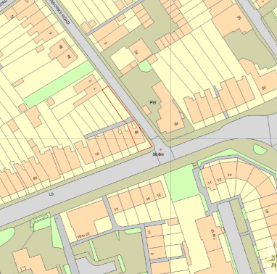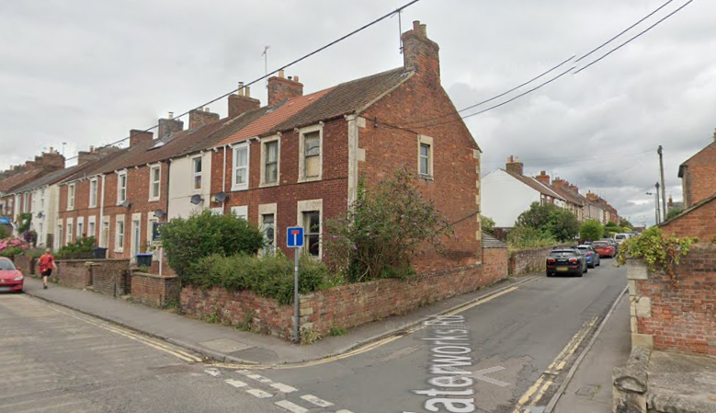
Location Plan and Google Earth Site Photo

The proposal site is southwest of Trowbridge town centre, on the corner of Waterworks Road, in an area of dense C19 development and with the Trowbridge (Newtown) Conservation Area.

The property is 36m from, and within sight lines of GII-designated no.2/4 Waterworks Road, also mid C19, also of red brick with slab window surrounds.

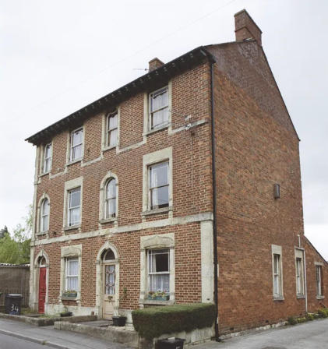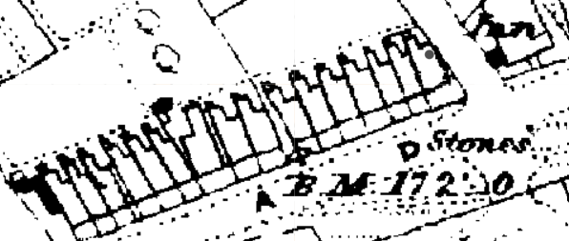
GII No’s 2-4 Waterworks Road and 1st epoch (1868-1899) mapping showing subject dwelling.

Whilst in flood zone 1 of lowest risk there is also a 25% increased groundwater flood risk.

PROPOSAL

The proposal is two-fold and seeks planning permission for:
- Regularise external render over external insulation and replacing the clay pantile roof with slate. This follows enforcement action - ENF/2025/00937.
- Proposed dropped kerb.

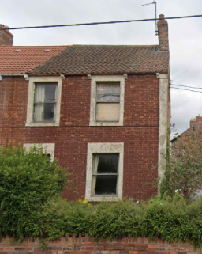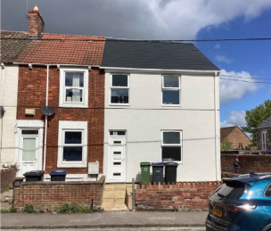

Previous and Proposed Front Elevation Photos

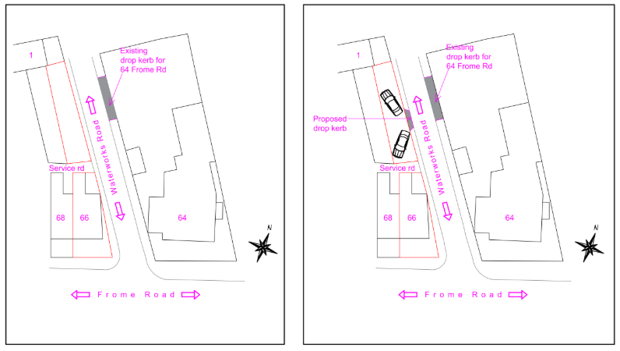
Existing and Proposed Site Plan
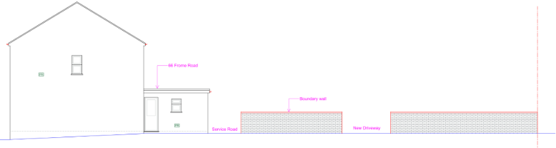
Proposed Access through boundary wall

PLANNING HISTORY

None.

RELEVANT POLICIES AND GUIDANCE
The Planning (Listed Building and Conservation Area) Act 1990,
Sections 16 and 66: Listed Buildings
Section 72: Conservation

The National Planning Policy Framework (NPPF)
The Planning Practice Guidance
National Design Guide
Wiltshire Design Guide: Appendix D – Design Guidance for Householder extensions

Wiltshire Core Strategy:
- Core Policy 57: Ensuring High Quality Design and Place Shaping
- Core Policy 58: Ensuring the Conservation of the Historic Environment
- Core Policy 61: Transport and New Development
- Core Policy 64: Demand Management
- Core Policy 67: Flood Risk

Trowbridge has a designated Neighbourhood Plan Area, but no made plans as yet.
Trowbridge Conservation Area Appraisal

CONSULTATION RESPONSES

Trowbridge Town Council:
No objection in relation to the retrospective works already carried out. However, an objection to the proposed parking arrangements due to the loss of on-street parking spaces arising from the creation of off-street parking and concerns identified within the swept path analysis.

Highways: object, stating the proposed development would result in an unacceptable impact on highways safety due to poor visibility, on what is a narrow road with high density parking, and narrow pavements. This report includes a more detailed assessment of the impacts on the highway network.

REPRESENTATIONS
5 comments received.

2 comments of objection: noting that the proposals seek to remove all architectural detailing, evident across the rest of the terrace, and in particular a highly visible end terrace, that slate is not consistent or appropriate with the terrace, the harmful impact of the development to character of the Conservation Area, impact to the setting of designated 2-4 Waterworks Lane, and inadequate supporting information regarding Highways impact.

3 comments of support: noting the previous poor state of repair of the property, complimenting the clean, renewed appearance, and reuse of a previously empty property.

ASSESSMENT
Section 38(6) of the Planning and Compulsory Purchase Act 2004 states:

"If regard is to be had to the development plan for the purposes of any determination to be made under the planning Acts, the determination must be made in accordance with the plan unless material considerations indicate otherwise."

In accordance with this statutory requirement, this application has been assessed against the relevant policies of the Development Plan, including the adopted Wiltshire Core Strategy (2015) and, where applicable, any made Neighbourhood Plans.

Heritage, Design and Impact upon the upon the character and context of the area
From the point of view of the historic environment the main statutory tests are set out within the Planning (Listed Building and Conservation Areas) Act 1990.

Section 72(1) of the Act requires the Council to pay special attention to the desirability of preserving or enhancing the character or appearance of designated Conservation Areas.

Section 66 requires that special regard be given to the desirability of preserving listed buildings, their settings or any features of special architectural or historic interest which they possess.

The Council’s Core Strategy Policy CP58 ‘Ensuring the conservation of the historic environment’ requires that designated and non-designated heritage assets and their settings will be conserved, and where appropriate enhanced, in a manner appropriate to their significance and encourages proposals which improve the condition of heritage assets at risk.

The Council’s Core Strategy CP 57: Ensuring high quality design requires a high quality of design in all new developments. The policy requires applicants to “demonstrate how the proposal will make a positive contribution to the character of Wiltshire through (amongst other things) responding to the value of the natural and historic environment and being sympathetic to and conserving historic buildings and landscapes. Development is required to respond positively to the existing in terms of building layouts, built form, height, mass, scale, building line, plot size, elevational design, materials, streetscape and rooflines to effectively integrate the building into its setting.

The NPPF outlines government policy for planning. Chapter 16 of the NPPF 'Conserving and enhancing the historic environment' sets out the Government's high-level policies concerning heritage and sustainable development.

Listed building
The subject building sits within the historic context of the setting of the Grade II listed building 2-4 Waterworks Road.
The Historic England listing for this property states ‘Dated 1869. Unusual Italianate pair. 3 storeys. 4 ranges of windows. Red brick with plinth, bands over ground and 1st floors raised to window cills and eaves band. Incised Greek key pattern on side pilasters over which the bands are mitred. Slab surrounds to windows and doors. [ … ] Slate roof with bracketed eaves. 2 brick ridge chimneys.’

While distanced at 36m across Waterworks Road, the proposed development would adversely impact the historic setting of the listed building. Whilst at the lower end of the less than substantial scale of harm, it nevertheless fundamentally alters the legibility of the neighbouring coeval smaller terraces, around the larger villa with similar but elevated architectural detailing.

The corner position of this non-designated heritage asset, at the entrance to Waterworks Road, heightens its local historic significance and forms a strong gateway feature with the former public house opposite which also informs the setting of the listed building. The works that have been applied to the non-designated heritage asset have weakened this relationship such that the setting of the listed building has been harmed.

For the above reasons, the proposed development would result in harm to the setting and significance of a Grade II listed building without any public benefits to outweigh such harm.

Conservation Area
The property lies within the Trowbridge Conservation Area, with the Newtown area of Trowbridge being built from 1860 onwards by small scale speculative builders who created a compact neighbourhood.

The significance and interest of the heritage terraces lies in the care and architectural detailing of the properties, with simple brick and stone terraces at Frome Road through to semi-detached villas further in.

The area retains its historic character and legibility, as is reflected by the inclusion in the Conservation Area. The subject property, being an end-terrace contributes three prominent elevations to the streetscape.

This historic character is challenged by the proposed retrospective works that seek to remove all architectural detailing so essential in establishing the shared design, materiality and scale of the terrace, such as stone window and door surrounds, stone quoin detailing, rafter tails, and texture of continuous clay roof pantiles. Removing these details by adding unsympathetic and incongruous details such as external render and slate tiles is poor design which alters the key traditional design elements of the terrace, harming the character of the Conservation Area and altering the legibility of the subject dwelling and its inclusion with the heritage terrace.

It is noted that nos. 70 and 80 have painted brickwork, but do not have planning consent. Paint enables the texture of the brickwork to be revealed, and will wear, so does not entail the same high level of harm as external insulation and a silicon-based render that will trap moisture within and lead to dampness and then structural failure of the soft heritage bricks.

The boundary wall in its entirety, is characteristic of the area, and any removal of sections of this wall are assessed to be harmful to the Conservation Area.

That the property was previously unoccupied and in a poor state of repair, does not justify the harm done. Paragraph 209 of the NPPF states that ‘where there is evidence of deliberate neglect of, or damage to, a heritage asset, the deteriorated state of the heritage asset should not be taken into account in any decision.’ The proposal is not supported by any justification of public benefits.

As per third party comments, it is noted that the retrospective works also include replacement of timber windows/door with uPVC side/top hinged designs, uPVC rainwater goods, removal of a chimney stack, and the partial demolition of the original brick boundary wall to Waterworks Road, which do not form part of this application. To clarify, the removal of the chimney stack, demolition of a boundary wall taller than 1m in a Conservation Area, and altered windows designs, would also require Planning Permission and would be refused.

The proposed development would result in harm to the historic fabric of a non-designated heritage asset, and its legibility as an original end terrace dwelling.

The proposed development would fail to preserve or enhance the character and appearance of the Trowbridge (Newtown) Conservation Area.

Conclusion
Therefore, the proposal is contrary to the statutory duty under Section 72(1) of the Planning (Listed Buildings and Conservation Areas) Act 1990, Core Policy 58 and CP 57 of the Wiltshire Core Strategy, and the relevant provisions of the National Planning Policy Framework, notably paragraph 215. The application must therefore be refused on heritage grounds.

Heritage Reason for Refusal:
The proposed development, by reason of its unsympathetic and incongruous design, use of materials and impact on architectural detailing, would fail to preserve or enhance the character and appearance of the Conservation Area, the setting of a listed building nor the terraced setting of the non-designated heritage asset itself. The proposal would cause less than substantial harm to the significance of the heritage assets and no clear and convincing justification or public benefit has been demonstrated to outweigh this harm.

The proposal is therefore contrary to Core Policies 57 and 58 of the Wiltshire Core Strategy (2015), Sections 66(1) and 72(1) of the Planning (Listed Buildings and Conservation Areas) Act 1990, and Chapter 16 of the National Planning Policy Framework, which collectively require development to conserve heritage assets in a manner appropriate to their significance.

Design Reason for Refusal:
The proposed development, by reason of its unsympathetic and incongruous design, use of materials and impact on architectural detailing, would result in a form of development that fails to respond positively to the character, context and distinctiveness of the host dwelling and its setting but rather actively harms it. The proposal would appear unsympathetic to the character of the area and would detract from the visual amenity of the surrounding area.

As such, the proposal is contrary to Core Policy 57 (i and iii) of the Wiltshire Core Strategy (2015), the design principles set out in Appendix D of the Wiltshire Design Guide SPD, and paragraphs 131 and 135 of the National Planning Policy Framework, which collectively seek to ensure high-quality design that respects local character and integrates appropriately with its surroundings.

Amenity
Point vii of Core Policy 57 - Ensuring High Quality Design and Place Shaping of the Wiltshire Core Strategy seeks to ensure that developments do not adversely affect neighbouring properties.

The National Planning Policy Framework (NPPF), particularly Paragraph 135(f), stresses that planning decisions should ensure developments provide a high standard of amenity for existing and future users.

The proposed development has been assessed in terms of its potential impact on the residential amenity of neighbouring properties, with particular regard to loss of light, overshadowing, loss of privacy, and overbearing effects.

The proposal, as alterations to the external materials of the dwelling, would not harm neighbouring amenity by overshadowing or loss of privacy.

The proposal therefore accords with Core Policy 57 point vii in respect of safeguarding residential amenity and Appendix D of the Wiltshire Design Guide.

Highways Impact
Core Policy 57 (xiv) of the Wiltshire Core Strategy seeks to ensure that development must meet the requirements of Core Policy 61. This policy requires proposals to be capable of being served by safe access to the highway network. Core Policy 64 seeks to ensure compliance with parking standards set out in the Local Transport Plan.

The National Planning Policy Framework (NPPF), particularly Paragraph 115 and 116, requires that development proposals do not have an unacceptable impact on highway safety and that safe and suitable access to the site can be achieved for all users.

The proposal seeks to create two parking spaces to the rear garden and access through a brick boundary wall.

The Highways officer noted that:
- The width of the area of land, as stated in the accompanying Statement is 400mm, therefore is not of adequate length to park a vehicle perpendicular to Waterworks Road (4.8m is required).
- The proposed diagonal parking arrangement creates several adverse issues regarding highway safety:
- Drivers will be forced to travel along Waterworks Road in the direction as per the car parking spaces.
- The proposal would lead to a poor driving position when exiting the spaces which will result in very little, if any visibility for drivers.
- The parked vehicles either side of the proposed access will obscure visibility for vehicles exiting the parking spaces.
- The width of Waterworks Road is very narrow and therefore may result in excessive manoeuvres.
- Adequate provision cannot be made on the site for the parking and manoeuvring of vehicles onto the highway in a satisfactory manner.

The latest aerial and street view images, below, show how narrow Waterworks Road is, with high density parking and narrow pavements, which together makes its use by pedestrians and road users challenging.

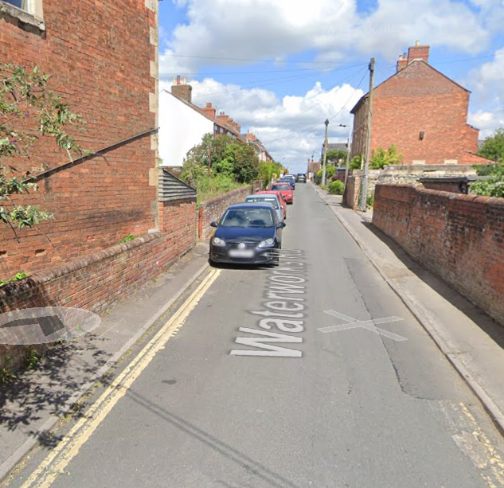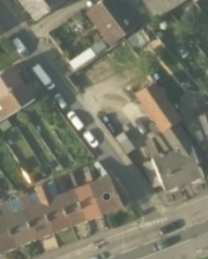

The proposed development would result in an unacceptable impact on highway safety, and that the impact would be severe given the narrow and constrained nature of the road, with little to no visibility, and no mitigation seemingly available.

Further compounding this issue, the narrow width of the pavement restricts pedestrian visibility. When combined with parked vehicles, this makes it more difficult for pedestrians to safely negotiate the access crossing and assess oncoming traffic or exiting vehicles, particularly for those using prams, thereby creating a potential safety hazard.

Therefore, the proposal is considered to be detrimental to the interests of highway safety and sustainable transport.

The development is therefore contrary to Core Policies 57 (criterion xiv), 61, and 64 of the Wiltshire Core Strategy, the relevant provisions of the National Planning Policy Framework, and the objectives of the Wiltshire Local Transport Plan. The application must therefore be refused on highways grounds.

Highways Reason for Refusal:
The proposed development, by reason of its inadequate access and failure to meet visibility requirements, would result in an unacceptable impact on highway safety.

As such, the proposal is contrary to Core Policies 57 (xiv), 61 and 64 of the Wiltshire Core Strategy (2015), and paragraphs 115 and 116 of the National Planning Policy Framework, which collectively require development to be safely accessed and not have an unacceptable impact on highway safety.

Drainage and Flood Risk
Core Policy 67 of the Wiltshire Core Strategy and paragraph 181 of the NPPF requires that all new development avoids increasing flood risk on-site or elsewhere and, where appropriate, incorporates sustainable drainage measures. Development must also comply with national policy on flood risk management and drainage design. Paragraph 176 (via footnote 62) of the NPPF states that householder development should not be subject to the sequential test, nor the exception test.

The proposal site is within flood risk zone 1, with the additional risk of groundwater flooding.

Householder development is considered Minor Development, under the Flood Risk planning guidance, if “physical extensions to the existing dwelling itself,” and, barring a few exceptions not relevant here, “are unlikely to raise significant flood risk.” The proposal to remodel an existing property, is therefore deemed to not result in any loss of land prone to flood risk.

The existing drainage arrangements are unaltered by the proposals, but the proposal fails to include any SuDS-appropriate materials for the proposed parking area.

As such, the proposal has the potential to be safe for its users for the intended lifetime of the development with respect to the level and nature of the flood risk, but further information has not been sought given the reasons for refusal.

Biodiversity Net Gain
Householder planning applications are exempt from the requirement to deliver Biodiversity Net Gain under Schedule 7A, Section 4(2)(a) of the Town and Country Planning Act 1990, as inserted by the Environment Act 2021.

CONCLUSION
The proposed development, by reason of the identified harm, is considered to conflict with the aims and objectives of the Wiltshire Core Strategy and the National Planning Policy Framework. The proposal fails to demonstrate compliance with the relevant policies and guidance, and no overriding material considerations have been identified that would justify a departure from the development plan.

Accordingly, the application is recommended for refusal.

RECOMMENDATION: That Planning Permission be REFUSED.

