APPLICATION FOR FULL PLANNING PERMISSION
DELEGATED REPORT

APPLICATION REFERENCE: | PL/2025/07940
APPLICATION TYPE: | Full planning permission
SITE ADDRESS: | 38 Delamere Road, Trowbridge, BA14 8ST
DEVELOPMENT DESCRIPTION: | Change of use from office to residential C3a
RECOMMENDATION: | Approve with Conditions

PROPOSAL

The proposal seeks planning permission for the change of use of an existing bungalow from office use to residential C3a use.

SITE DESCRIPTION/CONTEXT

The site is 38 Delamere Road, Trowbridge and consists of a detached three bedroom single storey bungalow located within an established residential area of Trowbridge. The surrounding built form consists of similar single storey bungalows and is the defining character of the area. The site is not in a Conservation Area and there are no heritage assets within the vicinity.

RELEVANT PLANNING HISTORY
PL/2021/4185 - Demolition of existing garage and construction of double garage with accommodation above. Approved with conditions.

W/10/02222/FUL - Approved with Conditions Date: 15/9/2010 - Change of use from dwelling to office and staff training facilities

W/88/01313/FUL - Approved with Conditions Date: 24/1/1989. Garage and first floor bedroom.

RELEVANT POLICIES AND GUIDANCE
Wiltshire Core Strategy:

- Core Policy 29: Spatial Strategy for Trowbridge
- Core Policy 50: Biodiversity and Geodiversity
- Core Policy 51: Landscape
- Core Policy 57 Ensuring High Quality Design and Place Shaping
- Core Policy 58: Ensuring the Conservation of the Historic Environment
- Core Policy 61: Transport and New Development
- Core Policy 64: Demand Management

Trowbridge ‘emerging’ Neighbourhood Plan

Wiltshire Design Guide: Appendix D – Design Guidance for Householder extensions
The National Planning Policy Framework (NPPF)
The Planning Practice Guidance
National Design Guide

Emerging Wiltshire Local Plan:
At Full Council on 19 May 2026, the elected members of Wiltshire Council agreed to withdraw the emerging Wiltshire Local Plan. It will now be subject to a legal process to finalise its withdrawal - which is likely to happen in July or August (2026). The said Plan has no material weight for the purposes of this application.

CONSULTATION RESPONSES
Trowbridge Town Council: No objections subject to no significant impact on neighbouring amenity.

Highways: No objections.

REPRESENTATIONS
Five emails received from No.36 raising the following points:

-No.36 did not receive letter from the consultation process.
-Object to the proposals, particularly converting the front garden area to car parking.
-Loss of plants, shrubs and a tree from the front garden of No.38.
-Loss of light and views to living room at No.36 with a car parked to the front of the building.
-The use of the front garden area for car parking purposes would mean that cars utilising this space would shine their headlights into the living room area of No.36 as well as polluting the air with petrol/diesel fumes.
-The use of this garden area for car parking would block out natural daylight and incur a loss of garden greenery. There would also be a noise disturbance from an engine running. The loss of shrubs would harm the residential character of the neighbourhood.
-Concerns relating to construction works and loss of garden creating a noise issue.

ASSESSMENT
Section 38(6) of the Planning and Compulsory Purchase Act 2004 states:

"If regard is to be had to the development plan for the purposes of any determination to be made under the planning Acts, the determination must be made in accordance with the plan unless material considerations indicate otherwise."

In accordance with this statutory requirement, this application has been assessed against the relevant policies of the Development Plan, including the adopted Wiltshire Core Strategy (2015).

Principle of the Development: The site is located within the defined settlement boundary limits of development for Trowbridge, where there is a presumption in favour of sustainable development. The principle of the proposal of the existing building reverting back to C3 residential dwelling use is therefore considered to be in accordance with CP1, CP2 and CP29 of the adopted Wiltshire Core Strategy, subject to being in accordance with CP57.

The site’s planning history is of relevance, in that within planning permission reference: W/10/02222/FUL the property underwent a change of use from residential to office use, therefore prior to 2010, the official use of the building was that of a residential Class C3 dwelling. The current scheme is to revert back to this use, no alterations or works are proposed to the building and so the application consists purely of a change within the Use Class Order. The application includes a detailed floor plan showing the layout of the building with its rooms and three bedrooms, which officers can confirm to be the case following a site visit.

Design and Impact upon the upon the character and context of the area
Core Policy 57 - Ensuring High Quality Design and Place Shaping of the Wiltshire Core Strategy seeks to ensure that all new development is of high design quality, reflecting local context, character, and distinctiveness.

The proposals can be viewed within the plan snippets taken from the submitted plans:

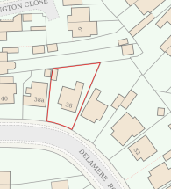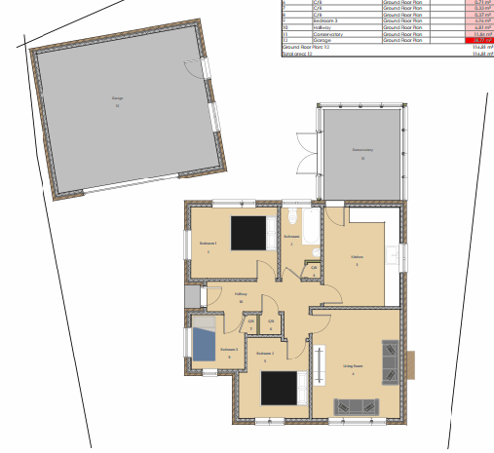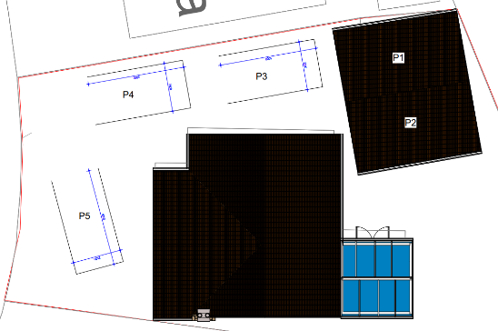
Location Plan Proposed Site/floor Plan Existing/proposed car parking plan.

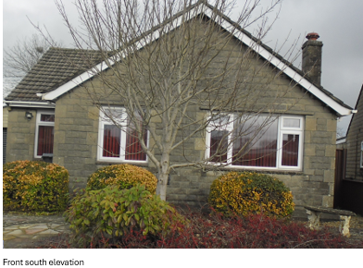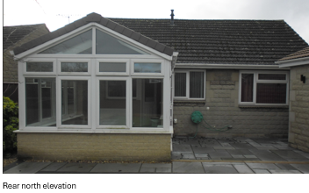
Front & rear elevations.

The proposal does not include any drawn plan elevations of the building but instead photographs showing the four elevations of the building are wholly acceptable, as no works are proposed to alter the building itself, with it remaining the same and unaltered throughout.

As no changes are proposed to the building, its presence with its use of matching materials with neighbouring dwellings is appraised as being acceptable.

Therefore, in summary, having regard to the above, the proposal complies with the design principles set out in Core Policy 57 of the Wiltshire Core Strategy and Appendix D of the Wiltshire Design Guide.

Amenity
Point vii of Core Policy 57 - Ensuring High Quality Design and Place Shaping of the Wiltshire Core Strategy seeks to ensure that developments do not adversely affect neighbouring properties. The National Planning Policy Framework (NPPF), particularly Paragraph 135(f), stresses that planning decisions should ensure developments provide a high standard of amenity for existing and future users.

The proposed residential use of the building would not include any alterations or new windows, with its existing fenestration remaining the same throughout, with no new views or outlook, and is appraised as being acceptable, as there would be no harm in terms of neighbouring amenity.

However, concern has been received from the neighbour at No.36 in regard to a harmful impact on amenity by the conversion of the front garden to a car parking space. The Street View photograph below shows that a number of properties, including No.36 have converted their front gardens to car parking areas:

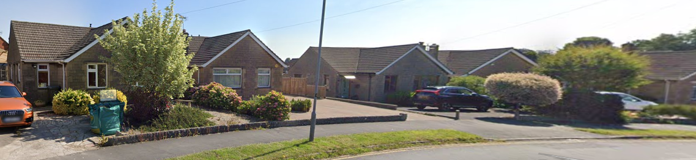

The principle of this use of properties’ front area for car parking is firmly established, so it is not expedient to consider a refusal on such grounds. Notwithstanding this, it is noted that there is a low-level hedge row between the two properties, which could serve to mitigate car headlights impacting on No.36.

Taking the above arguments into full account, it is appraised that the proposal therefore accords with Core Policy 57 point vii in respect of safeguarding residential amenity. The council’s highways officer has not raised any objections.

Highway Matters.
In accordance with the council’s adopted car parking strategy, where there are three bedrooms within the house, therefore, there is a requirement to provide a minimum of two off road car parking spaces. This has been achieved with the parking plan showing a maximum of five such spaces, with the use of the double garage and driveway providing four readily accessible spaces.

The fifth space as shown on the plans relates to the loss of the front garden area, which is acceptable for all the reasons as discussed above. Likewise, as discussed, the principle of car parking to the front of dwellings is acceptable within the vicinity.

The highways officer was consulted on the proposed parking arrangements, with no highway objections being raised.

Ecology Impact
CP50 requires no net loss of biodiversity on site. The site is located within the grey hatched zone of the Trowbridge Bat Mitigation Strategy Area. The proposed change of use would not require any development or changes to the building and is considered unlikely to result in harm to bats or their habitat. Accordingly, the proposal is acceptable in this regard. As such, the development complies with Core Policy 50 of the Wiltshire Core Strategy and the relevant provisions of the NPPF.

Biodiversity Net Gain. This application is exempt from the requirement to deliver Biodiversity Net Gain under Schedule 7A, Section 4(2)(a) of the Town and Country Planning Act 1990, as inserted by the Environment Act 2021, beause the proposal is below the de minimis threshold.

Five year housing land supply.
The Wiltshire Housing Land Supply Statement (June 2025) provides the latest position on the Council’s ability to demonstrate a five-year supply of deliverable housing land, which is a material consideration in the determination of planning applications. At the time of assessing this application, the Council can demonstrate a 2.8 year supply, which is openly accepted to constitute as a significant shortfall when tested against the NPPF 5-year requirement.

The absence of a five-year housing land supply is a material consideration in the determination of this application, with the current shortfall being a factor, which has to be considered in the overall planning balance. In this case, the change of use proposal would provide one market dwelling, which would serve to address the housing shortfall, albeit it would be only one dwelling, would be an effective contribution.

S.111 Legal Agreement.
The site falls within the grey zone of the TWBMS and so the applicant was liable for a related financial contribution plus administrative costs. The applicant has paid this financial sum in full and the legal agreement has been sealed, consequently the LPA is now in a position to determine the application.

Other Matters.
Third party neighbour comments have been received to the effect that they did not receive a neighbour notification letter concerning the current planning application. However, a check on the council’s system confirms that neighbour letters were sent out to all neighbouring residents bordering the application site. It is noted that the said neighbour has written in to comment. Concerns relating to the development of the front garden for car parking purposes have been addressed within the main body of the report above.

CONCLUSION
The proposed change of use of the building to that of a residential Class C3 dwelling is appraised as being acceptable, with the very principle of a dwelling at this location being firmly established.

The proposed scheme represents an efficient and effective reuse of the building. There are no adverse impacts that have been identified that outweigh the benefits or warrant refusal of the scheme and as such granting planning permission is recommended.

The proposal is therefore considered to comply with the relevant policies of the Wiltshire Core Strategy, the Wiltshire Local Plan, and the National Planning Policy Framework. As such, the application is recommended for approval, subject to the conditions set out below.

RECOMMENDATION: Planning Permission be GRANTED subject to conditions.

