APPLICATION FOR HOUSEHOLDER PLANNING PERMISSION
DELEGATED REPORT

APPLICATION REFERENCE: | PL/2026/02246
APPLICATION TYPE: | Householder planning permission
SITE ADDRESS: | 8 Budbury Place, Bradford on Avon, BA15 1QF
DEVELOPMENT DESCRIPTION: | Single and Two Storey Extension to the Front Elevation, Kitchen to the rear and internal alteration
RECOMMENDATION: | That Planning Permission be GRANTED

PROPOSAL

The proposal seeks planning permission for the erection of a single storey extension and two storey extension to the front elevation with a first-floor balcony area created. To the rear elevation a single storey extension would be added. This submission is a duplicate of the consented application 20/10098/FUL.

SITE DESCRIPTION/CONTEXT

The proposal relates to a two-storey detached dwelling, 8 Budbury Place dwelling located within an established residential cul-de-sac in Bradford on Avon. The host dwelling lies within the Bath and Bradford on Avon Special Area of Conservation for bats and just outside the Bradford on Avon Conservation Area. To the south lies a terraced row of Grade II properties, Budbury House.

The application site comprises of an off-road parking area to the front elevation, the garage has been converted to ground floor accommodation but retains its garage door

PLANNING HISTORY
Proposal / Summary
20/10098/FUL - Full planning permission Decision - Approve with Conditions Date: 27/5/2021 – Single and two storey extension to the front elevation, kitchen to the rear and internal alterations.

RELEVANT POLICIES AND GUIDANCE

Wiltshire Core Strategy:
Core Policy 2 Delivery Strategy
Core Policy 7 – Spatial Strategy for the Bradford on Avon Community Area
Core Policy 50 – Biodiversity and Geodiversity
Core Policy 57 - Ensuring High Quality Design and Place Shaping
Core Policy 58 - Ensuring the Conservation of the Historic Environment
Core Policy 60 – Sustainable Transport
Core Policy 61 – Transport and Development
Core Policy 64 – Demand Management
Emerging Policy – Wiltshire Local Plan Review
At Full Council on 19 May, the elected members of Wiltshire Council agreed to withdraw the emerging WLP. It will now be subject to a legal process to finalise its withdrawal - which is likely to happen in July or August (2026). The said Plan has no material weight for the purposes of the application.
Wiltshire Local Transport Plan 2011 – 2026 (March 2015)

Bath and Bradford on Avon Bat SAC Guidance September 2015
Bradford on Avon Neighbourhood Plan 2013 – 2026 Made October 2017

Wiltshire Design Guide: Appendix D – Design Guidance for Householder extensions

The National Planning Policy Framework (NPPF)

The Planning Practice Guidance

National Design Guide

CONSULTATION RESPONSES

Bradford on Avon Town Council: No objection

Wiltshire Council Highways: No objection subject to conditions

REPRESENTATIONS
Bradford on Avon Preservation Trust: No objection
‘We have no objection subject to no adverse impact on the residential of amenity of neighbouring dwellings due to overlooking of adjacent houses and gardens from the proposed first floor decking and balconies’

ASSESSMENT
Section 38(6) of the Planning and Compulsory Purchase Act 2004 states:

"If regard is to be had to the development plan for the purposes of any determination to be made under the planning Acts, the determination must be made in accordance with the plan unless material considerations indicate otherwise."

In accordance with this statutory requirement, this application has been assessed against the relevant policies of the Development Plan, including the adopted Wiltshire Core Strategy (2015) and, where applicable, any made Neighbourhood Plans.

Heritage, Design and Impact upon the character and context of the area:
From the point of view of the historic environment the main statutory tests are set out within the Planning (Listed Building and Conservation Areas) Act 1990.

Section 66 requires that special regard be given to the desirability of preserving listed buildings, their settings or any features of special architectural or historic interest which they possess.

Section 72(1) of the Act requires the Council to pay special attention to the desirability of preserving or enhancing the character or appearance of designated Conservation Areas.

The Council’s Core Strategy Policy CP58 ‘Ensuring the conservation of the historic environment’ requires that designated and non-designated heritage assets and their settings will be conserved, and where appropriate enhanced, in a manner appropriate to their significance and encourages proposals which improve the condition of heritage assets at risk.

The Council’s Core Strategy CP 57: Ensuring high quality design requires a high quality of design in all new developments. The policy requires applicants to “demonstrate how the proposal will make a positive contribution to the character of Wiltshire through (amongst other things) responding to the value of the natural and historic environment and being sympathetic to and conserving historic buildings and landscapes. Development is required to respond positively to the existing in terms of building layouts, built form, height, mass, scale, building line, plot size, elevational design, materials, streetscape and rooflines to effectively integrate the building into its setting.

The NPPF outlines government policy for planning. Chapter 16 of the NPPF 'Conserving and enhancing the historic environment' sets out the Government's high-level policies concerning heritage and sustainable development.

The host dwelling lies just outside the Bradford on Avon conservation area which is located to the south. As views in and out of the conservation area are important, any proposal has to be assessed mindful of Section 72 of the abovementioned Act as well as CP58 of the Wiltshire Core Strategy and the relevant paragraphs of the NPPF.
Within the vicinity of the host dwelling lie some listed buildings therefore, any works to the host dwelling have to be appraised in relation to any impact upon the immediate setting of these listed buildings.

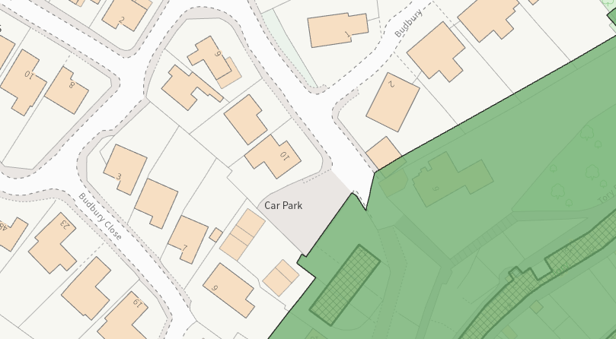
Conservation area (shaded green) and listed buildings (hatched black)

The applicant seeks to erect a two-storey extension on the front elevation with a front facing gable and extend the existing porch area and previous garage area at ground floor. The two-storey proposal would create an enlarged first floor bedroom with access to a balcony area above the enlarged footprint of the single storey extension.

The balcony area would consist of glazed panels that would sit at a height of 1.3m along the front and southeast side elevation and 1.8m on the northwest facing side elevation. No additional windows are proposed on the front elevation however a window would be inserted on the southeast side elevation of the two-storey extension, which would be obscure glazed.

The single storey extension would create an enlarged front entrance area with extended ground floor accommodation and windows would be inserted on the front elevation replacing the existing garage doors.

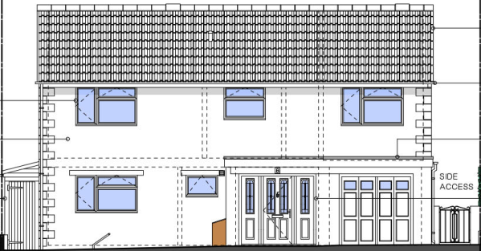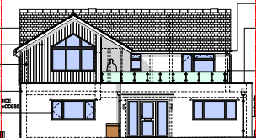

Existing (left) and proposed (right) front elevation

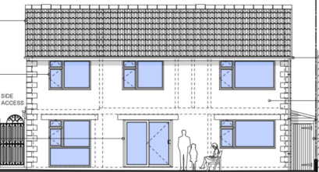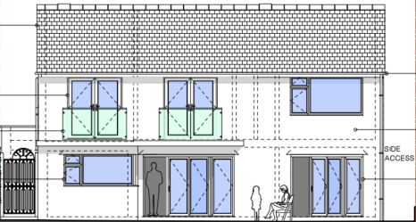
Existing (left) and proposed (right) rear elevation

To the southwest rear elevation, the existing kitchen area would be extended marginally with a single storey extension with a flat roof form, a set of additional patio doors would be added on the rear elevation and at first floor two windows would be replaced with patio doors with Juliet balconies.

The applicant seeks to utilise cream coloured render to all elevations with an area of cedar cladding at first floor on the two-storey extension, the whole of the roof would be replaced with slate roof tiles, and black fenestration would be inserted to all elevations.

The scheme seeks to extend the accommodation with contemporary style extensions and upgrade the existing elevations with natural sustainable materials. Whilst the use of contemporary style materials would be a deviation from the existing aesthetic of the host dwelling, the properties within the immediate area consist of a mix of architectural styles and materials, with more modern styled properties nestled close to more traditional dwellings.

In this instance, when viewed in the wider context of the residential development within the area, the development is not considered to have an adverse impact on the character and appearance of the area, with many properties within Bradford on Avon celebrating contemporary design. It is considered that the extensions would by virtue of their height, scale and design constitute complementary additions to the host dwelling that would appear commensurate to the size of the property and plot.

The use of the natural sustainable material is supported and given the works proposed would be set within the built envelope of the application site, it is considered that there would be nominal harm to the conservation area. Officers raise no objections as the proposal, by virtue of its scale, would preserve the character and appearance of the conservation area and would not result in harm to the significance of any heritage assets.

The development is therefore considered to comply with Core Policy 58 of the Wiltshire Core Strategy and Sections 66 and 72 of the Planning (Listed Buildings and Conservation Areas) Act 1990, as well as the relevant provisions of the NPPF.

Amenity
Point vii of Core Policy 57 - Ensuring High Quality Design and Place Shaping of the Wiltshire Core Strategy seeks to ensure that developments do not adversely affect neighbouring properties.

The National Planning Policy Framework (NPPF), particularly Paragraph 135(f), stresses that planning decisions should ensure developments provide a high standard of amenity for existing and future users.

The proposed development has been assessed in terms of its potential impact on the residential amenity of neighbouring properties, with particular regard to loss of light, overshadowing, loss of privacy, and overbearing effects.

The proposal seeks to insert windows at ground floor and first floor on the front and rear elevations which would match the existing fenestration arrangement. The applicant seeks to insert a first-floor balcony on the front elevation of the host dwelling, and officers are cognisant that this could introduce some overlooking to neighbouring properties.

The balcony would consist of glazed panels that would sit at a height of 1.3m to the front elevation and to the northwest side elevation a screen would be erected at a height of 1.8m which would negate any overlooking to the adjacent property at No.6 Budbury Place ( which also benefits from a first floor balcony on the front elevation )

Given the plan layout of the properties within Budbury Close officers raise no concerns in regard to any overlooking from the southeast side elevation of the balcony area to the adjacent dwelling at No. 10 Budbury Close, with the balcony area only affording views across to the front driveway area of the adjacent dwelling.

The balcony would overlook the host dwelling’s front driveway area and the public highway that is positioned to the northeast of the application site. The closest neighbours to the northwest are positioned some 25 metres from the proposed balcony as illustrated in the map insert below.

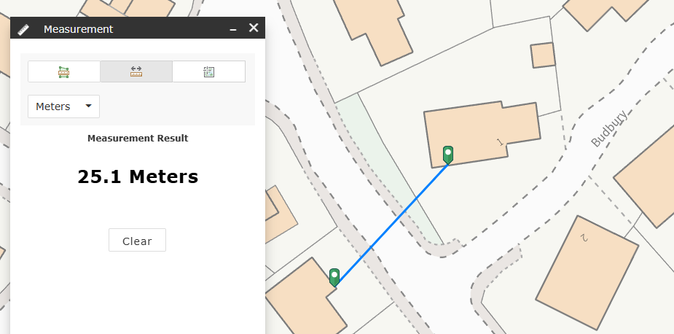

The Council’s preferred ‘general rule of thumb’ would be of 21 metres between habitable windows of adjacent properties and 10.5 metres between first floor habitable windows and neighbour’s gardens (which approach has been accepted as good practice by the Planning Inspectorate). Therefore, in this instance the insertion of the balcony area is not considered to introduce any adverse overlooking impacts.

A window would be inserted on the southeast elevation of the two-storey extension, close to the side elevation of the adjacent dwelling at No.10 Budbury Close, however this would be conditioned to be obscure glazed to negate any overlooking.

The introduction of two Juliet balconies at first floor on the rear elevation raises no overlooking issues given they replace existing openings and do not afford the opportunity for the occupiers to stand out on any platform and overlook any private residential curtilages of neighbouring properties.

The proposal seeks to erect two storey and single storey extensions over a limited footprint and given the detached nature of the host dwelling, orientation of the building, and separation distances to any adjacent dwellings, it is considered that the proposal would not introduce any adverse overbearing or overshadowing impacts or any adverse loss of light to neighbouring properties.

The proposal therefore accords with Core Policy 57 point vii in respect of safeguarding residential amenity and Appendix D of the Wiltshire Design Guide.

Highways Impact
Core Policy 57 (xiv) of the Wiltshire Core Strategy seeks to ensure that development must meet the requirements of Core Policy 61. This policy requires proposals to be capable of being served by safe access to the highway network. Core Policy 64 seeks to ensure compliance with parking standards set out in the Local Transport Plan.

The National Planning Policy Framework (NPPF), particularly Paragraph 115 and 116, requires that development proposals do not have an unacceptable impact on highway safety and that safe and suitable access to the site can be achieved for all users.

The proposal seeks to retain the first-floor arrangement as three bedrooms with a study, however the Council’s highway officer has acknowledged that the study could be utilised as a bedroom and the remodelled ground floor accommodation could also be utilised as sleeping quarters, which would increase the number of bedrooms to five.
In order to comply with the Wiltshire Local Transport Plan 2011 – 2026: Car Parking Strategy (March 2015) three on-site car parking spaces would be required for a 4+ bed dwelling (standard min. size 2.4m x 4.8m).The proposed scheme would remove the existing garage as a parking area therefore 3 off road parking spaces would need to be provided within the front driveway.
The proposed site plan illustrates that two parking spaces would be available within the front driveway once the extensions have been implemented. Whilst the applicants would be able to park two cars on the existing driveway, it is unlikely that the applicants would be able to accommodate the parking of an additional third vehicle on-site.
However, it is acknowledged that immediately to the south of the application site there is a public car park, and the unrestricted parking opportunities along the frontage of the property could make up for any deficit should the property owners have any need to accommodate a third vehicle.
The Council’s Car Parking Strategy should be adhered to where possible, however in this instance the possible displacement of one vehicle to the road, in this cul-de-sac location is not considered to result in severe highway harm. In terms of Para.116 of the NPPF, any displaced parking in the locality would not cause such harm that refusing permission on these grounds would be reasonable or justified. As such, the proposal would comply with the policy highlighted above.

The Council’s Highway officer raised no highway objection providing a number of conditions were imposed, however the recommended conditions cited by the officer are not deemed necessary or reasonable and these have not been imposed.

The proposal is therefore considered to comply with Core Policies 57 (xiv), 61 and 64 of the Wiltshire Core Strategy, the NPPF, and the Wiltshire Local Transport Plan.

Ecology Impact
Core Policy 50 of the Wiltshire Core Strategy seeks to protect and enhance biodiversity and geodiversity, including through ensuring that development avoids harm to protected species and habitats.

The National Planning Policy Framework (NPPF), in Paragraphs 193, requires that development minimises impacts on and provides net gains for biodiversity, including ensuring mitigation is secured where harm cannot be avoided.
The application site sits within the Bath and Bradford on Avon Special Area of Conservation for bats and as this application involves disturbance to the existing roof due consideration has to be given to the potential disturbance of any bats because of the proposed development.

The proposed development comprises an extension of existing residential development consisting of limited built form close to the existing dwelling and given the established high density urban residential nature of the location, it is considered highly unlikely that any bats would be affected and significant effects relating to the disturbance to bats can be ruled out.

As a precautionary measure an informative would be added to any decision that in event any evidence of bat activity is detected that the applicant should follow the advice of a professional ecologist or contact Natural England.

As such, the development complies with Core Policy 50 of the Wiltshire Core Strategy and the relevant provisions of the NPPF.

Biodiversity Net Gain
Householder planning applications are exempt from the requirement to deliver Biodiversity Net Gain under Schedule 7A, Section 4(2)(a) of the Town and Country Planning Act 1990, as inserted by the Environment Act 2021.

CONCLUSION
The proposed development is considered to be acceptable in terms of its design, scale, and relationship with the surrounding area. It would not result in any unacceptable harm to the character of the locality, the amenities of neighbouring occupiers, or the interests of highway safety, heritage, or ecology.

The proposal is therefore considered to comply with the relevant policies of the Wiltshire Core Strategy, the Wiltshire Local Plan, and the National Planning Policy Framework. As such, the application is recommended for approval, subject to the conditions set out below.

RECOMMENDATION: That Planning Permission be GRANTED subject to conditions.

Conditions

1.The development hereby permitted shall be begun before the expiration of three years from the date of this permission.
REASON: To comply with the provisions of Section 91 of the Town and Country Planning Act 1990 as amended by the Planning and Compulsory Purchase Act 2004.

2. The development hereby permitted shall be carried out in accordance with the following approved plans and documents:
Existing Plans DWG No 01
Location Plan & Proposed Plans DWG No 02
Proposed Floor & Roof Plans DWG No 03
Existing Floor & Roof Plans DWG No 04
All Plans Received 06.04.2026

REASON: For the avoidance of doubt and in the interests of proper planning.

3. The hereby approved front balcony shall not be brought into use until the 1.8m high obscure glazed flanking screening have been completely installed. The obscure glazed screens shall be to an obscurity level of no less than level 4 and shall be maintained and retained in accordance with the approved details in perpetuity.
REASON: In the interests of residential amenity and privacy.

4. The upper floor window in the southeast side elevation as shown on approved plan (Drawing No 03) shall be glazed with obscure glass to an obscurity level of no less than level 4 and permanently fixed shut / fixed with a ventilation stay restricting the opening of the window and shall be permanently maintained in perpetuity.
REASON: In the interests of residential amenity and privacy.

5. The roof over the rear extension hereby approved on the southwest elevation of the development hereby permitted shall not be used as a balcony, roof garden or elevated external amenity area.
REASON: In the interests of safeguarding neighbouring residential amenity and privacy.

Informative
If bats or evidence of bats are found during the works, the applicant is advised to stop work and follow advice from an independent ecologist or to contact Natural England’s Bat Line through the internet.

