Bartlett Tree Experts

Planning Permission Application
18 Woodland Park, Calne, Wiltshire, SN11 0JX

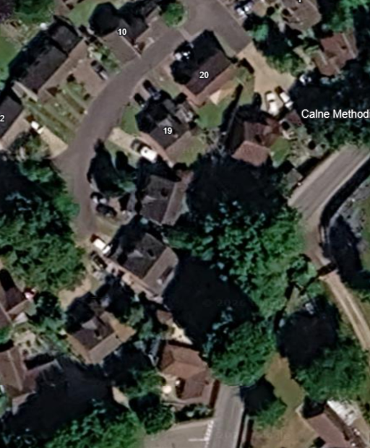
G1
T1

Species: | Location: | Specification: | Photo:
T1: Beech | Back of the property | Reduce crown by 2-3m. Remove all major deadwood.  Install a cabling system. | 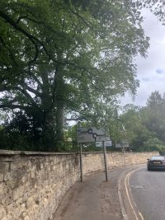
G1: Cypress | Front of the property | Reduce height by 50%.  Trim the sides. | 