APPLICATION FOR FULL PLANNING PERMISSION
DELEGATED REPORT

APPLICATION REFERENCE: | PL/2026/01691
APPLICATION TYPE: | Full Planning Permission
SITE ADDRESS: | Land South of Home Farm Close Steeple Ashton, BA14 6AH
DEVELOPMENT DESCRIPTION: | Construction of 2 storey timber-framed passive house and double garage, creation of an access off Acreshort Lane into the site, installation of culvert in existing drainage ditch; creation of gravel drive and parking.
RECOMMENDATION: | Planning Permission be REFUSED

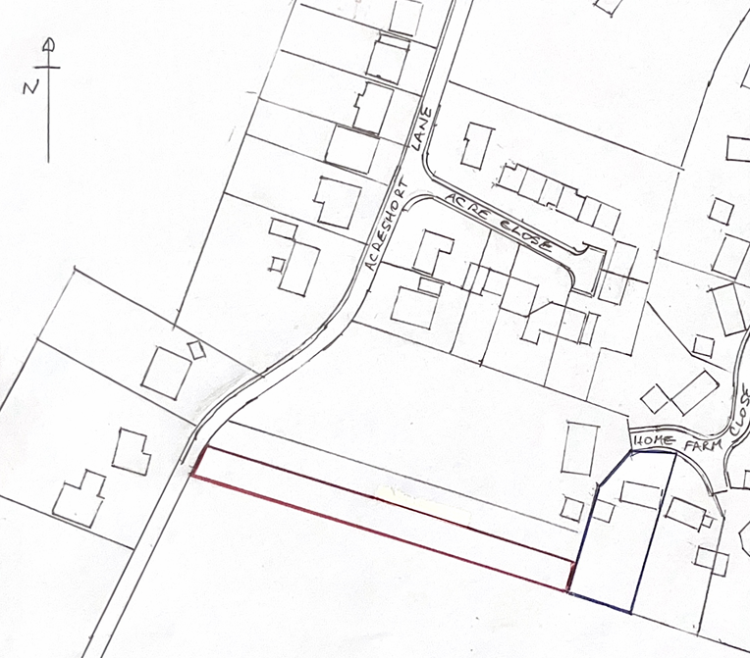
PROPOSAL

The application seeks full planning permission for the erection of a two-storey, three-bedroom dwelling with a pitched roof, finished externally in white-painted acrylic render, with feature elements including timber tongue-and-groove panels between fenestration and doors, and grey weatherboarding to the front elevation. The scheme also includes a detached double garage of single-storey scale with a hipped tiled roof and painted rendered walls. Associated residential development is proposed, including boundary treatments, hardstanding, a new vehicular access formed via a concrete culvert over an existing roadside ditch to connect to Acreshort Lane, and the installation of an air source heat pump and solar photovoltaic panels on the southern roof slope. Foul drainage would be served by a proposed buried septic tank located within the front garden.

SITE DESCRIPTION / CONTEXT
The site comprises a long, narrow strip of land measuring approximately 9.6 metres in width and 122 metres in length, outside the village limits of Steeple Ashton, and physically detached from the defined settlement boundary. As shown below by way of the black line.

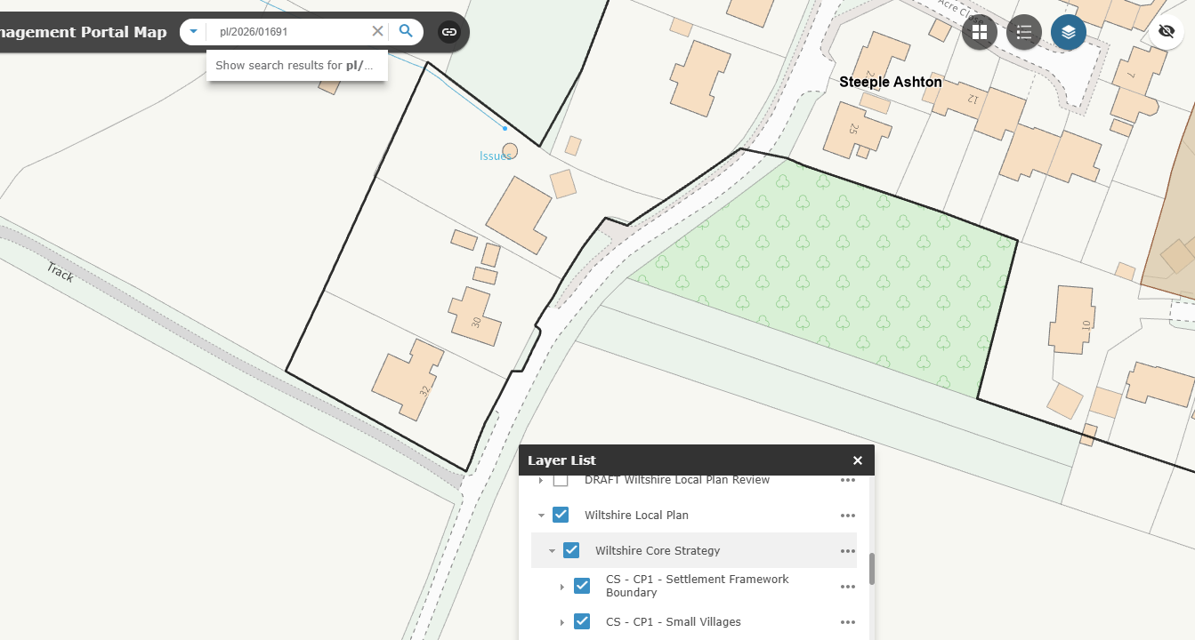

Historically, the site formed part of a large agricultural field, as evidenced by 19th century Ordnance Survey mapping and still shown as such in the 2011 Street View imagery, after which time, the land appears to have been removed from agricultural use between 2011 and 2015.

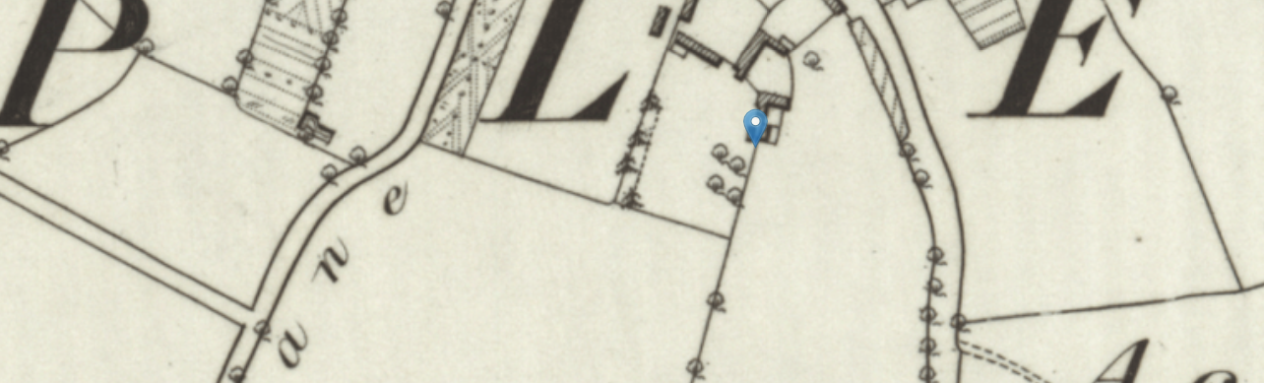
19th century OS Map
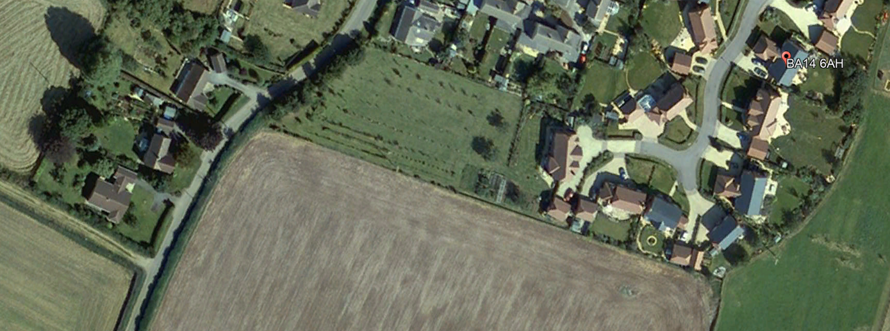
Google Earth 2005 Aerial

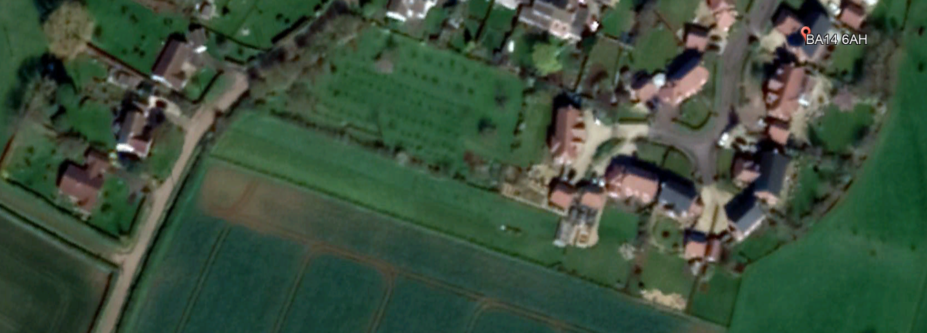
Google Earth 2015 Aerial

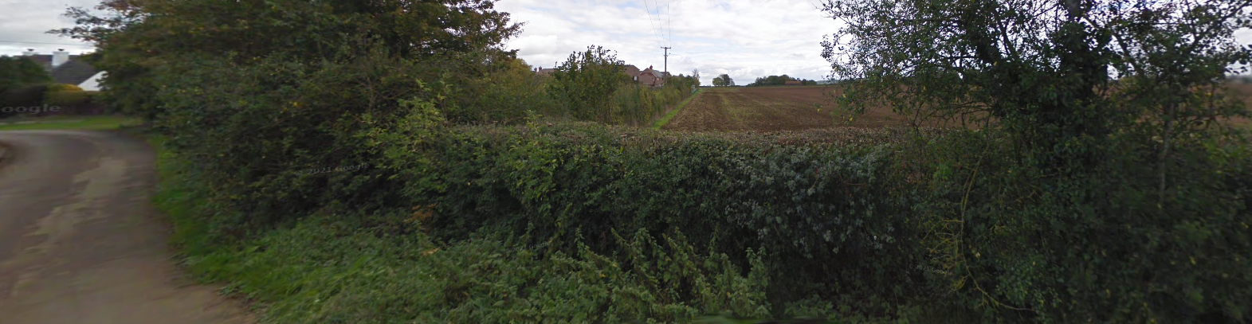
Google Steetview 2011 (prior to the incorporation of the land into residential garden)

The site has a distinctly rural character reinforced by its relationship with open countryside, agricultural hedgerows, located off the unclassified stretch of Acreshort Lane. The site has a managed appearance but retains an orchard-style character with dense boundary hedging and intermittent tree planting.

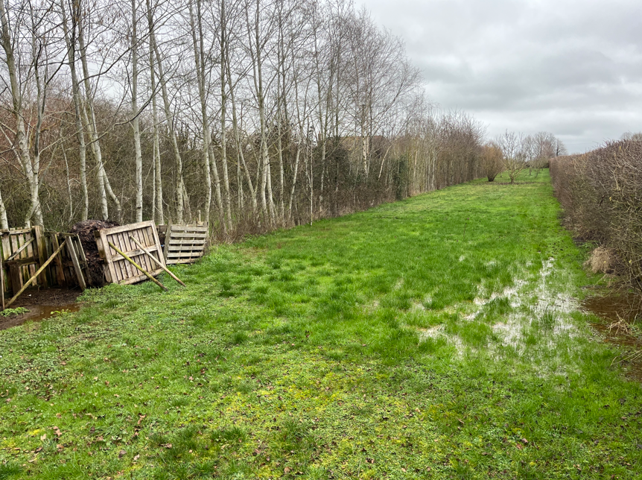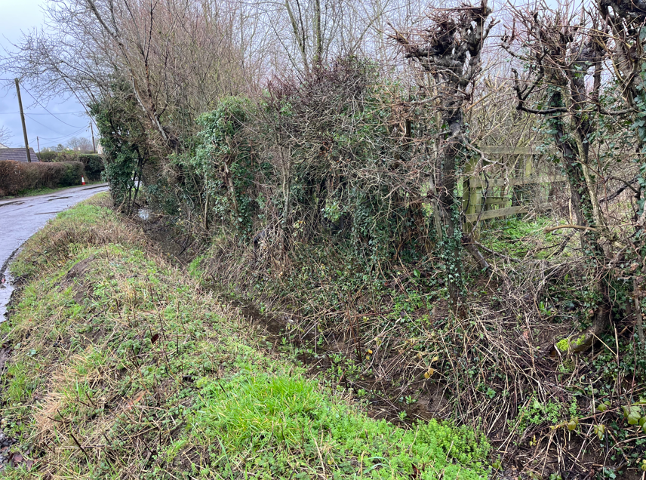

The wider area is subject to a number of constraints, including proximity to the Steeple Ashton Conservation Area to the east, the site is within the Trowbridge and Westbury Bat Mitigation Strategy (grey buffer zone) and a Bechstein bat core roost buffer. The site is also identified as being at groundwater flood risk, all of which are material considerations in the assessment of the proposal. The site is within the 6.4km visitor catchment of the Salisbury Plain SPA where additional recreational pressures associated with new residential development should be mitigated to protect ground nesting birds and their habitat.

Steeple Ashton is not far from the Bath and Bradford on Avon Bat Special Area of Conservation (SAC). This is a European Site and an HRA is often necessary. Although the Bath and Bradford on Avon Bat SAC forms the ‘main hubs or nodes’ for bat habitat, guidance describes how bats travel far beyond these for temporary roosts, foraging areas and commuting corridors.

The adopted Trowbridge and Westbury Bat Mitigation Strategy (TWBMS) dated July 2025 states that:

“The landscape surrounding Trowbridge is known to be of high importance for bats, supporting at least 14 of the 18 UK bat species… In particular, woodlands to the east and south-east of Trowbridge are known to support a large and internationally- significant breeding meta-population of Bechstein’s bat that is functionally and demographically linked to the Bath and Bradford on Avon Bats SAC, including significant maternity colonies in Biss Wood, Green Lane Wood [located just over 2km from the application site] and Picket and Clanger Woods”.

The emerging Steeple Ashton Neighbourhood Plan identifies the following with regard to the existing housing for the neighbourhood plan area.

“2.34 As of the 2021 census data, the parish hosts approximately 510 households, a mixture of mostly detached and semi-detached dwellings with character. Some of the properties are of historical importance which can be found mainly in the Conservation Area, including along High Street, Church Street and the Strand, all of which propose different house types and materials. There are also several cul-de-sacs that extend of the southwestern side of the main village street and serve more recent housing developments, which have a more geometric layout than the historic parts of the village. Much of these recent developments have taken place on the western side of the High Street, the most recent of which have been the developments at Home Farm and Bartletts Mead. Since then, new developments have been through small sites of 1 or 2 units. More modern houses across the village tend to have been faced with reconstructed stone and have cement tile roofs.

2.35. Considering the 510 households, almost 1/3rd are occupied by a single person and 66% made up of one-family occupiers. 84% of the dwellings are owner occupied with approximately 8% socially rented. 83% of the housing stock is made up of 3- and 4-bedroom houses, leaving only 17% made up for 1- or 2- bedroom houses which is significantly lower than the Wiltshire average. The average number of bedrooms per household is 3.3 with over half of the dwellings being detached and 31% semi-detached. 90% of all the dwellings are over-occupied by 1 or more bedrooms, this means the households have at least 1 more bedroom than is required based on people living there. It is noted this figure does not take into account a household’s desire for space.

2.36. There is a low percentage of houses that have no permanent residents (i.e. holiday let properties), with over 95% of households having at least one permanent occupier”.

PLANNING HISTORY

Reference No. | Proposal / Summary | Decision
15/03080/FUL | Ground floor kitchen extension with velux roof lights | Approved

RELEVANT LEGISLATION, POLICIES AND GUIDANCE

Wiltshire Core Strategy:

Core Policy 1 Settlement Strategy;
Core Policy 2 Delivery Strategy;
Core Policy 15 Spatial Strategy: Melksham Community Area;
Core Policy 50 Biodiversity and Geodiversity;
Core Policy 51 Landscape;
Core Policy 57 Ensuring High-Quality Design and Place Shaping;
Core Policy 58 Ensuring Conservation of the Historic Environment;
Core Policy 60 Sustainable Transport;
Core Policy 61 Transport and Development;
Core Policy 64 Demand Management;
Core Policy 67 Flood Risk;

The National Planning Policy Framework (NPPF) and Planning Practice Guidance (PPG)

The Trowbridge and Westbury Bat Mitigation Strategy (TWBMS) (July 2025).

Wiltshire Design Guide

The Wiltshire Local Transport Plan 2011 – 2026: Car Parking Strategy (March 2015).

The Wiltshire Local Transport Plan 4 (LTP4) (March 2025)

Emerging Policy – Wiltshire Local Plan Review

At Full Council on 19 May, the elected members of Wiltshire Council agreed to withdraw the emerging WLP. The said Plan has no material weight for the purposes of the application.

Steeple Ashton emerging Neighbourhood Plan for the period 2020-2038

The Steeple Ashton Neighbourhood Development Plan (Submission Version, December 2025) sets out a locally derived framework for managing growth to 2038, with a clear emphasis on protecting the parish’s rural character, landscape setting, and ecological assets, whilst directing limited housing growth to appropriate and sustainable locations. The Plan identifies a network of Green and Blue Infrastructure corridors (Policy SA4), including Corridor GBI3 along Acreshort Lane, which is recognised for its hedgerows and habitat connectivity and is to be protected and enhanced. Policy SA5 requires development to retain and, where possible, enhance features of biodiversity value, including species-rich hedgerows, while Policy SA6 requires proposals affecting sensitive bat habitats to be supported by sufficient ecological information to inform Habitats Regulations Assessment. In addition, Policy SA11 seeks to ensure that development does not increase flood risk and incorporates robust drainage solutions, and Policy SA13 requires high-quality design that responds positively to local character and landscape context.

Critically, Policy SA15 establishes a plan-led housing strategy, identifying specific sites to meet the parish housing requirement; the application site is not allocated, and proposals outside this strategy are not supported. Whilst the Plan is emerging, it has progressed through Regulation 16 consultation and examination and therefore carries increasing weight. The Plan is likely to gain full weight should this application be refused and be appealed, at which point NPPF para 14 will be engaged.

The Plan demonstrates that housing needs have been explicitly assessed and spatially directed and is therefore a material consideration in understanding the emerging, evidence-based strategy for growth in Steeple Ashton.

CONSULTATION RESPONSES

Steeple Ashton Parish Council – Objects based on the following:
The Parish Council objects to the proposal primarily on highway safety and access grounds, noting that Acreshort Lane and its junction with the High Street are narrow, constrained, and unsuitable for additional traffic, particularly construction and delivery vehicles. Concerns are also raised regarding the specific access point being located on a blind bend, the lack of adequate space for vehicle manoeuvring or contractor parking, and the potential for significant obstruction to existing users, including nearby residents and an agricultural business. Furthermore, the Council highlights insufficient information regarding drainage and flood risk management, as well as a lack of ecological survey data for a site considered likely to support protected and notable species.

Local Highway Authority (Wiltshire Council) – Objects based on the following:

Insufficient information has been provided to assess the safety and suitability of the proposed access, particularly due to the absence of visibility splays. Clarification is also required regarding the garage access and vehicle movements within the site, supported by a swept path analysis. The highway officer further notes the site’s unsustainable location outside the settlement boundary and advises policy assessment against relevant transport policies.

Conservation Officer (Wiltshire Council) – No Objection

Archaeology Officer (Wiltshire Council) – No Objection

Ecologist (Wiltshire Council) – No response to consultation, but it should be noted the application is not supported with ecological surveys.

PUBLIC REPRESENTATIONS

Eight letters of objection were received raising concerns primarily in relation to highway safety, drainage and flood risk, the principle of development, and the impact on the character and appearance of the area.

Many objectors highlight the constrained nature of Acreshort Lane, which is described as a narrow, single-track route with limited passing opportunities, no continuous footways and a restricted junction with the High Street.

Particular concern is raised regarding the siting of the proposed access on or near a sharp bend with poor visibility, together with the absence of demonstrated visibility splays and uncertainty as to whether vehicles could safely enter, turn and exit the site.

Local residents also raise concerns regarding increased traffic, including construction vehicles, potential obstruction of the lane, conflicts with existing driveways, the presence of pedestrians and agricultural vehicles, and existing issues such as parking and speeding, all of which are considered would be exacerbated by the proposal.

Concerns were also raised regarding drainage, noting that the site is prone to waterlogging and forms part of an existing surface water flow path, with the roadside ditch already reported as inadequate and associated with flooding of neighbouring properties. The proposed development which would require the culverting of the existing ditch and introduction of hardstanding could exacerbate these issues, particularly in the absence of a detailed drainage strategy.

Third parties object to the development on the basis that the site is outside the defined settlement boundary and would represent an encroachment into open countryside, resulting in harm to the rural character of the area and setting a precedent for further similar development.

Additional concerns relate to the loss of hedgerow and interruption of an established rural frontage, impacts on biodiversity (including potential bat activity), the lack of ecological and technical assessments, and questions regarding the lawful use of the land as residential curtilage and the deliverability of the proposed access.

ASSESSMENT

Section 38(6) of the Planning and Compulsory Purchase Act 2004 states:

"If regard is to be had to the development plan for the purposes of any determination to be made under the planning Acts, the determination must be made in accordance with the plan unless material considerations indicate otherwise".

In accordance with this statutory requirement, this application has been assessed against the relevant policies of the Development Plan, including the adopted Wiltshire Core Strategy and, where applicable, any made Neighbourhood Plans.

Principle of Development

Core Policy 1 of the Wiltshire Core Strategy sets out the settlement strategy, identifying Steeple Ashton as a Large Village where development is limited to that which is necessary to meet the housing needs of the settlement and to support local services and facilities. Core Policy 2 further establishes that, unless justified by other specific policies, development will not be permitted outside defined settlement boundaries. The application site lies clearly beyond the limits of development and is not physically well-related to the built form of the village. None of the exceptions set out under paragraph 4.25 of the Core Strategy are applicable in this case. The proposal does not represent rural exception housing, is unsupported by evidence of a local housing need, and is not justified by any agricultural, employment or rural enterprise requirement. As such, the development represents an unjustified form of new residential development in the open countryside, contrary to the spatial strategy of the development plan and the emerging Steeple Ashton Neighbouurhodd Plan which is approaching a Referendum.

In addition, the site is not considered to be sustainably located. Whilst the village centre and nearest bus stop are within approximately 0.3 miles, bus services are limited in frequency and do not provide a realistic alternative to private car use for day-to-day needs.

Pedestrian access is constrained, with sections of narrow pavement and limited street lighting. The village itself offers only limited day-to-day services, with no primary or secondary school and only a small shop, meaning that most trips for employment, education and shopping would need to be made to larger centres such as Trowbridge, approximately 5.5 miles away.

Future occupiers would therefore be highly reliant on the private motor vehicle. The proposal would not represent as a rounding off of the village but would instead extend built form into an undeveloped strip of land beyond the established settlement edge, creating an incongruous and isolated form of development and leaving a residual gap that could increase pressure for further encroachment into the countryside in the future.

Although the land may have been taken out of being part of an agricultural field to be used as ancillary land linked to a dwellinghouse as extended curtilage, this does not benefit form planning permission or a lawful development certificate, and unauthorised development is a material consideration that can weigh against an application. As the following report will set out, the proposal is considered unacceptable for several substantive grounds.

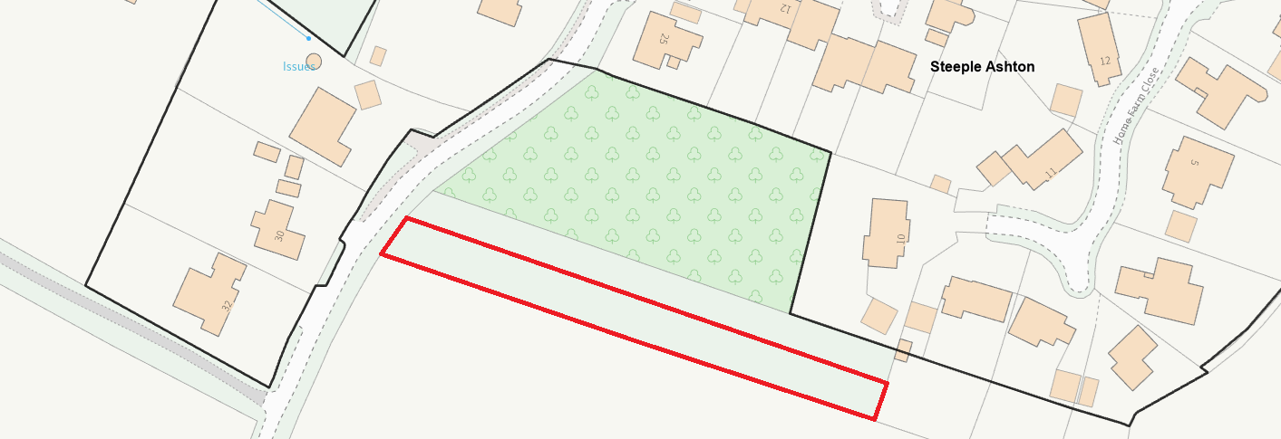
Settlement Boundary

Design and impact on the character and context of the area

Core Policy 57 Ensuring High Quality Design and Place Shaping of the Wiltshire Core Strategy requires all new development to achieve a high standard of design that responds positively to its local context. Proposals must reinforce and enhance local character and distinctiveness, relate appropriately to the surrounding landscape, and demonstrate a thoughtful response to existing townscape features. This includes careful consideration of elements such as building height, scale, massing, building line, materials, and overall appearance, ensuring new development integrates harmoniously with its setting.

Core Policy 51 of the WCS states that development should conserve and protect existing landscape character. It additionally states that local features such as hedgerows and watercourses must be considered as part of any analysis, as well as other matters which relate to the overall distinctive quality of the specific locality in question.

The proposal would result in a material change to the existing rural edge character of the site, primarily through the removal of the established hedgerow along Acreshort Lane to form a new vehicular access, visibility splay and culverted crossing, and as noted later in this report, the application is supported by inadequate information pertaining to the creation of a safe access and the Council is not able to confirm whether the applicant would even have full control/ownership of the land to satisfy the necessary 2.4m x 43m visibility splays. Where it is known that the applicant has control/ownership, the loss of the well-established hedgerow would result in harm that is not even supported by appropriate ecological surveys, and in particular bats.

At present, the site does not appear as a natural infill site and instead reads as being part of the wider rural landscape when viewed from the public realm, with the continuous, dense hedgerow forming a strong and characteristic boundary to the lane.

The introduction of an engineered access, together with the removal of a section of this hedgerow (including approximately 18m along the southern boundary), and the construction of a two-storey dwelling set back from the Lane would create a marked break in this otherwise uninterrupted frontage.

The primary views from the lane would be directed towards the proposed dwelling, a garage, hardstanding and more than likely domestic paraphernalia. This would harm the character of this stretch of the rural lane and would erode the present verdant and enclosed characteristics of the site.

The proposed new roadside boundary treatment comprising fencing and earth banking (and culverting the ditch, creating an engineered new vehicular access would further erode the countryside character.

In terms of the proposed new dwelling, the proposed palette of materials of render, timber cladding and weatherboarding have some presence within the wider area, the overall design approach appears somewhat arbitrary in its detailing and lacks a strong contextual response to the site and its surroundings.

The site occupies a visually sensitive position outside the village and the proposed introduction of a full two-storey dwelling at this location would result in a visually prominent development that would not assimilate neatly with the rural landscape. and, when combined with the loss of hedgerow, the proposed building would be somewhat exposed within the landscape.

Rather than providing a transition or softening at the settlement edge, the development would read as a harmful encroachment into the countryside, failing to respect the prevailing pattern of development and the need for a graduated relationship between built form and open agricultural fields.

Overall, the proposal would fail to conserve the existing landscape character of the site and its surroundings. The loss of the well-established hedgerow, the introduction of suburbanising elements, and the scale and siting of the dwelling would collectively harm the distinctive rural qualities of this rural location.

The application is inadequately supported in terms of satisfying fundamental highway, ecological and drainage requirements.

Whilst some aspects of the material palette may draw from the wider area, this is not sufficient to outweigh the more fundamental concerns relating to landscape impact, spatial character and the prominence of built form. As such, the proposal is not considered to accord with the objectives of Core Policies 51 and 57, the emerging Steeple Ashton Neighbourhood Plan and the NPPF.

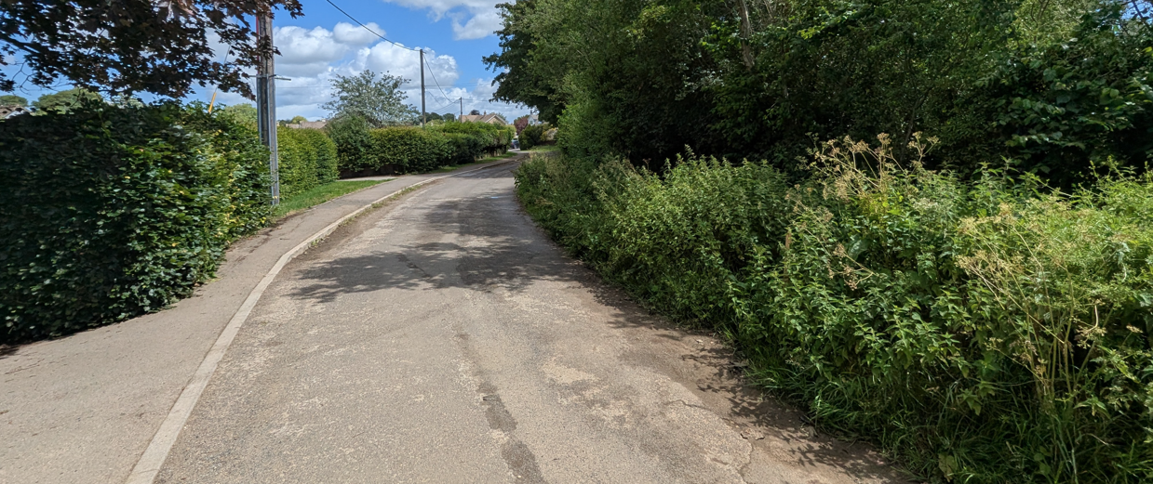View facing North along Acreshort Lane

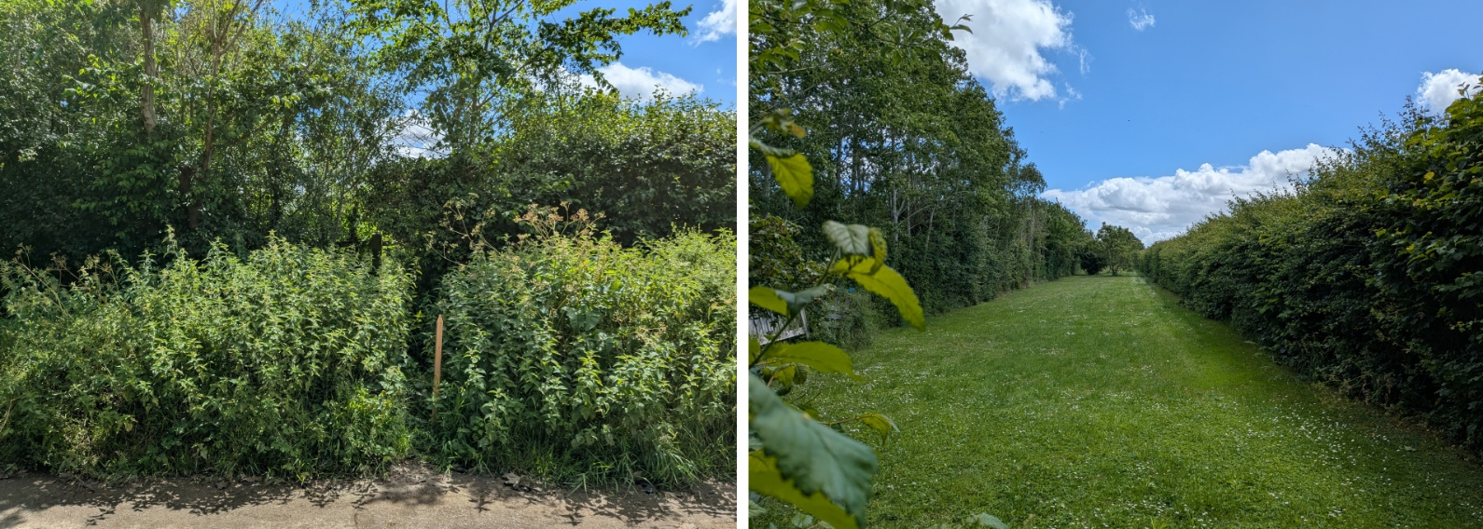Site Visit (proposed access location, and view into the site)

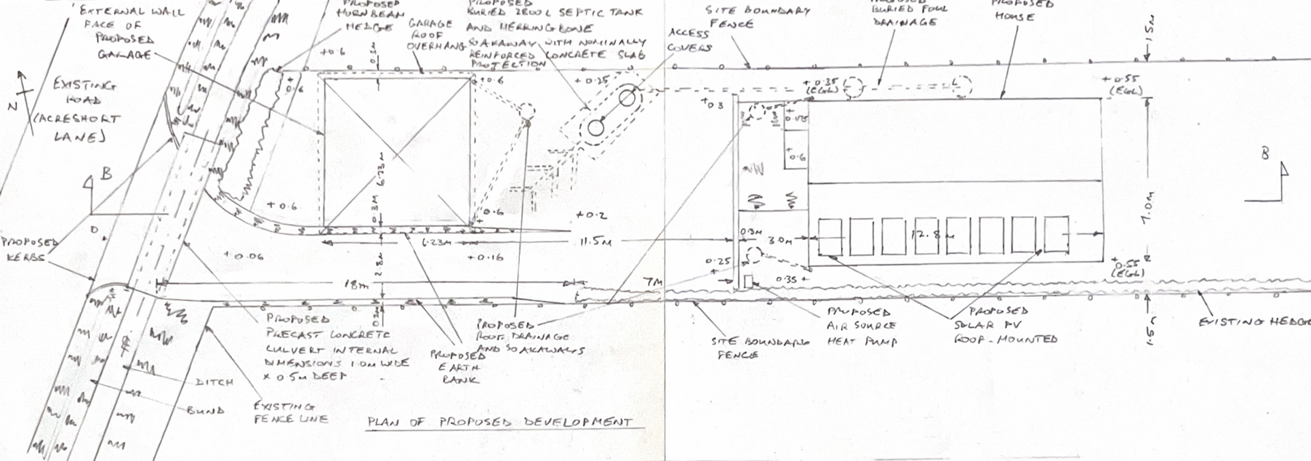
Proposed Site Plan
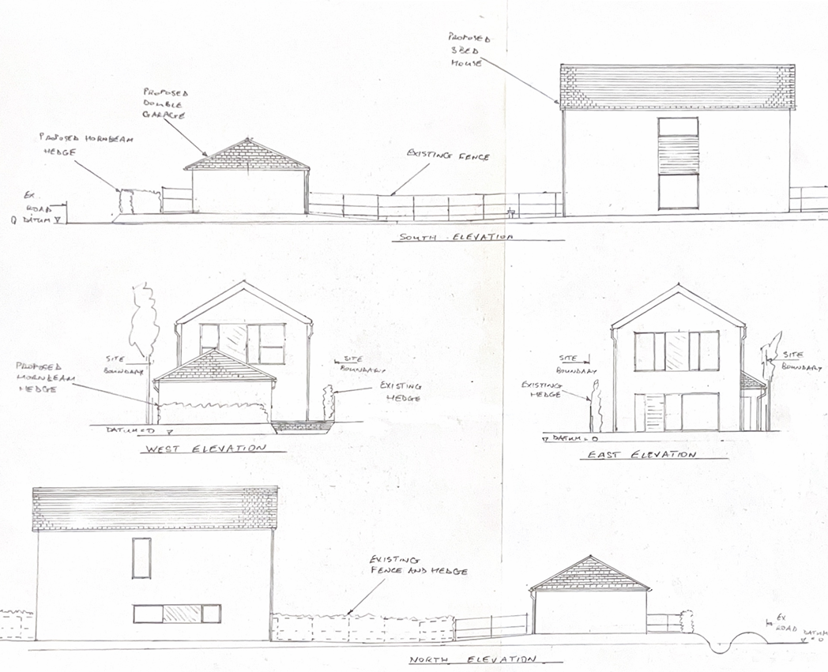
Proposed Elevations

Amenity Effects

Point vii of Core Policy 57 Ensuring High-Quality Design and Place Shaping of the Wiltshire Core Strategy seeks to ensure that developments do not adversely affect neighbouring properties.

The National Planning Policy Framework (NPPF), particularly Paragraph 135, stresses that planning decisions should ensure that new development provide a high standard of amenity for existing and future users.

The submitted plans indicate that the proposed welling would have adequate separation distances from neighbouring residential properties, with the nearest relationships more than 30 metres away. While first-floor windows are proposed on all elevations, these distances are sufficient to suitably safeguard the amenities of nearby / neighbouring occupiers.

The proposed two-storey dwelling would occupy a large curtilage, and by virtue of the separation to other properties, it would not likely result in harmful overbearing impacts, loss of outlook, or unacceptable overshadowing to nearby properties.

Overall, it is considered that the proposal would not give rise to any significant adverse impacts on the living conditions of neighbouring occupiers. The development would not conflict with the neighbouring impact criterion set out within Core Policy 57 (vii) of the Wiltshire Core Strategy and the relevant guidance within the Wiltshire Design Guide in respect of safeguarding residential amenity.

Transport and Highways

Core Policy 60 of the WCS states that the Council encourages safe and efficient movement of people and, where necessary, developers are asked to mitigate the impact of development on transport users and local communities. Core Policy 61 specifies that development should demonstrate that consideration has been given to a hierarchy of transport users and that proposals must, where relevant, serve as a safe access to the highway network.

Paragraph 116 of the NPPF states that “Development should only be prevented or refused on highways grounds if there would be an unacceptable impact on highway safety, or the residual cumulative impacts on the road network, following mitigation, would be severe, taking into account all reasonable future scenarios”.

The WCS, through Core Policy 64, outlines the need for development to comply with a minimum level of parking standards. This is further discussed through the Wiltshire Local Transport Plan, and policy PS6 which identifies that new residential development is required to take account of dwelling size and the mix of associated parking function.

The proposal seeks to create a new vehicular access off Acreshort Lane, which is a narrow, unclassified road, together with associated parking and turning provision within the site. In terms of parking, the proposal would provide a double garage and driveway area sufficient to accommodate at least two vehicles, which would meet the minimum standards set out within Core Policy 64 and the Wiltshire Local Transport Plan for a three-bedroom dwelling. Subject to detailed layout, it is reasonable to conclude that adequate on-site parking provision can be achieved.

Notwithstanding this, Wiltshire Council’s planning and highway officers have concerns regarding the lack of supporting information submitted with the application. In particular, the applicant has failed to submit a plan showing how the necessary 2.4m x 43m visibility splays (in both directions) can be achieved without affecting land outside the applicant/Council’s control.

In addition, the application is missing swept path analysis to demonstrate that vehicles can safely enter, turn within, and exit the site in a forward gear.

These matters are material to the assessment of highway safety and the overall functionality of the access.

Having regard to the site context and observations gained following the case officer’s site visit, Acreshort Lane is a quiet rural highway with relatively low traffic flows and low vehicle speeds. The creation of a new vehicular access at the location proposed cannot be supported by the Council given the inadequacy of the submission and the uncertainties that exist over whether the applicant would have full control to provide and maintain the stated necessary visibility splays in both directions (whilst also noting the presence of a bend in the highway and lack of pavement and street lighting).

The application is therefore considered contrary to Core Policies 60 and 61 of the Wiltshire Core Strategy and the National Planning Policy Framework.

Ecology Interests

Core Policy 50 of the Wiltshire Core Strategy requires development to protect and enhance biodiversity and to avoid and adequately mitigate any disturbance to protected species or habitats. In this instance, no ecological information has been submitted in support of the application. The site lies within the Bechstein bat 1.5km core roost buffer and the Trowbridge and Westbury Bat Mitigation Strategy (grey zone), where there is a known likelihood of bat activity and where development proposals are expected to demonstrate an understanding of ecological constraints and deliver appropriate mitigation.

In the absence of any ecological survey work, habitat assessment, or supporting appraisal by a suitably qualified ecologist, it has not been demonstrated that the proposal would avoid harm to protected species or comply with the requirements of the Habitat Regulations, Core Policy 50 or the NPPF.

The proposal would require the removal of a stretch of well-established hedgerow along the site boundary, including sections explicitly identified on the plans and potentially further areas where the extent of removal or retention is unclear.

The hedgerow presently forms a continuous and well-established boundary feature, which is likely to provide important habitat and commuting corridors for bats, birds, and other species. The scale of hedgerow loss, when combined with the introduction of built form and associated domestic activity, is of material concern regarding direct harm to wildlife, protected species and the fragmentation of habitat and disruption of wildlife corridors.

Furthermore, the proposed dwelling, by virtue of its height and siting may have potential impacts on bat flight paths which have not been fully considered/evidenced by the applicant despite the site / surroundings being in a very sensitive area for bats. No information has been provided to assess the ecological value of the on-site conditions and features, and the proposed removal of potentially important habitat cannot be supported when tested against the Habitat Regulations. In addition, the applicant has not submitted any mitigation or enhancement strategy.

Whilst it is acknowledged that Biodiversity Net Gain requirements and the Trowbridge and Westbury Bat Mitigation Strategy contribution would ordinarily be addressed in the event of a resolution to grant planning permission, such matters cannot be meaningfully secured or assessed in the absence of baseline ecological information.

The application therefore fails to provide sufficient information to enable a proper assessment of ecological impacts. As such, it has not been demonstrated that the proposal would conserve or enhance biodiversity, and the development is considered to be contrary to Core Policy 50 of the Wiltshire Core Strategy. Furthermore,

In the absence of sufficient ecological information, the Council is unable to conclude there would be no adverse effect on protected species and therefore cannot lawfully grant permission. Should the application be refused and appealed, any appointed inspector would be required to complete an Appropriate Assessment under the Habitat Regulations.

Flooding and Drainage

Core Policy 67 of the Wiltshire Core Strategy requires development to be located and designed so as to minimise vulnerability to flooding and avoid increasing flood risk elsewhere. The application site lies within Flood Zone 1; however, the Council’s Strategic Flood Risk Assessment identifies the site as being at risk from groundwater flooding. This is supported by the applicant’s own submission, which acknowledges that the site experiences waterlogging during wet weather, and is further evidenced by photographs showing standing water within the application site.

Notwithstanding this identified constraint, no site-specific Flood Risk Assessment or detailed drainage strategy has been submitted to demonstrate that the development can be accommodated safely or that it would not exacerbate existing flooding conditions.

Planning Practice Guidance confirms that the Sequential Test should be applied to development proposals in areas at risk from any source of flooding, unless it can be demonstrated through appropriate technical evidence that the development would not be at risk now or in the future.

In this instance, given the recorded and visual groundwater flood risk and absence of a Flood Risk Assessment, the Council cannot conclude that the site would be free from flood risk.

As such, the Sequential Test is required. Having regard to the modest scale and type of development proposed (a single dwelling), officers hold the view that there are reasonably available alternative sites at lower risk of flooding within or adjacent to the settlement, the Community Area, HMA. and across the County.

No evidence has been provided to demonstrate a functional or locational need for the development to take place on this site in particular. Consequently, the proposal fails the Sequential Test.

Furthermore, in the absence of any detailed drainage strategy, it has not been demonstrated how surface water runoff would be managed, particularly given the proposal includes new areas of hardstanding and alterations to the roadside ditch through culverting works. As such, it is not possible to conclude that the development would not increase flood risk elsewhere, including to the adjacent highway and neighbouring properties where localised flooding issues are known to occur.

The proposal therefore fails to demonstrate compliance with Core Policy 67 of the Wiltshire Core Strategy and the National Planning Policy Framework and is unacceptable in flood risk and drainage terms.

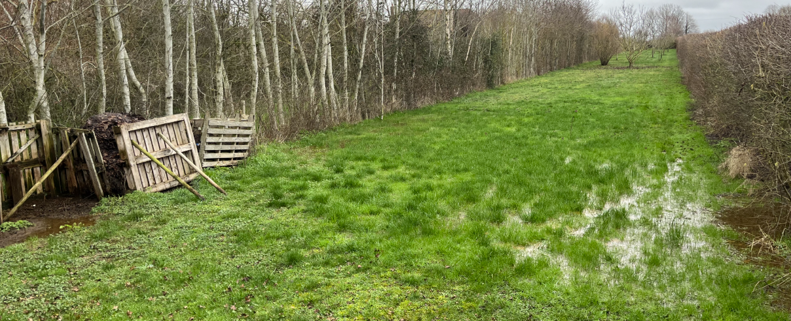
Photo of the site showing groundwater drainage issues.

Conservation and Heritage

Core Policy 58 of the Wiltshire Core Strategy requires that heritage assets and their settings are conserved and, where appropriate, enhanced. The site lies outside the Steeple Ashton Conservation Area, which is located to the east, and is also situated away from designated heritage assets, including the listed buildings associated with Home Farm.

Consultation with the Council’s Conservation Officer confirms that the proposal would have a neutral impact on the setting of nearby listed buildings and would not harm the character or appearance of the Conservation Area.

In this instance, there is limited intervisibility between the application site and the Conservation Area, with intervening modern development further reducing any visual relationship. As such, the proposed dwelling, which is of a contemporary domestic form, would not appear incongruous within the wider context nor give rise to harm to the significance of designated heritage assets.

In addition, the Council’s Archaeologist has raised no objection to the proposal, confirming that there are no archaeological constraints requiring further consideration.

Accordingly, the proposal is considered to comply with the requirements of Core Policy 58 of the Wiltshire Core Strategy and the statutory duties set out in Sections 16 and 72 of the Planning (Listed Buildings and Conservation Areas) Act 1990.

Planning Balance

The Local Planning Authority is currently unable to demonstrate a five-year supply of deliverable housing sites, with a supply position of approximately 2.8 years. As such, the most important policies for determining the application are considered to be out of date and the presumption in favour of sustainable development, as set out in paragraph 11(d) of the National Planning Policy Framework (NPPF), is engaged.

In this instance, it is considered that the proposal fails to satisfy the requirements of paragraph 11(d)(i) of the NPPF.

The site is identified as being at risk from groundwater flooding, as evidenced by both the Council’s Strategic Flood Risk Assessment and information submitted by the applicant demonstrating waterlogging on the site. In the absence of a site-specific Flood Risk Assessment and with no evidence to demonstrate that the development would be safe for its lifetime or would not increase flood risk elsewhere, the Sequential Test is required and has not been satisfied.

Flood risk is identified under Footnote 7 of the NPPF as a matter of particular importance, and in this case provides a clear reason for refusing the development.

Furthermore, when assessed against paragraph 11(d)(ii), it is considered that the adverse impacts of the proposal would significantly and demonstrably outweigh the benefits of erecting a single dwelling at a time when there is a HLS deficit since the benefit of erecting one dwelling can only manifest having limited weight, even in the context of an undersupply of housing.

The benefit would be substantively outweighed by a range of identified harms, including the conflict with the spatial strategy of the development plan and conflicting with the well-advanced Steeple Ashton Neighbourhood Plan that has reached decision statement following its examination.

The proposal would also result in material harm to the character and appearance of the countryside and edge of village setting, including the loss of an established hedgerow.

The application fails to provide sufficient information to enable the Council to fully assess the ecological impacts, including the loss of potentially valuable hedgerows within what is a recognised sensitive bat area. The lack of ecological surveying is fatal to the application when tested against the Habitat Regulations, the adopted WCS and the NPPF.

There is also a failure to adequately address drainage and flood risk matters, and substantive uncertainties exist pursuant to highway safety considerations through the proposed creation of a new vehicular access without visibility splays and a full review by the applicant to evidence if he has full control over the land affected.

The application would require a legal agreement to secure the necessary developer contribution of £925 (per dwelling) which the TWBMS states is to be reviewed annually (noting that the quoted £925 fee per dwelling was set in July 2025 and will be due an annual review in 2026), with the quoted sum being identified as being necessary to fund Council-led mitigation scheme(s) to offset the recreational pressures on the publicly accessible woodlands at Biss Wood and Green Lane Woods where a large colony of Bechstein bats are present and would be at risk by new occupants of housing in the grey buffer zone associated to the Bath and Bradford on Avon Bats SAC. No such legal agreement has been entered into by the applicant, which is another reason for refusing the application, although officers appreciate that as part of any appeal, this may be resolved.

Collectively at the point of determining the application at the end of June 2026, the above referenced harms carry significant weight against the application proposal.

Taking all matters into account, the proposal does not represent sustainable development and that the adverse impacts of granting permission would significantly and demonstrably outweigh the benefits. As such, the presumption in favour of sustainable development does not apply, and planning permission should be refused.

It should also be noted that with the expected progression of the Steeple ashton Neighbourhood Plan, which allocates multiple sites for housing and sets to deliver at least 35 new homes, NPPF para 14 will be engaged.

CONCLUSION

For the reasons set out above, the proposed development is considered to conflict with the development plan and does not accord with the progressing draft Steeple ashton Neighbourhood Plan Document which has advanced through examination, and the objectives of the National Planning Policy Framework. The proposal would result in unjustified harmful development in the open countryside, and these harms are compounded by the inadequacies of the application submission pursuant to ecological, highway and flood risk impacts. Accordingly, planning permission is hereby refused.

RECOMMENDATION: That Planning Permission be REFUSED for the following reasons:

- The proposed development is located outside the defined settlement boundary of Steeple Ashton and does not meet any of the exceptions for development in the open countryside set out within the Wiltshire Core Strategy. The proposal would therefore result in an unjustified and unsustainable form of residential development, contrary to Core Policies 1 and 2 of the Wiltshire Core Strategy and the spatial strategy of the development plan. The proposal is also contrary to the objectives of the National Planning Policy Framework, in particular those relating to the delivery of sustainable development. Whilst due regard is given to the Council's housing land supply deficit in the planning balance the benefits of this proposal would not outweigh all the harms.

- The proposed development, by virtue of the loss of an established hedgerow, the creation of a new access and associated engineering works, and the introduction of a two-storey dwelling and the domestication of the site (with household paraphernalia), would materially erode the rural character of this edge-of village location. The development would introduce a suburbanising form of development that fails to respond positively to its landscape context, contrary to Core Policies 51 and 57 of the Wiltshire Core Strategy and the National Planning Policy Framework.

- In the absence of an ecological survey, assessment, or supporting information, it has not been demonstrated that the proposed development would avoid harm to protected species or conserve and enhance biodiversity. The proposal includes the removal of established hedgerows and lies within a sensitive bat consultation area, yet no evidence has been provided to assess the ecological purpose or value of the site and its immediate surroundings or to identify appropriate mitigation or enhancement. The proposal is therefore contrary to Core Policy 50 of the Wiltshire Core Strategy and the National Planning Policy Framework.

- The site is identified as being at risk from groundwater flooding, and the application is not supported by a bespoke Flood Risk Assessment or adequate drainage strategy. As such, it has not been demonstrated that the development would be safe for its lifetime without increasing flood risk elsewhere. The Sequential Test has not been satisfied, and the proposal is therefore contrary to Core Policy 67 of the Wiltshire Core Strategy and the National Planning Policy Framework.

- Insufficient information has been submitted to demonstrate that safe and suitable vehicular access to the site can be achieved. In particular, no visibility splays or swept path analysis (affecting land within the control / ownership of the applicant) have been provided, and it has not been demonstrated that vehicles can safely enter, turn within, and exit the site in a forward gear. The proposal is therefore contrary to Core Policies 60 and 61 of the Wiltshire Core Strategy and the National Planning Policy Framework.

- In the absence of completed legal obligation at time of determination to secure necessary ecological mitigation measures / developer contributions as required by the adopted Trowbridge and Westbury Bat Mitigation Strategy, the proposed development fails to ensure appropriate mitigation of its impacts and compliance with relevant policy requirements. Without such secured mechanisms, the local planning authority cannot be satisfied that the development would adequately mitigate the recreational pressures on nearby bat sensitive sites. The proposal is therefore contrary to Core Policies 3 and 50 of the Wiltshire Core Strategy and the provisions of the National Planning Policy Framework.

Informative
Pursuant to reason for refusal No.6 cited above, if appealed, the appellant would be required to satisfactorily address the necessary developer obligation through a s106 /Unilateral agreement.

