APPLICATION FOR FULL PLANNING PERMISSION
CASE OFFICER REPORT

APPLICATION REFERENCE: | PL/2026/02883
APPLICATION TYPE: | Full planning permission
SITE ADDRESS: | 34 West Parade, Warminster, BA12 8LZ
DEVELOPMENT DESCRIPTION: | Retrospective application for siting an InPost Locker
RECOMMENDATION: | APPROVE SUBJECT TO CONDITIONS

SITE DESCRIPTION/CONTEXT: The application site is located within an established residential area of Warminster and within the settlement boundary for the town. The subject site comprises a two-storey, semi-detached red-brick building set back from the road, with an area of hardstanding to the front. The ground floor of the subject building is used as a Premier shop, with a flat above (registered as Flat 34a West Parade, Warminster).

The application site is located outside the Warminster Conservation Area but in proximity to it (c.33m to the west). The site is also situated within the 6.4km Salisbury Plain Special Protection Area (SPA) and within the Hampshire River Avon catchment.

PROPOSAL: This application seeks retrospective planning permission for the siting of an InPost locker, to the front of the existing Premier store. The lockers are already in situ, and with reference to the submitted completed application form, they have been in place since May 2025.

The lockers measure 2.4m in height, 2m in length, and 0.9m in width with a canopy and have been positioned on the eastern side of the site, close to the boundary with No. 34b

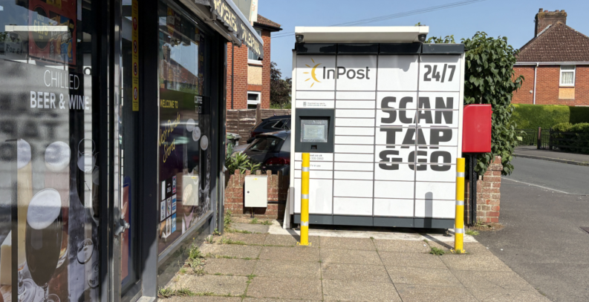

Extract taken from the case officer's site photograph

RELEVANT PLANNING HISTORY: There is no planning history associated with the site.

RELEVANT LEGISLATION, POLICIES AND GUIDANCE

National Context: The National Planning Policy Framework (NPPF) and National Planning Policy Guidance (NPPG); National Design Guide

Development Plan: The development plan for Wiltshire comprises the Wiltshire Core Strategy (WCS) (adopted January 2015) and any made neighbourhood plans, which remain the principal statutory planning document guiding development across the county. In line with Section 38(6) of the Planning and Compulsory Purchase Act 2004, planning decisions must be made in accordance with the development plan unless material considerations indicate otherwise.

Though the development plan is considered as a whole, those parts deemed to be particularly relevant to this application are listed below:

The adopted Wiltshire Core Strategy (WCS), with particular regard to:

- Core Policy 1 Settlement Strategy;
- Core Policy 2 Delivery Strategy;
- Core Policy 31 Spatial Strategy for the Warminster Community Area;
- Core Policy 50 Biodiversity and Geodiversity;
- Core Policy 57 Ensuring High Quality Design and Place Shaping;
- Core Policy 58 Ensuring the Conservation of the Historic Environment;
- Core Policy 60 Sustainable Transport;
- Core Policy 61 Transport & Development;
- Core Policy 64 Demand Management;
- Core Policy 67 Flood Risk;
- Core Policy 69 Protection of the River Avon SAC

Draft Wiltshire Local Plan Policies: At Full Council on 19 May 2026, the elected members of Wiltshire Council agreed to withdraw the emerging WLP. It will now be subject to a legal process to finalise its withdrawal, which is likely to happen in July and August 2026. As such, the WLP has no material weight for the purposes of the application.

Neighbourhood Plan: The Warminster Neighbourhood Plan 2015-2026, ‘made’ in November 2016

Supplementary Planning Documents and other Guidance:
- Wiltshire Design Guide (adopted April 2024)
- Trowbridge and Westbury Bat Mitigation Strategy (TWBMS), July 2025
- Wiltshire Local Transport Plan 2011-2026 (LTP3), adopted 2015 - including the Car Parking Strategy and Cycling Strategy
- Wiltshire Council Local Transport Plan 2025 -2038 (LTP4), adopted March 2025

ISSUES: Principle of the development; design and visual impact; heritage; amenity; highways; and ecology

CONSULTATION RESPONSES

Warminster Town Council: No objection, with a recommendation that the electricity supply be moved to alleviate the neighbour’s concerns.

The Town Council's recommendation regarding relocation of the electricity supply is noted; however, as this relates to land ownership and private infrastructure arrangements, it is not considered a material planning consideration, as this is a civil matter between the relevant parties.

REPRESENTATIONS: In accordance with the requirements of the Town and Country Planning (Development Management Procedure) (England) Order 2015 (as amended), the application was publicised by way of neighbour notification letters sent to adjoining and nearby properties.

This method was used to inform interested parties and provide a period of 21 days for comments to be submitted.

Below is a summary of the representations received during the consultation period. Only material planning considerations have been taken into account in the assessment of this application. Non-material issues, such as property values or private legal disputes, cannot be considered in the determination process.

Third-party representation: A total of three representations were received, raising the following summarised concerns/objections:

- Obstruction to visibility and right to light to neighbouring property
- Power supply to the locker has been secured to the neighbour's boundary wall without consent
- Out of character with the area
- Position of locker should be reconsidered

ASSESSMENT: Section 38(6) of the Planning and Compulsory Purchase Act 2004 states:

"If regard is to be had to the development plan for the purposes of any determination to be made under the planning Acts, the determination must be made in accordance with the plan unless material considerations indicate otherwise."

In accordance with this statutory requirement, this application has been assessed against the relevant policies of the Development Plan, including the Wiltshire Core Strategy (2015) and, where applicable, any made Neighbourhood Plans. Consideration has also been given to the policies of the National Planning Policy Framework (NPPF) as a material consideration in the assessment.

Principle of Development: Policy CP1 of the adopted Settlement Strategy of the WCS establishes a hierarchy of settlements to guide where development should be focused. The policy prioritises growth in:
- Principal Settlements (e.g., Salisbury, Chippenham, Trowbridge) – main focus for strategic growth.
- Market Towns – support local services and employment; suitable for sustainable development.
- Local Service Centres – smaller towns and villages with a range of services; limited development supported.
- Large and Small Villages – development should be limited and respond to local needs.
- Outside the defined settlements – development is strictly controlled and generally not supported unless exceptional circumstances apply.

Policy CP2 of the WCS sets out how development would be distributed and delivered across Wiltshire. The policy emphasises:
- Sustainable patterns of growth, reducing the need to travel and supporting local services.
- Development should be plan-led, aligning with the settlement strategy and supported by infrastructure.
- Windfall development (not allocated in plans) must still comply with the principles of sustainable development.
- Development outside settlement boundaries is generally not permitted, unless it meets specific policy exceptions (as set out in paragraph 4.25 of the WCS).

Together, CP1 and CP2 ensure that new development is strategically located, sustainable, and supports the character and function of Wiltshire’s communities.

The application is located within the settlement boundary for the town, where there is a presumption in favour of sustainable development. The stationing of an InPost locker in this established residential location is considered to provide a service to residents, providing a parcel collection service to customers. Such facilities are compatible with the function of local centres and are acceptable in principle, subject to detailed impact considerations. The lockers would be ancillary to the existing retail use, and as such, there is no objection to the principle of development.

It is important to mention that click and collect facilities such as this can, in some circumstances, be permitted development under Part 7, Class C of the GPDO. However, officers note the requirements of the criteria listed in C.1 stipulates that planning permission would be required if the collection facility is located within 2 metres of any boundary of the curtilage (C.1(d) and where “any part of the development would be between a shop front and a highway where the distance between the shop front and the boundary of the curtilage of the premises is less than 5 metres” in C.1(e) which this proposal would fail to satisfy, hence the submission of this application to regularise the stationing of the lockers in this particular location.

Design and Impact on the Character and Appearance of the Area: Policy 57 of the WCS requires high-quality design that:
- Enhances local character.
- Responds to the natural, historic, and built environment.
- Retains important features (e.g., trees, hedges).
- Supports sustainable construction and compatibility with surrounding uses.
- Creates safe, legible, and accessible spaces.

Section 12 of the NPPF emphasises design that is:
- Visually attractive.
- Functionally effective.
- Contributes to the quality of the built environment.

The Wiltshire Design Guide encourages sensitivity to local character, materials, and architectural styles and supports modern living standards while maintaining aesthetic and functional quality.

The design and size of the InPost lockers are functional for their intended purposes, and whilst the siting of the lockers to the front of the existing shop is unfortunate, the constraints of the site are noted, with there being limited alternative positions on-site to station the lockers.

Whilst the lockers do not positively enhance local character, their limited scale, functional relationship to the existing retail use, and siting on existing hardstanding mean that they do not result in unacceptable visual harm. On this basis, it is not considered that the lockers have caused material harm to the wider character and appearance of the area and thus would comply with the above-listed policies.

Impact on Heritage Assets: The application site is located outside of, but in close proximity to the conservation area boundary, and therefore, an assessment of the application against the relevant policies and legislation is required, as views in and out of the conservation area are important, any proposal has to be assessed mindful of Section 72 of the abovementioned Act as well as CP58 of the WCS and the relevant paragraphs of the NPPF.

From the point of view of the historic environment, the main statutory tests are set out within the Planning (Listed Building and Conservation Areas) Act 1990.

Section 72(1) of the Act requires the Council to pay special attention to the desirability of preserving or enhancing the character or appearance of designated Conservation Areas.

The NPPF outlines government policy for planning. Chapter 16 of the NPPF 'Conserving and enhancing the historic environment' sets out the Government's high-level policies concerning heritage and sustainable development. In particular:

Paragraph 208 requires LPAs should “avoid or minimise any conflict” between the heritage asset’s conservation (which includes achieving its optimum viable use) and any aspect of a proposal.

Paragraph 210 requires local planning authorities to take account of the desirability of sustaining and enhancing the significance of heritage assets and putting them to viable new uses, and of new development making a positive contribution to local character and distinctiveness.

Paragraph 212 requires “great weight” to be given to an asset’s conservation “irrespective of whether any potential harm amounts to substantial harm, total loss or less than substantial harm to its significance.”

Paragraph 213 advises that harm to the significance of a designated heritage asset should require “clear and convincing justification”.

Paragraphs 214-216 require a balanced approach, with any harm which would be caused being weighed against the potential public benefits which might be achieved.

Policy CP58 of the WCS requires that designated and non-designated heritage assets and their settings will be conserved, and where appropriate enhanced, in a manner appropriate to their significance and encourages proposals which improve the condition of heritage assets at risk.

In addition, CP57 of the adopted WCS requires a high quality of design in all new developments. The policy requires applicants to demonstrate how the proposal will make a positive contribution to the character of Wiltshire through (amongst other things) responding to the value of the natural and historic environment and being sympathetic to and conserving historic buildings and landscapes. Development is required to respond positively to the existing in terms of building layouts, built form, height, mass, scale, building line, plot size, elevational design, materials, streetscape and rooflines to effectively integrate the building into its setting.

The application seeks to retain existing click and collect lockers to the front of an existing shop. Whilst it is appreciated that the lockers are widely visible from the public realm due to their position on site, they are of a functional design and viewed in the context of the existing shop. On this basis, it is considered that the development has not detrimentally impacted the wider character and appearance of the nearby Conservation Area, resulting in no harm to its significance, and therefore, complies with the above-listed policies.

Amenity: Policy CP57 of the adopted WCS requires development to respect the amenity of existing occupants and ensure appropriate amenity levels for future residents.

Paragraph 135 of the NPPF, reinforces the need for development to provide a high standard of amenity for both existing and future users.

The 'made' Warminster Neighbourhood Plan endorses the Building for Life 12 industry standard for well-designed dwellings and places within its Policy L1 - Design, which states (with officer emphasis added) that:

“The design and layout of the West Urban Extension and other new developments are encouraged to reflect the principles outlined in the Building for Life 12 industry standard”.

Justification:
Good urban design
Quality and sustainability of new homes
Preservation of Warminster’s heritage and characteristics
Maintains a quality of life

It is appreciated that the lockers have been sited against a neighbouring boundary with the attached property and that concerns regarding the stationing of the lockers in this location have been raised within the submitted representations.

The development has been assessed in terms of its potential impact on residential amenity, in particular on the attached neighbouring property, with particular regard to loss of light, overshadowing, loss of privacy, and overbearing effects.

It is duly appreciated that the lockers have been sited in proximity to the attached neighbour and their existing ground-floor window, and this was observed during the case officer's site visit. Whilst it is acknowledged that the stationing of the lockers in this particular location would have some impact on the neighbouring property, due to its proximity to the existing window, officers have assessed the impact using the SunCalc tool, which can be modified by adjusting the time of any day of the year to appreciate when and to what extent a shadow may be cast. The extracts below illustrate the approximate level of shadow cast by lockers to the ground-floor window of No.34b at the time of the summer and winter solstices, and it demonstrates the extent of overshadowing that would be cast.

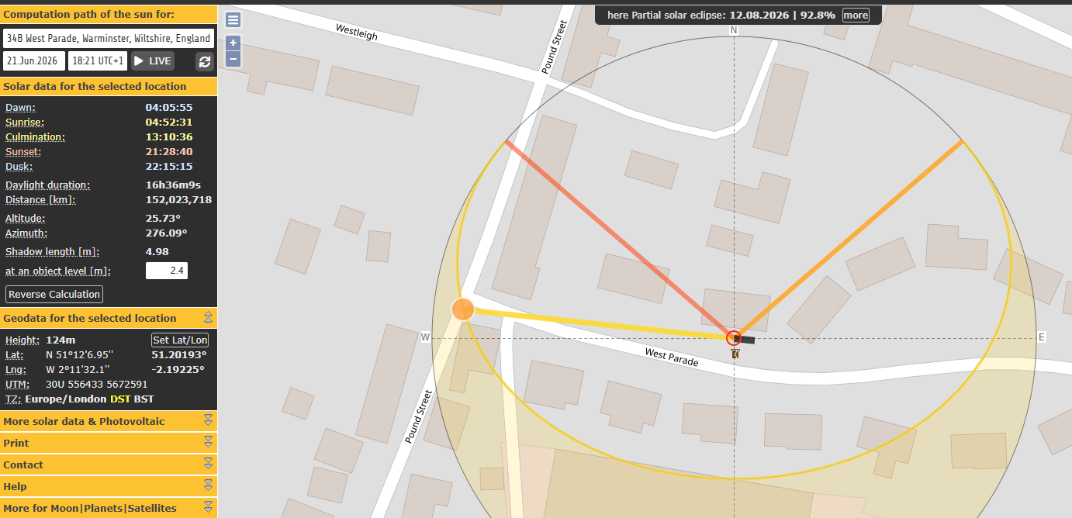
Summer solstice

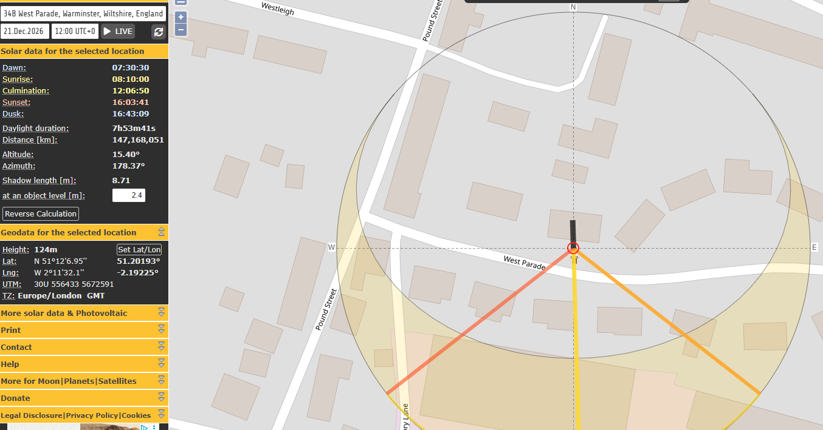
Winter solstice

The above extracts illustrate that there would be some overshadowing generated by the lockers over the front elevation of No.34b, but this would be limited to the late afternoon hours during the summer months only and therefore would not adversely impact the overall living conditions of the neighbouring occupiers. During the winter months, with the lockers being located to the south of the existing semi-detached pair, the lockers would not significantly reduce direct sunlight to the neighbouring property during daylight hours.

It is therefore considered that whilst the lockers would cause some overshadowing to the attached neighbour, due to the extent and duration of overshadowing that would be experienced over the course of a day and year to the neighbouring dwelling, the development would not have a detrimental impact on the overall living conditions of the occupiers over a significant period.

In terms of noise, it is anticipated that the lockers would predominantly be used by local residents, with most trips likely to be made on foot or involving vehicle movements comparable to those associated with the existing shop, so it is not considered that the stationing of the lockers would generate an unacceptable level of noise to neighbouring occupiers.

It is noted from the submitted representation that the power supply to the lockers has been attached to the boundary wall without the consent of the neighbour. However, the attachment of a power supply to a party wall without the consent of adjoining owners is a private civil legal matter between the interested parties under separate legal regimes (Party Wall etc Act 1996, separate to the planning system/legislation), and does not constitute a material planning consideration for the purposes of determining this application.

A grant of planning permission does not override private property rights, and therefore, this matter should be handled separately through civil law between the relevant parties.

Highways Impacts and Parking: Transport implications are a key factor in assessing planning applications, especially for larger developments. Proposals must demonstrate:
- Safe and suitable access for all users, including pedestrians, cyclists, and those with mobility impairments.
- No severe residual impacts on the surrounding highway network.
- Promotion of sustainable travel, reducing reliance on private vehicles.
- Adequate parking and cycle provision, in line with adopted standards.
- Protection and enhancement of public rights of way and active travel routes.

The application site is located within the settlement boundary for Warminster and within an established residential area where there is unrestricted on-street car parking.

Given the small-scale nature of the development and its ancillary relationship to the existing retail use, the lockers are unlikely to generate a significant number of additional vehicle movements beyond those already associated with the shop. The site is accessible by foot and located within an established residential area. It is therefore not considered that the development would have an unacceptable impact on highway safety.

Ecology and Biodiversity: The ecological impact of development is a key planning consideration, especially for larger schemes. Proposals must assess and address potential effects on:

- Protected species
- Priority habitats
- Ecological networks
- Green and blue infrastructure

Core Policy 50 of the Wiltshire Core Strategy requires development to:

- Avoid harm to ecological assets.
- Deliver measurable Biodiversity Net Gain (BNG), in line with the Environment Act 2021.
- Support habitat restoration and connectivity.
- Integrate biodiversity into site design.

The Green & Blue Infrastructure Strategy (2022–2030) promotes nature recovery, ecosystem services, and habitat connectivity through development.

Unless exempt, National policy requires a minimum of 10% Biodiversity Net Gain (BNG) for major developments, demonstrated via:

- Biodiversity Metric calculations
- Ecological assessments (e.g. PEAs, Phase 1 surveys, protected species surveys)

As of 2 April 2024, the requirement for Biodiversity Net Gain (BNG) on all new sites came into force. Any small-scale (non-major)/major scheme would need to demonstrate no net loss and a minimum of 10% net gain in biodiversity on the site, in line with the requirements of the NPPF, WCS policy CP50 (Biodiversity and Geodiversity) and the Environment Act.

In this instance the development satisfies the BNG exemption criteria as it is below the de minimis threshold, meaning the development that does not impact an onsite priority habitat (a habitat specified in a list published under section 41 of the Natural Environment and Rural Communities Act 2006); impacts less than 25 square metres of onsite habitat that has biodiversity value greater than zero, and less than 5 metres in length of onsite linear habitat (as defined in the statutory metric) is not required to provide mandatory BNG.

The application site falls within the recreational impact zone of the Salisbury Plain SPA for birds. Therefore, potential disturbance to nesting birds through the creation of additional visitor numbers to the Salisbury Plain has to be assessed. However, given that this application relates to the stationing of click and collect lockers, it is considered that there would not be any adverse impacts on the SPA.

The site is also located within the Hampshire River Avon SAC catchment, where phosphates and nutrients are carefully controlled and monitored to safeguard the River Avon. As this application does not seek to provide any accommodation, it would not have an impact on phosphates.

PLANNING BALANCE AND CONCLUSION: Whilst the retrospective nature of the proposal is regrettable, the application has been assessed against the development plan and material considerations, and it is considered to comply with the relevant local and national planning policies.

No material considerations have been identified that would significantly and demonstrably outweigh these benefits or indicate that permission should be refused, having regard to the assessment above and the representations received.

Accordingly, the application is considered acceptable in planning terms and in accordance with the Wiltshire Core Strategy, the National Planning Policy Framework, and all other relevant material considerations.

RECOMMENDATION: That Planning Permission be GRANTED, subject to conditions.

SunCalc - sunrise, sunset, shadow length, solar eclipse, sun position, sun phase, sun height, sun calculator, sun movement, map, sunlight phases, elevation, Photovoltaic system, Photovoltaic

