APPLICATION FOR HOUSEHOLDER PLANNING PERMISSION
DELEGATED REPORT

APPLICATION REFERENCE: | PL/2026/02570
APPLICATION TYPE: | Householder Planning Permission
SITE ADDRESS: | 16 Ludlow Close, Warminster, BA12 8BJ
DEVELOPMENT DESCRIPTION: | Single Storey Rear And Side Extension To Bungalow
RECOMMENDATION: | That Planning Permission be GRANTED

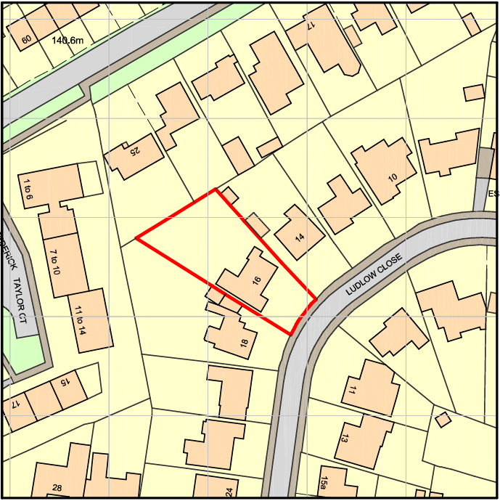
PROPOSAL

This application seeks planning permission to extend an existing bungalow to rationalise and unify the existing piecemeal rear additions to the dwelling through replacing a conservatory and a dressing room/ensuite extension with a single, consolidated rear extension, spanning the full width of the property. The new extension would project from the larger existing rear addition, infilling the rear elevation to create a coherent and continuous form. Internally, this would facilitate the creation of a more spacious open-plan kitchen and dining area, with a separate utility room positioned to the side. The existing kitchen would be reconfigured into a central snug with an open connection to the new space. Externally, the extension would feature a flat roof finished in EPDM to match the existing flat-roofed elements, buff brickwork to align with the host dwelling, and white uPVC windows and doors for visual consistency. A roof lantern is also proposed to enhance natural light in the enlarged kitchen area.

SITE DESCRIPTION / CONTEXT

The application site comprises a detached bungalow constructed in buff brick with a dual-pitched roof, situated within a low-density suburban residential area on the edge of the settlement. The surrounding context is characterised by predominantly detached dwellings set within generous plots, providing ample spacing between properties and a strong sense of openness. The streetscape exhibits a varied yet typical suburban palette of materials, including red and buff brick and areas of render. The site falls within the Warminster Settlement Boundary (Market Town) and is subject to several environmental constraints, including the Salisbury Plain Special Protection Area (SPA) 6400m buffer and the Hampshire River Avon catchment. Although located in Flood Zone 1 with no identified surface water flood risk, the Council’s Strategic Flood Risk Assessment indicates a potential groundwater flood risk. Overall, the site represents a conventional suburban setting with no unusual physical or visual constraints beyond these policy designations.

PLANNING HISTORY

No relevant planning history has been identified for the site subject of this application.

RELEVANT LEGISLATION, POLICIES AND GUIDANCE

Wiltshire Core Strategy:

Core Policy 1 Settlement Strategy;
Core Policy 2 Delivery Strategy;
Core Policy 31 Spatial Strategy: Warminster Community Area;
Core Policy 50 Biodiversity and Geodiversity;
Core Policy 51 Landscape;
Core Policy 57 Ensuring High-Quality Design and Place Shaping;
Core Policy 60 Sustainable Transport;
Core Policy 61 Transport and Development;
Core Policy 64 Demand Management;
Core Policy 67 Flood Risk;
Core Policy 69 River Avon SAC

Warminster Neighbourhood Plan 2015-2026

The National Planning Policy Framework (NPPF)

The Planning Practice Guidance (PPG)

Wiltshire Design Guide - Appendix D – Design Guidance for Householder extensions

The Wiltshire Local Transport Plan 2011 – 2026: Car Parking Strategy (March 2015).

The Wiltshire Local Transport Plan 4 (LTP4) (March 2025)

Emerging Policy – Wiltshire Local Plan Review

At Full Council on 19 May, the elected members of Wiltshire Council agreed to withdraw the emerging WLP. It will now be subject to a legal process to finalise its withdrawal - which is likely to happen in July or August (2026). The said Plan has no material weight for the purposes of the application.

CONSULTATION RESPONSES

Warminster Town Council – No Objection

REPRESENTATIONS

No comments received.

ASSESSMENT

Section 38(6) of the Planning and Compulsory Purchase Act 2004 states:

"If regard is to be had to the development plan for the purposes of any determination to be made under the planning Acts, the determination must be made in accordance with the plan unless material considerations indicate otherwise."

In accordance with this statutory requirement, this application has been assessed against the relevant policies of the Development Plan, including the adopted Wiltshire Core Strategy (2015) and, where applicable, any made Neighbourhood Plans.

Householder extensions are generally acceptable in principle, as they typically fall within the established residential curtilage of a property and do not result in new residential development in the open countryside. In this case, the proposal also lies within the defined limits of development set out in the Core Strategy, further reinforcing its acceptability in principle.

Design and Impact the upon the character and context of the area

Core Policy 57 of the Wiltshire Core Strategy requires all new development to achieve a high standard of design that responds positively to its local context. Proposals must reinforce and enhance local character and distinctiveness, relate appropriately to the surrounding landscape, and demonstrate a thoughtful response to existing townscape features. This includes careful consideration of elements such as building height, scale, massing, building line, materials, and overall appearance, ensuring new development integrates harmoniously with its setting.

The extension is appropriately scaled and clearly subservient to the original bungalow, occupying approximately two-thirds of the original footprint and maintaining a notably lower profile through its flat roof form. This ensures the proposal does not appear dominant or incongruous when viewed in relation to the existing dwelling. The use of matching materials, including buff brickwork, white uPVC fenestration, and an EPDM flat roof consistent with existing elements, ensures a cohesive and integrated appearance. Furthermore, the proposal represents an improvement to the dwelling’s overall design by consolidating a series of ad hoc rear additions into a single, unified and well-considered extension. Given the generous size of the rear garden and the established pattern of similar rear extensions within the locality, the development is considered to sit comfortably within its context, reinforcing local character while enhancing the functionality and appearance of the host property.
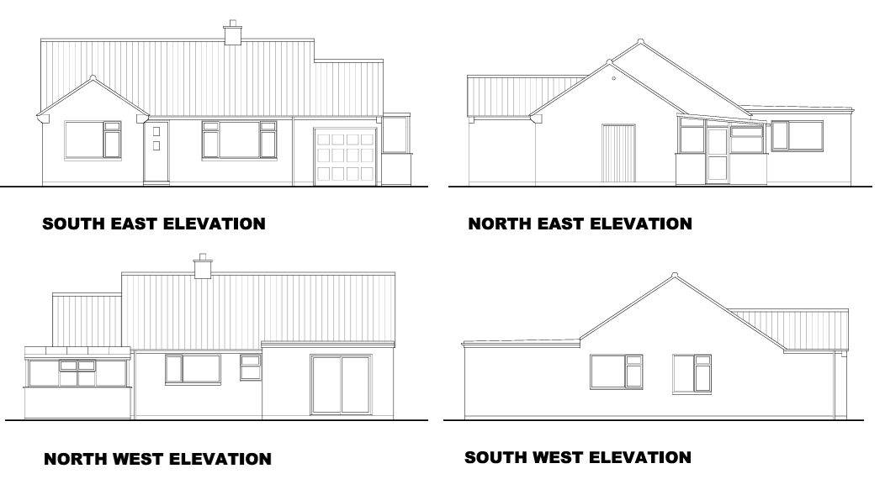
Existing Elevations

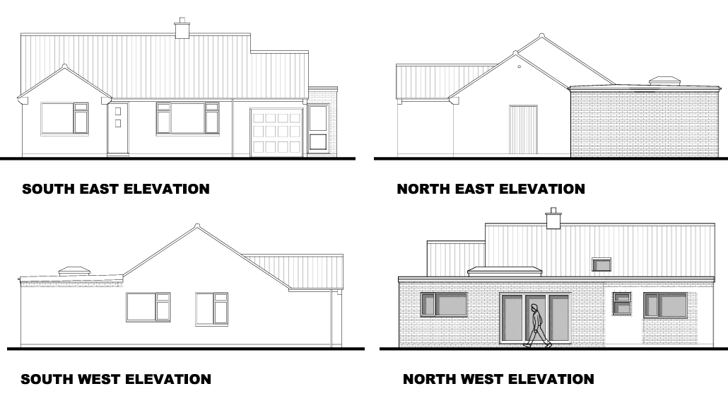
Proposed Elevations

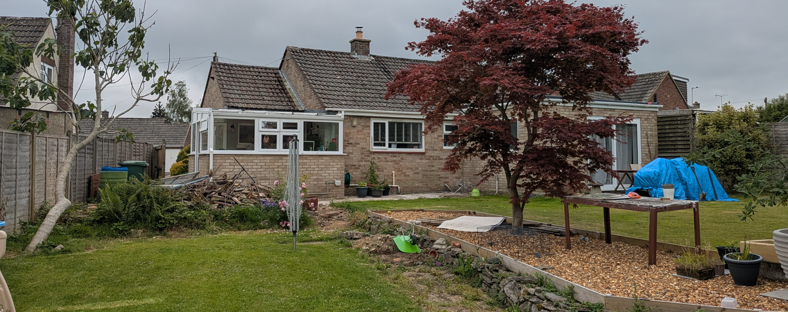
Site Visit Image

Having regard to the above, the proposal complies with the design principles set out in Core Policy 57 of the Wiltshire Core Strategy and Appendix D of the Wiltshire Design Guide.

Amenity

Point vii of Core Policy 57 seeks to ensure that development does not result in unacceptable impacts on neighbouring residential amenity, whilst Paragraph 135 of the NPPF requires a high standard of amenity for existing and future occupants. In this instance, the proposal is appropriately sited and designed such that it would not give rise to material harm in terms of outlook, privacy, or access to natural light. The extension does not introduce additional built form along the southwestern boundary beyond that which already exists, instead consolidating the current arrangement, and as such would not alter the established relationship with neighbouring properties in this direction.

To the northeastern boundary, the extension aligns with an existing garage structure, an area characterised by limited residential amenity value, and the modest height of the flat-roofed design, projecting only marginally above the boundary, ensures no overbearing impact or loss of light. Furthermore, the proposed fenestration is oriented solely toward the host property’s rear garden, with no opportunity for overlooking into adjoining private spaces. Given the subservient scale, limited height, and the context of adjacent structures and uses, the development would not result in any discernible adverse effects on neighbouring living conditions. The proposal therefore complies with Core Policy 57 (vii) and the guidance set out within Appendix D of the Wiltshire Design Guide.

Transport and Highways

Core Policies 60 and 61 of the Wiltshire Core Strategy seek to ensure that development promotes safe and efficient movement and provides suitable access arrangements, while Paragraph 116 of the NPPF confirms that development should only be refused on highways grounds where impacts would be severe. Core Policy 64 and associated guidance set out requirements for appropriate parking provision. In this case, the proposal relates solely to alterations and extensions to an existing dwelling, with no increase in the number of bedrooms and no changes to the existing access, parking arrangements, or vehicle movements. As such, the development would have a neutral impact on the local highway network and parking provision, and is considered acceptable in highways terms.

Ecology

Core Policy 50 of the Wiltshire Core Strategy seeks to ensure that development protects and, where possible, enhances biodiversity, avoiding adverse impacts on sensitive species and habitats. However, householder applications are exempt from the requirement to deliver Biodiversity Net Gain under Schedule 7A of the Town and Country Planning Act 1990 (as amended). The application site comprises an established residential garden which is largely hard surfaced and of limited ecological value, with little potential to support protected species or priority habitats. While the site lies within the Salisbury Plain SPA buffer zone and the Hampshire River Avon catchment, the scale of development, amounting to a modest increase of approximately 28.4 sqm, is minor and does not intensify the use of the dwelling, with no increase in bedrooms or additional kitchen facilities proposed. As such, the proposal would not give rise to increased recreational or nutrient impacts on these designated areas. Overall, the nature, scale, and location of the development are such that it would not result in harm to ecological interests and is therefore considered to accord with Core Policy 50.

Flooding and Drainage

Core Policy 67 of the Wiltshire Core Strategy requires development to minimise flood risk and ensure that it does not increase flooding elsewhere, supported by the NPPF’s sequential, risk-based approach. Paragraph 176 of the NPPF confirms that householder development of this scale is exempt from the sequential and exception tests. While the Council’s Strategic Flood Risk Assessment identifies a potential groundwater flood risk at the site, the proposal relates to a modest householder extension of limited scale, largely situated on areas of existing hardstanding. In this context, and given that the site lies within Flood Zone 1 with no identified surface water flood risk, it is considered that requiring a site-specific Flood Risk Assessment would be disproportionate. The development would not introduce a more vulnerable use, nor materially increase impermeable area or surface water runoff beyond existing conditions. As such, the proposal would not exacerbate flood risk on site or elsewhere and is considered to comply with the requirements of Core Policy 67 and national guidance.

CONCLUSION

The proposal is considered to be acceptable and in accordance with the relevant policies and guidance outlined above.

RECOMMENDATION: That Planning Permission be GRANTED subject to the following conditions:

1.
The development hereby permitted shall be begun before the expiration of three years from the date of this permission.
REASON: To comply with the provisions of Section 91 of the Town and Country Planning Act 1990 as amended by the Planning and Compulsory Purchase Act 2004.

2.
The development hereby permitted shall be carried out in accordance with the following approved plans and documents:

Proposed Elevations, Sections and Roof Plan (2665 04D)
Proposed Floor and Site Plan (2665 03D)
Existing Location, Site and Floor Plan (2665 01)

REASON: For the avoidance of doubt and in the interests of proper planning.

