APPLICATION FOR PRIOR NOTIFICATION - AGRICULTURAL
CASE OFFICER REPORT

APPLICATION REFERENCE: | PL/2026/02994
APPLICATION TYPE: | Prior notification: Excavation/waste material
SITE ADDRESS: | Manor Farm, Upton Folly, Upton Lovell, Warminster, BA12 0JN
DEVELOPMENT DESCRIPTION: | Proposed Excavation for Formation of an Earthbank Slurry Store and a Concrete Pad for the Storage of Silage Feed for the Dairy Herd
RECOMMENDATION: | Prior Approval Required and Granted

SITE DESCRIPTION/CONTEXT

Manor Farm comprises a substantial and established dairy farming enterprise with an existing complex of farm buildings. It also has 5 agricultural workers dwellings located immediately adjacent to the farm. It is located on a no through road from the Upton Lovell junction. The road from the junction is also not classified or adopted and therefore technically is a private road. The road does not serve any other property and only accesses land up to the B390. There is a public rights of way byway ULOV2 that runs from the Upton Lovel Junction up to the B390 to the north.

The site is within the Hampshire River Avon catchment and is also within the Salisbury Plain Special Protection Area 6.4km buffer zone. The site is within the Cranborne Chase and West Wiltshire Downs National Landscape. The site is not within a conservation area and there are no listed buildings. The site is not subject to any ancient monuments but is within an area covered by extensive and well-preserved later prehistoric field systems and localised settlement remains. The site is not subject to any groundwater or surface water flood risk.

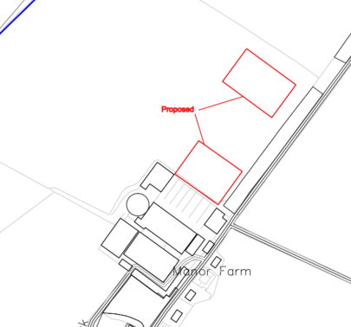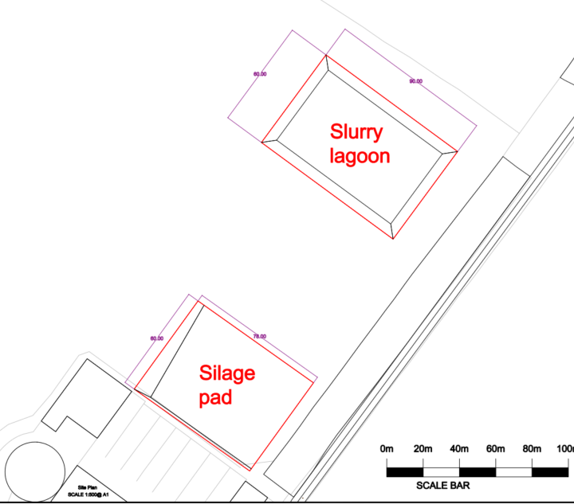

Site Location Plan and Block Plan

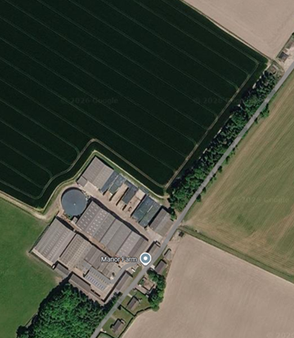

Aerial Photo of existing farm complex and proposed site

The site cannot be seen from the B390 to the north due to being behind a ridge (and woodland) on Knook Horse Hill. The southern end of the farm complex (and a couple of the agricultural workers dwellings) can be seen from the A36 to the south, but the application site itself cannot be seen from the A36. The site also cannot be seen from the east from Green Road or Chitterne Road (due to topography and woodland belts).

The site is therefore somewhat remote in its rural countryside setting.

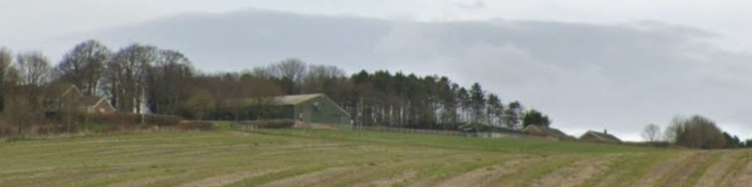
View from the A36

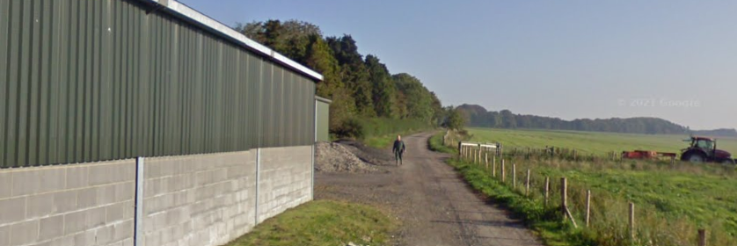

View from existing road access with farm complex (left) and application site behind the tree belt to the left

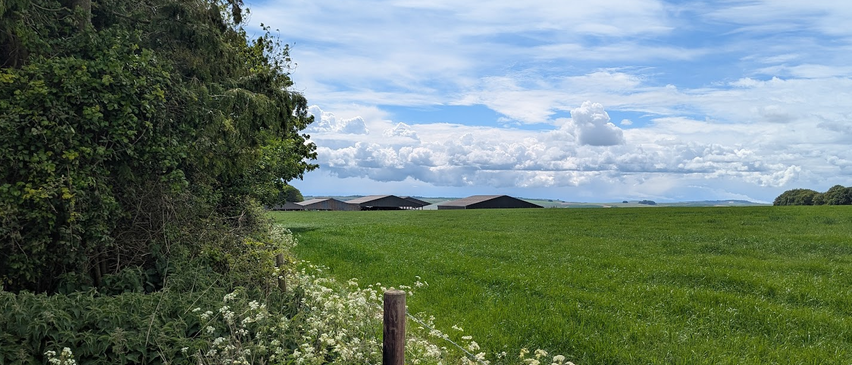

View from UL0V2 looking across application site with Manor farm behind

PROPOSAL

The proposal is to construct a slurry store and a silage feed to the north of the existing complex of buildings. Both would require some excavation, with an earth bank being constructed for the slurry store.

The slurry store would measure 90m long by 60m wide. It would be 6m deep following the construction of the earth bank. The applicants have submitted a cross-section plan which demonstrate the proposed level changes with the existing ground level shown as a green line.

On the northeastern (60m wide) side, the ground level would only be raised by c35cm, but on the opposite southeastern side, the ground level would be raised by c3.4m. Therefore, it is only the southeastern side of the slurry store which would see significant level changes. It is important to note that there is a significant tree and hedgerow line adjacent to the public right of way, which screens most, potentially all views across the valley from the east.

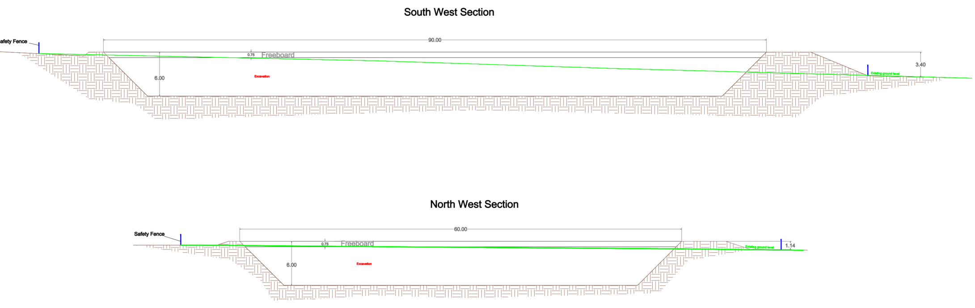

Slurry Lagoon Sections

The Silage Store would measure 78m long by 60m wide and by contrast would lower the existing ground level by 2m at its deepest point (on the western side), shallowing out as the pad moves eastwards. The agent has confirmed via email that “the pad is to be an open pad, in order to keep more flexibility in the size of the heaps stored and access to either end. That is why none were shown on the drawing.”

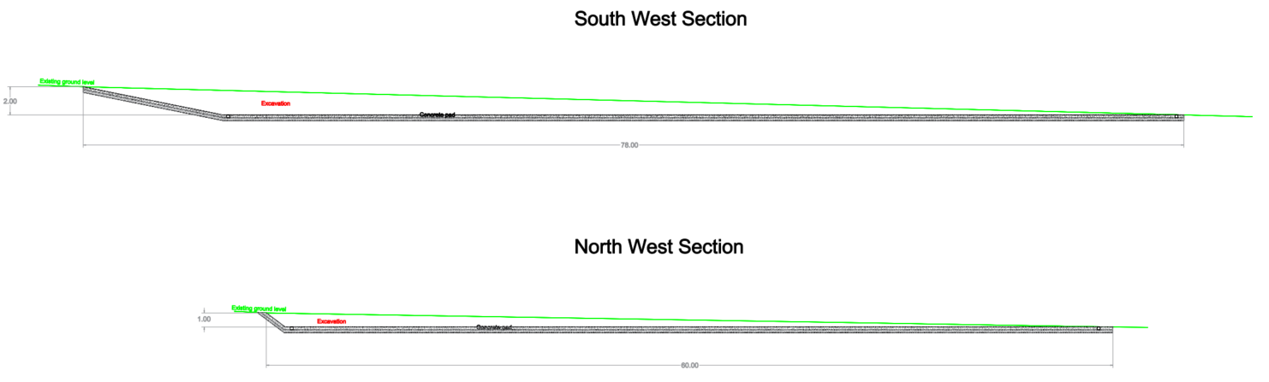

Silage Pad Sections

The applicants state that the slurry store is required because:

- Current capacity is insufficient and cannot be fully emptied.
- Proposal provides over 6 months storage, in line with Environment Agency and DEFRA guidance.
- Improves timing and efficiency of slurry spreading as fertiliser.

The silage store is required because:

- Existing facilities lack capacity and accessibility.
- New pad allows adequate storage of feed and better access to different silage cuts for the herd.

RELEVANT PLANNING HISTORY

Proposal / Summary
W/00/02113/AGD - Agricultural & Forestry - Detailed matters Decision - Approved Date: 22/1/2001 – Livestock building
W/03/01519/FUL - Full planning permission Decision - Approve with Conditions Date: 13/11/2003 – 3 Bedroom agricultural workers bungalow
W/91/00098/FUL - Full planning permission Decision - Approve with Conditions Date: 5/3/1991 – Erection of steel framed grain drying and storage building to replace existing unsafe building
W/96/01015/FUL - Full planning permission Decision - Refused Date: 3/10/1996 – Farm amenity building
13/02078/FUL - Full planning permission Decision - Approve with Conditions Date: 18/10/2013 – Agricultural workers bungalow
W/10/03005/FUL - Full planning permission Decision - Approve with Conditions Date: 23/11/2010 – New agricultural dirty water store lagoon, extend existing silage clamps
W/97/09026/AGD - Agricultural & Forestry - Detailed matters Decision - Approved Date: 13/10/1997 – Portal frame
W/93/01476/FUL - Full planning permission Decision - Approve with Conditions Date: 1/2/1994 – Single storey agricultural workers dwelling
W/93/01390/FUL - Full planning permission Decision - Approve with Conditions Date: 20/12/1993 – Agricultural buildings (animal housing)
W/95/09031/AGD - Agricultural & Forestry - Detailed matters Decision - Approved Date: 21/9/1995 – Two portal frame buildings
W/09/01987/FUL - Full planning permission Decision - Approved Date: 14/9/2009 – Roof over livestock gathering area
W/11/01993/FUL - Full planning permission Decision - Approve with Conditions Date: 21/9/2011 – Erection of new milking parlour buildings and calf shed ; relocation of existing building
W/93/09042/AGD - Agricultural & Forestry - Detailed matters Decision - Approved Date: 25/11/1993 – Fodder store
W/93/00080/FUL - Full planning permission Decision - Approve with Conditions Date: 1/6/1993 – 2 farm workers dwellings
17/00779/UN - Unknown – Covering of existing concrete circular slurry store with self-supporting cover
17/00717/FUL - Full planning permission Decision - Approve with Conditions Date: 30/3/2017 – Covering of existing concrete circular slurry store with a self-supporting cover to help protect the store from rainwater, reduce storage and field application costs, reduce the loss of Nitrogen, increasing the quality of slurry as fertiliser, reduce Ammo
17/08341/FUL - Full planning permission Decision - Approve with Conditions Date: 17/11/2017 – Construction of a general purpose agricultural storage building.
19/07001/FUL - Full planning permission Decision - Approve with Conditions Date: 16/9/2019 – Proposed agricultural storage building for cattle cubicle bedding and cattle feed. Consisting a galvanised mono pitch steel framed building, 9.75m wide x 9.15m deep (89 square metres or 960 square feet), split into two bays with pre-cast concrete walls 3m
19/12016/APD - Agricultural & Forestry - Detailed matters Decision - Prior Approval Not Required Date: 20/1/2020 – Erection of steel portal framed agricultural building.
PL/2021/03053 - Full planning permission Decision - Approve with Conditions Date: 15/6/2021 – Demolition of existing cow accommodation building, and the construction of a replacement cow accommodation building
PL/2021/06221 - Full planning permission Decision - Approve with Conditions Date: 18/8/2021 – The demolition of an existing cow accommodation building, and the construction of a replacement cow accommodation building.
PL/2022/04058 - Full planning permission Decision - Approve with Conditions Date: 22/8/2022 – The construction of an agricultural umbrella building to cover an existing open manure bunker.
PL/2026/01077 - Prior notification: Excavation/waste material Decision - Withdrawn by Applicant Date: 13/3/2026 – An earthbank lagoon for storing the slurry manure from the dairy herd

RELEVANT LEGISLATION, POLICY AND GUIDANCE

This application is assessed under Article 3 of the Town and Country Planning (General Permitted Development) (England) Order 2015 (as amended), which grants planning permission for certain types of development described in Schedule 2 of the Order. The grant of permission is subject to the limitations, conditions, and provisions set out within the relevant Classes of permitted development.

Under Schedule 2, Part 6, Class A of the Town and Country Planning (General Permitted Development) (England) Order 2015 (as amended), certain types of agricultural development may be permitted, including:

- Excavations or the deposit of waste material (where the relevant area exceeds 0.5 hectares); which are reasonably necessary for the purposes of agriculture within that unit.

Where such development is proposed, the developer is required to apply to the local planning authority for a determination as to whether prior approval is needed. This prior approval process is limited in scope and relates only to the following matters:

- The siting, design, and external appearance of the building;
- The siting and means of construction of the private way;
- The siting of the excavation or deposit;
- The siting and appearance of the tank.

CONSULTATION RESPONSES

Once it was determined that prior approval would be required a site notice was erected on site with a 21 day consultation period. Notification letters were also sent to the Council’s Archaeology Officer and external Cranborne Chase and West Wiltshire Downs Officer. No public comments were received.

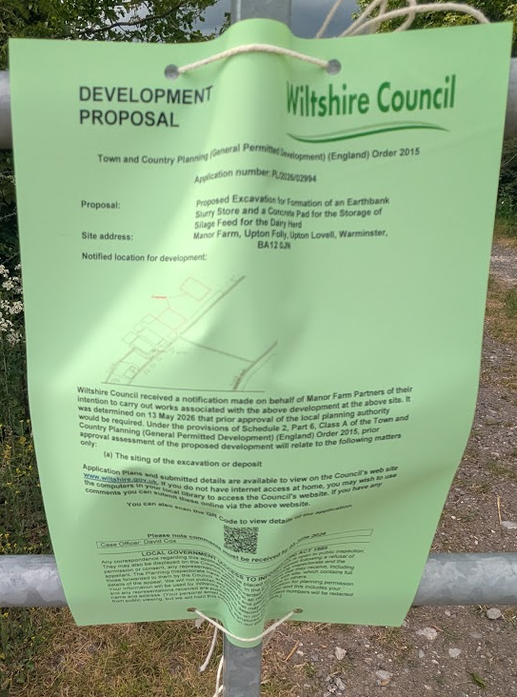

Archaeology Officer: No objection subject to condition

Cranborne Chase and West Wiltshire Downs Officer: Objection

I can confirm that no preapplication advice has been sought from this NL team. Whilst the CCNL Partnership is keen to support farming that sustains the character and qualities of the nationally important and nationally designated landscape it is very aware that government guidance is that development within NLs should be limited [NPPF 189].

Unfortunately the supporting statement does not provide information about the dimensions of what appears to be two separate proposals . There is a functional linkage in that silage effluent could be directed to the slurry store, although that appears to be uphill from the silage pad! It appears that the slurry store would be in addition to an existing slurry store. The statement draws conclusions about the appropriateness and acceptability of the proposals without providing supporting information.

The location is adjacent to a public access route, apparently a byway open to all traffic, so the proposals could be obvious to the public.

The application form appears to understate the height of the development, 0.5m, when plans / sections show features 1.14m to 3.4m high. The affected areas appear to be in the order of 13,500 sqm and not the 9700sqm on the application form. The development does, therefore, appear to be affecting in excess of 1ha.

The plans are very basic with no topographic or vegetation / woodland / hedging information to support the assertions in the Supporting Statement. The slurry lagoon appears to be quite large, some 60m x 90m surface area, and 6m deep with a bund at least 3.4m high on one side. The bunds / banks appear to extend to at least a further 10m is all directions with the addition of a safety fence. There appears to be a significant amount of material to be excavated and there is no information about what is proposed to happen to that material. I have not seen information about how the banks / bunds around the slurry lagoon would be treated and there is no landscape planting scheme or landscape management plan. It is unclear whether the lagoon would be lined and being in an elevated position on chalk strata running down towards the River Wylye there have to be concerns that the spreading of slurry regularly and in quantity risks increasing nutrient leaching into the river at a time when DEFRA is supporting a Landscape Recovery programme based around improving river characteristics and water quality. There is not sufficient information to support the proposal.

There is remarkably little information about the silage pad other than the dimensions, 60m x 78m. Presumably it would need to be concreted, involving a not inconsiderable quantity needing to be imported. Furthermore, silage usually needs some form of walls on three sides to support it, but none are shown. Those could be significant, visually intrusive, structures. Again, there is not sufficient information to form an informed view on the proposal or to support it.

To conclude, there is not enough information provided and information is lacking about both the extent of development and the proposals to help mitigate the impacts of extensive excavations and bund creation. Whether such proposals could fit into the designated landscape is unclear, and the landscape impacts, together with mitigation and enhancement, do need to be identified and evaluated.

Environment Agency: No objection; The Environment Agency raises no objection to the proposed earthbank slurry store and silage storage pad. The Agency advises that the development must comply with the requirements of the Water Resources (Control of Pollution) (Silage, Slurry and Agricultural Fuel Oil) (England) Regulations 2010 (SSAFO Regulations). The applicant is advised to review existing slurry and manure storage arrangements to ensure ongoing compliance and is reminded of the requirement to notify the Environment Agency at least 14 days prior to the construction of any new, reconstructed or enlarged slurry store or silage clamp. Informative advice is also provided with reference to DEFRA's Code of Good Agricultural Practice. No concerns are raised regarding groundwater protection, pollution risk or the suitability of the proposed development.

ASSESSMENT

Does the Proposal Qualify as Permitted Development?

Having completed the detailed assessment checklist at Appendix 1 of this report, it is concluded that the proposed development qualifies as permitted development under Schedule 2, Part 6, Class A of the Town and Country Planning (General Permitted Development) (England) Order 2015 (as amended), and the assessment may now proceed to consider the siting of the excavation or deposit of the development as required by the GPDO.

Is Prior Approval Required?

Condition A.2 (2) (i) states (with added Officer emphasis):

the developer must, before beginning the development, apply to the local planning authority for a determination as to whether the prior approval of the authority will be required as to the siting, design and external appearance of the building, the siting and means of construction of the private way, the siting of the excavation or deposit or the siting and appearance of the tank, as the case may be;

The silage pad and the slurry store are not buildings (they are engineering operations) and therefore the design and external appearance consideration does not apply. As set out above it is only the siting of the excavation works that can be taken into account.

The siting of the excavation works is considered to be acceptable. The farm sits well within the existing topography of Knook Horse Hill and combined with tree woodland belts screens the site well from public view. Although the full extent of the c260 hectare farm has not been shown, the slurry store has to be directly related to the farm complex it is serving, which is immediately adjacent to the site. To potentially move the store and silage pad would a) move it further away from the buildings it needs to be close to and b) risks exposing the site if located in a more exposed landscape position.

Additionally, given the reasonably remote location the farm complex and the lack of medium and long-distance views of the site from public roads and other residential or commercial buildings, the siting is considered to be acceptable. There could be some, although limited short distance views from the public right of way but the woodland/hedge tree belt is c17m deep and due to the current time of year with trees being in leaf, screens the site from public view. It is also considered that even in winter, the depth and extent of the tree screen (in combination with the limited overall views and general lack of the number of people who would walk past it) would still be sufficient as to not require prior approval of the siting of the two proposals.

Officers have taken into account the location within the National Landscape, the combined size of the two proposals, the level excavation and the spoil used to form the embankment (which would be quite substantial at 3.4m high and 60m long on its southeastern side) but given the remote location of the application site and the general lack of medium and long distance views any harm would be negligible. The embankment would likely be laid to grass helping it to integrate into its rural surroundings.

As this is a prior approval application (with a conclusion that prior approval is required and granted) conditions can be added where they are reasonably related to the matter under consideration i.e. the siting of the excavation.

The Council’s Archaeology Officer has requested a written scheme of investigation condition commenting:

“The sites are covered by extensive and well-preserved later prehistoric field systems and localised settlement remains. It is very possible that further, as yet unrecorded, sub-surface features dating from this period exist along the ridge of downland where Manor Farm is located. I advise that the footprint of both the lagoon and pad are topsoil stripped under archaeological supervision and any archaeological features that are exposed are to be excavated and fully recorded. This work is to be carried out ahead of any construction phase and secured via a condition to be attached to any planning permission.”

Given that the proposal involves extensive excavation works, the archaeological condition is directly related to the development authorised by this prior approval and is therefore reasonable and necessary.

As this recommendation is granting prior approval such conditions can be added to the decision notice and further confirms that the siting of the excavation is acceptable and should be granted.

National Landscape Officer concerns:

The comments of the Council’s Landscape (National Landscape) Officer are noted and have been carefully considered. However, it is important to recognise that this submission is made under the prior approval provisions of Class A, Part 6 of the GPDO, where the Local Planning Authority’s assessment is limited in scope. In this instance, the only relevant matter for consideration is the siting of the excavation works, rather than the broader planning merits, environmental impacts, or detailed design and engineering considerations raised within the consultation response.

A number of the matters identified, including the principle of development within the National Landscape, detailed design, environmental effects, and the level of supporting technical information, fall outside the matters capable of assessment under this prior approval process and are therefore afforded limited weight in the determination of this application.

The Environment Agency has reviewed the proposal and raises no objection. Whilst the application site lies within a Source Protection Zone, the statutory body responsible for groundwater and pollution control has not identified any concerns regarding the proposed slurry store or silage pad. The Agency's response is therefore a material consideration and weighs against the concerns raised regarding potential groundwater contamination or nutrient pollution. Compliance with the SSAFO Regulations will be a separate matter controlled by the Environment Agency.

Since the submission of the National Landscape Officer's comments, a Preliminary Risk Assessment has been provided which sets out the proposed engineering and operational controls. The report confirms that the slurry lagoon would be fully lined, incorporate an under-liner leak detection system and be designed in accordance with SSAFO requirements. The accompanying silage pad would include engineered effluent collection and storage infrastructure. The Environment Agency has reviewed the proposal and raises no objection. Accordingly, there is no technical evidence before the Authority demonstrating that the siting of the proposed facilities would result in unacceptable pollution risks.

The submitted Risk Assessment indicates that the purpose of the proposal is to increase slurry storage capacity such that slurry spreading can be undertaken in accordance with crop need and suitable weather conditions, thereby reducing the risk of pollution events associated with insufficient storage capacity. The proposed development is therefore presented not merely as additional storage infrastructure but as a measure intended to improve environmental management of the existing agricultural enterprise.

The Landscape Officer raises concerns regarding the scale and extent of the excavation works, including reference to the site area, the accuracy of information submitted within the application form, and the suggestion that the proposal may constitute significant or major development within the National Landscape. It is acknowledged that there are some discrepancies between the figures cited on the application form and those that can be derived from the submitted plans. However, the plans themselves provide sufficient detail and are considered to accurately illustrate the extent, form and siting of the proposed works. The Local Planning Authority is therefore satisfied that it has an adequate and reliable evidential basis upon which to assess the application.

In relation to scale, it is noted that the NPPF does not define “major development” by reference to any fixed site area threshold, and there is no policy basis for treating development as unacceptable solely on the basis of its size. Given the limited scope of assessment under the GPDO, the issue is not whether the proposal satisfies the planning balance applicable to major development in a National Landscape, but whether the siting of the excavation is acceptable having regard to the visual and landscape effects arising from that siting. Accordingly, the scale of the proposal is only material insofar as it informs the assessment of siting and the resulting landscape and visual effects, rather than being determinative in its own right.

In terms of siting, the proposed excavation is located immediately adjacent to the existing farm complex, which it is functionally required to serve. This relationship is an important material consideration, as relocating the excavation elsewhere within the holding would likely result in a more exposed and visually prominent position, potentially increasing landscape harm. The site is positioned within a fold in the landform of Knook Horse Hill and benefits from substantial containment by established woodland belts and hedgerow vegetation, which extend to approximately 17 metres in depth. This vegetation provides effective screening and significantly limits views into the site from the surrounding area.

Whilst there may be some limited and transient short-range views from the adjacent public right of way, these are largely filtered by the existing tree belt and do not give rise to wider visibility. There are no meaningful medium- or long-distance public views of the site from surrounding roads or receptors. Consequently, notwithstanding the scale of excavation and associated bunding (including embankments of up to approximately 3.4 metres in height), the development would not be widely perceived within the National Landscape and would be experienced in the context of the existing agricultural holding.

The Landscape Officer has also raised a concern regarding the volume of spoil arising from the excavation, particularly given that the extent of excavation may exceed that which can be readily accommodated within the proposed bunding. This is a valid observation, and it is acknowledged that the volume of excavated material is inherently linked to the siting and extent of the excavation. However, based on the submitted plans and the physical characteristics of the site, there is no substantive evidence before the Authority to demonstrate that the resulting material could not be appropriately accommodated or managed in a manner that would avoid unacceptable landscape effects at the application site. The key question for the purposes of this prior approval is whether the excavation has been appropriately sited to minimise landscape and visual impacts, and it is not considered that the anticipated volume of spoil, in itself, demonstrates that the siting is inappropriate.

Consideration has been given as to whether this matter could reasonably be controlled by condition. While prior approval decisions may include conditions where appropriate, any such condition must meet the established six tests, including being necessary and reasonable, and must relate directly to the matter under consideration, in this case the siting of the excavation. A condition requiring detailed spoil calculations or a scheme for the disposal of excess material would extend beyond controlling the effects of siting and instead regulate construction methods and material management, which fall outside the scope of this prior approval process. As the acceptability of the siting has been established without reliance on such controls, it is not considered that such a condition would meet the tests of necessity or reasonableness. On this basis, it would not be appropriate to impose a condition dealing with spoil management in this instance.

The Landscape Officer also notes the limited detail provided in respect of the silage pad, including the absence of any indicated retaining walls which are often associated with silage clamps. Whilst it is acknowledged that silage storage frequently incorporates side or rear walls to facilitate compaction and containment, this is not an invariable requirement of modern agricultural practice. Open silage pads without fixed retaining walls are also utilised in certain circumstances, particularly where greater operational flexibility is required. As such, the absence of walls in the submitted details does not, in itself, indicate that the development would be unworkable or inappropriate, nor does it materially alter the assessment of siting which is the only matter for consideration under this prior approval process.

Taking all of the above into account, it is considered that the applicant has demonstrated that the siting of the excavation has been appropriately selected to minimise landscape and visual impacts, whilst maintaining its necessary functional relationship with the existing farmstead. On this basis, and having regard to the limited scope of assessment under the prior approval process, the concerns raised by the Landscape Officer, including those relating to scale, discrepancies in submitted information, and spoil, do not justify withholding prior approval in respect of siting.

It is considered that the issue regarding spoil can be best addressed by way of an informative advising that any excess material will need to be carefully managed and appropriately disposed of, with a preference for removal outside the National Landscape where practicable.

CONCLUSION

The proposed development has been assessed against the provisions, limitations, and conditions set out in Schedule 2, Part 6, Class A of the Town and Country Planning (General Permitted Development) (England) Order 2015 (as amended). Based on the submitted plans, supporting documentation, and the findings of this report, it is concluded that the proposal complies with the criteria for permitted development and therefore falls within the scope of Class A. Following assessment, it is determined that prior approval is required in relation to the siting of the development. Having regard to the site's containment within the existing landform, the substantial woodland and hedgerow screening, the limited public visibility of the site, and its close functional relationship with the existing farm complex, the siting is considered acceptable.

Having considered the relevant matters, it is further concluded that Prior approval is granted, subject to the development being carried out in accordance with the submitted details and any conditions set out in this report.

RECOMMENDATION:
That Prior Approval is required and GRANTED

A
APPENDIX 1 – PERMITTED DEVELOPMENT CHECKLIST
 | Permitted Development | Yes / No
A | Does the proposal involve the carrying out, on agricultural land forming part of an agricultural unit of 5 hectares or more, of either:  (a) works for the erection, extension, or alteration of a building; or  (b) any excavation or engineering operations,  which are reasonably necessary for the purposes of agriculture within that unit? | Yes – this is excavation and engineering operation which are reasonably necessary for the purposes of agriculture in the unit. The applicant has set this out in the supporting statement stating that existing provision is inadequate and needs to be updated to be in line with Environment Agency and DEFRA guidance. The agricultural holding is 263 hectares.
Criteria (A.1) – Development not permitted by Class A:
(a) | Is the development proposed to be carried out on a separate parcel of land forming part of the agricultural unit that is less than 1 hectare in area? | No. The field itself is over 5 hectares, and is part of the larger agricultural unit.
(b) | Would the development consist of the erection or extension of any agricultural building on an established agricultural unit where development under Class Q or Class S of Part 3 (changes of use) has been carried out within the last 10 years? | No
(c) | Would the development consist of, or include, the erection, extension, or alteration of a dwelling? | No
(d) | Would it involve the provision of a building, structure or works not designed for agricultural purposes? | No
(e)(i) | Would the ground area covered by any works or structures (excluding fences) for accommodating livestock or plant/machinery arising from engineering operations exceed 1,000 square metres? | No– the proposed slurry lagoon and silage pad are engineering operations for agricultural storage and are not works for accommodating livestock, plant or machinery.
(e)(ii) | Would the ground area of any building erected, extended, or altered under Class A exceed 1,500 square metres? | No – the slurry store and Silage pad are not buildings, they are engineering works.
(f) | Is any part of the proposed building, structure, or works within 3 kilometres of the perimeter of an aerodrome and would exceed 3 metres in height? | No
(g) | Is any part of the proposed building, structure, or works not within 3 kilometres of an aerodrome and would exceed 12 metres in height? | No
(h) | Would any part of the development be within 25 metres of a metalled part of a trunk road or classified road? | No
(i) | Would the development consist of, or include, the erection or construction of, or works to, a building, structure, or excavation used or intended for the accommodation of livestock or storage of slurry/sewage sludge, and be within 400 metres of the curtilage of a protected building? | No – all adjacent dwellings within 400m are all within the agricultural unit and are not therefore ‘protected buildings’
(j) | Would the development involve excavations or engineering operations on or over article 2(4) land that are connected with fish farming? | No
(k)(i) | Would any building for storing fuel for or waste from a biomass boiler or anaerobic digestion system be used for storing waste not produced by that system or fuel not produced on land within the unit and be within 400 metres of the curtilage of a protected building? | No
(k)(ii) | Would any building for storing fuel for or waste from a biomass boiler or anaerobic digestion system and be within 400 metres of the curtilage of a protected building? | No
(l) | Would the erection or extension of a building be carried out on land or a building that is, or is within the curtilage of, a scheduled monument? | No

