Conditional Tree Assessment


Countryside Limited

Location:
25 Hamilton Drive,
Market Lavington. Devizes.
SN10 4BN

Date: 8th May 2026

Ref: N/A

Tree Conditional Survey
Client: Aster Housing Ltd
Application: Tree Conditional Survey
Location: 25 Hamilton Drive
Date: 08/05/2026
Surveyor: Olly Gurney
Our Reference: N/A

1.0 Instructions/introduction

1.1.1 This report was commissioned by Aster Housing Ltd in
terms of their condition. The survey was to make recommendations for any
necessary management in terms of the safety of the trees.

1.1.2 The trees are identified in the following schedule and marked on the attached plan.

1.1.3 Where works have been recommended, a priority rating has also been given
depending on the urgency of those works.
Priority 1 works relate to hazards with a high degree of risk (i.e. the hazard is highly
likely to cause harm to persons or property if not dealt with) and should be carried
out as soon as can be arranged (no more than 3 months).
Priority 2 works that relate to hazards with a moderate degree of risk and should be
carried out within 12 months of the date of this report.
Priority 3 works are non essential works that are recommended for example to
promote good growth, remove ivy to aid future inspections etc, and should be
carried out where finances allow.
Monitor a tree that should be inspected as a minimum of annually or after any
adverse weather conditions i.e. High winds, heavy levels of rain, excessive
temperatures both high and low, if the condition of the tree worsens professional
advice should be sought immediately.

2.0 Report Limitations

2.1.1 All the trees have been inspected from ground level using visual observation
methods. Should a more detailed report be required then this will be outlined within
the recommendations.

2.1.2 Trees are living organisms whose health and condition can change rapidly. The
health, condition and safety of the trees therefore should be checked on a regular
basis, preferably once a year. The conclusions and recommendations in this report are only valid for a period of one year. The period of validity may be reduced in the case of any change in condition or to proximity to the tree.

2.1.3 I have checked the local planning authority interactive mapping and identified that
both trees mentioned in this report are covered by a Preservation Order (TPO)
It would be advisable to check whether these controls are in operation. If they were,
it would be necessary to obtain consent before undertaking such work.

Tree  No | Species | Height (m) | Stem  Dia @ 1m(mm) | Single/ Multi-stem | Crown Spread (m) |  |  |  | Ground  Clearance  (m) | Condition  (Normal, Fair,Poor) | Age Class
 |  |  |  |  | North | East | South | West | Ground  Clearance  (m) | Condition  (Normal, Fair,Poor) | Age Class
T1 | Quercus ssp. | 16m | 800 | SIngle | 7 | 6 | 7 | 7 | 5m | Normal | Mature
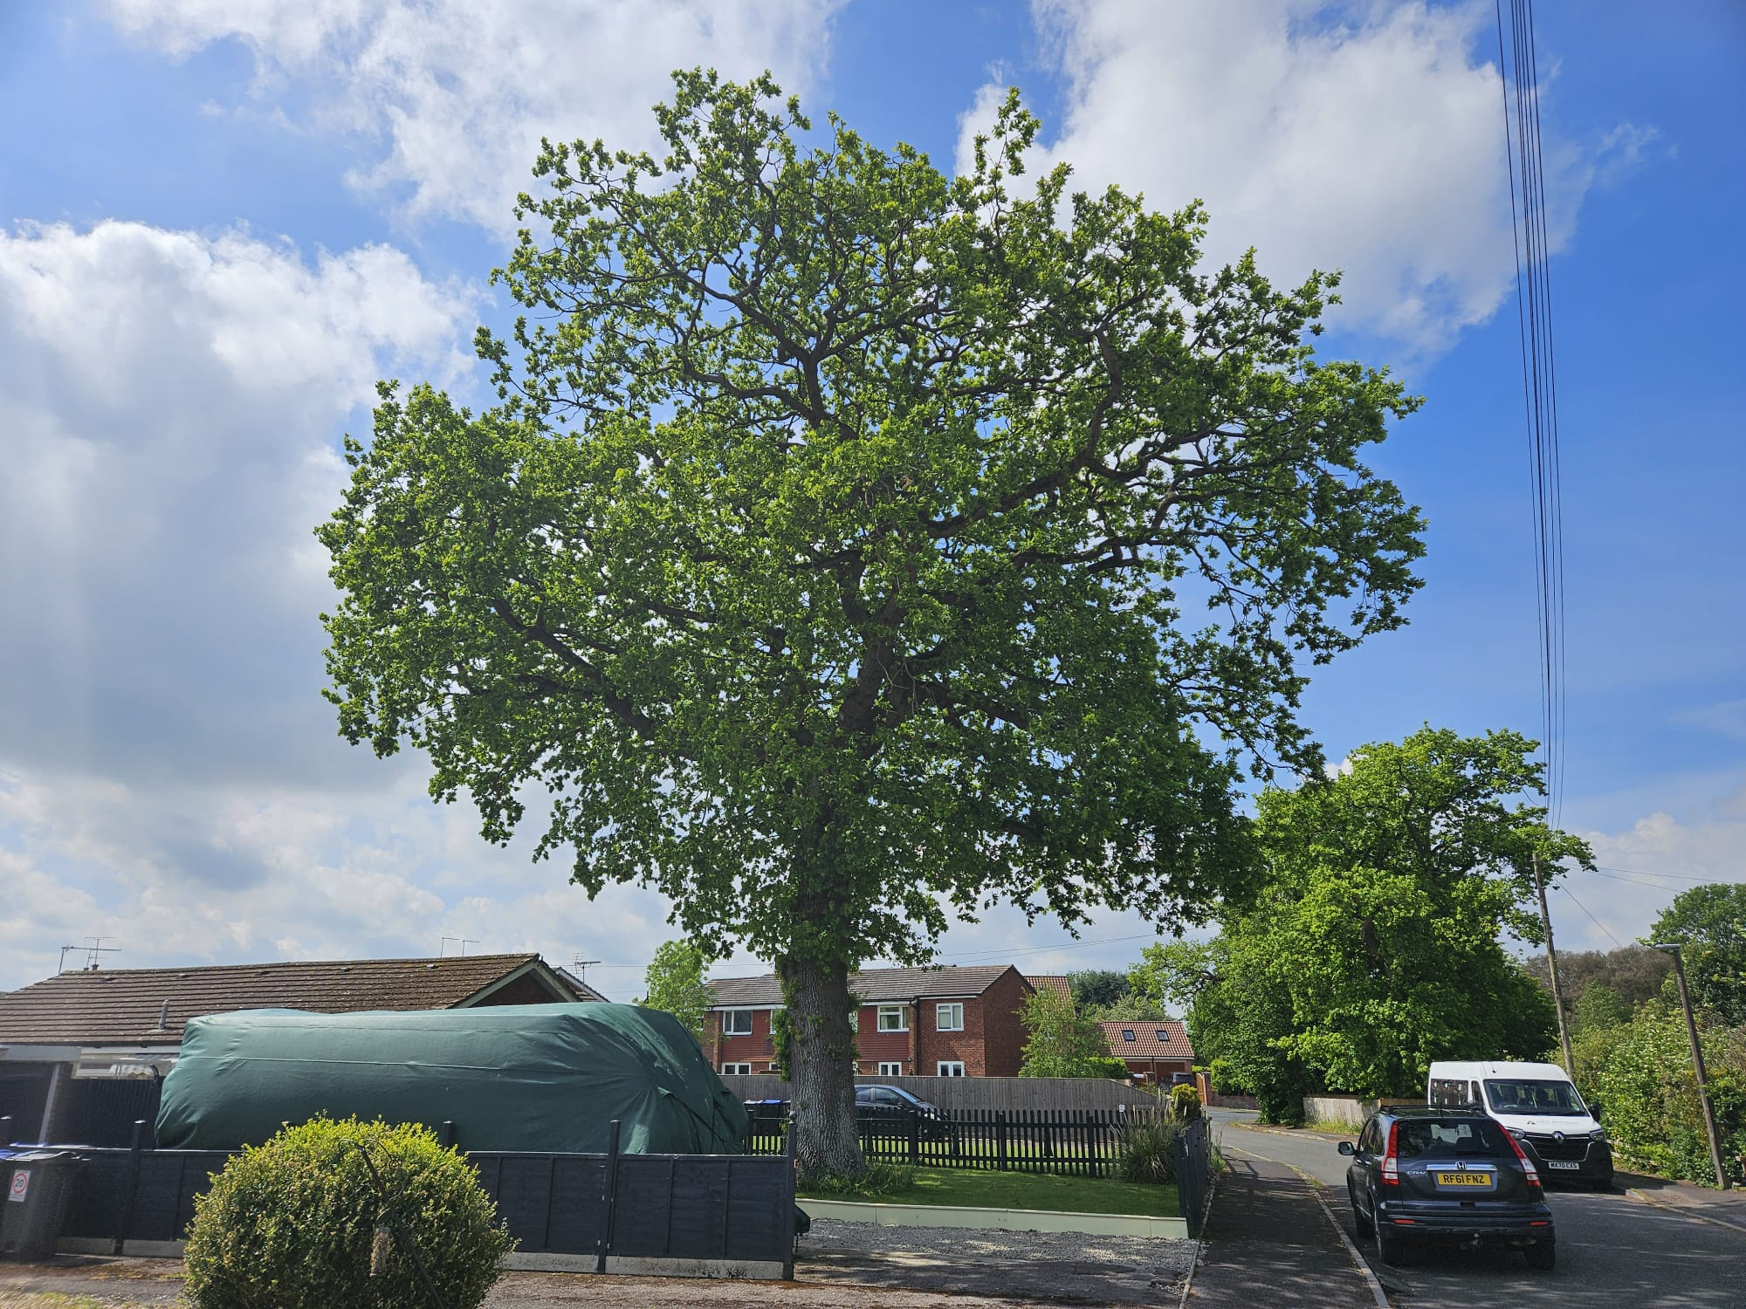 |  |  |  |  | Comments/Structural Condition:  Epicormic growth on main stem  Vitality Good  Deadwood >50mm throughout crown  Evidence of historic tear on underside lower primary lateral extending south - wound wood observed  Basal fungus mention by resident - no evidence at time of survey (May) |  |  |  |  |  | Life Exp  20+
Priority

Low
Preliminary Management Recommendations:

A crown reduction, full circa, by approx. 2m in length but not exceeding 50mm branch diameter to remove minor deadwood and reduce the likelihood of future deadwood fall

Further Photos

