DESIGN & ACCESS STATEMENT FOR
ALTERATIONS AND EXTENSIONS
TO THE OUTBUILDINGS AT
69 HIGH STREET, WEST LAVINGTON
SN10 4JB

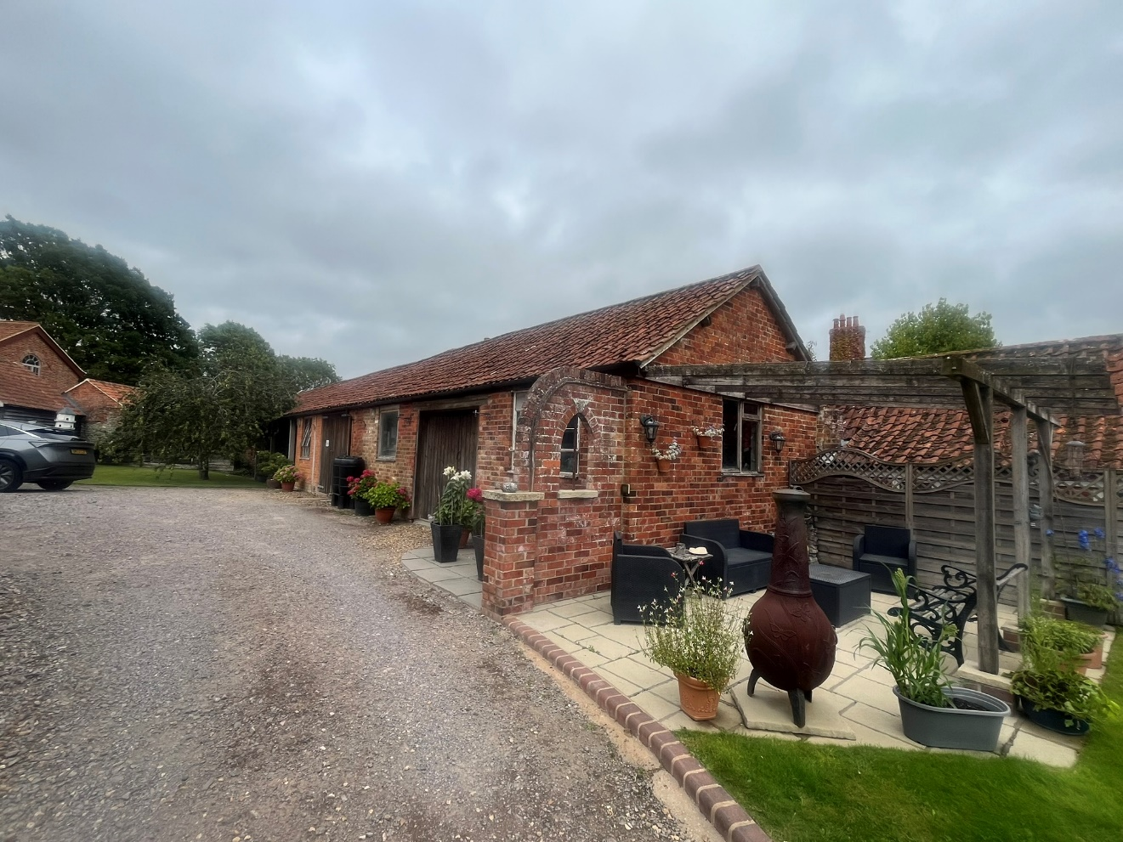


ASHLEY DESIGN
2871 D&A
NOVEMBER 2025
REVISED JUNE 2026

CONTENTS

- GENERAL

- SITE & CONTEXT

- DESIGN

- ACCESS

- GENERAL

  - This householder application is for the conversion and extension of outbuildings to form and annex to 69 High Street. The applicant purchased the property in April 1993 prior to that time the house had remained vacant for some six years after the Holloway Estate ceased to use it as office accommodation.
It was in a derelict state and uninhabitable with weeds clogging the access gate to the High Street.

  - Outbuilding 1 had previously been in use as the maintenance workshop and stores for the Holloway Estates. It had been altered on several occasions and repaired with for instance concrete support posts holding up the truss feet.

  - Building 2 referred to on 2871- 2 & 3 as the Shed was open ended and used as access from the High Street by Holloway Estates workforce with small farm equipment and vehicles. At the time of purchase in 1993 its roof was supported on the brick party wall on its north side, the south east side was open timber framing with a few rotted boards. The north east side was open to the adjoining estate farm area. Concrete block walls were constructed to close up the opening and to provide support for the roof on the north west side. Modern ship lap boarding was applied to the timber framed south east side and doors and frame constructed on the south west. The earth floor was replaced by concrete.

  - Early in the 1990’s after restoration of the properties the applicants commenced plumbing, building maintenance and sewing businesses from Building 1. Those activities continue to this day hence the need for the extension to Building 2.

- SITE & CONTEXT

  - West Lavington is a linear settlement linked to Littleton Panel on the A360 Devizes to Salisbury Road. 69 High Street is located towards the south eastern end of the village just before the road becomes Church Street.

  - Historically the property was part of the Holloway Estates (Now known as West Lavington Estates) a farming enterprise of considerable extent. The area to the north of the site is still part of the estate and includes a large maintenance building and farm shop.

  - West Lavington is a thriving community with a parish church, convenience store with post office, doctors’ surgery, village hall, primary school and public house. Dauntsey’s Independent school is also located in the village whilst Lavington Secondary School is located nearby in Market Lavington.

3.0 DESIGN
3.1 The main building to be converted is a single-story clay pantile roofed brick and stone structure part open fronted. At present the south western end contains a workshop and sewing room. The remainder of the building is open storage.

3.2 The shed is a pantile roofed timber clad structure; its south eastern end was close off when the property was purchased. It has been used as garaging and storage.

3.3 It is proposed to convert the closed in area of Building 1 into two bedrooms each with an en-suite bathroom, main entrance, and utility room. The open fronted area is to be closed in with a timber frame wall clad with stained boarding. French doors are to light the area which is to become the living room, dining room and kitchen area. A dining area with kitchen is to occupy that area whist an extension is to provide a living area and porch. The extension will be built with facing brick and pantile roof to match the existing with a glazed patio door.

3.4 The timber frame wall will support the existing trusses, trusses under the proposed solar panel area are to be reinforced as directed by the structural engineer.

3.5 It is proposed to extend the shed Building 2 to provide a workshop and sewing room where he existing businesses will relocate to continue. The extension will be roofed and clad to match the existing, solar panels are to be provided and the existing roof trusses reinforced as directed by the structural engineer.

3.6 The annex is to provide retirement accommodation for the applicants whose family will be occupying the existing dwelling.

3.7

  - ACCESS
4.1 There are no changes proposed to the existing access arrangements to
Property. However, is should be noted that the property has been used by the preset owners’ businesses the applicants Mr. Rowels though semi-retired runs a plumbing and building maintenance service and Mrs. Rowels operates The Old Stitching Post clothing repairs and alteration service from the site. Carpenter Simon Dickinson also worked from the site.
These activities resulted 10 to 15 vehicle movements in and out per day.
The conversion will result in fewer vehicle movements.

PHOTO SHEETS

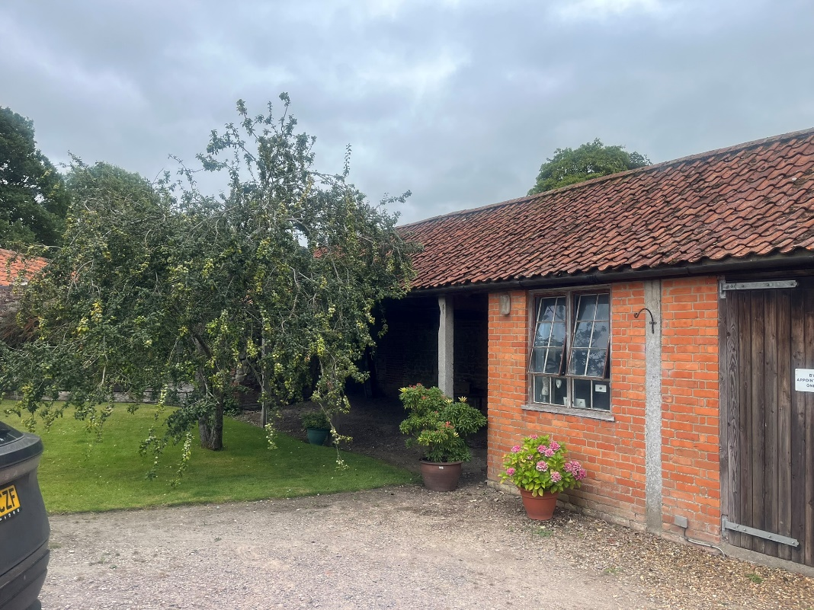

BUILDING 1
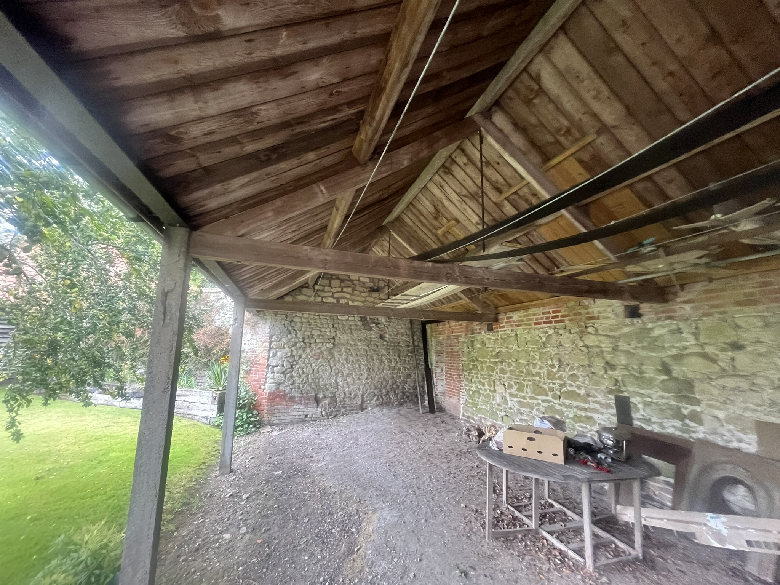

OPEN AREA BUILDING 1

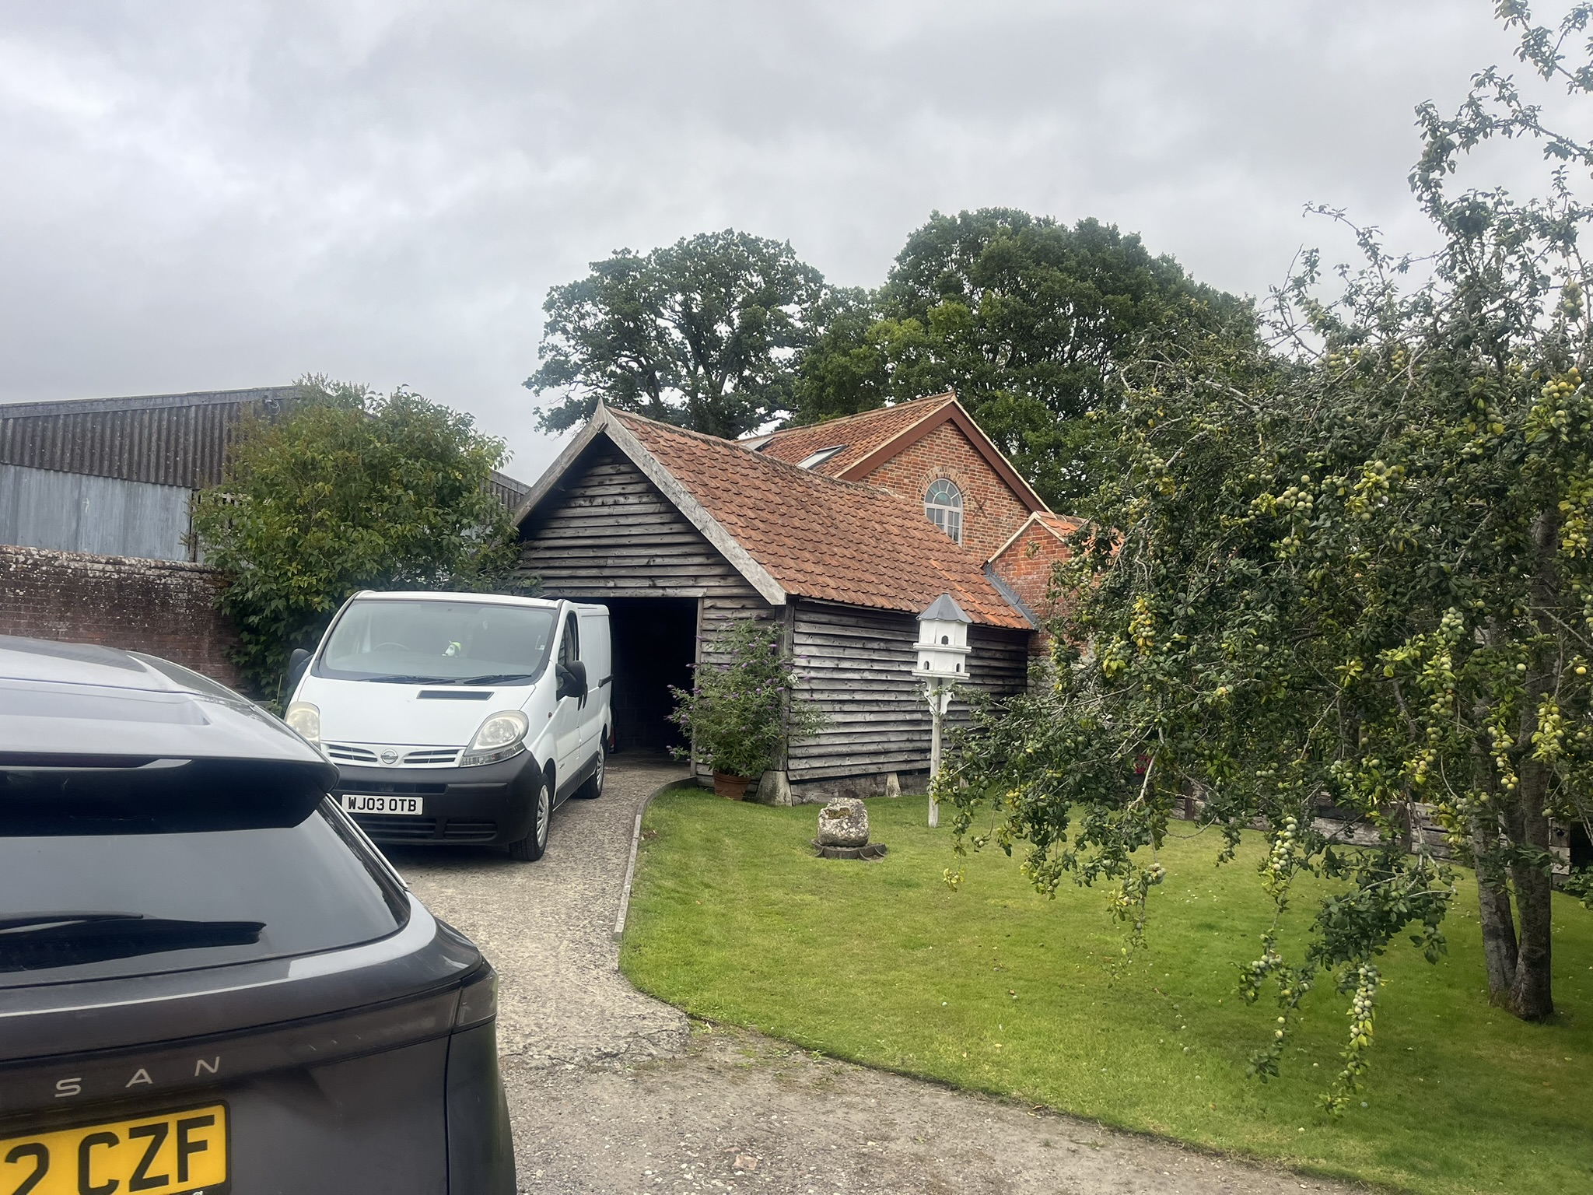

BUILDING 2

