HOUSEHOLDER PLANNING APPLICATION.
CASE OFFICER REPORT

APPLICATION REFERENCE: | PL/2026/01258
APPLICATION TYPE: | HOUSEHOLDER
SITE ADDRESS: | The Railings, 5A Frome Road, Bradford On Avon,  BA15 1LB
DEVELOPMENT DESCRIPTION: | Provision of an off street parking space
RECOMMENDATION: | Approve with Conditions.

PROPOSAL
The proposal seeks planning permission for the construction of an off street car parking space, that would sited off the Frome Road, in Bradford on Avon.

SITE DESCRIPTION/CONTEXT
The site is an area of residential land at 5A Frome Road, Bradford on Avon, which would be utilised as an area for off road car parking for the main host dwelling. The site is bounded by a high level stone wall which would have an opening created within it to allow access to the site. To offset the creation of this this new opening, an existing opening that is no longer utilised along the same stretch of wall and within the ownership of the applicant would be closed off by reusing the stone that would be surplus from the new opening.
The site is located within the Bradford on Avon Conservation Area and is also within the Bath and Bradford on Avon Bat SAC.

RELEVANT PLANNING HISTORY
Proposal / Summary
PL/2024/01233 Extension and material change of use of existing ancillary building to separate dwelling Approved.

RELEVANT POLICIES AND GUIDANCE

Wiltshire Core Strategy:

- Core Policy 07 Spatial Strategy for Bradford on Avon.
- Core Policy 57 Ensuring High Quality Design and Place Shaping.
- Core Policy 58 Ensuring conservation of the historic environment.
- Core Policy 50: Biodiversity and Geodiversity
- Core Policy 51: Landscape
- Core Policy 58: Ensuring the Conservation of the Historic Environment
- Core Policy 61: Transport and New Development
- Core Policy 64: Demand Management
- Core Policy 67: Flood Risk

Bradford on Avon ‘Made’ Neighbourhood Plan

Wiltshire Design Guide: Appendix D – Design Guidance for Householder extensions

The National Planning Policy Framework (NPPF)

The Planning Practice Guidance

National Design Guide

Emerging Wiltshire Local Plan:
At Full Council on 19 May 2026, the elected members of Wiltshire Council agreed to withdraw the emerging Wiltshire Local Plan. It will now be subject to a legal process to finalise its withdrawal - which is likely to happen in July or August (2026). The said Plan has no material weight for the purposes of this application.

Two consultation exercises were carried out, with responses received and detailed as below. The first scheme did not propose to seal off the existing garage opening, whereas the revised scheme did, with the second consultation exercise reflecting this. The responses are as follows:

First Consultation Responses. 05.03.2026
Bradford on Avon Town Council: Object to the proposal, due to the loss of a part of the stone frontage wall, the loss of a highway parking space and the loss of existing trees.

Bradford on Avon Preservation Trust. Object to the proposal due to the loss of a part of the stone frontage wall, the loss of a highway parking space and the loss of existing trees. There is also concern that the turntable might fail in the future.

Highways: No objections subject to conditions.

Arboricultural Officer: No objections.

Conservation Officer: Comments that further justification is required for the scheme.

Representations: No comments received.

Second Consultation Responses. 05.03.2026

Bradford on Avon Town Council. Object to the proposal for the same reasons as before and comment that the proposed revisions do not make any difference.

Bradford on Avon Preservation Trust: Object to the proposal for the same reasons as before and comment that the proposed revisions do not make any difference.

Highways: No objections subject to conditions.

Arboricultural Officer: No objections.

Conservation Officer: No objections

Representations: No comments were received.

PRINCIPLE OF THE PROPOSAL.
The principle of the proposed scheme is acceptable for the reasons as discussed below.

ASSESSMENT
Section 38(6) of the Planning and Compulsory Purchase Act 2004 states:

"If regard is to be had to the development plan for the purposes of any determination to be made under the planning Acts, the determination must be made in accordance with the plan unless material considerations indicate otherwise."

In accordance with this statutory requirement, this application has been assessed against the relevant policies of the Development Plan, including the adopted Wiltshire Core Strategy (2015) and the made Neighbourhood Plan for Bradford on Avon.

Design and Impact upon the upon the character and context of the area

Core Policy 57 - Ensuring High Quality Design and Place Shaping of the Wiltshire Core Strategy seeks to ensure that all new development is of high design quality, reflecting local context, character, and distinctiveness.

The proposals can be viewed within the plan snippets taken from the submitted plans:

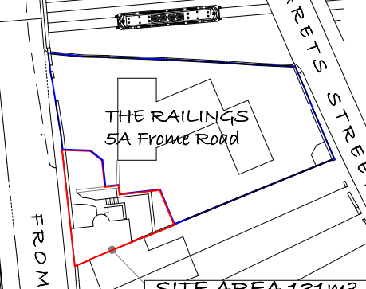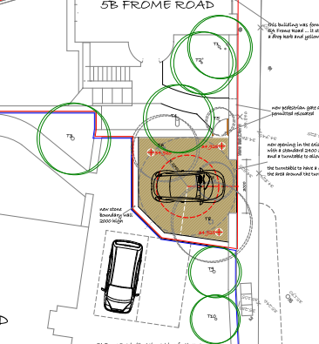
Location Plan Proposed Site Plan
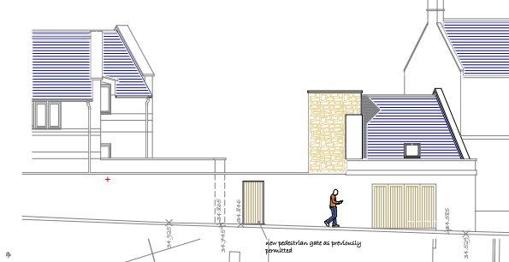
Existing West Elevation

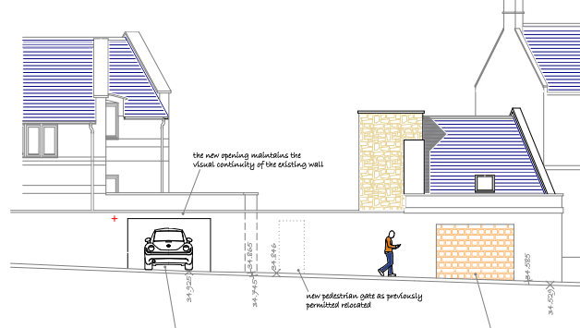
Proposed West Elevation

The proposal would see the provision of an off-road car parking space for an existing dwelling at 5a Frome Road, Bradford on Avon, which would utilise some of its garden land for this purpose. The proposals would involve the creation of an opening within a stone wall, which fronts onto the Frome Road, with the opening measuring 3m by 1.8m. A new pedestrian gate within the stone wall as previously permitted would not be undertaken, with the access instead taking place from inside the newly created parking area. This revision in itself further saves the natural stone from being cut into and removed.

Four domestic species trees will be removed to accommodate the proposal, which the Council’s Tree Officer has not raised any objections to.

The initial scheme did not consider infilling the existing garage door opening, which is located a few metres along from where the proposal would be sited. It was following discussions with the Conservation Officer and the applicant, that the revised scheme was submitted which would involve the infilling of the existing doorway with surplus stone from the proposal. The above plan snippets show the proposed elevation showing these proposals. The garage would remain ungated and open and would rely on a turntable to position the car to exit once driven in. The following Street View photograph serves to show the existing garage doorway and length of stone wall which would be altered:

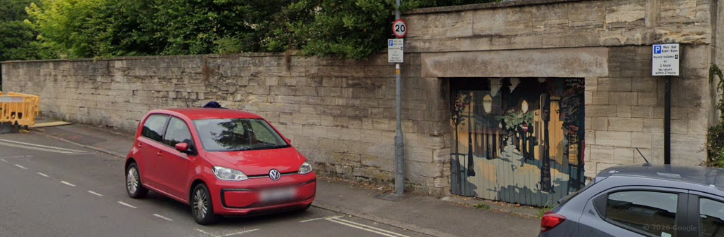

It is arguable that the removal of the aged timber painted garage doors and their replacement with matching natural stone would be an intrinsic improvement to the visual amenities of the area and it has been calculated that there would be enough stone for the infill.

Therefore, in summary, having regard to the above, the proposal complies with the design principles set out in Core Policy 57 of the Wiltshire Core Strategy and Appendix D of the Wiltshire Design Guide.

Amenity
Point vii of Core Policy 57 - Ensuring High Quality Design and Place Shaping of the Wiltshire Core Strategy seeks to ensure that developments do not adversely affect neighbouring properties. The National Planning Policy Framework (NPPF), particularly Paragraph 135(f), stresses that planning decisions should ensure developments provide a high standard of amenity for existing and future users.
The proposed creation of a new and separate entranceway into the site by way of the new car parking area is arguably offset by the sealing off of the existing doorway with aged gates.

The council’s conservation officer is supportive of these measures and as stated above it is considered to be a visual improvement over that as currently existing.

The proposal therefore accords with Core Policy 57 point vii. in respect of safeguarding residential amenity and Appendix D of the Wiltshire Design Guide.

Highway Matters.
Core Policy 57 (xiv) of the Wiltshire Core Strategy seeks to ensure that development must meet the requirements of Core Policy 61. This policy requires proposals to be capable of being served by safe access to the highway network. Core Policy 64 seeks to ensure compliance with parking standards set out in the Local Transport Plan.

The National Planning Policy Framework (NPPF), particularly Paragraph 115 and 116, requires that development proposals do not have an unacceptable impact on highway safety and that safe and suitable access to the site can be achieved for all users.

The proposal would create a new access onto the Frome Road, which has the support of the Highways Officer. A thorough Access Technical Note has been supplied, as has a ground work drawing and Design and Access Statement. The highways officer has requested that several conditions and informatives be attached to the decision.

Significantly, as explained by the officer, the works will require a Traffic Regulation Order (TRO), with the applicant bearing the costs of both the Order (£6,000) and the work. The technical note suggests that a S.184 licence would be required for the new access and whilst this would be usual, given the TRO required, re-location of signage, revised on-street markings and reinstatement of the existing access, it is likely that a S.278 Highway Works Permit, or full S.278 Agreement will be required instead. The applicant has been made aware of these commitments and has accepted and not raised any objections. Such matters fall within the legal jurisdiction of highways and so are not a planning consideration. The highways officer has asked that an informative be attached to this effect.

The requested conditions relate to the access and car parking area to have a consolidated surface, the control and management of private surface water, the access to remain ungated in perpetuity and the said access and turning area to be completed prior to first use. The suggested informatives all relate to the above detailed legal matters. Both the suggested conditions and informatives are appraised as necessary and relevant.

The proposal is therefore considered to comply with Core Policies 57 (xiv), 61 and 64 of the Wiltshire Core Strategy, the NPPF, and the Wiltshire Local Transport Plan.

Heritage Impact
From the point of view of the historic environment the main statutory tests are set out within the Planning (Listed Building and Conservation Areas) Act 1990.

Section 66 requires that special regard be given to the desirability of preserving listed buildings, their settings or any features of special architectural or historic interest which they possess.

Section 72(1) of the Act requires the Council to pay special attention to the desirability of preserving or enhancing the character or appearance of designated Conservation Areas.

The Council’s Core Strategy Policy CP58 ‘Ensuring the conservation of the historic environment’ requires that designated and non-designated heritage assets and their settings will be conserved, and where appropriate enhanced, in a manner appropriate to their significance and encourages proposals which improve the condition of heritage assets at risk.

The site is in the Bradford on Avon Conservation Area where CP58 is of relevance whereby development should protect, conserve and where possible enhance the historic environment and the Local Planning Authority has a duty to pay special attention to the preservation and enhancement of the character and appearance of the Conservation Area.

In this instance, a new entrance for the car park would be created and the stone reutilised to infill the existing garage entrance which is not utilised. Within the second set of consultation comments the Conservation officer is in support and states:

‘The loss of the garage doors and the new opening will alter the current street scene, but the overall appearance will remain similar. The changes to the wall and the development will be able to be read by the retention of the lintel and the stone in-filling being set back from the wall line. It is not proposed to add doors or gates to the new opening’.

The Conservation Officer then further summarises the merits of the scheme by the following comments:

‘The proposals will result in loss of part of the wall, but the stone will be reused to infill the existing opening. The wall is not a NDHA or listed but has been recognised as providing a positive contribution the character of the conservation area. The relocation of the opening is not considered to cause harm to the character of the conservation area. The impact of the proposals on heritage assets will be neutral. The requirements of current conservation legislation, policy or guidance are considered to be met, subject to conditions and there is therefore no objection to the approval of the application.’

The officer summarises by requesting conditions in regard to the rebuilding of the infill needing to be undertaken using lime mortar to protect the stone and that the infilling of the existing opening should be undertaken within 3 months of the new opening being formed. Both conditions are appraised as both relevant and necessary.

Ecology Impact CP50 requires no net loss of biodiversity on site. The site is located within the Bath and Bradford on Avon Bat SAC. The proposed development because of its relative minor nature and urban location is considered unlikely to result in harm to bats or their habitat. There is no mechanism for significant effects from recreational pressure since it does not result in the creation of a new dwelling. Accordingly, the proposal is acceptable in this regard. As such, the development complies with Core Policy 50 of the Wiltshire Core Strategy and the relevant provisions of the NPPF.

Biodiversity Net Gain. This application is exempt from the requirement to deliver Biodiversity Net Gain under Schedule 7A, Section 4(2)(a) of the Town and Country Planning Act 1990, as inserted by the Environment Act 2021, because the proposal is a householder extension.

CONCLUSION
The proposed development is acceptable in terms of its design, scale, and relationship with the surrounding area. It would not result in any unacceptable harm to the character of the locality, the amenities of neighbouring occupiers, or the interests of highway safety, heritage, or ecology.

The proposal is therefore considered to comply with the relevant policies of the Wiltshire Core Strategy, the Wiltshire Local Plan, and the National Planning Policy Framework. As such, the application is recommended for approval, subject to the conditions set out below.

RECOMMENDATION: Planning Permission be GRANTED subject to conditions.

