APPLICATION FOR HOUSEHOLDER PLANNING PERMISSION
DELEGATED REPORT

APPLICATION REFERENCE: | PL/2026/02879
APPLICATION TYPE: | Householder planning permission
SITE ADDRESS: | The Firs, 70 Martins Road, Keevil, Trowbridge, BA14 6NA
DEVELOPMENT DESCRIPTION: | Proposed Rear Single Storey Extension
RECOMMENDATION: | That Planning Permission be GRANTED

PROPOSAL

The proposal seeks planning permission for the erection of a single storey rear extension.

SITE DESCRIPTION/CONTEXT

The application relates to a detached bungalow, The Firs, that is accessed off one of the main routes through the village of Keevil. The property benefits from a detached single storey garage to the rear elevation. The general area comprises of a mixture of housing types and styles of different periods.

PLANNING HISTORY

Proposal / Summary
W/06/00800/FUL - Full planning permission Decision - Approve with Conditions Date: 10/4/2006 – Single storey extension to rear to provide facilities for a disabled occupant and a conservatory

RELEVANT POLICIES AND GUIDANCE

Wiltshire Core Strategy:
Core Policy 2 Delivery Strategy
Core Policy 29 – Spatial Strategy for the Trowbridge Community Area
Core Policy 57 - Ensuring High Quality Design and Place Shaping

Emerging Policy – Wiltshire Local Plan Review
At Full Council on 19 May, the elected members of Wiltshire Council agreed to withdraw the emerging WLP. It will now be subject to a legal process to finalise its withdrawal - which is likely to happen in July or August (2026). The said Plan has no material weight for the purposes of the application.

Wiltshire Design Guide: Appendix D – Design Guidance for Householder extensions

The National Planning Policy Framework (NPPF)

The Planning Practice Guidance

National Design Guide

CONSULTATION RESPONSES

Keevil Parish Council: No objection

REPRESENTATIONS
No comments were received.

ASSESSMENT
Section 38(6) of the Planning and Compulsory Purchase Act 2004 states:

"If regard is to be had to the development plan for the purposes of any determination to be made under the planning Acts, the determination must be made in accordance with the plan unless material considerations indicate otherwise."

In accordance with this statutory requirement, this application has been assessed against the relevant policies of the Development Plan, including the adopted Wiltshire Core Strategy (2015) and, where applicable, any made Neighbourhood Plans.

Design and Impact upon the character and context of the area
Core Policy 57 - Ensuring High Quality Design and Place Shaping of the Wiltshire Core Strategy seeks to ensure that all new development is of high design quality, reflecting local context, character, and distinctiveness.

The single storey extension would extend from the rear elevation of the host dwelling at a depth of 4.5m and would span a width of 4.1m. The extension would consist of a flat roof form sitting at a height of 2.7m with a glass roof lantern inserted to illuminate the internal space. A set of patio doors would be inserted on the south elevation, and an oriel window would be inserted on the rear elevation.

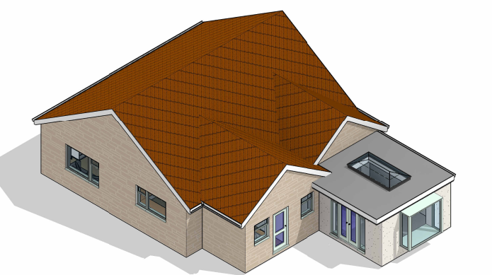

Visualisation of the proposed single storey rear extension

The use of matching materials (off white render with light grey fenestration) would ensure the proposal would integrate into the existing built form of the host dwelling and surrounding setting. It is considered that the extension would by virtue of its height, scale and design constitute a complementary addition to the host dwelling that would appear commensurate to the size of the property and plot.

Having regard to the above, the proposal complies with the design principles set out in Core Policy 57 of the Wiltshire Core Strategy and Appendix D of the Wiltshire Design Guide.
.
Amenity
Point vii of Core Policy 57 - Ensuring High Quality Design and Place Shaping of the Wiltshire Core Strategy seeks to ensure that developments do not adversely affect neighbouring properties.

The National Planning Policy Framework (NPPF), particularly Paragraph 135(f), stresses that planning decisions should ensure developments provide a high standard of amenity for existing and future users.

The proposed development has been assessed in terms of its potential impact on the residential amenity of neighbouring properties, with particular regard to loss of light, overshadowing, loss of privacy, and overbearing effects.

All windows would overlook the applicant’s private residential rear curtilage and given the single storey nature of the build no overlooking concerns are raised.

The proposal seeks to introduce a single storey extension on the rear elevation of the host dwelling and given the detached nature of the dwelling and separation distances to the adjacent neighbours, officers are of the opinion that no adverse overbearing or overshadowing impacts will occur.

The proposal therefore accords with Core Policy 57 point vii in respect of safeguarding residential amenity and Appendix D of the Wiltshire Design Guide.

Biodiversity Net Gain
Householder planning applications are exempt from the requirement to deliver Biodiversity Net Gain under Schedule 7A, Section 4(2)(a) of the Town and Country Planning Act 1990, as inserted by the Environment Act 2021.

CONCLUSION
The proposed development is considered to be acceptable in terms of its design, scale, and relationship with the surrounding area. It would not result in any unacceptable harm to the character of the locality or the amenities of neighbouring occupiers.

The proposal is therefore considered to comply with the relevant policies of the Wiltshire Core Strategy, the Wiltshire Local Plan, and the National Planning Policy Framework. As such, the application is recommended for approval, subject to the conditions set out below.

RECOMMENDATION: That Planning Permission be GRANTED subject to conditions.

Conditions

1. The development hereby permitted shall be begun before the expiration of three years from the date of this permission.
REASON: To comply with the provisions of Section 91 of the Town and Country Planning Act 1990 as amended by the Planning and Compulsory Purchase Act 2004.

2. The development hereby permitted shall be carried out in accordance with the following approved plans and documents:
Location Plan
Existing Floor Plans DWG No E1-1
Existing Elevations DWG No E1-2
Existing Block Plan DWG No E1-3
Existing Views DWG No E1-4
Proposed Floor Plan DWG No P1-1
Proposed Elevations DWG No P1-2
Proposed Block Plan DWG No P1-3
Proposed Views DWG No P1-4
All Plans Received 05.05.2026

REASON: For the avoidance of doubt and in the interests of proper planning.

