DELEGATED REPORT

Application Reference: | PL/2026/02555 & PL/2026/02790
Application Type: | Planning permission and advertisement consent
Site Address: | Pavement o/s Ramparts, Devizes Road, Salisbury, SP2 7EE
Proposal: | Full & Adv- The installation of 1no. BT Street Hub
Recommendation: | Planning Permission and Advertisement consent be REFUSED
PROPOSAL

The application is seeking consent for the installation of 1no. BT Street Hub unit, both full planning permission and advertisement consent are sought. Proposed BT Street Hub shown below.

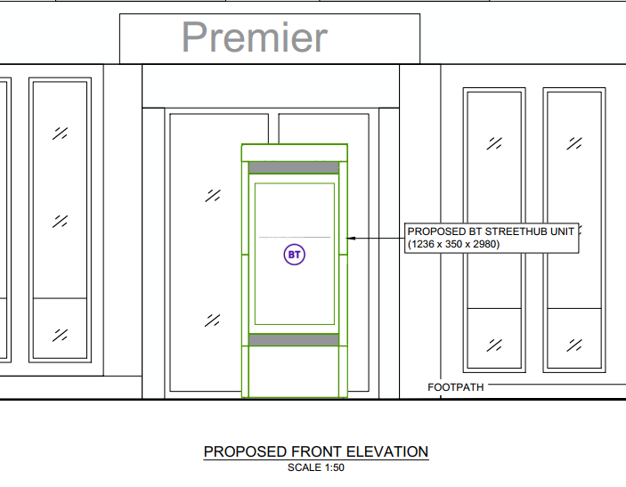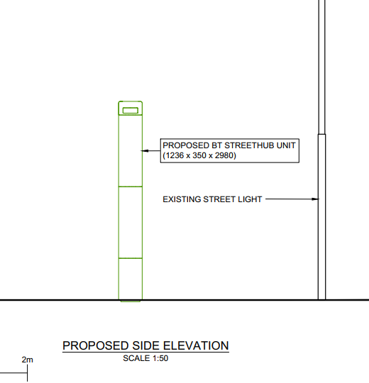

Example of a BT Street Hub taken from their product statement document.

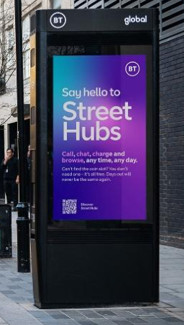

The proposed BT hub will measure approx. 2.98m in height, 1.24m wide with a depth of 0.35m. The main Street Hub structure will be made of galvanised mild steel, with a powder coated external grade aluminium exterior. Displays will be made of tempered and toughed laminated glass. The main Street Hub structure will include 2no. digital 75" LCD display screens, one on each side of the Street Hub unit, the advertisements will be internally illuminated. The Street Hub unit will therefore emit light and noise. The unit is not to be turned off at any point during the day/night.

In essence, the proposed BT Street Hub comprises a freestanding structure positioned within the public realm, which incorporates dual digital display screens primarily used for commercial advertising. In addition to this advertising function, the unit is designed as such that it could potentially provide a range of ancillary telecommunications features, including public Wi-Fi, telephone calls (including 999 calls), device charging and the potential to support small-cell network infrastructure. However, these additional functions are secondary to the principal role of the structure as a digital advertising display, and their provision is not guaranteed in planning terms. The proposal therefore represents, in practical terms, the introduction of a large-format illuminated advertisement within the streetscene, albeit within a multi-functional structure that has the capability to support wider connectivity and data-related services

The following report relates to both the above full planning permission and advertisement consent applications. This is considered to be appropriate in this case as the advertisements are integral to the structure being proposed with both applications therefore intrinsically linked with related issues for both applications.

Officers note that the application contains details in relation to the removal of an existing BT telephone kiosk as a trade-off for removing street clutter in lieu of installing the Street Hub. However, the location of the existing kiosk proposed for removal is nowhere near the application site but is actually much closer to the City Centre within the Maltings shopping area. Therefore, there is no direct correlation between the proposed new Street Hub and existing Kiosk, it is also understood that the Kiosk could be removed at any time without the need for permission; therefore, the applicant could indeed help de-clutter the City Centre by removing the cited Kiosk which is no longer required for its intended use.

SITE DESCRIPTION/CONTEXT

The application site comprises an area of pavement located adjacent to St Pauls Roundabout, at the junction where Wilton Road (to the south) meets Devizes Road (to the north). Wilton Road forms part of the A36, a trunk road within the strategic road network, and is therefore under the jurisdiction of National Highways rather than Wiltshire Council.

The site occupies a prominent position along a busy arterial junction, in close proximity to a number of listed buildings and situated between two designated conservation areas. It is also located adjacent to a small parking area serving the neighbouring convenience store and fish and chip shop.

Site location plan and proposed site plan shown below

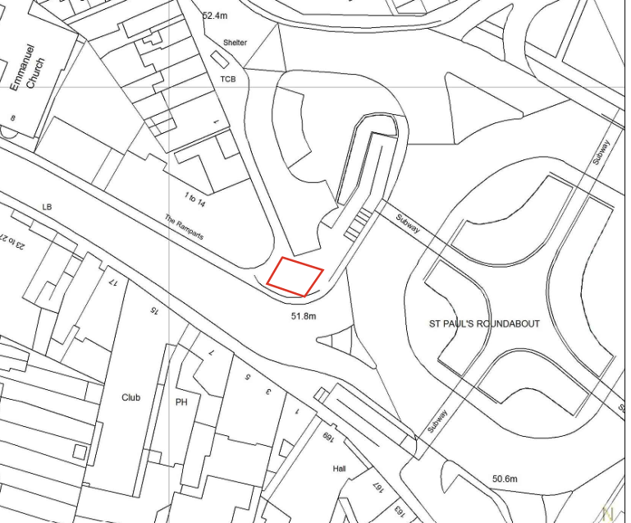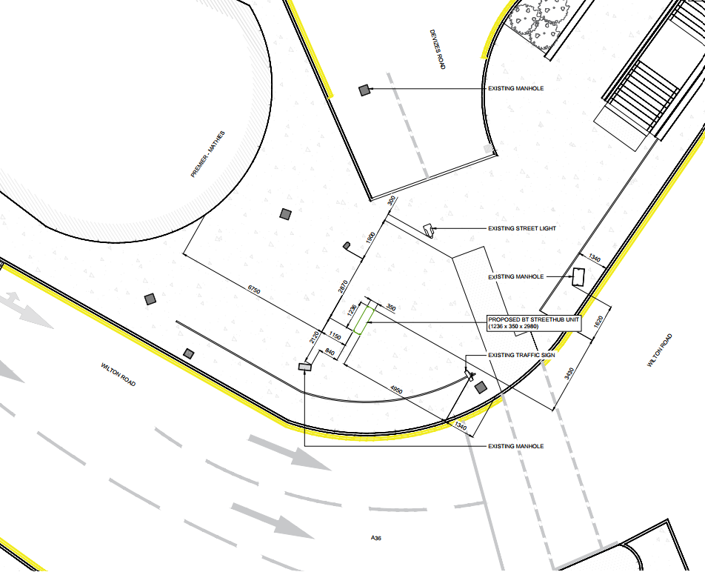

Images below courtesy of Google maps combined with case officers’ photos showing the site context.
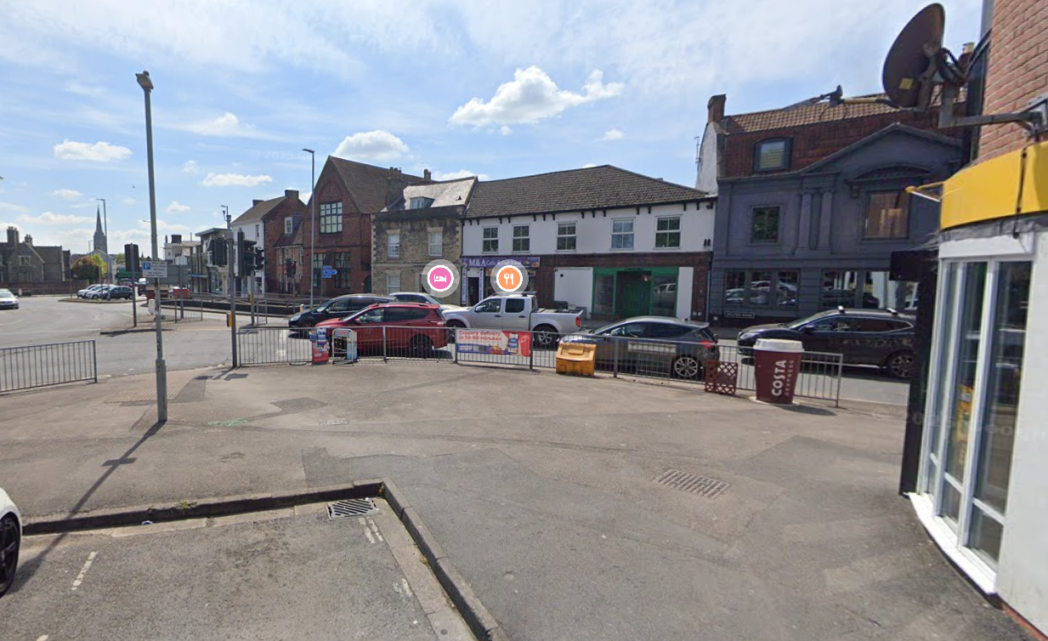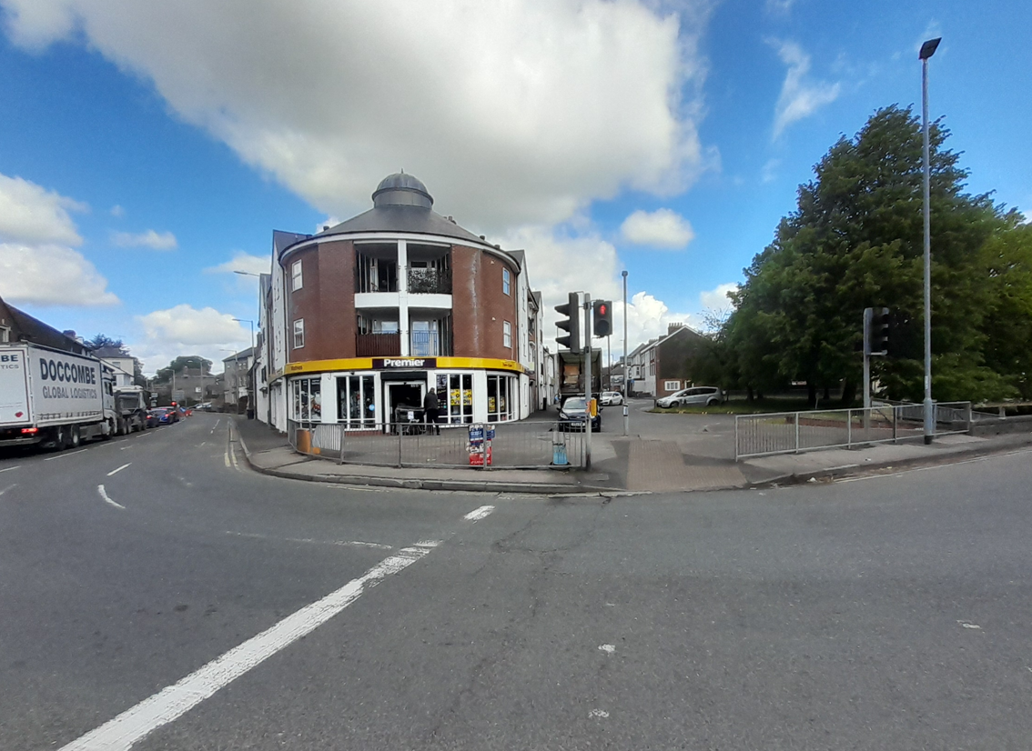

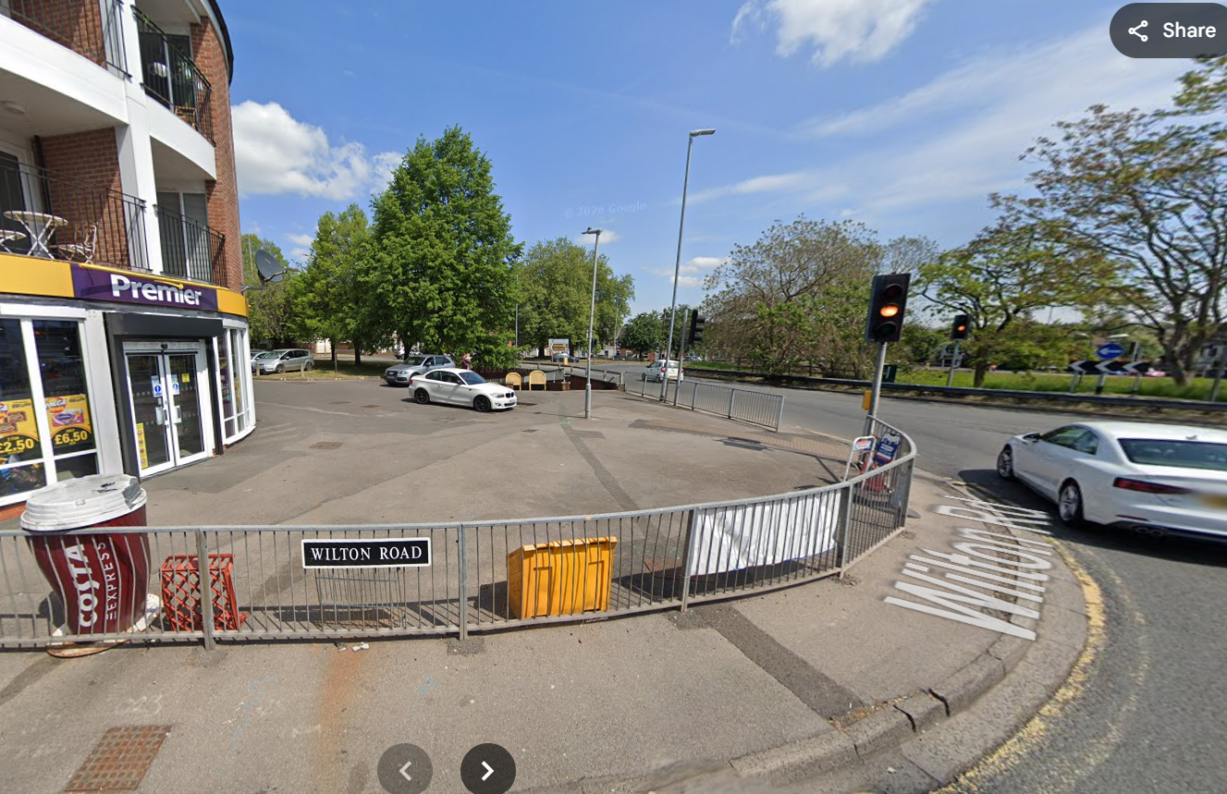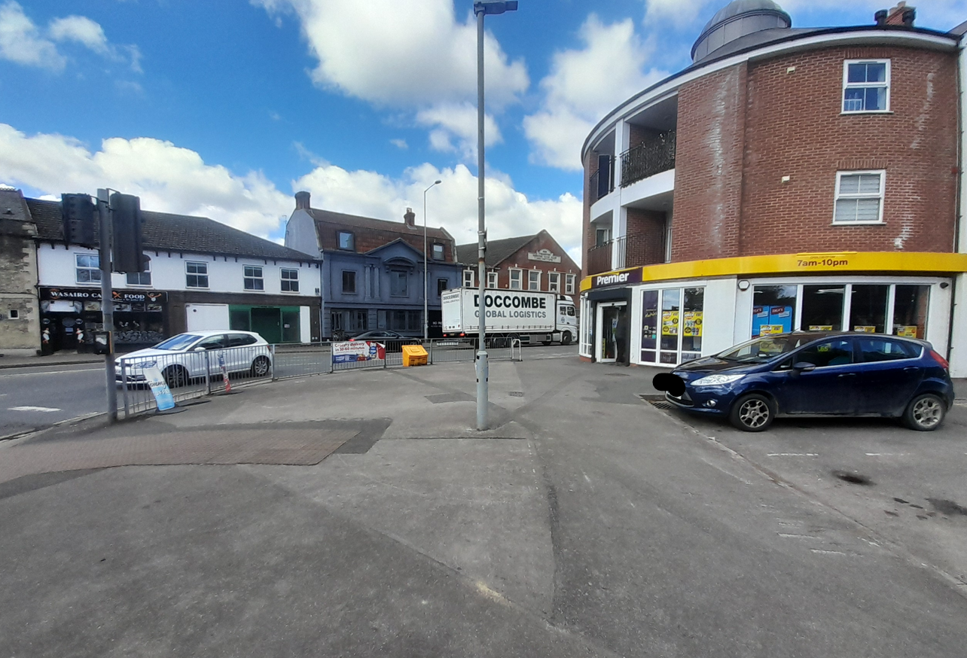

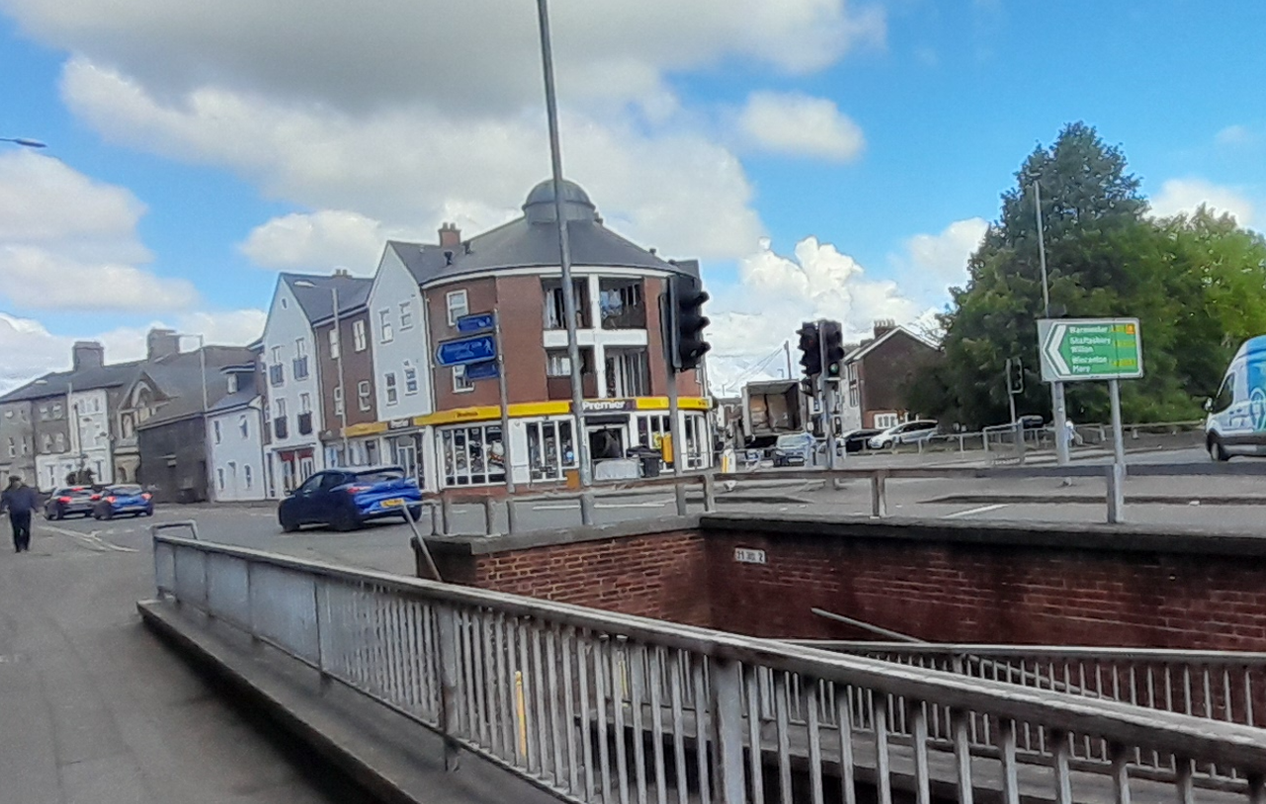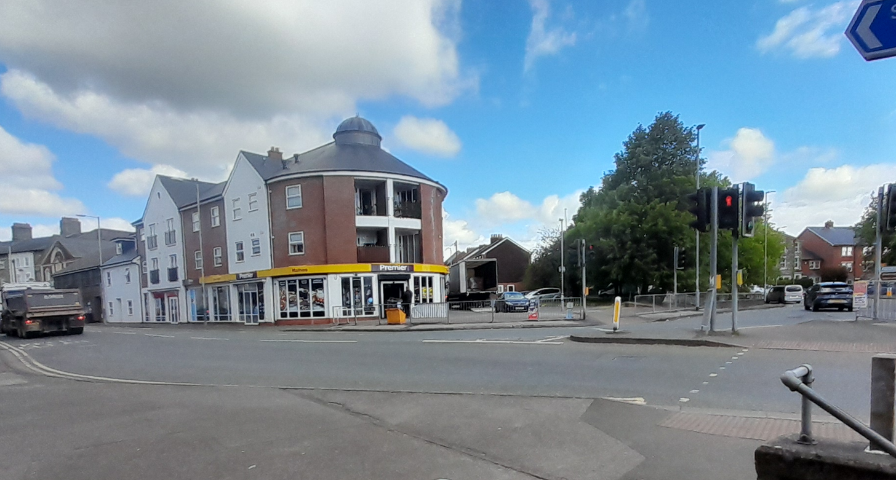

The map below shows the nearby listed buildings marked with black hatching.

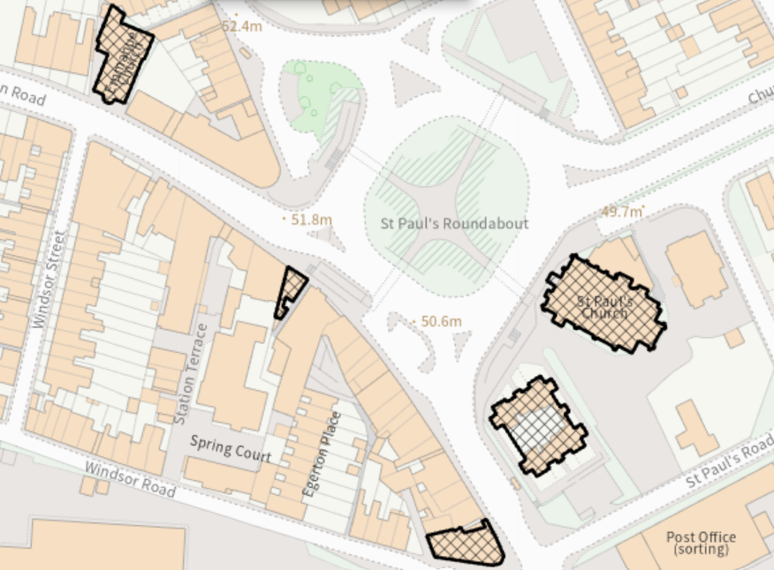

The map below shows the limits of the nearby conservation area boundaries.

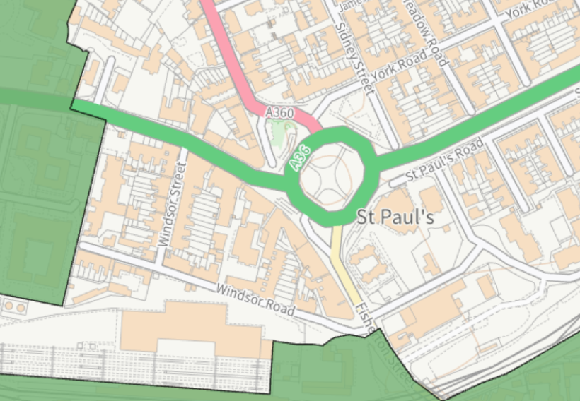

PLANNING HISTORY

Site history for the pavement area where the BT Street Hub is proposed outside Ramparts, Devizes Road.

S/2004/1208 Application to determine whether prior approval is required for the siting and appearance of a telephone kiosk. Prior Approval Not Required

The following applications were all for BT street hubs similar to that now proposed outside the Ramparts, Devizes Road.

PL/2022/09568 (adv) – Land adjacent 41 Blue Boar Row, Salisbury, SP1 1DE- Two digital 75 inch LCD display screens, one on each side of the Street Hub unit. REFUSED
PL/2022/09569 (full) – Land adjacent 41 Blue Boar Row, Salisbury, SP1 1DE - Installation of a BT Street Hub and associated display of advertisement to both sides of the unit. REFUSED
PL/2022/09570 (adv)– Land adjacent 35 Old George Mall, Salisbury, SP1 2AF - Two digital 75 inch LCD display screens, one on each side of the Street Hub unit. REFUSED
PL/2022/09571 (full) – Land adjacent 35 Old George Mall, Salisbury, SP1 2AF - Installation of a BT Street Hub and associated display of advertisement to both sides of the unit. REFUSED
PL/2022/09572 (adv)– Land adjacent New Canal, Salisbury, SP1 2NH - Two digital 75 inch LCD display screens, one on each side of the Street Hub unit. REFUSED
PL/2022/09573 (full)– Land adjacent New Canal, Salisbury, SP1 2NH - Installation of a BT Street Hub and associated display of advertisement to both sides of the unit. REFUSED
PL/2022/09574 - Land adjacent 42-44 High Street, Salisbury, SP1 2NT - Two digital 75 inch LCD display screens, one on each side of the Street Hub unit. REFUSED
PL/2022/09575 – Land adjacent 42-44 High Street, Salisbury, SP1 2NT - Installation of a BT Street Hub and associated display of advertisement to both sides of the unit. REFUSED
PL/2024/10342 The proposed installation of 1no. BT Street Hub unit and removal of 2no. associated BT payphone kiosks from the streetscene. REFUSED
PL/2024/10592 The proposed installation of 1no. BT Street Hub unit and removal of 2no. associated BT payphone kiosks from the streetscene. REFUSED

POLICIES

Planning (Listed Building and Conservation Areas) Act 1990 Section 66

National planning policy framework (NPPF)

National planning policy guidance

National Design Guide

Core Policy 1 Settlement Strategy
Core Policy 2 Delivery Strategy

Core Policy 20 Spatial Strategy for the Salisbury Community Area

Core Policy 36 Economic Regeneration

Core Policy 50 Biodiversity
Core Policy 57 Ensuring high quality design and place shaping
Core Policy 58 Ensuring the Conservation of the Historic Environment
Core Policy 60 Sustainable Transport
Core Policy 61 Transport and New Development

Saved policy PS7 - Telecommunications

Creating Places Design Guide

Wiltshire Design Guide
Salisbury Shopfronts and Advertisements Design Guide
Salisbury Neighbourhood Plan (including Salisbury Design and Advertising Guide)

ISSUES

Impact on visual amenity/heritage assets
Impact on Highways/public safety
Benefits and harms of the proposal

CONSULTATION

City Council - Salisbury City Council objects to this application on the grounds of street clutter and the potential for anti-social behaviour.

Wiltshire Highways – No objection

National Highways – No objection with advice.

Comments for full planning application PL/2026/02555

Annex A National Highways’ assessment of the proposed development

National Highways has been appointed by the Secretary of State for Transport as a strategic highway company under the provisions of the Infrastructure Act 2015 and is the highway authority, traffic authority and street authority for the Strategic Road Network (SRN). The SRN is a critical national asset and as such we work to ensure that it operates and is managed in the public interest, both in respect of current activities and needs as well as in providing effective stewardship of its long-term operation and integrity.

We have undertaken a review of the relevant documents supporting the planning application to ensure compliance with the current policies of the Secretary of State as set out in DfT Circular 01/2022 “The Strategic Road Network and the Delivery of Sustainable Development” and the National Planning Policy Framework (NPPF). This response represents our formal recommendations with regards to planning application reference PL/2026/02555.

Reasons

The application is seeking permission for the installation of a BT Street Hub, located within the pavement at the junction of the A36 Wilton Road and Devizes Road. A separate application for advertisement consent has also been submitted under application reference PL/2026/02790 in respect of the Street Hub digital advertisement panels.

National Highways primary interest in the development is the potential impact on the safe and efficient operation of the SRN, which in this case comprises the A36 Wilton Road and the St Pauls roundabout junction.

Having reviewed the site plans, we are satisfied that the Street Hub will be located wholly outside the A36 strategic highway boundary. We therefore have no objections to the siting of the proposed Street Hub, but you should seek the views of Wiltshire Council’s local highway team if you have not already done so.

However, we do have concerns with regards the proposed maximum luminance level of the advertisement panels incorporated into the sides of the Street Hub which at 600 cd/m2 is greater than the 300 cd/m2 recommended by the Institute of Lighting Professions for signs in proximity to the trunk road during the period from dusk until dawn. We consider this to have the potential to create distraction and glare, adversely impacting the safety of trunk road traffic which is a particular concern in proximity to a junction. We will be responding separately to the advertisement consent application.

Recommendation
National Highways has no objection to the proposed Street Hub but offers advice in respect of the proposed digital display which is subject to a separate application.

Standing advice to the local planning authority
The Climate Change Committee’s 2022 Report to Parliament notes that for the UK to achieve net zero carbon status by 2050, action is needed to support a modal shift away from car travel. The NPPF supports this position, with paragraphs 77 and 110 prescribing that significant development should offer a genuine choice of transport modes, while paragraphs 109 and 115 advise that appropriate opportunities to promote walking, cycling and public transport should be taken up as part of a visionled approach.

Moreover, the carbon reduction hierarchy (avoid-switch-improve) as set out in clause 4.3 of PAS2080:2023 promotes approaches and measures to minimise resource consumption and thereby reduce carbon emissions.

These considerations should be weighed alongside any relevant Local Plan policies to ensure that planning decisions are in line with the necessary transition to net zero carbon.

Comments for advertisement consent application PL/2026/02790

Thank you for providing National Highways with the opportunity to comment on the above application for advertisement consent. National Highways is the strategic highway authority with responsibility for the strategic road network, which in this case comprises the A36 Wilton Road and the associated St Pauls roundabout junction. Our primary consideration is the ongoing safe and efficient operation of the strategic road network, and it is in this context that our comments are made.
National Highways would be concerned about any advertisement signs which have the potential to cause distraction or glare to drivers, particularly on the approach to a junction, on highway safety grounds. Whilst we have no objection in principle to the installation of a BT Street Hub in the location proposed (please see our formal recommendation response to planning application PL/2026/02555), we do have concerns with regards the digital advertisement panels on the side of the Hub.
In considering digital displays in proximity to the SRN, particular issues that will need to be addressed include:
• the level of illumination which needs to avoid dazzle and glare to trunk road traffic. The Institute of Lighting Professionals advise that a maximum luminance level of 300 cd/m2 should be applied to advertisements at locations close to the SRN during the period from dusk to dawn;
• the transition of images that re-engage the attention of drivers should be ‘clean’ (ie without fades or swipes) and should be at sufficient intervals to minimise distraction from the task of driving;
• animation or moving images are considered unacceptable as these encourage drivers to continue to watch the advertisement, removing their focus from the task of driving;
• images that unlawfully incorporate elements of traffic sign design, such as directional arrows are strictly prohibited.
Having reviewed the submitted plans and associated planning statement, we note that the applicant is proposing a number of planning conditions to be applied in respect of the advertisement display. Whilst these are generally satisfactory and reflect the standard conditions National Highways would ordinarily look to have applied; we have concerns at the proposed maximum luminance level referenced.
The luminance level of the advertisement panels incorporated into the sides of the Street Hub is proposed to be no more than 600 cd/m2, but this is greater than the 300 cd/m2 recommended by the Institute of Lighting Professions for signs in proximity to the trunk road during the period from dusk until dawn. We consider this increased luminance level to have the potential to create distraction and glare, adversely impacting the safety of trunk road traffic which is a particular concern in proximity to a junction. An upper limit to luminance levels of 600 cd/m2 during the period from dusk to dawn is therefore unacceptable to National Highways.
We are therefore advising a revised condition in respect of luminance levels. In respect of the other standard planning conditions, we are willing to consider any alternative wording that the local planning authority may propose subject to its securing the same or greater protection for the A36 trunk road.
Proposed conditions
1. The intensity of the illumination of the sign hereby permitted shall be no greater than 300cd/m2 during the period between dusk and dawn.
Reason: In the interests of the safe and efficient operation of the A36 trunk road.
2. No advertisement at any time shall contain moving images, animation, flashing, intermittent or full motion video images, audio, directional symbols or any images that resemble road traffic signs or traffic signals.
Reason: In the interests of the safe and efficient operation of the A36 trunk road.
3. There shall be an uninterrupted transition from one screen image to another with no effects applied (including fades and swiping). Transitions shall be instantaneous, and no individual advertisement shall be displayed for a duration of less than 10 seconds.
Reason: In the interests of the safe and efficient operation of the A36 trunk road.
4. The advertisement display shall at all times contain a feature that will turn the display off (showing a black/blank screen) in the event of malfunction or error.
Reason: In the interests of the safe and efficient operation of the A36 trunk road.

REPRESENTATIONS

One letter of objection has been received; this is included in full below.

1) I object to internally illuminated signs, large pole signs, totem signs, flagpoles, banners and anything else that makes our medieval city look like America or distracts drivers.
2) If approved, please impose conditions that (a) the intensity of external illumination be reduced during hours of darkness, and (b) be constructed so as to prevent light pollution into the sky.
3) By the way, there's a Climate Emergency. Has anyone thought of asking a Citizen's Assembly to consider all this? (Look it up).

ASSESSMENT

Impact on visual amenity

Core Policy CP57 states a high standard of design is required in all new developments, including extensions, alterations, and changes of use of existing buildings. Development is expected to create a strong sense of place through drawing on the local context and being complimentary to the locality. Applications for new development must be accompanied by appropriate information to demonstrate how the proposal will make a positive contribution to the character of Wiltshire Core Policy CP57 (x) also states that “the sensitive design of advertisements and signage, which are appropriate and sympathetic to their local setting by means of scale, design, lighting and materials”.

Policy CP58 relates to heritage assets. The site is located near to several listed buildings.

The NPPF 2024 para 141 clearly states that “…the quality and character of places can suffer when advertisements are poorly sited and designed.”. It confirms that advertisements should be subject to controls in the interests of amenity and public safety, taking into account cumulative impacts. The NPPG defines amenity as:

“Amenity” is not defined exhaustively in the Town and Country Planning (Control of Advertisements) (England) Regulations 2007. It includes aural and visual amenity (regulation 2(1)) and factors relevant to amenity include the general characteristics of the locality, including the presence of any feature of historic, architectural, cultural or similar interest (regulation 3(2)(a)).
It is, however, a matter of interpretation by the local planning authority (and the Secretary of State) as it applies in any particular case. In practice, “amenity” is usually understood to mean the effect on visual and aural amenity in the immediate neighbourhood of an advertisement or site for the display of advertisements, where residents or passers-by will be aware of the advertisement.
So, in assessing amenity, the local planning authority would always consider the local characteristics of the neighbourhood: for example, if the locality where the advertisement is to be displayed has important scenic, historic, architectural or cultural features, the local planning authority would consider whether it is in scale and in keeping with these features.
This might mean that a large poster-hoarding would be refused where it would dominate a group of listed buildings, but would be permitted in an industrial or commercial area of a major city (where there are large buildings and main highways) where the advertisement would not adversely affect the visual amenity of the neighbourhood of the site.
If the advertisement makes a noise, aural amenity would also be taken into account before express consent would be given.
Paragraph: 079 Reference ID: 18b-079-20140306
Great weight must be attached to the heritage asset’s conservation by the NPPF. In relation to heritage assets, paras 207 – 214 of the NPPF 2024 detail heritage matters and how the applicants must provide appropriate information with their submission and how the Local planning authorities should assess heritage issues and the weight given.

Creating Places Design Guide Part 19 details shopfronts/advertisements. Page 80 states - Salisbury is perhaps the best surviving example of a medieval planned city in England. It has a special character and "sense of place" created by the buildings, local building styles and materials and the medieval pattern of the street and chequers. Within this context, shopfronts and advertisements have an important contribution to make to the character of the area and the quality of the environment. Page 81 states - While it is acknowledged that shopfronts and advertisements are designed to attract attention, it is important that care is taken to ensure that the design and materials of individual shops do not clash with or detract from, existing features of the area. It should be possible to create attractive, individualistic eye-catching shopfronts, which enliven the streetscene without introducing discordant elements.

Wiltshire Design Guide (2024), in particular Sections 4.5.12 and 5.4.1, which require signage to be carefully designed as part of the public realm, coordinated with street furniture, and appropriately located so as to avoid visual clutter and protect the character and quality of the surrounding environment.

Salisbury Neighbourhood Plan policy 6 is relevant, this states that All developments in Salisbury will be required to have regard to the Salisbury Design and Advertising Guide when addressing Core Policy 57 and 58, particularly for schemes requiring a design and access statement.

In terms of the current application for the erection of a BT Street Hub outside Ramparts, Devizes Road in Salisbury which as mentioned previously is located within the public highway alongside a roundabout adjacent to both the A36 which is part of the strategic road network and also the Devizes Road, also an A road (A360), a very busy road leading north to the A303. The siting of the proposed BT Street Hub is within an open space directly outside of a shop next to the pedestrian crossing over the A36 and also next to a small car park; thus, located within a very busy area for both vehicular movement, pedestrians and cyclists.

The provision of the large digital advertising panels within the proposed street hub requires the provision of electricity supplies, which requires the generation of electricity somewhere along the supply chain. This has the potential to generate unnecessary carbon.

More generally, the Council’s seeks to remove as much street clutter as possible to improve accessibility in and around the city, thus enhancing the character of the area. Whilst the Council acknowledges that there has been a reduction in the number of telephone kiosks within the City Centre as a whole, the provision of the street hub is considered to be the introduction of unnecessary street clutter. BT have not made a compelling case that there is a sufficiently strong need for the street hub from the point of view of the anticipated end user that the benefit of its provision outweighs the disbenefit.

It is noted that the location for the BT Street Hub on Devizes Road is within an area which had been more or less clutter free since at least 2014- see Google maps image below.
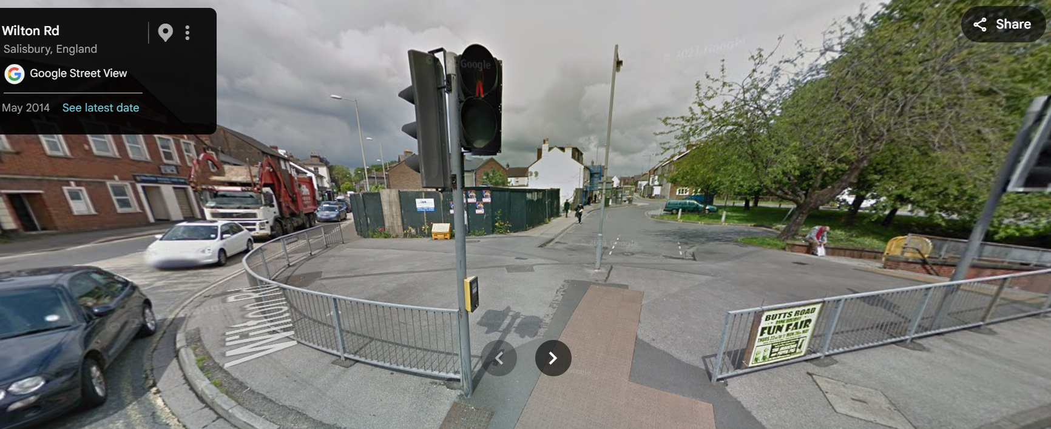

The immediate area comprises a mixed use of predominantly residential but also some commercial use; the Salisbury Railway Station is located just a few minutes’ walk to the south of the site off Fisherton Street, one of the main routes into the main shopping area of the city centre. The Council note that some properties have illuminated signage, these generally comprise of externally illuminated, historically illuminated or low key illumination; at present the character of the area does not include prominent, strident internally illuminated signage such as that proposed with the BT Street Hub.

The site occupies a prominent position on an important arterial route into Salisbury city centre. The surrounding townscape includes a number of nearby listed buildings, and the site lies between two designated conservation areas. Whilst the proposal would not give rise to direct harm to the setting of these heritage assets by reason of separation and intervening context, these assets nonetheless make a strong contribution to the character and appearance of the area.

In this context, the introduction of a large, internally illuminated and visually dominant structure would appear incongruous and unsympathetic, failing to respond positively to the historic and townscape qualities that define this gateway location. The proposal would therefore erode the character of the area, of which the nearby listed buildings and conservation areas form an integral part.

Of note and relevant is a recent appeal at a nearby site at 57 Wilton Road (PL/2024/04269) which proposed the replacement of a poster sign with a digital advertisement. This site is outside of the conservation area but views from the conservation area were affected, this application was refused for the following reason –

The proposed digital poster would replace an existing, unauthorised static poster advertisement. It would be significantly bolder and a more eye-catching display than the existing poster during the day and particularly during the hours of darkness. It would be readily visible in long range views including from within the nearby Old Manor Hospital conservation area.

It is concluded that the proposed digital poster would negatively impact on the visual qualities of the area by reason of its inappropriate scale, illumination and the fact it would be significantly bolder than the existing static poster sign.

The proposal is therefore considered to be contrary to the aims of the NPPF in particular paragraphs 8 and 141 and Core Policies 57 and 58 of the adopted Wiltshire Core Strategy.

This was dismissed at appeal (3351421), the Inspector concluded -

“I consider that the proposal conflicts with paragraph 141 of the National Planning Policy Framework and whilst not decisive, I have had regard to Policies 57 and 58 of the Wiltshire Core Strategy adopted January 2015 which require the sensitive design of advertisements which are appropriate and sympathetic to their local setting by means of scale, design, lighting and materials, and require proposals to conserve the settings of designated heritage assets, including the special character or appearance of Conservation Areas, especially in regard to orientation, size and night-time illumination.”

At nearly 3m tall and over 1m wide, the proposal would be a modern, stark and incongruous addition to the streetscape, in particular due to its tall and wide structure, with a rectangular block-like design. Due to its height and design, in its prominent location on this junction with several main roads in/out of the city centre, visible from several directions, the proposed ‘Street Hub’ would be an imposing and visually incongruous item of street furniture which would unduly detract from both the character and appearance of the area. The immediate area has little existing street furniture creating a pleasant open space, due to its disproportionate scale in comparison with most other items of nearby street furniture and its proposed prominent positioning on a pedestrian, cycle and vehicular route, it would serve to add visual clutter to the street scene to the detriment of the existing character of the locality, which comprises a number of listed buildings. There is no evidence to demonstrate that the stated telecommunications benefits could not be delivered through a less visually intrusive form of development.

As highlighted in the appeal examples listed above, by introducing a tall metal modern street hub such as that proposed which incorporates digital advertising on both sides would be a prominent and visually dominant feature when viewed by those approaching along the various footways/roads from all directions. The use of internally illuminated advertisements is not supported in such locations, in accordance with the expectations of adopted policies CP57 & CP58, the adopted shop front and advertisement guidance for Salisbury and Policy 6 of the Made Salisbury Neighbourhood Plan (Design and Advertisement Guide) which state that internally illuminated signage will not be supported. There are very few if any examples of similar digital advertisement/display screens within the city centre, and these proposals would set an undesirable precedent.

Given the large, illuminated screens, there is potential for the structure to be readily visible in all directions from the application site, and there is also the potential for adjacent fenestration from the adjacent commercial site and residential properties including the flats at Ramparts to reflect the source of the illumination. This could realistically result in a wider area being harmed by this proposal.
The applicants statement suggests that there are no real harms caused by the proposal but that there are also significant public benefits which would themselves outweigh any identified harms. These benefits will be discussed below.

Impact on Highways/public safety

The NPPG defines highway safety as:
Factors relevant to public safety are specified in regulation 3. Public safety is not confined to road safety and includes all of the considerations which are relevant to the safe use and operation of any form of traffic or transport on land (including the safety of pedestrians), over water or in the air.
See further guidance on the consideration of, and consultation regarding, possible effect of advertisements on public safety.
Paragraph: 028 Reference ID: 18b-028-20140306
Policy CP57 (criterion ix and xiv) of the WCS relate to highway matters and refer in particular to CP61 and 66 of the WCS. CP61 in particular relates to the safe functioning of the highway.

The proposals include the installation of a BT Street Hub on the public highway. The Highway Authority have not objected to the proposals and do not consider that there are direct public safety issues caused by the proposed development.

In this instance it has also been necessary to consult with National Highways due to the impacts on the A36 Strategic Network. Officers discussed the proposals with this statutory consultee and raised public safety concerns relating to the siting of the BT Street Hub on this junction, directly opposite the traffic lights and pedestrian crossing as well as being a distraction to vehicles on approach to the roundabout form more than one direction.

National Highways however, considered that the proposals could be controlled by appropriate conditions and provided a list of these which are included above within their full response to both the full and advertisement applications. The conditions required a lower of the intensity of the illumination lower than what the applicant had detailed within their submission. The highway conditions were sent to the applicant for review, and they confirmed acceptance to all the National Highway Stated conditions.

In terms of anti-social behaviour concerns, the site is located on a busy junction and can be widely seen from many directions. The site is also directly outside of a commercial premise and residential flats; it is considered that the siting is such that it is unlikely and there is no evidence that the proposed BT Street Hub would result in anti-social behaviour in this location.

Therefore, whilst officers have public safety concerns these are not supported by Statutory consultees and therefore it is not considered that a reason for refusal on public safety grounds is justified in this instance.

Benefits and harms of the proposal

Section 10 (para 119) of the NPPF indicates that communications infrastructure is essential for economic growth and social wellbeing, and that planning decisions should support the expansion of electronic communications networks. Paragraph 120 indicates that equipment should be sympathetically designed and camouflaged where appropriate. Paragraph 121 indicates that applications should be supported by the necessary evidence to justify the proposed development.

Saved policy PS7 of Wiltshire Core Strategy indicates that telecommunications development which involve conservation areas and buildings of architectural importance, such development will only be permitted where technical considerations mean that there are no satisfactorily alternative locations available. In such circumstances, the environmental impact of the development should be minimised by the judicious use of siting, design and landscaping.

Policy CP36 of the Wiltshire Core Strategy deals with economic regeneration of the main principal settlements, including Salisbury and the delivery of various wide ranging strategies covered by policy CP1, 2 & 3 of the WCS, which includes improve telecommunications infrastructure (para 4.41 of CP3 WCS).

The submitted documents indicate that the benefits in terms of free Wi-Fi connectivity and phone calls and 5G connectivity, the following has been taken directly form the submitted supporting statement.

BT is continuing to move forward with public connectivity and benefits in which Street Hubs will provide a sleek and modern answer to the demands of a digitally connected society. BT Street Hubs include the ability to house 5G small cells which is very much in line with current UK Government’s guidance on communications infrastructure and the National Infrastructure Strategy. This is echoed in the Government’s commitment towards telecommunications deployment which has been strengthened since the conception of InLinks and NPPF in particular, confirms that, ‘Advanced, high quality and reliable communications infrastructure is essential for economic growth and social well-being.

Planning policies and decisions should support the expansion of electronic communications networks, including next generation mobile technology (such as 5G)”.

Since the rollout of InLinks, there has been increased focus on green initiatives and environmental monitoring. Street Hubs take this into account and can house sensors that count pedestrian, cyclist and vehicle movements as well as monitor air, sound and light. This free information and will help the planning system actively manage patterns of growth in support of national air quality objectives and the Governments ten-point plan for a Green Industrial Revolution. It will be a useful source of realtime data in the delivery of the Council’s own green agenda, travel plans and can be used to present a business case for carbon offset credit.

Overall, Street Hubs will help future-proof the high street making them smarter, safer, and more sustainable. Investment in the high street is at an all-time low, but that has not slowed BT down as they look to ramp up their rollout of new Street Hubs across the UK. They are continuing their commitment to invest and improve in the high street, with one Street Hub at a time, and with that decluttering these environments with the associated removal of existing BT phone boxes.

However, the application has not been supported by any substantive or robust evidence that the above is needed in this location or indeed in Salisbury. Given that the listed benefits appear to be very much secondary to the main aim of the BT Street Hub in the form of large internally illuminated digital advertisements, it does appear as if these benefits are purely cited to try to demonstrate/back up the need for these large advertisements.

However, it is noted that there are a cafés and shops around the application site which also inevitably offer free WIFI, with the Railway Station just few minutes walk away. A large proportion of society now have smart phones which would mean the BT street hubs are not required, particularly with technology continually evolving. No evidence has been submitted to indicate whether the benefit could be delivered by a much smaller device without substantial LED advertisements. There is no indication that the agreement/support of the Council or other third parties regard such usage has been discussed.

There are numerous appeal decisions relating to BT Street Hubs, many of which have been dismissed on the basis of harm to visual amenity and the character and appearance of the area. Some such examples are included below noting these are such a small handful of appeals that could be reviewed and in addition, it is noted that each site must be taken on its own merits.

There are a number of recent appeal decisions relating to BT Street Hubs, including decisions in Stockton-on-Tees (6004725/ 6004726), New Milton (6004226/6004227), and Colchester (3313752/3313758), Oxford (3308280/ 3308281); Luton (6006294/6006296); Cheltenham (3289395 /3289397); Greenwich 6004724/6004728 and a further London appeal (3307432/ 3307434) where Inspectors have dismissed similar proposals on the basis of harm to visual amenity and the character and appearance of the area.

These decisions consistently conclude that, where the stated public benefits are not supported by robust or site-specific evidence, they attract only limited or moderate weight and do not outweigh identified harm. Inspectors have also placed weight on the absence of evidence demonstrating that the telecommunications functions could not be delivered in a less visually intrusive form.

Whilst each proposal must be assessed on its own merits, these appeal decisions are a material consideration and carry significant weight. In this case, the proposal raises closely comparable issues, and the same conclusions are reached.

As a result, in the case of the proposal subject of the application for a BT Street hub in Salisbury, (the proposals for which are very similar to that subject of the appeals outlined above and in similar central locations,) accordingly, the identified benefits attract only limited weight in the planning balance. They do not outweigh the identified harm to visual amenity and the character and appearance of the area.

Other

It is noted that many of the supporting documents are not recent document and date from 2021 or 2023, these seem to be very much generic documents and not specifically tailored for the site outside Ramparts in Devizes Road. Technology moves forward and changes very quickly, these generic documents would become out of date very quickly, therefore their weight as a material consideration is considered to be lessened.

CONCLUSION

The proposed BT Street Hub comprises a freestanding structure incorporating large, internally illuminated digital screens that would be prominently sited within the public realm. Whilst the applicant has identified a range of telecommunications and public benefits, these elements are ancillary to the principal function of the structure, which in practical terms represents the installation of a large-format, illuminated digital advertisement.

By reason of its scale, form, and prominent illumination, the proposal would appear visually intrusive, dominant and incongruous within the streetscene. Its siting within an area that is currently open and relatively uncluttered would further accentuate its prominence, introducing a discordant feature that would detract from the character and appearance of the area and erode the quality of the public realm.

The application is not supported by substantive or robust evidence to demonstrate a clear need for the proposed infrastructure in this location, nor that the stated benefits could not be delivered through a less visually intrusive form of development. As such, the identified benefits attract only limited weight in the planning balance.

The application site occupies a prominent and sensitive position on a key arterial route into the historic city centre, where the surrounding character is also informed by nearby listed buildings and the site’s location between two conservation areas. Whilst no direct harm to designated heritage assets has been identified, these assets nonetheless contribute positively to the character and appearance of the area.

In this context, the introduction of a visually dominant, internally illuminated structure would be incongruous and would erode the quality and distinctiveness of this important gateway into the city. The resulting harm to visual amenity and to the character and appearance of the area is not outweighed by the limited and unsubstantiated public benefits of the proposal.

RECOMMENDATION:

That Planning Permission be REFUSED for the following reasons:

The proposed development, by reason of its scale, design and prominent internally illuminated digital display, would represent a visually intrusive, dominant and incongruous feature within the streetscene, resulting in unacceptable harm to visual amenity and the character and appearance of the area. The proposal would introduce a substantial new element of street furniture into an area that is currently open and relatively uncluttered, thereby undermining established public realm improvements and eroding the quality of the environment.

This harm is further exacerbated by the site’s highly prominent location on an important arterial route into Salisbury city centre, where the surrounding character is informed by nearby listed buildings and the site’s position between two designated conservation areas. Whilst the proposal does not result in direct harm to designated heritage assets, these assets form an important part of the character of the area, which the development fails to respect or respond to.
The Street Hub would primarily function as a commercial advertising display, and the wider telecommunications benefits cited are ancillary, are not secured, and have not been demonstrated as necessary in this location. There is no evidence to indicate that such benefits could not be delivered through a less visually intrusive form of development. As such, these benefits attract only limited weight and do not outweigh the identified harm.

The development is therefore contrary to Core Policies 57 and 58 of the Wiltshire Core Strategy, the Creating Places Design Guide, Wiltshire Design Guide, the Council’s Supplementary Planning Guidance on Shopfronts and Advertisements, Policy 6 of the Salisbury Neighbourhood Plan, and the National Planning Policy Framework (2024), including paragraph 141, which seeks to ensure that advertisements do not harm amenity.

INFORMATIVE

The documents and plans considered in reaching the above decision are as follows:

Application form received 21/04/2026
Site location map Drg no 001 B received 30/04/2026
Proposed Site Plan Drg no 002 A received 21/04/2026
Existing and Proposed Elevations Drg no 003 A received 21/04/2026
Professional Lighting Guide PLG/05/23 dated 2023 received 21/04/2026
Street Hub Product Statement dated February 2021 received 21/04/2026
Planning Statement received 21/04/2026
Review of the telephony universal service obligation dated 2022 received 21/04/2026
Photomontage received 21/04/2026
Inclusive Mobility: A Guide to Best Practice on Access to Pedestrian and Transport Infrastructure dated December 2021 received 21/04/2026
Street Hub Anti-Social Behaviour Management Plan V3 dated April 2021 received 21/04/2026

