FLOOD RISK MITIGATION & EVACUATION MANAGEMENT REPORT
Site: Boreham Mill, Bishopstrow Road, Warminster, Wiltshire, BA12 9HQ
Proposal: Prior Approval Part 3, Class MA: Conversion of building into 6 residential flats
Purpose: To support the Flood Risk Assessment (FRA) by providing practical, actionable on-site mitigation and emergency egress strategies to satisfy Planning Practice Guidance (PPG) Paragraph 047.

1. Executive Summary
This report details the practical measures implemented to manage fluvial flood risk at Boreham Mill. While Environment Agency (EA) modelling indicates that extreme climate change events could temporarily submerge external site routes, the structural design of the building envelope, internal refuge strategies, and early-warning evacuation protocols will ensure occupant safety is maintained without increasing risk elsewhere.

2. On-Site Flood Mitigation Measures
See FRA and below
2.1 Fabric and Structural Protection (Water Exclusion)
Because the proposal involves no changes to the external facades and utilizes the existing building envelope, the focus is on reinforcing structural openings up to the design flood level plus climate change freeboard.
- Removable Flood Barriers: Heavy-duty, slot-in flood barriers will be fitted to all ground-floor external doorways. Ground-level residents will be trained to deploy these within 15 minutes of a flood warning. Section 6 of our report outlines "PROPOSED MITITGATION MEASURES", more specifically paragraphs 6.6 & 6.7 detail:
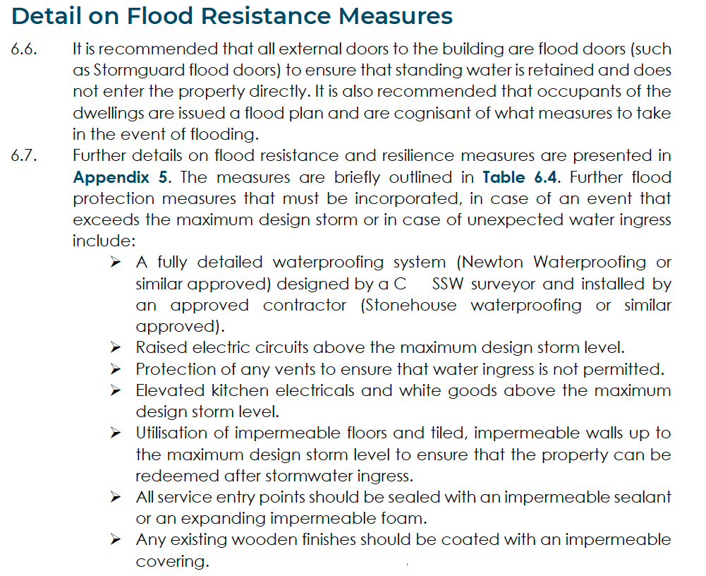
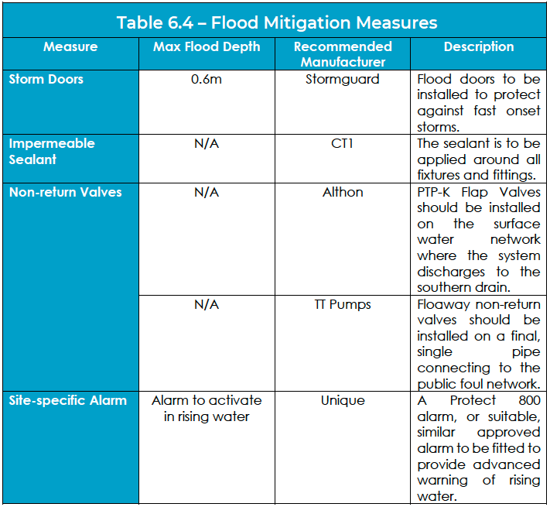
- Non-Return Valves: Anti-flooding non-return valves will be installed on all low-level drainage and sewerage pipes to prevent backflow from the local network.
- Waterproof Brick Sealing: The lower courses of the external brickwork will be treated with a breathable, clear water-repellent coating to minimize water ingress through porous masonry.
2.2 Services Protection
- Service Utilities: All electrical meters, distribution boards, and incoming utility points will be located above the maximum anticipated flood level (ideally on the first floor or raised significantly on ground-floor walls).
- Internal Ring Mains: Ground-floor electrical sockets will be wired from the ceiling downward, keeping circuits isolated from potential floor-level water.

3. Safe Access, Egress, and Evacuation Strategy
The site features three distinct exit routes: North (Bishopstrow Road Bridge), South (Southern Mill Pond Bridge), and West (Side Grounds). EA models indicate these routes carry a high hazard rating during a design flood event. Therefore, the primary strategy emphasises early evacuation, with internal safe refuge serving as the secondary fallback.
3.1 Flood Warning and Early Evacuation Protocol
To completely remove the risk of residents being cut off, a proactive evacuation trigger system will be legally tied to the management of the property:
- EA Flood Warning Registration: The building management company will register the property with the EA’s automated "Flood Warning Service."
- Trigger Phase 1 (Flood Alert): Residents are notified to prepare vehicles and monitor local river levels.
- Trigger Phase 2 (Flood Warning): Immediate, orderly evacuation of the site via the safest available route before floodwaters reach the site boundaries. Residents will move to a designated assembly point on higher ground outside the flood zone.
3.2 Safe Internal Refuge Strategy (Emergency Fallback)
If rapid flash flooding occurs or residents fail to evacuate before the three exit routes become impassable, the building design inherently provides safe refuge:
- Vertical Safe Refuge: The development converts the mill into multi-storey or upper-level apartments. All residents will have legal, unobstructed internal access to the first and second floors of the building.
- Duration of Refuge: The upper floors sit well above the maximum simulated climate change flood level, providing a dry, structurally sound environment.
- Emergency Provisions: A communal emergency cabinet will be maintained on the first floor, stocked with freshwater, emergency lighting, first-aid supplies, and a wind-up radio to liaise with emergency services.

4. Maintenance and Management
- Tenant Welcome Packs: Every new resident will receive a copy of this report, detailing the flood warning sign-up procedure, barrier deployment instructions, and the internal refuge plan.
- Annual Inspections: The building management company will conduct annual inspections of the flood barriers, non-return valves, and communal emergency supplies ahead of the winter flood season.

5. Conclusion
By combining structural water exclusion measures with a strict, early-alert evacuation plan and guaranteed upper-floor safe refuge, the development introduces a highly managed residential environment. The risk to life is effectively mitigated, satisfying the safety objectives of PPG Paragraph 047.

- Notes for reference.
- The maximum predicted flood depth (in meters or AOD)at the site during a 1-in0100 year event plus climate is a Maximum flood depth with climate change + freeboard allowance: 103.730 m AOD.
- The exact Danger is “Danger for most”, meaning emergency vehicles can access and egress the site safely.

