APPLICATION FOR VARIATION/REMOVAL OF CONDITION
CASE OFFICER REPORT

APPLICATION REFERENCE: | PL/2026/02400 & PL/2026/02823
APPLICATION TYPE: | Removal/variation of conditions & Listed Building Consent
SITE ADDRESS: | Lower Bridmore Farm, Berwick St John, Shaftesbury, SP7 0HG
DEVELOPMENT DESCRIPTION: | Variation of condition 3 (Change of materials for roof/silvered joinery) in relation to PL/2025/07483 Change of roof fabric from consented plain tiles to rust red corrugated metal roofing to match existing and a change from Oak to Douglas Fir for the naturally silvered joinery.
RECOMMENDATION: | Approve with conditions

SITE DESCRIPTION/CONTEXT

The site is situated in the countryside, approximately 1.2 kilometres to the east of the Small Village of Berwick St. John, as defined by Wiltshire Core Strategy (WCS) policies CP1 (Settlement Strategy), CP2 (Delivery Strategy) and CP27 (Tisbury Community Area).

As can be seen in PLAN A below, the site (outlined in red) is situated in the middle of an established farm complex, with a group of more traditional farm buildings and a farm house to the north, west and south; and a further group of larger, more modern agricultural buildings to the east of this site. The two sides of the farm complex are subdivided by a public Bridleway (Ref: BSJO14), identified with a thick green line on PLAN A below. Two of the buildings on the traditional side of the farmyard are Grade II listed buildings (identified with a black cross hatching on PLAN A below), with the remainder of the traditional farm buildings being curtilage listed. Access to the site is gained via the public bridleway, leading from Crook Hill to the north. This is a hard surfaced access track, that also serves the properties of Lower Bridmore Cottages to the north west of the site, at the junction with Crook Hill.

The site is situated within the Cranborne Chase & West Wiltshire National Landscape (formerly known as an Area of Outstanding Natural Beauty (AONB)). Whilst the site is situated in Flood Zone 1 and is not in the immediate vicinity of any rivers, it is situated within the catchment of the River Avon Special Area for Conservation (SAC).
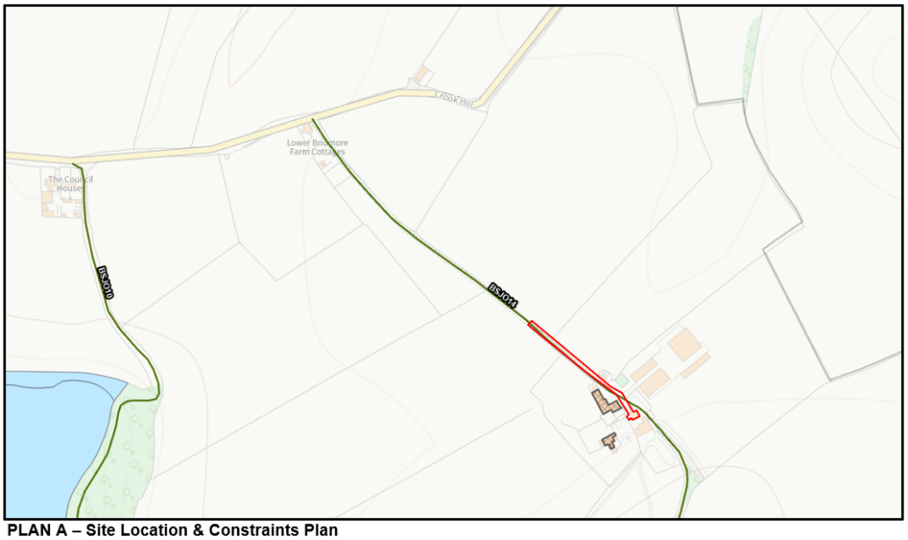

PROPOSAL

This report considers a dual scheme of a Section 73 application for the variation of condition 3 materials condition imposed on planning permission PL/2025/07483; and a separate application for listed building consent for the proposed change of materials of the roof of the barn from the previous consented plain tiles to a rust red corrugated metal roofing; and changes to the joinery material from Oak to Douglas fir.

RELEVANT PLANNING HISTORY

- S/2001/1371 Additional cattle housing. Permission – 07.01.2001
- S/2010/0636 (Farm House) 2 single storey side extensions, removal of chimney and reconstruct dormer windows to front elevation. Permission – 23.06.2010
- S/2010/0636 (Farm House) 2 single storey side extensions, removal of chimney and reconstruct dormer windows to front elevation. Consent – 23.06.2010
- 13/01080/FUL (Farm House) Erect single storey extension to rear of former brewhouse. Permission – 19.08.2013
- 13/01081/LBC (Farm House Erect single storey extension to rear of former brewhouse. Consent –19.08.2013 20/02168/LBC (building to north) Rebuild a partially collapsed barn. Consent – 11.10.2020
- PL/2025/02448 Restoration and improvement of the pond. Permission – 14.05.2025
- PL/2025/03669 Repairs to barn and change of roof material. Permission – 14.07.2025
- PL/2025/03809 Repairs to barn and change of roof material. Consent – 14.07.2025
- PL/2025/07483 & PL/2025/07743 Change of use of existing farm barn from Agricultural Store to Farm Office, Farm Store and Farm Welfare Facilities. To include repairs to barn; change of roof material; and new air source heat pump. Consent – 18.12.2025

RELEVANT LEGISLATION, POLICIES AND GUIDANCE

Town and Country Planning Act. 1990 (as amended)

Section 73 of the Town and Country Planning Act. 1990 (as amended) relates to the determination of applications to develop land without compliance with conditions previously attached. It states that:

(2) On such an application the local planning authority shall consider only the question of the conditions subject to which planning permission should be granted, and—

- if they decide that planning permission should be granted subject to conditions differing from those subject to which the previous permission was granted, or that it should be granted unconditionally, they shall grant planning permission accordingly, and

- if they decide that planning permission should be granted subject to the same conditions as those subject to which the previous permission was granted, they shall refuse the application.

The National Planning Practice Guidance (PPG) states the following:

- Nature of the Application: A Section 73 application is treated as a new planning permission, although it does not alter the original permission itself. The original permission remains intact and can still be implemented unless it has expired or been superseded.
- Limitations:
  - Section 73 cannot be used to change the description of development or the operative part of the permission (e.g. the nature or extent of the approved use).
  - It cannot be used to extend the time limit for implementing the original permission.
  - If the proposed changes go beyond what can reasonably be considered under Section 73, a new planning application under Section 70 would be required.
- Decision-making: The local planning authority must consider the application only in relation to the conditions subject to which the original permission was granted. However, it may impose new or revised conditions if granting a new permission.
- Legal Agreements: Because a Section 73 application results in a new permission, any existing Section 106 agreement may need to be varied or replaced via a deed of variation to ensure obligations continue to apply to the new permission.

National Planning Policy:
- National Planning Policy Framework (NPPF)
- Planning Practice Guidance (PPG)
- National Design Guide
Development Plan:
National Planning Policy Framework (NPPF)
National Planning Practice Guidance (NPPG)
National Design Guide (January 2021) (NDG)

Salisbury District Local Plan policies (Saved by Wiltshire Core Strategy) (SDLP):
C21 – Farm Diversification

Wiltshire Core Strategy (WCS):
CP1 (Settlement Strategy)
CP2 (Delivery Strategy)
CP3 (Infrastructure Requirements)
CP35 (Existing Employment Sites)
CP34 (Additional Employment Land)
CP48 (Supporting Rural Life)
CP50 (Biodiversity and Geodiversity)
CP51 (Landscape)
CP57 (Ensuring High Quality Design & Space Shaping)
CP58 (Ensuring the Conservation of the Historic Environment)
CP60 (Sustainable Transport)
CP61 (Transport & Development)
CP62 (Development Impacts on the Transport Network)
CP64 (Demand Management)
CP69 (Protection of the River Avon SAC)
Wiltshire Housing Site Allocations Plan (February 2020) (WHSAP)
Supplementary Planning Documents:
Wiltshire Design Guide (March 2024)
Creating Places Design Guide SPG (April 2006)
Achieving Sustainable Development SPG (April 2005)
Wiltshire Climate Strategy 2022-2027
Cranborne Chase AONB Management Plan 2019-2024
Wiltshire Local Transport Plan – Car Parking Strategy

ISSUES

The key considerations in the assessment of this application are as follows:

- Determining whether the proposed amendments fall within the scope of Section 73 of the Town and Country Planning Act 1990 which allows for the variation or removal of conditions attached to an existing planning permission.
- Assessing whether the development, as amended, remains in accordance with the relevant policies and provisions of the development plan, and whether the changes materially alter the nature or impacts of the approved scheme.

CONSULTATION RESPONSES

Berwick St John Parish Council: No Objection.

Conservation: No Objection: The existing roof is corrugated metal roofing (not complete). Whilst the clay tiles would have been a significant visual improvement, I have no objection to rust red corrugated metal, as this is a common material used for roofing on barns and therefore retains the agricultural character. No objection to douglas fir replacing oak.

REPRESENTATIONS
None received.

ASSESSMENT
Section 38(6) of the Planning and Compulsory Purchase Act 2004 states:

"If regard is to be had to the development plan for the purposes of any determination to be made under the planning Acts, the determination must be made in accordance with the plan unless material considerations indicate otherwise."

In accordance with this statutory requirement, this application has been assessed against the relevant policies of the Development Plan, including the Wiltshire Core Strategy (2015) and, where applicable, any made Neighbourhood Plans. Consideration has also been given to the policies of the National Planning Policy Framework (NPPF) as a material consideration in the assessment.

Principle of the Development – Do the proposed amendments fall within the scope of s73?

This dual section 73 application and listed building consent application proposes to change to roof fabric of the curtilage listed agricultural building from plain tiles to red corrugated metal roofing which matches the existing roof covering. Additionally, joinery details associated with the development are proposed to change from oak to douglas fir. This dual application does not extend the time limit for the implementation for the full planning permission approved on 18.12.2025.

The description of the original development with reference: PL/2025/07743 was Change of use of existing farm barn from Agricultural Store to Farm Office, Farm Store and Farm Welfare Facilities. To include repairs to barn; change of roof material; and new air source heat pump. While this S73 application proposes to alter the roof material again, the original description of development did not specifically describe the proposed material of the roof. Therefore, the proposed works, involving a further change to the roof material are considered to still confirm with the previous description of the development.

The proposed amendments have been reviewed and are considered to fall within the scope of Section 73 of the Town and Country Planning Act 1990. The changes do not result in a fundamentally different development from that originally approved, nor do they seek to alter the description of development or extend the time limit for implementation. As such, the application is valid under Section 73 and can be determined as a variation of condition(s) attached to the original planning permission.

Compliance with the Development Plan

There have not been any changes to the development plans since the original permission was granted that would make the amended proposed unacceptable.

- Wiltshire Core Strategy (WCS) policies;
- Neighbourhood Plans (where applicable);
- The National Planning Policy Framework (NPPF).
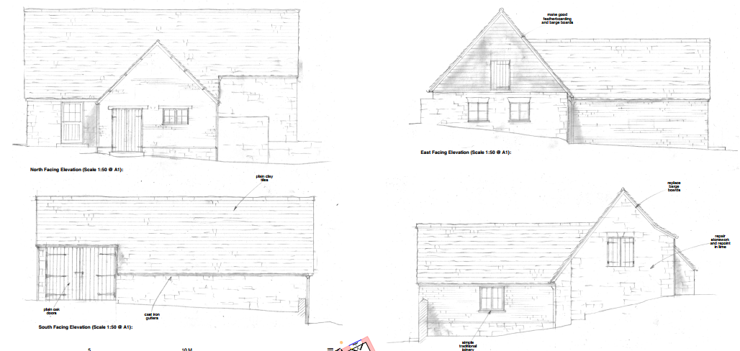
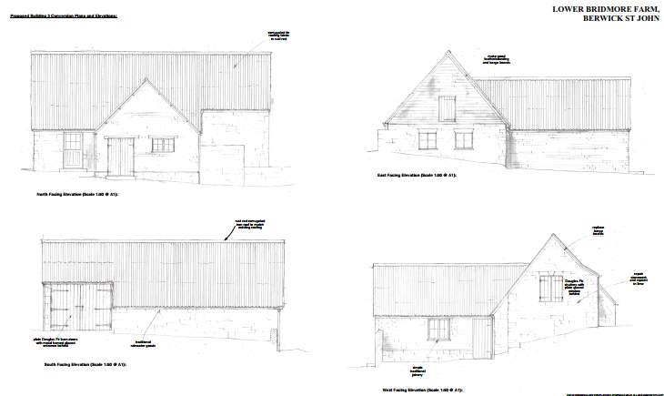
Assessment of Conditions

This dual section 73 application and listed building consent application proposes to change the roof fabric of the curtilage listed agricultural building from plain tiles to red corrugated metal roofing. The new finish matches the existing roof covering. The conservation officer has noted that while there would have been a visual improvement to the building if the roof was to be finished in clay tiles as previously proposed, using rust red corrugated metal is a common material used for roofing on barns in an agricultural setting such as this and matches the original finish for this particular building. It is therefore accepted. Additionally, joinery details associated with the development are proposed to change from an Oak to a Douglas fir finish. This material is proposed to be used on the barn doors on the south facing elevation and the shutters on the west facing elevation.

The proposed amended materials are minor in nature and are not significantly different from the materials approved or that were originally used in the existing barn. Therefore, it is not considered that the amendment of these materials will detrimentally impact the setting of the curtilage listed building and the associated Grade II listed dwelling; the setting of the nearby listed buildings; or have any implications for the landscape setting of the National Landscape.

The amendment roof material and joinery details would amend condition 2 plans condition and condition 3, materials condition. There are no other conditions of the extant approved application ref: PL/2025/07483 which this change would affect.

Condition 5 (external timber detail and joinery) Condition 6 (external window and door joinery and metal frame glazing) Condition 7 (stonework) of approved LBC ref: PL/2025/03809 were discharged by DoC application ref: PL/2025/07556. This has been noted in the recommendation of this dual section 73 and LBC application.

PLANNING BALANCE AND CONCLUSION
In determining this application under Section 73 of the Town and Country Planning Act 1990, the Local Planning Authority has considered whether the proposed amendments fall within the scope of Section 73. The proposed amendments have been assessed against the relevant policies of the Wiltshire Core Strategy, any applicable Neighbourhood Plan, and the National Planning Policy Framework. The assessment has also considered whether the development, as amended, materially alters the nature or impacts of the approved scheme.

In weighing the planning balance, the following factors have been considered:

- Benefits: The applicant has noted that the change of material is due to the cost of the previously approved materials. The change to more affordable materials help the viability of the proposed development.
- Harms: The conservation officer has noted that the use of clay tiles was seen as an improvement to the agricultural barn. However as the use of red corrugated roofing is of a typical material used in agricultural buildings such as this, this change would not warrant a refusal and is acceptable.

The proposed variation of condition(s) is considered acceptable. The benefits of the proposal, including viability of the proposed development are judged to outweigh any identified harms, which can be appropriately mitigated through planning conditions or other controls. The proposal remains in accordance with the development plan and relevant national guidance, and there are no material considerations that indicate otherwise.

RECOMMENDATION:

That Listed Building Consent be GRANTED subject to the following conditions:

1. The works for which Listed Building Consent is hereby granted shall be begin before the expiration of three years from the date of this consent.

REASON: To comply with the provisions of Section 18 of the Planning (Listed Buildings and Conservation Areas) Act 1990 as amended by the Planning and Compulsory Purchase Act 2004.

2. The development hereby permitted shall be carried out in accordance with the
following approved plans:

Application Form & Certificate

Ref: 1515/28A – Outbuilding 3 – Site Plan/Location Map. Received – 06.11.2025

Ref: 1515/49C – Building 3 – Proposed Plans & Elevations. Received – 14.04.2026

Ref: Daikin Altherma 3M (4-6-8 kW) Product Leaflet 2022. Received – 06.11.2025

REASON: For the avoidance of doubt and in the interests of proper planning.

3. No works to the roof shall be undertaken until details of the rust red corrugated metal roofing has been submitted to and approved in writing by the Local Planning Authority. Development shall be carried out in accordance with the approved details.

REASON: In the interests of preserving the character and appearance of the listed building and its setting; and the visual amenities and setting of the National Landscape and adjacent public right of way.

4. Notwithstanding the approved plans, the internal walls of the building shall be lined with horizontal boarding, details of which shall be first submitted to and approved in writing by the Local Planning Authority. The development shall be implemented in accordance with the approved details prior to its first use for the purpose hereby approved.

REASON: To preserve the agricultural character of the building in the interests of the heritage interest of the asset.

5. The external timber, including any paint or stain to be used on the external walls and window joinery, shall be finished, repaired and installed in accordance with the details approved by discharge of condition letter dated 8th October 2025 in response to application PL/2025/07556.

REASON: In the interests of preserving the character and appearance of the listed building and its setting; and the visual amenities and setting of the National Landscape and adjacent public right of way.

6. All new external window and door joinery and/or metal framed glazing will be installed in accordance with the details approved by discharge of condition letter dated 8th October 2025 in response to application PL/2025/07556.

REASON: In the interests of preserving the character and appearance of the listed building and its setting.

7. Any natural stonework to be used externally on the existing building shall be constructed in accordance with the details approved by discharge of condition letter dated 8th October 2025 in response to application PL/2025/07556.

REASON: In the interests of preserving the character and appearance of the listed building and its setting; and the visual amenities and setting of the National Landscape and adjacent public right of way.

8. Any external lighting that is installed across the site shall be designed and implemented to minimise sky glow, glare and light trespass. It shall be designed in a downward facing position at all times and shall meet the criteria for Environmental Zone E0 as defined by the Institute of Lighting Professionals ‘Guidance Notes for the Reduction of Obtrusive Light’ 2012. Any external lighting installed at the site shall be retained and maintained as such thereafter for the lifetime of the development.

REASON: To avoid illumination of habitat used by bats and other wildlife; and to protect the dark skies status of the National Landscape.

9. None of the development hereby approved, shall commence on site until full details of the number, design and locations of bat roosts and nesting opportunities for birds (e.g. bat and bird boxes) have been submitted to and approved in writing by the Local Planning Authority. The approved details shall be implemented in full before occupation of the dwellings hereby approved and shall be retained and maintained for the lifetime of the development.

REASON: The application contained insufficient information to enable this matter to be considered prior to granting planning permission and the matter is required to be agreed with the Local Planning Authority before development commences in order that the development is undertaken in an acceptable manner, to provide mitigation /enhancement for biodiversity.

10. The farm office and welfare facility hereby permitted shall not be used at any time other than for purposes ancillary to the agricultural use of the wider site (known as Lower Bridmore Farm), and it shall remain within the same planning unit as the other buildings in this farmyard.

REASON: In the interests of the amenity of the area/National Landscape; to enable the Local Planning Authority to consider individually whether planning permission should be granted for alternative uses in this unsustainable area; and to ensure that no additional phosphate burden is generated by the site which might adversely affect the special ecological interests of the River Avon Special Area for Conservation.

Informative

1.The applicant is advised that the development hereby approved may represent chargeable development under the Community Infrastructure Levy Regulations 2010 (as amended) and Wiltshire Council's CIL Charging Schedule. If the development is determined to be liable for CIL, a Liability Notice will be issued notifying you of the amount of CIL payment due. If an Additional Information Form has not already been submitted, please submit it now so that we can determine the CIL liability. In addition, you may be able to claim exemption or relief, in which case, please submit the relevant form so that we can determine your eligibility. The CIL Commencement Notice and Assumption of Liability must be submitted to Wiltshire Council prior to commencement of development. Should development commence prior to the CIL Liability Notice being issued by the local planning authority, any CIL exemption or relief will not apply and full payment will be required in full and with immediate effect. Should you require further information or to download the CIL forms please refer to the Council's Website:
www.wiltshire.gov.uk/planninganddevelopment/planningpolicy/communityinfrastructurelevy.

Informative

2. Any alterations to the approved plans, brought about by compliance with Building Regulations or any other reason must first be agreed in writing with the Local Planning Authority before commencement of work.

Informative

3. The effect of paragraph 13 of Schedule 7A to the Town and Country Planning Act 1990 is that planning permission granted for development of land in England is deemed to have been granted subject to the condition (biodiversity gain condition) that development may not begin unless:

a) a Biodiversity Gain Plan has been submitted to the planning authority, and

b) the planning authority has approved the plan.
The planning authority, for the purposes of determining whether to approve a Biodiversity Gain Plan, if one is required in respect of this permission would be Wiltshire Council. There are statutory exemptions and transitional arrangements which mean that the biodiversity gain condition does not always apply.
Based on the information available this permission is considered to be one which will not require the approval of a biodiversity gain plan before development is begun because the permission which has been granted is for development, which is exempt being below the de minimis threshold, meaning development which:

i. does not impact an onsite priority habitat (a habitat specified in a list published under section 41 of the Natural Environment and Rural Communities Act 2006); and

ii. impacts less than 25 square metres of onsite habitat that has biodiversity value greater than zero and less than 5 metres in length of onsite linear habitat (as defined in the statutory metric).

Informative

4. There is a low risk that bats may occur at the barn. Many species of bat depend on buildings for roosting, with each having its own preferred type of roost. Most species roost in crevices such as under ridge tiles, behind roofing felt or in cavity walls and are therefore not often seen in the roof space. Bat roosts are protected all times by the Conservation of Habitats and Species 2017 (as amended) even when bats are temporarily absent because, being creatures of habit, they usually return to the same roost site every year. Planning permission for development does not provide a defence against prosecution under this legislation or substitute for the need to obtain a bat licence if an offence is likely. If bats or evidence of bats is found during the works, the applicant is advised to stop work and follow advice from an independent ecologist or the applicant is advised to follow the advice of a professional ecologist or to contact Natural England’s Batline.

Informative

5. The applicant should note that it is a criminal offence to obstruct a public right of way under section 137 of the Highways Act 1980 and therefore no materials, plant, temporary structures or excavations of any kind should be deposited / undertaken which obstruct or adversely affect the public right of way BSJO14 whilst development takes place, without prior consultation with, and the further permission of, the highways authority at Wiltshire council.

That Planning Permission be GRANTED subject to the following conditions

1.The development hereby permitted shall be begun before the expiration of three years from the date of the extant permission PL/2025/07483 which was approved on: 18/12/2025.

REASON: To comply with the provisions of Section 91 of the Town and Country Planning Act 1990 as amended by the Planning and Compulsory Purchase Act 2004.

2. The development hereby permitted shall be carried out in accordance with the
following approved plans:

Application Form & Certificate

Ref: 1515/28A – Outbuilding 3 – Site Plan/Location Map. Received – 06.11.2025

Ref: 1515/49C – Building 3 – Proposed Plans & Elevations. Received – 14.04.2026

Ref: Daikin Altherma 3M (4-6-8 kW) Product Leaflet 2022. Received – 06.11.2025

REASON: For the avoidance of doubt and in the interests of proper planning.

3. No works to the roof shall be undertaken until details of the rust red corrugated metal roofing has been submitted to and approved in writing by the Local Planning Authority. Development shall be carried out in accordance with the approved details.

REASON: In the interests of preserving the character and appearance of the listed building and its setting; and the visual amenities and setting of the National Landscape and adjacent public right of way.
4. Notwithstanding the approved plans, the internal walls of the building shall be lined with horizontal boarding, details of which shall be first submitted to and approved in writing by the Local Planning Authority. The development shall be implemented in accordance with the approved details prior to its first use for the purpose hereby approved.
REASON: To preserve the agricultural character of the building in the interests of the heritage interest of the asset.
5. The external timber, including any paint or stain to be used on the external walls and window joinery, shall be finished, repaired and installed in accordance with the details approved by discharge of condition letter dated 8th October 2025 in response to application PL/2025/07556.
REASON: In the interests of preserving the character and appearance of the listed building and its setting; and the visual amenities and setting of the National Landscape and adjacent public right of way.
6. All new external window and door joinery and/or metal framed glazing will be installed in accordance with the details approved by discharge of condition letter dated 8th October 2025 in response to application PL/2025/07556.
REASON: In the interests of preserving the character and appearance of the listed building and its setting.
7. Any natural stonework to be used externally on the existing building shall be constructed in accordance with the details approved by discharge of condition letter dated 8th October 2025 in response to application PL/2025/07556.
REASON: In the interests of preserving the character and appearance of the listed building and its setting; and the visual amenities and setting of the National Landscape and adjacent public right of way.
8. Any external lighting that is installed across the site shall be designed and implemented to minimise sky glow, glare and light trespass. It shall be designed in a downward facing position at all times and shall meet the criteria for Environmental Zone E0 as defined by the Institute of Lighting Professionals ‘Guidance Notes for the Reduction of Obtrusive Light’ 2012. Any external lighting installed at the site shall be retained and maintained as such thereafter for the lifetime of the development.
REASON: To avoid illumination of habitat used by bats and other wildlife; and to protect the dark skies status of the National Landscape.
9. None of the development hereby approved, shall commence on site until full details of the number, design and locations of bat roosts and nesting opportunities for birds (e.g. bat and bird boxes) have been submitted to and approved in writing by the Local Planning Authority. The approved details shall be implemented in full before occupation of the dwellings hereby approved and shall be retained and maintained for the lifetime of the development.
REASON: The application contained insufficient information to enable this matter to be considered prior to granting planning permission and the matter is required to be agreed with the Local Planning Authority before development commences in order that the development is undertaken in an acceptable manner, to provide mitigation /enhancement for biodiversity.
10. The farm office and welfare facility hereby permitted shall not be used at any time other than for purposes ancillary to the agricultural use of the wider site (known as Lower Bridmore Farm), and it shall remain within the same planning unit as the other buildings in this farmyard.
REASON: In the interests of the amenity of the area/National Landscape; to enable the Local Planning Authority to consider individually whether planning permission should be granted for alternative uses in this unsustainable area; and to ensure that no additional phosphate burden is generated by the site which might adversely affect the special ecological interests of the River Avon Special Area for Conservation.
Informative
1.The applicant is advised that the development hereby approved may represent chargeable development under the Community Infrastructure Levy Regulations 2010 (as amended) and Wiltshire Council's CIL Charging Schedule. If the development is determined to be liable for CIL, a Liability Notice will be issued notifying you of the amount of CIL payment due. If an Additional Information Form has not already been submitted, please submit it now so that we can determine the CIL liability. In addition, you may be able to claim exemption or relief, in which case, please submit the relevant form so that we can determine your eligibility. The CIL Commencement Notice and Assumption of Liability must be submitted to Wiltshire Council prior to commencement of development. Should development commence prior to the CIL Liability Notice being issued by the local planning authority, any CIL exemption or relief will not apply and full payment will be required in full and with immediate effect. Should you require further information or to download the CIL forms please refer to the Council's Website:
www.wiltshire.gov.uk/planninganddevelopment/planningpolicy/communityinfrastructurelevy.
Informative
2. Any alterations to the approved plans, brought about by compliance with Building Regulations or any other reason must first be agreed in writing with the Local Planning Authority before commencement of work.
Informative
3. The effect of paragraph 13 of Schedule 7A to the Town and Country Planning Act 1990 is that planning permission granted for development of land in England is deemed to have been granted subject to the condition (biodiversity gain condition) that development may not begin unless:
a) a Biodiversity Gain Plan has been submitted to the planning authority, and
b) the planning authority has approved the plan.
The planning authority, for the purposes of determining whether to approve a Biodiversity Gain Plan, if one is required in respect of this permission would be Wiltshire Council. There are statutory exemptions and transitional arrangements which mean that the biodiversity gain condition does not always apply.
Based on the information available this permission is considered to be one which will not require the approval of a biodiversity gain plan before development is begun because the permission which has been granted is for development, which is exempt being below the de minimis threshold, meaning development which:
i. does not impact an onsite priority habitat (a habitat specified in a list published under section 41 of the Natural Environment and Rural Communities Act 2006); and
ii. impacts less than 25 square metres of onsite habitat that has biodiversity value greater than zero and less than 5 metres in length of onsite linear habitat (as defined in the statutory metric).
Informative
4. There is a low risk that bats may occur at the barn. Many species of bat depend on buildings for roosting, with each having its own preferred type of roost. Most species roost in crevices such as under ridge tiles, behind roofing felt or in cavity walls and are therefore not often seen in the roof space. Bat roosts are protected all times by the Conservation of Habitats and Species 2017 (as amended) even when bats are temporarily absent because, being creatures of habit, they usually return to the same roost site every year. Planning permission for development does not provide a defence against prosecution under this legislation or substitute for the need to obtain a bat licence if an offence is likely. If bats or evidence of bats is found during the works, the applicant is advised to stop work and follow advice from an independent ecologist or the applicant is advised to follow the advice of a professional ecologist or to contact Natural England’s Batline.
Informative
5. The applicant should note that it is a criminal offence to obstruct a public right of way under section 137 of the Highways Act 1980 and therefore no materials, plant, temporary structures or excavations of any kind should be deposited / undertaken which obstruct or adversely affect the public right of way BSJO14 whilst development takes place, without prior consultation with, and the further permission of, the highways authority at Wiltshire council.

