APPLICATION FOR HOUSEHOLDER PLANNING PERMISSION
DELEGATED REPORT

APPLICATION REFERENCE: | PL/2026/01630
APPLICATION TYPE: | Householder planning permission
SITE ADDRESS: | 13 Ludlow Close, Warminster BA12 8BJ
DEVELOPMENT DESCRIPTION: | Proposed demolition, extension, reconfiguration and thermal upgrade works
RECOMMENDATION: | That Planning Permission be GRANTED

PROPOSAL

The proposal seeks planning permission for replacement single storey extensions, to the side and rear of the host dwelling, and a porch on the front elevation. The scheme seeks to utilise contemporary materials with the use of cedar cladding on the host dwelling with blackened timber cladding on the rear extension. Revised plans were received (06.05.2026) reinstating the existing first floor window on the north elevation that had been mistakenly omitted on the original plans. The revised plans were consulted on for the statutory 21-day period.

SITE DESCRIPTION/CONTEXT
This application relates to a detached chalet style bungalow, 13 Ludlow Close located within an established residential area in Warminster. The host dwelling benefits from an off-road parking area to the front elevation and an attached garage.

The surrounding properties consist of detached bungalows, with a mix of architectural styles, many of which have first floor accommodation. This proposal falls within the recreational impact zone of the Salisbury Plain Special Protection Area for birds and located within the Hampshire catchment area of the River Avon SAC.

PLANNING HISTORY
N/a

RELEVANT POLICIES AND GUIDANCE

Wiltshire Core Strategy:

Core Policy 2 Delivery Strategy
Core Policy 31 – Spatial Strategy for the Warminster Community Area
Core Policy 50 – Biodiversity and Geodiversity
Core Policy 51 – Landscape
Core Policy 57 - Ensuring High Quality Design and Place Shaping
Core Policy 69 – Protection of the River Avon SAC
Emerging Policy – Wiltshire Local Plan Review
At Full Council on 19 May, the elected members of Wiltshire Council agreed to withdraw the emerging WLP. It will now be subject to a legal process to finalise its withdrawal - which is likely to happen in July or August (2026). The said Plan has no material weight for the purposes of the application.
Warminster Neighbourhood Plan 2015- 2026 Made November 2016
Wiltshire Design Guide: Appendix D – Design Guidance for Householder extensions
The National Planning Policy Framework (NPPF)
The Planning Practice Guidance
National Design Guide

CONSULTATION RESPONSES

Warminster Town Council: No objection

Wiltshire Council Highways team: No objection

REPRESENTATIONS
Two letters of objection were received from one adjacent neighbour. The points raised will be appraised within the officer report below.

ASSESSMENT
Section 38(6) of the Planning and Compulsory Purchase Act 2004 states:

"If regard is to be had to the development plan for the purposes of any determination to be made under the planning Acts, the determination must be made in accordance with the plan unless material considerations indicate otherwise."

In accordance with this statutory requirement, this application has been assessed against the relevant policies of the Development Plan, including the adopted Wiltshire Core Strategy (2015) and, where applicable, any made Neighbourhood Plans.

Design and Impact upon the character and context of the area
Core Policy 57 - Ensuring High Quality Design and Place Shaping of the Wiltshire Core Strategy seeks to ensure that all new development is of high design quality, reflecting local context, character, and distinctiveness.

The applicant seeks to remodel the existing garage building on the side elevation and replace it with a flat roof extension over the same footprint. The extension would sit at a height of 3.3m with blackened timber elevations, the existing garage doors would remain on the front elevation. To the rear elevation the existing single storey rear extension and conservatory building would be replaced with a single storey extension that would adjoin the rear of the side extension.

A neighbouring occupier has queried the dimensions of the new garage, stating that measurements are not available on the plans, however the plans are clearly labelled with a scale plan, but for clarity the garage would measure 8.3m in length and 3.3m in width as existing.

The rear extension would sit at a height of 3.3m and would employ a flat roof form with two glass lanterns inserted to illuminate the internal space. The applicant seeks to insert two sets of patio doors and a window on the rear elevation. The extension would consist of blackened timber elevations with grey UPVC fenestration.

To the front elevation a central porch area would be erected, extending over a limited footprint with a pitched roof and front facing gable end.

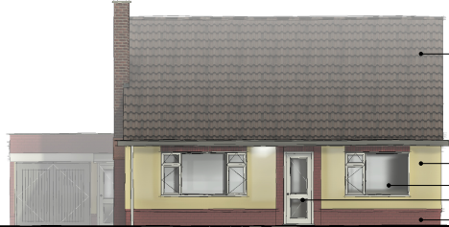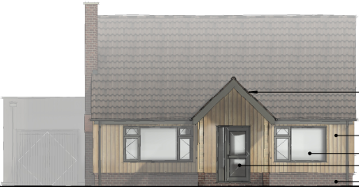
Existing(left) and proposed (right) front elevation

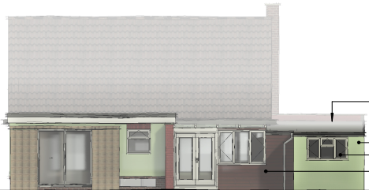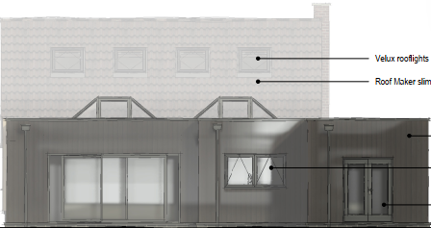
Existing(left) and proposed (right) rear elevation

A neighbouring property has objected to the scheme, raising concerns that the design would be out of character with the area, and this is duly noted.

The scheme seeks to extend the accommodation with a contemporary style extension and upgrade the existing elevations with natural sustainable materials. Officers acknowledge that the adjacent properties retain the existing more traditional architectural features of the original estate, however it is also acknowledged that more contemporary styled properties are present within the immediate area, as illustrated in the image insert below.
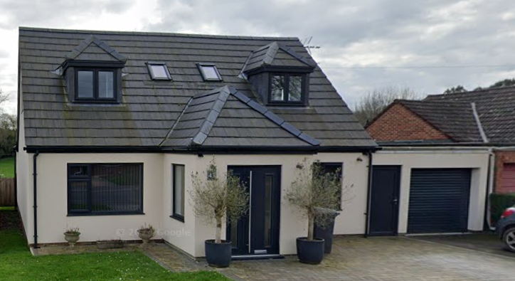

The majority of the darkened timbers would be on the rear extension and therefore would not be widely visible from the public realm and officers support the use of the natural sustainable materials. In this instance, when viewed in the wider context of the residential development within the area, the development is not considered to have an adverse impact on the character and appearance of the area.

It is considered that the extensions would by virtue of their height, scale and design constitute complementary additions to the host dwelling that would appear commensurate to the size of the property and plot, extending over existing built form.

Having regard to the above, the proposal complies with the design principles set out in Core Policy 57 of the Wiltshire Core Strategy and Appendix D of the Wiltshire Design Guide.

Amenity
Point vii of Core Policy 57 - Ensuring High Quality Design and Place Shaping of the Wiltshire Core Strategy seeks to ensure that developments do not adversely affect neighbouring properties.

The National Planning Policy Framework (NPPF), particularly Paragraph 135(f), stresses that planning decisions should ensure developments provide a high standard of amenity for existing and future users.

The proposed development has been assessed in terms of its potential impact on the residential amenity of neighbouring properties, with particular regard to loss of light, overshadowing, loss of privacy, and overbearing effects.

All windows proposed on the extensions would overlook the applicant’s private residential curtilage to the front and rear elevations and no windows would be inserted on the side elevation adjacent to the neighbour at No.11 Ludlow Close.

Two ground floor windows are proposed on the south side elevation of the host dwelling adjacent to the property at No.15 Ludlow Close, however given these windows would serve bathrooms a condition would be added to ensure that they would be obscure glazed, in the interests of private residential amenity. Therefore, no overlooking concerns are raised.

The proposal seeks to replace existing form, extending over a similar footprint, which would be of a single storey nature, therefore officers raise no concerns in regard to any adverse overbearing or overshadowing impacts or loss of light to neighbouring occupiers.

The proposal therefore accords with Core Policy 57 point vii in respect of safeguarding residential amenity and Appendix D of the Wiltshire Design Guide.

Highways Impact
Core Policy 57 (xiv) of the Wiltshire Core Strategy seeks to ensure that development must meet the requirements of Core Policy 61. This policy requires proposals to be capable of being served by safe access to the highway network. Core Policy 64 seeks to ensure compliance with parking standards set out in the Local Transport Plan.

The National Planning Policy Framework (NPPF), particularly Paragraph 115 and 116, requires that development proposals do not have an unacceptable impact on highway safety and that safe and suitable access to the site can be achieved for all users.

Impact on parking provision – Core Policy 64 (Demand Management) seeks to manage the demand for vehicle parking and confirms that residential parking standards are to be based on minimum parking standards.
The proposal does not seek to introduce any additional bedrooms therefore the property would remain a three bedroomed dwelling. In order to comply with the Wiltshire Local Transport Plan 2011 – 2026: Car Parking Strategy (March 2015) two on-site car parking spaces would be required for a 3-bed dwelling (standard min. size 2.4m x 4.8m).
The site plan (below) illustrates that the driveway would provide sufficient off -road parking for two cars and would retain the existing access. The Local Authority Highways officer was consulted on the scheme and offered no objections.
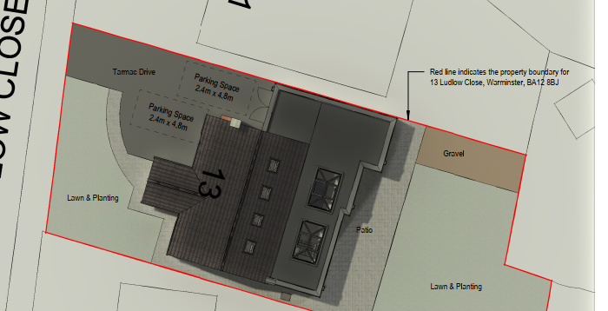
The proposed development would not result in any adverse impact on highway safety, and adequate parking and turning provision is provided in accordance with Wiltshire’s adopted parking standards, and access arrangements are acceptable.

The proposal is therefore considered to comply with Core Policies 57 (xiv), 61 and 64 of the Wiltshire Core Strategy, the NPPF, and the Wiltshire Local Transport Plan.

Ecology Impact
Core Policy 50 of the Wiltshire Core Strategy seeks to protect and enhance biodiversity and geodiversity, including through ensuring that development avoids harm to protected species and habitats.

The National Planning Policy Framework (NPPF), in Paragraphs 193, requires that development minimises impacts on and provides net gains for biodiversity, including ensuring mitigation is secured where harm cannot be avoided.

Salisbury Plain SPA
This proposal falls within the recreational impact zone of the Salisbury Plain Special Protection Area for birds. Therefore, potential disturbance to nesting birds through the creation of additional visitor numbers to the Salisbury Plain has to be assessed. However, given that this proposal relates to an extension to existing accommodation only, without the creation of separate independent living accommodation, it is considered that there would not be any adverse impacts on the Special Protection Area.

River Avon SAC
The site is located within the Hampshire catchment area of the River Avon SAC where phosphates and nutrients are carefully controlled and monitored. However, given that this proposal relates to an extension to existing accommodation only, without the creation of separate independent living accommodation, it is considered that there would not be any adverse impacts on the phosphates/nutrient discharge.

As such, the development complies with Core Policy 50 of the Wiltshire Core Strategy and the relevant provisions of the NPPF.

Biodiversity Net Gain
Householder planning applications are exempt from the requirement to deliver Biodiversity Net Gain under Schedule 7A, Section 4(2)(a) of the Town and Country Planning Act 1990, as inserted by the Environment Act 2021.

Other Matters
The neighbouring occupier has queried the extent to which the boundary fencing, boundary delineation and gate posts would be retained during the construction process, however this matter falls outside of the planning process and is not a material planning consideration, falling within the planning remit of the Party Wall Act.
Similarly, a condition to ensure site works are supervised and a contact number made available in the event of any emergency does not meet the test for planning conditions, as not being ‘necessary’ to make the development acceptable.

CONCLUSION
The proposed development is considered to be acceptable in terms of its design, scale, and relationship with the surrounding area. It would not result in any unacceptable harm to the character of the locality, the amenities of neighbouring occupiers, or the interests of highway safety, or ecology.

The proposal is therefore considered to comply with the relevant policies of the Wiltshire Core Strategy, the Wiltshire Local Plan, and the National Planning Policy Framework. As such, the application is recommended for approval, subject to the conditions set out below.

RECOMMENDATION: That Planning Permission be GRANTED subject to conditions.

Conditions

1.The development hereby permitted shall be begun before the expiration of three years from the date of this permission.
REASON: To comply with the provisions of Section 91 of the Town and Country Planning Act 1990 as amended by the Planning and Compulsory Purchase Act 2004.

2. The development hereby permitted shall be carried out in accordance with the following approved plans and documents:
Location Plan - Received 10.03.2026
Location & Block Plan DWG No 25-035-001-P2 - Received 10.03.2026
Existing Ground Floor Plan DWG No 25-035-002-P2 - Received 10.03.2026
Existing First Floor Plan DWG No 25-035-003-P2 - Received 10.03.2026
Existing Roof Plan DWG No 25-035-004-P2 - Received 10.03.2026
Existing Elevations DWG No 25-035-005-P2 - Received 10.03.2026
Proposed Site Plan DWG No 25-035-011-P6 - Received 10.03.2026
Proposed Ground Floor Plan DWG No 25-035-012-P6 - Received 10.03.2026
Proposed First Floor Plan DWG No 25-035-013-P7 - Received 06.05.2026
Proposed Roof Plan DWG No 25-035-014-P6 - Received 10.03.2026
Proposed Elevations DWG No 25-035-015-P7 - Received 06.05.2026
Proposed Typical Section DWG No 25-035-018-P5 - Received 10.03.2026
Proposed Typical Section DWG No 25-035-019-P4 - Received 10.03.2026

REASON: For the avoidance of doubt and in the interests of proper planning.

3. Before the development hereby permitted is first occupied the ground floor windows in the south elevation shall be glazed with obscure glass only [to an obscurity level of no less than level 3 and the windows shall be permanently maintained with obscure glazing in perpetuity.

REASON: In the interests of residential amenity and privacy.

