APPLICATION FOR FULL-PLANNING PERMISSION
CASE OFFICER REPORT

APPLICATION REFERENCE: | PL/2026/03017
APPLICATION TYPE: | Full planning permission
SITE ADDRESS: | Market Place, Salisbury, SP1 1JH
DEVELOPMENT DESCRIPTION: | Extending the existing disabled access toilet block to create two DDA toilets
RECOMMENDATION: | Approve with Conditions

SITE DESCRIPTION/CONTEXT

The application site relates to the existing above ground public disabled toilet located within the Market Place in the centre of the historic core of Salisbury city centre. Salisbury is defined as a principal settlement by Wiltshire Core Strategy (WCS) core policies 1 (Settlement Strategy), 2 (Delivery Strategy) and 20 (Spatial Strategy for the Salisbury Community Area).

The Market Place is a large, predominantly hard‑surfaced public square of medieval origin that has historically functioned as the principal focus for trade, civic activity and community gatherings, and continues to host regular markets and events.

The existing above-ground accessible (DDA) toilet is located along the northern side of the Market Place, alongside Blue Boar Row. The immediate site also includes the existing below-ground public toilets accessed via external steps; areas of seating, street furniture and formal tree planting. The image below shows the application site and general aerial view of the Market Place and immediate surrounds.

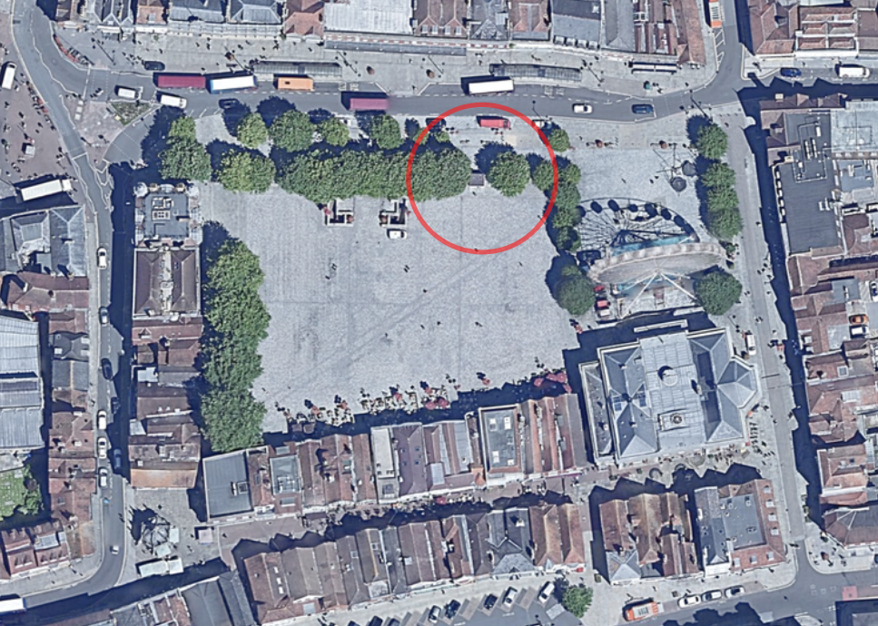

The site lies within the Salisbury Conservation Area and is surrounded by numerous designated heritage assets, including the Guildhall, Poultry Cross, the War Memorial and a range of Grade I, II* and II listed on all sides. The map extract below demonstrates the large number of listed buildings surrounding the Market Place, these are shown in black hatching.

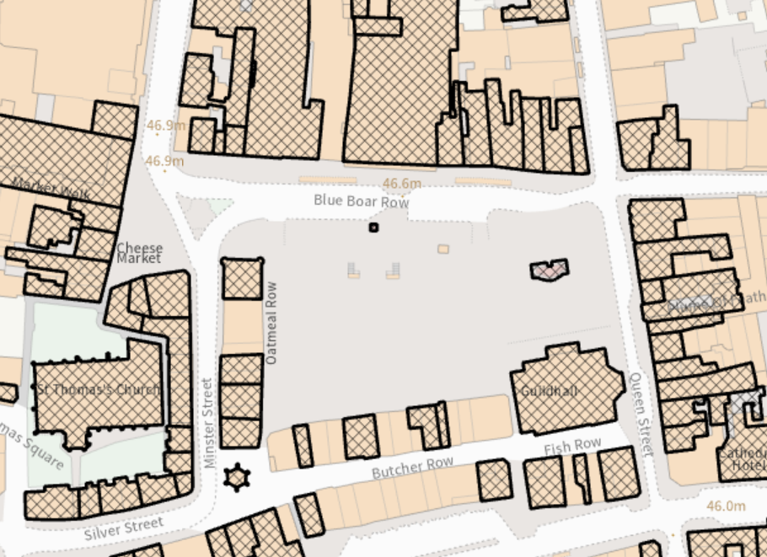

There are a number of public footpaths across the Market Place (see map extract below), none are immediately adjacent to or affected by the proposed development.

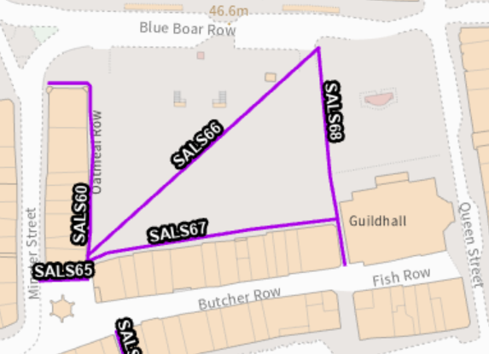

The site is located in flood zone 2, flood zone 3 and at risk of surface water flooding.

Flood Zone 2 Flood Zone 3 Surface water flooding

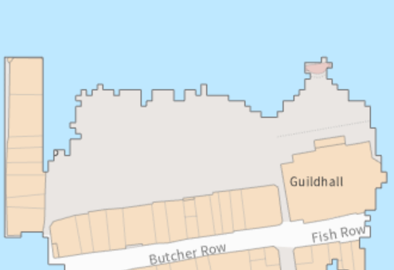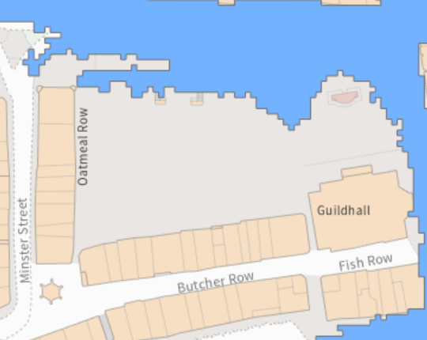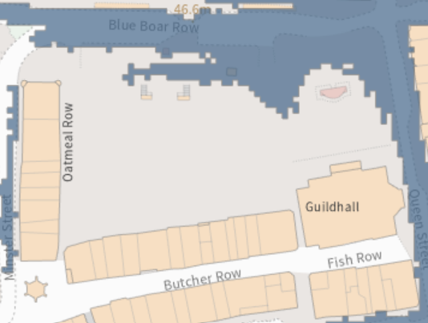

Groundwater levels are between 0.025m and 0.5m below the ground surface. Within this zone there is a risk of groundwater flooding to surface and subsurface assets. There is the possibility of groundwater emerging at the surface locally.

The site is also situated within the catchment of the River Avon Special Area for Conservation (SAC) and lies within the 13.8km zone of influence for the New Forest protected sites, which comprises the New Forest SPA, New Forest SAC and New Forest Ramsar site.

PROPOSAL

The application is seeking permission for the extension of the existing above ground disabled toilet block located within the Market Place to create two DDA toilets. The proposals will comprise extending to both sides of the existing disabled toilet block, retaining the same height as existing and using the same materials to match the existing. The existing separate below ground toilet bock will remain untouched and does not form part of the development as proposed.

Existing site plan Proposed site plan

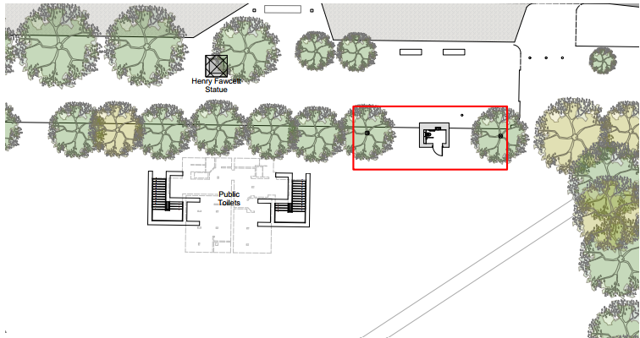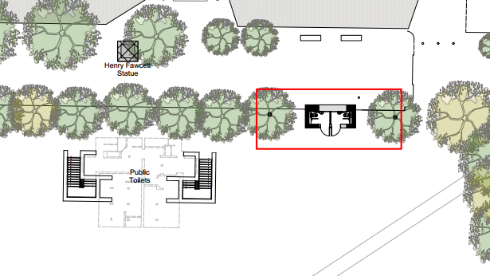

Existing plans/elevations Proposed plans/elevations
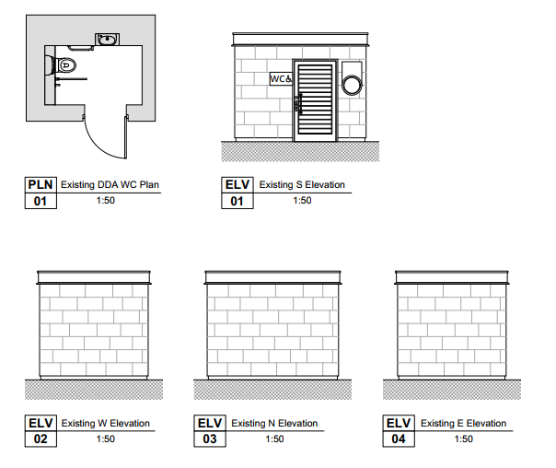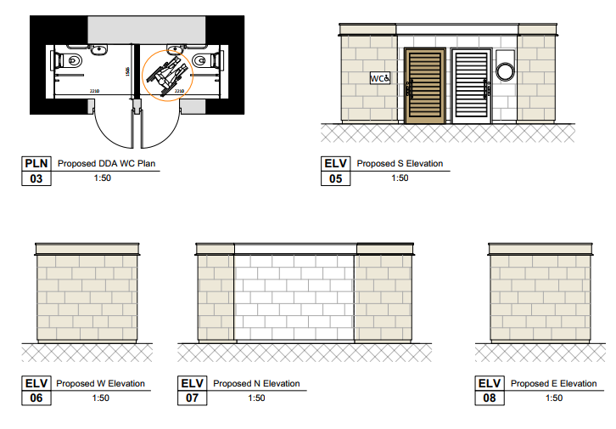

PLANNING HISTORY

There is extensive site history across the Guildhall Square and Market Place, there is however only one relevant planning application relating to the toilets.

PL/2025/01539 - Full planning permission Decision - Withdrawn by Applicant Date: 22/4/2025 – Redevelopment of public toilets in the Market Square to include the closure and conversion of the existing toilets to provide storage with associated works to the access stairs including part demolition of western above ground stair wall. Erection of a new detached single storey toilet block.

RELEVANT LEGISLATION, POLICIES AND GUIDANCE

Statutory Legislation:

Planning (Listed Building and Conservation Areas) Act 1990

Section 66: Special considerations affecting planning functions (LISTED BUILDINGS)
Section 72: General duties of planning authorities (CONSERVATION AREAS)

National Planning Policy:

- National Planning Policy Framework (NPPF)
- Planning Practice Guidance (PPG)
- National Design Guide

Development Plan:

The development plan for Wiltshire comprises the Wiltshire Core Strategy (WCS) (adopted January 2015) and any made neighbourhood plans, which remains the principal statutory planning document guiding development across the county. In line with Section 38(6) of the Planning and Compulsory Purchase Act 2004, planning decisions must be made in accordance with the development plan unless material considerations indicate otherwise.

Though the development plan is considered as a whole, those parts deemed to be particularly relevant to this application are listed below:

The adopted Wiltshire Core Strategy (WCS), with particular regard to:

Core Policy 1 Settlement Strategy
Core Policy 2 Delivery Strategy
Core Policy 3 The Spatial Vision for Wiltshire
Core Policy 20 Salisbury Community Area
Core Policy 22 Salisbury Central Area
Core Policy 50 Biodiversity and Geodiversity
Core Policy 57 Ensuring high quality design and place shaping
Core Policy 58 Ensuring conservation of the historic environment
Core Policy 67 Flood Risk
Core Policy 69 Protection of the River Avon SAC

Saved policies from Salisbury District Local Plan

E3/H7 - Salisbury Central Area
S2 - Secondary Shopping Area

Supplementary Planning Documents:

Wiltshire Design Guide
Creating Places Design Guide SPG (April 2006)
City of Salisbury Conservation Area Appraisal 2014
Salisbury Neighbourhood Plan
Salisbury City Central Area Framework

ISSUES

The main issues that need to be addressed in this case include:

- Principle
- Design, Impact on the Character and Appearance of the Area and Impact on Heritage Assets (Conservation Area and Setting of Listed Buildings)
- Amenity
- Highways
- Trees
- Ecology
- Flood risk

CONSULTATION RESPONSES

City Council - Support

Conservation – No objections

Historic England - Historic England provides advice when our engagement can add most value. In this case we are not offering advice. This should not be interpreted as comment on the merits of the application.

Archaeology - We note that although the Market Place is of historic significance and there have been historic and archaeological features recording in the vicinity, the impact of this proposal is low and will be in an area identified in the Heritage Statement to have been already disturbed. We therefore have no further comments to make in relation to this proposal

Public Protection – No comment

Trees - No objection subject to trees being protected in accordance with the Arb Report and the Tree Protection Plan.

Highways - No objections

REPRESENTATIONS

In accordance with the requirements of the Town and Country Planning (Development Management Procedure) (England) Order 2015 (as amended), the application was publicised by way of:

- A site notice displayed near the site
- An advertisement placed in the local press

These methods were used to inform interested parties and provide a period of 21 days for comments to be submitted.

Below is a summary of the representations received during the consultation period. Only material planning considerations have been taken into account in the assessment of this application. Non-material issues, such as property values or private legal disputes, cannot be considered in the determination process.

No third party representations have been received

ASSESSMENT

Section 38(6) of the Planning and Compulsory Purchase Act 2004 states:

"If regard is to be had to the development plan for the purposes of any determination to be made under the planning Acts, the determination must be made in accordance with the plan unless material considerations indicate otherwise."

In accordance with this statutory requirement, this application has been assessed against the relevant policies of the Development Plan, including the Wiltshire Core Strategy (2015) and, where applicable, any made Neighbourhood Plans. Consideration has also been given to the policies of the National Planning Policy Framework (NPPF) as a material consideration in the assessment.

Principle of Development

The proposal relates to the extension of an existing public toilet facility within Salisbury Market Place, a long-established area of public and commercial use at the heart of the city centre. The provision of improved and accessible public amenities is consistent with the established function of the site, supporting its ongoing use as a key public space and market venue. The principle of development is considered acceptable subject to compliance with other relevant planning policies and guidance and material impacts including design, character, impacts on heritage assets and impact on trees.

Design, Impact on the Character and Appearance of the Area and Impact on Heritage Assets (Conservation Area and Setting of Listed Buildings)

From the point of view of the historic environment the main statutory tests are set out within the Planning (Listed Building and Conservation Areas) Act 1990.

Section 66 (Planning Permission) requires that special regard be given to the desirability of preserving listed buildings, their settings or any features of special architectural or historic interest which they possess.

Paragraph 58B of the Planning Act 1990 requires that in considering whether to grant planning permission or permission in principle for the development of land in England which affects a registered park and garden, the LPA must have special regard to the desirability of preserving or enhancing the asset or its setting.

Section 72(1) of the Act requires the Council to pay special attention to the desirability of preserving or enhancing the character or appearance of designated Conservation Areas.
The NPPF outlines government policy for planning.

Chapter 16 of the NPPF 'Conserving and enhancing the historic environment' sets out the Government's high-level policies concerning heritage and sustainable development. In particular:

Paragraph 208 requires LPAs should “avoid or minimise any conflict” between the heritage asset’s conservation (which includes achieving its optimum viable use) and any aspect of a proposal.

Paragraph 210 requires local planning authorities should take account of the desirability of sustaining and enhancing the significance of heritage assets and putting them to viable new uses and of new development making a positive contribution to local character and distinctiveness.

Paragraphs 212 requires “great weight” to be given to an asset’s conservation “irrespective of whether any potential harm amounts to substantial harm, total loss or less than substantial harm to its significance.”

Paragraph 213 advises that harm to the significance of a designated heritage asset should require “clear and convincing justification”.

Paragraphs 214-216 require a balanced approach with any harm which would be caused being weighed against the potential public benefits which might be achieved.

Paragraph 220 advises that not all elements of a Conservation Area or World Heritage Site will necessarily contribute to its significance. Loss of a building (or other element) which makes a positive contribution to the significance of the Conservation Area or World Heritage Site should be treated either as substantial harm or less than substantial harm as appropriate.

The Planning Practice Guidance provides guidance on interpreting the NPPF.

The Council’s Core Strategy Policy CP58 ‘Ensuring the conservation of the historic environment’ requires that designated and non-designated heritage assets and their settings will be conserved, and where appropriate enhanced, in a manner appropriate to their significance and encourages proposals which improve the condition of heritage assets at risk.

The Council’s Core Strategy CP 57: Ensuring high quality design requires a high quality of design in all new developments. The policy requires applicants to “demonstrate how the proposal will make a positive contribution to and enhance the character of Wiltshire through (amongst other things); responding to the value of the natural and historic environment and being sympathetic to and conserving historic buildings and landscapes; retain important features (e.g., trees, hedges); supports sustainable construction and compatibility with surrounding uses and Creates safe, legible, and accessible spaces. Development is required to respond positively to the existing in terms of building layouts, built form, height, mass, scale, building line, plot size, elevational design, materials, streetscape and rooflines to effectively integrate the building into its setting.

Section 12 of the NPPF emphasises design that is:
- Visually attractive.
- Functionally effective.
- Contributes to the quality of the built environment.

The Wiltshire Design Guide encourages sensitivity to local character, materials, and architectural styles and supports modern living standards while maintaining aesthetic and functional quality.

The Market Place itself is not a heritage asset in its own right but it is part of the City of Salisbury conservation area and as such, is part of a designated heritage asset. It is also surrounded on all sides by listed buildings of all grades, including the grade II* Guildhall, the listed war memorial and the listed statue of Fawcett which is sited directly to the north of the existing underground toilets.

The Market Place has been transformed within the last 10 years and is an important civic space and setting for historic buildings including the imposing and pre-eminent Guildhall. It has its own character which changes depending on its uses (ie a dignified ceremonial character when celebrating Armed Forces Day; a symbolic one when the new mayor is being inaugurated and a busy commercial vibe when the Market is operating (which also has huge historic significance for the space).

The presence of the trees defines the space and contributes welcome texture and shade to an otherwise ‘hard’ environment.

There is an adopted conservation area appraisal for Salisbury. The following is snipped from the townscape map. It identifies principal views, including a long view towards the cathedral spire.

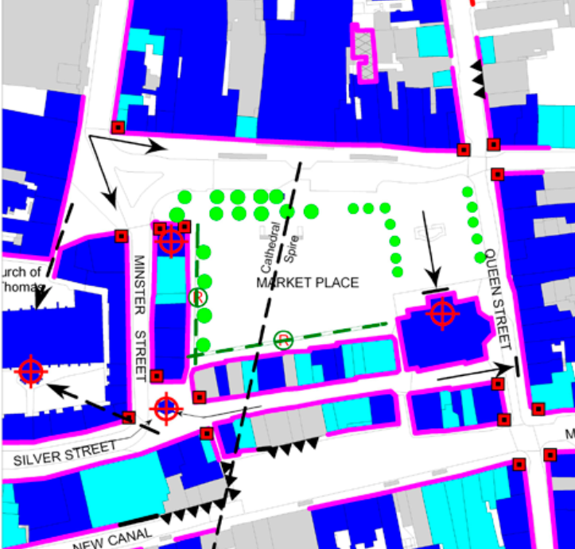

In this instance the design, impact on the character of the area and heritage assets is the main issue and area for concern. It is key that any development in this sensitive location is well designed and respectful of the historic importance and does not add unnecessary structures in to this vibrant, open space and that key views identified above are not adversely affected.

The proposals are considered to add modest extensions to both sides of the existing disabled toilet block, the proposed extensions will match the design of the existing structure and will use materials to match, specifically Chilmark Stone. The photos below are taken from the submitted planning statement showing the existing toilet block and a close up of the existing external finish in Chilmark Stone.

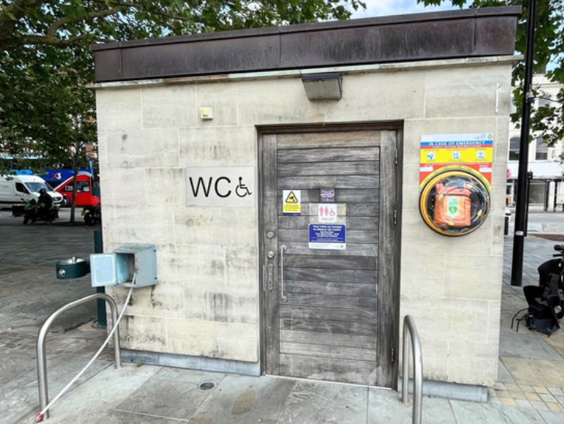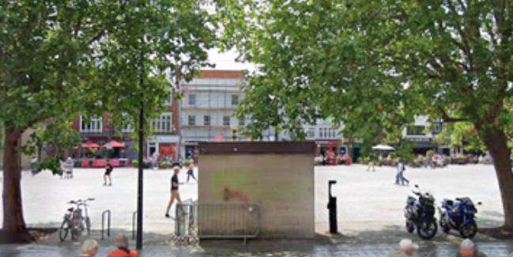
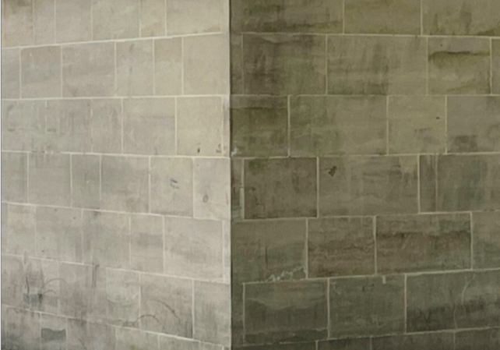

The Council’s conservation officer has been consulted as part of the application process and has raised no objections; their comments are included in full below.

“The site is obviously very prominent in the middle of the city conservation area and directly in the setting of many listed buildings, the character, setting and appearance of which warrant special considerations under sections 66 and 72 of the PLBCA Act 1990, the NPPF and CP58. The proposal is to enlarge the existing wc building, using the same materials and design. The enlarged building would remain a modest structure to the side of the Market Place and its locally sourced stone cladding ensures that it sits comfortably in its setting.

I see no cause for concern whatsoever...the new stonework should of course be done to the same minimal-joint quality as the existing.”

Historic England were also consulted as part of the application process and have not raised any objections to the proposed development.

Therefore, given that there are no objections from either Historic England or the Council’s conservation officer in relation to the impact of the development as proposed on the conservation area or setting of the many adjacent listed buildings, it is not considered that the development will cause harm to the heritage assets in this sensitive historic city centre location.

The scale, design and siting of the proposals are considered appropriate and are unlikely to impact on the key views across the Market Place. In this instance, whilst there are no significant harms found to be arising from the proposed development, there is significant public benefit from the provision of a second disabled public toilet which would outweigh the very limited harms in this instance.

Neighbour Amenity

Core Policy 57 (Point vii) of the Wiltshire Core Strategy requires development to respect the amenity of existing occupants and ensure appropriate amenity levels for future residents.

The National Planning Policy Framework (NPPF), particularly Paragraph 135, reinforces the need for development to provide a high standard of amenity for both existing and future users.

The proposals relate to the modest extension of an existing public toilet within the Market Place in the centre of Salisbury, given the siting, scale and nature of the development and its context within the city centre, there are no concerns regarding neighbour amenity impacts.

Highways Impacts

The proposals relate to the extension of an existing single public toilet structure to create a second disabled toilet. The location of the proposed works does not impact on key vehicle access within the Market Place and does not impinge on existing footpaths. The proposals are not considered to hinder public access across the open space of the Market Place; no objections are therefore raised regarding highway safety.

Trees

The Market Place comprises a large number of trees which help to form the character of the area, the trees are predominantly located around the permitter of the Market Place. Trees in close proximity to the development site comprise a mix of London plane and lime trees. The trees are protected by virtue of their location within a Conservation Area and there are no TPOs on site. In this instance the trees form a very important part in the character of the Market Place.

The applicant has submitted a tree survey, constraints plans, Arboricultural Method Statement (AMS) with Tree Protection Plan (TPP) in support of the application. The report states that

Following a site survey and assessment, 10 trees were included within this survey, with 2 of these trees potentially being adversely affected by the proposed development. The toilet block sits specifically between two London plane trees, identified as T01 and T02. The proposed expansion encroaches into the Root Protection Area (RPA) of T02 and results in a very minor overlap with the RPA of T01.

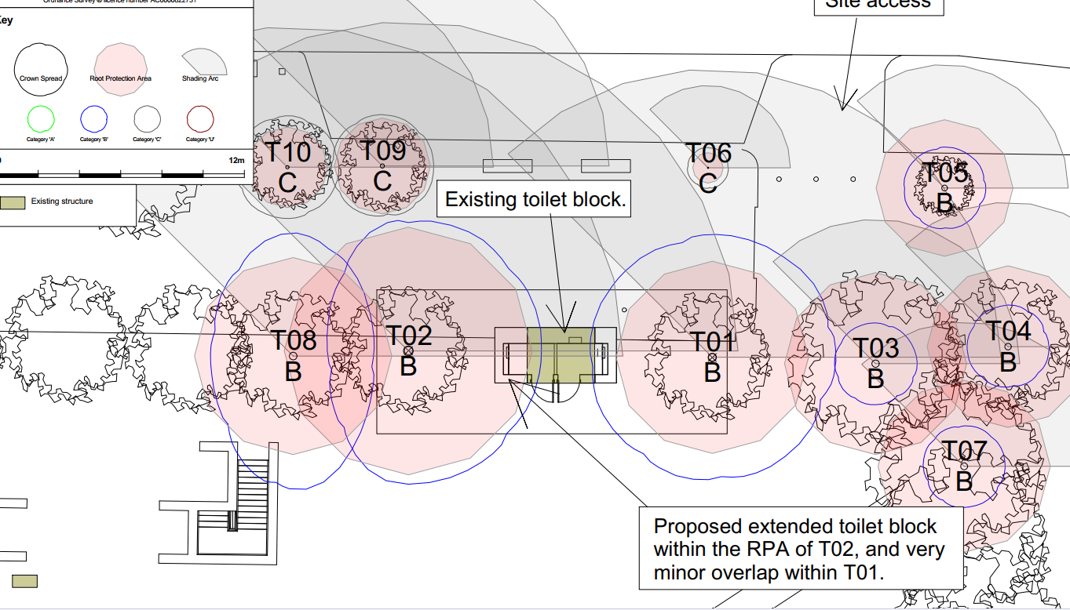

6.7.3 The use of sensitive foundation installation methods, such as ground screws, will minimise impact on the rooting environment and enable the works to proceed whilst reducing potential harm to the trees. Ground screws are to be installed at each corner of the proposed building footprint, with concrete slabs laid above to form the foundation.

6.7.4 During installation, all practicable measures shall be taken to avoid significant roots. Any root pruning shall only be undertaken under arboricultural supervision to ensure that it does not adversely affect the long-term health of the trees.

The trees currently exhibit good overall health and vitality and are expected to tolerate
and recover from any minor root pruning that may be required.

6.7.5 The proposed expansion will increase the structural footprint within the RPA of T02 to
approximately 4.13% of the total RPA, which is within the generally accepted threshold of 20% encroachment.

As the existing surface comprises hardstanding, the development is unlikely to result in any significant additional impact on soil aeration or moisture exchange, which are likely to be already reduced.

The Council’s tree officer has been consulted and has raised no objections subject to the works being carried out in strict accordance with the submitted Arboricultural Method Statement and Tree Protection Plan.

Ecology and Biodiversity

The ecological impact of development is a key planning consideration, especially for larger schemes. Proposals must assess and address potential effects on:

- Protected species
- Priority habitats
- Ecological networks
- Green and blue infrastructure

Core Policy 50 of the Wiltshire Core Strategy requires development to:

- Avoid harm to ecological assets.
- Deliver measurable Biodiversity Net Gain (BNG), in line with the Environment Act 2021.

Biodiversity Net Gain - From 12 February 2024 Biodiversity Net Gain (BNG) became mandatory under Schedule 7A of the Town and Country Planning Act 1990 (as inserted by Schedule 14 of the Environment Act 2021). Based on the information available the biodiversity gain planning condition is not considered to apply to this application as the development meets the following criteria and is therefore below the de minimis threshold, meaning the development:

- does not impact an onsite priority habitat (a habitat specified in a list published under section 41 of the Natural Environment and Rural Communities Act 2006);
- and impacts less than 25 square metres of onsite habitat that has biodiversity value greater than zero and less than 5 metres in length of onsite linear habitat (as defined in the statutory metric).

New Forest Protected Sites - The proposed development site lies within the 13.8km zone of influence for the New Forest internationally protected sites, which comprises the New Forest SPA, New Forest SAC and New Forest Ramsar site.

Any applications within this area are screened into appropriate assessment under the Conservation of Habitats and Species Regulations 2017 (as amended) on account of its potential to cause adverse effects on the New Forest protected sites through increased recreational pressure which may occur alone and in-combination with other plans and projects.

Many of the special features of the New Forest protected sites afforded protection are vulnerable to adverse effects associated with an increase in recreation as demonstrated in Natural England’s supplementary advice issued for the SPA on 19 March 2019 and for the SAC on 18 March 2019. Following a Cabinet decision on 7 May 2024, Wiltshire Council’s “Interim recreation mitigation strategy for the New Forest internationally protected sites” (Version 1.1, 21 March 2023) is being revised.

However, as the proposals relate to the extension of an existing public disabled toilet block and does not involve new overnight accommodation, nor will it be bringing additional people to the locality which will impact on the New Forest protected sites it is screened out of appropriate assessment.

Habitat Regulations Assessment: River Avon Special Area of Conservation (SAC) Hampshire Catchment

This development falls within the catchment of the River Avon SAC and has potential to cause adverse effects alone or in combination with other developments through discharge of phosphorus in wastewater. Appropriate Assessment (AA) must be carried out by the relevant Competent Authority (the LPA) to determine the potential significant effects, and the suitability of any measures proposed to avoid or mitigate those effects. However, given the scale and nature of the development there is no mechanism for adverse effect, the proposals do not constitute new residential development nor the provision of new or additional overnight accommodation. The HRA has concluded that the application is not likely to have significant impacts on the River Avon Catchment and subsequently the application is screened out of Appropriate Assessment.

Flood Risk

As identified above, the application site lies within flood zones 2 and 3 and within an area at risk of surface water flooding.

The submitted planning statement has considered flood risk and states -

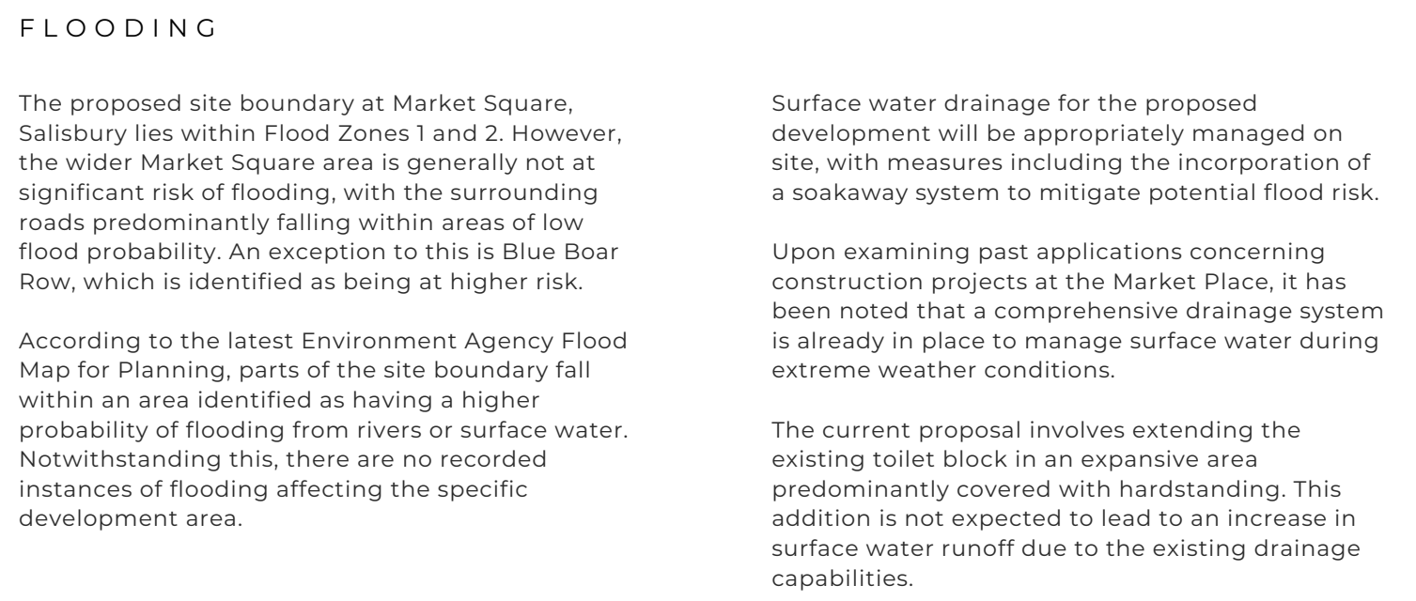

Given the siting and modest scale of the proposed development with a small increase in footprint over an existing area of hardstanding, it is not considered that the proposed development will result in flood risk impacts to the local area or indeed to the development itself.

PLANNING BALANCE AND CONCLUSION

At the heart of the NPPF there is a presumption in favour of sustainable development requiring local planning authorities to approve development proposals that accord with an up-to-date development plan without delay; and where there are no relevant development plan policies, or the policies which are most important for determining the application are out-of-date, permission should be granted unless (taken from paragraph 11d of the NPPF):

- The application of policies in the NPPF that protect areas or assets of particular importance provides a clear reason for refusing development proposed; or
- any adverse impacts of doing so would significantly and demonstrably outweigh the benefits, when assessed against the policies in the NPPF taken as a whole

In this instance, the development relates to the modest extension of an existing above ground public toilet, specifically for disabled users with appropriate access. The site lies within a sensitive local in the centre of the historic core of the city of Salisbury, within a conservation area and surrounding by listed buildings.

There have been no objections from statutory consultees and no third party comments received.

No significant harms have been identified subject to conditions relating to materials and tree protection; notwithstanding this, there are obvious public benefits through the provision of an additional DDA complaint public toilet in this location.

Following consideration of the consultee comments received and careful assessment of this proposal, officers are of the opinion that this proposal conforms to the objectives of the above listed Core Policies of the Wiltshire Core Strategy and Saved Policies of the Salisbury District Local Plan, Sections 66 and 72 of PLBCA Act 1990 and the aims of the NPPF. Taking the above into account, the application is not considered contrary to these policies as it does not cause any significant material harm that would justify a refusal of planning permission. Therefore, planning permission should be granted for the development.

RECOMMENDATION: That Planning Permission be GRANTED, subject to conditions

1. The development hereby permitted shall be begun before the expiration of three years from the date of this permission.

REASON: To comply with the provisions of Section 91 of the Town and Country Planning Act 1990 as amended by the Planning and Compulsory Purchase Act 2004.

2. The development hereby permitted shall be carried out in accordance with the
following approved plans and documents:

Application form received 11/05/2026
1025 - 09C Existing Location Plan received 11/05/2026
1025 - 10C Proposed Site Plan received 11/05/2026
1025 - 14A Proposed Plans & Elevations received 11/05/2026

REASON: For the avoidance of doubt and in the interests of proper planning

3. The materials to be used in the construction of the external surfaces of the development (specifically Chilmark Stone to be used with the same minimal-joint quality as the existing) hereby permitted be in accordance with those stated on the approved plans and application form, all to match the existing.

REASON: In the interests of visual amenity and the character and appearance of the area

4. The development should be carried out strictly in accordance with the Arboricultural Method Statement by Bawden tree care and tree protection plan by Bawden tree care dated 27/04/2026 both received 28/05/2026. The trees must be protected in accordance with the agreed report/statement throughout the period of development, unless the Local Planning Authority has given its prior written consent to any variation.

REASON: To comply with the duties indicated in Section 197 of the Town and Country Planning Act 1990, so as to ensure that the amenity value of the important trees, shrubs and hedges growing within or adjacent to the site is adequately protected during the period of construction.

INFORMATIVES

1. BNG not required

The effect of paragraph 13 of Schedule 7A to the Town and Country Planning Act 1990 is that planning permission granted for development of land in England is deemed to have been granted subject to the condition (biodiversity gain condition) that development may not begin unless:

(a) a Biodiversity Gain Plan has been submitted to the planning authority, and
(b) the planning authority has approved the plan.

The planning authority, for the purposes of determining whether to approve a Biodiversity Gain Plan, if one is required in respect of this permission would be Wiltshire Council.

There are statutory exemptions and transitional arrangements which mean that the biodiversity gain condition does not always apply. For further information on exempt developments please refer to:
https://www.gov.uk/guidance/biodiversity-net-gain-exempt-developments
Based on the information available this permission is considered to be one which will not require the approval of a biodiversity gain plan before development is begun because one or more of the statutory exemptions or transitional arrangements is considered to apply.

2. Building Regulations

Any alterations to the approved plans, brought about by compliance with Building Regulations or any other reason must first be agreed in writing with the Local Planning Authority before commencement of work.

