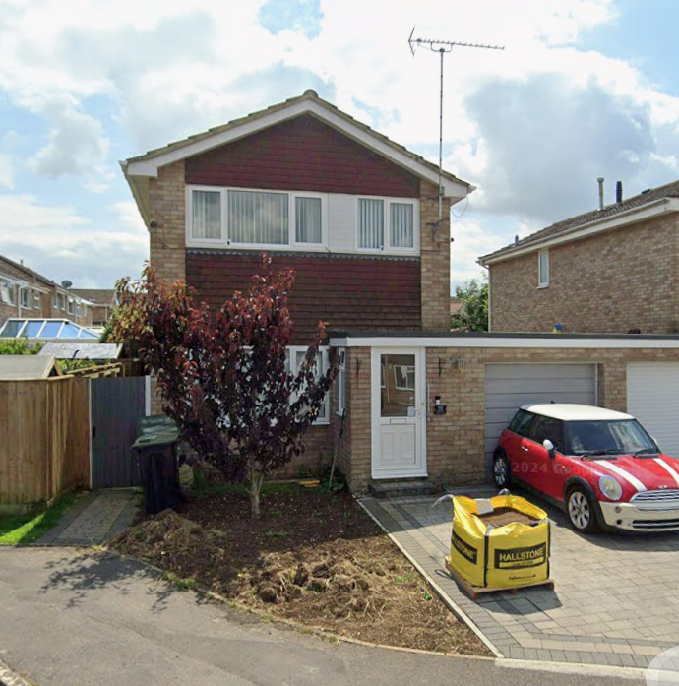
My existing property – 10 Heron Close, Calne – Existing tiled finish

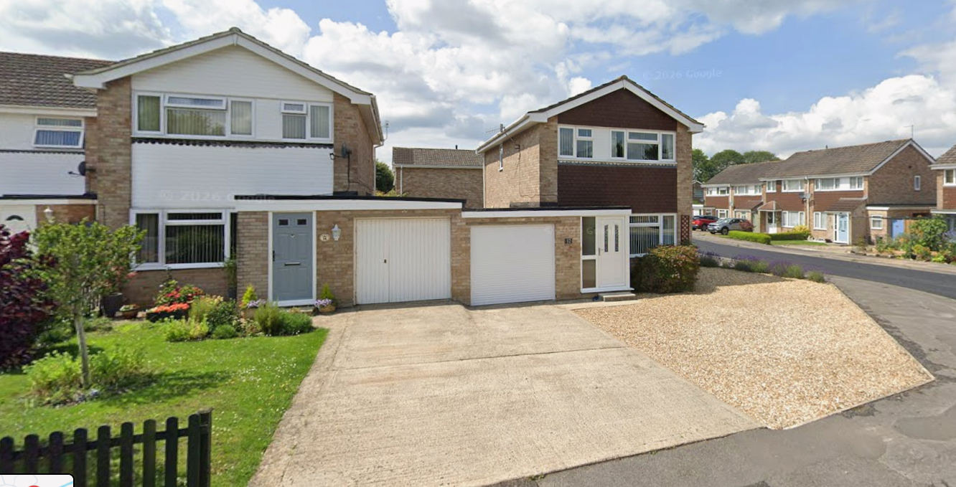Neighbouring examples of differing finishes to house frontage 12 and 14 Heron Close, Calne
Original tiling and uPVC facia boards

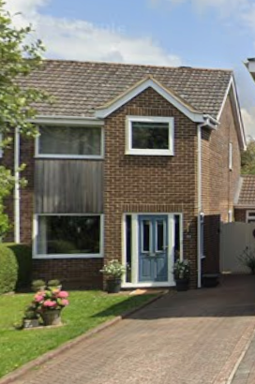53 Heron Close, Calne (semi) finished in cedar planks
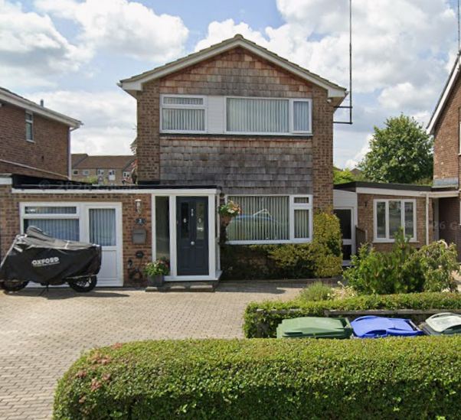3 Heron Close, Calne finished in cedar tiles

