APPLICATION FOR FULL-PLANNING PERMISSION
CASE OFFICER REPORT

APPLICATION REFERENCE: | PL/2026/02465
APPLICATION TYPE: | Full planning permission
SITE ADDRESS: | Longmead, Barrow Street, Mere, Warminster, BA12 6AB
DEVELOPMENT DESCRIPTION: | Construction of steel frame storage barn
RECOMMENDATION: | Approve with Conditions

SITE DESCRIPTION/CONTEXT

The application site relates to Longmead, a grade 2 listed building located on the west side of Barrow Street and more specifically the agricultural fields associated with Longmead. Barrow Street is a dispersed group of properties located to the south east of Mere, a Local Service Centre as defined by Core Policies, 1, 2 and 17 of the Wiltshire Core Strategy. As the site is outside of any settlement boundaries it is considered to be in the open countryside. The proposed development is to be constructed in a field to the north of the existing dwelling and existing outbuildings as shown on the extract below taken from the submitted location plan.

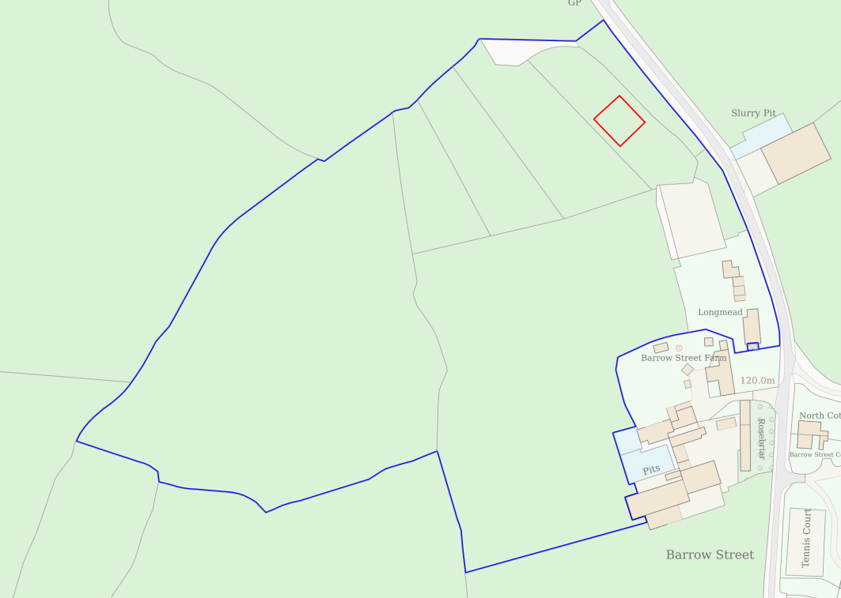

There are a number of public rights of way in the area as shown on the map below, however none of these are directly impacted by the development or in close proximity.

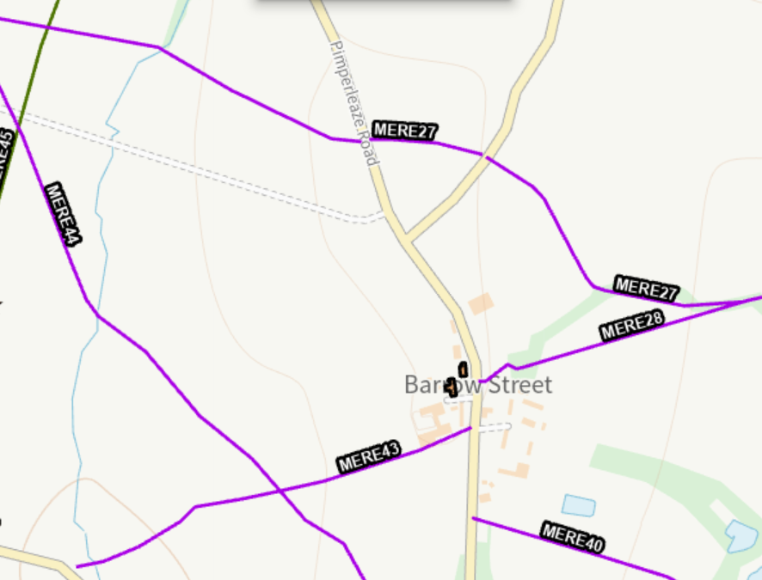

The site is not located within a conservation area or within the National Landscape but is located within a Special Landscape Area – saved policy C6 from Salisbury District Local Plan.

PROPOSAL

It is proposed to erect a detached building for use for agricultural storage of items such as hay, straw and machinery to be used in association with the land at Longmead, Barrow Street, Mere. The building will measure approximately 20 metres by 20 metres with a pitched roof with a ridge height of approx. 5.90 metres.

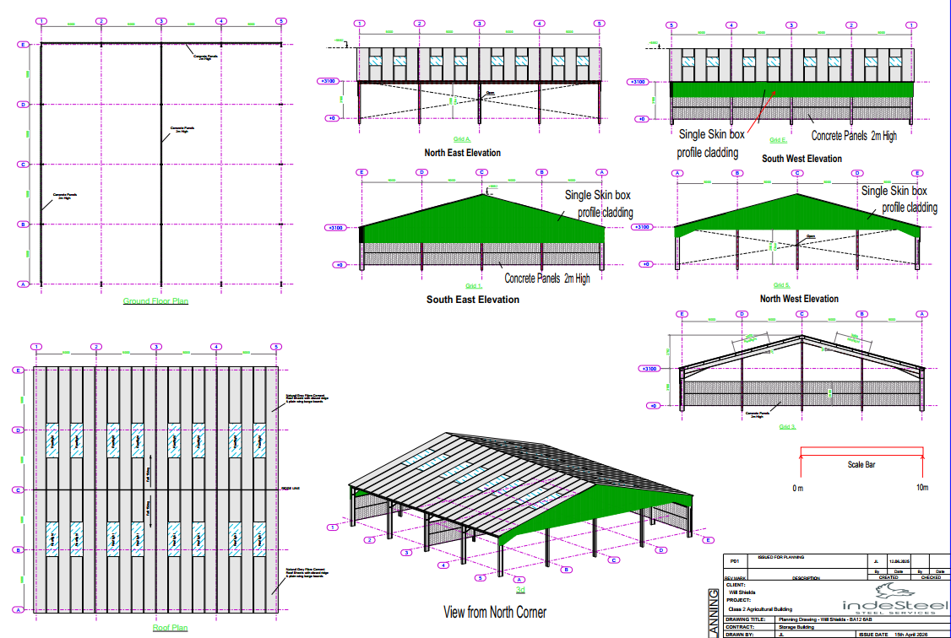

In terms of proposed materials, the walls will comprise pre cast concrete panels 2 metres high on two elevations and single skin box profile cladding to one elevation above the pre cast panels and to the eaves. The roof will be finished with natural grey fibre cement roof sheets with closed ridge and plain wing barge boards.

PLANNING HISTORY

There is planning history for the associated dwelling and within its residential curtilage, there is no relevant planning history related to the wider land/fields at Longmead except for the following two permissions on land to the south of the location for the proposed barn.

18/04855/FUL Construction of outdoor all weather menage. Approved

PL/2021/04729 Construction of new three stables, one secure tack room and two open fronted storage units on land adjacent to the menage. The stables are for personal use. Approved

RELEVANT LEGISLATION, POLICIES AND GUIDANCE

Statutory Legislation:

Sections 66: Special considerations affecting planning functions (LISTED BUILDINGS & Conservation Area) Act 1990

National Planning Policy:
- National Planning Policy Framework (NPPF)
- Planning Practice Guidance (PPG)
- National Design Guide

Development Plan:
The development plan for Wiltshire comprises the Wiltshire Core Strategy (WCS) (adopted January 2015) and any made neighbourhood plans, which remains the principal statutory planning document guiding development across the county. In line with Section 38(6) of the Planning and Compulsory Purchase Act 2004, planning decisions must be made in accordance with the development plan unless material considerations indicate otherwise.

Though the development plan is considered as a whole, those parts deemed to be particularly relevant to this application are listed below:

The adopted Wiltshire Core Strategy (WCS), with particular regard to:

Core Policy 1 Settlement Strategy
Core Policy 2 Delivery Strategy
Core Policy 17 Spatial Strategy Mere Community Area
Core Policy 34 Additional Employment Land
Core Policy 48 Rural life
Core Policy 50 Biodiversity and Geodiversity
Core Policy 51 Landscaping
Core Policy 57 Ensuring high quality design and place shaping
Core Policy 58 Historic Environment
Core Policies 60-64 Highways.

Adopted Salisbury District Local Plan saved policies: Special Landscape Area – C6

Supplementary Planning Documents and other Guidance:

Wiltshire Design Guide (adopted April 2024)
Wiltshire Local Transport Plan 2011-2026, adopted 2015 - including the Car Parking Strategy and Cycling Strategy, adopted 2015
Creating Places Design Guide

ISSUES

Principle
Visual impacts
Amenity
Highways
Ecology

CONSULTATION RESPONSES

Parish Council – support

Ecology – no objections subject to conditions

REPRESENTATIONS

In accordance with the requirements of the Town and Country Planning (Development Management Procedure) (England) Order 2015 (as amended), the application was publicised by way of:

- Neighbour notification letters sent to adjoining and nearby properties;
- A site notice displayed near the site

These methods were used to inform interested parties and provide a period of 21 days for comments to be submitted.

No third party representations have been received.

ASSESSMENT

Section 38(6) of the Planning and Compulsory Purchase Act 2004 states:

"If regard is to be had to the development plan for the purposes of any determination to be made under the planning Acts, the determination must be made in accordance with the plan unless material considerations indicate otherwise."

In accordance with this statutory requirement, this application has been assessed against the relevant policies of the Development Plan, including the Wiltshire Core Strategy (2015) and, where applicable, any made Neighbourhood Plans. Consideration has also been given to the policies of the National Planning Policy Framework (NPPF) as a material consideration in the assessment.

Principle of Development

The site is situated in the countryside where, as per WCS policies CP1 (Settlement Strategy), CP2 (Delivery Strategy) and CP17 (Mere Community Area), there is a general presumption against new unsustainable development. However, this field is already in use as a paddock for grazing livestock. The proposals will essentially provide a new purpose built agricultural building for the undercover storage of associated feed, bedding, machinery and other associated items currently stored ad hoc outside within the wider site at Longmead.

WCS policy CP34 (Additional Employment Land) confirms that ‘Outside the Principal Settlements, Market Towns and Local Service Centres, developments that:…ii Support sustainable farming and food production through allowing development required to adapt to modern agricultural practices and diversification…will be supported where they’ amongst other things ‘Are consistent in scale with their location, do not adversely affect nearby buildings and the surrounding area or detract from residential amenity;…Are supported by evidence that they are required to benefit the local economic and social needs; and…Are supported by adequate infrastructure’.

Whilst no supporting statement has been submitted with the application, the case officer discussed the proposed agricultural building during a site visit and the context of the building in association with the surrounding land was understood. The proposed building is functional in design and has an agrarian vernacular. The principle of the proposed development, even in this countryside location and special landscape area, is therefore accepted in line with policy.

Overall, this principal acceptability is subject to the detail in terms of how the proposals will integrate into the character of the area and landscape; its implications for highway safety; and neighbouring amenities. These matters will therefore be addressed in more detail below.

Design and Impact on the Character and Appearance of the Area

Core Policy 51 states Development should protect, conserve and where possible enhance landscape character and must not have a harmful impact upon landscape character, while any negative impacts must be mitigated as far as possible through sensitive design and landscape measures.

Core Policy 57 states a high standard of design is required in all new developments, including extensions, alterations, and changes of use of existing buildings. Development is expected to create a strong sense of place through drawing on the local context and being complimentary to the locality.

Core Policy 58 states that designation of a conservation area or listed building does not preclude the possibility of new development. In considering applications for new development, the council will seek to ensure that the form, scale, design and materials of new buildings are complementary to the historic context.

Section 66 of the Planning (Listed Buildings and Conservation Areas) Act 1990 requires ‘special regard’ to be given to the desirability of preserving a listed building or its setting.

Saved policy C6 states - Within the Special Landscape Area, proposals for development in the countryside will be considered having particular regard to the high quality of the landscape. Where proposals which would not have an adverse effect on the quality on the landscape are acceptable, they will be subject to the following criteria;

(i) the siting and scale of development to be sympathetic with the landscape; and
(ii) high standards of landscaping and design, using materials which are appropriate to the locality and reflect the character of the area.

The proposals relate to the erection of an agricultural barn for use for agricultural storage in association with the land at Longmead. The building is a large building with a footprint of 400 metres square and is fairly tall at just under 6 metres in height at the ridge. The proposed design is however agrarian in design and form and having regard to the scale of agricultural building that can be constructed (subject to detail, site specifics, use etc) under Schedules 2 Part 6 of the GDPO which allows a footprint of up to 1500 metres square to be constructed under permitted development rights; in this context, the building in terms of overall area covered is acceptable. The materials proposed for the construction of the proposed building are considered appropriate for a building of agricultural design and use.

The proposed building will be constructed in fields to the west of Pimperleaze Road, to the north of the residential curtilage at Longmead and also north of the recently permitted and constructed stables and manege. The area is inherently rural with agricultural fields forming the general character of the locality with other agricultural buildings including slurry pits in the vicinity. A building of the design, scale and use such as that proposed and seeking permission with this planning application is therefore not considered to be out of keeping for this area. Included below are an extract from the submitted site plan and an extract from the Council’s mapping showing the context of the proposed building in the local area.

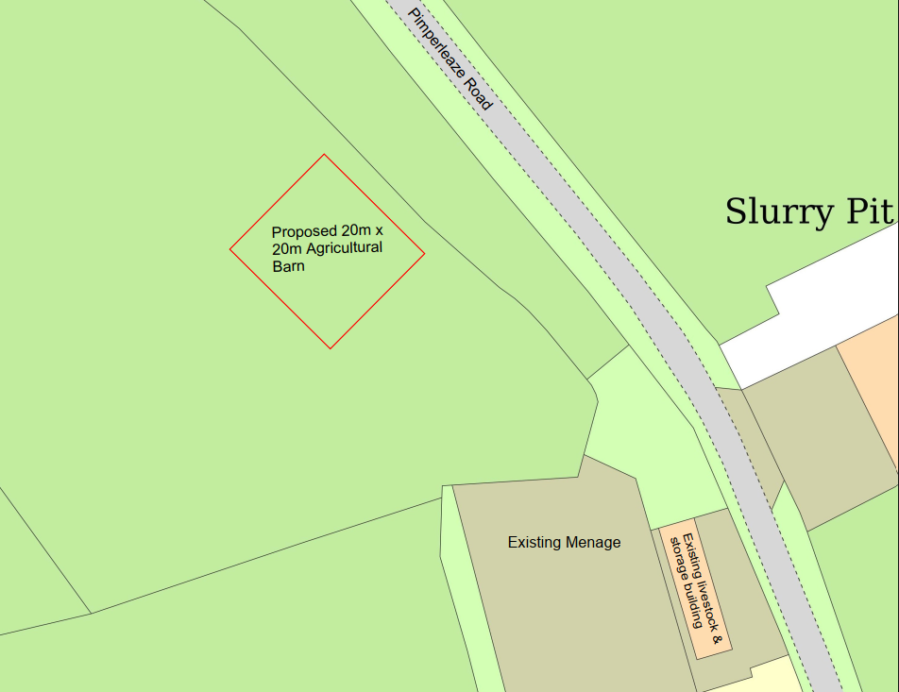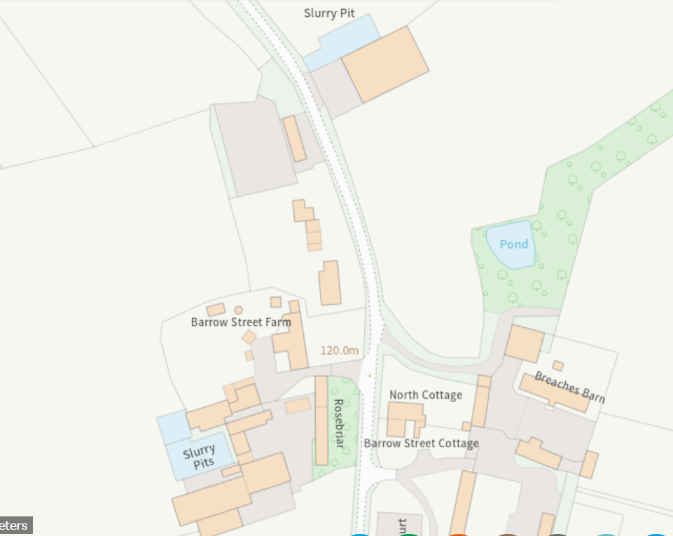

In terms of visual impact, the building will be set back from the road with two mature hedgerows forming screening from Pimperleaze Road, However, given the height of the proposed building it is inevitable that this will be seen over the hedges both close up and from a distance. As already detailed above, the building is agrarian in design with appropriate materials and would not appear incongrous and would not have a signfiicant adverse visual impact on the landscape character of the area.

In terms of heritage impacts, the proposed building will be constructed approximately 100 metres from the nearest listed building (Longmead) and further from the next listed building at Barrow Street Farm (shown black hatched on the map extract below). Given the separation distance, natural screening as existing through hedges and trees and also through the siting of the existing mange and stables there are no concerns regarding impacts on the setting of the nearby listed buildings.

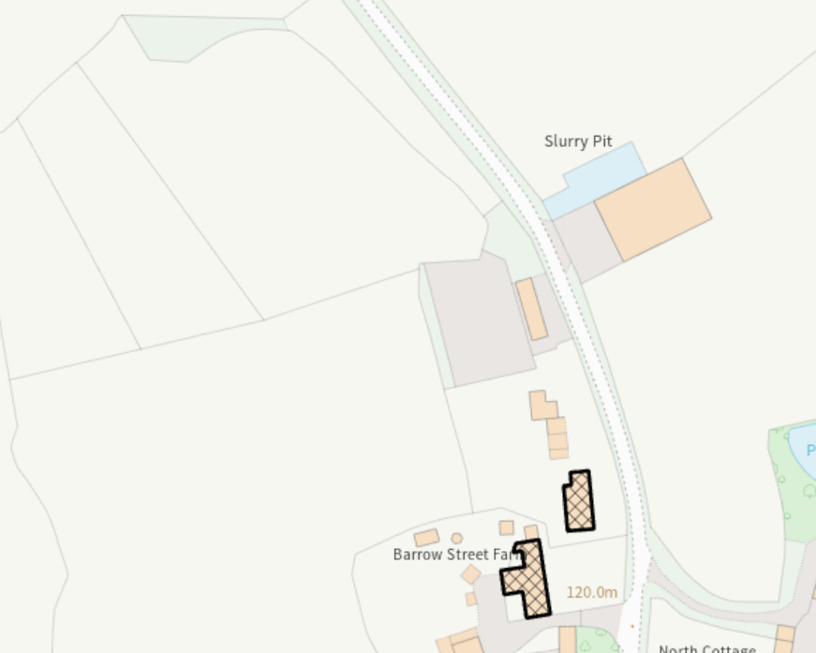

It is however considered appropriate to condition the use of the building to agricultural storage only, given that this is the use by which the development as proposed has been assessed. Any other use would then need to be assessed on its own merits at the time through a separate or new/change of use application.

Amenity

Core Policy 57 (Point vii) of the Wiltshire Core Strategy requires development to respect the amenity of existing occupants and ensure appropriate amenity levels for future residents.

The National Planning Policy Framework (NPPF), particularly Paragraph 135, reinforces the need for development to provide a high standard of amenity for both existing and future users.

Due to the scale, design and use of the development and its siting away from residential neighbours to the south of the site in excess of 100 metres away, it is considered the proposal would not impact on neighbour amenity.

Highways Impacts and Parking

Transport implications are a key factor in assessing planning applications, especially for larger developments. Proposals must demonstrate:
- Safe and suitable access for all users, including pedestrians, cyclists, and those with mobility impairments.
- No severe residual impacts on the surrounding highway network.
- Promotion of sustainable travel, reducing reliance on private vehicles.
- Adequate parking and cycle provision, in line with adopted standards.
- Protection and enhancement of public rights of way and active travel routes.

In this instance the proposed development relates to the erection of an agricultural storage barn to be used in association with the associated land. Existing access is to be retained with
no changes proposed, see extract below from the plan submitted to support the application.

There are therefore no concerns raised regarding highway impacts.

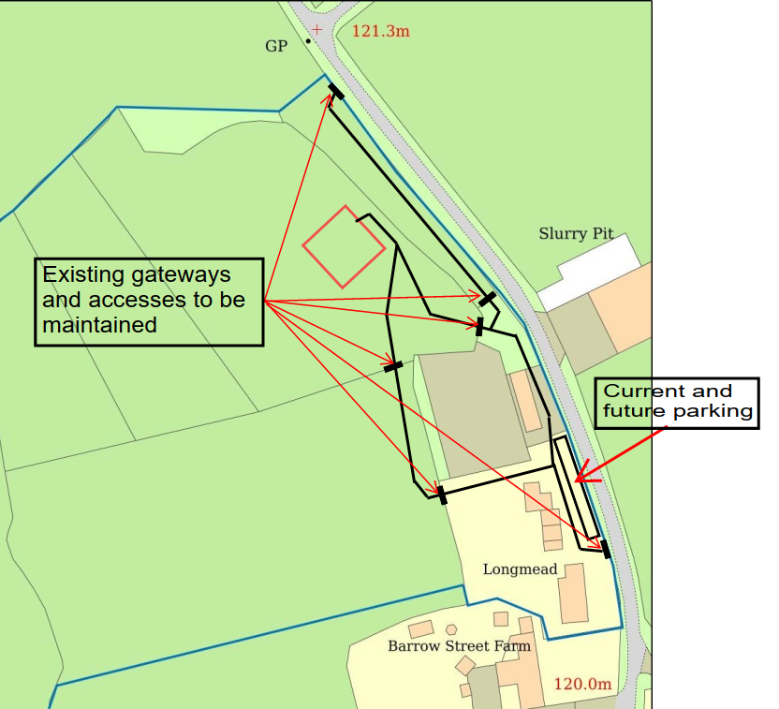

Ecology and Biodiversity

The ecological impact of development is a key planning consideration; Core Policy 50 of the Wiltshire Core Strategy requires development to:

- Avoid harm to ecological assets.
- Deliver measurable Biodiversity Net Gain (BNG), in line with the Environment Act 2021.
- Support habitat restoration and connectivity.
- Integrate biodiversity into site design.

The Council’s ecology team have been consulted and have raised no objections subject to conditions; their comments are included in full below.

The following submitted documentation was reviewed to inform this response:

Biodiversity Net Gain Assessment. June 2026. Stark Ecology
Statutory Biodiversity Metric. April 2026. Georgie Starkie

Protected Species and Habitats

The proposal is to erect a steel frame storage barn at Longmead. No ecological survey information has been submitted in support of the application; however, it is anticipated that the construction will be undertaken in the field parcel only which consists of modified grassland as per the submitted BNG metric data. No other habitats are proposed to be impacted by the works.

Priority hedgerow exists along the north-western boundary, any impacts on hedgerows must be included in an impact assessment and any changes to the location of the barn would require a consultation with ecology. Although no direct impacts to the hedgerows are anticipated, indirect impacts through lighting may occur. Lighting can imp[act ecological foraging and commuting routes for a number of species and therefore no external lighting unless agreed by the LPA should be erected on site, this could be secured by condition.

It is understood that ecology surveys were carried out by Darwin Ecology, however, these were not submitted in support of the application.

BNG
Under Schedule 7A of the Town and Country Planning Act 1990 (as inserted by Schedule 14 of the Environment Act 2021) this application is required to deliver 10% Biodiversity Net Gain (BNG). The Biodiversity Gain Plan condition will automatically apply if approval is forthcoming. A completed metric (Statutory Biodiversity Metric. April 2026. Georgie Starkie) using previous survey data from Darwin Ecology confirms the baseline and predicted post- development biodiversity units of the site.

Information in the completed on-site baseline habitat tabs is accepted as accurate based on the information submitted. The pre-development (baseline) situation is summarised below.

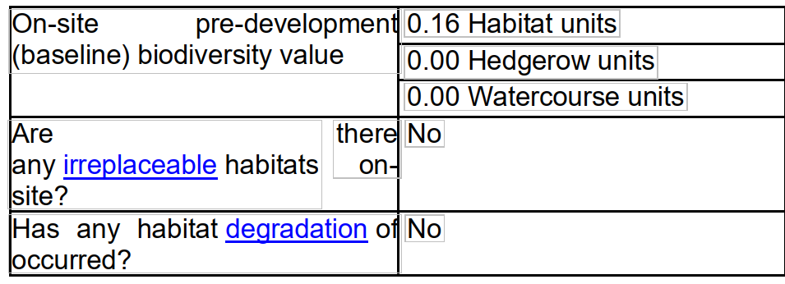
Confirmation of how the development will achieve BNG is a post-determination matter however consideration should be given to how any proposed BNG will be secured.

The submitted metric indicates 0.25 biodiversity units or less will be required to meet the 10%BNG requirement and that on-site BNG is not achievable. In these circumstances statutory credits can be bought without providing evidence that insufficient off-site options are available in England. For further information please refer to guidance on Statutory Biodiversity Credits on the GOV.UK website (https://www.gov.uk/guidance/statutory-biodiversity-credits) under ‘How to prove statutory credits are needed’

PLANNING BALANCE AND CONCLUSION

At the heart of the NPPF there is a presumption in favour of sustainable development requiring local planning authorities to approve development proposals that accord with an up-to-date development plan without delay; and where there are no relevant development plan policies, or the policies which are most important for determining the application are out-of-date, permission should be granted unless (taken from paragraph 11d of the NPPF):

- The application of policies in the NPPF that protect areas or assets of particular importance provides a clear reason for refusing development proposed; or
- any adverse impacts of doing so would significantly and demonstrably outweigh the benefits, when assessed against the policies in the NPPF taken as a whole;

There are no harms identified through the development in terms of heritage impacts, amenity impacts or highway safety and subject to appropriate BNG mitigation being secured prior to commencement of development there are no concerns raised regarding ecological matters. The proposed development is not considered to have an adverse impact on the character and appearance of the area and therefore accords with the above listed polices and guidance.

RECOMMENDATION:
That Planning Permission be GRANTED, subject to conditions

1. The development hereby permitted shall be begun before the expiration of three years from the date of this permission.

REASON: To comply with the provisions of Section 91 of the Town and Country Planning Act
1990 as amended by the Planning and Compulsory Purchase Act 2004.

2.The development hereby permitted shall be carried out in accordance with the following
approved plans:

Application form received 16/04/2025
Location plan received 16/04/2025
Proposed site plan Drg no CWGS 01 received 27/04/2026
Proposed ground floor plan and elevations Drg no PL01 P02 received 28/04/2026
Site plan showing existing access and parking Drg no CWGS/04 received 29/04/2026

REASON: For the avoidance of doubt and in the interests of proper planning.

3. The development will be carried out in strict accordance with the following documents:

Statutory Biodiversity Metric. April 2026. Georgie Starkie

REASON: For the avoidance of doubt and for the protection, mitigation and enhancement of biodiversity.

4. All lighting provided on site shall be in accordance with the appropriate Environmental Zone standards set out by the Institute of Lighting Engineers in their publication GN01:2021, ‘Guidance for the Reduction of Obtrusive Light’ (ILP, 2021), and Guidance note GN08/23 “Bats and artificial lighting at night”, issued by the Bat Conservation Trust and Institution of Lighting Professionals.

REASON: In the interests of the amenities of the area and to minimize impacts on biodiversity caused by light spillage to areas above and outside the development site.

5. The materials to be used in the construction of the external surfaces of the development hereby permitted shall match in material, colour and texture to those detailed on the application form and approved plans.

REASON: For the avoidance of doubt and in the interests of visual amenity and the character and appearance of the area.

6. Notwithstanding the provisions of the Town and Country Planning (General Permitted Development) (England) Order 2015 (or any Order revoking or re- enacting or amending that Order with or without modification), the site shall be used solely for purposes of agricultural storage in association with land at Longmead, Barrow Street, Mere.

REASON: The proposed development is in designated countryside and is only granted on the basis of a need for a new building for such purposes of agricultural storage in this location; and to enable the Local Planning Authority to consider individually whether planning permission should be granted for a change of use

INFORMATIVES

1. BNG required - The effect of paragraph 13 of Schedule 7A to the Town and Country Planning Act 1990 is that planning permission granted for the development of land in England is deemed to have been granted subject to the condition “(the biodiversity gain condition”) that development may not begin unless:

(a) a Biodiversity Gain Plan has been submitted to the planning authority, and
(b) the planning authority has approved the plan.

The planning authority, for the purposes of determining whether to approve a Biodiversity Gain Plan if one is required in respect of this permission would be Wiltshire Council. There are statutory exemptions and transitional arrangements which mean that the biodiversity gain condition does not always apply. For further information on exempt developments please refer to: https://www.gov.uk/guidance/biodiversity-net-gain-exempt-developments

Based on the information available this permission is considered to be one which will require the approval of a biodiversity gain plan before development is begun because none of the statutory exemptions or transitional arrangements are considered to apply. Irreplaceable habitat If the onsite habitat includes irreplaceable habitat (within the meaning of the Biodiversity Gain Requirements (Irreplaceable Habitat) Regulations 2024) there are additional requirements for the content and approval of Biodiversity Gain Plans.

The Biodiversity Gain Plan must include, in addition to information about steps taken or to be taken to minimise any adverse effect of the development on the habitat, information on arrangements for compensation for any impact the development has on the biodiversity of the irreplaceable habitat.

The planning authority can only approve a Biodiversity Gain Plan if satisfied that the adverse effect of the development on the biodiversity of the irreplaceable habitat is minimised and appropriate arrangements have been made for the purpose of compensating for any impact which do not include the use of biodiversity credits.

2. Nesting birds - The adults, young, eggs and nests of all species of birds are protected by the Wildlife and Countryside Act 1981 (as amended) while they are breeding.

Please be advised that works should not take place that will harm nesting birds from March to August inclusive. All British birds, their nests and eggs are protected under Section 1 of the Wildlife and Countryside Act 1981 (as amended) and the Countryside and Rights of Way Act 2000 while birds are nesting, building nests and sitting on eggs. The applicant is advised to check any structure or vegetation capable of supporting breeding birds and delay removing or altering such features until after young birds have fledged. Damage to extensive areas that could contain nests/breeding birds should be undertaken outside the breeding season. This season is usually taken to be the period between 1st March and 31st August, but some species are known to breed outside these limits.

3. Any alterations to the approved plans, brought about by compliance with Building Regulations or any other reason must first be agreed in writing with the Local Planning Authority before commencement of work.

