APPLICATION FOR HOUSEHOLDER PLANNING PERMISSION DELEGATED REPORT

APPLICATION REFERENCE: | PL/2026/02809
APPLICATION TYPE: | Householder planning permission
SITE ADDRESS: | 20 Hillside Close, West Dean, Salisbury, SP5 1EX
DEVELOPMENT DESCRIPTION: | Single storey rear extension with flat roof and lantern and a front porch
RECOMMENDATION: | That Planning Permission be GRANTED

PROPOSAL

The proposal seeks planning permission for the erection of a single storey rear extension with a flat roof and the erection of a front porch.

Proposed elevations and ground floor plan included below.

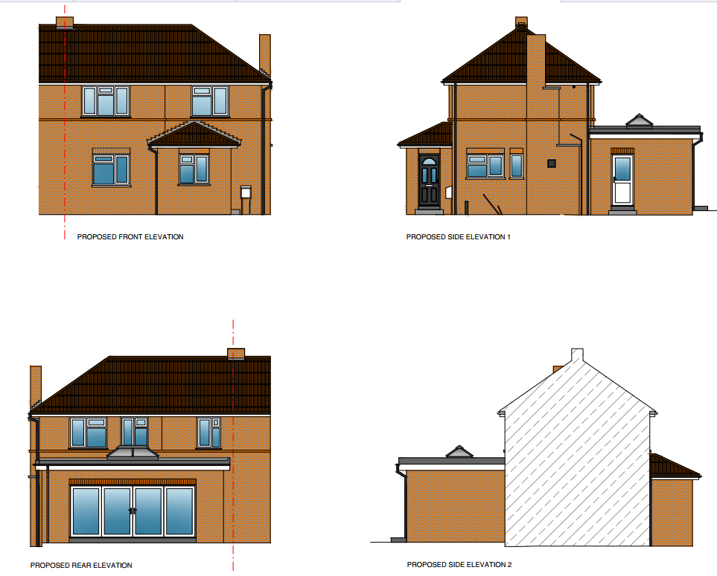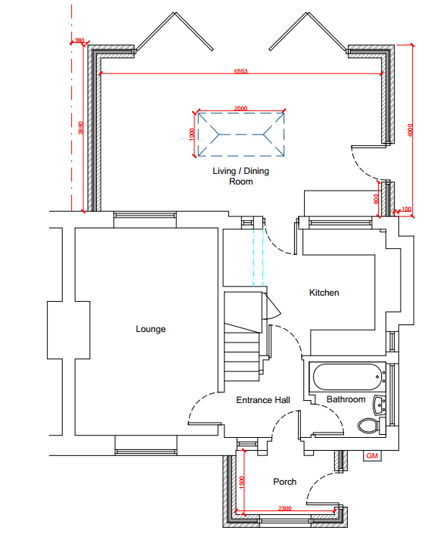

Officers note that the application site unusually sites over the Local Authority boundary split between Wiltshire Council and Test Valley Borough Council, as shown by the thick black line on the map extract included below left. Wiltshire Council is to the left of the black line and Test Valley to the right. In terms of the proposed development, the majority of the works fall within Wiltshire Council jurisdiction with a small part of the rear extension falling within Test Valley jurisdiction.

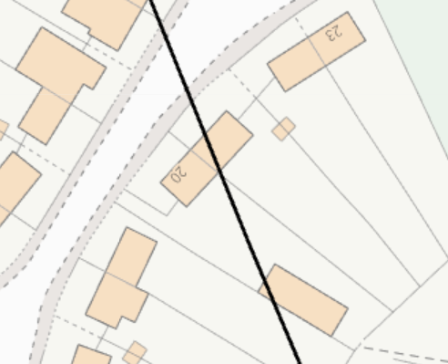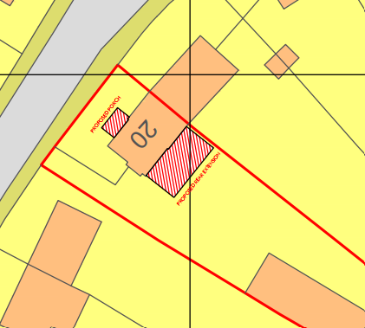

The applicant was therefore required to provide a duplicate application to be assessed and determined by Test Valley Borough Council and essentially requires approval from both Local Planning Authorities to be able to undertake the proposed development. Planning application reference 26/01246/FULLS is currently being considered by planning officers of Test Valley Borough Council but at the time of writing this report, is not yet determined.

SITE DESCRIPTION/CONTEXT

The application site relates to a two storey semi-detached dwellinghouse located on Hillside Close in a residential area within the rural settlement of West Dean, which is defined as a small village by Core Policies 1, 2 and 23 of the Wiltshire Core Strategy. The site is bisected by the Test Valley and Wiltshire Council boundary and lies within the Hillside Close cul-de-sac. The dwelling is in the second block of semi-detached dwellings on the south side of the road when entering Hillside Close, with a small front and side garden with off road parking provided in this area. The property has a good sized enclosed linear garden which is mainly laid to lawn and has a large, detached outbuilding towards the rear of the garden. The site is located within flood zone 1, the River Test catchment and the Special Landscape Area.

PLANNING HISTORY

PL/2022/02170 - Householder planning permission Decision - Approve with Conditions Date: 31/5/2022 – Build a combined workshop and summer house to the rear of the property.

RELEVANT POLICIES AND GUIDANCE

The National Planning Policy Framework (NPPF)
The Planning Practice Guidance
National Design Guide

Wiltshire Core Strategy:

- Core Policy 1: Settlement Strategy
- Core Policy 2: Delivery Strategy
- Core Policy 23: Southern Wiltshire Community Are
- Core Policy 57 Ensuring High Quality Design and Place Shaping
- Core Policy 50: Biodiversity and Geodiversity
- Core Policy 51: Landscape
- Core Policy 61: Transport and New Development
- Core Policy 64: Demand Management

Saved Policies from the Salisbury District Local Plan

- Saved Policy C24 Extensions to buildings
- Saved Policy H31 Extensions to dwellings in the countryside
- Saved Policy C6 Special Landscape Area

Wiltshire Design Guide: Appendix D – Design Guidance for Householder extensions

Creating Places Design Guide

West Dean and West Tytherley Neighbourhood Plan (2022-2035)

West Dean Village Design Statement (April 2009

CONSULTATION RESPONSES

Parish Council: No objection

Test Valley: None received

REPRESENTATIONS

The application was publicised by neighbour letters and also a site notice given the property lies on the boundary of two local planning authorities.

No comments were received.

ASSESSMENT

Section 38(6) of the Planning and Compulsory Purchase Act 2004 states:

"If regard is to be had to the development plan for the purposes of any determination to be made under the planning Acts, the determination must be made in accordance with the plan unless material considerations indicate otherwise."

In accordance with this statutory requirement, this application has been assessed against the relevant policies of the Development Plan, including the adopted Wiltshire Core Strategy (2015) and, where applicable, any made Neighbourhood Plans.

Design and Impact upon the character and context of the area

Core Policy 57 - Ensuring High Quality Design and Place Shaping of the Wiltshire Core Strategy seeks to ensure that all new development is of high design quality, reflecting local context, character, and distinctiveness.

Starting with the front porch, this part of the proposals comprises a modest hipped roof addition to be constructed using materials to match the existing dwelling. During the site visit, it was noted that other properties within the cul-de-sac have similar porches such as No’s 1 and 4 Hillside Close. The images below are taken from Google maps 2025.

No 1 and No 4 Hillside Close respectively.

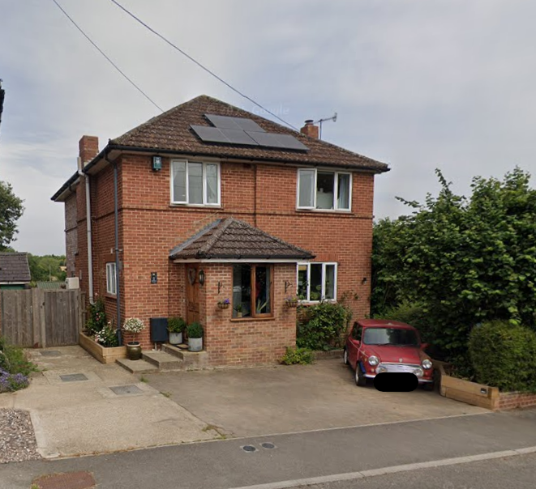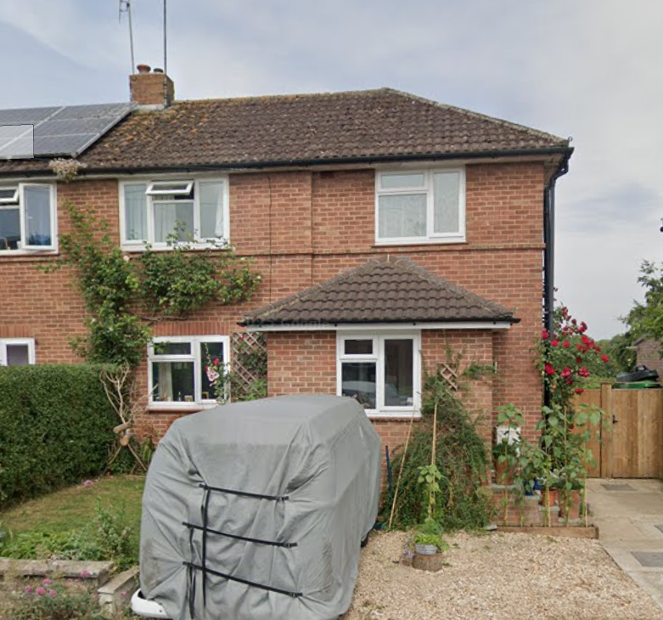

There are no particular concerns raised regarding the scale, design and materials of the proposed porch, it is considered that this part of the development is in keeping with the character of the locality and does not harm an adverse impact on the streetscene.

Moving on to the proposed single storey extension, this part of the proposals comprises a flat rood addition with a roof lantern positioned centrally on the roof; the extension will measure approx. 4metres in depth and will be constructed across the majority of the existing rear elevation of the host dwelling but set in from the common boundary with adjoining dwelling No21 Hillside Close by approx. 0.38 metres. The proposed extension will be constructed using materials to match the host dwelling.

Due to the location of the proposed extension at the rear of the property, it is screened from public views and will have no impacts on the character of the streetscene. In terms of scale and design, the use of matching materials is considered appropriate; the siting and design of the roof lantern raises no concerns. Overall, there are no particular concerns regarding the scale design and siting of the proposed rear extension, and it is considered that this element of the proposed development will not have a harmful impact on the character and appearance of the existing dwelling.

Having regard to the above, the proposal complies with the design principles set out in Core Policy 57 of the Wiltshire Core Strategy and Appendix D of the Wiltshire Design Guide.

Amenity

Point vii of Core Policy 57 - Ensuring High Quality Design and Place Shaping of the Wiltshire Core Strategy seeks to ensure that developments do not adversely affect neighbouring properties.

The National Planning Policy Framework (NPPF), particularly Paragraph 135(f), stresses that planning decisions should ensure developments provide a high standard of amenity for existing and future users.

The proposed development has been assessed in terms of its potential impact on the residential amenity of neighbouring properties, with particular regard to loss of light, overshadowing, loss of privacy, and overbearing effects.

Starting again with the proposed front porch, given the siting, scale and design of this element of the proposed development and relationship with neighbouring properties it is not considered that the proposed porch will conflict with neighbour amenity.

In terms of the proposed rear extension, it will be constructed approx. 0.38 metres from the shared boundary with No 21 Hillside Close, this close proximity will lead to some impacts on the amenity of the occupiers of this adjacent dwelling. It is noted that under permitted development a single storey rear extension can be erected up to 3 metres in depth with an eave’s height of up to 3 metres within 3 metres of the boundary and no more than 4 metres in height. There is also scope for a large single storey extension through the prior approval for a larger home extension process.

Overall, the proposed extension is not considered to significantly impact on the amenity of the occupiers of No21 through overbearing or overshadowing impacts. Furthermore, the single storey scale of the proposed extension and location of associated fenestration will not result in loss of privacy to the adjoining dwelling.

It is not considered that any other neighbouring dwelling will be affected by the proposed rear extension due to its siting.

The proposal therefore accords with Core Policy 57 point vii in respect of safeguarding residential amenity and Appendix D of the Wiltshire Design Guide.

Given the close proximity of the proposed rear extension to the boundary with No21, the applicant should note that the Party Wall Act is likely to come into play. However, this is not a planning matter but is a civil matter between affected parties.

Highways Impact

Core Policy 57 (xiv) of the Wiltshire Core Strategy seeks to ensure that development must meet the requirements of Core Policy 61. This policy requires proposals to be capable of being served by safe access to the highway network. Core Policy 64 seeks to ensure compliance with parking standards set out in the Local Transport Plan.

The National Planning Policy Framework (NPPF), particularly Paragraph 115 and 116, requires that development proposals do not have an unacceptable impact on highway safety and that safe and suitable access to the site can be achieved for all users.

It is understood the application site is a three bed dwelling, therefore, to comply with Wiltshire Council parking standards, two off road parking spaces must be provided. A parking plan has been provided to demonstrate that two off road parking spaces can be provided. In addition, Hillside Close is located off a no through road, there is some unrestricted on street parking which could be used as necessary.

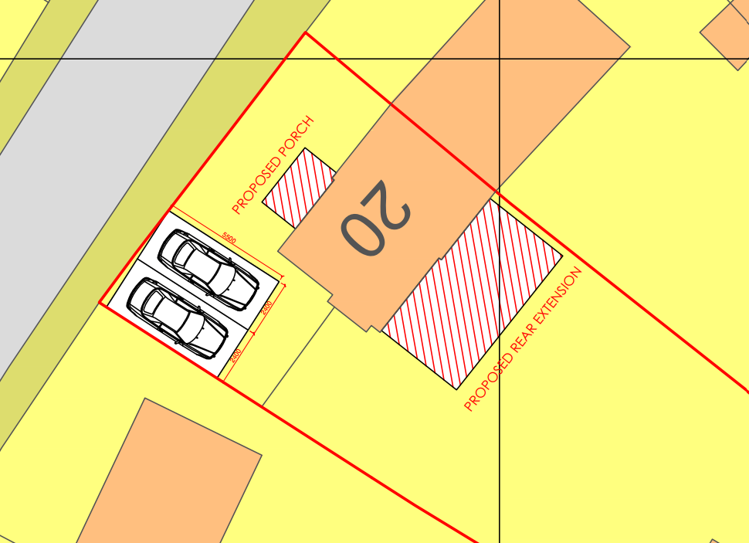

The proposed development would not result in any adverse impact on highway safety. Adequate parking is provided in accordance with Wiltshire’s adopted parking standards, and access arrangements are acceptable.

The proposal is therefore considered to comply with Core Policies 57 (xiv), 61 and 64 of the Wiltshire Core Strategy, the NPPF, and the Wiltshire Local Transport Plan.

Ecology Impact

Core Policy 50 of the Wiltshire Core Strategy seeks to protect and enhance biodiversity and geodiversity, including through ensuring that development avoids harm to protected species and habitats.

The National Planning Policy Framework (NPPF), in Paragraphs 193, requires that development minimises impacts on and provides net gains for biodiversity, including ensuring mitigation is secured where harm cannot be avoided.

Biodiversity Net Gain - Householder planning applications are exempt from the requirement to deliver Biodiversity Net Gain under Schedule 7A, Section 4(2)(a) of the Town and Country Planning Act 1990, as inserted by the Environment Act 2021.

As such, the development complies with Core Policy 50 of the Wiltshire Core Strategy and the relevant provisions of the NPPF.

CONCLUSION

The proposed development is considered to be acceptable in terms of its design, scale, and relationship with the surrounding area. It would not result in any unacceptable harm to the character of the locality, the amenities of neighbouring occupiers, or the interests of highway safety, or ecology.

The proposal is therefore considered to comply with the relevant policies of the Wiltshire Core Strategy, the Wiltshire Local Plan, and the National Planning Policy Framework. As such, the application is recommended for approval, subject to the conditions set out below.

RECOMMENDATION: That Planning Permission be GRANTED subject to conditions.

1.The development hereby permitted shall be begun before the expiration of three years from the date of this permission.

REASON: To comply with the provisions of Section 91 of the Town and Country Planning Act
1990 as amended by the Planning and Compulsory Purchase Act 2004.

2.The development hereby permitted shall be carried out in accordance with the following
approved plans:

Application form received 30/04/2026
Location plan Drg no DAK/HC/01 received 30/04/2026
Proposed block plan Drg no DAK/HC/02 received 30/04/2026
Proposed ground floor plan Drg no DAK/HC/05 received 30/04/2026
Proposed elevations Drg no DAK/HC/06 received 30/04/2026
Proposed section Drg no DAK/HC/07 received 30/04/2026
Proposed parking plan Drg no DAK/HC/08 received 30/04/2026

REASON: For the avoidance of doubt and in the interests of proper planning.

3. The materials to be used in the construction of the external surfaces of the development hereby permitted shall match in material, colour and texture to those detailed on the application form and approved plans and to match the existing dwelling.

REASON: For the avoidance of doubt and in the interests of visual amenity and the character and appearance of the area.

INFORMATIVE TO APPLICANT(S):

The applicant is advised that part of the approved development extends into the administrative area of Test Valley Borough Council and is subject to a separate planning permission (ref: 26/01246/FULLS).

The granting of this planning permission (PL/2026/02809) relates only to the part of the development within Wiltshire Council’s administrative area. The development should also be carried out in accordance with the planning permission to be approved by Test Valley Borough Council, ensuring that the scheme as implemented is consistent across both jurisdictions.

The applicant is advised to ensure that both planning permissions are in place prior to commencement of any works.

