APPLICATION FOR HOUSEHOLDER PLANNING PERMISSION
DELEGATED REPORT

APPLICATION REFERENCE: | PL/2026/02172
APPLICATION TYPE: | Householder planning permission
SITE ADDRESS: | Rood Ashton Manor, Rood Ashton Park, West Ashton, Trowbridge, BA14 6AS
DEVELOPMENT DESCRIPTION: | Proposed timber fence (part retrospective)
RECOMMENDATION: | That Planning Permission be GRANTED

PROPOSAL

The proposal seeks householder part retrospective planning permission for the erection of a timber fence on the eastern boundary of the host dwelling.

SITE DESCRIPTION/CONTEXT

The host dwelling is the Grade II listed property known as Rood Ashton Manor, located down a private road to the east of the village of West Ashton. The host dwelling is a large, detached country house, with generous grounds stretching to the east and south of the building, to the northeast of the property lies a Grade II listed Coach House.

The application site lies within the Bath and Bradford on Avon Special Area of Conservation for bats and Trowbridge and Westbury Bat Mitigation Strategy (TWBMS). It also falls within the recreational impact zone of the Salisbury Plain Special Protection Area for birds

PLANNING HISTORY
Proposal / Summary
PL/2022/00294 - Householder planning permission Decision - Approve with Conditions Date: 1/3/2022 – Proposed alterations and conversion of existing 1980s garage to provide additional accommodation.
PL/2022/00507 - Listed building consent Decision - Approve with Conditions Date: 1/3/2022 – Proposed alterations and conversion of existing 1980s garage to provide additional accommodation.
PL/2021/07828 - Householder planning permission Decision - Approve with Conditions Date: 11/10/2021 – Erection of greenhouse, and wall and fence along boundary line.
PL/2024/05874 - Householder planning permission Decision - Approve with Conditions Date: 28/8/2024 – Erection of timber outbuilding

RELEVANT POLICIES AND GUIDANCE

Wiltshire Core Strategy:
Core Policy 2 Delivery Strategy
Core Policy 29 – Spatial Strategy for the Trowbridge Community Area
Core Policy 50 – Biodiversity and Geodiversity
Core Policy 57 - Ensuring High Quality Design and Place Shaping
Core Policy 58 - Ensuring the Conservation of the Historic Environment
Emerging Policy – Wiltshire Local Plan Review
At Full Council on 19 May, the elected members of Wiltshire Council agreed to withdraw the emerging WLP. It will now be subject to a legal process to finalise its withdrawal - which is likely to happen in July or August (2026). The said Plan has no material weight for the purposes of the application.
West Ashton Neighbourhood Development Plan 2018-2026 Made June 2021
Salisbury Plain Special Protection Area

Trowbridge Bat Mitigation Strategy SPD, adopted February 2020

Bath and Bradford on Avon Bat SAC Guidance September 2015

Wiltshire Design Guide: Appendix D – Design Guidance for Householder extensions

The National Planning Policy Framework (NPPF)

The Planning Practice Guidance
Planning (Listed Buildings and Conservation Areas) Act 1990

National Design Guide

CONSULTATION RESPONSES

West Ashton Parish Council: No comment

REPRESENTATIONS
One letter of objection was received from an adjacent neighbour. The points raised will be assessed within the officer report below

ASSESSMENT
Section 38(6) of the Planning and Compulsory Purchase Act 2004 states:

"If regard is to be had to the development plan for the purposes of any determination to be made under the planning Acts, the determination must be made in accordance with the plan unless material considerations indicate otherwise."

In accordance with this statutory requirement, this application has been assessed against the relevant policies of the Development Plan, including the adopted Wiltshire Core Strategy (2015) and, where applicable, any made Neighbourhood Plans.

Heritage, Design and Impact upon the character and context of the area:
From the point of view of the historic environment the main statutory tests are set out within the Planning (Listed Building and Conservation Areas) Act 1990.

Section 66 requires that special regard be given to the desirability of preserving listed buildings, their settings or any features of special architectural or historic interest which they possess.

The Council’s Core Strategy Policy CP58 ‘Ensuring the conservation of the historic environment’ requires that designated and non-designated heritage assets and their settings will be conserved, and where appropriate enhanced, in a manner appropriate to their significance and encourages proposals which improve the condition of heritage assets at risk.

The Council’s Core Strategy CP 57: Ensuring high quality design requires a high quality of design in all new developments. The policy requires applicants to “demonstrate how the proposal will make a positive contribution to the character of Wiltshire through (amongst other things) responding to the value of the natural and historic environment and being sympathetic to and conserving historic buildings and landscapes. Development is required to respond positively to the existing in terms of building layouts, built form, height, mass, scale, building line, plot size, elevational design, materials, streetscape and rooflines to effectively integrate the building into its setting.

The NPPF outlines government policy for planning. Chapter 16 of the NPPF 'Conserving and enhancing the historic environment' sets out the Government's high-level policies concerning heritage and sustainable development.

The host building, Rood Ashton Manor is Grade II listed as is the Coach House located to the northeast of the application site, therefore due consideration must be given to whether any development would impact on the setting of these listed buildings.

The proposal relates to part retrospective permission for limited development to the eastern boundary of the host dwelling, Rood Ashton Manor, erecting a row of fence panels to the rear of an existing yew hedge. The fencing would consist of untreated timber section panels (23 in total) stretching a distance of 40m along the boundary line, as illustrated by the blue line in the site plan below.

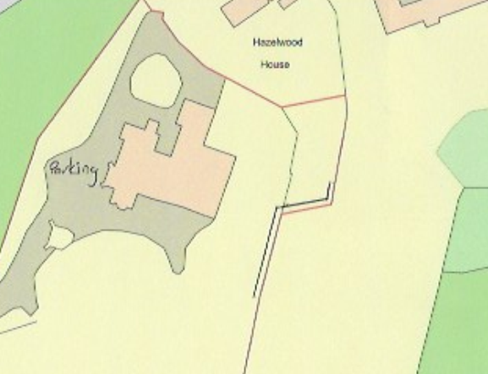
The panels have been erected to provide privacy screening for the applicants and their family members following the removal of any existing hedgerow from the boundary of the neighbouring property, which has resulted in open areas of the applicants existing yew hedging.

The panels would sit behind the existing yew hedge to provide screening until the yew hedge matures. The panels would be left untreated to allow them to weather down over time to integrate into the natural setting of the landscaping within the boundary line.

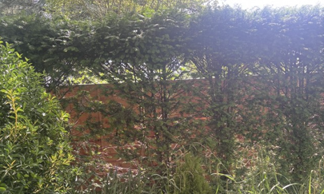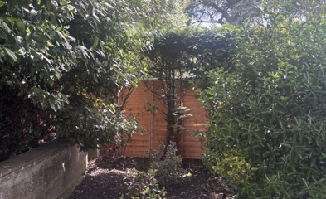
Site visit photos illustrating some of the fencing in situ

A neighbouring occupier has objected to the scheme on the grounds that the panels would be of a poor quality and would not be in keeping with existing boundary fencing within other areas of the application site, and this is duly noted.

However, the panels would not be readily visible from either the residential curtilage of the host dwelling, once the existing yew hedge has established, or the rear elevation of the neighbouring property given the existing mature trees and soft landscaping within the adjacent residential curtilage. Similarly, the panels would not be visible from the public footpath to the south and east of the host dwelling as the path is located some 200m away.

The neighbour has also queried whether the fence panels could be erected without any adverse impacts on the existing mature tress that line the eastern boundary of the host dwelling. However, officers have observed on site that due to the lightweight nature of the panels, that only limited ground works would be required to erect the fence posts at set points along the boundary, which would be set back from the root system of the existing mature trees.

Given the limited scale of the works, set within the built envelope of the application site, screened from view by existing mature soft landscaping, and separation distances to the listed buildings, officers are of the opinion that the proposal would not result in harm to the significance of any heritage assets.

The development is therefore considered to comply with Core Policy 57 and 58 of the Wiltshire Core Strategy and Sections 66 and 72 of the Planning (Listed Buildings and Conservation Areas) Act 1990, as well as the relevant provisions of the NPPF and the Wiltshire Design Guide.

Amenity
Point vii of Core Policy 57 - Ensuring High Quality Design and Place Shaping of the Wiltshire Core Strategy seeks to ensure that developments do not adversely affect neighbouring properties.

The National Planning Policy Framework (NPPF), particularly Paragraph 135(f), stresses that planning decisions should ensure developments provide a high standard of amenity for existing and future users.

The proposed development has been assessed in terms of its potential impact on the residential amenity of neighbouring properties, with particular regard to loss of light, overshadowing, loss of privacy, and overbearing effects.

The fence panels would sit at a maximum of 1.5m and would be set behind the existing yew hedging to the east of the host dwelling. Due to the nature of the works and separation distances to any neighbouring dwellings no concerns are raised in regard to any overshadowing, overbearing impacts or loss of light to neighbouring properties.

The proposal therefore accords with Core Policy 57 point vii in respect of safeguarding residential amenity and Appendix D of the Wiltshire Design Guide.

Ecology Impact
Core Policy 50 of the Wiltshire Core Strategy seeks to protect and enhance biodiversity and geodiversity, including through ensuring that development avoids harm to protected species and habitats.

The National Planning Policy Framework (NPPF), in Paragraphs 193, requires that development minimises impacts on and provides net gains for biodiversity, including ensuring mitigation is secured where harm cannot be avoided.

This proposal falls within the recreational impact zone of the Salisbury Plain Special Protection Area for birds. Therefore, potential disturbance to nesting birds through the creation of additional visitor numbers to the Salisbury Plain has to be assessed. However, given that this proposal relates to the erection of fencing panels, without the creation of separate independent living accommodation, it is considered that there would not be any adverse impacts on the Special Protection Area.

The application site sits within the Bath and Bradford on Avon Special Area of Conservation for bats as well as the grey, hatched zone of the Trowbridge, therefore due consideration has to be given to the potential disturbance of any bats because of the proposed development.

The proposed development comprises part retrospective development consisting of the erection of a boundary fence, given the small-scale nature of the works it is considered highly unlikely that any bats would be affected and significant effects relating to the disturbance to bats can be ruled out.

As such, the development complies with Core Policy 50 of the Wiltshire Core Strategy and the relevant provisions of the NPPF.

Biodiversity Net Gain
Householder planning applications are exempt from the requirement to deliver Biodiversity Net Gain under Schedule 7A, Section 4(2)(a) of the Town and Country Planning Act 1990, as inserted by the Environment Act 2021. Applications for retrospective development are also not subject to the requirement to deliver Biodiversity Net Gain at present.

Other Matters
The neighbouring occupier to the east has queried whether the fencing has been erected on the applicant’s property and not within the boundary of the neighbour’s private residential curtilage. The application form has stated that the works would be carried out on the applicant’s land only and officers have no reason to dispute the applicants claim. However, the issue of any boundary disputes is not a planning matter and a civil matter instead, dealt with under separate law.

CONCLUSION
The development is considered to be acceptable in terms of its design, scale, and relationship with the surrounding area. It would not result in any unacceptable harm to the character of the locality, the amenities of neighbouring occupiers, or the interests of heritage or ecology.

The proposal is therefore considered to comply with the relevant policies of the Wiltshire Core Strategy, the Wiltshire Local Plan, and the National Planning Policy Framework. As such, the application is recommended for approval, subject to the conditions set out below.

RECOMMENDATION: That Planning Permission be GRANTED subject to conditions.

Conditions
- The development hereby permitted shall be begun before the expiration of three years from the date of this permission.
REASON: To comply with the provisions of Section 91 of the Town and Country Planning Act 1990 as amended by the Planning and Compulsory Purchase Act 2004.

- The development hereby permitted shall be carried out in accordance with the following approved plans and documents:
Location Plan - Received 28.04.2026
Fence Elevation - Received 24.04.2026
Proposed Site Pan - Received 21.04.2026

REASON: For the avoidance of doubt and in the interests of proper planning

