APPLICATION FOR PRIOR NOTIFICATION – PART 3 CLASS Q
CASE OFFICER REPORT

APPLICATION REFERENCE: | PL/2026/02089
APPLICATION TYPE: | Prior approval Part 3 Class Q: Agricultural buildings to dwellinghouses
SITE ADDRESS: | Pickers Palmers Farm, Capps Lane, Heywood, Westbury, Wiltshire, BA13 4NE
DEVELOPMENT DESCRIPTION: | Convert barn 4 and barn 6 into 4 dwellings with external insulation to walls and roof not exceeding 0.2m (200mm) and proposed external garden and parking space area to not exceed the original Barn area
RECOMMENDATION: | That Prior Approval is REFUSED

SITE DESCRIPTION/CONTEXT

Pickers Palmers Farm is located in the open countryside to the east of the village of Heywood. The site is surrounded by farmland with mainly farm buildings located adjacent, although some of these have been subject to previous Class Q approvals for conversion to residential uses.

The site is located within the Salisbury Plain Special Protection Area (SPA) and within the ‘Grey’ and 'Yellow’ zones of the adopted Trowbridge and Westbury Bat Mitigation Strategy (TWBMS) relating to areas at medium risk for habitat loss and increased pressure from recreational impacts. A lake referenced as the Clay Pit is located directly to the south. The site does not lie within Flood Zones 2 or 3 and is not subject to high levels of surface water or ground water flooding.

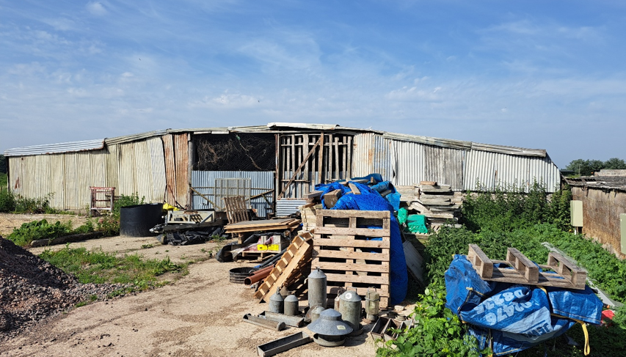
Existing building east elevation

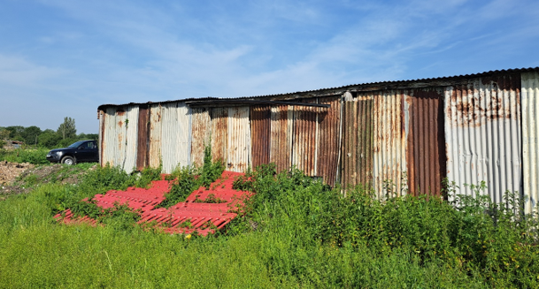
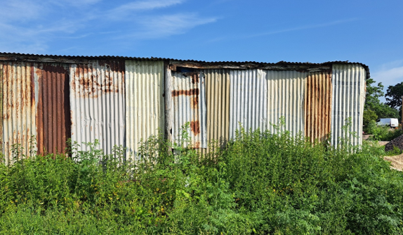
Existing building south elevation

PROPOSAL

This application seeks the conversion of 2 barns on site to 4 residential dwellings (1 x 1 bed, 1 x 2 bed, 1 x 3 bed and 1 x 4 bed) as detailed in the plans below.
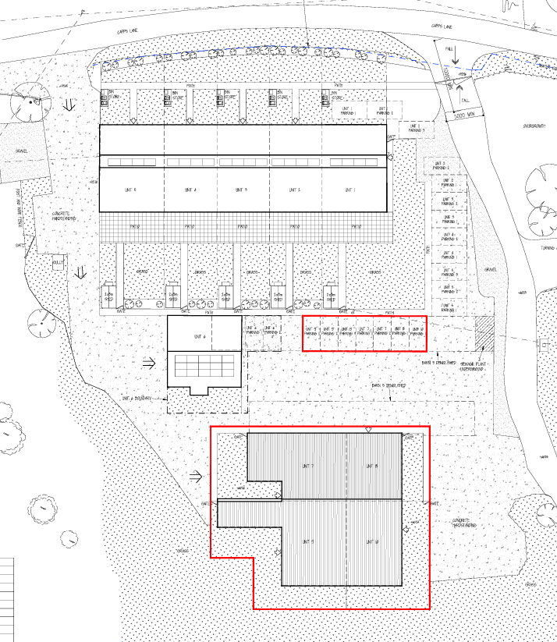
Proposed block plan detailing proposed 4 new dwellings (units 7 to 10 within red line) and existing 6 dwellings (units 1 to 6)
approved under previous prior approval/ full applications
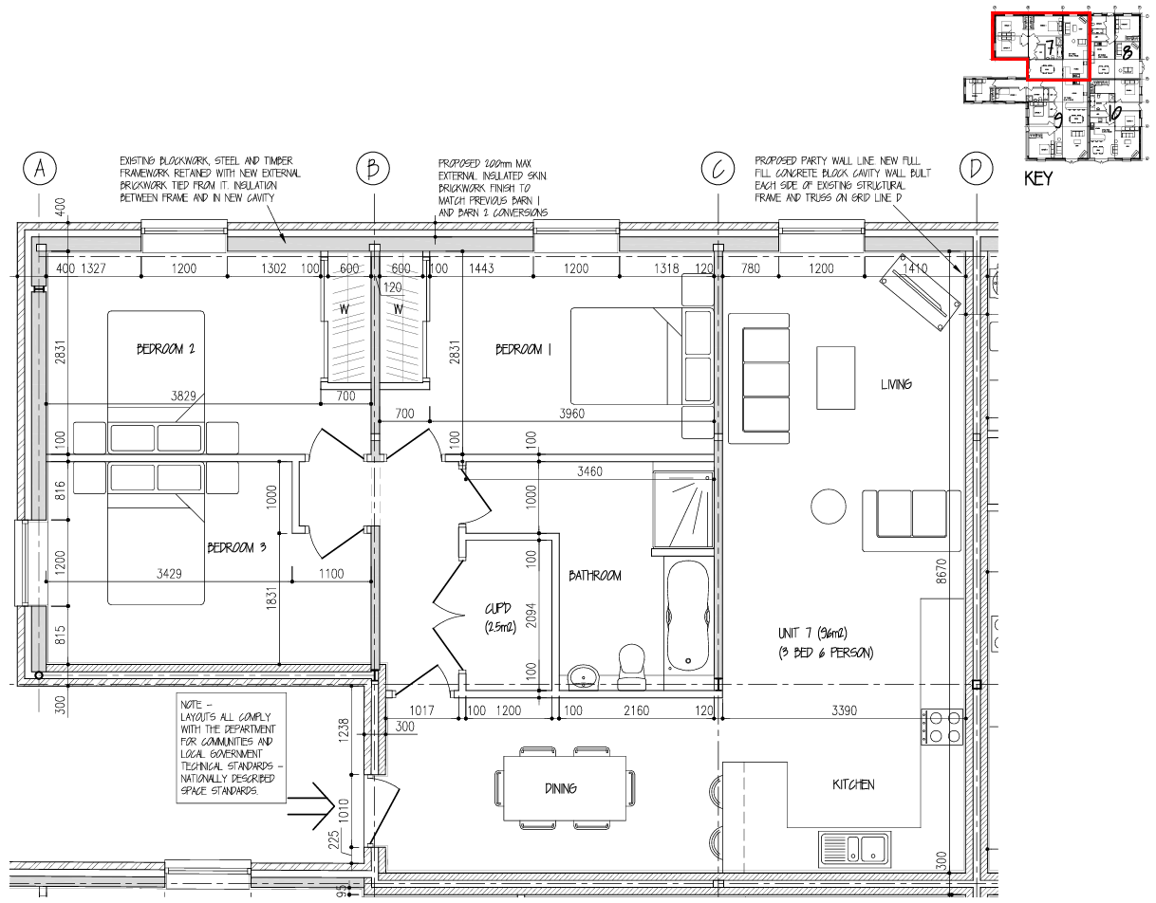
Floorplan unit 7

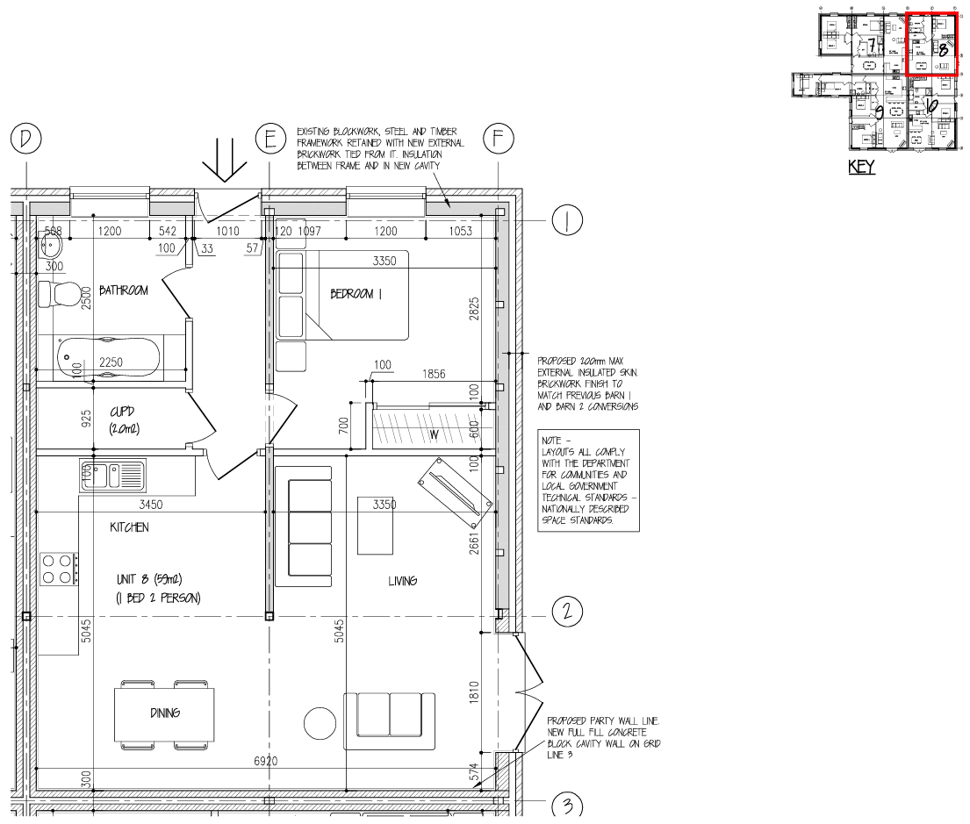
Floorplan unit 8

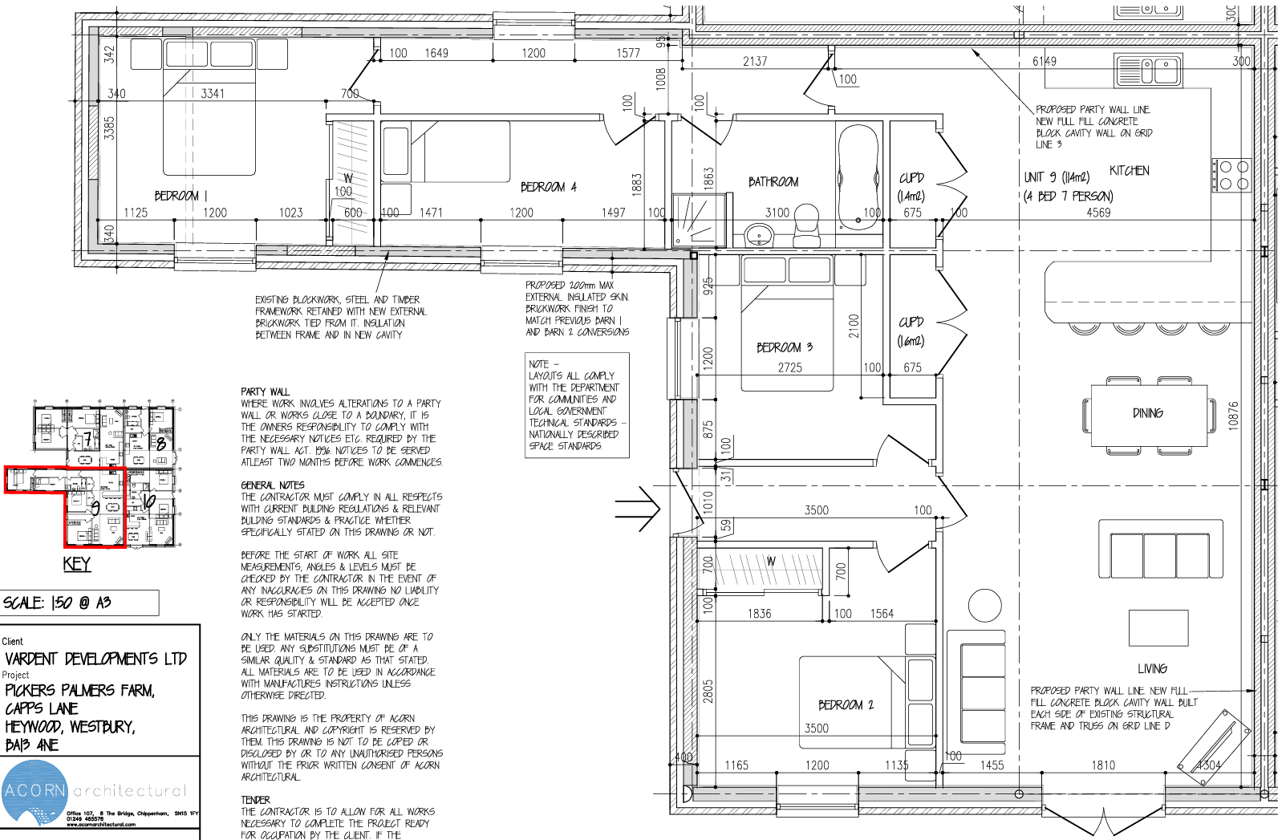
Floorplan unit 9

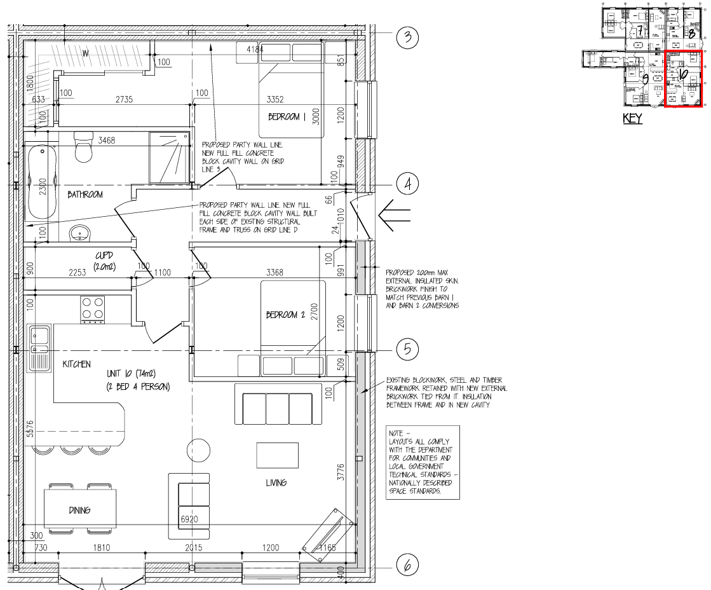
Floorplan unit 10

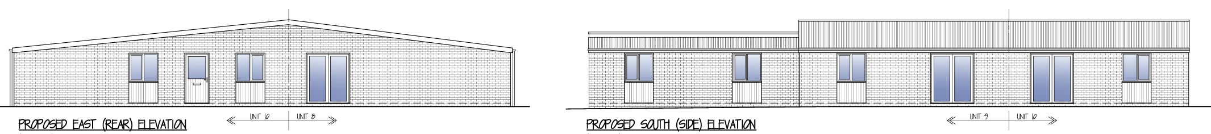

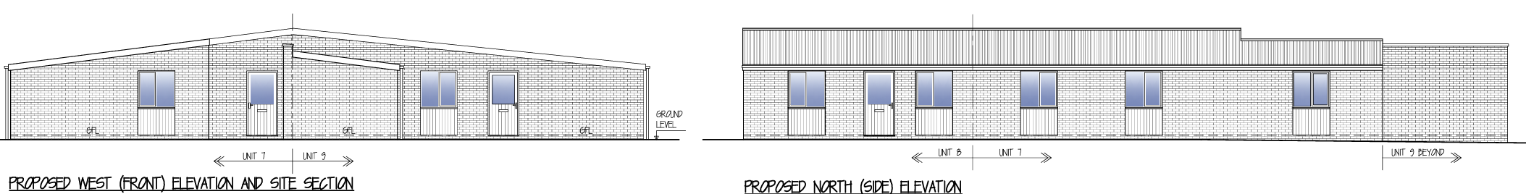
Proposed elevations

RELEVANT LEGISLATION, POLICY AND GUIDANCE

This application is assessed under Article 3 of the Town and Country Planning (General Permitted Development) (England) Order 2015 (as amended), which grants planning permission for certain types of development described in Schedule 2 of the Order. The grant of permission is subject to the limitations, conditions, and provisions set out within the relevant Classes of permitted development.

Under Schedule 2, Part 3, Class Q of the Town and Country Planning (General Permitted Development) (England) Order 2015 (as amended), certain changes of use and associated operations may be permitted subject to prior approval from the Local Planning Authority.

Conservation of Habitats and Species Regulations 2017 (as amended).

RELEVANT PLANNING HISTORY

There is no planning history relating to the subject buildings. The following planning history relates to other buildings within the overall farm complex:

PL/2025/09355 – Changes after approval for Barn 1 (residential conversion to units 1-5), Barn 2 (residential conversion to unit 6). Proposed boundary change to external areas for units 1-6. Proposed roof alteration to units 1-5 to include solar panels. Proposed brickwork finish to unit 6 to match units 1-5. Proposed bin store area and sheds added for units 1-6. – Approved

PL/2025/06077 – Convert barn 2 into 1 dwelling with proposed rear extension and external insulation to walls and roof not exceeding 0.2m (200mm). Proposed external garden and parking space area to not exceed the original Barn area. – Prior Approval Granted

PL/2025/04488 – Prior approval under Part 3 Class Q for the Conversion of barn to 1 dwelling. – Prior Approval Refused

PL/2025/03730 – Prior approval under Part 3 Class Q to convert barn to 5 dwellings with proposed rear extension and external insulation to walls and roof not exceeding 0.2m (200mm). Proposed external garden and parking space area to not exceed the original Barn area. – Prior Approval Not Required

PL/2023/06122 – (Class Q) Change of use of agricultural building to 4 no. dwellinghouses – Prior Approval Not Required

CONSULTATIONS

Bratton Parish Council: ‘The PC has consistently made comment concerning the traffic implications on Capps Lane but each application seems to have been assessed on its own merit and without any consideration of the total effect. In this current application for two more barn conversions it adds another 7 car parking spaces (including those for visitors) which takes the total on site now to 21. In each application that has been made it makes reference to the initial highways assessment for four 2 bedroom units where the highways officer raised a number of concerns and, despite comments from the PC, no further overall traffic assessment has been carried out. The PC again raises concerns that the overall traffic effect has not been assessed.’

Wiltshire Council Highways Officer: No objection

Wiltshire Council Public Protection Officer: No comment

ASSESSMENT

This application seeks prior approval under Class Q, which sets out the provisions, limitations and conditions for the permitted development right to change the use of “buildings on agricultural units and former agricultural buildings to dwellinghouses” as follows:
Q. Development consisting of—

(a) a change of use of—

- a building that is part of an established agricultural unit and any land within that building’s curtilage, or
- a former agricultural building that was (but is no longer) part of an established agricultural unit and any land within that building’s curtilage,

to a use falling within Class C3 (dwellinghouses) of Schedule 1 to the Use Classes Order,

(b) development referred to in sub-paragraph (a) together with the extension of the building referred to in sub-paragraph (a), or

(c) development referred to in sub-paragraph (a) together with building operations reasonably necessary to convert the building referred to in sub-paragraph (a) to a use falling within Class C3 (dwellinghouses) of that Schedule or to extend that building.

For the purposes of the PD right, the building’s curtilage is defined by para. Q.3 as being:

(a) the piece of land, whether enclosed or unenclosed, immediately beside or around the agricultural building, closely associated with and serving the purposes of the agricultural building, or

(b) an area of land immediately beside or around the agricultural building no larger than the land area occupied by the agricultural building, whichever is the lesser;

Does the Proposal Qualify as Permitted Development?

Development under Class Q is subject to a number of conditions and limitations. Development is not permitted by this class if any of the specified restrictions apply. These are set out at Appendix 1. Subject to compliance with these criteria and any limitations or conditions specified within the Order, the proposed development may be considered permitted development.

Having completed the detailed assessment checklist at Appendix 1 of this report, it is concluded that the proposed development does not qualify as permitted development, and therefore planning permission would be required for the proposed works, when having regard to the extent of works which are necessary in the context of the following limitation

(j)the development under Class Q(c) would consist of building operations other than—

(i)the installation or replacement of—

(aa)windows, doors, roofs, or exterior walls, or

(bb)water, drainage, electricity, gas or other services,

to the extent reasonably necessary for the building to function as a dwellinghouse, and

(ii)partial demolition to the extent reasonably necessary to carry out building operations allowed by paragraph Q.1(j)(i),

In addition to the limitations set out in Paragraph Q.1 of the GPDO, case law has established that the extent of works required in certain proposals may exceed the scope of a “change of use” and conversion of an existing building and instead constitute the construction of a new dwelling. In such instances, the development would fall outside the permitted development rights granted under Class Q. Therefore, it is necessary to assess whether the proposed works amount to a genuine “conversion” of the existing agricultural building, or whether they effectively result in a “replacement building” as a matter of fact and degree. The Planning Practice Guidance (PPG) provides helpful clarification on this point, emphasising that the structural integrity and extent of building operations must be considered when determining whether a proposal qualifies as a conversion under Class Q. More specifically the PPG provides the following guidance in this regard:

“The right allows either the change of use (a), or the change of use together with reasonably necessary building operations (b). Building works are allowed under the right permitting agricultural buildings to change to residential use...

However, the right assumes that the agricultural building is capable of functioning as a dwelling. The right permits building operations which are reasonably necessary to convert the building, which may include those which would affect the external appearance of the building and would otherwise require planning permission. This includes the installation or replacement of windows, doors, roofs, exterior walls, water, drainage, electricity, gas or other services to the extent reasonably necessary for the building to function as a dwelling house; and partial demolition to the extent reasonably necessary to carry out these building operations. It is not the intention of the permitted development right to allow rebuilding work which would go beyond what is reasonably necessary for the conversion of the building to residential use. Therefore it is only where the existing building is already suitable for conversion to residential use that the building would be considered to have the permitted development right...

Internal works are not generally development. For the building to function as a dwelling it may be appropriate to undertake internal structural works, including to allow for a floor, the insertion of a mezzanine or upper floors within the overall residential floor space permitted, or internal walls, which are not prohibited by Class Q.”

It is established from the above that whilst a proposed conversion may include significant works and elements of new building works relating to the external fabric of the building, the structural elements of the building must be capable of being retained and supporting the new fabric.

The application is supported by a Visual Structural Inspection undertaken by David Edwards and Associates (March 2026). The report concludes that “the existing structures appear to be permanent and substantial” and that the buildings are “considered to be structurally suitable for conversion into residential accommodation, subject to upgrading works and detailed structural design.” However, the report states that its findings are based mainly on a visual inspection, with no intrusive investigations (section 1.4). As such, the conclusions carry limited weight in demonstrating the building’s actual structural capability to support the proposed conversion.

In response to officer concerns, additional information has been submitted, including structural calculations for the timber posts, sections through the building, and photographic evidence of the dwarf wall to the south elevation. Whilst this information provides some further clarity, it does not satisfactorily address fundamental concerns regarding the structural integrity of the existing building.

Barn 6 is described as comprising a single-skin dense concrete blockwork dwarf wall to the northern and eastern elevations, with a timber-framed superstructure incorporating limited steel posts and corrugated metal sheeting. Whilst sections and photographs confirm that a dwarf wall exists along parts of the southern elevation, this evidence also demonstrates that sections of the wall have collapsed or are in a poor state of repair. The partial collapse and degraded condition of this wall cast serious doubt on its ability to contribute to a structurally sound envelope capable of supporting a residential conversion.

Furthermore, the evidence indicates that above the dwarf wall, the structure consists largely of lightweight, non-loadbearing corrugated sheeting, with internal timber boarding present in places.

Notwithstanding the submitted calculations regarding the timber posts present on site, and following a site inspection, the existing timber frame and purlins appear to be aged and in poor condition, with evidence of ad hoc supports such as additional timber bracing. This suggests that the existing structural framework is insufficiently robust and would require substantial intervention, replacement, or augmentation in order to support the proposed development.

Limited steel framing is present within the building and site observations confirm that these elements are sporadic and do not form a comprehensive structural framework, extending only marginally above the height of the dwarf wall. As such it is considered they cannot be reasonably be relied upon to form a primary loadbearing structure for conversion.

In addition, the structural report acknowledges that the roof covering requires upgrading. However, based on site observations, it is considered that the roof structure itself, including timber purlins, is likely to require complete replacement, rather than minor upgrading works. This further reinforces the conclusion that the proposal would involve significant rebuilding rather than conversion.

The section through the building indicates that, at one end at least, a new external block wall, requiring its own concrete foundations, is necessary to support the existing external wall and new roof structure. It appears to be constructed entirely independently of the existing dwarf wall and suggests that the existing dwarf wall is superfluous for the purposes of supporting the new building fabric necessary to be considered a conversion of the building. The introduction of new structural elements of this nature, which go beyond typically non-structural works such as insulation, infilling of existing openings and repair works, strongly indicates that the existing building is not already suitable for conversion to residential use without such significant structural interventions. Internal walls between units also comprise a double skin of new blockwork, in which the presence of the existing dwarf wall again appears somewhat inconsequential in facilitating a conversion.

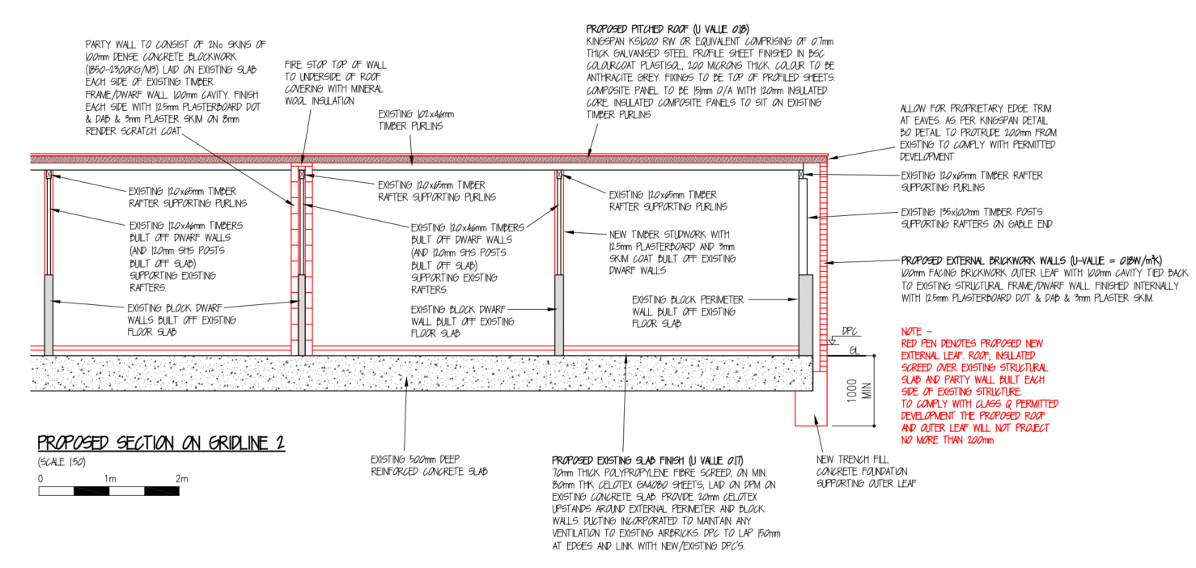

Critically, therefore, the additional submitted information fails to satisfactorily demonstrate how the existing structure, particularly the incomplete dwarf wall on the southern elevation and the inadequate timber framework, could be retained and utilised without extensive rebuilding or the introduction of new structural elements. It is considered that the additional information has not adequately addressed officers’ concerns that the extent of intervention required would not go beyond what is reasonably necessary to carry out a conversion.

The Council has had regard to the judgment in Hibbitt and another v Secretary of State for Communities and Local Government and Rushcliffe Borough Council [2016] EWHC 2853 (Admin), which established that for development to fall within Class Q, the building must be capable of conversion without operations that amount to a rebuild. The Court confirmed that the GPDO does not permit works which would effectively result in the construction of a new building under the guise of conversion.

Paragraph Q.1 of the GPDO permits development consisting of a change of use together with building operations reasonably necessary to convert the building. However, the scale and nature of works indicated in this case, including the likely reconstruction of sections of the external walls, new foundations, replacement of the roof structure, and insertion of a new structural framework, would exceed what can reasonably be described as conversion.

Paragraph: 105 of the Planning Practice Guidance (PPG) further advises that the building must be capable of functioning as a dwelling without the need for substantial rebuilding, and that permitted development rights do not extend to cases where the building is effectively replaced.

Accordingly, it has not been satisfactorily demonstrated that Barn 6 is a “permanent and substantial” building capable of conversion within the meaning of Class Q. For these reasons, the proposed development would involve works that go beyond those permitted under Class Q of the GPDO, and the proposal fails to comply with the limitations set out in paragraph Q.1(a). The development is therefore not permitted development.

Is Prior Approval Required?

Where a proposal complies with all the provisions limitations set out under Class Q of Schedule 2, Part 3 of the Town and Country Planning (General Permitted Development) (England) Order 2015 (as amended), the developer must apply to the Local Planning Authority (LPA) for a determination as to whether prior approval is required for the specified impacts and, if so, whether it should be granted.

In respect of this proposal, the following considerations must be assessed as part of the prior approval process as set out by Q.2.

Where the development proposed is development under Class Q(a) together with development under Class Q(c), development is permitted subject to the condition that before beginning the development, the developer must apply to the local planning authority for a determination as to whether the prior approval of the authority will be required as to—

(a) transport and highways impacts of the development,
(b) noise impacts of the development,
(c) contamination risks on the site,
(d) flooding risks on the site,
(e) whether the location or siting of the building makes it otherwise impractical or undesirable for the building to change from agricultural use to a use falling within Class C3 (dwellinghouses) of Schedule 1 to the Use Classes Order,
(f) the design or external appearance of the building, and
(g) the provision of adequate natural light in all habitable rooms of the dwellinghouses,

and the provisions of paragraph W (prior approval) of this Part apply in relation to that application.

Paragraph W sets out a number of requirements for both the developer (in terms of the application submission) and the LPA (relating to consultations and advertisement of the application). Paragraph W(10) states that:

The local planning authority must, when determining an application—
(a) take into account any representations made to them as a result of any consultation under sub-paragraphs (5) or (6) and any notice given under sub-paragraph (8);

(b) have regard to the National Planning Policy Framework issued by the Ministry of Housing, Communities and Local Government in February 2019 July 2021, so far as relevant to the subject matter of the prior approval, as if the application were a planning application; and

(c) in relation to the contamination risks on the site—
- determine whether, as a result of the proposed change of use, taking into account any proposed mitigation, the site will be contaminated land as described in Part 2A of the Environmental Protection Act 1990, and in doing so have regard to the Contaminated Land Statutory Guidance issued by the Secretary of State for the Environment, Food and Rural Affairs in April 2012, and
- if they determine that the site will be contaminated land, refuse to give prior approval

Para. W(13) allows LPAs to grant prior approval unconditionally or subject to conditions reasonably related to the subject matter of the prior approval.

Transport and highways impacts of the development

Policy Context
Paragraph 115 of the National Planning Policy Framework (NPPF) emphasises the importance of promoting sustainable transport modes, ensuring safe and suitable access for all users, and designing development in accordance with national guidance. It also requires that any significant impacts on the transport network—whether in terms of capacity, congestion, or highway safety—can be mitigated in a cost-effective manner. Paragraph 116 of the NPPF further clarifies that development should only be refused on highways grounds where there would be an unacceptable impact on highway safety, or where the residual cumulative impacts on the road network, following mitigation, would be severe.

In terms of locational sustainability, the Local Planning Authority (LPA) is not able to assess whether the site’s location in open countryside is sustainable in relation to access to services, employment, or facilities. This is not a consideration under the relevant prior approval provisions. Accordingly, the key matter for assessment is the impact of the proposal on highway safety, particularly in relation to the site access and the surrounding local highway network.

Assessment
Access to the site would be off an existing driveway off Capps Lane. Seven parking spaces are proposed for the 4 dwellings. Council parking standards would normally require 8 for the proposed 4 units however there is considered plenty of room on site to accommodate an additional parking space. In addition, details submitted under application PL/2025/09355 advise the access works to the site have been completed as detailed in the photo below and confirmed following a site visit. The existing access is considered adequate to accommodate additional vehicular movement without alteration. Whilst noting comments from Bratton Parish Council, it is not considered that the scheme would result in the level of harm to highway safety to warrant a recommendation for refusal or to request additional details.

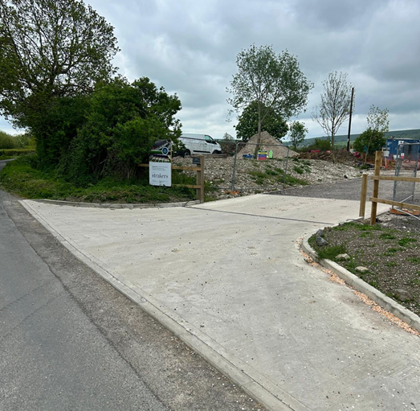
Photograph of completed access submitted with application PL/2025/09355
Conclusion
Prior approval in relation to traffic matters is not required.

Noise impacts

Policy Context
Paragraph 187(e) of the National Planning Policy Framework (NPPF) requires that planning decisions contribute to and enhance the natural and local environment by ensuring that new and existing development does not contribute to, or is not exposed to, unacceptable levels of noise pollution. This includes preventing development from being put at risk or adversely affected by such impacts.

Further to this, Paragraph 198(a) advises that new development should be appropriate for its location, taking into account the likely effects, including cumulative impacts, of pollution on health, living conditions, and the natural environment. It emphasises the need to mitigate potential adverse impacts arising from noise and to avoid noise that could result in significant harm to health or quality of life.

In the context of this proposal, the key consideration is whether the development would result in, or be exposed to, unacceptable levels of noise, and whether any such impacts can be appropriately mitigated to ensure a suitable living environment.

Assessment
The building is located in an open countryside location where previous farming operations on the former agricultural holding have ceased, therefore it is considered there would be no noise issues impacting the amenity of future residents.

Conclusion
Prior approval in relation to noise matters is not required.

Contamination risks

Policy Context
Paragraph 196 of the National Planning Policy Framework (NPPF) sets out the expectations for planning decisions in relation to land quality and safety. It states that:

- Sites must be suitable for their proposed use, taking into account ground conditions and any risks arising from land instability or contamination. This includes risks from natural hazards or former activities such as mining, and any proposed mitigation measures, including land remediation and its potential environmental impacts.
- Following any necessary remediation, land should not be capable of being determined as contaminated under Part IIA of the Environmental Protection Act 1990.
- Adequate site investigation information, prepared by a competent person, must be available to inform the assessment of these risks.

In the context of this proposal, the Local Planning Authority must be satisfied that the site is not subject to contamination or instability that would render it unsuitable for the proposed use, and that any necessary investigations or mitigation measures have been appropriately considered.
Assessment
The Council’s public protection officer has raised no specific issues in respect of contamination, and it is therefore considered there are no contamination risks on site.

Conclusion
Prior approval in relation to contamination matters is not required.

Flooding risks

Policy Context
The NPPF makes clear that inappropriate development in areas at risk of flooding should be avoided by steering development towards areas with the lowest risk, whether that risk is current or future. Where development is necessary in areas at risk, it must be demonstrated that the development can be made safe for its lifetime without increasing flood risk elsewhere.

Assessment
The site does not lie within Flood Zones 2 or 3 and is not subject to surface water or groundwater flooding. As such it is considered the development is not subject to flooding risks.

Conclusion
Prior approval in relation to flood risk matters is not required.

Location (impractical or undesirable)

Policy Context
The PPG advises that LPAs should apply a reasonable approach to the assessment of the location being “impractical or undesirable”. It goes on to advise that:

When considering whether it is appropriate for the change of use to take place in a particular location, a local planning authority should start from the premise that the permitted development right grants planning permission, subject to the prior approval requirements. That an agricultural building is in a location where the local planning authority would not normally grant planning permission for a new dwelling is not a sufficient reason for refusing prior approval.

Applications should only be refused if there may be circumstances where adverse impacts cannot be mitigated. Examples given by the PPG, when looking at location, include an agricultural building on the top of a hill with no road access, power source or other services being impractical and the location of a building (whose use would change) may be undesirable if it is adjacent to other uses such as intensive poultry farming buildings, silage storage or buildings with dangerous machines or chemicals.

Assessment
Previous applications as detailed above have already been approved for residential use on the wider site. The location and siting of the buildings currently under consideration, located directly to the south of those previously approved, is therefore considered acceptable in principle.

Conclusion
Prior approval in relation to location matters is not required.

Design or external appearance of the building

Policy Context
Paragraph 131 of the National Planning Policy Framework (NPPF) highlights that good design is a fundamental aspect of sustainable development, helping to create better places in which people live and work, and making development more acceptable to communities.

Relevant to this application type, Paragraph 135 sets out key principles to ensure that new development:

- Functions well and contributes positively to the overall quality of the area, not just in the short term but over the lifetime of the development;
- Is visually attractive through high-quality architecture, thoughtful layout, and effective landscaping;
- Is sympathetic to local character and history, including the surrounding built environment and landscape setting;
- Creates places that are safe, inclusive, and accessible, promoting health and well-being and providing a high standard of amenity for both existing and future users.

The NPPF also encourages Local Planning Authorities to make appropriate use of design tools and processes to assess and improve the quality of development proposals. This includes reference to national guidance such as the National Design Guide and assessment frameworks like Building for a Healthy Life, which support the delivery of well-designed, contextually appropriate development.

Assessment
The design and appearance of the dwellings is considered acceptable in this rural location, reflecting the former use as agricultural buildings.

Conclusion
Prior approval in relation to design matters is not required.

Provision of Natural Light

Policy Context
The prior approval matter to be assessed under para. Q.2(1)(g) relates to the provision of natural light into habitable rooms of the proposed dwelling.

For the purposes of the Part 3 (change of use) PD rights, para. X of the GPDO defines “habitable rooms” as:

...any rooms used or intended to be used for sleeping or living which are not solely used for cooking purposes, but does not include bath or toilet facilities, service rooms, corridors, laundry rooms, hallways or utility rooms.
Assessment
Submitted plans indicate adequate natural light to all habitable rooms can be provided by new window openings in the new walls which would be provided.

Conclusion
Prior approval in relation to natural light matters is not required.

Other matters

The site is located within the Salisbury Plain Special Protection Area (SPA) and within the ‘Grey’ and 'Yellow’ zones of the adopted Trowbridge and Westbury Bat Mitigation Strategy (TWBMS) relating to areas at medium risk for habitat loss and increased pressure from recreational impacts.

The applicant is therefore advised that they should consult with Natural England, and that the conversion to dwellings (under prior approval) may need to be subject to an application under Regulation 77 of the Conservation of Habitats and Species Regulations (2017).

CONCLUSION

The proposed development has been assessed against the provisions, limitations, and conditions set out in Schedule 2, Part 3, Class Q of the Town and Country Planning (General Permitted Development) (England) Order 2015 (as amended). Based on the submitted plans, supporting information, and the findings of this report, it is concluded that the proposal does not comply with the criteria for permitted development under Class Q, and therefore planning permission is required for the proposed works and the application is refused.

RECOMMENDATION:
That prior approval be REFUSED.

A
APPENDIX 1 – PERMITTED DEVELOPMENT CHECKLIST CLASS Q
Class Q – agricultural buildings to dwellinghouses
 |  | Yes / No
Q. | Permitted Development  Note: If the answer is "Yes" to any, proceed to assessment under Q.1. If the answer is "No" to all, the proposal does not qualify as permitted development under this class.
(a) | Does the development consist of change of use of:  - a building and any land within its curtilage from use as an agricultural building, or  - a former agricultural building that was (but is no longer) part of an established agricultural unit and any land within that building’s curtilage?  to a use falling within Class C3 (dwellinghouses)? | Yes
(b) | Does it include development referred to in sub-paragraph (a) together with the extension of the building referred to in sub-paragraph (a), or | No
(c) | Does it include development referred to in sub-paragraph (a) together with building operations reasonably necessary to convert the building referred to in sub-paragraph (a) to a use falling within Class C3 (dwellinghouses) of that Schedule or to extend that building? | No
Q.1 | Development is not permitted by Class Q if -  Note: If the answer to any of the questions below is "Yes", the proposed development would not constitute permitted development under this class
(a) | Was the site not part of the established agricultural unit:  - on 24th July 2023, or  - where the site became part of the established agricultural unit after 24th July 2023, for a period of at least 10 years before the date development under Class Q begins? | No
(b) | Is the site no longer part of an established agricultural unit and either:  - Was not part of one on 24 July 2023,  - Has not been part of one for at least 10 years before development begins, or  - Has been used for any non-agricultural purpose since leaving the unit? | No
(c) | Does any proposed dwelling exceed 150 square metres in floor space? | No (see submitted floor plans)
(d)(i) | Would the total number of dwellings on the agricultural unit (including previous Class Q developments) exceed 10? | No (a total of 10 units are now proposed on this site)
(d)(ii) | Would the total cumulative floor space of all dwellings on the unit exceed 1,000 square metres? | No (applicants advise total cumulative floorspace over the 10 units is 835sq metres)
(e) | Is the site occupied under an agricultural tenancy without written consent from both landlord and tenant? | No
(f) | Was an agricultural tenancy terminated less than 1 year before development begins for the purpose of Class Q development, without written agreement that the site is no longer needed for agriculture? | No
(g) | Has development under Class A(a) or B(a) of Part 6 (agricultural buildings/operations) occurred on the unit within the last 10 years? | No
(h) | Would the development extend the building beyond its existing external dimensions, except for:  - Extensions allowed under Q.1(i), or  - Protrusions up to 0.2m allowed under Q.1(j)(i)? | No
(i) | Would the proposed extension:  - Have more than one storey?  - Be sited anywhere other than the rear?  - Extend more than 4m beyond the rear wall?  - Have eaves higher than the existing building?  - Be taller than the highest part of the roof or 4m above ground?  - Extend beyond a side or principal elevation?  - Be sited on land not covered by a hard surface installed before 24 July 2023 or not in place for at least 10 years? | N/A
(j) | Would the building operations include anything other than:  - Installation/replacement of windows, doors, roofs, exterior walls, or services, or  - Partial demolition reasonably necessary for those operations? | See report
(k) | Is the site located on article 2(3) land (e.g., National Parks, AONBs, conservation areas)? | No
(l) | Is the site or any part of it:  - A Site of Special Scientific Interest?  - A safety hazard area?  - A military explosives storage area? | No
(m) | Is the site or any part of it a scheduled monument? | No
(n) | Is the building a listed building? | No
(o) | Would the converted building (excluding extensions) fail to meet the nationally described space standard? | No
(p) | Does the building lack suitable existing access to a public highway? | No

Planning Practice Guidance - Paragraph: 105 Reference ID: 13-105-20180615 (revision date 15/06/2018).
Planning Practice Guidance - Paragraph: 109 Reference ID: 13-109-20150305, Revision date: 05/03/2015.

