APPLICATION FOR HOUSEHOLDER PLANNING PERMISSION
DELEGATED REPORT

APPLICATION REFERENCE: | PL/2026/02093
APPLICATION TYPE: | Householder planning permission
SITE ADDRESS: | 29 Holders Road, Amesbury, Salisbury, SP4 7PH
DEVELOPMENT DESCRIPTION: | Replacing a Summer house with a Shepherds hut on wheels for incidental use in garden
RECOMMENDATION: | That Planning Permission be GRANTED

PROPOSAL

The proposal seeks planning permission to replace an existing summer house with a Shepherds hut on wheels for incidental use of the host dwelling.

SITE DESCRIPTION/CONTEXT

The site comprises a Grade II listed building with list entry number: 1182598.

II Pair of experimental smallholders' dwellings. c1920, for the Board of Agriculture and Fisheries. Cavity brickwork with Roman tiled roof. Single storey and attic, each cottage of 2 bays with the roof of the outer bay extending down over front section containing entrance. Panelled door with 6-paned glazing. One, 3 and 5-light timber paned windows, all with brick soldier courses over, but the 5-light bedroom window has a relieving arch. Open raftered eaves. Three brick stacks. No 31 has windows and door replaced in later C20 and small dormer added, but included as part of original block. (Country Life, 20th and 27th November 1920, illustrated)

Listing NGR: SU1629941468

The site comprises of a 1.5 storey semi- detached dwelling located within the settlement boundary of Amesbury which is defined as a Market Town by Wiltshire Core Strategy (WCS) policies CP1, CP2 and CP4. The site is located in Flood Zone 1 and not at risk of groundwater or surface water flooding according to the Strategic Flood Risk Assessment. While the application site is situated within the Hampshire River Avon Catchment area this has no impact on the assessment of the nature of the proposed development. The site is located adjacent to the highway on the east and is bordered by residential dwellings on the north, south and east.

PLANNING HISTORY

Proposal / Summary
S/2012/0309 - Listed building consent Decision - Approved Date: 1/6/2012 – Internal alterations and replacement of existing UPVC windows and doors with timber (retrospective)
13/01020/FUL - Full planning permission Decision - Approve with Conditions Date: 18/7/2013 – Replacement garage
S/2011/0102 - Full planning permission Decision - Refused Date: 24/3/2011 – Erection of detached two storey dwelling and associated parking

RELEVANT POLICIES AND GUIDANCE

Wiltshire Core Strategy:

- Core Policy 1: Settlement Strategy
- Core Policy 2: Delivery Strategy
- Core Policy 4: Spatial Strategy: Amesbury Community Area
- Core Policy 50: Biodiversity and Geodiversity
- Core Policy 57: Ensuring High Quality Design and Place Shaping
- Core Policy 69: Protection of the River Avon SAC

Wiltshire Design Guide: Appendix D – Design Guidance for Householder extensions

The National Planning Policy Framework (NPPF)

The Planning Practice Guidance

National Design Guide

Wiltshire Local Transport Plan 2011-2026 - Car Parking Strategy

CONSULTATION RESPONSES

Amesbury Town Council: Support.

REPRESENTATIONS

No comments were received.

ASSESSMENT

Section 38(6) of the Planning and Compulsory Purchase Act 2004 states:

"If regard is to be had to the development plan for the purposes of any determination to be made under the planning Acts, the determination must be made in accordance with the plan unless material considerations indicate otherwise."

In accordance with this statutory requirement, this application has been assessed against the relevant policies of the Development Plan, including the adopted Wiltshire Core Strategy (2015) and, where applicable, any made Neighbourhood Plans.

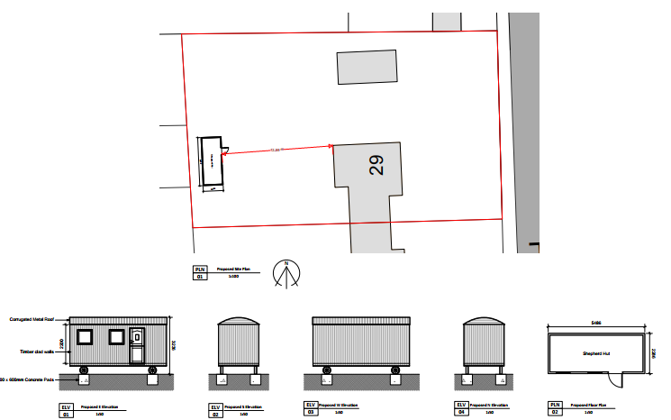
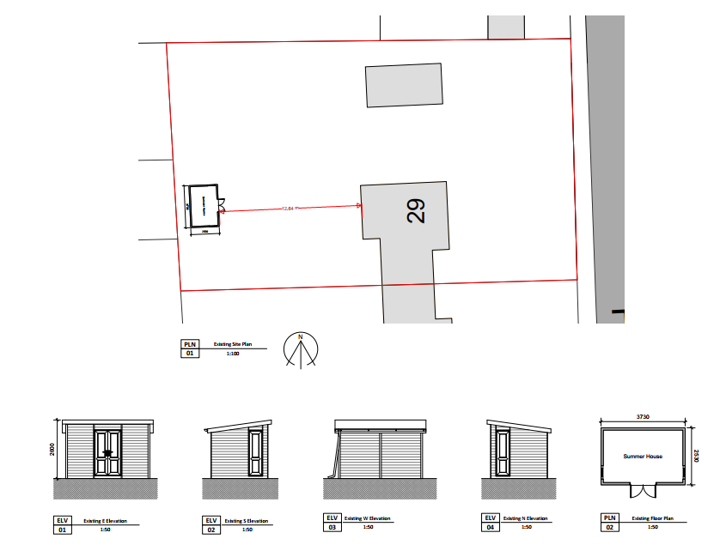
Design and Impact upon the character and context of the Grade II listed building

CP57 seeks to secure good design. The policy seeks to ensure that proposals enhance local distinctiveness by responding to the value of the natural and historic environment and requires all applications for new development to be accompanied by appropriate information to demonstrate how the proposal will make a positive contribution to the character of the area.

CP58 ‘Ensuring the conservation of the historic environment’ requires that “designated heritage assets and their settings will be conserved, and where appropriate enhanced, in a manner appropriate to their significance.” It is also required that distinctive elements of Wiltshire’s historic environment, including non-designated heritage assets, which contribute to a sense of local character and identity will be conserved, and where possible enhanced.

The proposed works lie within the garden and curtilage of a Grade II listed building, the listed building is half of a pair of semi-detached dwellings. The site is not within a conservation area. The impact on this designated heritage assets is a key consideration.

Section 16 of the Planning (Listed Buildings and Conservation Areas) Act 1990 states that in considering whether to grant LBC for any works the local planning authority (LPA) [or the Secretary of State] shall have special regard to the desirability of preserving the building or its setting or any features of special architectural or historic interest which it possesses.

Section 66 of the Planning (Listed Buildings and Conservation Areas) Act 1990 requires ‘special regard’ to be given to the desirability of preserving a listed building or its setting.

Section 72 of the Planning (Listed Buildings and Conservation Areas) Act 1990 states that in the exercise of any functions, with respect to any buildings or other land in a conservation area, under or by virtue of any of the provisions mentioned in this Section, special attention shall be paid to the desirability of preserving or enhancing the character or appearance of that area.

Assessment of Heritage Significance:
The significance and special interest of No. 29 and 31 Holders Road [Listing: 1182598] derives mainly from its historic value as a part of a pair of attached cottages built in 1920s as an experimental smallholders dwellings.

The application site consists of an existing single storey summer house measuring approximately 3.7 metres in length and 2.5 metres in width and 2.6 metres in height located 12.6 metres from the host dwelling. This application proposes to replace this existing summer house with a Shepherds hut on wheels which will measure approximately 5.4 metres in length, 2.2 metres in width and 3.2 metres in height 12.6 metres from the host dwelling and 2 metres from the boundary fence of the host dwelling on the west. The proposed Shepherds hut will have a circular corrugated metal roof with timber clad walls on 0.6 m x 0.6 m concrete pads with wheels. The submitted design and access statement notes that the Shepherds hut is proposed to be used as an annex associated with the host dwelling to create a place to sit and enjoy the garden and study or homework. The design, scale, materials and detailing are simple, of a modest scale and is considered to be of a nature that is acceptable and associated with residential use. The location is separated from the host listed dwelling and allows for ample amenity space to be retained within the plot. The location of the proposed hut is similar to where an existing summer house is located and proposed to be replaced. Lastly, the outbuilding is not visible from the street scene and has minimal impact on the surrounding special landscape area as the outbuilding is located within residential curtilage and is a development associated with surrounding established residential use of the local vicinity. The proposed hut will be erected on concrete pads allowing for a light touch connection to the ground.

Nonetheless, this householder planning application is regarding the erection of an outbuilding for the associated ancillary use of the residential host dwelling. A condition has been included in the recommendation notice that prevents the use of the outbuilding as a separate independent unit.

Heritage Balance and Conclusion:
Special regard has been had to preserving the listed building, its setting, and the parts of it that are of special architectural and historic interest, as required by the statutory duty under section 16(2) of the Planning (Listed Buildings and Conservation Areas) Act 1990.

A conservation officer was not consulted as part of this application as there are no direct proposed changes to the listed heritage assets itself. It is considered that as the proposed hut is located 12 metres from the listed building, the construction of this outbuilding will have no impact on historic fabric and have a neutral impact to the setting of the listed building. As the proposed hut is minimal in scale and has been designed to use traditional looking materials. The hut is also not visible from the street scene, however it is visible from the neighbouring listed building.

Amenity
Point vii of Core Policy 57 - Ensuring High Quality Design and Place Shaping of the Wiltshire Core Strategy seeks to ensure that developments do not adversely affect neighbouring properties.

The National Planning Policy Framework (NPPF), particularly Paragraph 135(f), stresses that planning decisions should ensure developments provide a high standard of amenity for existing and future users.

The proposed development has been assessed in terms of its potential impact on the residential amenity of neighbouring properties, with particular regard to loss of light, overshadowing, loss of privacy, and overbearing effects.

Loss of Light / Overshadowing and Overbearing Impact
The outbuilding is located on the east of the application site. It is single storey and not in close proximity to any neighbouring dwellings and does not cause any overshadowing or overbearing impact to the neighbouring amenity to warrant a refusal.

Loss of Privacy
The outbuilding is single storey and only has fenestrations on the eastern side elevation which is the elevation which faces the host dwelling. It is considered that there is no overlooking generated by the proposed outbuilding to the neighbouring dwellings. A condition has been included to remove the permitted development rights of inserting windows on the proposed west elevation as this elevation faces the boundary of the application site and faces neighbouring dwelling. The proposal therefore accords with Core Policy 57 point vii in respect of safeguarding residential amenity and Appendix D of the Wiltshire Design Guide.

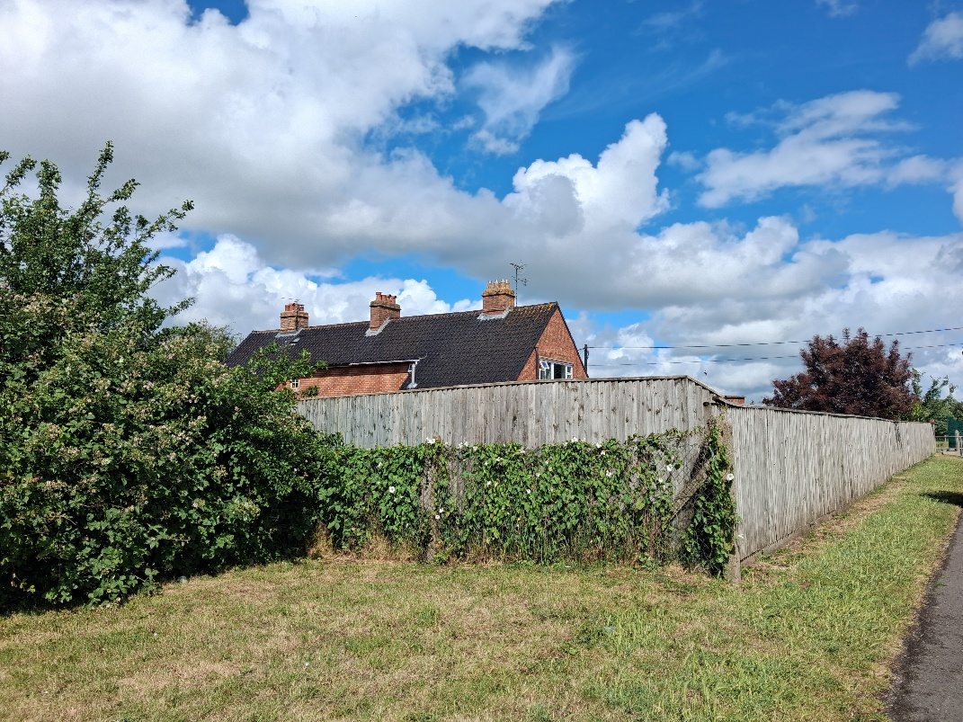

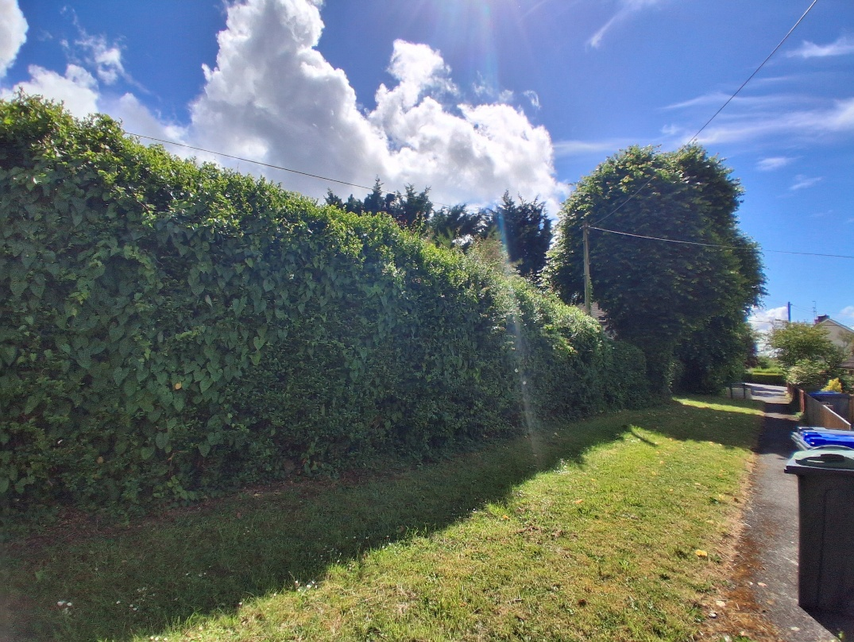

Biodiversity Net Gain
Householder planning applications are exempt from the requirement to deliver Biodiversity Net Gain under Schedule 7A, Section 4(2)(a) of the Town and Country Planning Act 1990, as inserted by the Environment Act 2021.

CONCLUSION
The proposed development is considered to be acceptable in terms of its design, scale, and relationship with the surrounding area. It would not result in any unacceptable harm to the character and setting of the associated listed building and conservation area, the amenities of neighbouring occupiers, or the interests of highway safety, heritage, or ecology.

The proposal is therefore considered to comply with the relevant policies of the Wiltshire Core Strategy, the Wiltshire Local Plan, and the National Planning Policy Framework. As such, the application is recommended for approval, subject to the conditions set out below.

RECOMMENDATION: That Planning Permission be GRANTED subject to the following conditions:

1.The development hereby permitted shall be begun before the expiration of three
years from the date of this permission.

REASON: To comply with the provisions of Section 91 of the Town and Country
Planning Act 1990 as amended by the Planning and Compulsory Purchase Act
2004.

2.The development hereby permitted shall be carried out in accordance with the
following approved plans and documents:

Location Plan Drawing No. 1190/03 Received: 21 April 2026

Proposed site plan and Shepherds Hut elevations and floor plan Drawing No. 1190/02 Received: 21 April 2026

REASON: For the avoidance of doubt and in the interests of proper planning.
3.Materials to be used in the construction of the works hereby permitted shall be as stated on the application form and in the submitted documents.
REASON: In the interests of visual amenity and the character and appearance of the area.

4. The Sheperd’s hut hereby permitted should only be used for purposes incidental to the residential use of the main dwelling, known as 29 Holders Road, Amesbury SP4 7PH and it shall remain within the same planning unit as the main dwelling.

REASON: The detached Sheperd’s hut is sited in a position where the Local Planning Authority, having regard to the reasonable standards of residential amenity, access, and planning policies pertaining to the area, would not permit a wholly separate unit or habitable accommodation. The use of the building for incidental use to the main dwelling complies with the NPPF and Wiltshire Core Strategy and ensures the development is nutrient neutral.

