APPLICATION FOR FULL PLANNING PERMISSION
DELEGATED REPORT

APPLICATION REFERENCE: | PL/2026/00222
APPLICATION TYPE: | Full Planning Permission
SITE ADDRESS: | 115 Station Road, Westbury, BA13 4HN
DEVELOPMENT DESCRIPTION: | Proposed New Dwelling & Associated Landscaping
RECOMMENDATION: | That Planning Permission be GRANTED

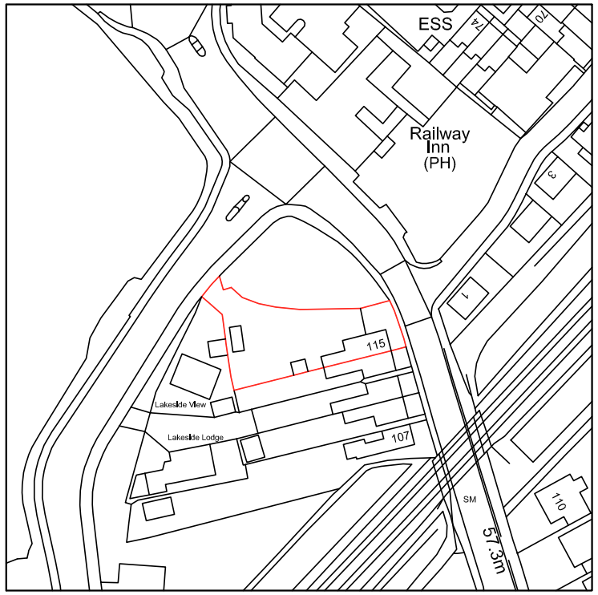

PROPOSAL

The proposal seeks full planning permission for the construction of a detached single‑storey dwelling within the rear garden of 115 Station Road, Westbury, including the creation of a new vehicular access and on‑site parking. The development would utilise part of the existing residential curtilage and incorporates associated amenity space, with plans provided showing the layout, scale and form of the building.

SITE DESCRIPTION / CONTEXT

The site consists of part of the rear garden of 115 Station Road, a two‑storey dwelling within an established residential area characterised by a mix of bungalows and two‑storey properties, including examples of backland and infill development. The land is generally level, enclosed by fencing and vegetation, and contains domestic garden features and outbuildings. It is located within walking distance of Westbury railway station and other local services, with surrounding development forming a typical suburban pattern. The site lies within the Westbury Settlement Boundary and within ecological consultation zones, including the Salisbury Plain SPA 6.4km buffer and the GHS 4km Core Roost Buffer, which require consideration through appropriate assessment processes. Drainage is intended to connect to existing systems.

The application site is subject to the following planning policy constraints:

- Salisbury Plain SPA 6.4km Buffer
- GHS 4km Core Roost Buffer
- Within Westbury Settlement Boundary (Market Town)
- Trowbridge and Westbury Bat Mitigation Strategy (TWBMS) Grey Zone

PLANNING HISTORY

No relevant planning history has been identified for the site subject of this application.

RELEVANT LEGILSATION, POLICIES AND GUIDANCE

Wiltshire Core Strategy:

Core Policy 1 Settlement Strategy;
Core Policy 2 Delivery Strategy;
Core Policy 32 Spatial Strategy: Westbury Community Area;
Core Policy 50 Biodiversity and Geodiversity;
Core Policy 51 Landscape;
Core Policy 57 Ensuring High-Quality Design and Place Shaping;
Core Policy 60 Sustainable Transport;
Core Policy 61 Transport and Development;
Core Policy 64 Demand Management;
Core Policy 67 Flood Risk;

Westbury Neighbourhood Plan 2023-2036

The National Planning Policy Framework (NPPF)

The Planning Practice Guidance (PPG)

Wiltshire Design Guide

The Wiltshire Local Transport Plan 2011 – 2026: Car Parking Strategy (March 2015).

The Wiltshire Local Transport Plan 4 (LTP4) (March 2025)

Emerging Policy – Wiltshire Local Plan Review

At Full Council on 19 May, the elected members of Wiltshire Council agreed to withdraw the emerging WLP. It will now be subject to a legal process to finalise its withdrawal - which is likely to happen in July or August (2026). The said Plan has no material weight for the purposes of the application.

CONSULTATION RESPONSES

Westbury Town Council – No Objection

Local Highway Authority (Wiltshire Council) – No Objection (subject to conditions)
This support is subject to conditions requiring gates to be set back and inward opening, and the completion and retention of the approved parking and turning areas, in order to ensure the access operates safely and does not result in obstruction or conflict on the public highway.

Ecology (Wiltshire Council) – No Objection (subject to conditions)
Ecology raises no objection to the proposal subject to conditions securing compliance with the approved ecology and BNG documents, agreed hedgerow planting and ecological enhancement features, a restriction on external lighting, and the submission of a Construction Method Statement to protect adjacent habitats and species during works. An informative also notes that the Habitats Regulations Appropriate Assessment concludes no adverse effects on designated sites, subject to the agreed mitigation measures, including the required financial contribution toward strategic recreational pressure mitigation.

Drainage (Wiltshire Council) - Objects
The Council’s drainage team has raised a holding objection because insufficient information has been submitted to demonstrate how surface water would be managed safely on the site, despite its location within Flood Zone 1. In particular, the absence of a detailed surface water drainage strategy and exceedance routing.

REPRESENTATIONS

No comments received.

ASSESSMENT

Section 38(6) of the Planning and Compulsory Purchase Act 2004 states:

"If regard is to be had to the development plan for the purposes of any determination to be made under the planning Acts, the determination must be made in accordance with the plan unless material considerations indicate otherwise."

In accordance with this statutory requirement, this application has been assessed against the relevant policies of the Development Plan, including the adopted Wiltshire Core Strategy (2015) and, where applicable, any made Neighbourhood Plans.

Core Policies 1 and 2 of the Wiltshire Local Plan identify Westbury as a Market Town where sustainable growth is supported, with development directed to within the defined settlement boundary. As the application site lies within this boundary and comprises a modest proposal for a single additional dwelling, the location is considered appropriate in principle. Development of this scale is consistent with the plan‑led strategy, which seeks to focus new housing in settlements capable of accommodating growth and supporting local services.

Core Policy 32, which relates specifically to the Westbury Community Area, supports appropriately located residential development that aligns with the town’s role and function. The redevelopment of part of an existing residential curtilage for a single dwelling represents a small‑scale infill opportunity that makes efficient use of land without extending the built form beyond established limits. Subject to detailed considerations set out elsewhere in this report, the proposal is therefore acceptable in principle.

Design and Impact upon the upon the character and context of the area

Core Policy 57 Ensuring High Quality Design and Place Shaping of the Wiltshire Core Strategy requires all new development to achieve a high standard of design that responds positively to its local context. Proposals must reinforce and enhance local character and distinctiveness, relate appropriately to the surrounding landscape, and demonstrate a thoughtful response to existing townscape features. This includes careful consideration of elements such as building height, scale, massing, building line, materials, and overall appearance, ensuring new development integrates harmoniously with its setting.

The proposed dwelling adopts a chalet-style form that is broadly consistent with the established pattern of development in the immediate area, including the recently completed properties on Amazon Way, which also incorporate a lower-profile roof structure and dormer elements. While the neighbouring chalet dwellings reach a ridge height of approximately 7.2m, the proposed dwelling is marginally lower at around 6.9m, helping to ensure it sits comfortably within the overall roofscape. The eaves height, at around 3m, remains comparable to the adjacent chalet-style properties, maintaining a coherent relationship while allowing for modest variation in built form.

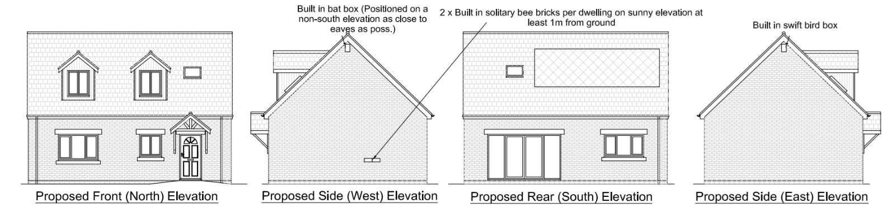
Proposed Elevations

The proposed materials have clear reference to the local context. The use of red brick for the primary elevations reflects both the established character of Station Road and the palette utilised on Amazon Way, while the inclusion of Bath-stone-coloured reconstructed headers and cills provides a visual link to the decorative detailing found on several traditional properties along Station Road. The proposed slate-effect roof tiles in black-grey, anthracite-clad dormers, and anthracite UPVC fenestration mirror materials used in the recent Amazon Way development, further contributing to a unified appearance between the new and existing built form. The integration of photovoltaic panels within the roof slope also provides a modern, energy-efficient element without detracting from the overall character of the dwelling.

Taken together, the form, scale, and palette of materials would allow the dwelling to respond appropriately to both the older architectural character along Station Road and the more contemporary designs introduced by recent development at Amazon Way. When viewed from external vantage points, the proposed building would sit cohesively alongside these existing dwellings, achieving a balance between contextual integration and subtle differentiation. Overall, the design is considered acceptable and appropriate for its setting, and the proposal is therefore supported in design terms.

Having regard to the above, the proposal complies with the design principles set out in Core Policy 57 of the Wiltshire Core Strategy and Appendix D of the Wiltshire Design Guide.

Amenity

Point vii of Core Policy 57 Ensuring High Quality Design and Place Shaping of the Wiltshire Core Strategy seeks to ensure that developments do not adversely affect neighbouring properties. The National Planning Policy Framework (NPPF), particularly Paragraph 135, stresses that planning decisions should ensure developments provide a high standard of amenity for existing and future users.

The submitted site plan indicates that the proposed dwelling would have a footprint of approximately 65.3sqm, accompanied by a private garden area of 78.1sqm. The host property at 115 Station Road has a footprint of 67.5sqm and would retain a resulting garden area of 117.7sqm. In both cases, the retained or provided private amenity space would exceed the footprint of the respective dwellings, which aligns with the principles set out in the Wiltshire Design Guide, where Section 9.2 addresses the need for adequate private amenity space and supports the use of numerical standards to ensure functional and usable garden areas. On this basis, the proposal is considered to provide acceptable levels of private amenity space for both the existing and proposed dwellings.

The new dwelling would be positioned between Lakeside View at a separation distance of approximately 7.8m and 115 Station Road at around 6.9m, placing it relatively close to existing residential properties. However, the arrangement is on an east–west axis, which substantially reduces the potential for harmful overshadowing due to the sun’s southern trajectory. The absence of windows in the east and west elevations avoids direct overlooking toward neighbouring dwellings, and it is noted that the south‑east‑facing first‑floor window at Lakeside View—identified on plans approved under 19/03513/FUL—is obscure glazed and angled obliquely, further limiting intervisibility. The existing pattern of development in this part of Station Road comprises seven dwellings within approximately 0.27ha, and the proposed spatial relationship would be broadly consistent with these established separation distances, where upper‑floor windows generally face garden areas and serve rooms with lower privacy sensitivity, such as bedrooms. Overall, the layout is considered acceptable and would not give rise to undue harm to neighbouring residential amenity.

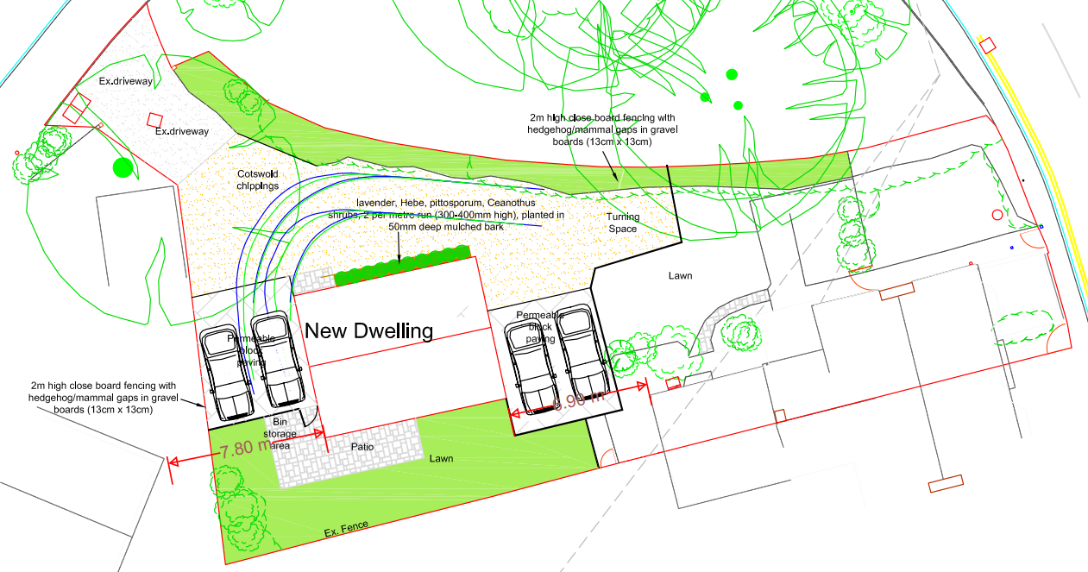
Proposed Site Plan

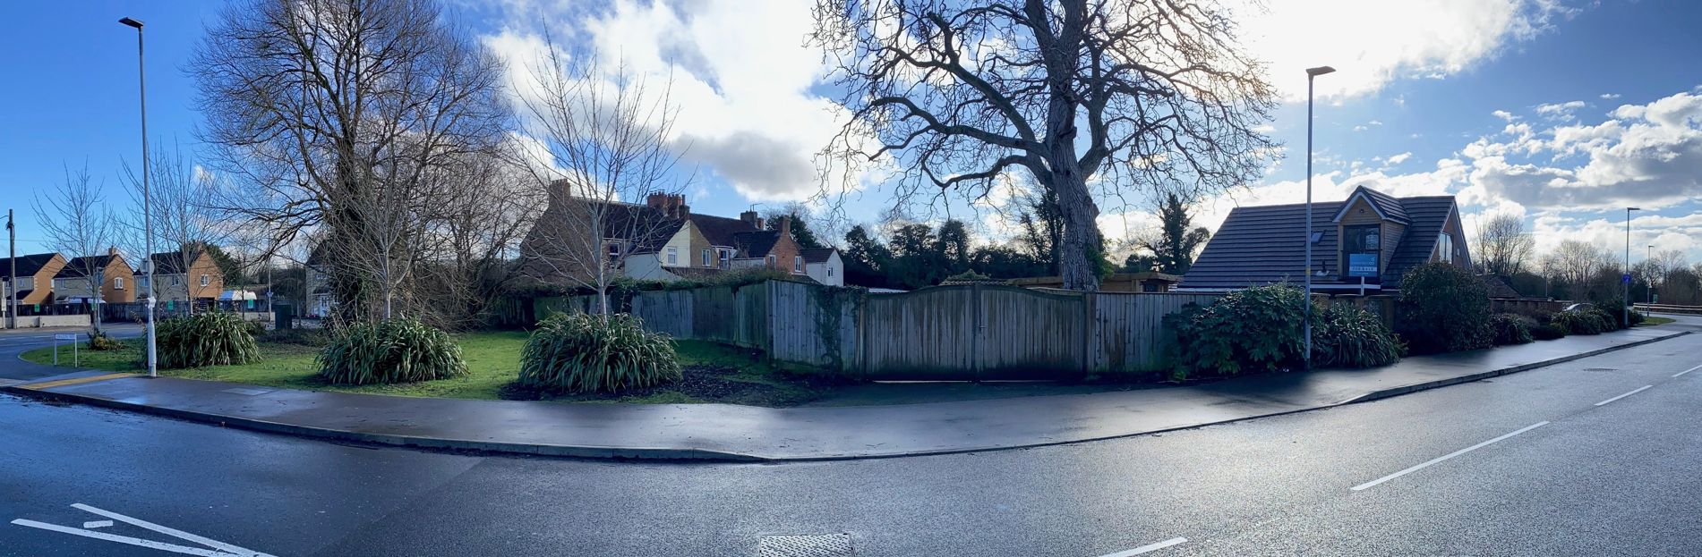
Site Visit Image (From Amazon Way)

The proposal is appropriately sited, designed, and oriented to ensure that it would not result in unacceptable impact upon/to the amenities or living conditions of neighbouring residential occupiers, particularly in terms of outlook, privacy, or access to natural light.

The proposal therefore accords with Core Policy 57 point vii in respect of safeguarding residential amenity and Appendix D of the Wiltshire Design Guide.

Transport and Highways

Core Policy 60 of the WCS states that Council will support and encourage safe and efficient movement of people and, where necessary, mitigate the impact of development on transport users and local communities. Core Policy 61 specifies that development should demonstrate that consideration has been given to a hierarchy of transport users and that proposals must, where relevant, serve as a safe access to the highway network. Paragraph 116 of the NPPF states that “Development should only be prevented or refused on highways grounds if there would be an unacceptable impact on highway safety, or the residual cumulative impacts on the road network, following mitigation, would be severe, taking into account all reasonable future scenarios”.

Core Policy 64 of the Wiltshire Core Strategy requires new development to provide an appropriate level of parking in accordance with the standards set out within the Wiltshire Local Transport Plan. Policy PS6 of the Car Parking Strategy further identifies that parking provision should reflect the size of the dwelling and the associated functional requirements. The existing dwelling at 115 Station Road contains three bedrooms, while the proposed new dwelling would contain two bedrooms. Under the adopted parking standards, a minimum of two on-site parking spaces is required for dwellings of this scale. The submitted plans demonstrate that each dwelling would be served by two dedicated parking spaces, all of which meet the minimum dimensions of 2.4m by 4.8m. The Highways Officer has reviewed the layout and confirmed that the submitted swept-path analysis is accurate and would allow vehicles to enter and exit the site in a forward gear. They have also requested conditions requiring the gate setback and inward opening, as well as the provision and retention of turning and parking areas, to ensure the access operates safely given its direct relationship with the public highway. It is considered that these conditions are appropriate because they prevent vehicles from waiting or manoeuvring within the carriageway, thereby reducing the potential for conflict with passing traffic and ensuring safe entry and exit from the site.

The development would utilise the existing access from Amazon Way, which presently serves the rear of 115 Station Road. The proposal would result in a modest increase in vehicle movements associated with an additional dwelling; however, this increase is limited to a small number of daily trips and is not considered likely to give rise to any adverse impacts on the safety or operation of the local highway network. Overall, the development is considered acceptable in terms of parking provision and highway safety.

Ecology

The WCS, through Core Policy 50, states that development proposals are expected to avoid and reduce disturbance of sensitive wildlife species and habitats. Biodiversity Net Gain (BNG) was established as a mandatory aspect of planning evaluation through Schedule 7A of the Town and Country Planning Act 1990 (as amended by the Environment Act 2021 Schedule 14). It is considered that the development does trigger the threshold for required BNG in association with the development proposal and as such must be considered further.

The application site lies within the Greater Horseshoe Bat 4km core roost buffer and the Trowbridge and Westbury Bat Mitigation Strategy (TWBMS) grey zone, where residential development has the potential to affect bat foraging and commuting behaviour associated with the Bath and Bradford on Avon Bat SAC. Notwithstanding this sensitivity, the site itself comprises residential garden land with limited ecological value, characterised primarily by managed lawn, small areas of scrub and domestic boundary vegetation. As such, the ecological interest of the site is low; however, given the proximity of higher‑value habitats and the wider ecological network, the potential impacts of introducing a new dwelling must be carefully controlled. The Council’s ecologist has therefore requested conditions to secure mitigation and enhancement measures, including the retention and reinforcement of boundary planting, ecological enhancement features, and strict control over external lighting to ensure that light spill does not disrupt bat commuting or foraging routes through upward or lateral illumination. A further condition is necessary to secure a Construction Method Statement to ensure that construction activities do not adversely affect nearby habitats or species, including through uncontrolled lighting, noise or pollution during works. The submitted Biodiversity Net Gain metric has been reviewed and accepted by the Council’s ecologist, with the identified shortfall to be addressed off‑site in accordance with legislation. Natural England has confirmed agreement with the Council’s Appropriate Assessment and its conclusion of no adverse effect on the integrity of the SAC, subject to the agreed mitigation measures. Subject to these controls and mitigation being secured by condition, the proposal is considered acceptable in ecological terms.

Flooding and Drainage

Core Policy 67 of the Wiltshire Core Strategy requires development to be designed to minimise vulnerability to flooding and to ensure that surface water is managed in a safe and sustainable manner without increasing flood risk elsewhere. Paragraph 172 of the NPPF requires a sequential, risk-based approach to development only where sites are at risk of flooding. In this instance, the site lies within Flood Zone 1, the area of lowest flood risk, and the Strategic Flood Risk Assessment identifies negligible risk from both surface water and groundwater flooding, such that there is no requirement to apply the Sequential Test.

The Design and Access Statement confirms that foul drainage would connect to the existing mains sewer, with surface water to be managed through sustainable drainage methods, such as a soakaway or equivalent SuDS solution. Given the limited scale of development, the modest increase in impermeable area, and the absence of any identified flood risk constraints, the principle of managing surface water on-site using SuDS is considered acceptable. While the Council’s drainage officer has raised a holding objection due to the absence of a detailed surface water drainage scheme at this stage, it is considered that this matter can be appropriately addressed through a pre-commencement condition, consistent with the approach taken on nearby approved development 19/03513/FUL.

It is therefore reasonable and proportionate to secure the detailed design of a surface water drainage scheme by condition, ensuring compliance with national SuDS standards and providing assurance that the development will not increase flood risk on or off site.

CONCLUSION

The proposal is considered to be acceptable and in accordance with the relevant policies and guidance outlined above.

RECOMMENDATION: That Planning Permission be GRANTED subject to the following conditions:

1.
The development hereby permitted shall be begun before the expiration of three years from the date of this permission.

REASON: To comply with the provisions of Section 91 of the Town and Country Planning Act 1990 as amended by the Planning and Compulsory Purchase Act 2004.

2.
The development hereby permitted shall be carried out in accordance with the following approved plans and documents:

Proposed Elevations and Floor Plans AH2025/80 Rev B (24 February 2026)
Exisiting and Proposed Block Plan / Location Plan AH2025/80 Rev B (24 February 2026)

REASON: For the avoidance of doubt and in the interests of proper planning.

3.
The development shall be carried out in accordance with the mitigation and enhancement measures set out within the approved Ecology & BNG Assessment (ABR Ecology, February 2026), insofar as they relate to ecological avoidance, mitigation and on-site enhancement measures, including boundary planting and installed wildlife features, unless otherwise agreed in writing by the Local Planning Authority.

REASON: To ensure the protection and mitigation of ecological interests, in accordance with Core Policy 50 of the Wiltshire Core Strategy and the National Planning Policy Framework.

4.
No development shall commence until a detailed surface water drainage scheme has been submitted to and approved in writing by the Local Planning Authority. The scheme shall be designed in accordance with the National Standards for Sustainable Drainage Systems (SuDS) and shall include:

- Details of the proposed drainage method and discharge destination;
- Calculations demonstrating post-development runoff rates and volumes do not exceed pre-development rates;
- Details of exceedance routing for the 1 in 100 year rainfall event plus 40% climate change;
- A maintenance and management plan for the lifetime of the development.

The approved scheme shall be implemented before the development is first occupied and thereafter retained and maintained in accordance with the approved details.
REASON: To ensure that surface water is managed sustainably and that the development does not increase flood risk elsewhere, in accordance with Core Policy 67 of the Wiltshire Core Strategy and the NPPF.

5.
No development shall commence (including any site clearance, vegetation removal or works to existing structures) until a Construction Method Statement (CMS) has been submitted to and approved in writing by the Local Planning Authority. The CMS shall include:

- Measures to protect sensitive habitats and species during construction, with particular reference to bats, nesting birds, and the adjacent Westbury Lakes County Wildlife Site;
- Details of pollution prevention measures, including the control of surface water runoff, sediment, fuels and chemicals during construction;
- Measures to prevent increased flood risk or pollution to surrounding land, waterbodies and the highway during construction works;
- Details of construction lighting (if any), hours of work, and the location of storage areas.

The approved CMS shall be implemented in full for the duration of the construction phase.

REASON: To ensure that construction activities do not result in adverse impacts to protected species, sensitive habitats, or increased flood risk or pollution, in accordance with Core Policies 50 and 67 of the Wiltshire Core Strategy and the National Planning Policy Framework.

6.
No external lighting shall be installed within the site unless details of the proposed lighting have first been submitted to and approved in writing by the Local Planning Authority. The submitted details shall include the location, type, specification, direction and level of illumination, and shall demonstrate that lighting will not result in light spill onto wildlife-sensitive habitats or established bat foraging and commuting routes.

Any approved lighting scheme shall be designed in accordance with the Institution of Lighting Professionals Guidance Notes for the Reduction of Obtrusive Light and Guidance Note GN08/23 Bats and Artificial Lighting at Night (Bat Conservation Trust and ILP), and shall thereafter be retained as approved.

REASON: To avoid adverse impacts on bats and other nocturnal wildlife, in accordance with Core Policy 50 of the Wiltshire Core Strategy and the National Planning Policy Framework.

7.
No part of the development hereby permitted shall be first brought into use/occupied until the turning area & parking spaces [4] have been completed in accordance with the details shown on the approved plans. The areas shall always be maintained for those purposes thereafter and maintained free from the storage of materials.

REASON: In the interests of highway safety.

8.
No gates shall be installed within the site unless they are set back a minimum of 4.5 metres from the edge of the carriageway and are designed to open inwards only.

REASON: In the interests of highway safety.

